A new seat booking system is required to help users reserve a seat based on the following requirements:
• First or Standard Class.
• By Window or Aisle.
• With or Without Table.
• Seat Price (The maximum price the user could afford).
When a suitable match is found, the user (identified by their eMail) should be able to reserve the seat. Seat reservations may also be cancelled. The seat data should be modelled in a file seats.txt that will contain the seat data and any reservations, though initially every seat should be unreserved. Upon application launches, the data should be loaded into appropriate data structures and upon application exits, the data should be saved back to the file.
Nouns:
Seat booking system
seat
First or Standard Class
By Window or Aisle
With or Without Table
Seat Price
maximum price
eMail

Verb phrases:
reserve the seat
reservations may also be cancelled
data should be loaded
the data should be saved back to the file

Seat booking system:
-Maximum price
-eMail
-Reserve seat
-Cancel Seat
-View Seat
-Load data
-Save Data
Seat:
-First or Standard Class
-By Window or Aisle
-With or Without Table
-Seat Price
-eMail
-userLikeness
-Reserve

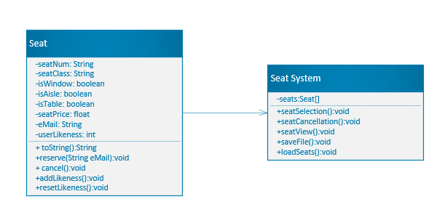
The value of user likeness is used to determine if the seat is appropriate for the user's needs. There is a total of 5 conditions to be met, that is the class of the seat, whether seat is by the window/aisle, does it have a table, and if the price is within user's range. If all 5 conditions are met, user likeness value is equal to 5 and any seat with that value is displayed. If no seats match all of the requirements, the program will display seats that meet at least 4 conditions. If there are none, it will search for 3 conditions, etc. That way the user will always get their perfect match, or the closest thing to it.

