

Uniwersytet Bielsko-Bialski
Wydział Budowy Maszyn i Informatyki

Digital Signal Processing

Exercise number:
1

Topic of the exercise:
Spectral analysis of deterministic signals: DFT and IDFT in matrix notation
(variant 7)

Radosław Walczak
Student ID: 60038
1. Aim of the exercise
The aim is to use the discrete Fourier transform pair in matrix notation: to build the index matrix K and the Fourier matrix W, to synthesise a discrete-time signal with the IDFT x = (1/N) W X for different values of N and to plot the result.
2. Theory
DFT: X[μ] = Σ x[k] e^{-j2πkμ/N}, IDFT: x[k] = (1/N) Σ X[μ] e^{+j2πkμ/N}, k, μ = 0 … N-1.
In matrix form: x_{μ} = W* x_{k} and x_{k} = (1/N) W x_{μ}, where W = exp(j 2π/N · K) (applied element-wise) is the N×N Fourier matrix and K = [0 1 … N-1]^{T}·[0 1 … N-1] contains all products kμ. The columns of W are the DFT eigensignals; W is symmetric and W⁻¹ = W^{H}/N = W*/N.
3. Task (variant 7)
Variant 7: x_{μ} = [6, 8, 2, 4, 3, 4, 5, 0, 0, 0]^{T}, i.e. N₀ = 10 coefficients. The matrices are shown for N = N₀ = 10. The signal is synthesised for N = 10, 16 and 20; for N > N₀ the coefficient vector is padded with zeros at the end (X[μ] = 0 for μ ≥ 10).
4. Results
Index matrix K for N = 10:
k\μ | 0 | 1 | 2 | 3 | 4 | 5 | 6 | 7 | 8 | 9
0 | 0 | 0 | 0 | 0 | 0 | 0 | 0 | 0 | 0 | 0
1 | 0 | 1 | 2 | 3 | 4 | 5 | 6 | 7 | 8 | 9
2 | 0 | 2 | 4 | 6 | 8 | 10 | 12 | 14 | 16 | 18
3 | 0 | 3 | 6 | 9 | 12 | 15 | 18 | 21 | 24 | 27
4 | 0 | 4 | 8 | 12 | 16 | 20 | 24 | 28 | 32 | 36
5 | 0 | 5 | 10 | 15 | 20 | 25 | 30 | 35 | 40 | 45
6 | 0 | 6 | 12 | 18 | 24 | 30 | 36 | 42 | 48 | 54
7 | 0 | 7 | 14 | 21 | 28 | 35 | 42 | 49 | 56 | 63
8 | 0 | 8 | 16 | 24 | 32 | 40 | 48 | 56 | 64 | 72
9 | 0 | 9 | 18 | 27 | 36 | 45 | 54 | 63 | 72 | 81

Fourier matrix W = exp(j2πK/10) for N = 10 (values rounded to two decimals):
k\μ | 0 | 1 | 2 | 3 | 4 | 5 | 6 | 7 | 8 | 9
0 | 1 | 1 | 1 | 1 | 1 | 1 | 1 | 1 | 1 | 1
1 | 1 | 0.81+0.59j | 0.31+0.95j | -0.31+0.95j | -0.81+0.59j | -1 | -0.81-0.59j | -0.31-0.95j | 0.31-0.95j | 0.81-0.59j
2 | 1 | 0.31+0.95j | -0.81+0.59j | -0.81-0.59j | 0.31-0.95j | 1 | 0.31+0.95j | -0.81+0.59j | -0.81-0.59j | 0.31-0.95j
3 | 1 | -0.31+0.95j | -0.81-0.59j | 0.81-0.59j | 0.31+0.95j | -1 | 0.31-0.95j | 0.81+0.59j | -0.81+0.59j | -0.31-0.95j
4 | 1 | -0.81+0.59j | 0.31-0.95j | 0.31+0.95j | -0.81-0.59j | 1 | -0.81+0.59j | 0.31-0.95j | 0.31+0.95j | -0.81-0.59j
5 | 1 | -1 | 1 | -1 | 1 | -1 | 1 | -1 | 1 | -1
6 | 1 | -0.81-0.59j | 0.31+0.95j | 0.31-0.95j | -0.81+0.59j | 1 | -0.81-0.59j | 0.31+0.95j | 0.31-0.95j | -0.81+0.59j
7 | 1 | -0.31-0.95j | -0.81+0.59j | 0.81+0.59j | 0.31-0.95j | -1 | 0.31+0.95j | 0.81-0.59j | -0.81-0.59j | -0.31+0.95j
8 | 1 | 0.31-0.95j | -0.81-0.59j | -0.81+0.59j | 0.31+0.95j | 1 | 0.31-0.95j | -0.81-0.59j | -0.81+0.59j | 0.31+0.95j
9 | 1 | 0.81-0.59j | 0.31-0.95j | -0.31-0.95j | -0.81-0.59j | -1 | -0.81+0.59j | -0.31+0.95j | 0.31+0.95j | 0.81+0.59j

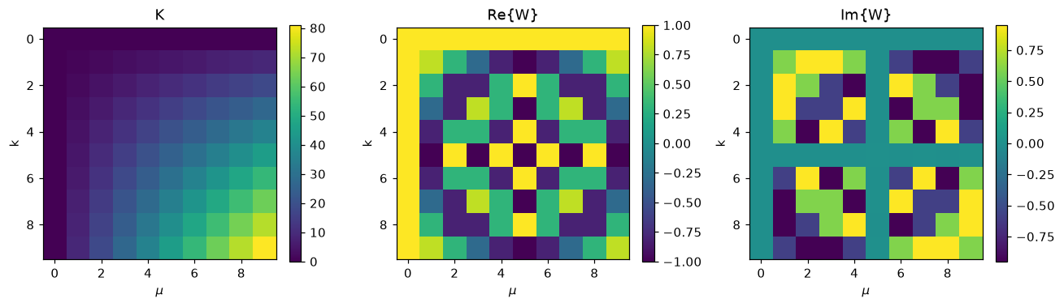
Figure 1. Index matrix K, real and imaginary part of the Fourier matrix W for N = 10.
Synthesised signal x[k] = (1/N) W X for N = 10:
k | 0 | 1 | 2 | 3 | 4 | 5 | 6 | 7 | 8 | 9
Re x[k] | 3.200 | 0.138 | 1.009 | 0.362 | -0.109 | 0.000 | -0.109 | 0.362 | 1.009 | 0.138
Im x[k] | 0.000 | 0.923 | 0.833 | 0.218 | 0.778 | -0.000 | -0.778 | -0.218 | -0.833 | -0.923
|x[k]| | 3.200 | 0.934 | 1.309 | 0.422 | 0.786 | 0.000 | 0.786 | 0.422 | 1.309 | 0.934

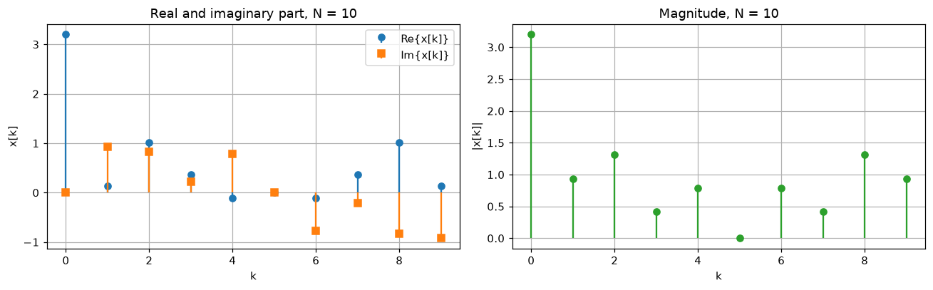
Figure 2. Synthesised signal for N = 10: real and imaginary part (left), magnitude (right).
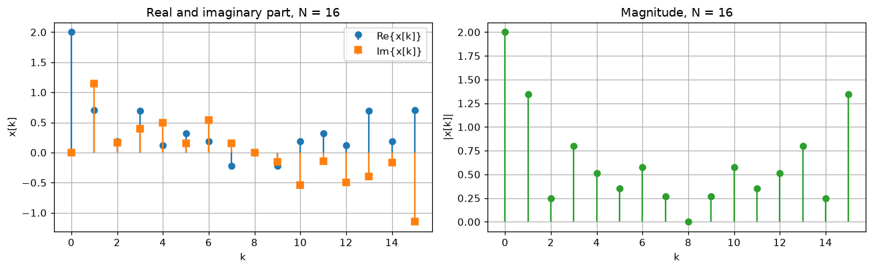
Figure 3. Synthesised signal for N = 16 (X zero-padded).
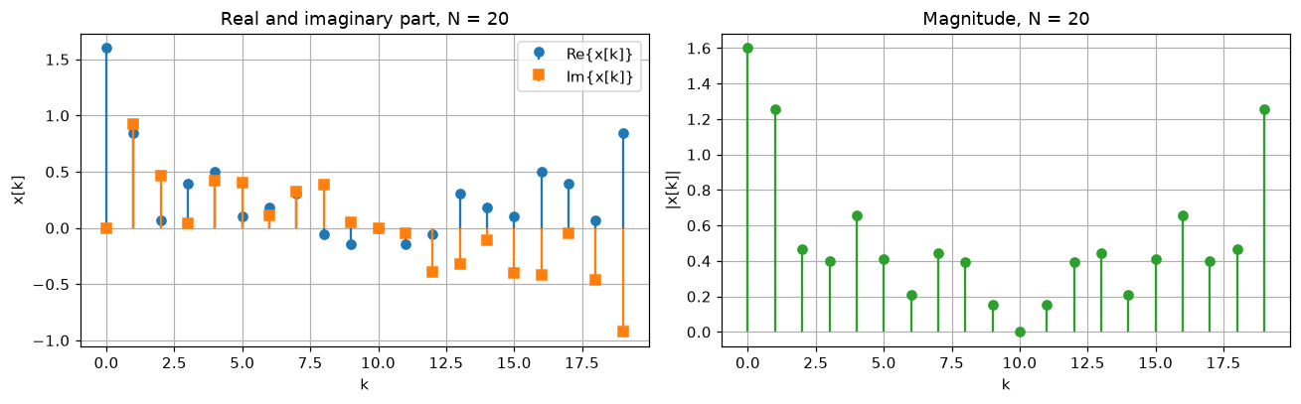
Figure 4. Synthesised signal for N = 20 (X zero-padded).

5. Interpretation
- Complex or real? The coefficients are real, but X[N-μ] ≠ X[μ]* (e.g. X[1] = 8, X[9] = 0), so the synthesised signal is complex-valued. For N = 10 the signal has the symmetry x[N-k] = x[k]*: the real part is even and the imaginary part is odd around k = 5 (e.g. x[1] = 0.138+0.923j, x[9] = 0.138-0.923j). The values x[0] = 32/10 = 3.2 and x[5] = (6-8+2-4+3-4+5)/10 = 0 are real.
- Check: for N = 10, 16 and 20 the result of the matrix multiplication agrees with numpy.fft.ifft to about 1e-15; W^{H}W = N·I, W is symmetric and W⁻¹ = W*/N, as stated in the theory. The mean of x[k] equals X[0]/N = 0.6.
- Influence of N: X[μ] multiplies the eigensignal with μ periods per N samples, so zero-padding the coefficient vector to a larger N places the same coefficients at lower digital frequencies 2πμ/N and the signal contains fewer periods of each component; its shape changes and it is longer. Because of the factor 1/N the amplitudes drop: x[0] = 32/N = 3.2 (N = 10), 2.0 (N = 16), 1.6 (N = 20). For N > 10 the vector X is no longer conjugate-symmetric in the DFT sense, so the signal does not have the symmetry of the N = 10 case and stays complex.
6. Conclusions
The IDFT in matrix notation reproduces the result of the FFT routine exactly (to rounding error). The signal for variant 7 is complex-valued because the coefficient vector is not conjugate-symmetric, and a change of N changes its length, amplitude scale (1/N) and the frequencies assigned to the coefficients.
Repository: https://github.com/RadoslawWalczak63/dsp_intro

