

Uniwersytet Bielsko-Bialski
Wydział Budowy Maszyn i Informatyki

Digital Signal Processing

Exercise number:
2

Topic of the exercise:
Windowing in spectral analysis
(variant 7)

Radosław Walczak
Student ID: 60038
1. Aim of the exercise
The aim is to study the influence of window functions on the spectral analysis of a signal with the DFT (FFT): the width of the mainlobe, the sidelobe level, the ability to resolve close frequencies and the detectability of weak tones next to a strong one.
GitHub: https://github.com/RadoslawWalczak63/dsp_lab1
2. Task and parameters (variant 7)
The signal x[k] = A₁ sin(2π f₁/f_{s} k) + A₂ sin(2π f₂/f_{s} k) + A₃ sin(2π f₃/f_{s} k), 0 ≤ k < N, was generated with:
f1 [Hz] | f2 [Hz] | f3 [Hz] | A1 | A2 = 0.1 A1 | A3 = 0.01 A1 | fs [Hz] | N
400 | 400.25 | 399.75 | 3 | 0.3 (-20 dB) | 0.03 (-40 dB) | 600 | 3000

Aliasing. For this variant fs/2 = 300 Hz, so all three frequencies are above the Nyquist frequency. They appear in the spectrum as aliases fs - f: f1 → 200 Hz, f2 → 199.75 Hz, f3 → 200.25 Hz. The spectra are therefore analysed around 200 Hz. The bin spacing is Δf = fs/N = 0.2 Hz (T = 5 s): f1 lies exactly on bin 1000, f2 and f3 lie between bins (998.75 and 1001.25), i.e. 1.25 bins from the strong tone.
3. Method
Rectangular, Hann, Hamming, Blackman and flat-top windows (periodic, sym=False) of length N were multiplied with the signal. The DFT was computed with the FFT and normalised to sine amplitudes (independent of N, factor 2 for the one-sided spectrum). The window DTFT spectra were obtained with zero-padding (100·N samples), normalised to the mainlobe maximum. Code: file lab2_windowing_variant7.ipynb.
4. Results
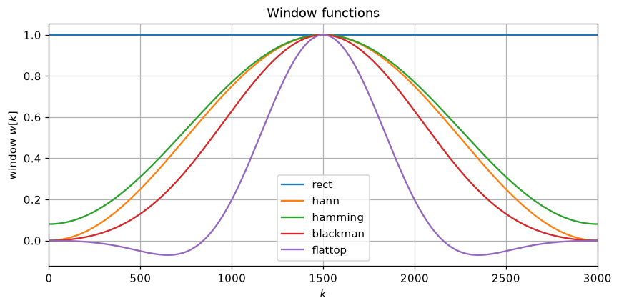
Figure 1. Window functions (N = 3000).
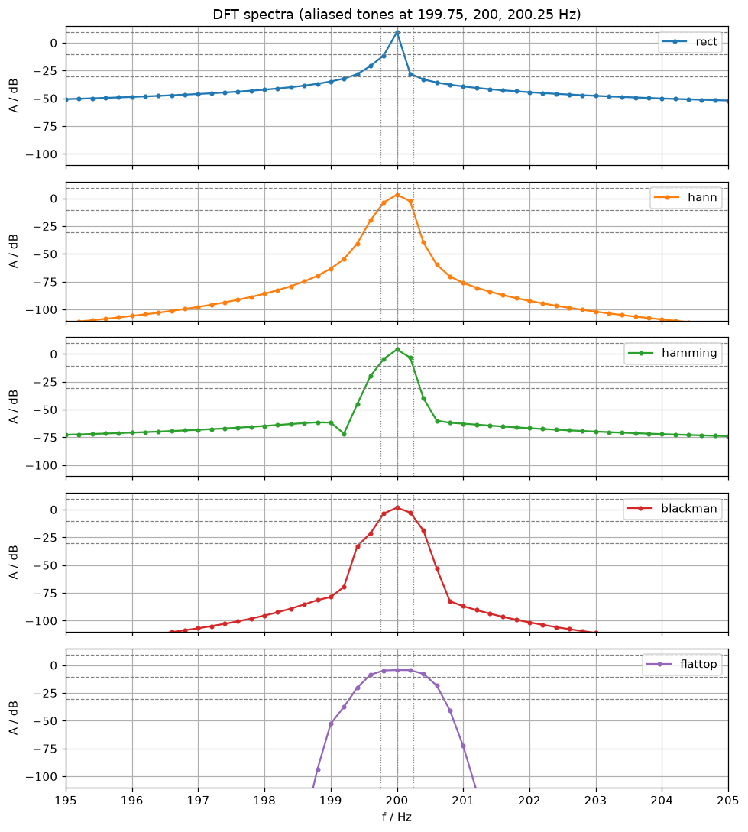
Figure 2. Normalised DFT spectra of the windowed signal, 195-205 Hz. Dashed horizontal lines: true tone levels (9.54, -10.46, -30.46 dB); dotted vertical lines: aliased tone frequencies.
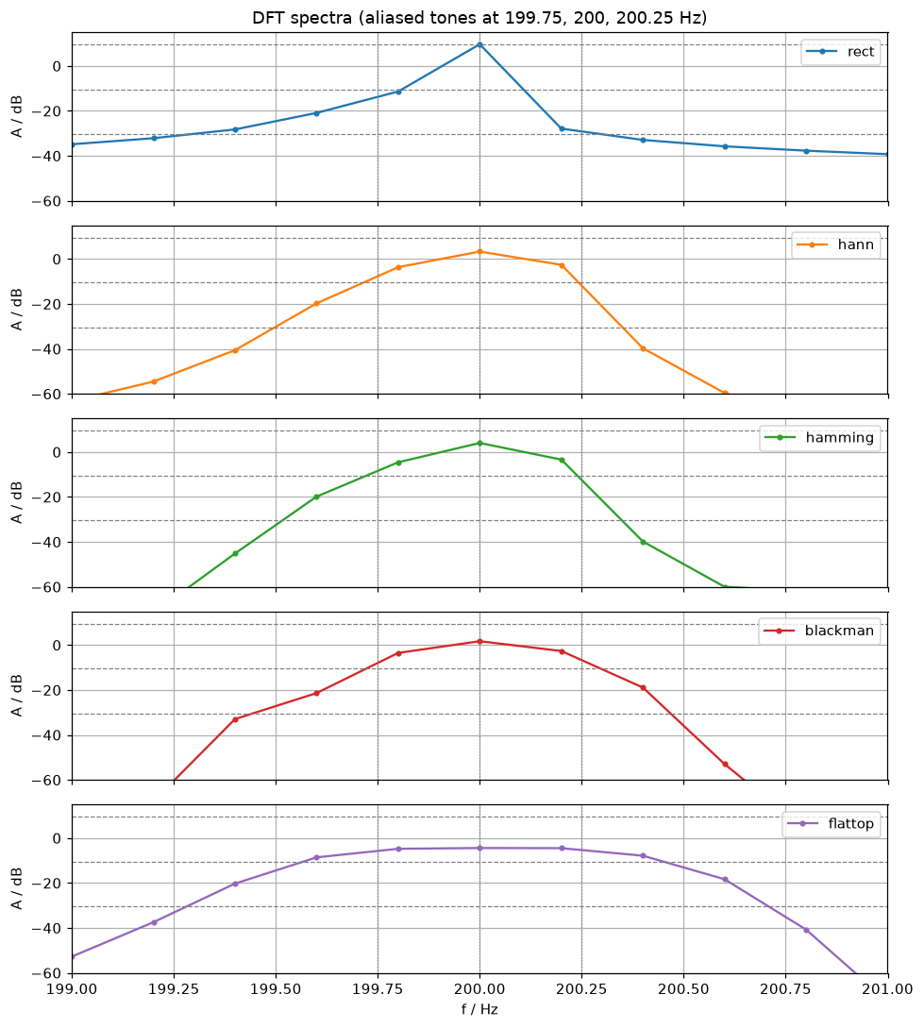
Figure 3. Zoom of the DFT spectra on the three tones (199-201 Hz).
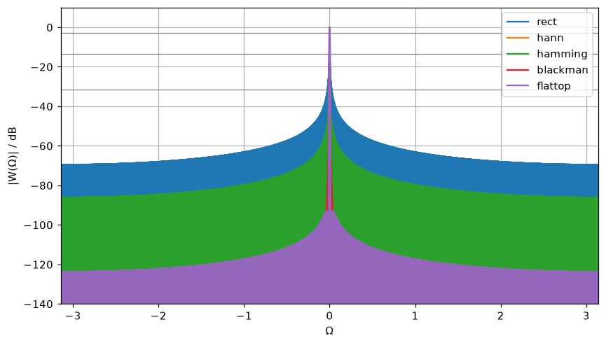
Figure 4. Window DTFT spectra normalised to the mainlobe maximum, -π ≤ Ω ≤ π. Gray lines: -3.01, -13.3, -31.5 and -93.6 dB.
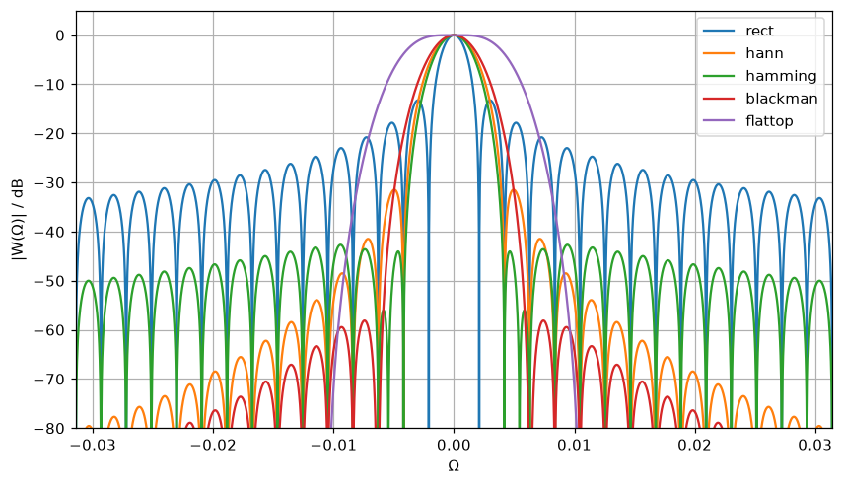
Figure 5. Mainlobe of the window spectra, -π/100 ≤ Ω ≤ π/100.
Window parameters measured from the DTFT (in DFT bins, 1 bin = 0.2 Hz) and DFT peaks of the signal (zero-padded x16):
Window | -3 dB width [bins] | half width to 1st null [bins] | max sidelobe [dB] | peak at 200 Hz [dB]
rectangular | 0.90 | 1.00 | -13.3 | 9.7
Hann | 1.46 | 2.00 | -31.5 | 3.3
Hamming | 1.32 | 2.00 | -42.7 | 4.0
Blackman | 1.66 | 3.00 | -58.1 | 1.7
flat top | 3.20 | 4.73 | -93.0 | -4.3

The peak levels are lower than the true 9.54 dB for all windows except the rectangular one because of the coherent gain of the window (mean of w[k]); scipy's flat top is not normalised to unity gain.

5. Interpretation
Observations
- Record length is T = N/fs = 5 s, so the DFT bin spacing is 0.2 Hz. The tones f2 and f3 (aliased to 199.75 Hz and 200.25 Hz) are only 0.25 Hz = 1.25 bins away from the strong tone at 200 Hz. This is the decisive fact for the whole experiment.
- Rectangular: the narrowest mainlobe (-3 dB width 0.9 bin, first null at 1 bin) but the highest sidelobes (-13.3 dB, slow decay). The leakage floor stays at about -35 dB (absolute level) even 1 Hz away from the strong tone. The -20 dB tone f2 is visible as a shoulder on the left of the main peak (zero-padded DFT peaks: 200.00 Hz / 9.7 dB, 199.71 Hz / -1.2 dB). The -40 dB tone f3 is not visible, because it lies in the leakage of f2.
- Hann, Hamming, Blackman: the sidelobes fall to about -60 ... -100 dB far from the peak, but the mainlobe is 4-6 bins wide (null-to-null) and the tones at +-1.25 bins lie inside it. The three tones merge into a single broadened peak; neither f2 nor f3 can be identified. The peak is lower than the true 9.5 dB because of the coherent gain of the window (3.3 dB for Hann, 4.0 dB for Hamming, 1.7 dB for Blackman).
- Flat top: the widest mainlobe (-3 dB width 3.2 bins, half width 4.7 bins) and the lowest sidelobes (-93 dB). All three tones fall onto its flat top, so the result is a plateau with a single maximum and no information about the individual tones. Its advantage is an accurate amplitude reading of an isolated tone, which is not what is needed here.
Interpretation
- Best detection of weak tones near a strong tone: for this variant no window really detects f3 (-40 dB at 1.25 bins distance). A low sidelobe level (Blackman, flat top) only helps when the weak tone lies outside the mainlobe of the strong tone, i.e. several bins away; there, e.g. Blackman shows a floor of about -57 dB (1 Hz away from the peak) compared with -13 dB for the rectangular window. Inside the mainlobe the weak tone is hidden by the strong one.
- Best separation of close frequencies: the rectangular window, because it has the narrowest mainlobe (1 bin to the first null, less than the 1.25 bin tone spacing). It is the only window in which f2 is still visible next to f1. The price is the high sidelobe level (-13.3 dB), so a weak tone far from the strong one would be buried in the leakage.
- Trade-off: a lower sidelobe level is always paid for with a wider mainlobe (rect: 1 bin, Hamming/Hann: 2 bins, Blackman: 3 bins, flat top: 4.7 bins half width). For the three tones of this task the mainlobe width is the limiting factor, not the sidelobe level.
- Why the tones look different although they are close: f1 = 200 Hz (after aliasing) gives exactly 1000 periods in the record, so it lies exactly on bin 1000 and with the rectangular window it produces no leakage on the other bins. f2 and f3 lie at bins 998.75 and 1001.25, i.e. between bins, so they leak into all bins. In addition their amplitudes are 10x and 100x lower, and the leakage of the neighbouring tones adds with different phases (the spectrum is asymmetric around 200 Hz).
- To resolve the tones the mainlobe has to be narrower than the 0.25 Hz spacing, i.e. the observation time must be longer. For Hann (null-to-null width 4/T) this means T > 16 s, N > 9600 at fs = 600 Hz. Zero-padding only interpolates the spectrum and does not improve the true resolution.
- Aliasing: since fs/2 = 300 Hz < 400 Hz, the real frequencies are not visible in the spectrum; the magnitude spectrum shows their aliases fs - f. To observe the tones at 400 Hz fs would have to be above 800 Hz.
6. Conclusions
None of the windows allows all three tones to be separated for this variant, because the tone spacing (0.25 Hz = 1.25 bins) is comparable with the mainlobe width. The rectangular window gives the best separation (f2 is visible as a shoulder), while the Hann, Hamming, Blackman and flat-top windows lower the sidelobes at the cost of a wider mainlobe and merge the tones into one peak. Low sidelobe windows are the right choice only for weak tones located far from the strong one; to resolve the given tones a longer record (about N > 9600 for Hann) is needed. Also, the chosen fs = 600 Hz is below the Nyquist rate for 400 Hz, so the analysed tones are aliases.

GitHub: https://github.com/RadoslawWalczak63/dsp_lab1

