1. Create this structure by using HTML and CSS only.

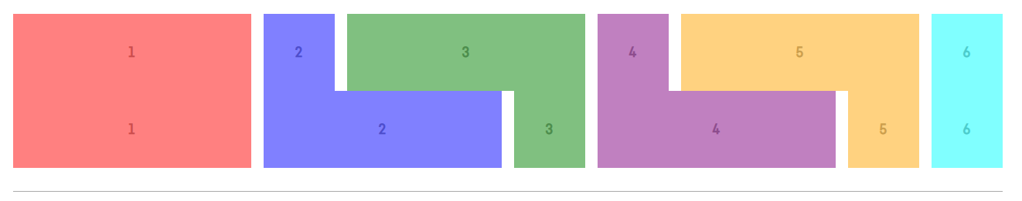

1. Create this pattern by using HTML and CSS only.

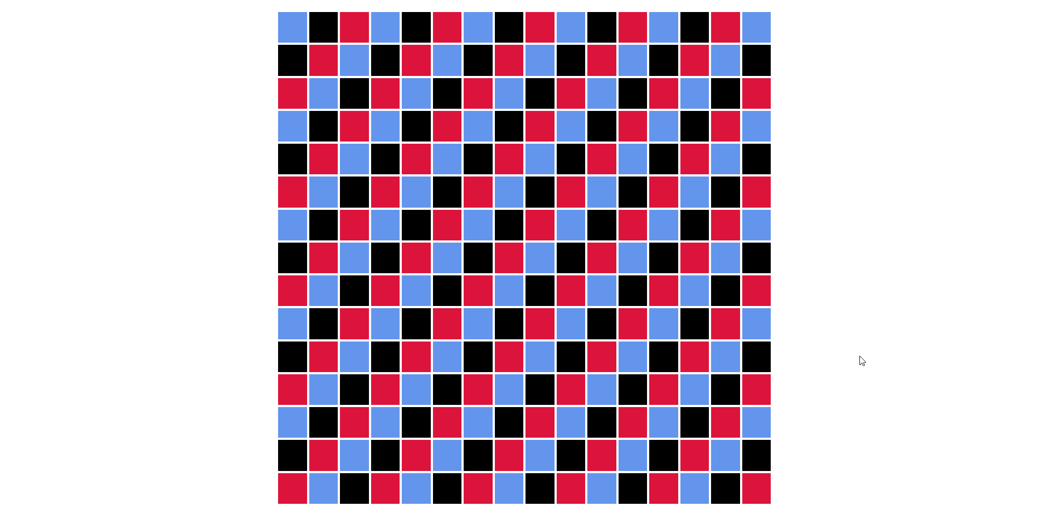

1. Style the table using CSS only and using the markup from the HTML task.

