1. Create a webpage that prints your name to the screen.
2. Print your name in green.
3. Print the squares of the numbers 1 - 20. Each number should be on a separate line, next to it the number 2 superscripted, an equal sign and the result (Example: 102 = 100).
4. Create some links to various search engines (Example: google, yahoo, altavista, lycos, etc).
5. Display five different images. Skip two lines between each image. Each image should have a title.
6. Pick 5 corporations and hunt down their current stock prices. Place them in a neatly arranged table with their name, symbol, last price, 52wk high, 52wk low and PE ratio. The end result should look like the following. Notice that the first column is aligned left and the rest are centered.

|  |  |  |  |  |  |
| --- | --- | --- | --- | --- | --- |
| ***My tech stock picks*** | | | | | |
| **NAME** | **SYMBOL** | **CURRENT** | **52WK HI** | **52WK LO** | **P/E RATIO** |
| Microsoft | MSFT | 86-3/8 | 119-15/16 | 75-1/2 | 56.09 |
| Cisco Systems | CSCO | 72-1/8 | 82 | 24-13/16 | 400.69 |
| America Online | AOL | 63 | 95-13/16 | 38-15/32 | 350.00 |
| Qwest Communications | Q | 44-7/16 | 66 | 25-3/4 | 74.06 |
| Dell Computers | DELL | 53-59/64 | 59-11/16 | 31-3/8 | 86.97 |

7. Make a simple page and put two text inputs and a Submit button into it. Ask for the user's name and address. Example:

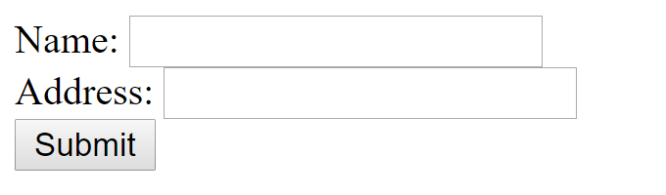

8. Create a HTML form which will contain a input field for username, password, a select field, a radio button, a text area, checkbox reset and Register button. Example:

