Repducible Research, week 2

Radsaur

24 12 2021

## Introduction

As per the assignment we have to create an RMarkdown document to analyze a number of steps performed by individuals. In order to work as effective as R permits we have to upload certain pacakges. The R code shows whcihc packages were uploaded:

library(dplyr)

##   
## Attaching package: 'dplyr'

## The following objects are masked from 'package:stats':  
##   
## filter, lag

## The following objects are masked from 'package:base':  
##   
## intersect, setdiff, setequal, union

library(tidyverse)

## -- Attaching packages --------------------------------------- tidyverse 1.3.1 --

## v ggplot2 3.3.5 v purrr 0.3.4  
## v tibble 3.1.1 v stringr 1.4.0  
## v tidyr 1.1.3 v forcats 0.5.1  
## v readr 1.4.0

## -- Conflicts ------------------------------------------ tidyverse_conflicts() --  
## x dplyr::filter() masks stats::filter()  
## x dplyr::lag() masks stats::lag()

library(ggplot2)  
library(xtable)  
library(lubridate)

##   
## Attaching package: 'lubridate'

## The following objects are masked from 'package:base':  
##   
## date, intersect, setdiff, union

## 1. Code for reading in the dataset and/or processing the data

In order to read the dataset, we first set the working directroey and then command R to read the file.

setwd('D:/DOCS/Sauran.S/R/Coursera/Literate_programming')  
df<- read.csv('activity.csv')  
summary(df) %>% xtable()

% latex table generated in R 3.6.3 by xtable 1.8-4 package % Mon Dec 27 17:46:37 2021

#2. Histogram of the total number of steps taken each day Below we present the histogram of the total numbe of steps. In order to plot the histogram, some data preprocessing has to be done first. Since the tasks requests that we plot the total number of steps, we have to sum up the number of steps per each day. In the code below, the first line calculates the number of steps per day and the second one plots the histogram. 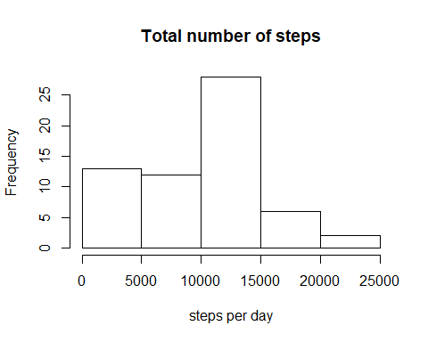

Note that the echo = FALSE parameter was added to the code chunk to prevent printing of the R code that generated the plot.