Software Requirements Specification

for

Tinkermind
Version 1.0 approved
Prepared by Neremzoiu Ionuț-Dragoș, Toporan Radu Gabriel, Dumitrescu Mihnea Ionuț
Computer Science-English <organization>?
27.02.2021

Table of Contents
Table of Contents ii
Revision History ii
1. Introduction 1
1.1 Purpose 1
1.2 Document Conventions 1
1.3 Intended Audience and Reading Suggestions 1
1.4 Product Scope 1
1.5 References 1
2. Overall Description 2
2.1 Product Perspective 2
2.2 Product Functions 2
2.3 User Classes and Characteristics 2
2.4 Operating Environment 2
2.5 Design and Implementation Constraints 2
2.6 User Documentation 2
2.7 Assumptions and Dependencies 3
3. External Interface Requirements 3
3.1 User Interfaces 3
3.2 Hardware Interfaces 3
3.3 Software Interfaces 3
3.4 Communications Interfaces 3
4. System Features 4
4.1 System Feature 1 4
4.2 System Feature 2 (and so on) 4
5. Other Nonfunctional Requirements 4
5.1 Performance Requirements 4
5.2 Safety Requirements 5
5.3 Security Requirements 5
5.4 Software Quality Attributes 5
5.5 Business Rules 5
6. Other Requirements 5
Appendix A: Glossary 5
Appendix B: Analysis Models 5
Appendix C: To Be Determined List 6

Revision History
Name | Date | Reason For Changes | Version

Introduction

Purpose
The system will allow students to submit their projects/homework assignments online to professors, which can also evaluate their work. The system includes an user interface (web browser or dedicated application), a database server which will store data about students, their grades, their projects; application server which manages data about professors, students, projects, grades; and a Web Server. The user has access to the service only via the user interface.

Document Conventions
Term | Abbreviation
UI | User Interface
DB | Database
SRS | Software Requirements Specifications
OS | Operating System
ID | Identity card

Intended Audience and Reading Suggestions
<The document is intended only for the use of the following categories of people in the educational field:
- students
- professors
- university staff
- IT staff employed within the institution
Depending on the kind of user the reader is, it is suggested to consult the overview of the document(2.3 User Classes) and proceed to the section which is addressed to that type of user.

Product Scope
The scope of this application is to streamline the more aspects of school project work. This application can be marketed to universities and all pre-university institutions. The benefits of acquiring this software are:
- It offers students a reliable virtual environment in which their work is transmitted in a much quicker and easier way.
- Students can be given updates about their project without requiring them to be physically present at the institution.
- Professors have all the work that their students have made so far in a single place where they can download, review, grade and most importantly notify students about their work (either by sending them review on assignments or by letting them know their grade).

References
https://support.google.com/chrome/a/answer/7100626?hl=en

Overall Description

Product Perspective
The context for the creation of this application is the need for a more efficient and less time-consuming way of turning in and grading school work projects for universities, and all pre-university institutions. Moreover, this application is meant to be a self-contained product.

Product Functions
The system will provide facilities to students and teachers after they successfully log in [password and identifier] (the username and password are already considered generated):
- Viewing account information
- Password change
- Uploading projects by the student
- Professors can visualize the project files and all necessary data(such as name of the student and the time the student uploaded the project/assignment) regarding the student who uploaded them

User Classes and Characteristics
As it was mentioned in 1.4 Product Scope, this section contains more detailed information on what to expect from this application depending on what kind of user the person reading is:
- Student:
- can log in with the id and password generated by the secretary staff and sent by them on student’s e-mail address>
- can upload school related content when having to turn in an assignment
- can check his/her received grade
- can leave public or private comments on any public post uploaded by any professor
- can change his/her password
- can see the deadline of the assignment allocated to them
- Professor:
- can upload any announcement which only students enrolled in the virtual classroom can see
- can grade students’ assignment
- can see if any student turned in late an assignment or if the assignment is missing
- can download students’ assignments
- Secretary staff:
- can update students’ data except grade (university year, current courses, etc.)
- creates accounts for students and professors

Operating Environment
The minimal requirements for this application are:
- OS: Windows 7/8/10, Linux, Mac, Android,IOS
- Web browsers: Google Chrome, Mozilla Firefox, Microsoft Edge, Opera, etc.
- RAM: 2.5GB
- Video card: not necessary required, but recommended in general not only for this app
- CPU: Intel Pentium 4 processor or later than SSE3(for use of chrome browser on Windows or Linux), OS X El Captain 10.11 or later(for use of chrome browser on Mac), Android Lollipop 5.0 (for use of chrome browser on Android device)

Design and Implementation Constraints
There are no corporate or regulatory policies, because this is a self-contained product that doesn’t rely on other licensed software to function. For the UI, the user needs to know enough English such that he/she can understand the functionalities of the application.

User Documentation

Assumptions and Dependencies
- Students can only send files and can’t assign grades to projects
- Professors can only grade projects that they themselves have assigned
- Secretary staff cannot alter the grade given by professors

External Interface Requirements

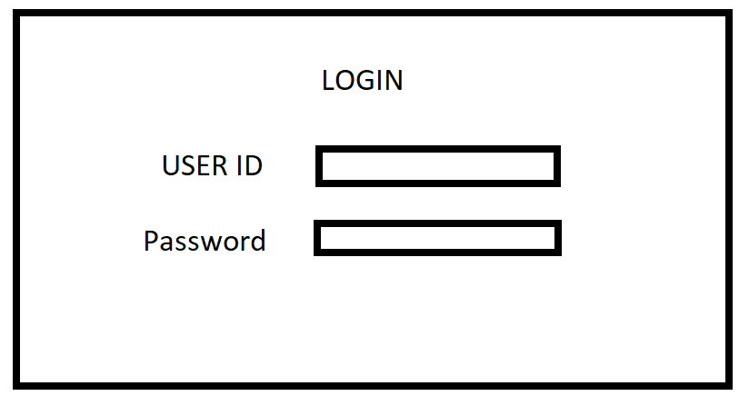
User Interfaces

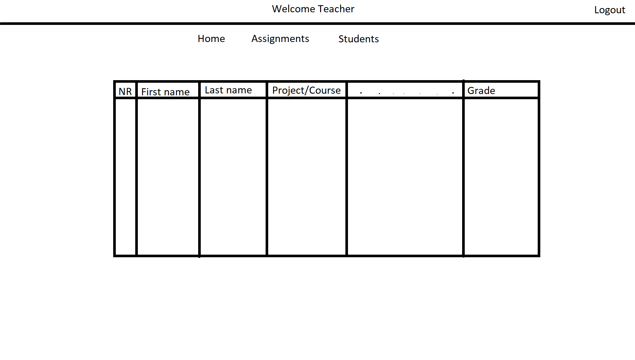

Hardware Interfaces
Not applicable.

Software Interfaces
The product will be connected to an internal database which will store all the individual entities such as: students, courses, teachers etc.

Communications Interfaces
The users in order to access the product require an internet connection and an email account. These are necessary for logging in to the main platform.

System Features

Turning in projects
4.1.1 Description
The students will be able to submit the files necessary for the project in order to be graded by their teacher.

Grading the projects
4.2.1 Description
The teachers can receive and give grades to the projects of each specific student.

Other Nonfunctional Requirements

Performance Requirements
Not applicable

Safety Requirements
Not applicable.

Security Requirements
In order to log in, the user must fill in the ID and password fields. There are sent via e-mail by university staff to students and professors. Students and professors MUST not reveal, by any means, their password to anyone in order to avoid getting their student/professor account lost. Security-wise, the password will consist of 9 characters which can be letters(be them capital or not) and numbers, so that the chances of having their accounts stolen are much lower. In the unfortunate case that a student/professor’s account gets hacked, the student/professor must notify the university staff as soon as possible in order to block the account, to prevent from leaking the student’s or the professor’s data and to restore the student’s/professor’s data.

Software Quality Attributes
Specify any additional quality characteristics for the product that will be important to either the customers or the developers. Some to consider are: adaptability, availability, correctness, flexibility, interoperability, maintainability, portability, reliability, reusability, robustness, testability, and usability. Write these to be specific, quantitative, and verifiable when possible. At the least, clarify the relative preferences for various attributes, such as ease of use over ease of learning.

Business Rules
This software product is meant to be used only by those involved in the field of education.

Other Requirements

Appendix A: Glossary
<>
Appendix B: Analysis Models
<>
Appendix C: To Be Determined List
<>

