**MeAd application**

1. **Introduction**

The team:

Focsa D. Mihaela (mihaela.focsa@info.uaic.ro);

Pastravanu C. Radu Gabriel ([gabriel.pastravanu@info.uaic.ro](mailto:gabriel.pastravanu@info.uaic.ro));

**Students at The Faculty of Computer Science (FII), "Alexandru Ioan Cuza University" (UAIC), Iași, Romania.**

1. **Project requirements**

High-school students want to learn more about specific medical conditions (common diseases, allergies, food intolerance, obesity, disorders etc.) in an easy way. The purpose of this project is to create an Web Application about how this conditions affect the human body and the population of a given geographical area (such as town, country, continent) based on specific conditions : climate, industrial development, population density, cultural factors etc. This informations can be obtained from DBpedia and Wikidoc.

**Keywords**: project, infoiasi, wade, web, fii, uaic, semantic, rdf, sparql.

### Use cases

In this sub-section we will provide some use-cases regarding possible uses of the application

#### 1. First Usage Flow

The following sketch depicts the flow of the user when he uses the application for the first time. In this use-case, the user has to complete the following three steps:

1. Provide relevant account details like email and password so he can login.
2. If the user doesn't have an account he need to create one and provide some information about him : firstname, lastname, sex, geographical location, email, password etc .
3. Privacy options for his details : for example if he wants his geographical location, sex etc. to be seen by other users and if our application can collect statistic data from him.

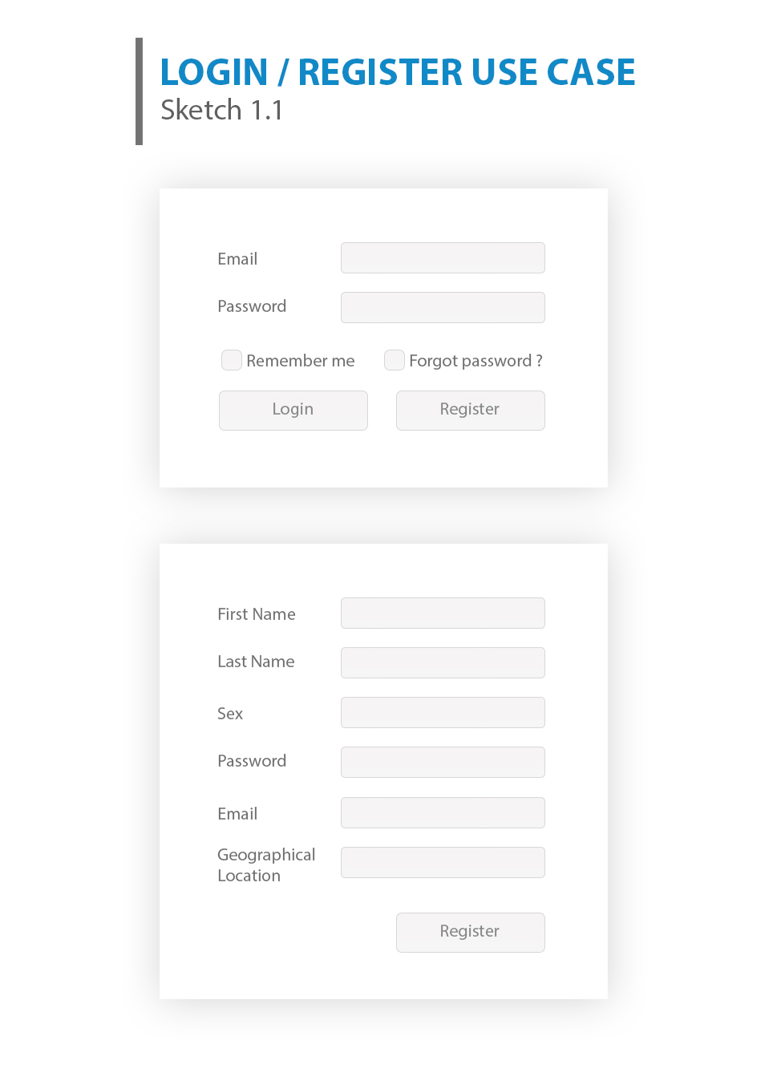

#### 2. Most common illnesses in a country

In the sketch 2.1 we have the menu bar from our web application. After we select a country we can see the diseases from that country with general information about that diseases ( sketch 2.2), when the "More" button is pressed we'll be redirected to the disease's page.

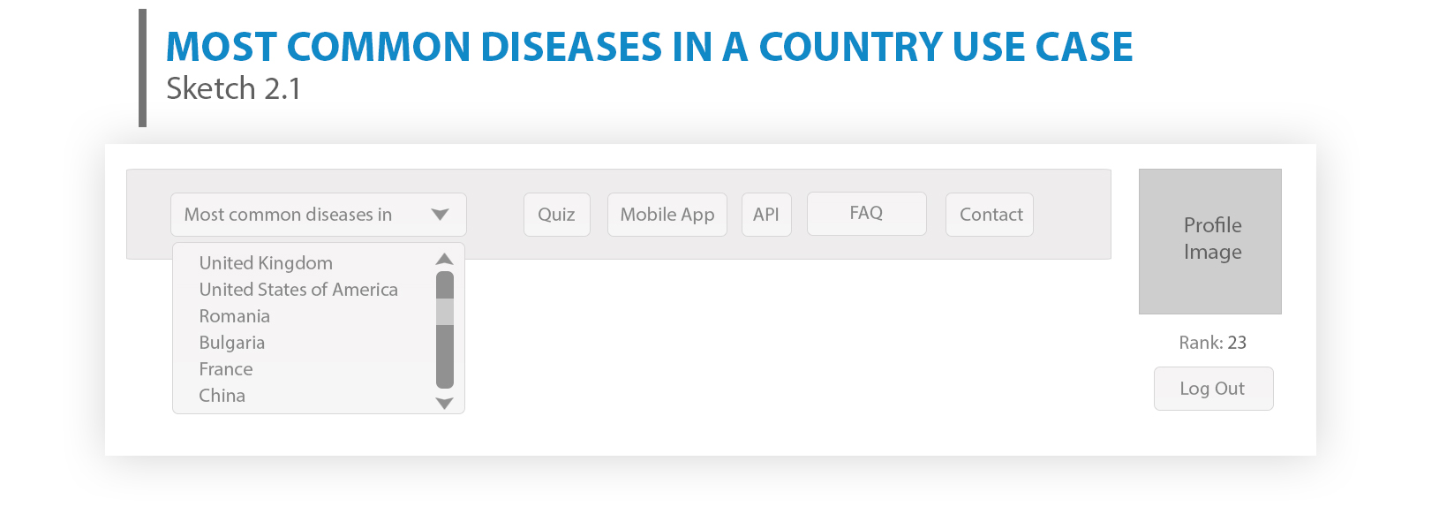

**Sketch 2.1**

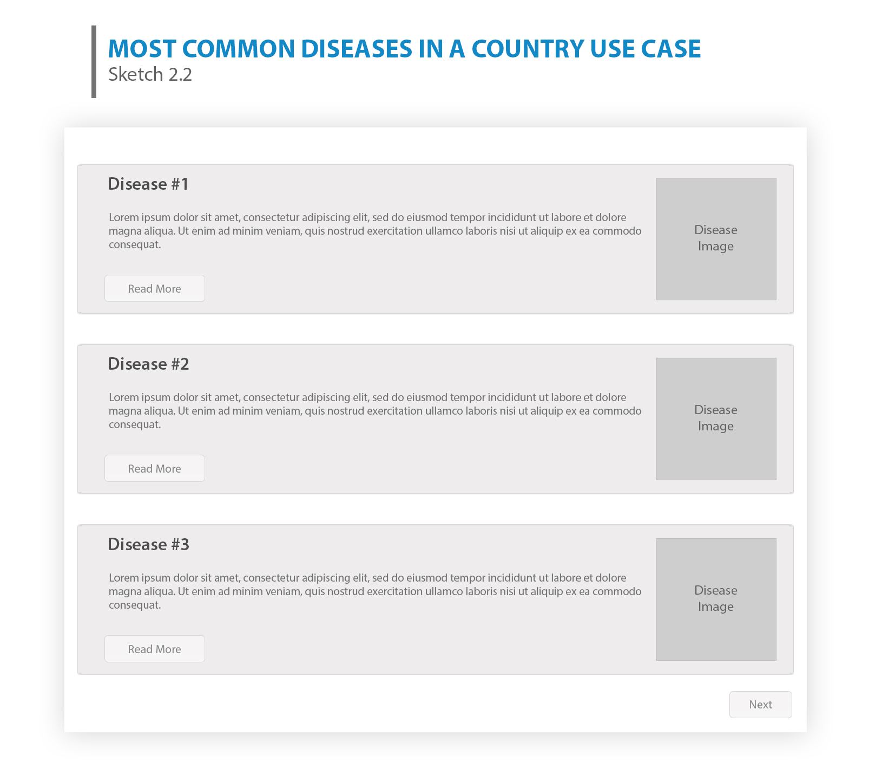

**Sketch 2.2**

*3. Quiz*

In the sketch 3.1 we have a quiz with random questions about some diseases and four answer options with names of random disease. The user can make points if he answers correctly. We can see top 15 with the users that have the most points.If the "Learn More" button is pressed, the user will be redirected to that disease page.

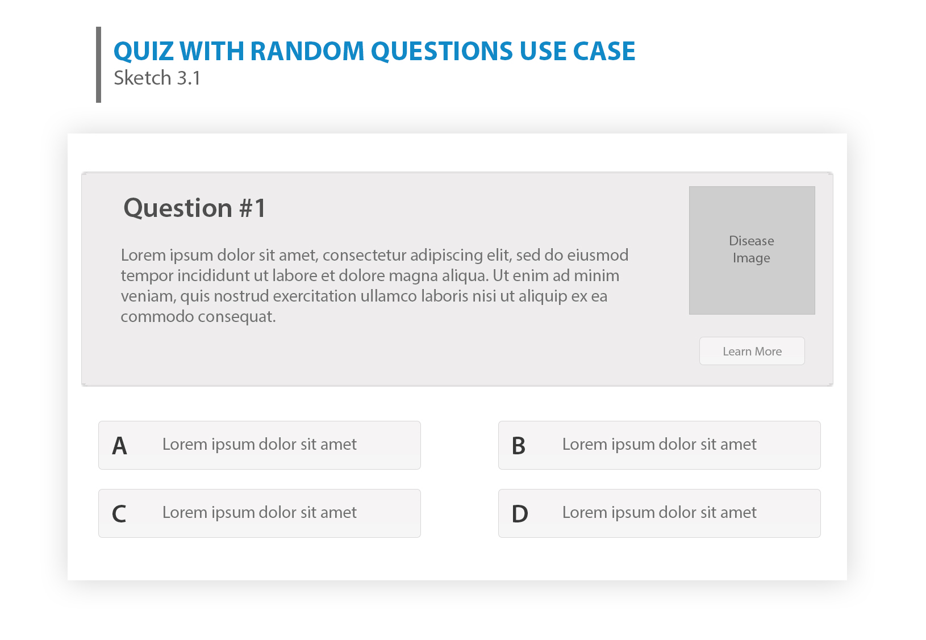

*4. Search a Disease*

In the search field the user can write the name of a disease , after that if he will press the "Search" button some results will be displayed that contains in their name the keywords written by the user (sketch 4.1). . For instance, using the keyword cancer the search function will return different cancer diseases such as pancreatic cancer, lung cancer, etc.

**Sketch 4.1**

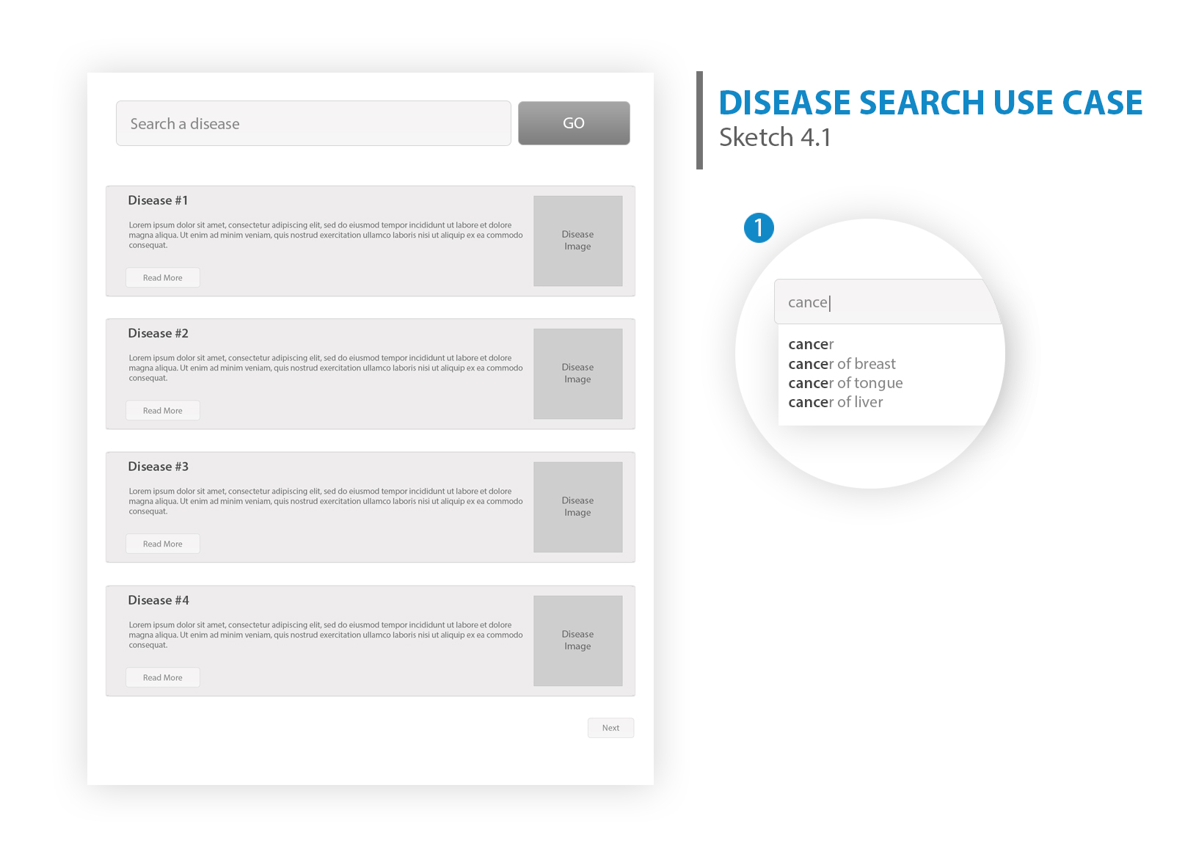

If the user will click a disease he will be redirect to that disease page (sketch 4.2). Here we have a description about that disease,a picture and an interactive map with all the countries where statistics about that illness are displayed, according to several criteria (climate, population density etc ). Countries that meet the search criteria will be colored with a specific color on that map and if the user will click on a country the statistics will appear.

**Sketch 4.2**

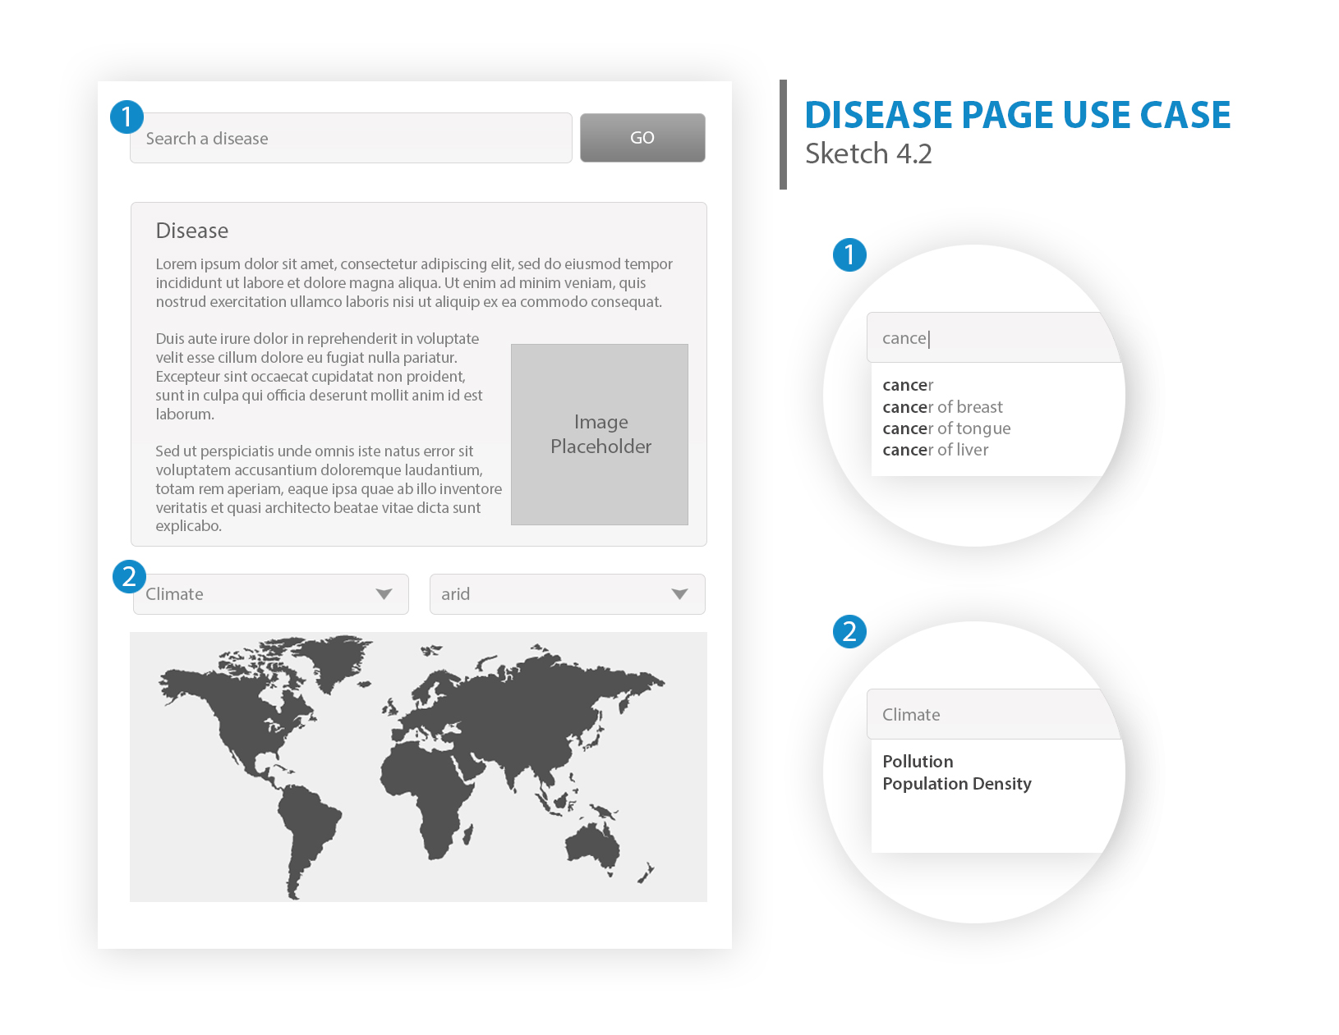

*5. Mobile App*

In the last sketch we can see the mobile app interface. This app has the following functionalities:

- it detects your current location and displays the most common diseases from your location

- it displays neighboring countries and most common diseases from them

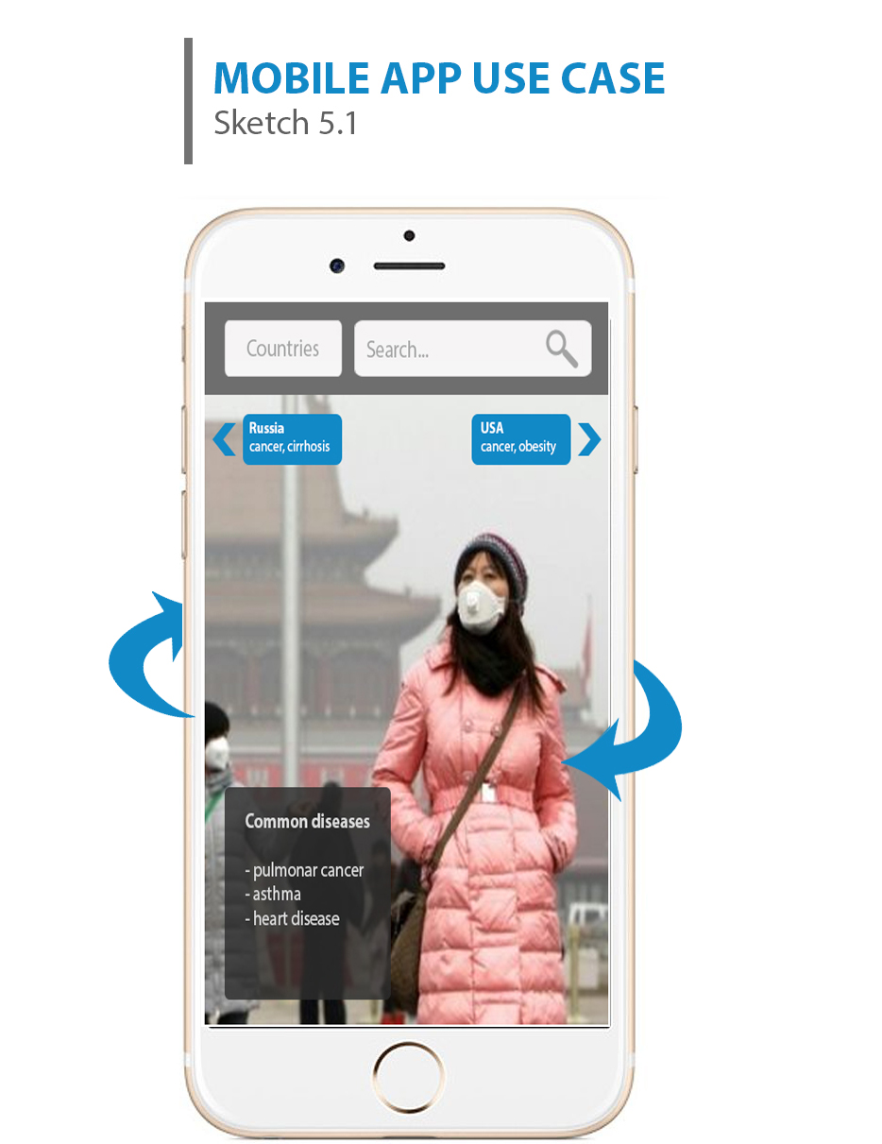

## 3. Software Design

### a. Data Modelling

The first step in developing the application requires involves defining the data model(s).

[**Medical Subject Headings**](https://github.com/RaduGabriel/MeAd/wiki/www.nlm.nih.gov/mesh/)

Is the National Library of Medicine's controlled vocabulary thesaurus. It consists of sets of terms naming descriptors in a hierarchical structure that permits searching at various levels of specificity

[**Disease Items Ontology**](http://www.disease-ontology.org/)

"The Disease Ontology has been developed as a standardized ontology for human disease with the purpose of providing the biomedical community with consistent, reusable and sustainable descriptions of human disease terms, phenotype characteristics and related medical vocabulary disease concepts through collaborative efforts of researchers at Northwestern University, Center for Genetic Medicine and the University of Maryland School of Medicine, Institute for Genome Sciences."

[**GeoNames Ontology**](http://api.geonames.org/)

We can use this ontology in order to add semantic information to our data from a geographical standpoint. This will entail us to make recommendation that are nearby of the user, take into consideration to season in the respective location an similar aspects.

[**Maps API**](https://developers.google.com/maps/web/)

We will use this APIs to embed a Google Maps image in order to pinpoint the locations of the stores recommended to the user.

[**Places API**](https://developers.google.com/places/)

This API will be used to obtain information about hospitals and countries for a particular geographical location.

**b. Software Architecture**

Tools

Mysql, CSS ,HTML ,JavaScript , C#

[**ASP .NET MVC**](http://www.w3schools.com/aspnet/mvc_intro.asp)

MVC is a framework for building web applications using a MVC (Model View Controller) design:

The Model represents the application core (for instance a list of database records). The View displays the data (the database records). The Controller handles the input (to the database records).

The system will be structured according to this UML diagram:

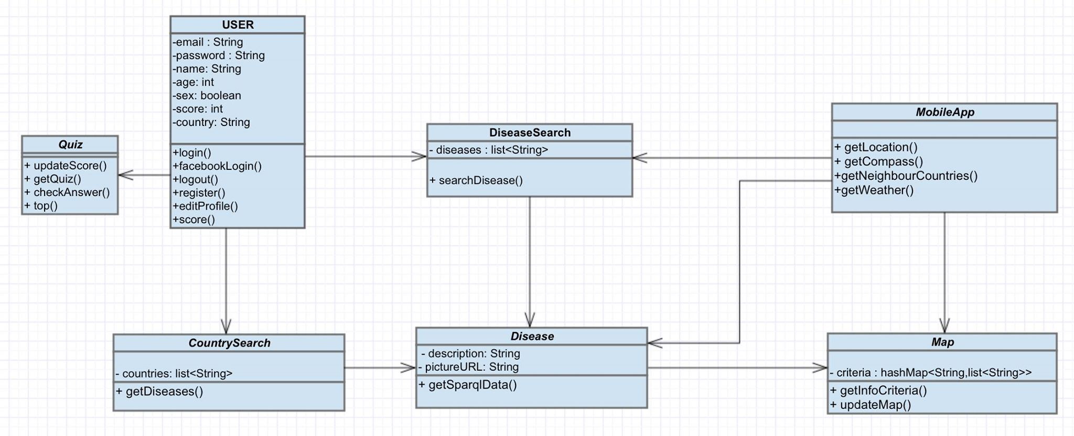

We have the following main modules:

1. User

The user module will be used to register, login, logout , edit profile and recover the password using the email provided by the user. To access the web app it is not necessary to be registered, but if the user wants to take a quiz he needs to be logged in. If the user has set his country he can see most common diseases from his country. Also we can get his score from the quiz with this module.

2. DiseaseSearch

This module will facilitate the search of a disease and show all the diseases with similar name. It will use sparql to get a list of diseases from DBpedia. The user may click on a specific disease to learn more about it (the disease module will be called when a disease is selected).

3. Disease

The Disease module will show more information about a disease, and will call the API map to show how spread is the disease in different countries according to some criteria.

4. CountrySearch

This module purpose is to get specific information about a country and the most frequent diseases in it. The user may search for a specific country and then a list of the most common diseases will be showed.

5. Quiz

Because the principal aim of the MeAd application is to help students to learn more about diseases, the best way to check if they learn something is by taking a quiz. The Quiz module will give the user two types of quiz: a. *recap quiz* b. *learning quiz*

The first type of quiz uses the users search history to give questions. The second type of quiz will give random questions from all the database of the app.

The quiz module will provide a short description of the disease and a list of possible names from which the user has to select one, or it will give a disease name and the users has to select from a list some of the words which describes it. Another way to evaluate the users is to give them a country name and they must select the top 3 diseases from that country.

6. Map

The map module will be available on the web and mobile app, and will be used to show how is spread the selected disease on different countries using different criteria or the top 3 diseases in all the countries.

7. MobileApp

The Mobile App module will have all the options from the web application, but also a new feature: *augmented reality*. This option will help the user to see in real time the nearby dangerous, which risks will he take if he travels to a different country and which are the risks from its country. The app will use GPS location, compass, accelerometer and camera and the network data to provide all this information. Also using location history the app will provide a list of all the diseases the user is in risk.

8. Translate

This module will be use to set the app language as the user prefers. The default language will be english. Using the Google Translate API will translate the content of the app to a specific language if a disease is not available in the user's language.

**4. REST API**

<http://tinyurl.com/MeAdDiseases>

**5. Bibliography**

1. ***, Dr. Sabin-Corneliu Buraga, FII, UAIC. Web Application Development. [http://profs.info.uaic.ro/~busaco/teach/courses/wade/](http://profs.info.uaic.ro/%7Ebusaco/teach/courses/wade/);
2. ***, W3.ORG, Richard Cygniak et al. RDF 1.1 Concepts and Abstract Syntax. <http://www.w3.org/TR/2014/REC-rdf11-concepts-20140225/>;
3. ***, W3.ORG, Tim Berners-Lee. Linked Data. <http://www.w3.org/DesignIssues/LinkedData.html>;
4. ***, W3.ORG, Guus Scheriber et al. RDF 1.1 Primer. <http://www.w3.org/TR/2014/NOTE-rdf11-primer-20140624/>;
5. ***, W3.ORG, Dan Brickley et al. RDF Schema 1.1. <http://www.w3.org/TR/2014/REC-rdf11-concepts-20140225/>;