Milestone 3
Project: PageWise
Team: Baccela Radu-Costin & Ștefan Mădălina-Eliana

1) Introduction
PageWise is an eLibrary management system that helps readers and librarians manage books in an organized and efficient way. Readers can browse the catalog, search and filter books, borrow and return titles, and keep track of due dates. Librarians can add, edit, or remove books, manage availability, and monitor borrowing activity. The system also sends notifications when books become available again or when due dates approach.
This milestone evaluates three alternative architectures for the same system:
- Monolithic (layered) architecture - single deployable application with internal modular structure.
- Microservices architecture - several independently deployable services, each with its own data.
- Event driven (distributed) architecture - services communicate mainly via asynchronous domain events over a message broker.
For each architecture we describe structure, interactions and data flow, provide component and deployment diagrams, analyse pros and cons against PageWise’s non-functional requirements, and finish with a comparison and a justified final choice.

2) Architecture significant requirements catalogue
The following non functional requirements from the course catalogue are considered architecture significant for PageWise. They influence how we split responsibilities, how we deploy components, and which style is more suitable for the current scope of the project.
Nr. | Non functional requirement name | Yes / Not architecture significant | If Yes, how may the requirement influence the architecture, according to you?
1. | Scalability | Yes | Book catalog browsing and searching can generate many read requests, especially if PageWise is used by multiple classes or institutions. The architecture must allow scaling the catalog and search logic without rewriting the whole system.
2. | Availability & Reliability | Yes | Borrowing and returning books must work reliably to avoid losing reservations or creating inconsistent due dates. Drives the need for clear module boundaries, error handling, and possibly redundancy in distributed variants.
3. | Security & Privacy | Yes | User accounts, borrowing history, and overdue information are sensitive. This motivates a central authentication and authorization mechanism and secure interfaces between components.
4. | Maintainability & Modularity | Yes | Domains such as Users, Catalog, Borrowing, and Notifications should evolve independently. This influences the way we separate packages in the monolith and how we split services in the distributed architectures.
5. | Extensibility | Yes | Future features like recommendations, analytics, or integration with an external campus library should be added without rewriting core logic. This encourages a modular structure and, in distributed variants, event based communication that new consumers can subscribe to.
6. | Usability & Understandability | Partial | User experience mainly depends on the user interface design. However, a clear separation between UI and backend logic makes it easier to evolve the interface without breaking backend code.
7. | Performance / Efficiency | Partial | Search performance and response time can be improved with caching or optimized queries. This does not fully change the architecture style, but influences decisions such as where to place caching layers.
8. | Interoperability | Yes | PageWise may expose REST APIs for importing books or synchronizing with other systems. This requires clearly defined interfaces and data formats, which are easier to standardize in service oriented or event driven architectures.

3. Monolithic architecture

3.1 Description (structure and data flow)
In the monolithic (layered) architecture, PageWise is implemented as a single application that contains all functionalities: catalog browsing, search, borrowing, returning, notifications, and librarian management. Although it is packaged and deployed as one unit, the internal codebase is organized into logical layers and modules.
Main components
- Presentation layer
Contains the user facing part (for example controllers or handlers for a web UI or future REST API). Typical components are ReaderController, LibrarianController, and AuthController. They receive requests, validate basic input, and delegate work to application services.
- Application layer (services)
Implements use case logic. Important services are:
- CatalogService for searching and filtering books using Strategy based search and sorting algorithms.
- BorrowingService for borrowing, returning, and calculating due dates.
- UserService for managing user accounts and roles.
- NotificationService for registering observers and sending notifications when a book becomes available or when a due date approaches, using the Observer pattern.
- Domain layer
Contains the core entities and value objects such as Book, User, Loan, and Reservation. Creation of these objects can be centralized using Factory Method to ensure consistent defaults and validation. Catalog and notification center can be implemented as Singleton-like components to keep a single source of truth in the monolith.
- Infrastructure layer
Includes persistence adapters (repositories for books, users, and loans), database access, and external gateways such as an email or messaging adapter used by the notification service.
Typical data flow for the "borrow a book" use case in the monolith:
1. A reader sends a request through the UI to borrow a specific book.
2. ReaderController receives the request and calls BorrowingService.
3. BorrowingService checks book availability via CatalogService and verifies the reader via UserService.
4. If borrowing is allowed, BorrowingService creates a new Loan object, updates the book status, and persists the changes using repositories that talk to the shared relational database.
5. After a successful borrow, BorrowingService notifies NotificationService.
6. NotificationService uses the Observer-based mechanism to notify subscribed readers or schedule due date reminders.
7. ReaderController returns the result to the UI.
All modules share the same database schema (for example PageWiseDB), and all calls between components are local method calls inside the same process.

3.2 Component diagram (monolithic architecture)

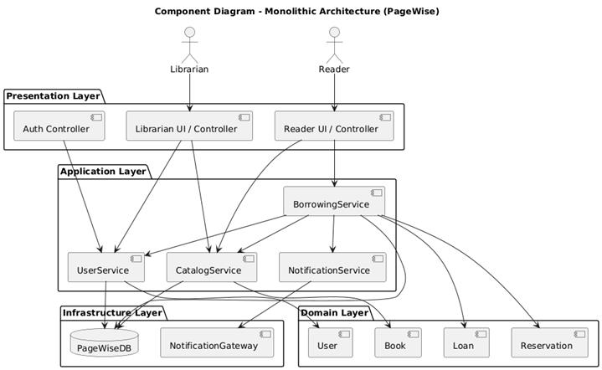

3.3 Deployment diagram (monolithic architecture)

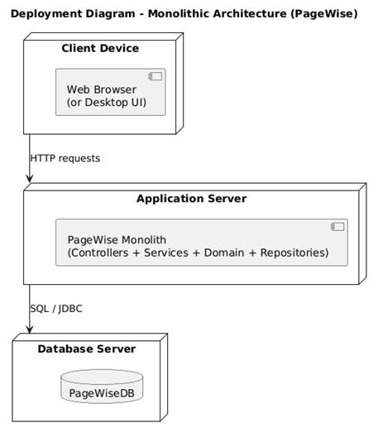

3.4 Pros and cons
Advantages:
- Simple structure that matches the current implementation and demo scope.
- Easy to develop, debug, and deploy as one unit.
- Strong consistency because all data is stored in one database with transactional operations.
- Best fit for a small student team and for the current academic milestones.
- Patterns such as Factory, Strategy, Singleton, and Observer can be applied internally without distributed complexity.
Disadvantages:
- Limited scalability: to handle more load we must scale the entire application, not just the busy parts like catalog search.
- Single point of failure: if the monolith crashes, all features become unavailable.
- Over time the codebase can become harder to maintain if boundaries between modules are not enforced carefully.
- Harder to introduce independent technology stacks or languages for different parts of the system.
- Migrating later to microservices requires effort to extract clear service boundaries from the monolith.

4. Microservices architecture

4.1 Description (structure and data flow)
In the microservices architecture, PageWise is decomposed into several smaller services. Each service focuses on one domain, owns its data, and can be deployed independently. Services communicate mainly through synchronous REST calls, using JSON over HTTP.
Main services
- API Gateway
Single entry point for all external clients. It routes requests to the correct backend service and can centralize cross-cutting concerns such as authentication, rate limiting, logging, or simple request validation.
- Auth and User Service
Manages user accounts, roles (reader or librarian), login, and registration. Owns UserDB.
- Catalog Service
Manages the book catalog: creation, update, deletion, and search. Search and sorting strategies are still used inside this service, but its data is stored in CatalogDB.
- Borrowing Service
Handles borrowing, returning, due date calculation, and reservation queues. Owns BorrowingDB. For operations it may call the Auth service to validate users and the Catalog service to check availability.
- Notification Service
Sends notifications to readers (for example by email or another channel) about due dates and availability. In this synchronous microservices variant, the Borrowing service calls the Notification service directly through REST.
Example flow for borrowing a book:
1. The reader sends an HTTP request (for example from a web client) to the API Gateway to borrow a book.
2. The gateway forwards the request to the Borrowing service.
3. Borrowing service calls the Auth service (REST) to verify the user and check permissions.
4. Borrowing service calls the Catalog service to confirm availability.
5. If all checks pass, Borrowing service updates BorrowingDB and sends a REST request to Notification service to send confirmations and due date information.
6. Notification service records the notification and responds to the Borrowing service, which returns the final response to the gateway and then to the client.
Each service owns its schema and no other service accesses its database directly. This follows the "database per service" pattern discussed in the course.

4.2 Component diagram (microservices architecture)

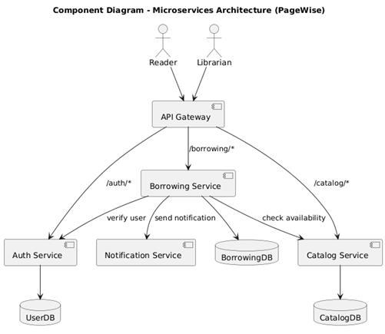

4.3 Deployment diagram (microservices architecture)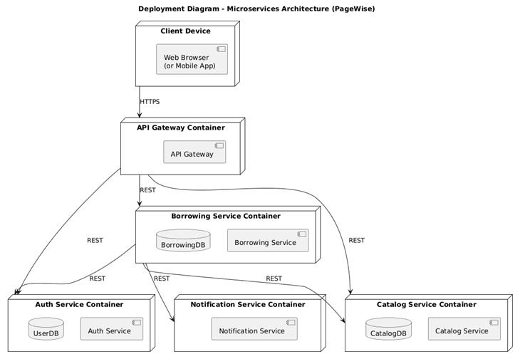

4.4 Pros and cons
Advantages:
- Each service can be scaled independently based on its load (for example more instances of Catalog service when browse traffic is high).
- Fault isolation: a failure in Notification service does not automatically stop Catalog or Auth services.
- Better long term modularity and maintainability: teams could work on services independently.
- Technology flexibility: each service could use its own stack or database technology if needed.
- Easier to integrate external systems using stable REST APIs exposed by specific services.
Disadvantages:
- Overall deployment and operations become more complex, needing service discovery, gateway configuration, and monitoring for multiple services.
- Cross service operations, such as borrowing a book that touches User, Catalog, and Borrowing data, become harder and may need distributed transactions or sagas.
- Debugging a flow that passes through several services is more difficult than in a single process.
- Higher latency due to network calls between services compared to in-process method calls in the monolith.
- Requires more infrastructure such as CI/CD for multiple deployables, log aggregation, and centralized configuration.

5. Event driven architecture

5.1 Description (structure and data flow)
The event driven architecture still uses separate services, but their main coordination is based on asynchronous domain events rather than only synchronous REST calls. Services publish events to a message broker when something important happens, and other services subscribe to those events.
This style fits PageWise naturally because some operations are time-shifted or notification oriented, matching the Observer pattern used in the design.
Main components
- API Gateway
Same role as before: routes client commands (borrow, return, add book) to backend services.
- Auth and User Service
Manages user accounts and roles; still owns UserDB and is called synchronously for authentication.
- Catalog Service
Owns the catalog and CatalogDB. Subscribes to events like BookBorrowed and BookReturned to update availability and statistics.
- Borrowing Service
Handles borrow and return commands and owns BorrowingDB. After successfully processing a command it publishes domain events such as BookBorrowed or BookReturned to the message broker.
- Notification Service
Subscribes to events and sends messages to readers when due dates are created or when books become available again. It no longer needs to be called directly by other services.
- Message Broker
Middleware such as RabbitMQ or Kafka that receives published events and distributes them to interested consumers. In the architecture description we treat it as a central message bus.
For a borrow operation:
1. Reader sends a borrow command via the API Gateway to Borrowing service.
2. Borrowing service validates the command, possibly calling Auth and Catalog services synchronously for checks.
3. Borrowing service records the new loan in BorrowingDB.
4. Borrowing service publishes a BookBorrowed event to the message broker, containing identifiers for user, book, and due date.
5. Message broker pushes the event to all subscribers:
- Catalog service updates book availability and maybe popularity statistics in CatalogDB.
- Notification service constructs and sends a confirmation message to the reader and maybe schedules a reminder.
6. If Notification or Catalog services are temporarily down, the broker can buffer events, so Borrowing service does not need to wait for them to respond.
The same pattern can be used for BookReturned, ReservationCreated, and other domain events.

5.2 Component diagram (event driven architecture)

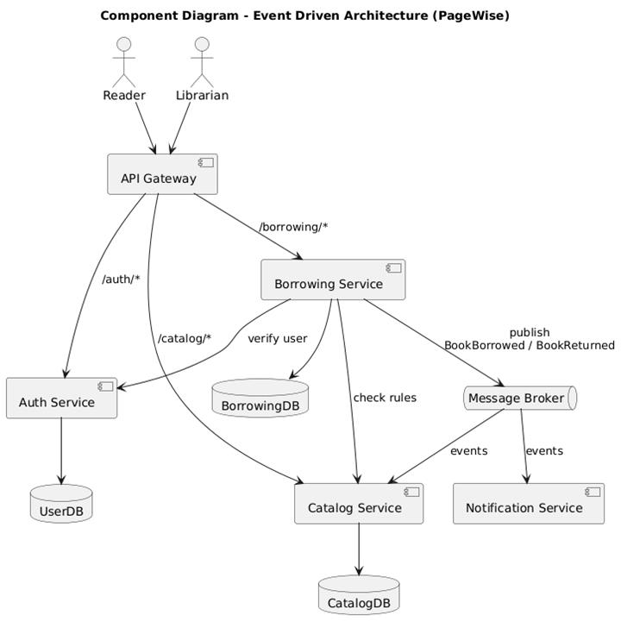

5.3 Deployment diagram (event driven architecture)

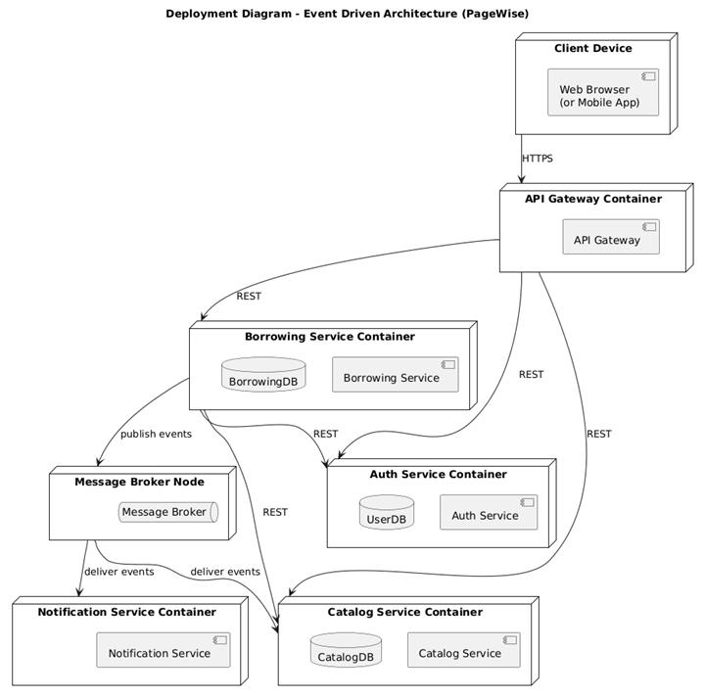

5.4 Pros and cons
Advantages:
- Very loose coupling between services: producers do not know about specific consumers.
- Naturally models PageWise notifications and future analytics modules as event consumers.
- Easy to add new features by subscribing to existing events without modifying existing services (for example a new Reporting service that listens for book events).
- Scales well for background and high volume tasks such as sending many due date reminders.
- Improves resilience: if Notification service is down, events can be replayed after it restarts.
Disadvantages:
- Introduces eventual consistency: catalog status or notifications may be slightly delayed compared to the moment when the loan is stored.
- Debugging is harder, because the flow spreads over asynchronous messages that may be retried or delayed.
- Introduces additional infrastructure to operate and monitor, namely the message broker.
- Consumers must handle duplicate events or out of order delivery, which increases logic complexity.
- Development and testing are more complex than in the monolith because unit tests must simulate the broker.

6. Comparison and evaluation (numeric)
The following table summarizes the three architectures against the selected quality attributes, using a 1 to 5 scale (1 = lowest support, 5 = highest support for that attribute in our context).
Quality attribute | Monolithic | Microservices | Event driven | Explanation
Scalability | 2 | 4 | 5 | Monolith scales only as a whole instance. Microservices allow scaling hot services. Event driven architecture scales background consumers and decouples producers.
Availability / Fault tolerance | 3 | 4 | 5 | A monolith restart affects all features. Microservices isolate failures per service. Event driven adds buffering via the broker, so some operations can continue even if consumers are down.
Security & Privacy | 4 | 3 | 3 | Centralized security in a single monolith is easier to manage. In distributed architectures, secure communication and consistent auth across services are harder.
Maintainability & Modularity | 3 | 5 | 4 | Microservices provide the clearest modular boundaries. Event driven adds flexibility but also complexity. Monolith is maintainable while small, but tends to degrade if not carefully structured.
Extensibility | 3 | 5 | 5 | Both microservices and event driven architectures allow adding new services or consumers without rewriting existing ones. Monolith can be extended but changes are concentrated in one codebase.
Usability & Understandability | 4 | 3 | 3 | For developers, the monolith is easier to understand as one application. Distributed styles require understanding multiple services and their interactions.
Data consistency | 5 | 3 | 2 | Monolith uses a single database and strong ACID transactions. Microservices often rely on eventual consistency between service databases. Event driven style pushes consistency even more toward the eventual side.
Operational complexity | 1 | 4 | 5 | Monolith requires the least infrastructure. Microservices add gateway, multiple deployments, and monitoring. Event driven adds a broker and message processing complexity.
Implementation speed (for the course) | 5 | 2 | 2 | For the current academic scope and team size, the monolith is the fastest and safest to implement. Distributed alternatives require additional setup and tooling.

7. Final comparison and justified choice
All three architectures can work for PageWise, but they fit different situations.
The monolithic architecture is the easiest to start with. Everything is in one application and one database, so it is simple to develop and debug. It would be great for a small prototype, but it does not scale very well and becomes harder to change when the system grows.
The event driven architecture is the most flexible. Using a message broker and domain events would be perfect for things like notifications and analytics, and new services could just subscribe to existing events. However, it is also the most complex to build and test, and the eventual consistency is not easy to show properly in a lab project.
For this project we choose the microservices architecture as the main option. Splitting PageWise into Auth, Catalog, Borrowing and Notification services matches the natural domains of the system, and each service can be scaled or updated separately. It also fits very well with the next milestones, which focus on microservice patterns. Later, we could keep the same services and add event driven communication on top of them if we need more advanced features.

