Student:

Schiop Radu

**Group:**

**30234**

Table of Contents

1. Requirements Analysis 3

1.1 Assignment Specification 3

1.2 Functional Requirements 3

1.3 Non-functional Requirements 3

2. Use-Case Model 3

3. System Architectural Design 3

4. UML Sequence Diagrams 3

5. Class Design 3

6. Data Model 3

7. System Testing 3

8. Bibliography 3

1. Requirements Analysis

# Assignment Specification

*[Application description]*

# Functional Requirements

*[Present the functional requirements]*

# Non-functional Requirements

*[Discuss the non-functional requirements for the system]*

2. Use-Case Model

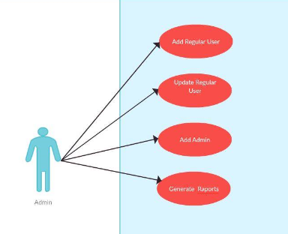

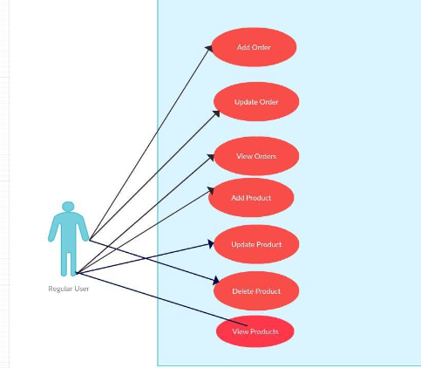

3. System Architectural Design

**3.1 Comceptual Diagram**

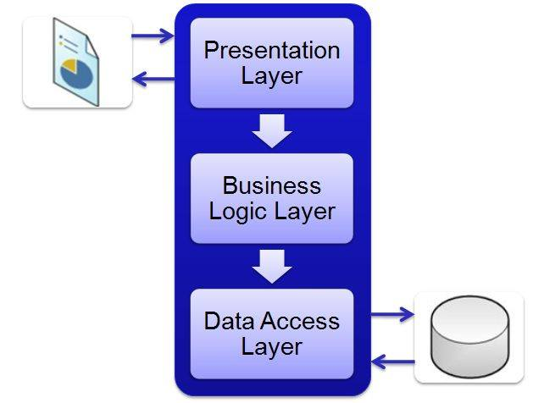

**3.2 Diagrams**

*[Create the system’s conceptual architecture; use architectural patterns and describe how they are applied. Create package, component and deployment diagrams]*

4. UML Sequence Diagrams

*[Create a sequence diagram for a relevant scenario.]*

5. Class Design

**5.1 Design Patterns Description**

*[Describe briefly the used design patterns.]*

**5.2 UML Class Diagram**

*[Create the UML Class Diagram and highlight and motivate how the design patterns are used.]*

6. Data Model

*[Present the data models used in the system’s implementation.]*

7. System Testing

*[Present the used testing strategies (unit testing, integration testing, validation testing) and testing methods (data-flow, partitioning, boundary analysis, etc.).]*

8. Bibliography