**Forest Rangers**

*Ștefan Dubinciuc & Radu Târșa*

1. **Introduction**

Forest Rangers is a WEB Application that serves a solution to decontaminate the EARTH by reducing the waste.

1. **Functional requirements**

* The user can register/login and post places that are polluted or search for places to help cleaning the area.
* The user can comment on every post and he/she has the possibility to add an image
* On posts, the user can add the location, the image of that place and a description
* The app can be accessible on mobile (responsive app)

1. **Nonfunctional requirements**

* Compatibility: the app is available on web browser on pc and mobile
* Security: all the user data is encrypted, you can’t access/edit/delete other’s information
* Availability: the app can be ON 24/7 at least 99.9% of time
* Usability: the app can be used by all types of persons, including old people (the UI elements having a large font)
* Scalability: the app can be used all over the world if internet connection is available on your device

1. **Project structure**

The user can be the post initiator or the one who comments on posts in order to help others.

1. **Architecture**

It is made of 4 main parts: CRUD functionalities for the posts, user customization, add/delete comment, location picker.

1. **Technologies**

ASP.Net Core, HTML, CSS, Javascript, JQuery, Bootstrap, Razor Pages, SQL Server, Google Maps API.

1. **Code managing/versioning**

Github: <https://github.com/RaduTarsa/Forest_Rangers>

1. **Design**

The app is mostly designed with bootstrap. The rest is simple HTML+CSS.

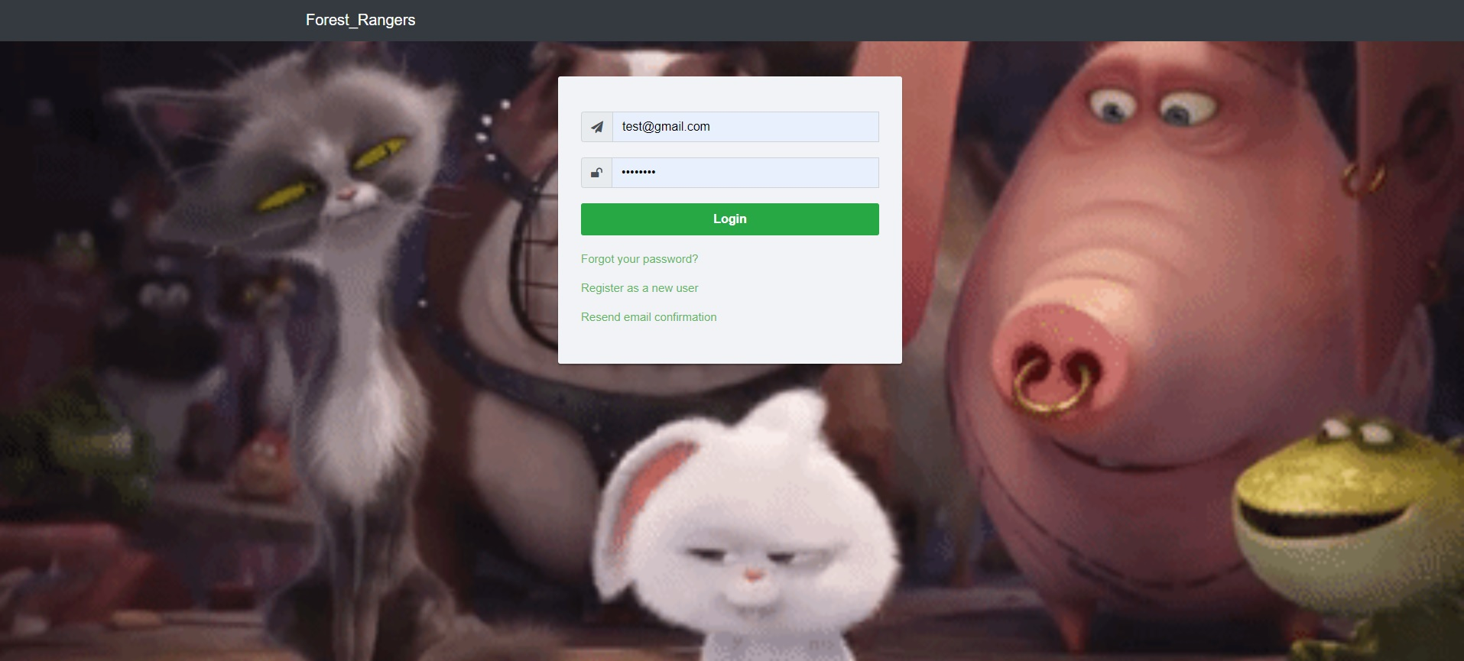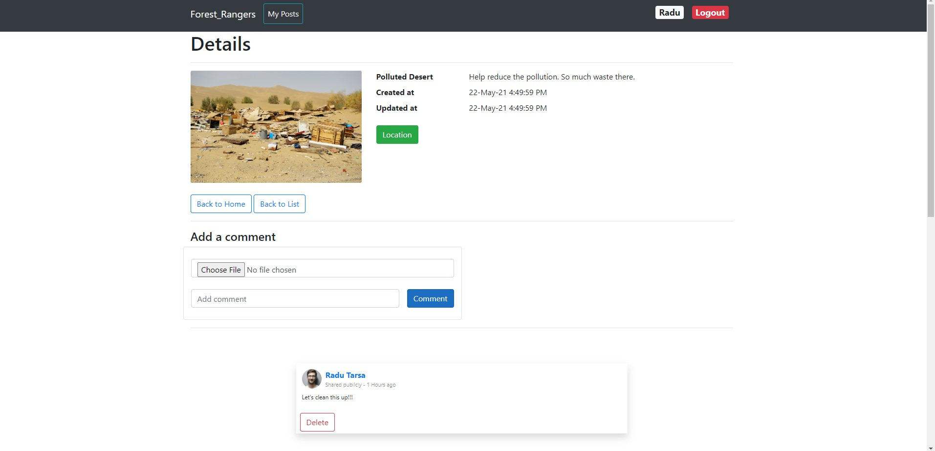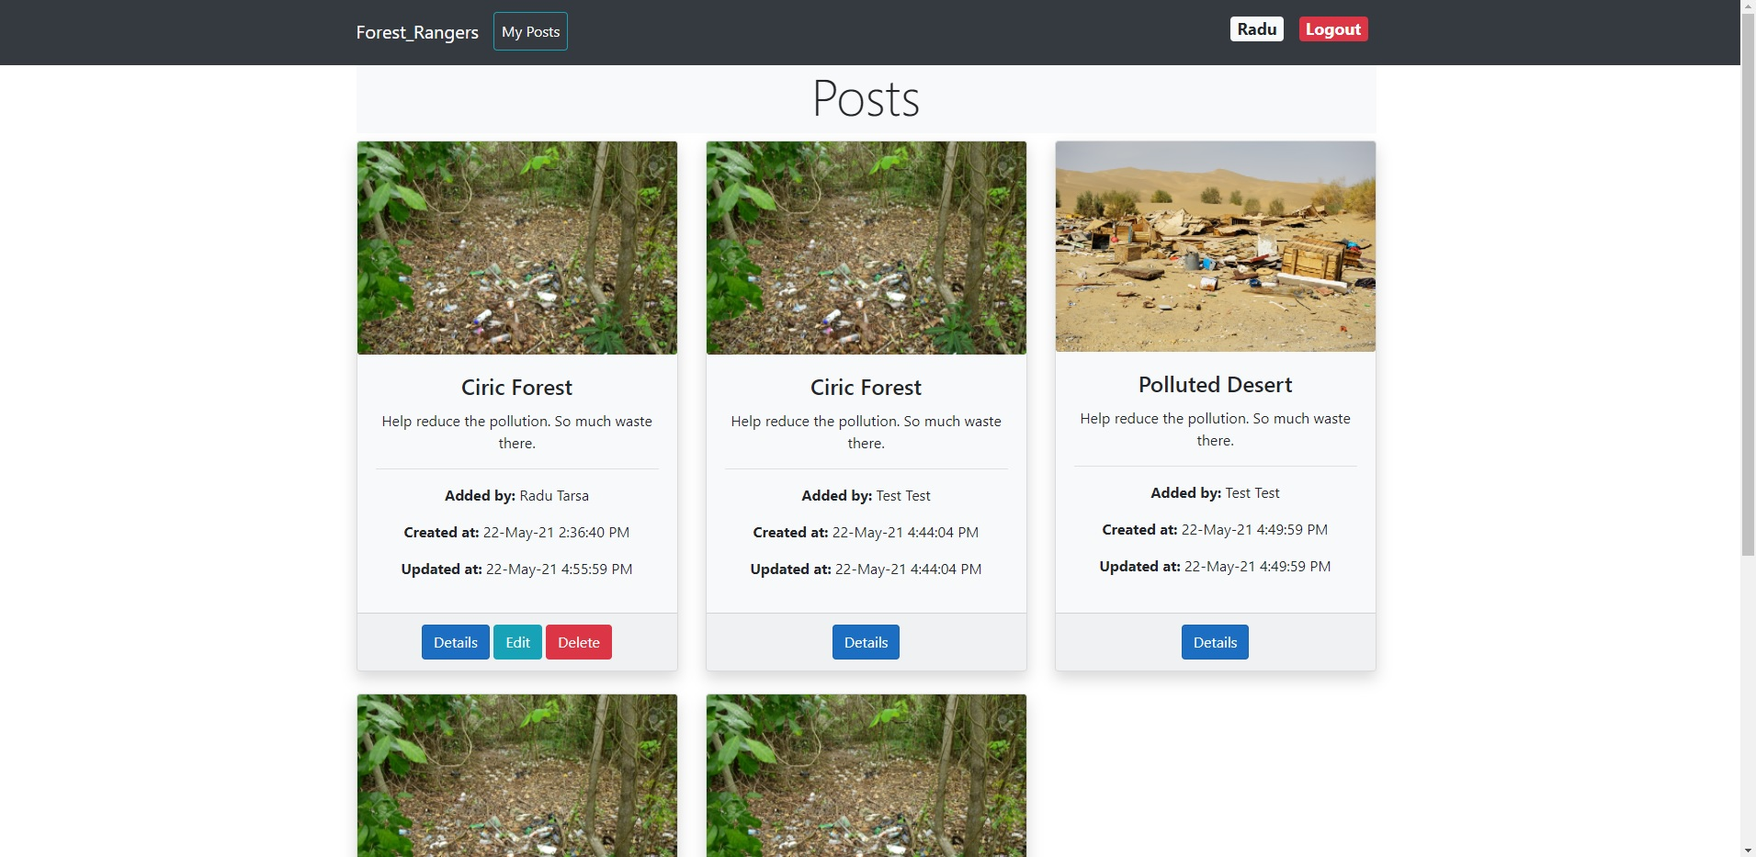

1. **Technical innovation**

It is an application just for helping the world, not just a simple social media app that keeps you distracted from work/school or anything else.

1. **Viability**

It’s simple, it’s easy to use, pretty interactive and it’s ECO-friendly.

1. **Business potential**

Yes. Making the world cleaner is our business.

1. **Originality/Creativity/Insight**

Originality: I didn’t see any app that does what our app can do.

Creativity: cleaning the world doesn’t need creativity, it only needs people that want a change.

Insight: no need for explanation here…

1. **Conclusion**

It is a beautiful project and we are proud of it.

I think it can be a successful idea.

It is specially designed for a better world so I know that this app will be on cloud some day.

