Run the following commands to install PostgreSQL version 12.8. server on Ubuntu 20.04:

*sudo apt update  
sudo apt install postgresql postgresql-contrib*

To log in to the PostgreSQL server as the postgres user, first switch to the user and then access the PostgreSQL prompt using the psql utility:

*sudo su - postgres*

*psql*

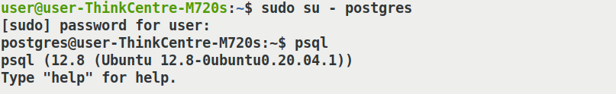

This database is created to record the data of medicinal plants used by tribals in Nilgiri district and parts of Western Ghats. The database is named as “nilgiri_med_plants”.

This database consist of 5 tables:

1. Names
2. Family
3. Habitat
4. Plant_parts
5. Uses

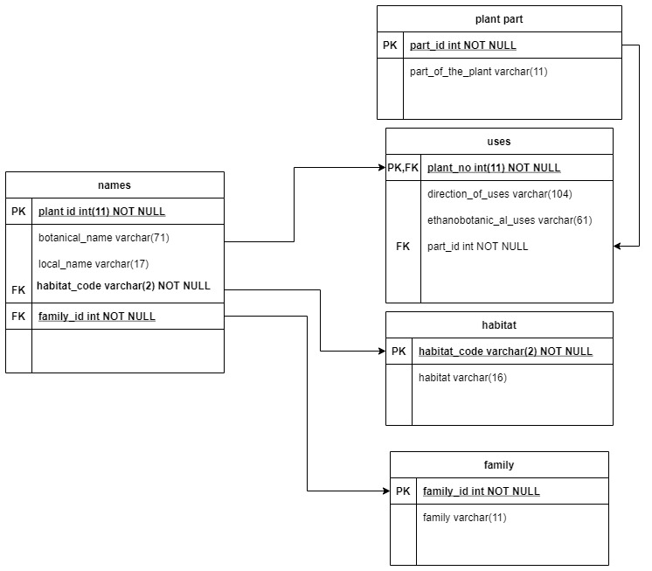

To create database

postgres=# CREATE DATABASE nilgiri_med_plants;

to list databases

postgres=#\l

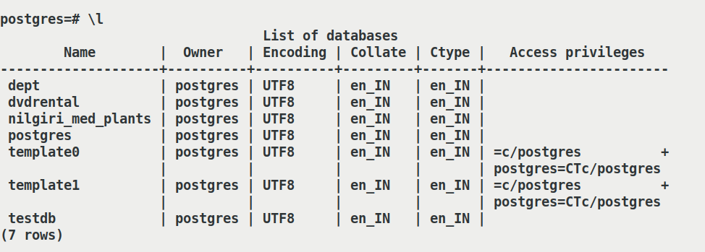

to connect to database

postgres=#\c nilgiri_med_plants

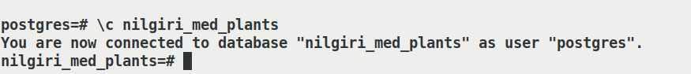

description about tables:

nilgiri_med_plants=# \d

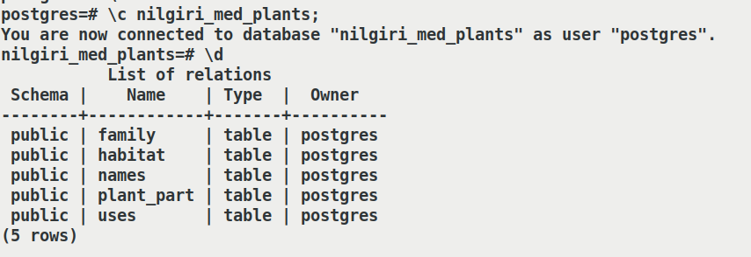

Description of each tables

family

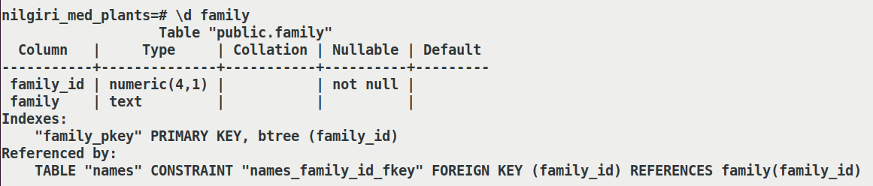

habitat

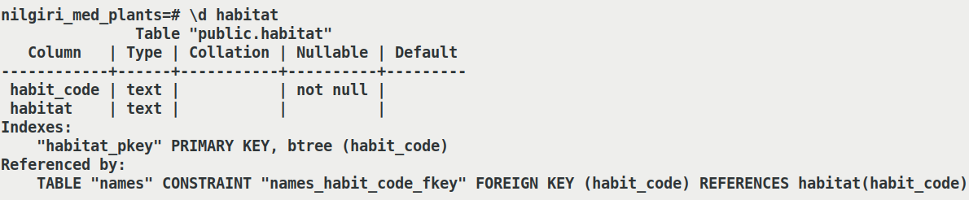

Names

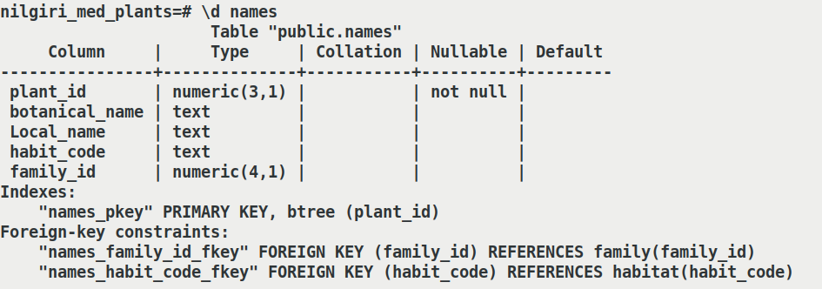

Plant_parts

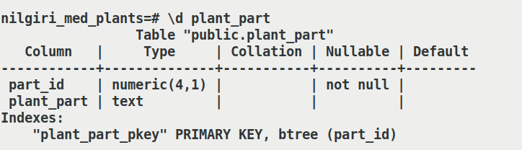

Uses

