1.Python program to find maximum of two numbers.

Program:

a = eval(input("enter number 1: "))
b = eval(input("enter number 2: "))
if a>b:
print(f"{a} is largest num")
elif a<b:
print(f"{b} is largest num")
else:
print("both are equal")

Output:

2.Python program to find a factorial of a number.
Program:
a = eval(input("enter a number to find factorial : "))
fact = 1
for i in range(a,1,-1):
fact = fact * i

print("factorial of the given number is : ",fact)

Output:
3. Python Program to find compound interest.
Program:
p = eval(input("initial balance : "))
r = eval(input("interest rate : "))
t = eval(input("time period elapsed: "))
n = 100

A = p * ((1 + r/n) ** t)

print("tottal amount is",round(A,2))
print("interest for the time period is ",round(A-p,2))

output:

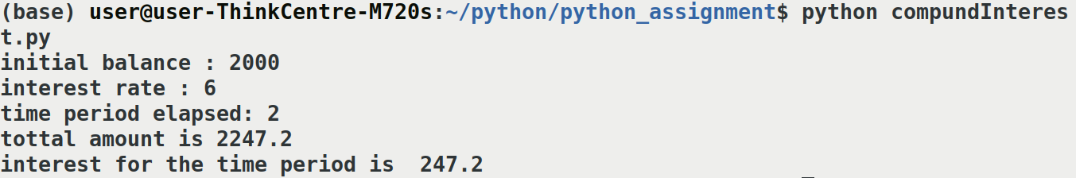

4. Python Program to check Armstrong Number.
Program:
a = eval(input("enter a number to be checked : "))
k = a
sum = 0

while a > 0:
num = a % 10
sum += num ** 3
a = a//10

if sum == k:
print(f"{k} is an amstrong number")

else:
print(f"{k} is not an amstrong number")

Output:
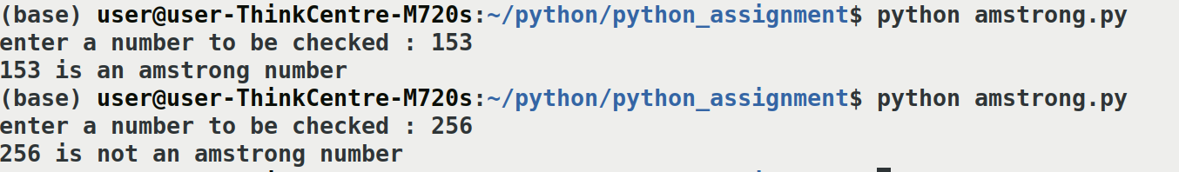
5. Python Program to find area of a circle.
pi = 3.14

radius = eval(input("enter radius: "))

print("area : ", pi*(radius**2))

Output:
6. Python program to check whether a number is Prime or not.
Program:
def checkPrime(num):
count = 0

for i in range(num,1,-1):

if num % i == 0:
count+=1

if count>=2:
print(num,"is not a prime")
else:
print(num,"is a prime")

number = eval(input("enter a number to check prime: "))
checkPrime(number)

Output:
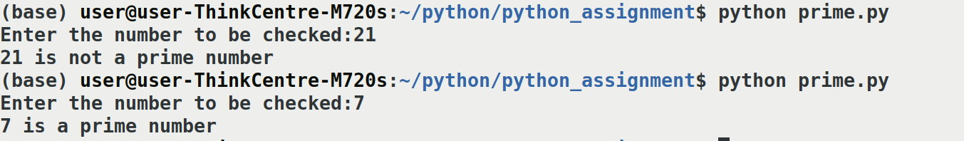
7. Python Program for printing Fibonacci series.
Program:

a = eval(input('enter the limit : '))

fib = 0
m = 1
l = 0
for i in range(1,a+1):
print(fib)
l = m + fib
fib = m
m = l

Output:
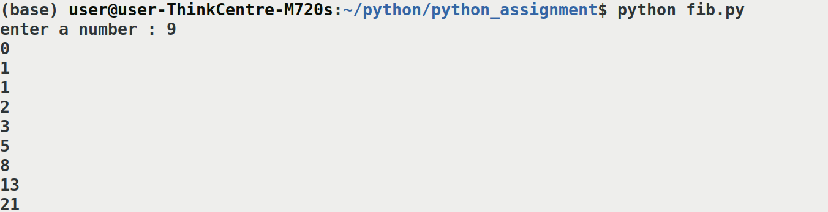
8. Program to print ASCII Value of a character.
Program:

letter=input("enter the character:")
asciiValue=ord(letter)
print("ASCII VALUE OF",letter,"is:",asciiValue)

Output:
9. Program to print first n even numbers.
Program:

n=eval(input("enter the limit:"))
count=1;
for i in range(2,n+1,2):
count=count+1
print(i)

Output:

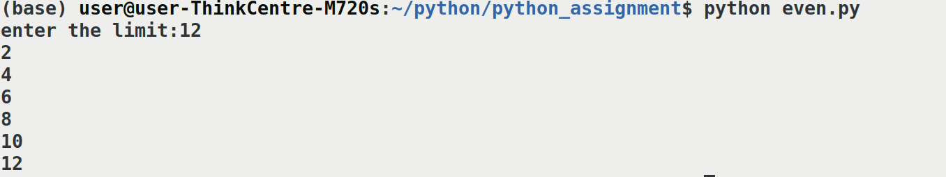
10. Python Program for Sum of squares of first n natural numbers.
Program:
def square(n)
sum=0
for i in range (1,n+1):
sum=sum+(i*i)
return sum
n=int(input("enter the number:"))
print("sum of the squares from 1 to ",n," =",square(n))
output:
LIST PROGRAMS

1.Python program to find sum of elements in list.
Program:
a = [1,2,3,4,5]
sum = 0
for i in a:

sum += i

print(f"sum of list {a} \nis {sum}")

Output:
2.Python program to reversing a list.
Program:
list = ["APPLE" , "BANANA" , "ORANGE"]
print('Original List:', list)
list.reverse()
print('Updated List:', list)

Output:
3.Python program to print all positive and negative numbers in range.
Program:
a = eval(input("enter starting number: "))
b = eval(input("enter ending number: "))

if a <= -1:
a=a
for i in range(a,b+1):
print(i)
else:
for i in range(a,b-1,-1):
print(i)

Output:
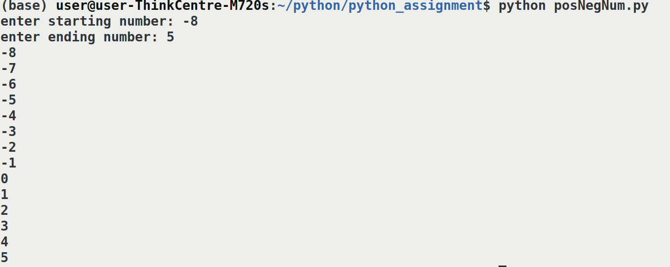
string programs

1. Python program to Check if a Substring is Present in a Given String .
Program:
def checkString(string,substring):
if string.find(substring)==-1:
print("the substring", substring, "is not present in ", string )
else:
print("the substring", substring, "is present in ", string )

str1 = input("Enter the String: ")
substr1 = input("Enter the subString: ")

checkString(str1,substr1)

Output:
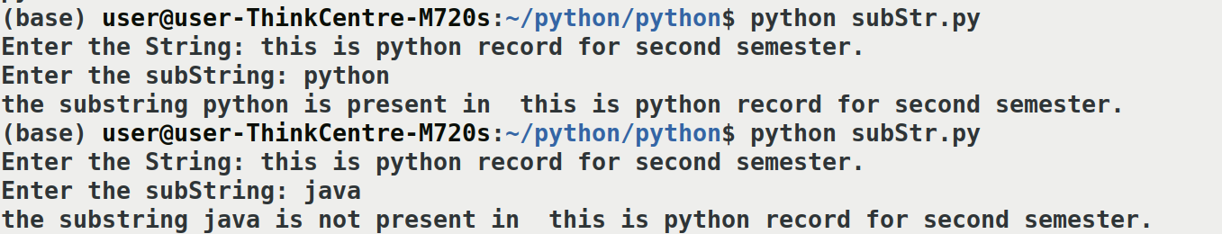
2.Reverse words in a given string in a python.

Program:

word = input("enter a string: ")

print("string reversed : ",word[::-1])

Output:
3.Python program to accept the strings which contains vowels.

Program:

def checkVowels(string):
for char in string:
if char in 'aeiouAEIOU':
return True
return False
string = input('Enter any String: ')
if (checkVowels(string) == True):
print('Yes, String contains vowels.')
else:
print('No, String does not contain vowels.')

Output:
DICTIONARIES

1.Python program to merging two dictionaries.

Program:

def merge(dict1,dict2):
return dict2.update(dict1)

dict1 = {1,5,6,8,5}
dict2 = {9,3,6,4,6}

print(dict1)
print(dict2)
merge(dict1,dict2)
print(dict2)

Output:

2.python program to remove a key from dictionary

Program:

myDict = {'a':1,'b':2,'c':3,'d':4}
print(myDict)
if 'a' in myDict:
del myDict['a']
print(myDict)

Output:
PATTERN PRINTING PROGRAM

1.Python program to print a inverted star pattern.
Program:
a = eval(input("enter a number: "))

for i in range(a,0,-1):
print(i * '*')

Output:
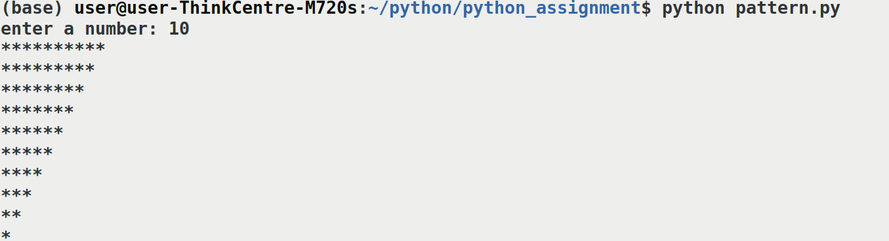
modules
1. write a program using various methods in math module.
Program:
import math

print(math.ceil(10.26))
print(math.floor(10.86))
print(math.exp(1))
print(math.log(2.718))
print(math.log(8,2))
print(math.sqrt(9))
print(math.sin(3.14159))
print(math.asin(1))
print(math.cos(0))
print(math.acos(1))
print(math.tan(3.14/4))
print(math.degrees(1.57))
print(math.radians(89.9999))

output:
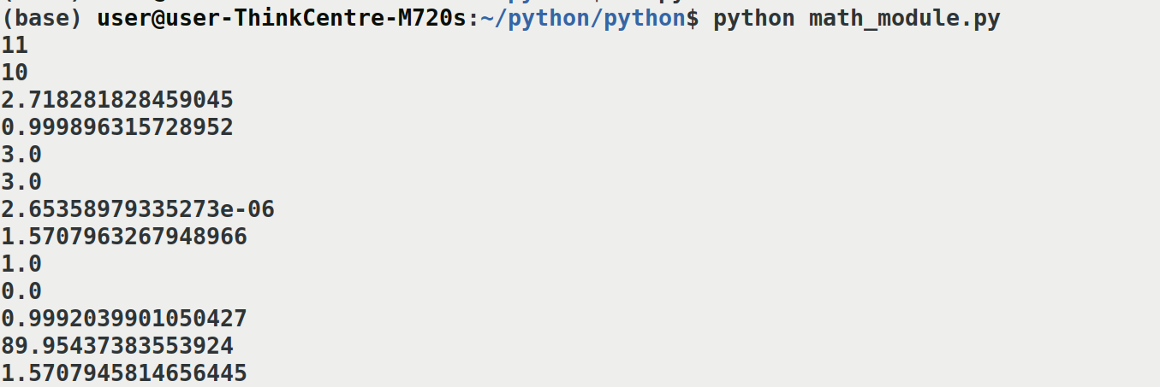
2. write a program using various methods in random module.

Program:
import random
num = [1,2,3,4,5,6]
roll = input('do you want to roll dice ?? Y/N: ')

if roll == 'Y':
random.shuffle(num)
print(num[1])

else:
print('stopped !!')

output:

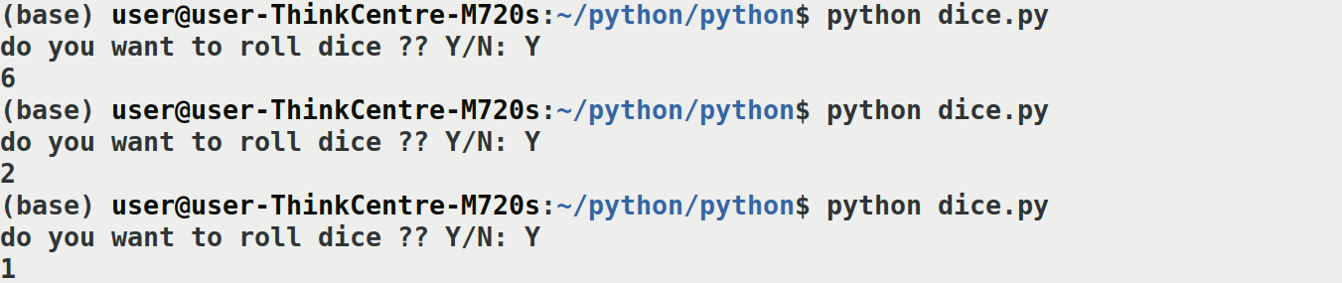
object oriented programming

1. write a program to input a few details of a student.
Program:
class Student:
def __init__(self,name,age,place):
self.name = name
self.age = age
self.place = place

def printStudentDetails(self):
print("I'm ",self.name,". im coming from ",self.place," and I'm ",self.age," years old.")

studentName = input("Enter your name: ")
studentAge = input("Enter your age: ")
studentPlace = input("Enter your place: ")

student1 = Student(studentName,studentAge,studentPlace)
student1.printStudentDetails()

output:
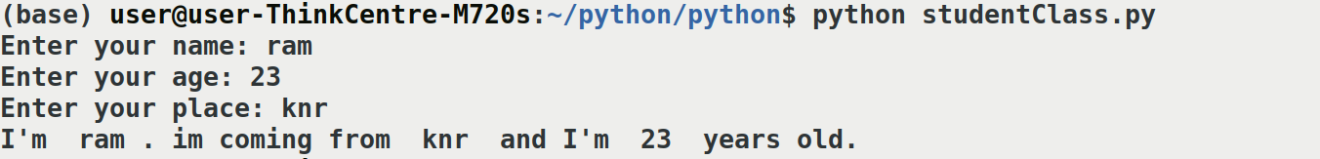
2.write a program

