NTI – IC Digital Design using FPGA
SPI master/slave in HDL verilog
Supervised by: Eng. Ahmed AlHussieny

TEAM MEMBERS:

Esther George Fayez Abdo

Eyad Khaled Mabrouk Noah

Radwa Ahmed Abd-Elsatar Ali

Abstract
This project presents the design, implementation, and verification of a configurable Serial Peripheral Interface (SPI) communication system using Verilog HDL. The system consists of a parameterized SPI Master, an SPI Slave, and an SPI RAM module integrated through a wrapper. The SPI Master supports configurable data width, SPI mode selection, clock division, and selectable transmission order (MSB-first or LSB-first). The SPI Slave receives serial commands from the master, decodes the requested operation, and communicates with the RAM to perform memory read and write transactions. Functional verification was carried out through comprehensive simulation using self-checking testbenches.

1. Introduction
The Serial Peripheral Interface (SPI) is one of the most widely used synchronous serial communication protocols in embedded systems and digital integrated circuits. It provides high-speed full-duplex communication between a master device and one or more slave devices using a small number of signal lines.
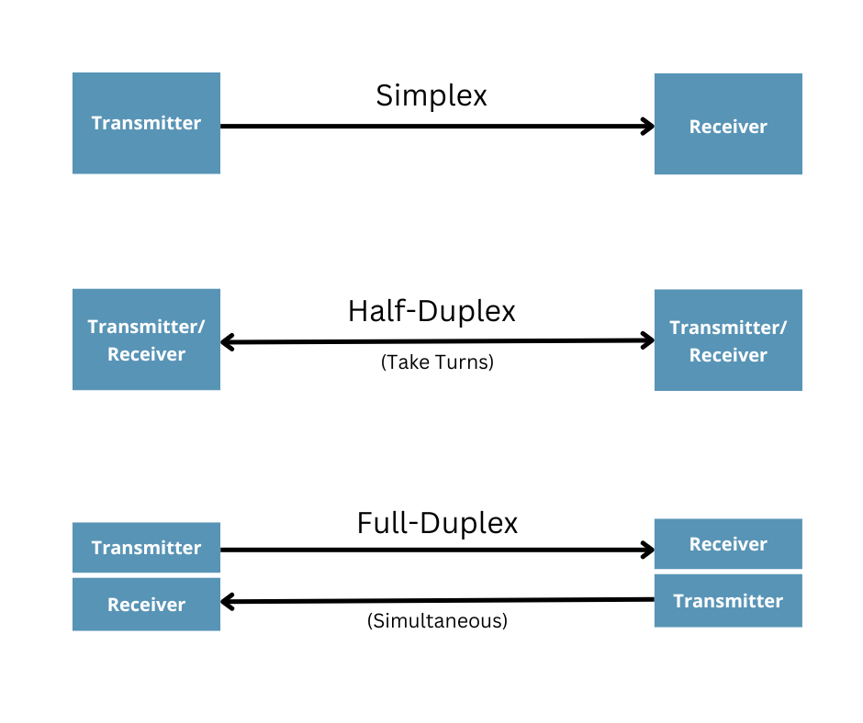
Unlike asynchronous protocols such as UART, SPI uses a dedicated clock generated by the master, allowing higher communication speeds and deterministic timing.
This project implements an SPI communication system completely in Verilog HDL suitable for FPGA implementation.

2. Project Objectives
The objectives of this project are:
- Design a configurable SPI Master.
- Design an SPI Slave capable of decoding SPI commands.
- Interface the slave with an internal RAM.
- Support configurable SPI parameters.
- Verify correct data transmission using simulation.
- Produce synthesizable RTL suitable for FPGA implementation.

3. SPI Protocol Overview

SPI communication uses four primary signals:
Signal | Direction | Description
SCLK | Master → Slave | Serial clock generated by the master
MOSI | Master → Slave | Master Out Slave In
MISO | Slave → Master | Master In Slave Out
CS/SS | Master → Slave | Active-low Slave Select

Communication begins when the master asserts the Chip Select (CS) line low. The master then generates clock pulses while transmitting data through MOSI and simultaneously receiving data from the slave through MISO.

4. System Architecture
The implemented SPI system consists of three major modules:
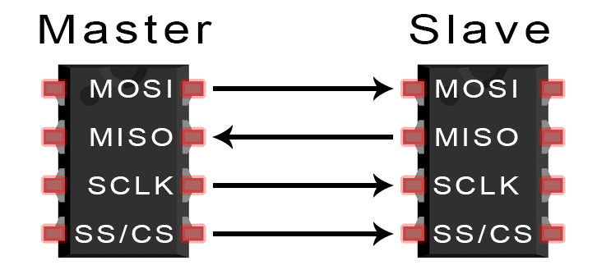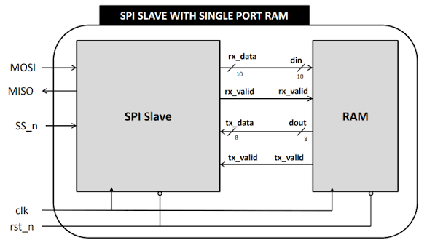
The master initiates all communication while the slave interprets incoming commands and accesses the RAM accordingly.

5. SPI Master Design

5.1 Features
The SPI Master was designed to be fully parameterized.

Supported parameters include:

Parameter | Description
DATA_WIDTH | Number of transmitted bits
MODE | SPI Mode (CPOL/CPHA)
CLK_DIV | Serial clock divider
MSB_FIRST | Transmission order

This allows the module to be reused in different SPI systems without modifying the RTL code.

5.2 Finite State Machine
The SPI Master operates using a four-state finite state machine.
IDLE
- Waits for the Start signal.
- CS remains high.
- SCLK remains at idle polarity.

LOAD
- Loads transmit data into the shift register.
- Clears receive register.
- Initializes counters.
- Activates Chip Select.

TRANSFER
During this state:
- Clock divider generates the SPI clock.
- SCLK toggles according to CLK_DIV.
- MOSI shifts one bit every transmission edge.
- MISO is sampled every reception edge.
- Bit counter tracks transmitted bits.
Transmission continues until all bits have been transferred.

FINISH
- Stores received data.
- Returns SCLK to idle polarity.
- Deasserts CS.
- Raises Done flag.
- Returns to IDLE.

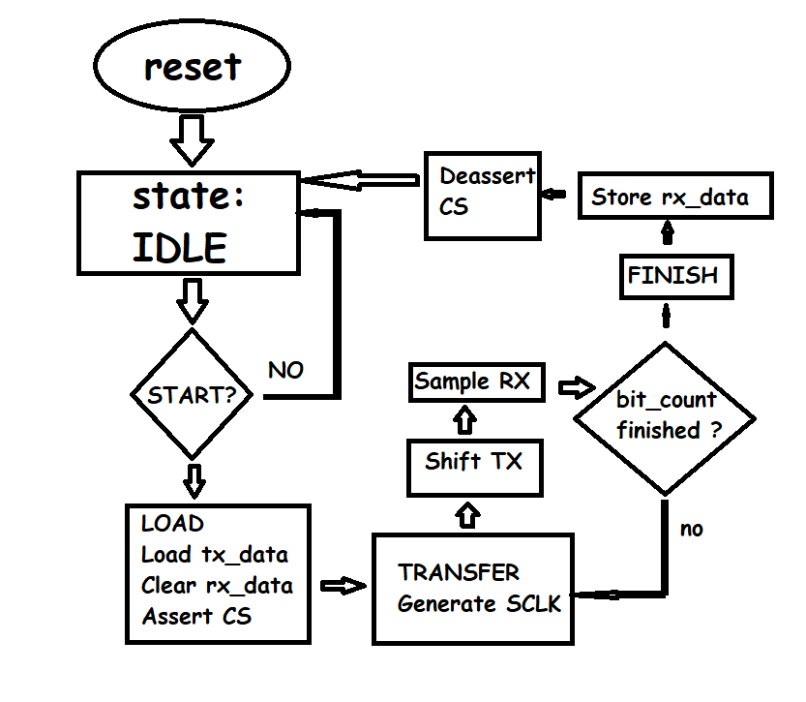
Flowchart of Master FSM

6. Clock Divider

The SPI clock is generated internally from the FPGA system clock.
Instead of toggling SCLK every system clock cycle, a counter counts from
0 → CLK_DIV-1
When the counter reaches
CLK_DIV-1
the counter resets and SCLK toggles.
Example:
For
CLK_DIV = 4
System Clock:

↑ ↑ ↑ ↑ ↑ ↑ ↑ ↑

Counter:

0 1 2 3 0 1 2 3

SCLK:

______----____----
Therefore,
SPI Clock Frequency

F_SPI = F_CLK / (2 × CLK_DIV)
The divider allows communication with slower slave devices while keeping the FPGA operating at a much higher frequency.
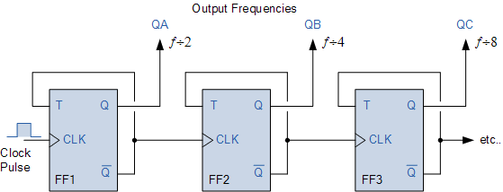

7. SPI Slave Design
The SPI Slave receives serial data from the master and interprets incoming packets.
The slave consists of two major parts:
- SPI Receiver
- RAM Interface
The slave continuously monitors the Chip Select line.
Once selected, it samples incoming MOSI data using the serial clock provided by the master.

Slave States
The implemented slave includes the following states:
State | Function
IDLE | Wait for CS assertion
CHECK | Decode transaction type
WRITE | Receive write command
READ_ADDR | Receive read address
READ_DATA | Transmit requested data
The slave reconstructs serial data into a parallel packet before forwarding it to RAM.

8. RAM Module

The RAM module stores user data.
Supported operations include:
Command | Function
00 | Write Address
01 | Write Data
10 | Read Address
11 | Read Data
The RAM stores 8-bit data across 256 memory locations.

9. Data Packet Format
The implemented SPI packet contains ten bits.

---------------------------------

| CMD[1:0] | DATA[7:0] |

---------------------------------
Where:

00 → Write Address

01 → Write Data

10 → Read Address

11 → Read Data
This packet structure simplifies communication between the SPI slave and RAM.

10. Verification
Functional verification was performed using a self-checking Verilog testbench.
The following test cases were evaluated:

- Reset functionality
- Multiple transmit patterns
- All zeros
- All ones
- Alternating bits
- Random data
- Variable DATA_WIDTH
- Variable CLK_DIV
- Clock edge verification
Loopback testing connected
MOSI → MISO
allowing transmitted data to be immediately received and compared automatically.
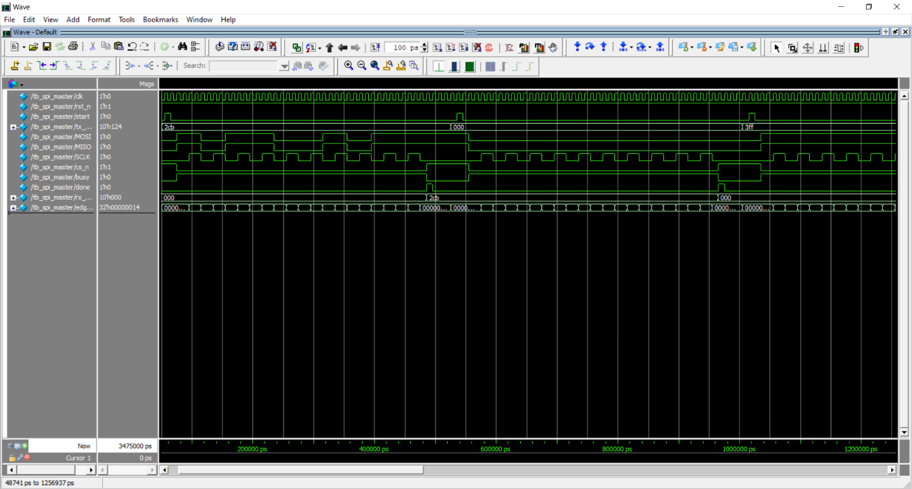
Testbench for master
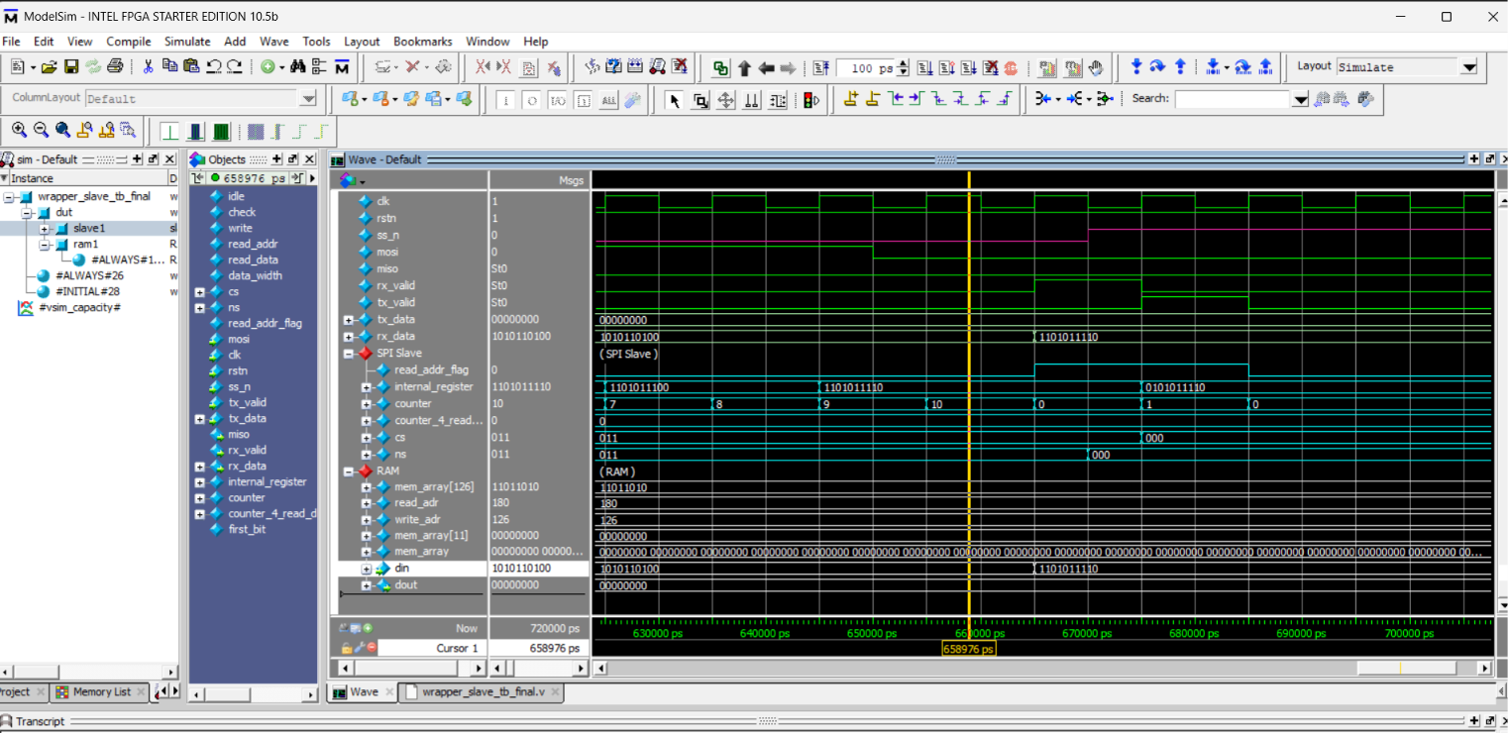
Testbench for read_data case in slave
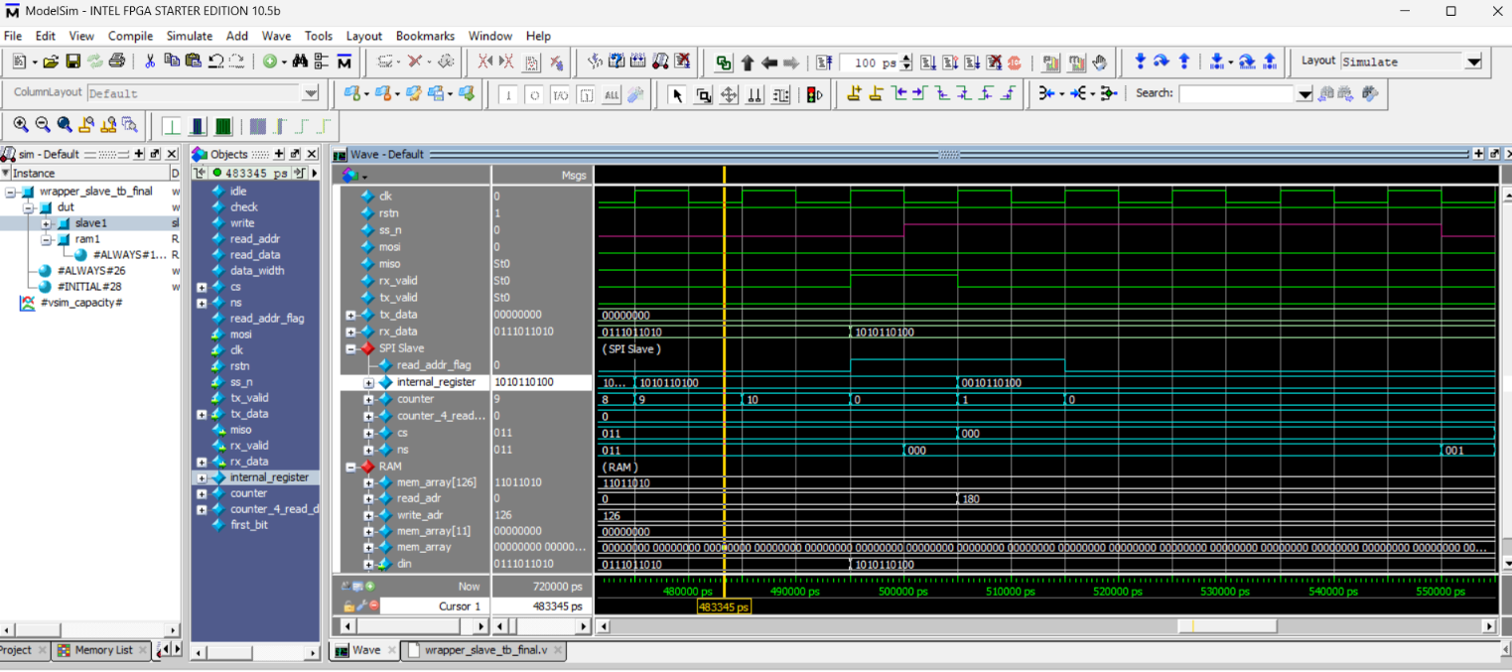
Testbench for read_addr case in slave

Testbench Features

The verification environment automatically:
- Generates system clock.
- Generates reset sequence.
- Starts SPI transactions.
- Counts SCLK edges.
- Checks received data.
- Reports PASS/FAIL automatically.
- Monitors internal FSM states.
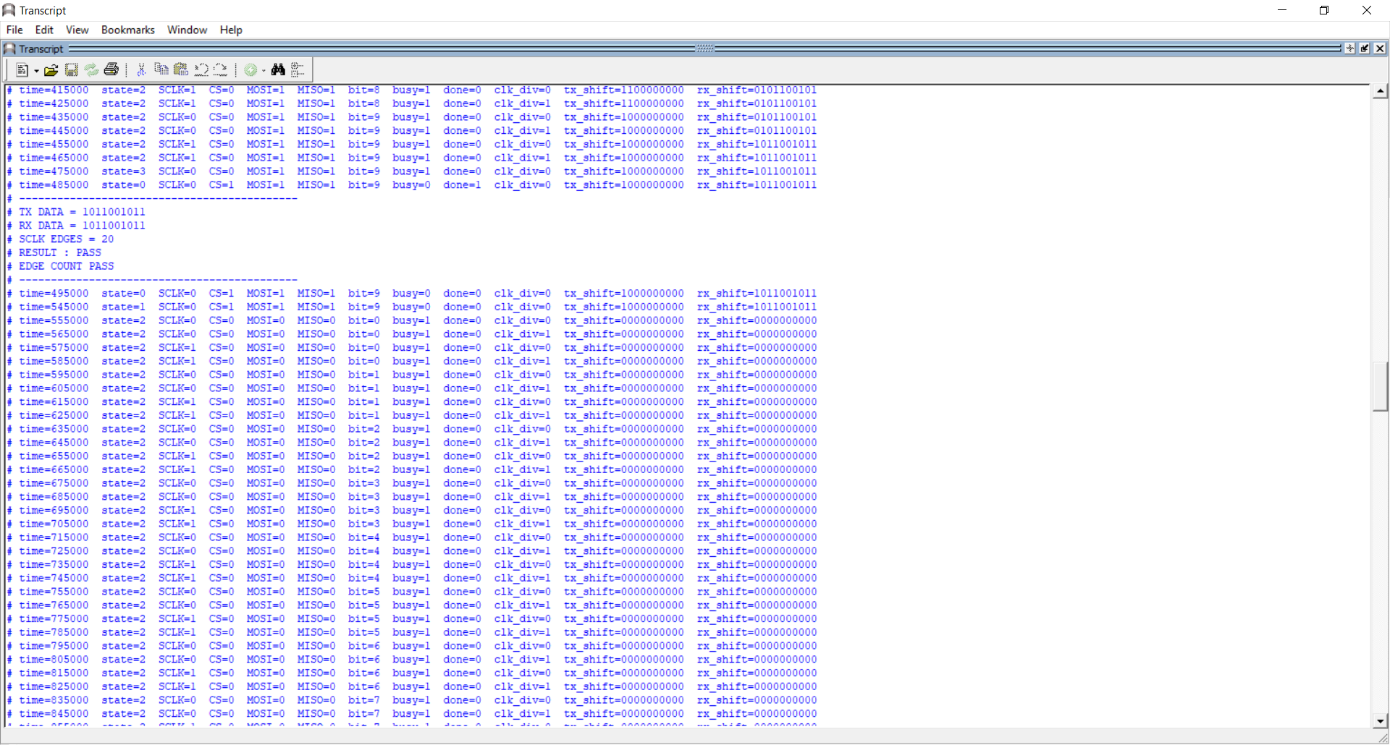
Pass/fail reports in master testbench

11. Results
Simulation demonstrated successful SPI communication under multiple operating conditions.
The SPI Master correctly:
- Generated the SPI clock.
- Shifted transmitted data.
- Sampled incoming data.
- Controlled Chip Select.
- Produced correct Busy and Done signals.
The SPI Slave successfully:
- Decoded SPI commands.
- Received serial packets.
- Interfaced with RAM.
- Returned requested data through MISO.
No functional errors were observed during loopback verification.

12. Synthesis
Synthesis is the process of converting the Register Transfer Level (RTL) description written in Verilog into a technology-specific gate-level netlist that can be implemented on the target FPGA. During this stage, the synthesis tool analyzes the HDL code, infers the required hardware components, optimizes the logic, and maps the design to the available resources of the target device.
The SPI Master and SPI Slave modules were synthesized independently using Xilinx Vivado Design Suite targeting the Artix-7 FPGA family. Independent synthesis allows each module to be verified individually before being integrated into the complete SPI communication system.

12.1 SPI Master Synthesis
The SPI Master module was synthesized successfully without any synthesis errors or warnings. During synthesis, the RTL description was translated into FPGA resources such as Look-Up Tables (LUTs), Flip-Flops (FFs), multiplexers, and clock routing resources.
The synthesis tool inferred the following hardware components from the RTL design:
- Finite State Machine (FSM) controlling the SPI transaction.
- Transmit shift register for serializing parallel input data.
- Receive shift register for capturing serial input data.
- Bit counter used to determine the completion of data transmission.
- Programmable clock divider used to generate the SPI serial clock (SCLK).
- Output control logic for the MOSI, SCLK, CS, busy, and done signals.
Logic optimization was performed automatically by the synthesis tool while preserving the intended functionality of the design. Since the SPI Master is fully parameterized, the synthesized hardware can be configured for different data widths, clock division ratios, transmission order (MSB-first or LSB-first), and SPI operating modes without modifying the RTL code.
The generated RTL schematic verifies the architecture of the SPI Master and confirms the correct interconnection between the control FSM, clock divider, shift registers, counters, and output control logic.
Following synthesis, timing analysis was performed to verify that the synthesized logic satisfies the required timing constraints before placement and routing.
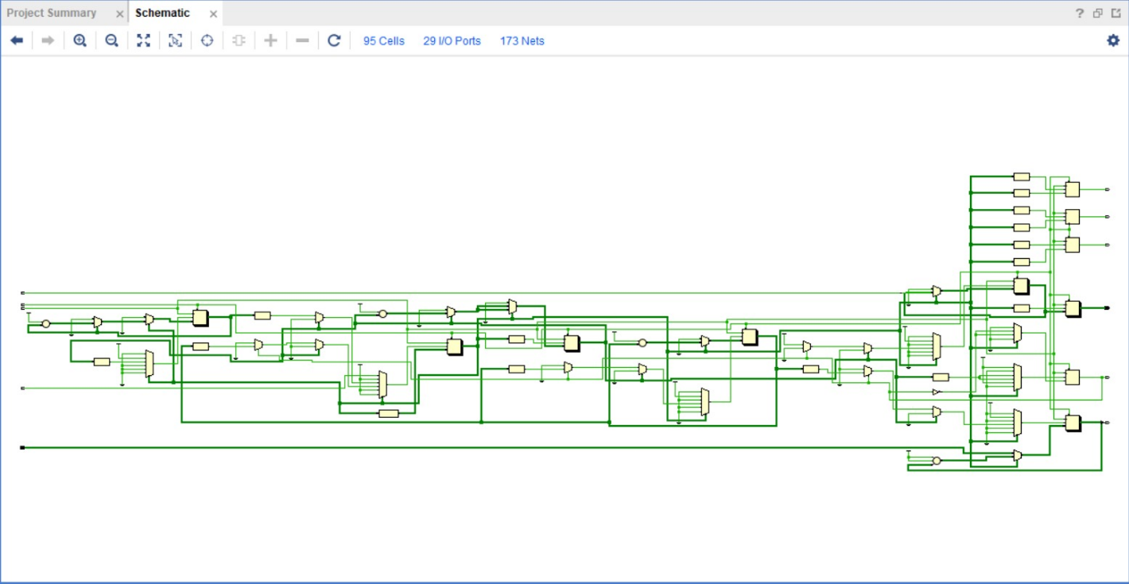
RTL Schematic of SPI Master

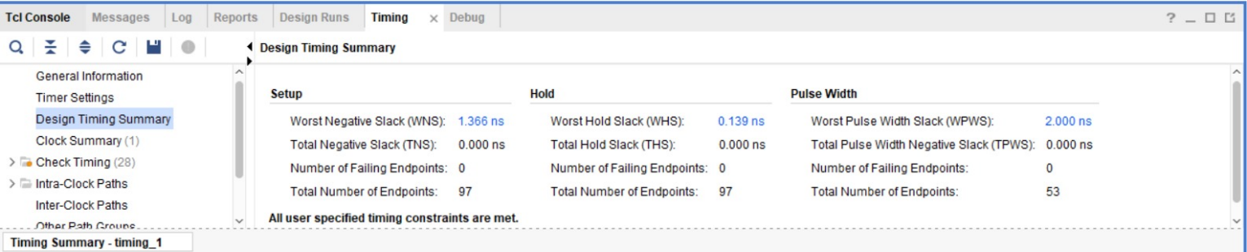
Timing analysis Pre-PnR (fitting)

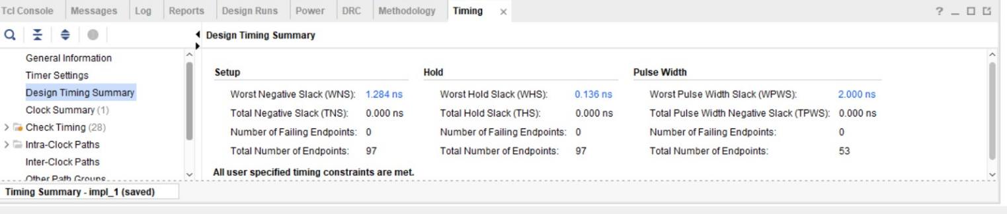
Timing analysis after PnR (fitting)

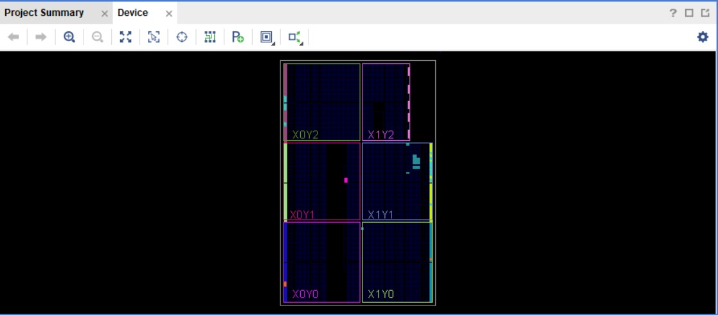
Placement & routing of spi master in FPGA (Utilized sections of FPGA)

12.2 SPI Slave Synthesis
The SPI Slave module was synthesized independently using the same FPGA target device. The synthesis process converted the behavioral Verilog description into FPGA logic resources while preserving the communication protocol required by the SPI interface.
The synthesized hardware consists of the following major functional blocks:
- Slave Finite State Machine (FSM).
- Serial receive logic for collecting incoming MOSI data.
- Serial transmit logic for driving the MISO line.
- Receive data register.
- Bit counters controlling serial reception and transmission.
- Interface logic connecting the slave controller with the RAM module.
The synthesis tool optimized the control logic and datapath while maintaining correct synchronization between the SPI signals and the internal memory interface. The synthesized RTL schematic confirms the implementation of the slave controller and the proper connection of its receive, transmit, and state-control circuitry.
Static timing analysis performed after synthesis verified that the synthesized design satisfies the specified timing requirements prior to physical implementation.
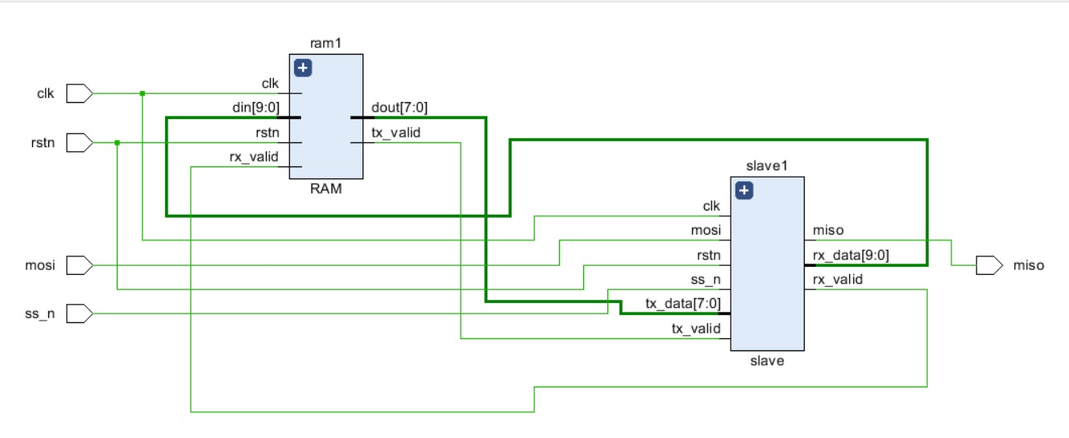
Block diagram of slave & RAM
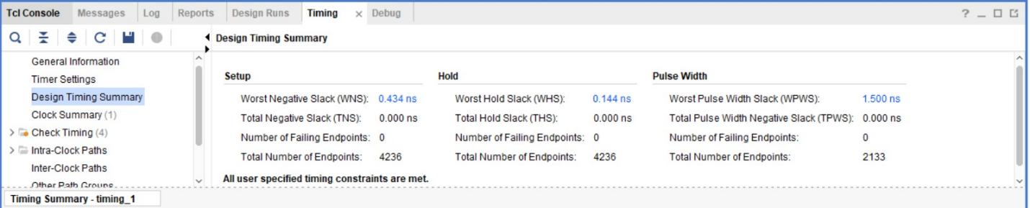
Timing analysis Pre-PnR (fitting) 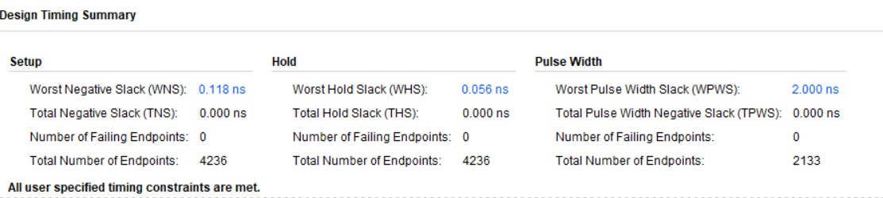
Timing analysis after PnR
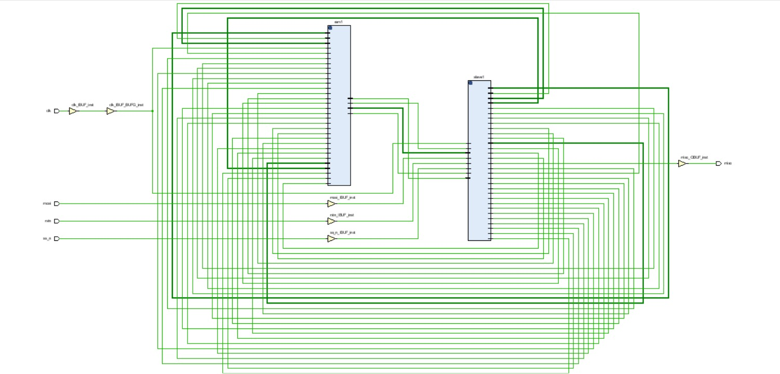
Implementation, placement & routing of slave and RAM
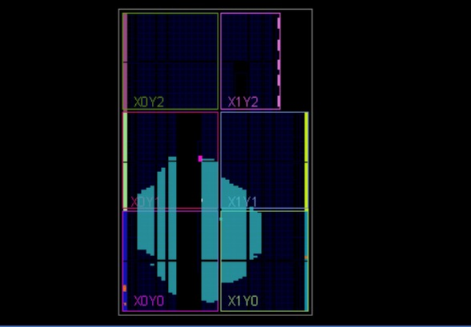
Placement & routing of spi master in FPGA (Utilized sections of FPGA)

12.3 Synthesis Results
Both the SPI Master and SPI Slave modules were synthesized successfully and were found to be fully synthesizable for implementation on the Xilinx Zynq-7000 FPGA. No synthesis errors were reported, and the generated RTL schematics accurately represent the intended hardware architecture described in the Verilog source code.
Resource utilization reports indicate that both modules occupy only a small percentage of the available FPGA resources, leaving sufficient logic capacity for additional peripherals or future system expansion. The timing reports also confirm that the synthesized designs satisfy the required timing constraints, making them suitable for subsequent implementation stages.
The successful completion of synthesis verified the correctness of the RTL designs and prepared both modules for placement, routing, and hardware implementation on the target FPGA.

13. Advantages of the Design
The implemented design provides several advantages:
- Fully parameterized architecture
- Synthesizable RTL
- Modular design
- Configurable SPI clock
- Configurable data width
- Supports MSB-first and LSB-first transmission
- Easily reusable in larger FPGA systems

14. Future Improvements
Several enhancements can be incorporated into future versions:
- Full support for all four SPI modes (CPOL/CPHA)
- Multiple slave selection
- FIFO buffering
- Interrupt generation
- DMA support
- Burst transfers
- CRC/Error detection
- Configurable frame sizes larger than 32 bits

15. Conclusion
A complete SPI communication system was successfully designed and verified using Verilog HDL. The project demonstrated the implementation of a configurable SPI Master, an SPI Slave, and an integrated RAM interface capable of executing serial read and write operations. Through parameterization and modular RTL design, the architecture can be adapted to different communication requirements and FPGA platforms. Comprehensive simulation verified correct clock generation, serial data transmission, packet decoding, and memory access, demonstrating the functionality and reliability of the proposed design. The project also provides a scalable foundation for implementing more advanced SPI features such as support for all SPI modes, multiple slave devices, burst transfers, and FIFO-based buffering in future developments

