1.

Question 1

A computer program is said to learn from experience E with

respect to some task T and some performance measure P if its

performance on T, as measured by P, improves with experience E.

Suppose we feed a learning algorithm a lot of historical weather

data, and have it learn to predict weather. In this setting, what is T?





The probability of it correctly predicting a future date's weather.

Question 2

Suppose you are working on weather prediction, and your weather

station makes one of three predictions for each day's weather:

Sunny, Cloudy or Rainy. You'd like to use a learning algorithm

to predict tomorrow's weather.

Would you treat this as a classification or a regression problem?

Classification

Suppose you are working on stock market prediction. You would like to predict whether or not a certain company will declare bankruptcy within the next 7 days (by training on data of similar companies that had previously been at risk of bankruptcy). Would you treat this as a classification or a regression problem?



Classification

Some of the problems below are best addressed using a supervised

learning algorithm, and the others with an unsupervised

learning algorithm. Which of the following would you apply

supervised learning to? (Select all that apply.) In each case, assume some appropriate

dataset is available for your algorithm to learn from.

Examine a web page, and classify whether the content on the web page should be considered "child friendly" (e.g., non-pornographic, etc.) or "adult."



*In farming, given data on crop yields over the last 50 years, learn to predict next year's crop yields.*

Question 5

Which of these is a reasonable definition of machine learning?

Machine learning is the field of study that gives computers the ability to learn without being explicitly programmed.

Quiz 2

1.

Question 1

Consider the problem of predicting how well a student does in her second year of college/university, given how well she did in her first year.

Specifically, let x be equal to the number of "A" grades (including A-. A and A+ grades) that a student receives in their first year of college (freshmen year). We would like to predict the value of y, which we define as the number of "A" grades they get in their second year (sophomore year).

Refer to the following training set of a small sample of different students' performances (note that this training set may also be referenced in other questions in this quiz). Here each row is one training example. Recall that in linear regression, our hypothesis is h_\theta(x) = \theta_0 + \theta_1x*hθ*​(*x*)=*θ*0​+*θ*1​*x*, and we use m*m* to denote the number of training examples.

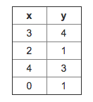

For the training set given above, what is the value of m*m*? In the box below, please enter your answer (which should be a number between 0 and 10)

*4*

2.

Question 2

Many substances that can burn (such as gasoline and alcohol) have a chemical structure based on carbon atoms; for this reason they are called hydrocarbons. A chemist wants to understand how the number of carbon atoms in a molecule affects how much energy is released when that molecule combusts (meaning that it is burned). The chemist obtains the dataset below. In the column on the right, “kJ/mol” is the unit measuring the amount of energy released.

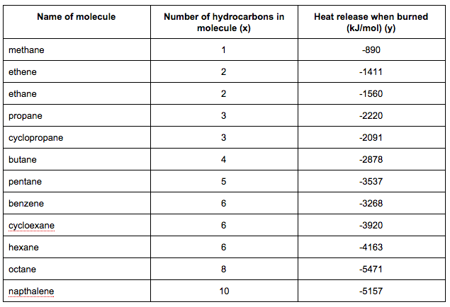

You would like to use linear regression (h_{\theta}(x) = \theta_0 + \theta_1 x*hθ*​(*x*)=*θ*0​+*θ*1​*x*) to estimate the amount of energy released (y) as a function of the number of carbon atoms (x). Which of the following do you think will be the values you obtain for \theta_0*θ*0​ and \theta_1*θ*1​? You should be able to select the right answer without actually implementing linear regression.

*theta_0 = -569.6, \theta_1 = -530.9*θ*0​=−569.6,*θ*1​=−530.9*

Suppose we set \theta_0 = -1, \theta_1 = 0.5*θ*0​=−1,*θ*1​=0.5. What is h_{\theta}(4)*hθ*​(4)?

*1*

In the given figure, the cost function J(\theta_0,\theta_1)*J*(*θ*0​,*θ*1​) has been plotted against \theta_0*θ*0​ and \theta_1*θ*1​, as shown in 'Plot 2'. The contour plot for the same cost function is given in 'Plot 1'. Based on the figure, choose the correct options (check all that apply)

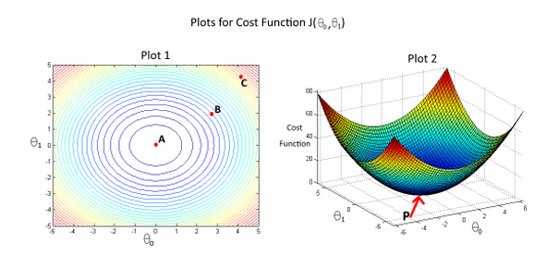



*Point P (the global minimum of plot 2) corresponds to point A of Plot 1.*

**

*If we start from point B, gradient descent with a well-chosen learning rate will eventually help us reach at or near point A, as the value of cost function J(\theta_0,\theta_1)J(θ0​,θ1​) is minimum at A.*

Suppose that for some linear regression problem (say, predicting housing prices as in the lecture), we have some training set, and for our training set we managed to find some \theta_0*θ*0​, \theta_1*θ*1​ such that J(\theta_0, \theta_1)=0*J*(*θ*0​,*θ*1​)=0.

Which of the statements below must then be true? (Check all that apply.)

*Our training set can be fit perfectly by a straight line, i.e., all of our training examples lie perfectly on some straight line*

Quiz 3

1.

Question 1

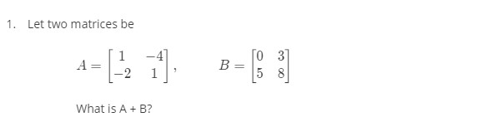

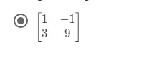

Question 2

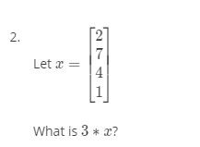

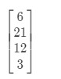

​

3.

Question 3

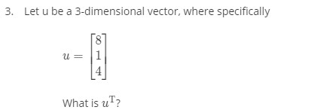



4.

Question 4

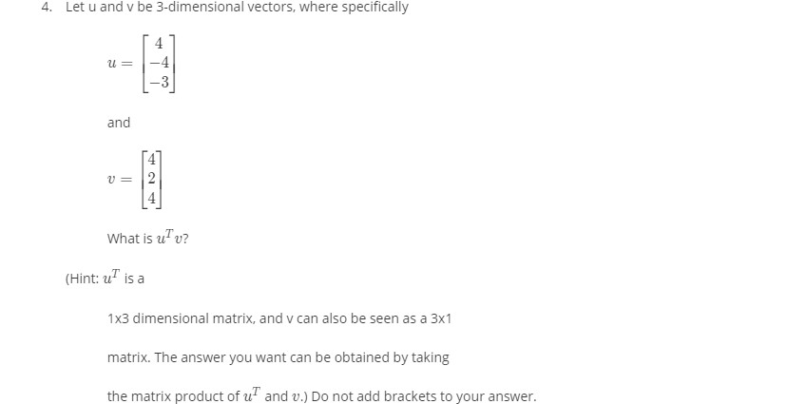

-4

5.

Question 5

Let A and B be 3x3 (square) matrices. Which of the following

must necessarily hold true? Check all that apply.

*A*+*B*=*B*+*A*

If A is the 3x3 identity matrix, then A * B = B * A *A*∗*B*=*B*∗*A*

​