Name

**Radwa Gamal Fathi Mahmoud**

Student Id: (314)

Group Number: (3)

Section Number: (14)

B.N: (12)

Project about

**Programming Languages**

# **GitHub Link:** [**https://github.com/RadwaGamal3/html_project_repo**](https://github.com/RadwaGamal3/html_project_repo)

# **Website Link:** [**https://radwagamal3.github.io/html_project_repo/**](https://radwagamal3.github.io/html_project_repo/)

# **Application Brief:**

Today everything in our world are depend heavily on programming. Computer programming applications are used by ever body in our world every day   
as :

- Mobile applications.  
- Desktop applications.  
- Web applications.  
- others

Computer programming is evolving and so are the languages that are used to develop software and applications.

Different programming languages are used for different categories of developers. Some languages are best for beginners, while others are more suited for advanced computer programmers. In addition, some languages are best for different use cases such as web apps, mobile apps and distributed systems.  
The best way to determine what programming languages to learn is to know what skills you will need in order to be a successful computer programmer.  
Popular and important computer programming languages based on necessity and application include:

* Python
* Java
* C/C++
* others

Each of these language ranges in usability and ease of learning. Python is considered the best beginner programming language. It is easy to learn and to deploy. Java has been a popular language for many decades. It is the official language for Android apps. C and C++ are considered the foundational languages for many operating systems and file systems. JavaScript is popular for front end developers because it helps make applications look clean and clear for the user. Swift is a native iOS language and has been growing in popularity as Mac and Apple products become industry favorites.

So everyone must know more about Programming and try to learn one of these Programming languages.

# **Screenshots for my website:**

* 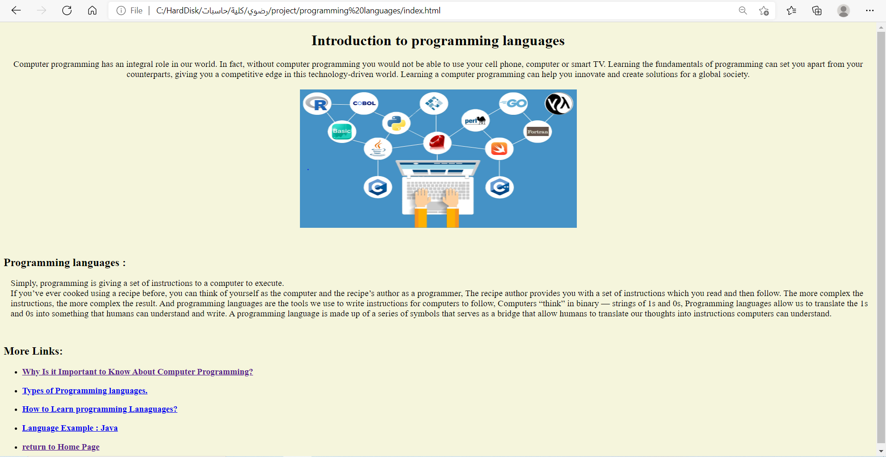**Page 1 :**
* 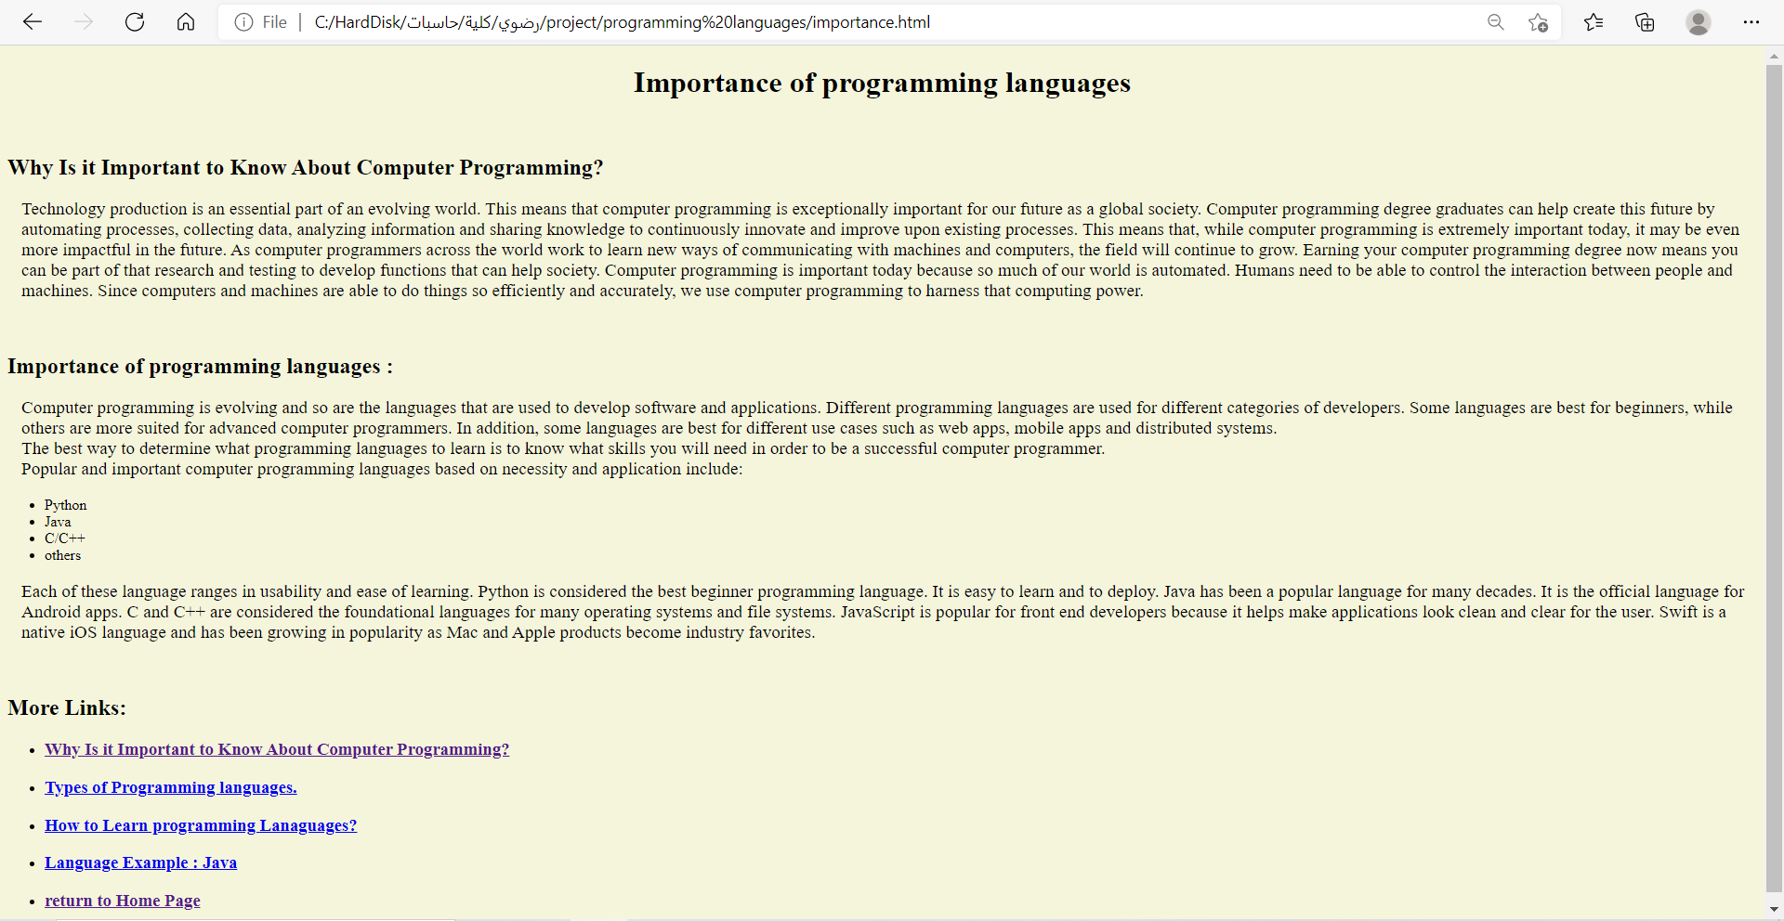**Page 2 :**
* 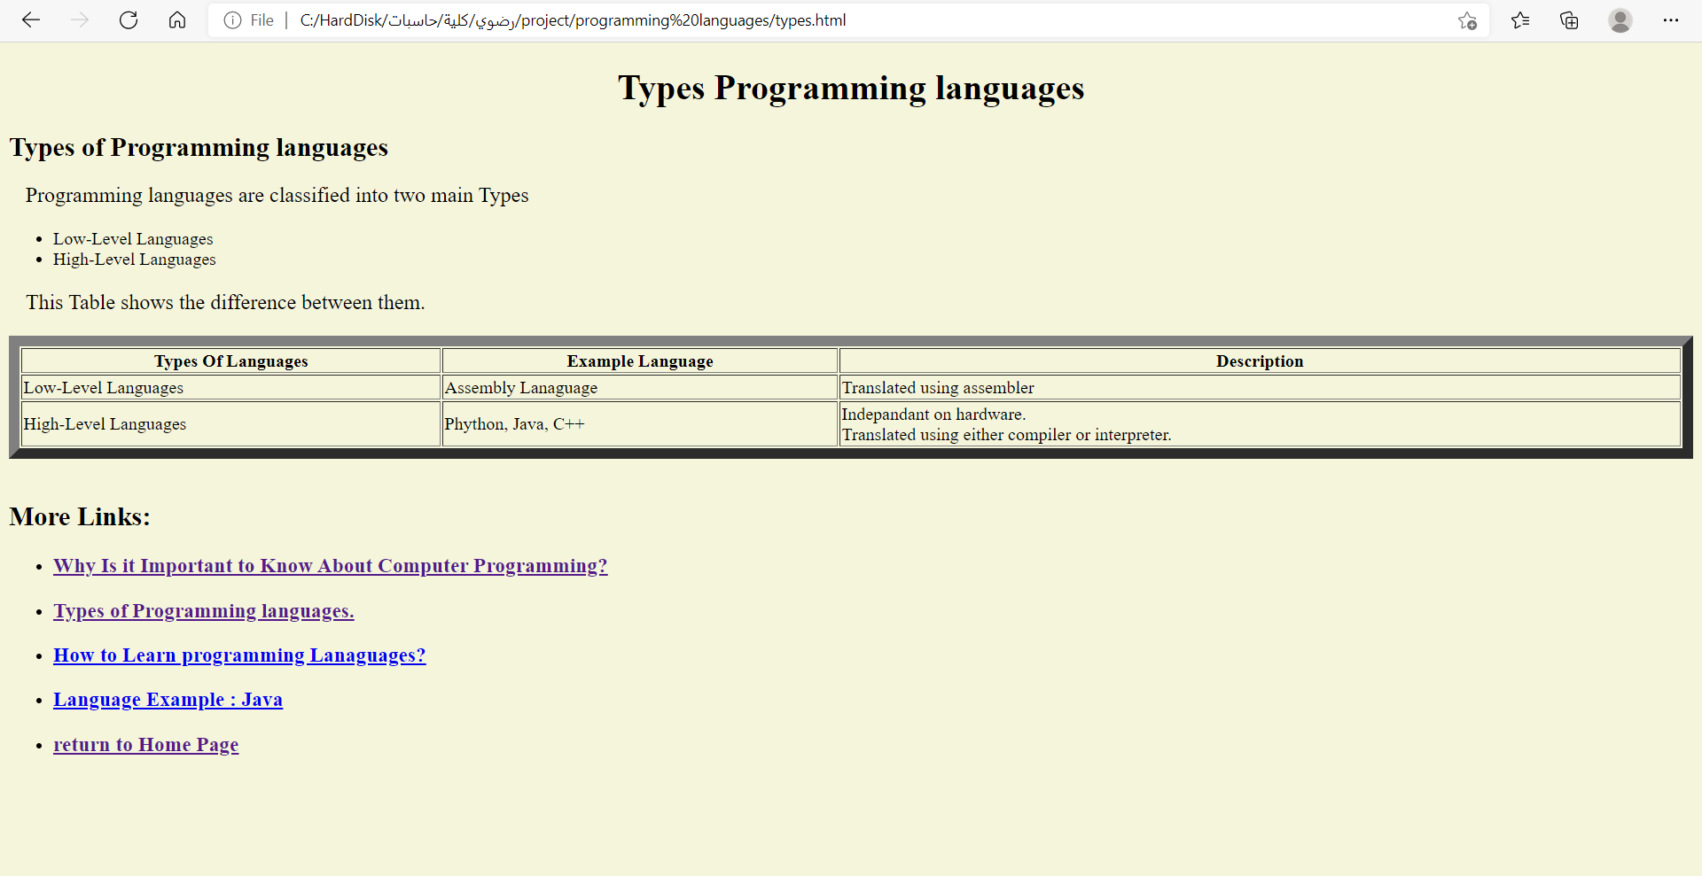**Page 3 :**
* **Page 4 :**

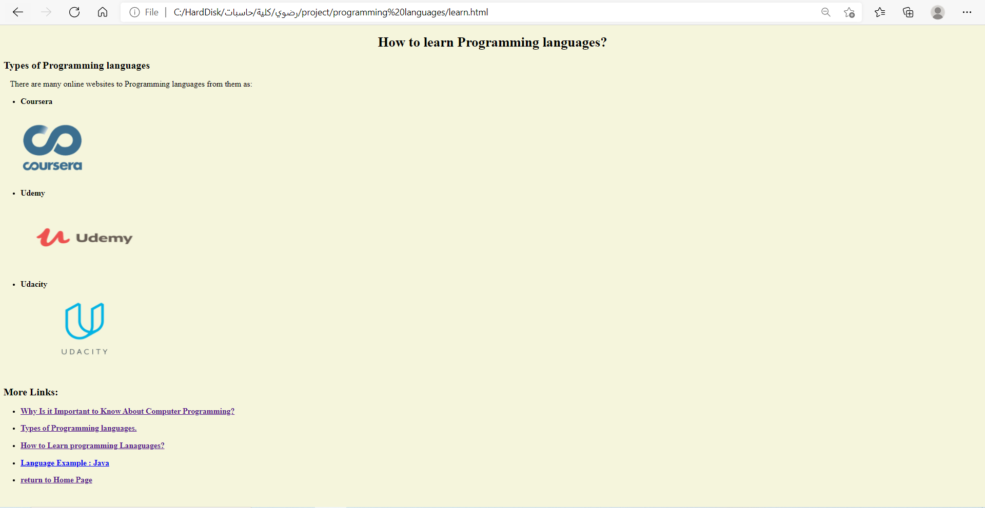

* **Page 5 :**

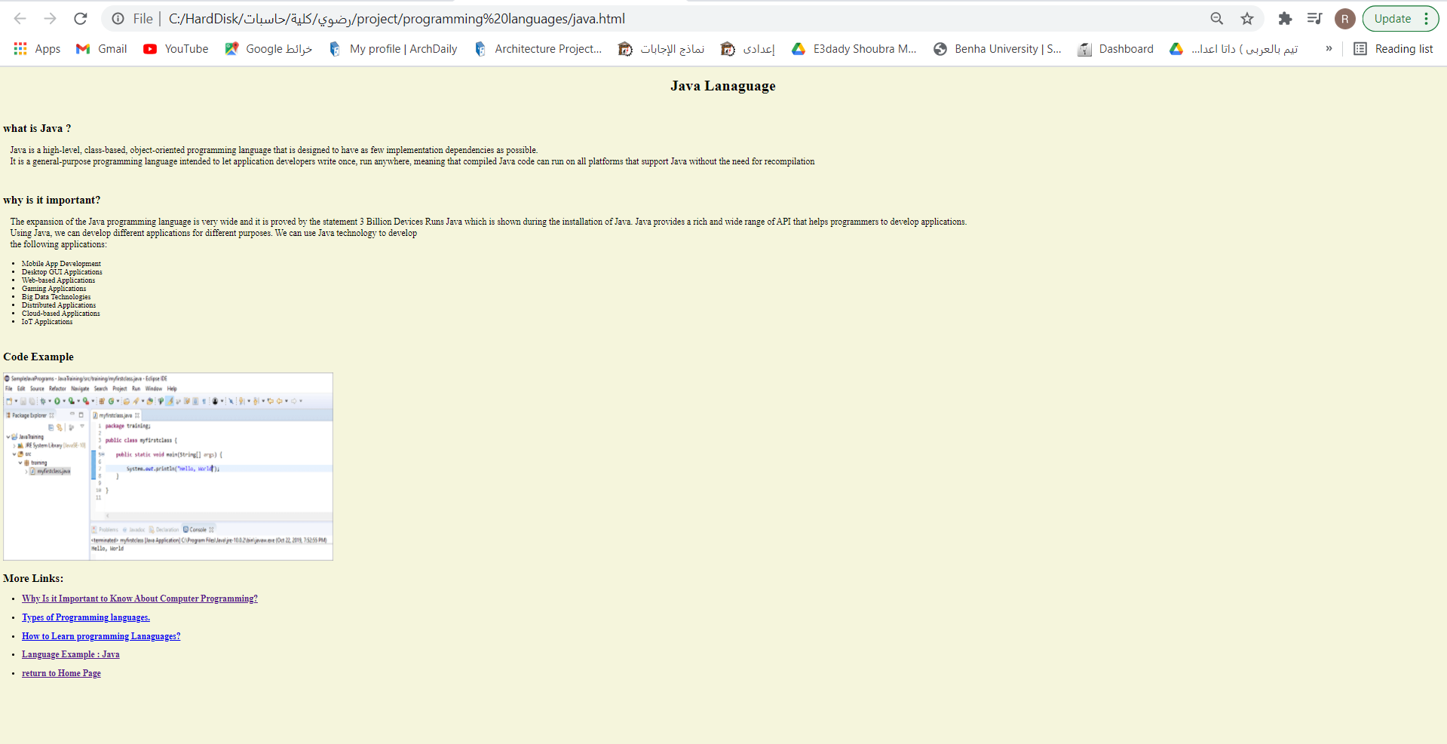

# **My source code:**

**Page 1 :** 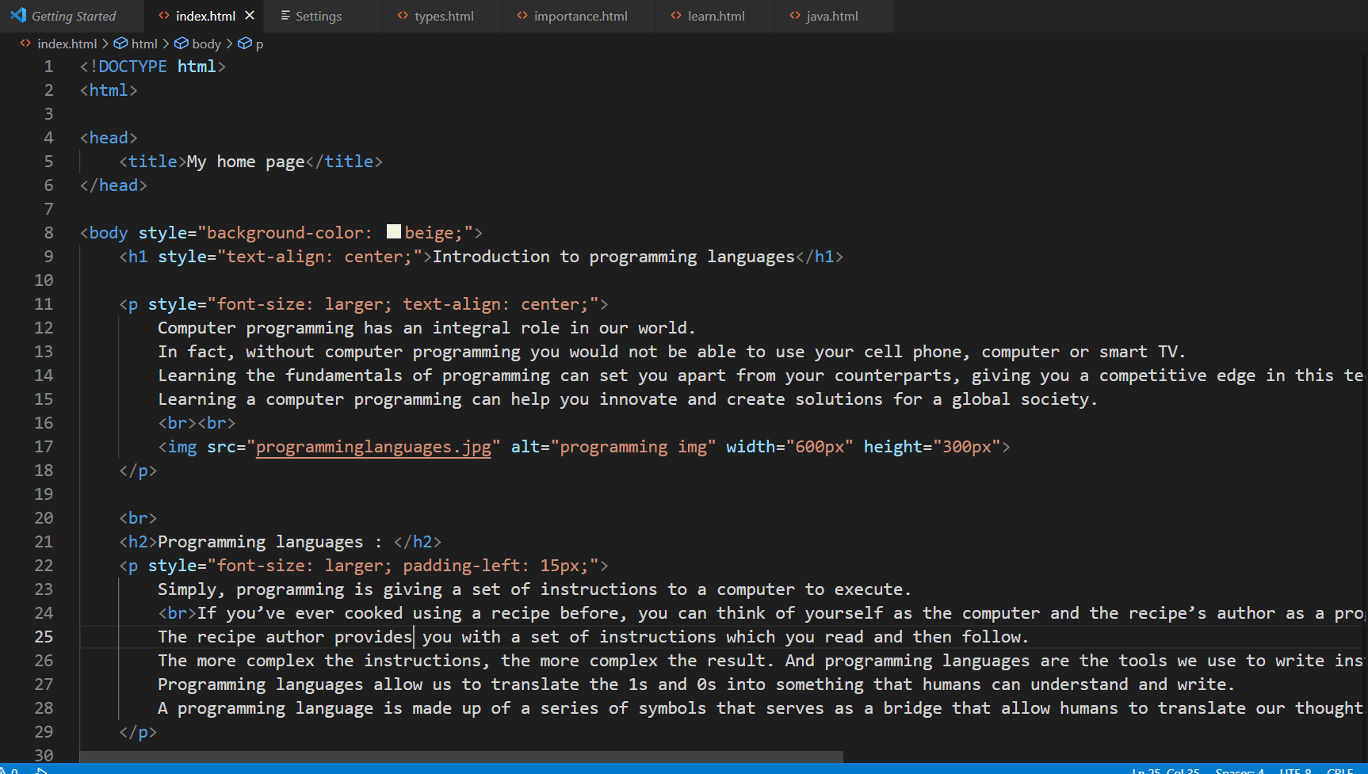

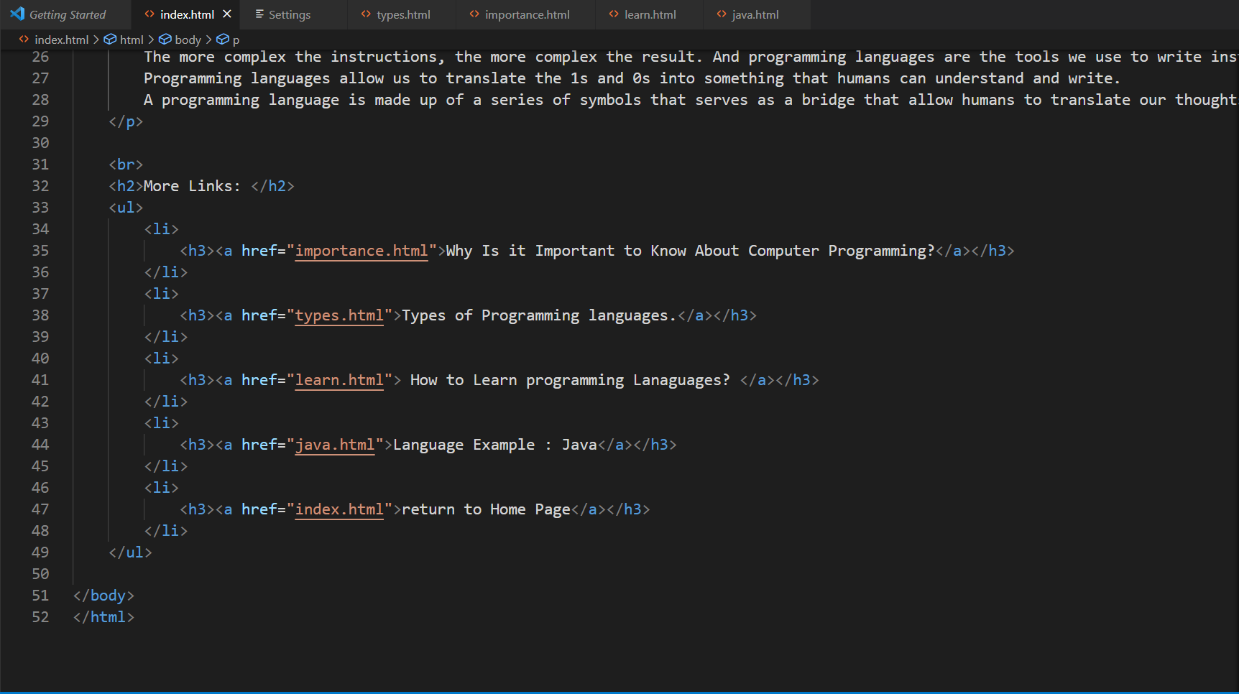

**Page 2 :**

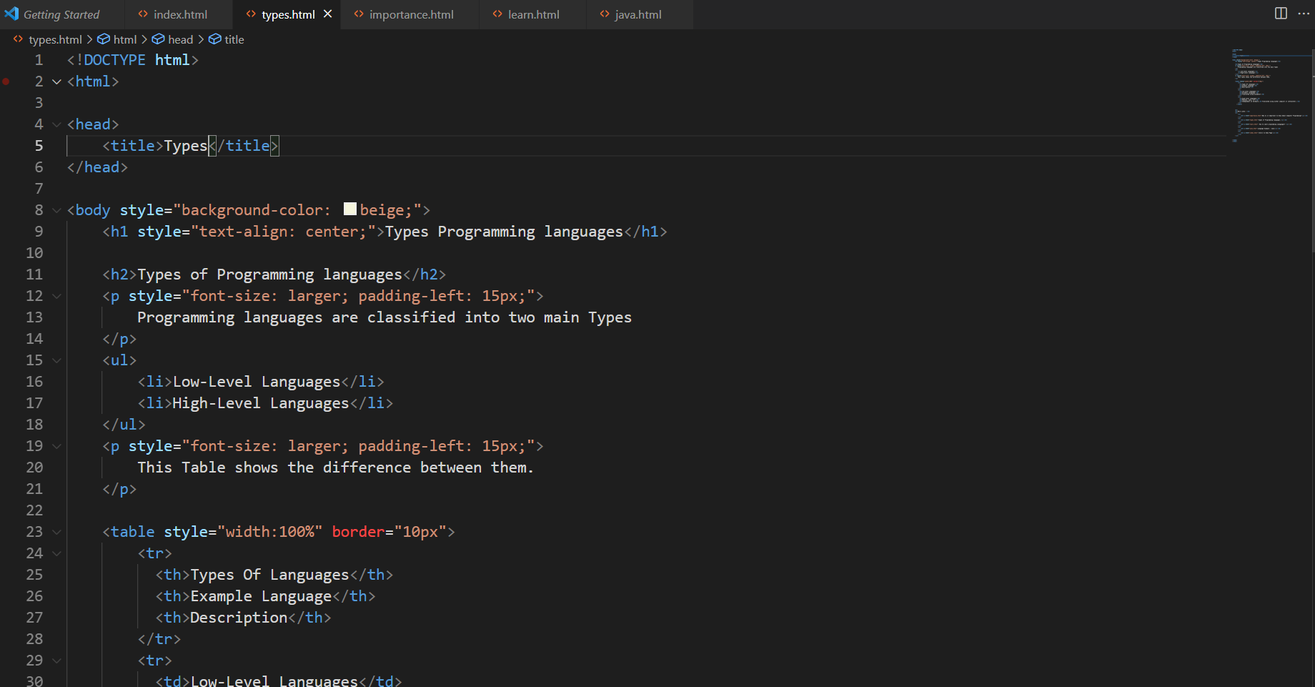

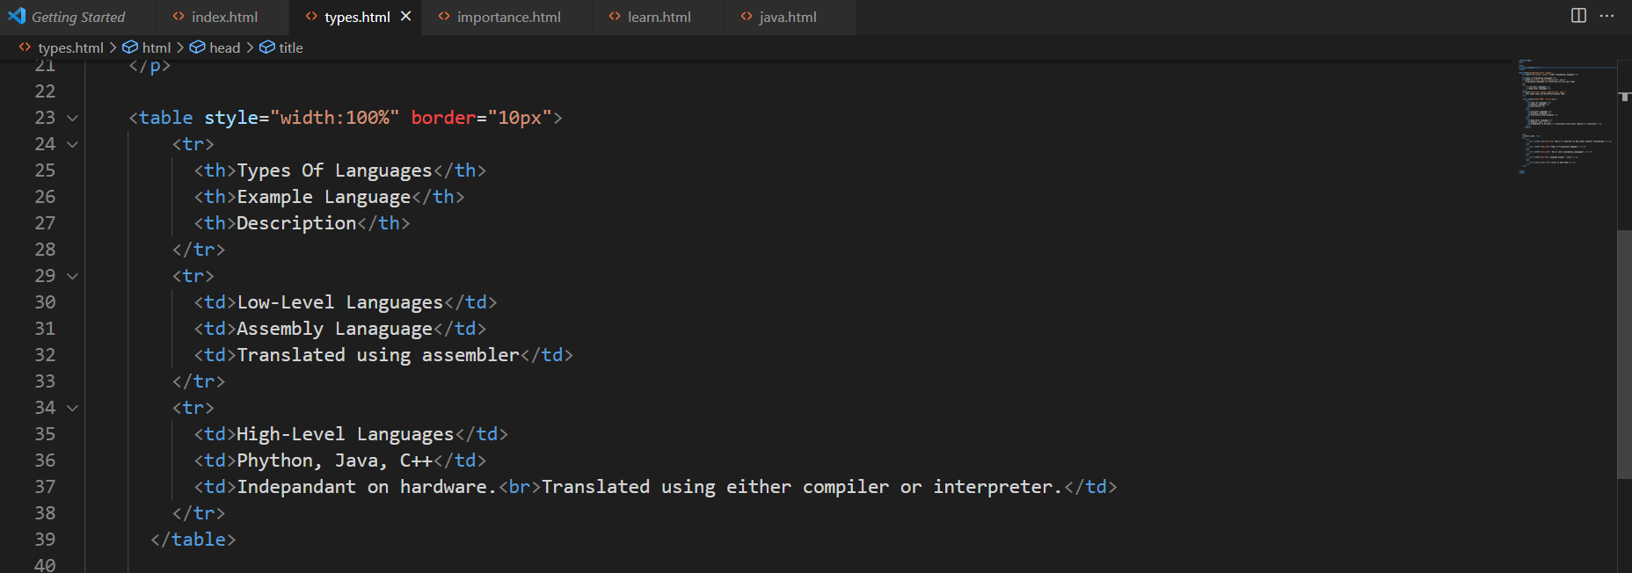

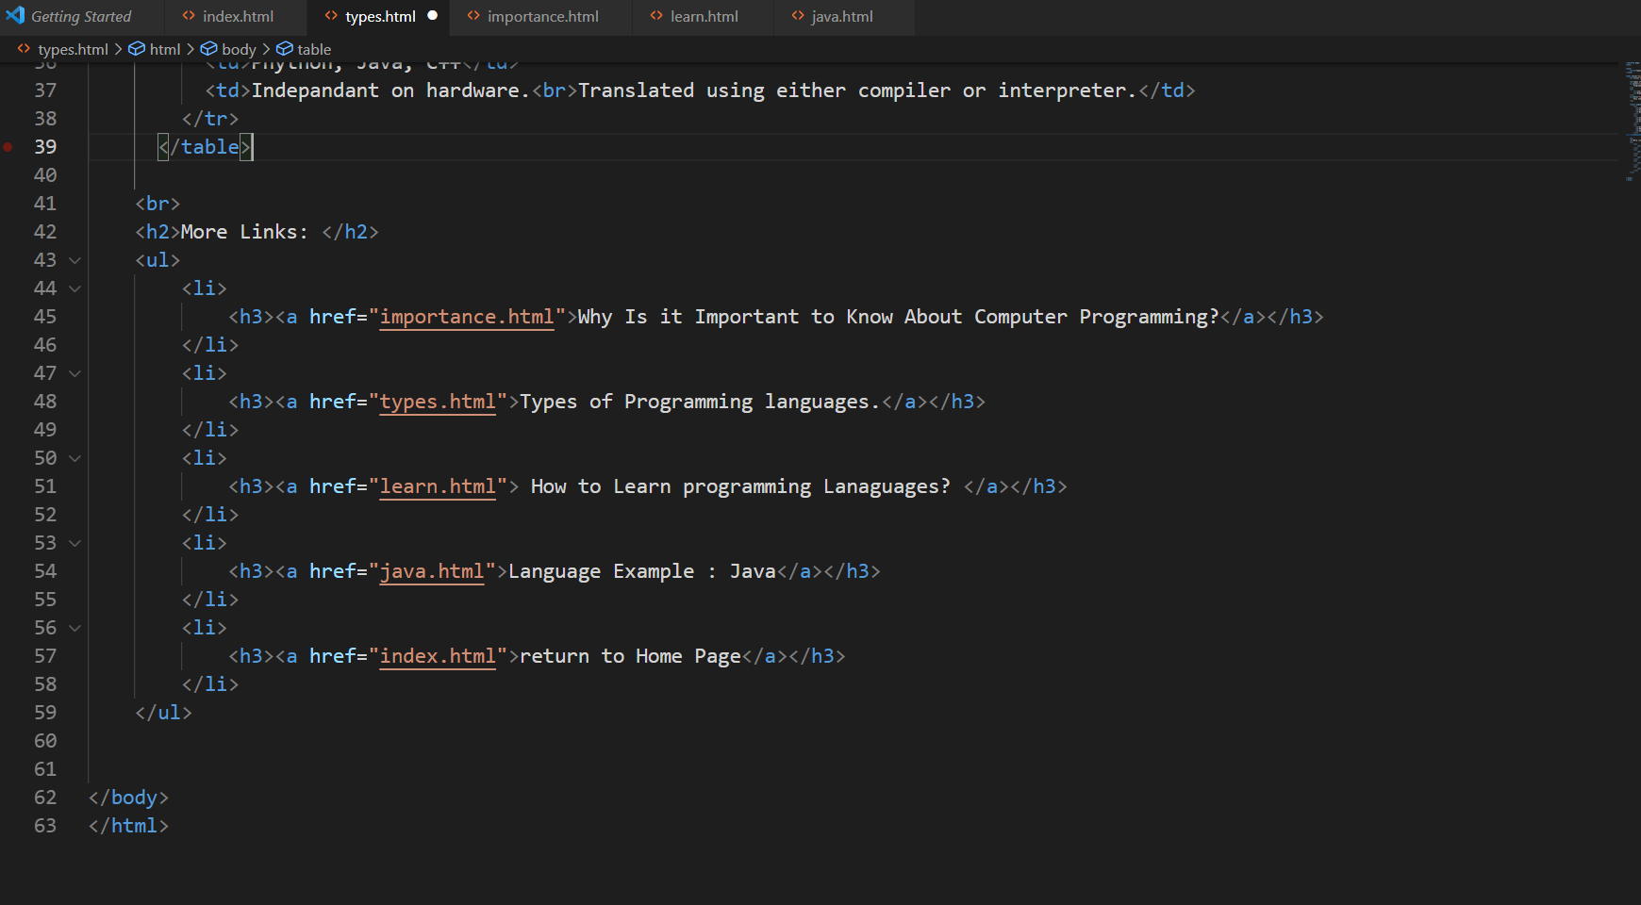

**Page 3 :**

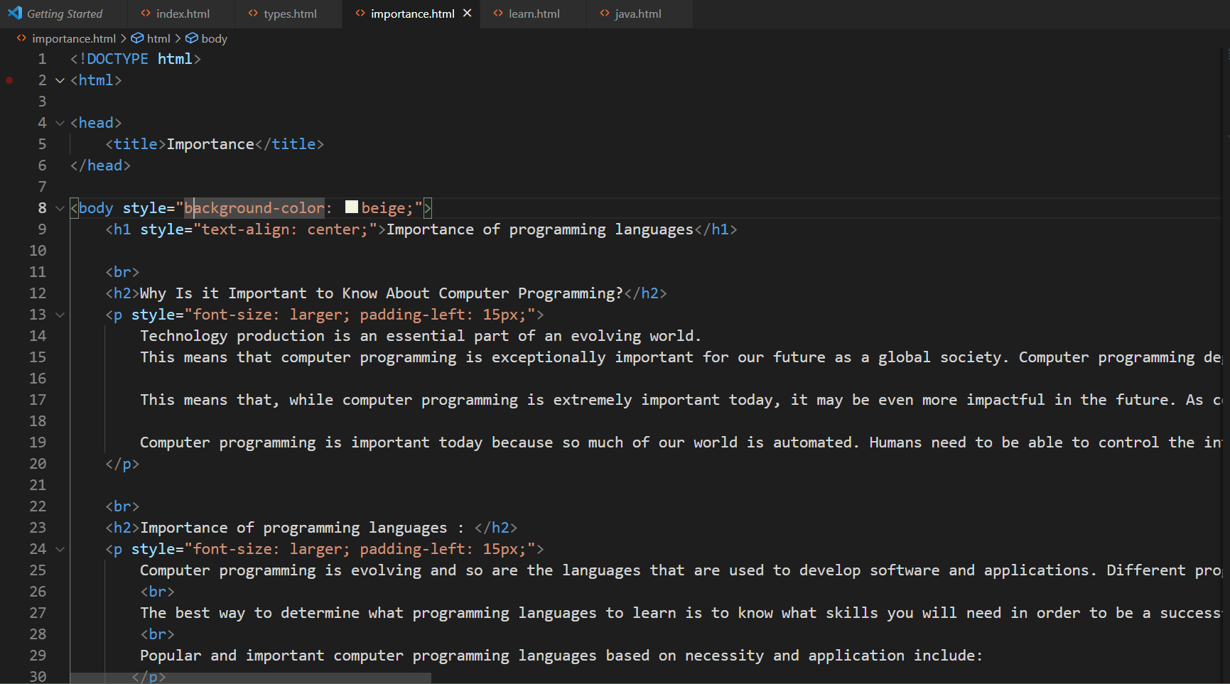

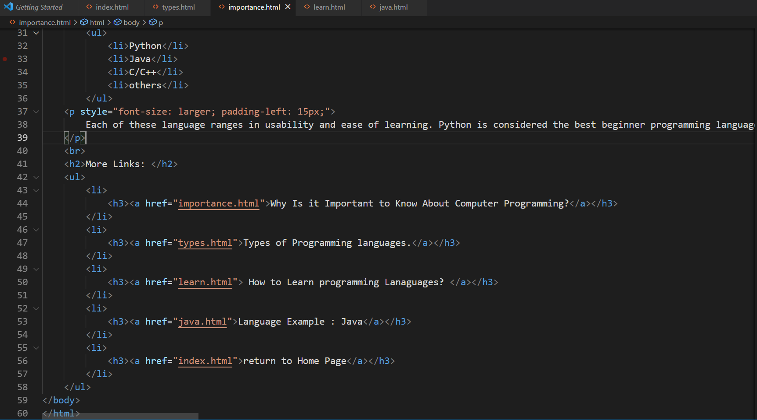

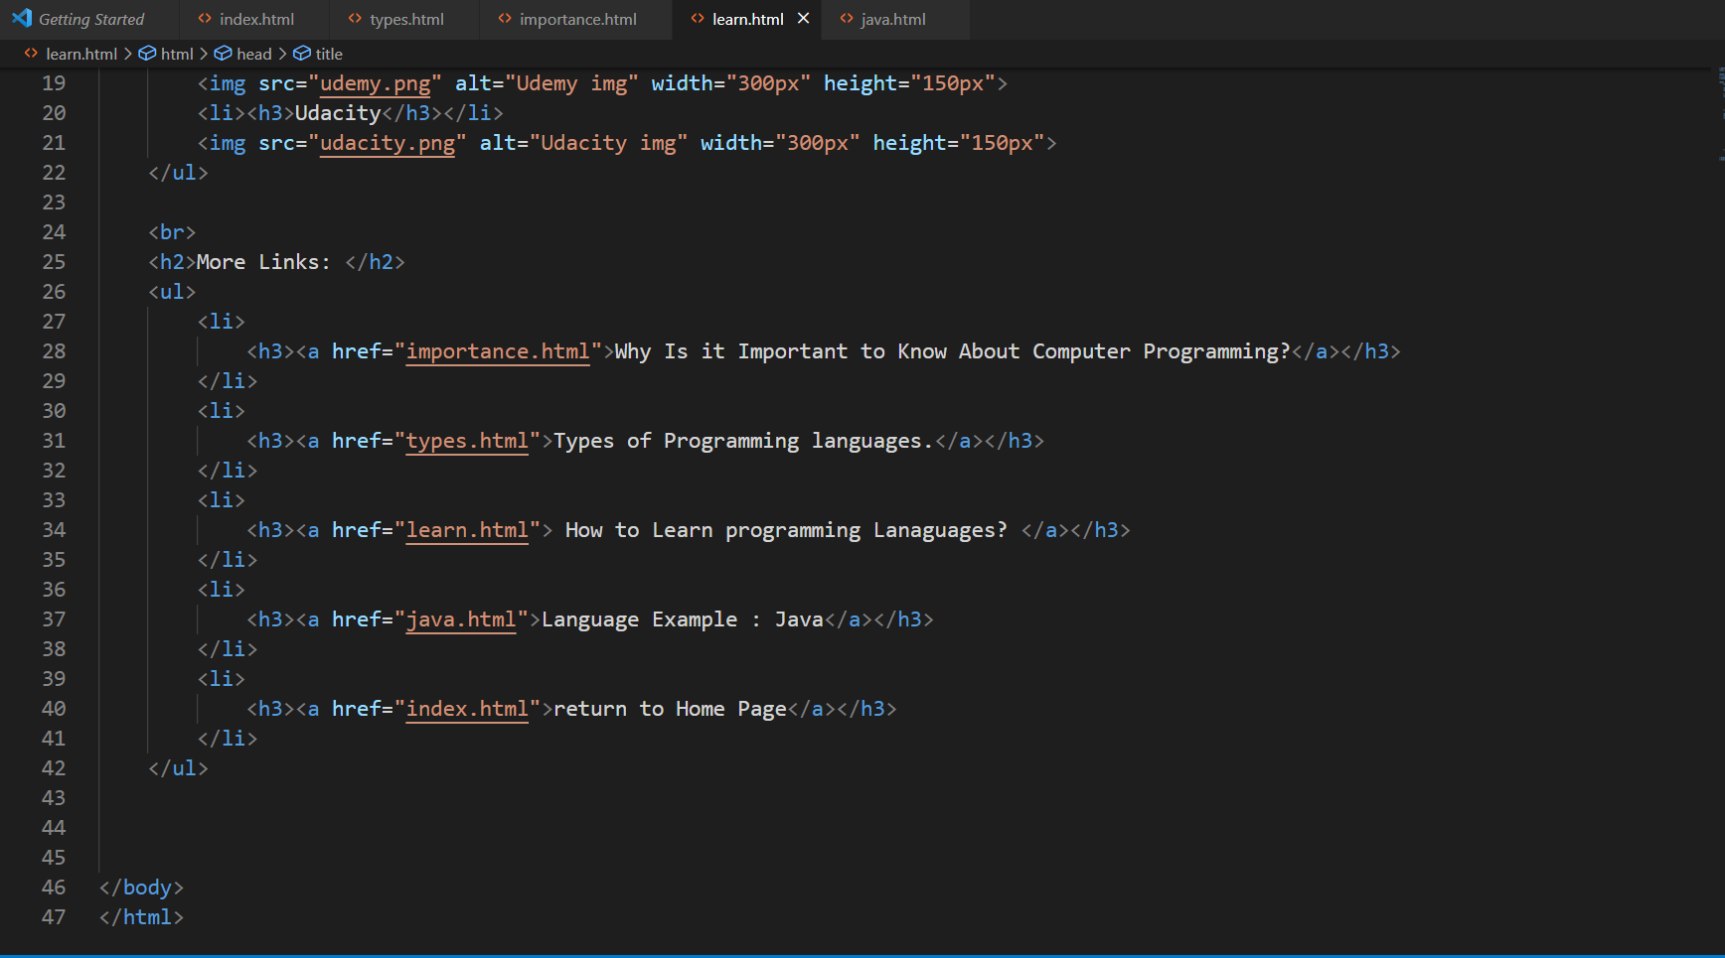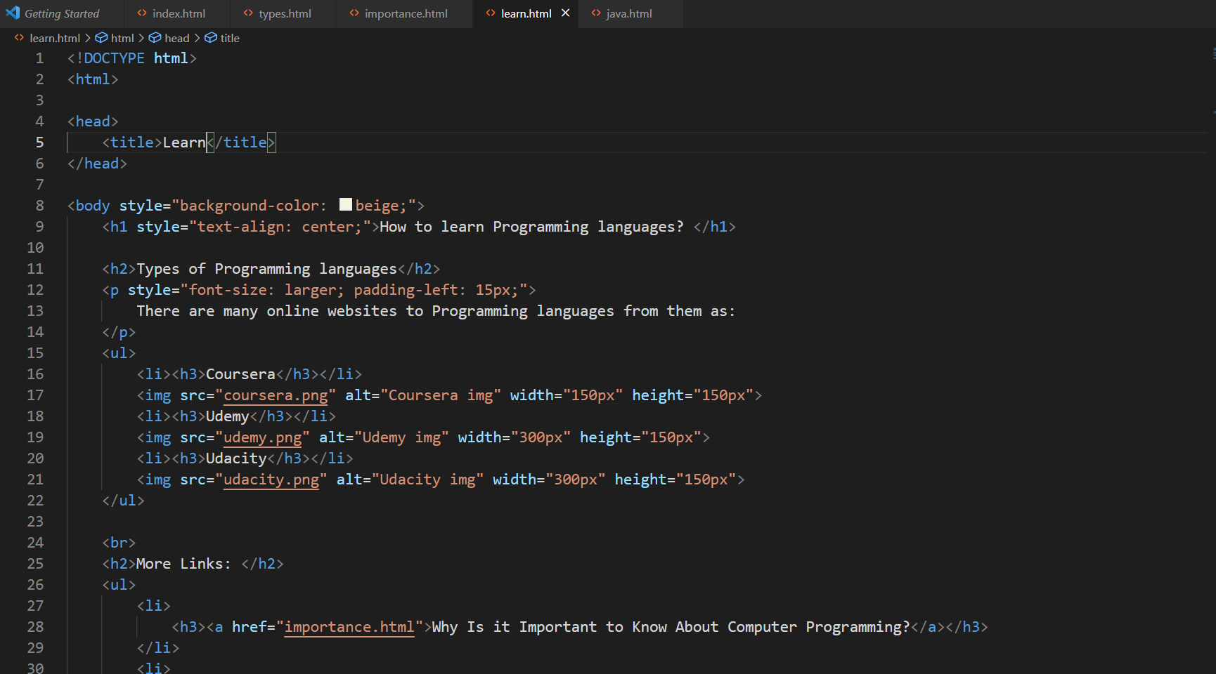**Page 4 :**

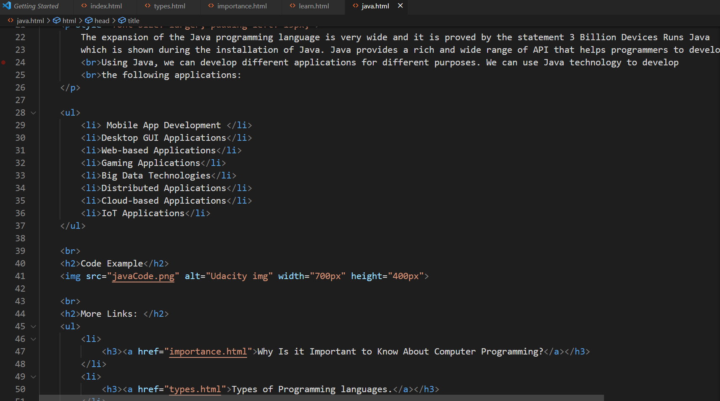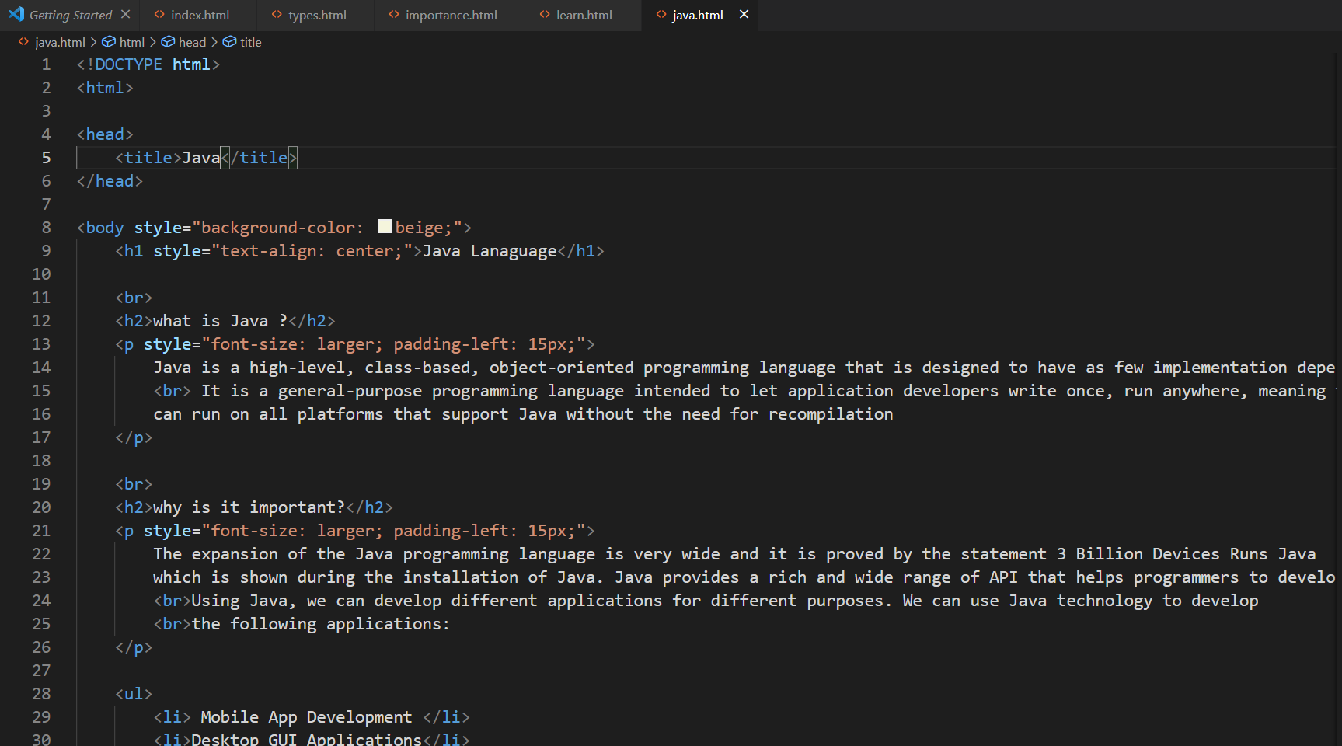**Page 5 :**

