Question 1: What is the count of each gender on each flight?

select f.flight_id, c.gender, count(*) gender_count

from p_customer c

join p_reservations_fact r

on c.customer_id = r.customer_id

join p_flight f

on f.flight_id = r.flight_id

group by c.gender, f.flight_id

order by f.flight_id;

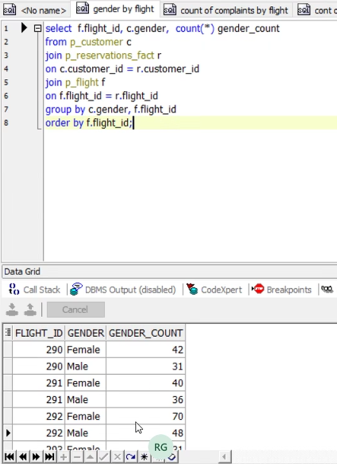

Question 2: What is the count of customer complaints?

select complaints_, count(complaints_) count_complaints

from p_customer_care

group by complaints_;

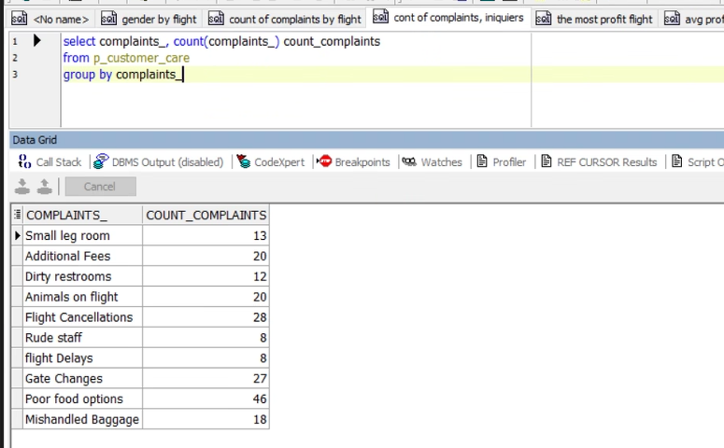

Question 3: What is the count of customer complaints and inquiries per flight?

select f.flight_id, cc.complaints_, cc.inquiries,count(cc.complaints_) count_complaints, count(cc.inquiries) count_nquiries

from p_customer_care cc

join p_customer_care_fact cf

on cc.id = cf.customer_care_id

join p_flight f

on f.flight_id =cf.flight_id

group by f.flight_id, cc.complaints_,cc.inquiries

order by f.flight_id;

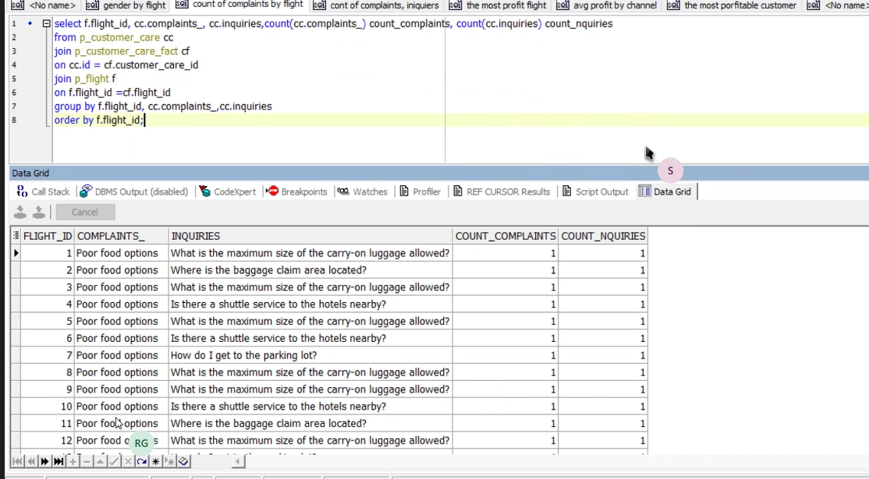

Question 4: What is the highest profitable flight?

select *

from

(select f.flight_id, sum(r.profit) flight_profit

from p_flight f

join p_reservations_fact r

on f.flight_id = r.flight_id

group by f.flight_id

order by flight_profit desc)

where rownum <= 1;

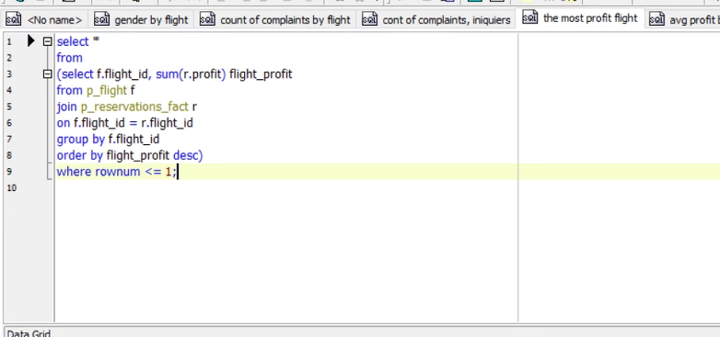

Question 5: What is the average profit for each channel?

select c.name, avg(rf.profit) avg_profit

from p_reservations_fact rf

join p_channel c

on c.channel_id = rf.channel_id

group by c.name

order by avg_profit desc;

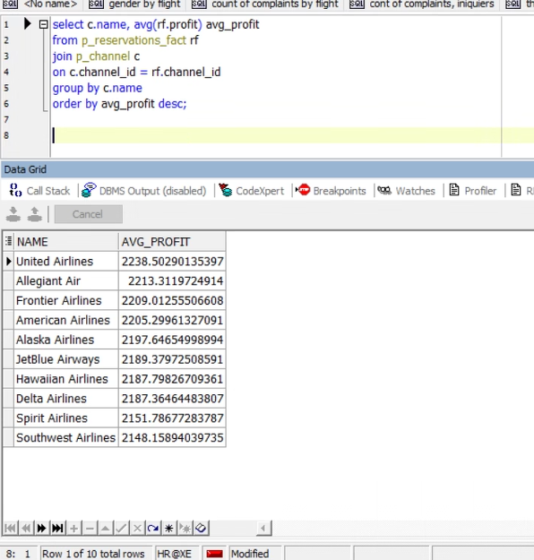

Question 6: Who is the customer that delivers the most profit?

select *

from

(select c.customer_id, c.first_name || ' ' || c.last_name name, sum(r.profit) highest_profit

from p_customer c

join p_reservations_fact r

on c.customer_id = r.customer_id

group by c.customer_id, c.first_name || ' ' || c.last_name

order by highest_profit desc)

where rownum <= 1;

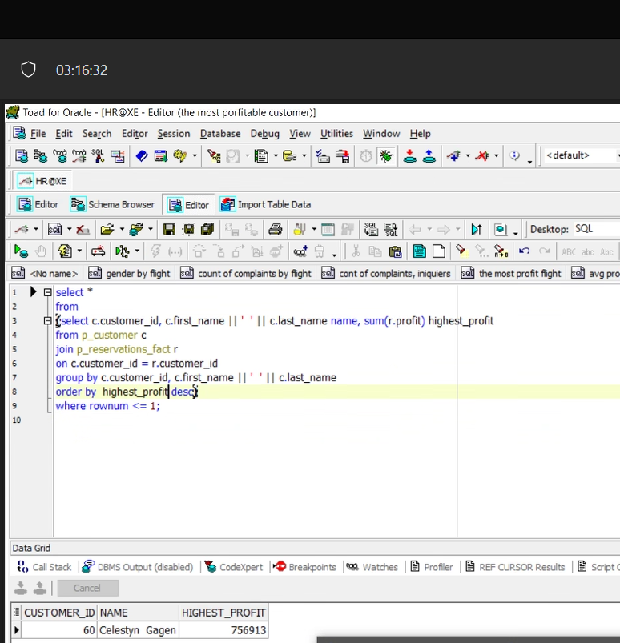

Question 7: How many tickets are being reserved by class?

select fb.fare_basis_code, count(c.customer_id) No_TICTS

from p_fare_basis fb

join p_flight f

on f.code = fb.fare_basis_code

join p_marketing_fact m

on m.flight_id = f.flight_id

join p_customer c

on m.customer_id = c.customer_id

group by fb.fare_basis_code ;

