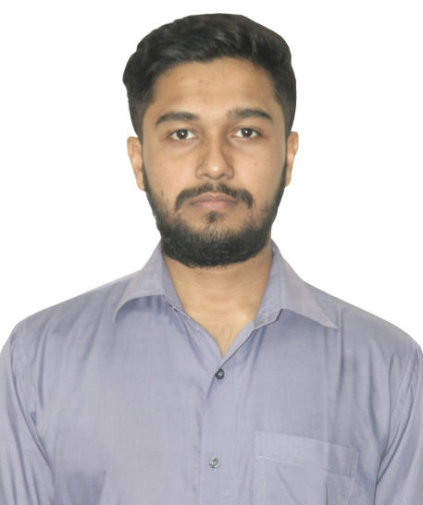

MANAGEMENT

**AS**

**Phone: +8801786601210**

I am a highly motivated and detail-oriented web developer and designer with a passion for creating beautiful, functional websites and applications. My unique combination of technical and creative skills has allowed me to excel in both the design and development aspects of web development, and I am always striving to stay up-to-date with the latest technologies and design trends.

**2016-2018**

**HSC**

SCIENCE

Afaz Uddin School and College

**2019-2023**

**B.Sc.**

CSE

Bangladesh Army University of Science and Technology

***HOBBIES***

CYCLING PHOTOGRAPHY READING BOOK

SWIMMING

**Radwan Ahmed**

WEB DESIGNER & DEVELOPER,

ANDROID DEVELOPER

ANDROID DEVELOP

[**Email:**](mailto:youremail@email.com) **radwanahmedsahed07@gmail.com**

**Address: Dhamrai, Dhaka**

***EXPERIENCE***

**Head of Design ABC Company**

**2018 - 2020**

Sedut perspiciatis unde omnis iste natus error sit v oluptatem

accusan tiumyu dolor emque laudatium, totam remaperi, eaque ipsa quae ab inventoreveritasi quasi.

Sedut perspiciatis unde omnis iste natus Perspiciatis unde omnis iste natus

Sedut perspiciatis unde omnis iste natus

**Senior Graphic Designer DEF Company**

**2016 - 2018**

Sedut perspiciatis unde omnis iste natus error sit v oluptatem

accusan tiumyu dolor emque laudatium, totam remaperi, eaque ipsa quae ab inventoreveritasi quasi.

***EDUCATION***

Sedut perspiciatis unde omnis iste natus Perspiciatis unde omnis iste natus

Sedut perspiciatis unde omnis iste natus

**Junior Graphic Designer GHI Company**

**2013 - 2016**

Sedut perspiciatis unde omnis iste natus error sit v oluptatem

accusan tiumyu dolor emque laudatium, totam remaperi, eaque ipsa quae ab inventoreveritasi quasi.

Sedut perspiciatis unde omnis iste natus Perspiciatis unde omnis iste natus

Sedut perspiciatis unde omnis iste natus

***LANGUAGE***

***SOFTWARE***

***KNOWLEDGE***

Bangla

WEB DESIGN

Hindi

**Ps**

WEB DEVELOP

English

**Id**