**EE496 Computer Architecture and VHDL**

Assignment 2: Crypto processor

Due date: 4 December 2017

# **Section 1: Combinational Logic**

**Task: Write a Verilog module for an N-bit adder.**

|  |
| --- |
| **N_bit_adder** |
| `timescale 1ns / 1ps  module N_bit_adder(input1,input2,answer);  parameter N=32;  input [N-1:0] input1,input2;  output [N-1:0] answer;  wire carry_out;  wire [N-1:0] carry;  genvar i;  generate  for(i=0;i<N;i=i+1)  begin: generate_N_bit_Adder  if(i==0)  half_adder f(input1[0],input2[0],answer[0],carry[0]);  else  full_adder f(input1[i],input2[i],carry[i-1],answer[i],carry[i]);  end  assign carry_out = carry[N-1];  endgenerate  endmodule  // Verilog code for half adder  module half_adder(x,y,s,c);  input x,y;  output s,c;  assign s=x^y;  assign c=x&y;  endmodule // half adder  // Verilog code for full adder  module full_adder(x,y,c_in,s,c_out);  input x,y,c_in;  output s,c_out;  assign s = (x^y) ^ c_in;  assign c_out = (y&c_in)| (x&y) | (x&c_in);  endmodule // full_adder |

|  |
| --- |
| **ts_N_bit_adder** |
| `timescale 1ns / 1ps  module tb_N_bit_adder;  // Inputs  reg [31:0] input1;  reg [31:0] input2;  // Outputs  wire [31:0] answer;  // Instantiate the Unit Under Test (UUT)  N_bit_adder uut (  .input1(input1),  .input2(input2),  .answer(answer)  );  initial begin  // Initialize Inputs  input1 = 1209;  input2 = 4565;  #100;  // Add stimulus here  end  endmodule |

**Result:**

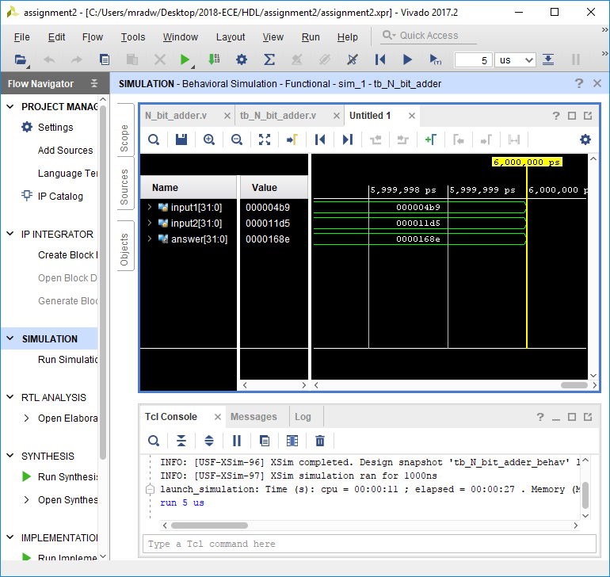

**Task: Implement the ALU described above in VHDL, making use of the Verilog N-bit adder that you implemented in the last section.**

|  |
| --- |
| **ALU** |
| library IEEE;  use IEEE.STD_LOGIC_1164.ALL;  entity ALU is  port (  ABUS: in std_logic_vector(15 downto 0); -- ABUS data input of the 16-bit ALU  BBUS: in std_logic_vector(15 downto 0); -- BBUS data input of the 16-bit ALU  ALUctrl: in std_logic_vector(3 downto 0); -- ALUctrl control input of the 16-bit ALU  ALUOUT: out std_logic_vector(15 downto 0) -- 16-bit data output of the 16-bit ALU  );  end ALU;  architecture Behavioral of ALU is  -- N-bit Adder in Verilog  component N_bit_adder is  generic (  N: integer:=32  );  port( input1: in std_logic_vector(N-1 downto 0);  input2: in std_logic_vector(N-1 downto 0);  answer: out std_logic_vector(N-1 downto 0)  );  end component N_bit_adder;  signal BBUS_not: std_logic_vector(16-1 downto 0);  signal tmp_out1: std_logic_vector(16-1 downto 0);  signal tmp_out2: std_logic_vector(16-1 downto 0);  signal tmp: std_logic_vector(16-1 downto 0);  begin  -- instantiate Verilog N-bit Adder in VHDL code  u1_N_bit_adder: N_bit_adder generic map ( N => 16) -- ABUS + BBUS  port map( input1 => ABUS, input2 => BBUS,answer => tmp_out1 );  u2_N_bit_adder: N_bit_adder generic map ( N => 16) -- ABUS + (~BBUS)  port map( input1 => ABUS, input2 => BBUS_not,answer => tmp_out2 );  u3_N_bit_adder: N_bit_adder generic map ( N => 16) -- ABUS + (~BBUS) + 1 = ABUS - BBUS  port map( input1 => tmp_out2, input2 => x"0001",answer => tmp );  BBUS_not <= not BBUS;  -- Other instructions of the 16-bit ALU in VHDL  process(ALUctrl,ABUS,BBUS,tmp_out1,tmp)  begin  case(ALUctrl) is  when "0000" => ALUOUT <= tmp_out1; -- ADD  when "0001" => ALUOUT <= tmp ;-- SUB  when "0010" => ALUOUT <= ABUS and BBUS; -- AND  when "0011" => ALUOUT <= ABUS or BBUS; -- OR  when "0100" => ALUOUT <= ABUS xor BBUS; -- XOR  when "0101" => ALUOUT <= not ABUS; -- NOT  when "0110" => ALUOUT <= ABUS; -- MOVE  when others => ALUOUT <= tmp_out1;  end case;  end process;    end Behavioral; |

|  |
| --- |
| **ts_ALU** |
| LIBRARY ieee;  USE ieee.std_logic_1164.ALL;  use IEEE.std_logic_unsigned.all;  -- Testbench  ENTITY tb_ALU IS  END tb_ALU;    ARCHITECTURE behavior OF tb_ALU IS    -- Component Declaration for the 16-bit ALU    COMPONENT ALU  PORT(  ABUS : IN std_logic_vector(15 downto 0);  BBUS : IN std_logic_vector(15 downto 0);  ALUctrl : IN std_logic_vector(3 downto 0);  ALUOUT : OUT std_logic_vector(15 downto 0)  );  END COMPONENT;    --Inputs  signal ABUS : std_logic_vector(15 downto 0) := (others => '0');  signal BBUS : std_logic_vector(15 downto 0) := (others => '0');  signal ALUctrl : std_logic_vector(3 downto 0) := (others => '0');  --Outputs  signal ALUOUT : std_logic_vector(15 downto 0);    BEGIN    -- Instantiate the 16-bit ALU  uut: ALU PORT MAP (  ABUS => ABUS,  BBUS => BBUS,  ALUctrl => ALUctrl,  ALUOUT => ALUOUT  );  stim_proc: process  begin  ABUS <= x"000A";  BBUS <= x"0002";  ALUctrl <= x"0";  -- change ALU Control input  for i in 0 to 15 loop  ALUctrl <= ALUctrl + x"1";  wait for 100 ns;  end loop;  ABUS <= x"00F6";  BBUS <= x"000A";  wait;  end process;  END; |

**Result:**

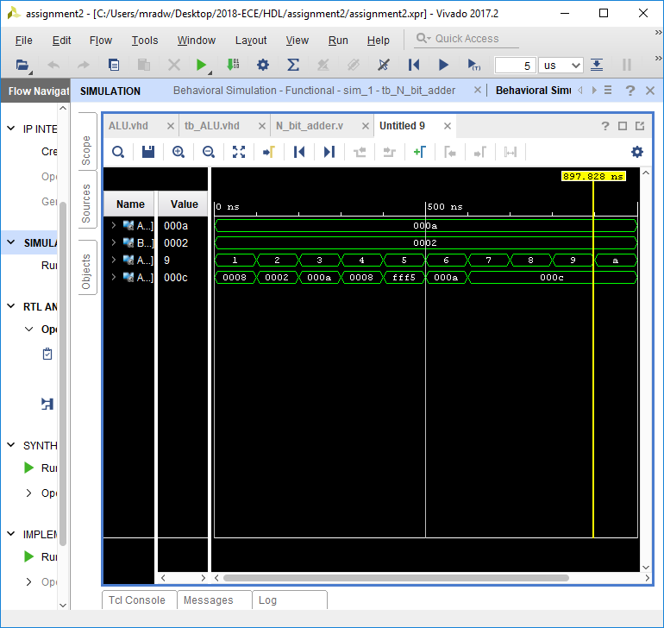

**Task: Implement the Shifting Unit described above in VHDL.**

|  |
| --- |
| case(SHIFT_Ctrl) is  when "1000" => SHIFTOUT <= SHIFTINPUT(3 downto 0)&SHIFTINPUT(15 downto 4);  when "1001" => SHIFTOUT <= SHIFTINPUT(11 downto 0)&SHIFTINPUT(15 downto 12);  when "1010" => SHIFTOUT <= SHIFTINPUT(11 downto 0) & "0000";  when "1011" => SHIFTOUT <= "0000" & SHIFTINPUT(15 downto 4);  when others => SHIFTOUT <= x"0000";  end case; |

The above code for the shifter is based on the below table.

|  |  |  |
| --- | --- | --- |
| 1000 | ROR4 | Rotate right 4 bits |
| 1001 | ROL4 | Rotate left 4 bits |
| 1010 | SLL4 | Shift left logic 4 bits |
| 1011 | SRL4 | Shift right logic 4 bit |

Below is an image of the stimulation of the code above.

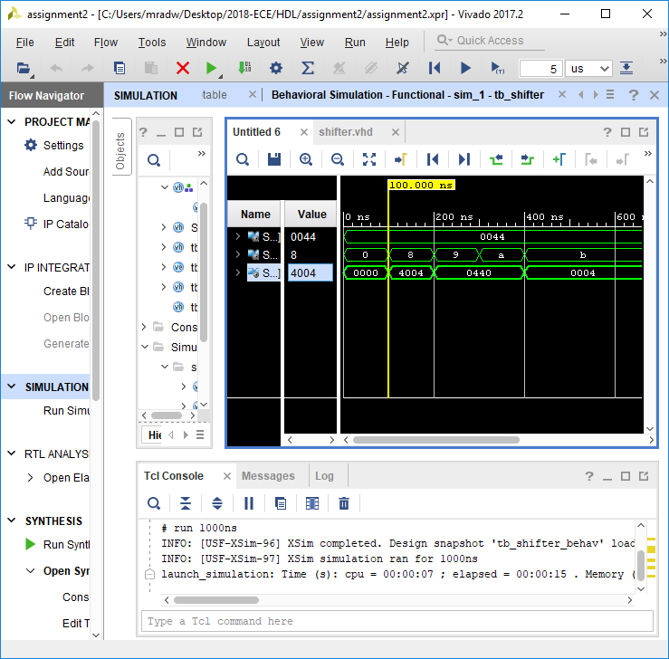

1.4 Non-Linear Lookup Operations in VHDL

To create the non-linear lookup table, the look up table entity is declared which takes in one input and returns a single output.

The table below is the input and output of the lookup table.

|  |  |
| --- | --- |
| INPUT(Hex) | OUTPUT(hex) |
| 00 | 1F |
| 01 | 10 |
| 02 | 1D |
| 03 | 17 |
| 04 | 1B |
| 05 | 1E |
| 06 | 15 |
| 07 | 1A |
| 08 | 19 |
| 09 | 12 |
| 0A | 1C |
| 0B | 11 |
| 0C | 13 |
| 0D | 14 |
| 0E | 18 |
| 0F | 16 |

Below is the result of the stimulation.

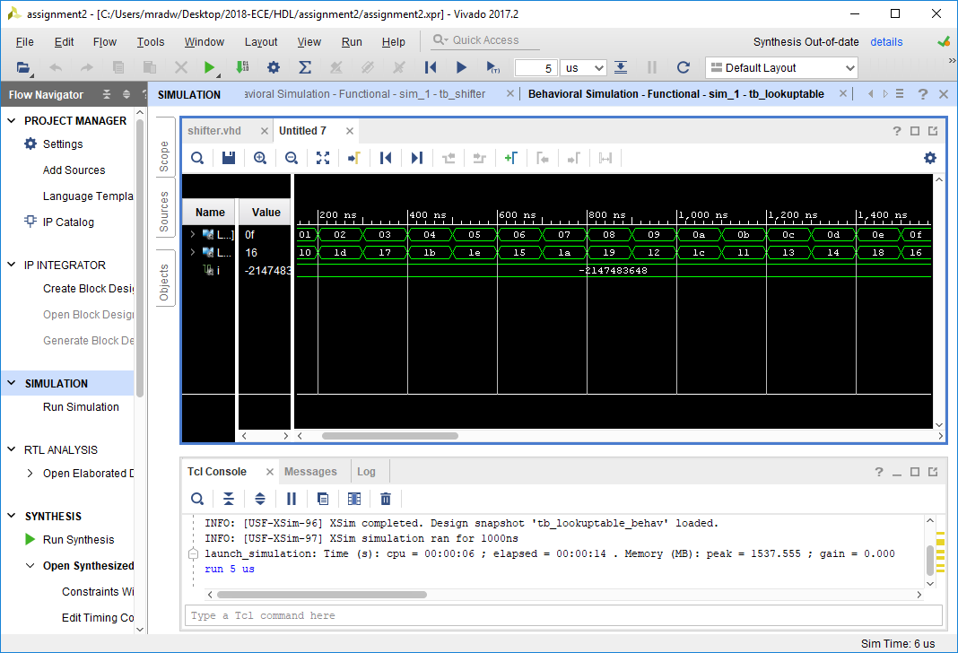

1.5 Structural VHD model

The structural VHDL code is made up from adding the look up table, ALU and Shifter, the result is then dependent on what the CTRL signal. The non-linear lookup table, shifter and ALU are declared as components of the structural VHDL code.

The design van be seen below.

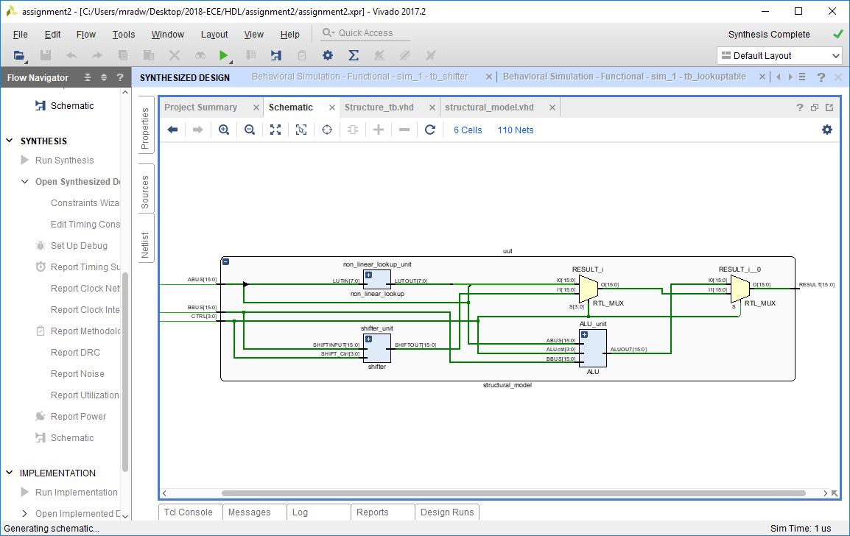

result from the lookup table will be shown and in all other cases, the result will be from the shifter.

|  |  |  |
| --- | --- | --- |
| CTRL | Component | Instruction |
| 0000 | ALU | ADD |
| 0001 | ALU | SUB |
| 0010 | ALU | AND |
| 0011 | ALU | OR |
| 0100 | ALU | XOR |
| 0101 | ALU | NOT A |
| 0110 | ALU | MOVE |
| 0111 | ALU | ADD |
| 1000 | Shifter | ROR |
| 1001 | Shifter | ROL |
| 1010 | Shifter | SLL |
| 1011 | Shifter | SRL |
| 1100 | Shifter | 0 |
| 1101 | Shifter | 0 |
| 1110 | Shifter | 0 |
| 1111 | Lookup | lookup |

1.6 VHDL Test bench for Structural Design

|  |
| --- |
| library IEEE;  use IEEE.STD_LOGIC_1164.ALL;  use ieee.numeric_std.all;  use ieee.std_logic_unsigned.all;  entity Structure_tb is  end Structure_tb;  architecture Behavior of Structure_tb is  -- component declaration of structure  component Structural_model  port(  ABUS, BBUS: in std_logic_vector(15 downto 0);  ctrl: in std_logic_vector(3 downto 0);  result: out std_logic_vector(15 downto 0)  );  end component;  -- inputs  signal ABUS : std_logic_vector(15 downto 0) := (others => '0');  signal BBUS : std_logic_vector(15 downto 0) := (others => '0');  signal ctrl : std_logic_vector(3 downto 0) := (others => '0');  -- output  signal result : std_logic_vector(15 downto 0);  begin  -- initiate structural model  uut: structural_model port map(  ABUS => ABUS,  BBUS => BBUS,  ctrl => ctrl,  result => result  );  stim_proc: process  begin  ABUS <= x"0001";  BBUS <= x"0002";    ctrl <= x"0";    wait for 10ns;  if result = x"0003" then  report"PASS: 1";  else  report"FAIL: 1";  end if;  ctrl <= x"1";  wait for 10ns;  if result = x"FFFF" then  report"PASS: 2";  else  report"FAIL: 2";  end if;    ctrl <= x"2";  wait for 10ns;  if result = x"0000" then  report"PASS: 3";  else  report"FAIL: 3";  end if;      ctrl <= x"3";  wait for 10ns;  if result = x"0003" then  report"PASS: 4";  else  report"FAIL: 4";  end if;      ctrl <= x"4";  wait for 10ns;  if result = x"0003" then  report"PASS: 5";  else  report"FAIL: 5";  end if;    ctrl <= x"5";  wait for 10ns;  if result = x"FFFE" then  report"PASS: 6";  else  report"FAIL: 6";  end if;    ctrl <= x"6";  wait for 10ns;  if result = x"0001" then  report"PASS: 7";  else  report"FAIL: 7";  end if;    ctrl <= x"7";  wait for 10ns;  if result = x"0003" then  report"PASS: 8";  else  report"FAIL: 8";  end if;    ctrl <= x"8";  wait for 10ns;  if result = x"2000" then  report"PASS: 9";  else  report"FAIL: 9";  end if;    ctrl <= x"9";  wait for 10ns;  if result = x"0020" then  report"PASS: 10";  else  report"FAIL: 10";  end if;    ctrl <= x"a";  wait for 10ns;  if result = x"0020" then  report "PASS: 11";  else  report "FAIL: 11";  end if;    ctrl <= x"b";  wait for 10ns;  if result = x"0000" then  report "PASS: 12";  else  report "FAIL: 12";  end if;    ctrl <= x"c";  wait for 10ns;  if result = x"0" then  report "PASS: 13";  else  report "FAIL: 13";  end if;    ctrl <= x"d";  wait for 10ns;  if result = x"0" then  report "PASS: 14";  else  report "FAIL: 14";  end if;    ctrl <= x"e";  wait for 10ns;  if result = x"0" then  report "PASS: 15";  else  report "FAIL: 15";  end if;    ctrl <= x"f";  wait for 10ns;  if result = x"10" then  report "PASS: 16";  else  report "FAIL: 16";  end if;    end process;  end; |

Above is the test bench that was used to test all 12 possible modes of operation as can be seen when the A and B were set to 1, and 2 respectively the result will be as follows.

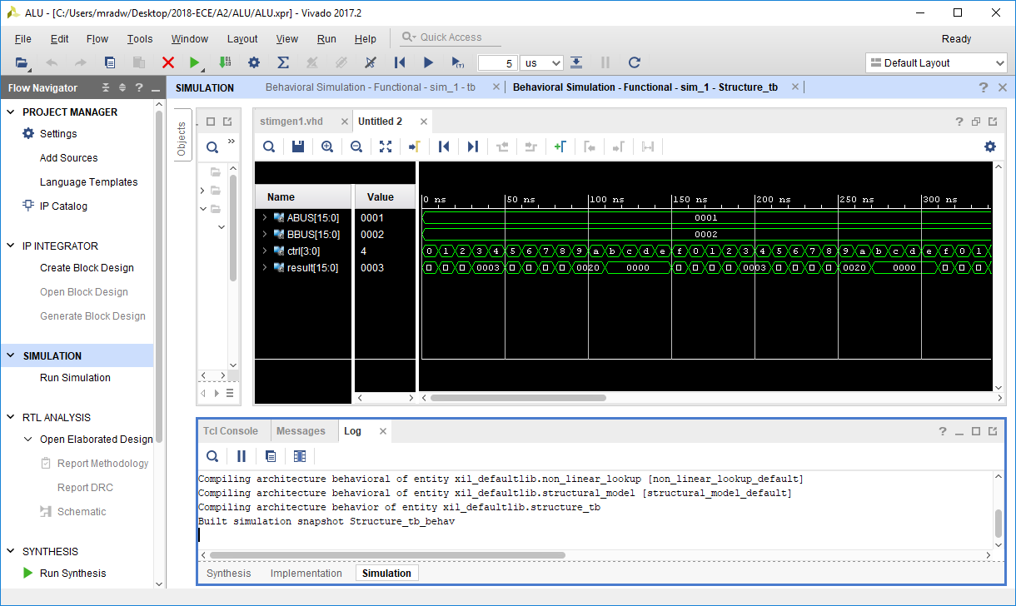

2.1 Registers

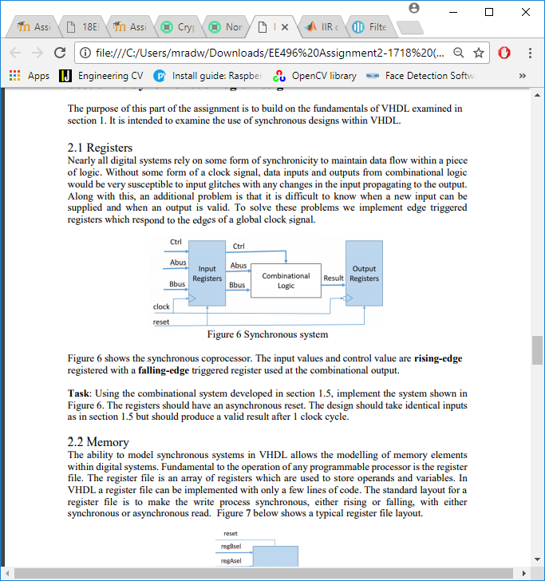

From the image above to create a synchronous system there needs to be an input and output registered the image above also includes what inputs are needed.

If the clock edge is rising and reset is disabled, the combinational logic system reads in the input values as seen below.

|  |
| --- |
| process(clock,reset)  begin  if rising_edge(clock) then  if reset ='1' then  ctrl <= "0000";  ABUS <= x"0000";  BBUS <= x"0000";  else  ctrl <= ctrlin;  ABUS <= ABUSin;  BBUS <= BBUSin;  end if;  end if;  end process; |

If the clock edge is falling and reset is disabled, then the combinational logic system is writing out the result.

|  |
| --- |
| process(clock,reset)  begin  if falling_edge(clock) then  if reset = '1' then  result <= x"0000";  else  result <= resultin;  end if;  end if;  end process; |

2.2 Memory

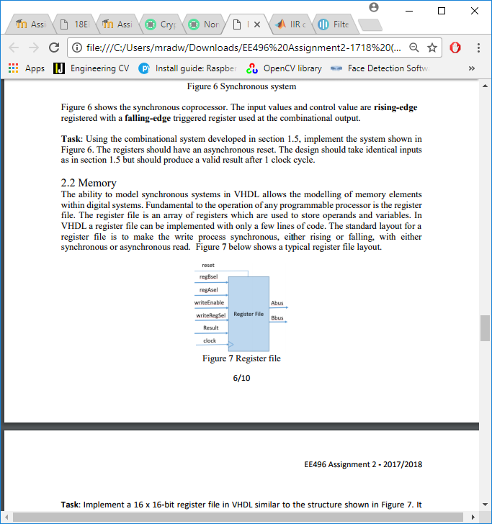

|  |
| --- |
| library IEEE;  use IEEE.STD_LOGIC_1164.ALL;  use IEEE.NUMERIC_STD.ALL;  entity register_file is  Port (  Abus : out std_logic_vector(15 downto 0); --srca  Bbus : out std_logic_vector(15 downto 0); --srcb  result : in std_logic_vector(15 downto 0); --res  writeEnable : in std_logic; --rdwen  regAsel : in std_logic_vector(3 downto 0); --ra  regBsel : in std_logic_vector(3 downto 0); --rb  writeRegSel : in std_logic_vector(3 downto 0); --rd  reset : in std_logic;  clock : in std_logic  );  end register_file;  architecture Behavioral of register_file is  type memory is array(0 to 15) of std_logic_vector(15 downto 0);  signal REG_FILE: memory :=(  0 => x"0001",  1 => x"c505",  2 => x"3c07",  3 => x"d405",  4 => x"1186",  5 => x"f407",  6 => x"1086",  7 => x"4706",  8 => x"6808",  9 => x"baa0",  10 => x"c902",  11 => x"100b",  12 => x"c000",  13 => x"c902",  14 => x"100b",  15 => x"B000",  others => (others => '0')  );  begin  write_op: process(clock)  begin  if(falling_edge(clock)) then  if(writeEnable='1') then  REG_FILE(to_integer(unsigned(writeRegSel))) <= result;  end if;  end if;  end process;  read_op: process(clock)  begin  if(rising_edge(clock)) then  if(reset='1') then  ABUS <= x"0000";  BBUS <= x"0000";  else  ABUS <= REG_FILE(to_integer(unsigned(regAsel)));  BBUS <= REG_FILE(to_integer(unsigned(regBsel)));  end if;  end if;  end process;  end Behavioral; |

2.3 Complete Crypto Coprocessor

|  |
| --- |
| library IEEE;  use IEEE.STD_LOGIC_1164.ALL;  use IEEE.NUMERIC_STD.ALL;  entity coprocessor is  Port (  clock: in std_logic;  reset: in std_logic;  ctrl: in std_logic_vector (3 downto 0);  regA : in std_logic_vector(3 downto 0); --ra  regB : in std_logic_vector(3 downto 0); --rb  writeReg : in std_logic_vector(3 downto 0)  );  end coprocessor;  architecture Behavioral of coprocessor is  --register file  component register_file is  port(  Abus : out std_logic_vector(15 downto 0); --srca  Bbus : out std_logic_vector(15 downto 0); --srcb  result : in std_logic_vector(15 downto 0); --res  writeEnable : in std_logic; --rdwrite_enable  regAsel : in std_logic_vector(3 downto 0); --ra  regBsel : in std_logic_vector(3 downto 0); --rb  writeRegSel : in std_logic_vector(3 downto 0); --rd  reset : in std_logic;  clock : in std_logic  );  end component register_file;  --structural component  component structural_model is  port(  ABUS: in std_logic_vector(15 downto 0);  BBUS: in std_logic_vector(15 downto 0);  CTRL: in std_logic_vector(3 downto 0);  RESULT: out std_logic_vector(15 downto 0)  );  end component structural_model;  -- internal signals  signal write_enable: std_logic;  signal read1, read2, write : std_logic_vector(15 downto 0);  signal tmp1, tmp2: std_logic_vector(3 downto 0);  begin  uut1: register_file port map(  clock=> clock,  reset => reset,  writeEnable => write_enable,  result => write,  regAsel => regA,  regBsel => regB,  writeRegSel => tmp2,  Abus => read1,  Bbus => read2  );  uut2: Structural_model port map(  ABUS => read1,  BBUS => read2,  ctrl => tmp1,  result => write  );  process(clock,reset) begin  if(rising_edge(clock)) then  if (reset ='1') then  tmp1 <= x"0";  tmp2 <= x"0";  else  tmp1 <= ctrl;  tmp2 <= writeReg;  if (tmp1 = "0111") then  write_enable <= '0';  else  write_enable <= '1';  end if;  end if;    end if;  end process;    end Behavioral; |

2.4 Test Program

A stimulus generator is created that implements the code specified in the task after performing a system reset.

