

# BIM423 – SOFTWARE ENGINEERING 2022-2023 FALL SEMESTER



UniMeet

# Group 4

**Week 9 / 29nov-05dec 2022**

# Members

1. ***Radwan Rachid Houssein***
2. ***İsmail Bölükbaşı***
3. ***Kemal Yağız Özcan***
4. ***Emre Can Çakir***
5. ***Kadir Koç***
6. ***Ayten Ertaş.***

# Roles in the project

### Radwan : Mobile Development.

* + ***Emre & Ayten : Frontend Development.***

### Kemal: UI design

* + ***Kadir and Ismail: Backend Development.***

# Links

* ***Website Link:*** [***UniMeet-Webpage***](https://radwanh.github.io/UniMeet-Webpage/)
* ***Repo Link:*** [***github.com/RadwanH/UniMeet-Project***](https://github.com/RadwanH/UniMeet-Project)

# MEETING

In this meeting following points were curried out:

* we talked about what each individual has done so far.
* we helped each other debugging errors some of us were facing.
* We also discussed what could be accomplished the following week.
* We discussed some design choices.

# Individual works

* + Kemal : *UI Design*

This week I redesigned our app to almost final design and that can be summed up as follows:

* + - Redesign the logo to looks like this:



* + - Change our colors throughout the app.
    - Created custom icons for our app

 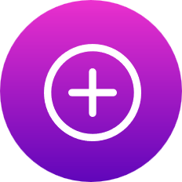 



* + - Created new default profile and homepage icon

 

* + - Created the layout of our app
    - 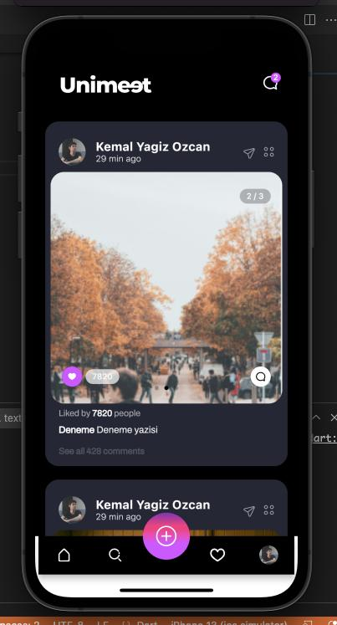 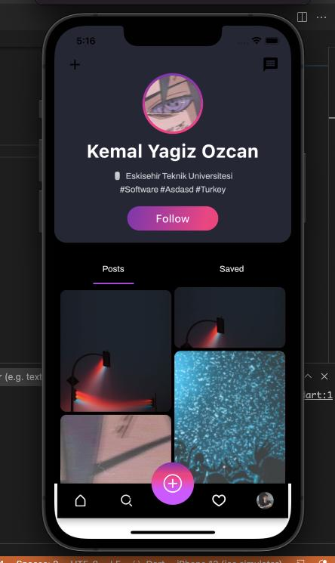 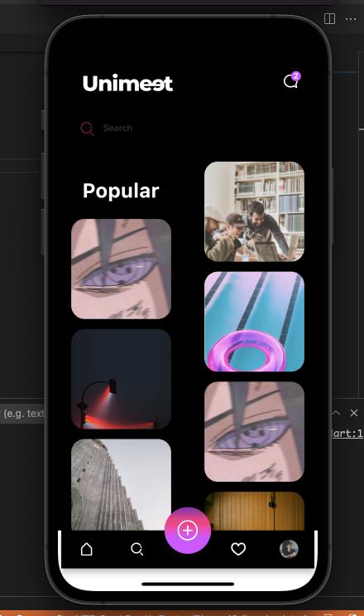
  + Radwan : *mobile development*

In this week I fulfilled all the tasks that were mentioned in “**Plans for the Following Week**” section so now we have:

* functional posts that are actually saved in the database with unique id and a caption and user id

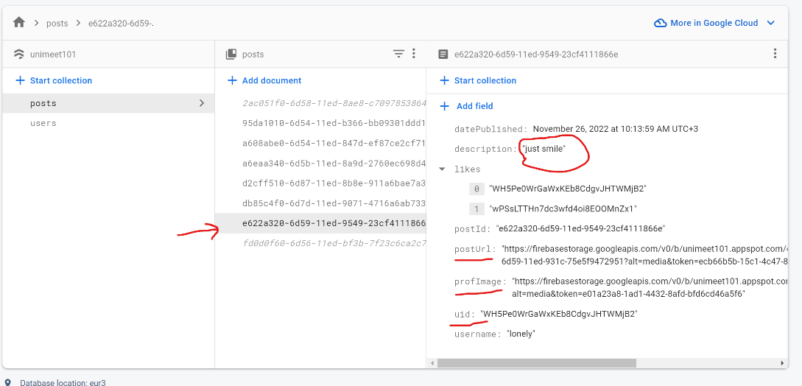

* added staring functionality to each post with animations when the button is clicked.
* Added comment functionality which is stored in the database as shown below.

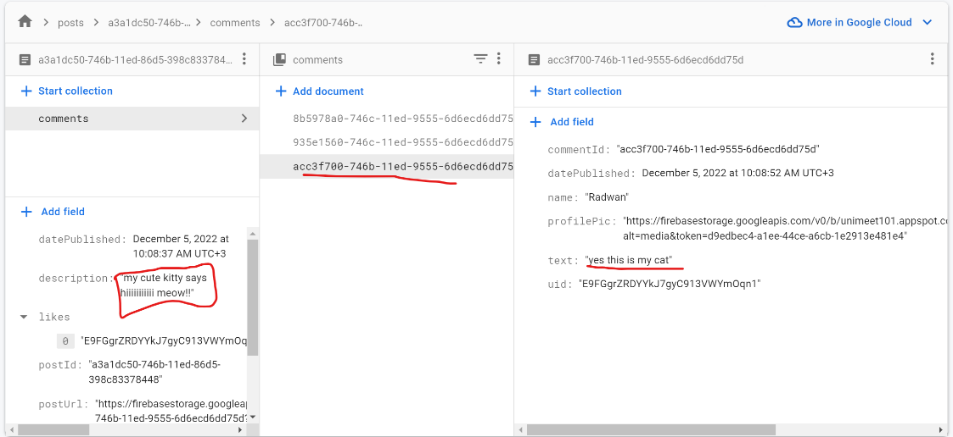

* Other features like number of followers and followings and more as I’ll showcase in a video:
* Check out the video[**HERE**](https://youtu.be/eR8FaS9D8ck) ***(or*** [***https://youtu.be/eR8FaS9D8ck***](https://youtu.be/eR8FaS9D8ck)***).***

**[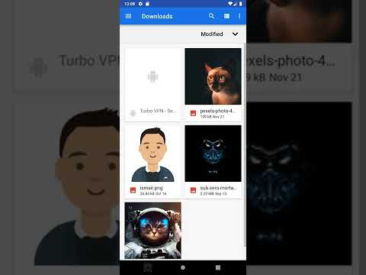](https://www.youtube.com/embed/eR8FaS9D8ck?feature=oembed)**

* + Kadir & Ismail : *backend development*

We have finished back-end side almost %80. Now we can create a user, we can create a post, and we can like a post and we can comment to a post. Also we can get all users, posts, likes ,comments, universities and their departments. Next week We can update user, we can upload a image of a user and we can add a image to a post.

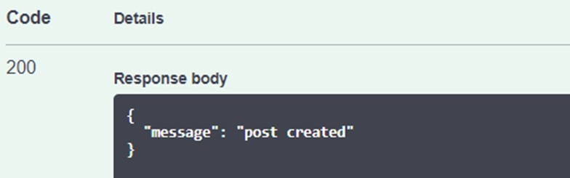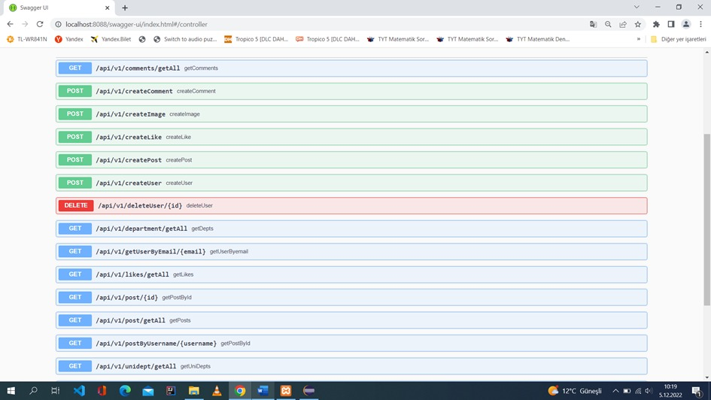

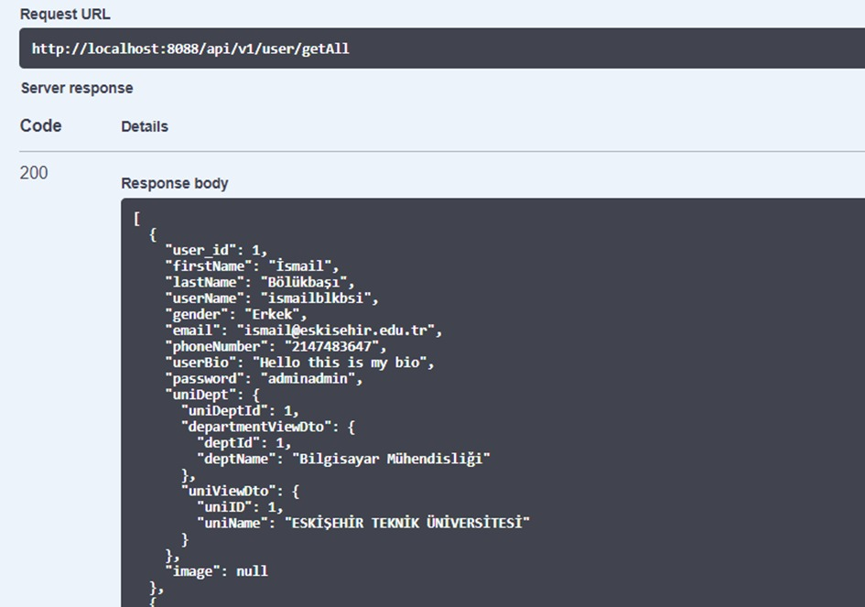

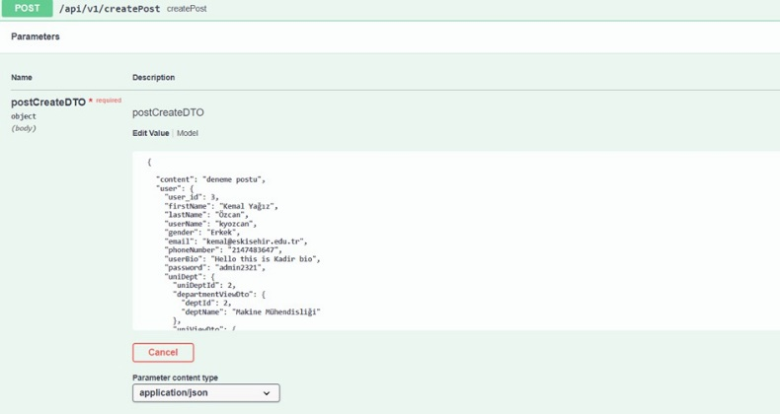

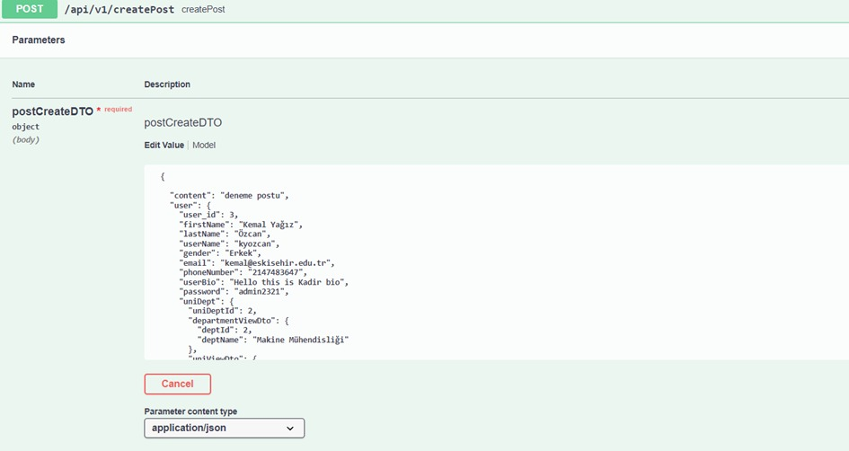

* + Emre & Ayten: *frontend development*

- This week we added a button to the sidebar section where the user can share a new post. When this button is clicked, the popup opens and the user can share a new post.

- We have made a warning message at the top of the Login page that appears when the user tries to log in with a correct value.

- We have checked the login and sign-up pages that can work.

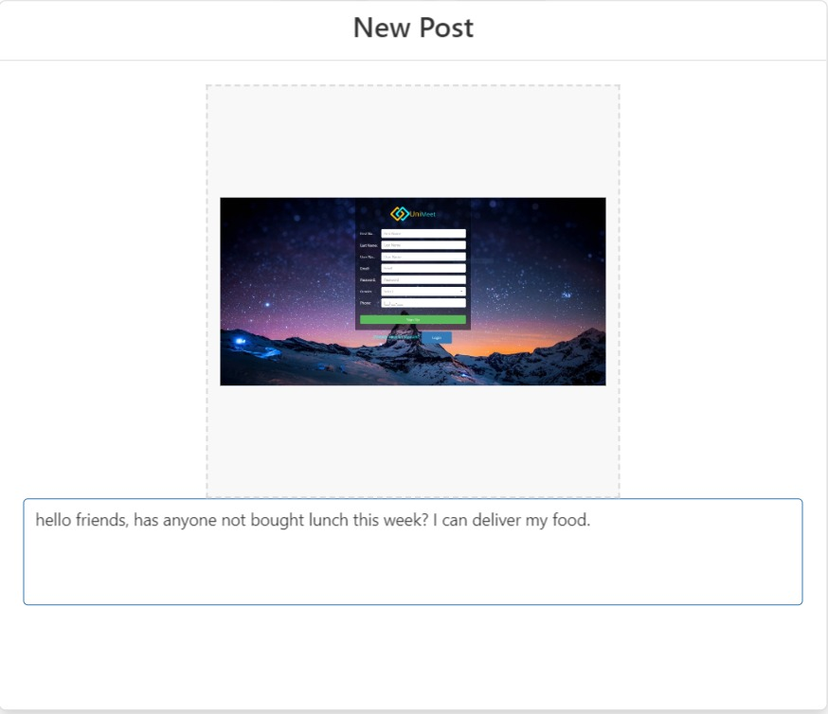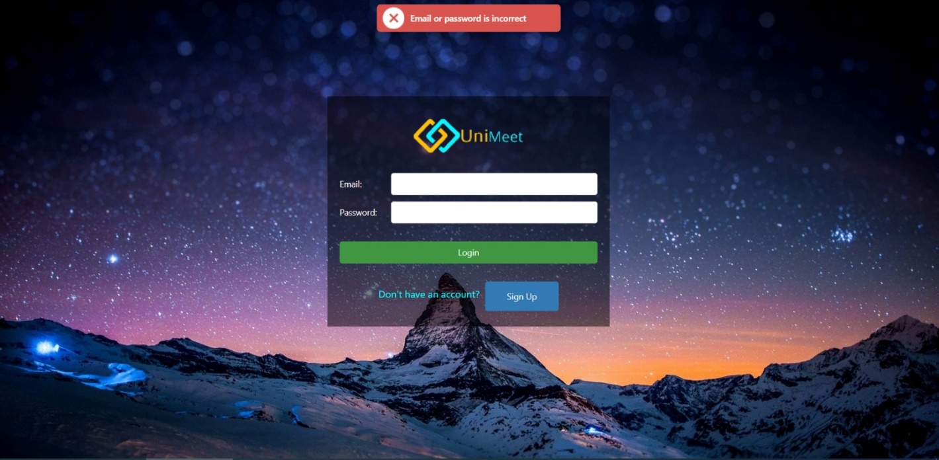

# Plans for the Following Week

* Applying new design to the mobile app.
* Create a search page which also shows a peak of the posts as in the design.
* Applying any further designs suggested by the designer.
* putting real data on main page and profile pages
* complete the deficiencies in the design part of the web page.
* In the backend update user, upload a image of a user and add a image to a post.