

**ESKİŞEHİR TECHNICAL UNIVERSITY**

**FACULTY OF ENGINEERING**

**COMPUTER ENGINEERING**

**2021-2022 SPRING SEMESTER**

**BIM312**

**DATABASE MANAGEMENT SYSTEMS**

**TERM PROJECT**

PHASE-2

**G9-PNo9:** University Club Membership Database System

**Çağla ŞEN - 38996140066**

**Radwan Rachid HOUSSEIN -99936402866**

Contents

**E/R Diagram** [HERE] 3

NOTE (*changes*): 4

The Relational Schema 5

Database Schema (SQL codes) 6

SQL EER Diagram [HERE] 11

## [**E/R Diagram**](https://github.com/RadwanH/University-Club-Membership/blob/main/Diagrams/ER-Diagram.drawio.png?raw=true) [[HERE]](https://github.com/RadwanH/University-Club-Membership/blob/main/Diagrams/ER_diagram.png?raw=true)

## NOTE (*changes*):

To maintain the simplicity and keep our database in BCNF and ofcourse after after discussing with our potential users we decided to make the following changes

* The HAS A relationship between MEMBER and COMMITTEE entity sets was changed to M:N relationship as a specific member with position can actually be member in several COMMITEEs.
* The relationship ORGANIZES relationship between MEMBER and BUDGET entity sets was removed as we decided that it would make more sense if there is actually just one member that can be responsible for all budget transactions and that member’s position can actually be declared in the COMMITTEE table under the *position* attribute so this relationship would cause us redundancy (very unwanted thing) and there for was *removed*.

The Relational Schema [[HERE]](https://github.com/RadwanH/University-Club-Membership/blob/main/Diagrams/Schema.png?raw=true)

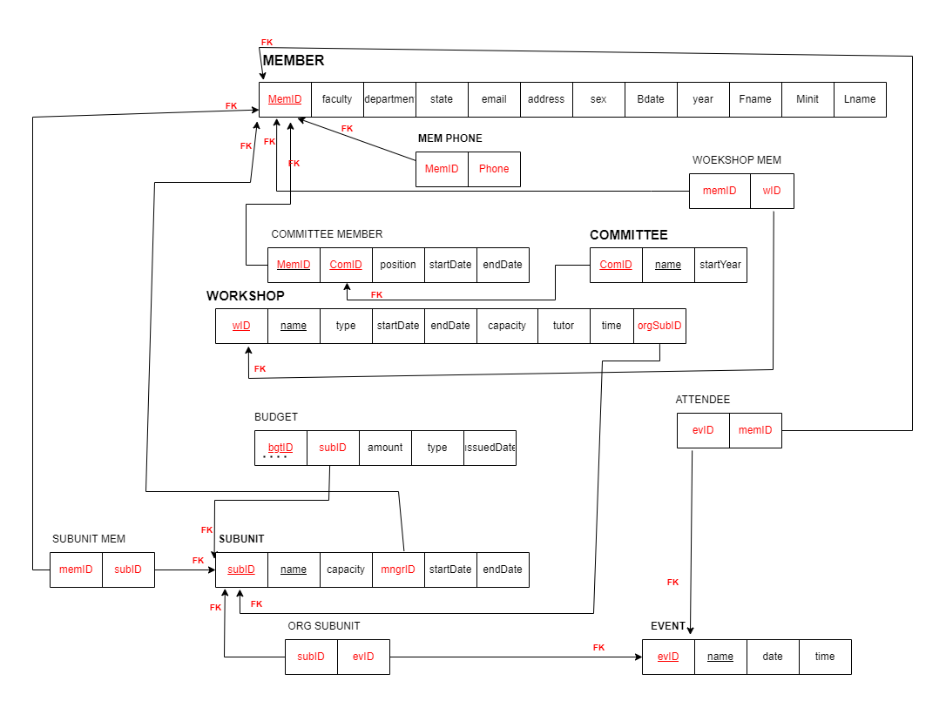

# Database Schema (SQL codes)

**CREATE TABLE CLUB_MEMBER**

(`member_id` CHAR(9) NOT NULL,

`first_name` VARCHAR(15) NOT NULL,

`minit` varchar(1),

`last_name` VARCHAR(15) NOT NULL,

`sex` CHAR(1),

`birth_date` DATE,

`faculty` VARCHAR(50),

`department` VARCHAR(50) NOT NULL,

`year` INT(1) NOT NULL,

`email` VARCHAR(30) NOT NULL,

`address` VARCHAR(50),

`membership_state` VARCHAR(7) NOT NULL,

PRIMARY KEY (`member_id`) );

);

**CREATE TABLE `COMMİTTEE`**

(`com_id` İNT(5) NOT NULL,

`com_name` VARCHAR(30) NOT NULL,

`start_year` YEAR NOT NULL,

PRIMARY KEY (`com_id`),

UNIQUE KEY `com_name_UNIQUE` (`com_name`) );

**CREATE TABLE `COMMİTTEE_MEM**`

(`com_member_id` CHAR(9) NOT NULL,

`com_id` İNT(5) NOT NULL,

`position` VARCHAR(30) NOT NULL,

`start_date` DATE,

`end_date` DATE,

PRIMARY KEY (`com_member_id`,`com_id`),

FOREIGN KEY (`com_id`) REFERENCES `committee` (`com_id`),

FOREIGN KEY (`com_member_id`) REFERENCES `club_member` (`member_id`) );

**CREATE TABLE `BUDGET`**

(`mngr_id` CHAR(9) NOT NULL,

`bgt_id` İNT(5) NOT NULL,

`bgt_amnt` DOUBLE(7,2) NOT NULL,

`bgt_type` VARCHAR(50),

`issuedto_subid` İNT(5) NOT NULL,

`issued_date` DATE,

PRIMARY KEY (`bgt_id`,`issuedto_subid`),

FOREIGN KEY (`issuedto_subid`) REFERENCES `sub_unit` (`sub_id`) );

**CREATE TABLE `SUB_UNİT`**

(`sub_id` İNT(5) NOT NULL,

`sub_name` VARCHAR(50) NOT NULL,

`sub_capacity` İNT(4) NOT NULL,

`mngr_id` CHAR(9) NOT NULL,

`sub_start_date` DATE,

`sub_end_date` DATE,

PRIMARY KEY (`sub_id`),

UNIQUE KEY `sub_name_UNIQUE` (`sub_name`) );

**CREATE TABLE `WORKSHOP`**

(`w_id ` İNT(5) NOT NULL,

`w_name` VARCHAR(50) NOT NULL,

`w_type` VARCHAR(30),

`w_start_date` DATE,

`w_end_date` DATE,

`w_capacity` İNT(4) NOT NULL,

`tutor` VARCHAR(30) NOT NULL,

`time` TİME,

`org_sub_id` İNT(5) NOT NULL,

PRIMARY KEY (`w_id`,`org_sub_id`),

UNIQUE KEY `w_name_UNIQUE` (`w_name`),

FOREIGN KEY (`org_sub_id`) REFERENCES `sub_unit` (`sub_id`) );

**CREATE TABLE `PHONES`**

(`phone` CHAR(9) NOT NULL,

`mem_id` CHAR(11) NOT NULL,

PRIMARY KEY (`phone`,`mem_id`),

UNIQUE KEY `phone_UNIQUE` (`phone`),

FOREIGN KEY (`mem_id`) REFERENCES `club_member` (`member_id`) );

**CREATE TABLE `EVENT**`

(`ev_id` İNT(5) NOT NULL,

`ev_name` VARCHAR(50) NOT NULL,

`ev_date` DATE,

`time` TİME NOT NULL,

PRIMARY KEY (`ev_id`),

UNIQUE KEY `ev_name_UNIQUE` (`ev_name`));

**CREATE TABLE `ATTENDEE`**

(`ev_att_id` CHAR(9) NOT NULL,

`ev_id` İNT(5) NOT NULL,

PRIMARY KEY (`ev_att_id`,`ev_id`),

FOREIGN KEY (`ev_att_id`) REFERENCES `club_member` (`member_id`),

FOREIGN KEY (`ev_id`) REFERENCES `event` (`ev_id`));

**CREATE TABLE `WORKSHOP_MEM`**

(`w_member_id` CHAR(9) NOT NULL,

`w_id` İNT(5) NOT NULL,

PRIMARY KEY (`w_member_id`,`w_id`),

FOREIGN KEY (`w_id`) REFERENCES `workshop` (`w_id`),

FOREIGN KEY (`w_member_id`) REFERENCES `club_member` (`member_id`));

**CREATE TABLE `SUB_MEM`**

(`sub_mem_id` CHAR(9) NOT NULL,

`sub_id` İNT(5) NOT NULL,

PRIMARY KEY (`sub_mem_id`,`sub_id`),

FOREIGN KEY (`sub_id`) REFERENCES `sub_unit` (`sub_id`),

FOREIGN KEY (`sub_mem_id`) REFERENCES `club_member` (`member_id`) );

**CREATE TABLE `EVENT_ORGANİZER_SUB`**

(`organizer_sub_id` İNT(5) NOT NULL,

`organized_event` İNT(5) NOT NULL,

PRIMARY KEY (`organizer_sub_id`,`organized_event`),

FOREIGN KEY (`organized_event`) REFERENCES `event` (`ev_id`),

FOREIGN KEY (`organizer_sub_id`) REFERENCES `sub_unit` (`sub_id`) );

# SQL EER Diagram [[HERE]](https://github.com/RadwanH/University-Club-Membership/blob/main/Diagrams/SQL_EER.png?raw=true)

