Task3:
I store the last key selection in a mode variable (MODE_COLOR, MODE_GRAY, MODE_BLUR, MODE_FLIP, MODE_INVERT). Each captured frame is processed according to the current mode so the effect persists across frames.
how each color channel is weighted in the conversion:
I checked Wikipedia for this equation and learned that this RGB-to-grayscale conversion is based on the Rec. 601 luma standard.
The green channel contributes the most to perceived brightness because the human eye is most sensitive to green wavelengths, while the blue channel contributes the least because human vision is less sensitive to blue light in terms of brightness perception.

The original and cvtColor version of the greyscale image: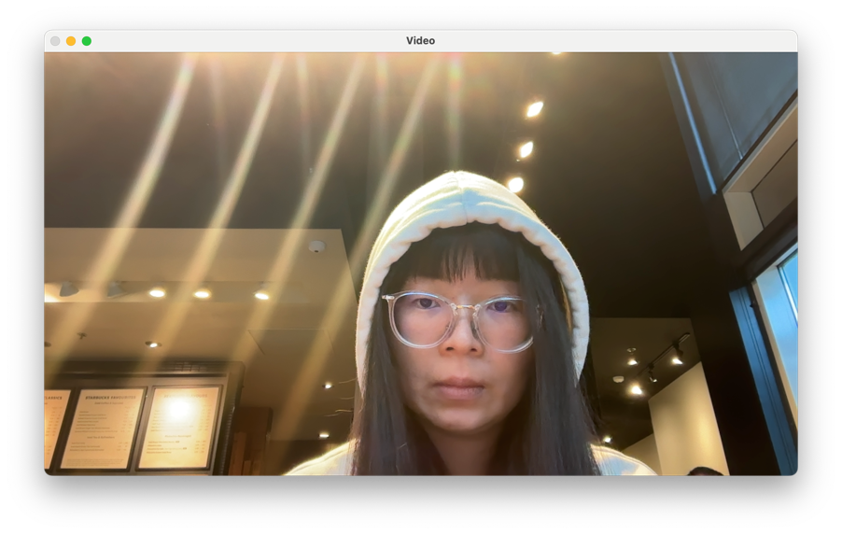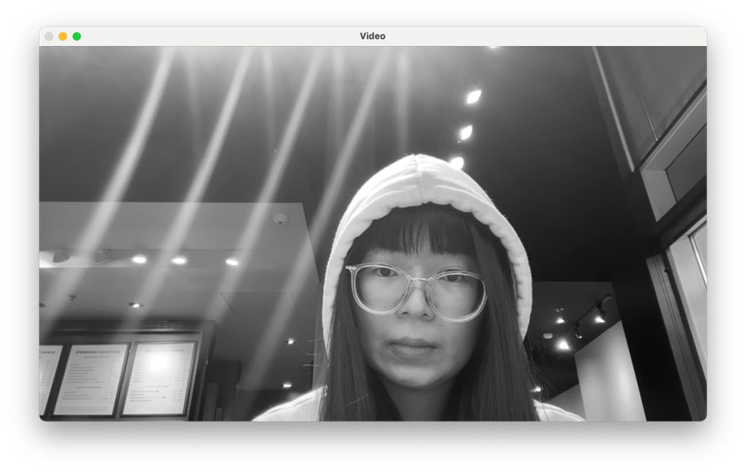
Task 4:
My customized greyscale image: 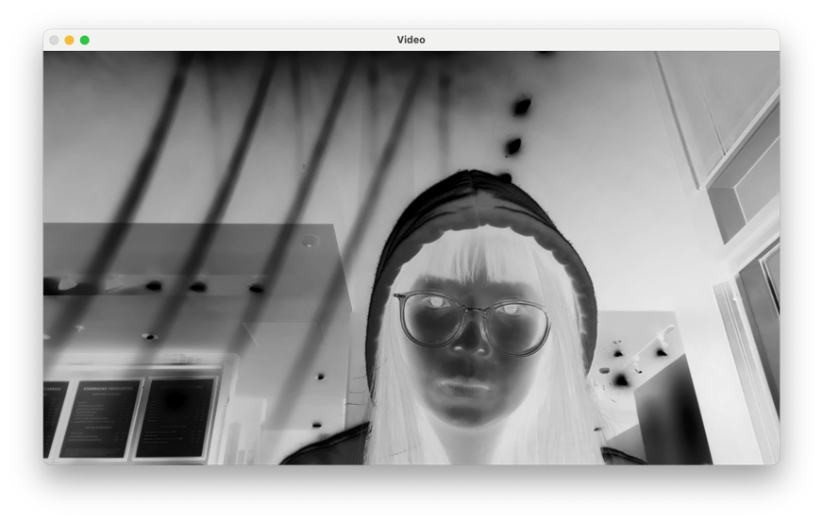
how I decided to generate my greyscale version:
Invert the red channel value: R->255-R, and use this value for each of the three channels so that it becomes a greyscale image.
the differences with the default greyscale image:

 | default | My custom
Number of channels | 1 | 3
How the value of Luma component Y ′is calculated | 0.299R+0.587G+0.114B | 255-R
Whether it aligns with human brightness perception | Yes | No

