FYP Thesis Draft

TODO

需要跑数据才能填的表格
- Table 5.5 — FP32 vs INT8 对比（model size / M-Score / Se / Sp / latency）
- Table 6.1 — 各阶段推理延迟（bandpass / Mel / SQA / diagnostic，FP32 vs INT8）
- Table 6.2 — 资源占用（Peak CPU % / RSS MB / FP32 model size）
- Table 6.3 — 量化精度对比（M-Score / Se / Sp / Accuracy，FP32 vs INT8）

需要补充的引用
- [CITE PhysioNet 2016] — Section 3.1
- [CITE Howard et al., MobileNets, 2017] — Section 4.2
- [CITE Hou et al., CVPR 2021] — Section 4.3（CoordAtt）
- [CITE Hu et al., CVPR 2018] — Section 4.3（SE block）

需要写的章节
- Chapter 1 — Introduction（motivation、contribution list、chapter outline）
- Chapter 2 — Related Work（已有心音分类方法综述、Edge AI/TinyML、本文方法定位）
- Chapter 7 — Conclusion（7.1 Summary of Contributions / 7.2 Limitations / 7.3 Future Work）

需要补充的对比内容
- SOTA 对比表 — 在 PhysioNet 2016 上与已发表方法横向对比（M-Score / Se / Sp / 参数量 / 部署设备）

写完后清理
- 删除各节开头的中文 bullet note（规划时留下的，正文已写完可删）

Chapter 3: Dataset and Preprocessing

3.1 Dataset Overview
- PhysioNet/CinC Challenge 2016
- 数据集统计（Normal / Abnormal 数量、比例、来源）
- 类别不平衡问题说明（4:1）
The primary dataset for the diagnostic model is the PhysioNet/CinC Challenge 2016 heart sound database [CITE PhysioNet 2016]. The dataset comprises recordings collected from clinical and non-clinical environments across six subsets (training-a through training-f), each accompanied by a REFERENCE.csv file assigning a binary diagnostic label (Normal / Abnormal) and a REFERENCE-SQI.csv file providing a signal quality index (SQI) score per recording.
Recordings with SQI score = 0 are excluded from the diagnostic dataset, as they are marked as acoustically unusable by the challenge organisers. After this quality filtering, 2,876 recordings remain. The class distribution is heavily skewed: 2,304 Normal (80.1%) and 572 Abnormal (19.9%), yielding an approximately 4:1 imbalance. This ratio reflects the prevalence of pathological conditions in the source population and is a persistent challenge for training unbiased classifiers on this dataset.
After segmentation into 2-second windows (detailed in Section 3.2), the 2,876 recordings produce 62,003 fixed-length segments in total. The dataset is partitioned at the recording level—all segments from a given recording appear in exactly one split—to prevent data leakage. Using a fixed random seed (seed = 42), the split is 80/10/10, yielding 49,833 training, 5,897 validation, and 6,273 test segments. The test set filenames are persisted to disk on the first training run and never modified thereafter, ensuring the test set remains unseen throughout all subsequent experiments.

3.2 Signal Preprocessing Pipeline
- 带通滤波（25–400 Hz，Butterworth）
- 滑动窗口分割（2s，50% overlap）
- Log-Mel 频谱图提取（32×64）
All recordings are resampled to 2,000 Hz. The Nyquist frequency of 1,000 Hz comfortably covers the diagnostically relevant range of heart sounds (20–600 Hz), while the reduced sampling rate minimises both storage and downstream computation relative to typical audio sampling rates.
Bandpass filtering. A 5th-order Butterworth bandpass filter with cutoff frequencies of 25 Hz and 400 Hz is applied to each recording using zero-phase forward-backward filtering (scipy.signal.filtfilt). The lower cutoff at 25 Hz suppresses residual low-frequency baseline wander and body motion artefacts; the upper cutoff at 400 Hz removes high-frequency noise above the dominant energy range of S1, S2, and common murmurs. Zero-phase filtering is used to avoid introducing any group delay distortion that would shift the temporal positions of cardiac events.
Sliding window segmentation. Each filtered recording is divided into fixed-length segments of 2 seconds (4,000 samples at 2,000 Hz) using a sliding window with 50% overlap (hop size = 2,000 samples). Segments shorter than 2 seconds at the end of a recording are zero-padded to the required length. The 50% overlap balances the trade-off between data volume and redundancy: it ensures that cardiac events near a segment boundary are fully captured in at least one adjacent window, while avoiding the excessive redundancy that a higher overlap ratio would introduce.
Log-Mel spectrogram. Each 2-second segment is transformed into a log-Mel spectrogram using the librosa library. The STFT is computed with a 256-point FFT (window length 256, hop length 96), and the magnitude spectrogram is projected onto 32 Mel-scale filter banks spanning 20–400 Hz. The power spectrogram (power = 2.0) is converted to a decibel scale via power_to_db, with a small epsilon (10⁻⁶) added before the logarithm to avoid numerical instability on silent frames. The resulting 2D feature map is fixed to shape 32×64 along the time axis using zero-padding or truncation, producing the final model input of shape 1×32×64.
Figure 3.1: Preprocessing pipeline applied to a representative heart sound recording. (a) Raw waveform; (b) after 25–400 Hz bandpass filtering; (c) first 2-second segment; (d) resulting Log-Mel spectrogram (64×64). 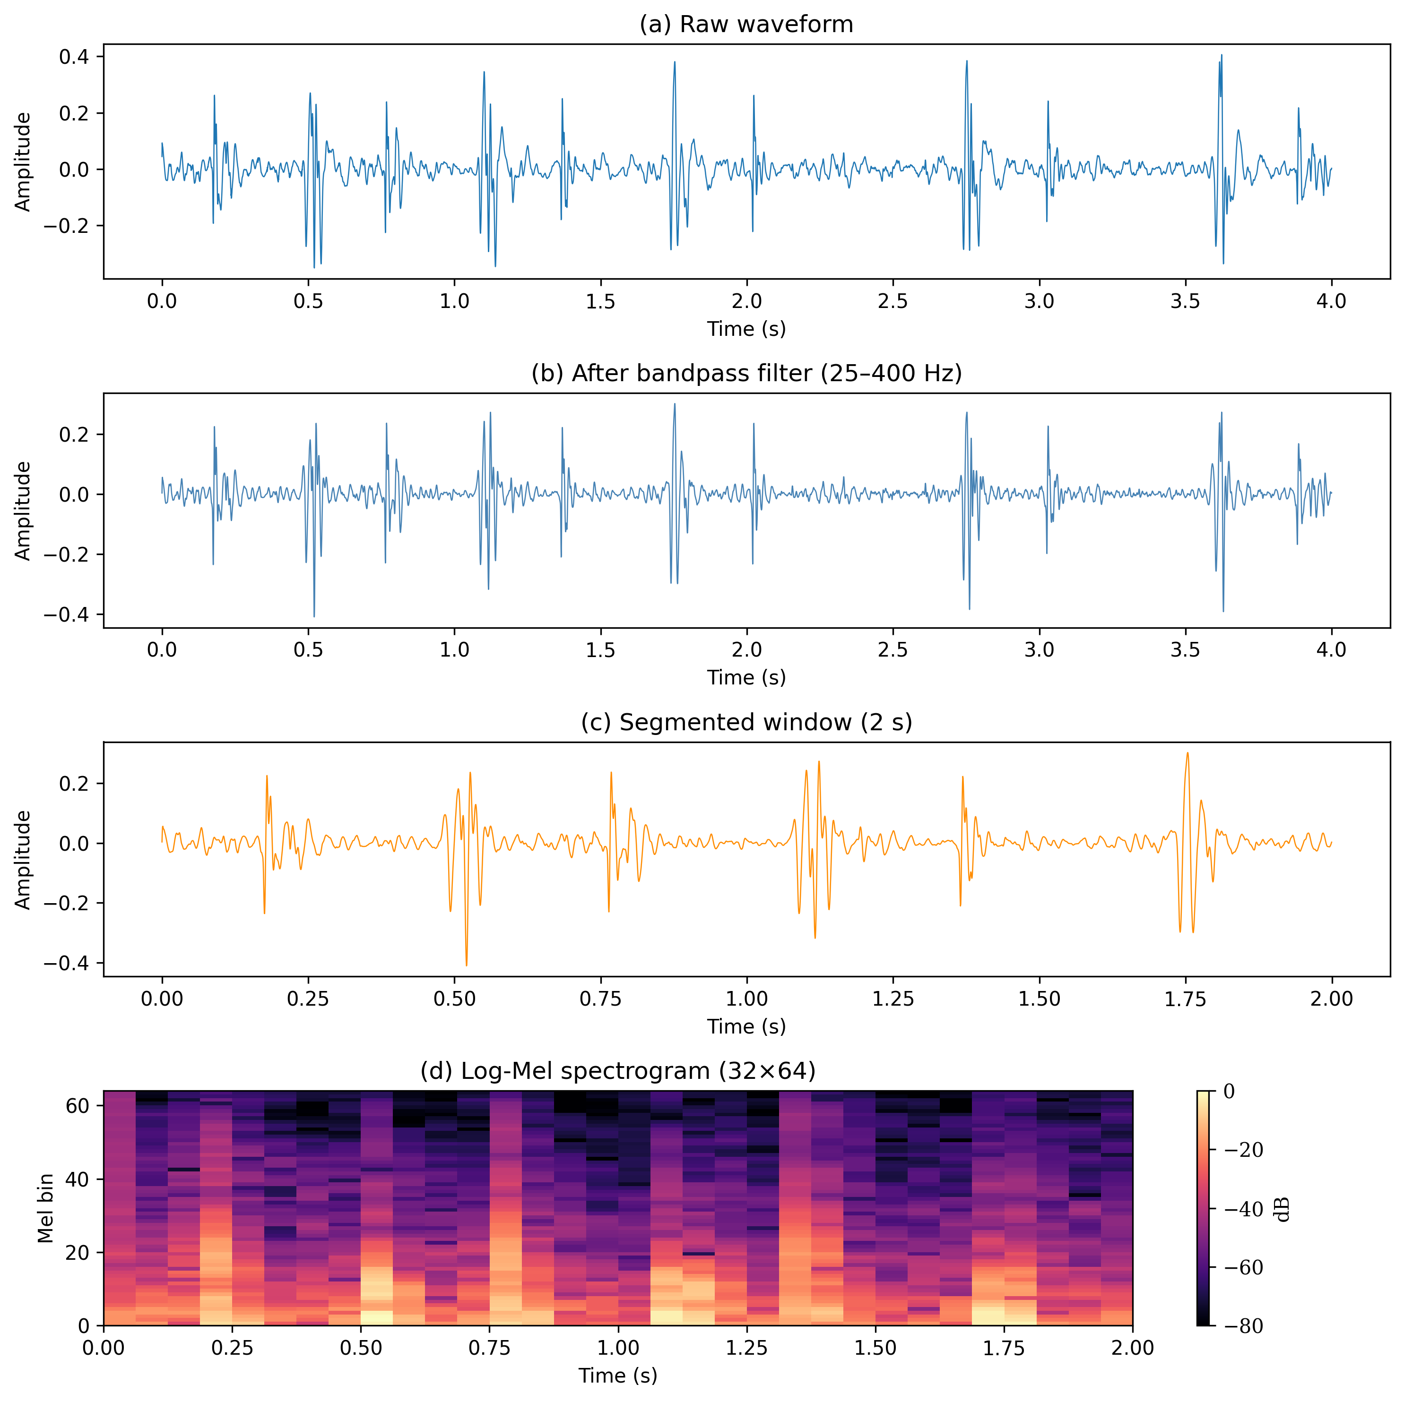
Figure 3.2: Log-Mel spectrograms for a Normal (left) and Abnormal (right) recording after full preprocessing. 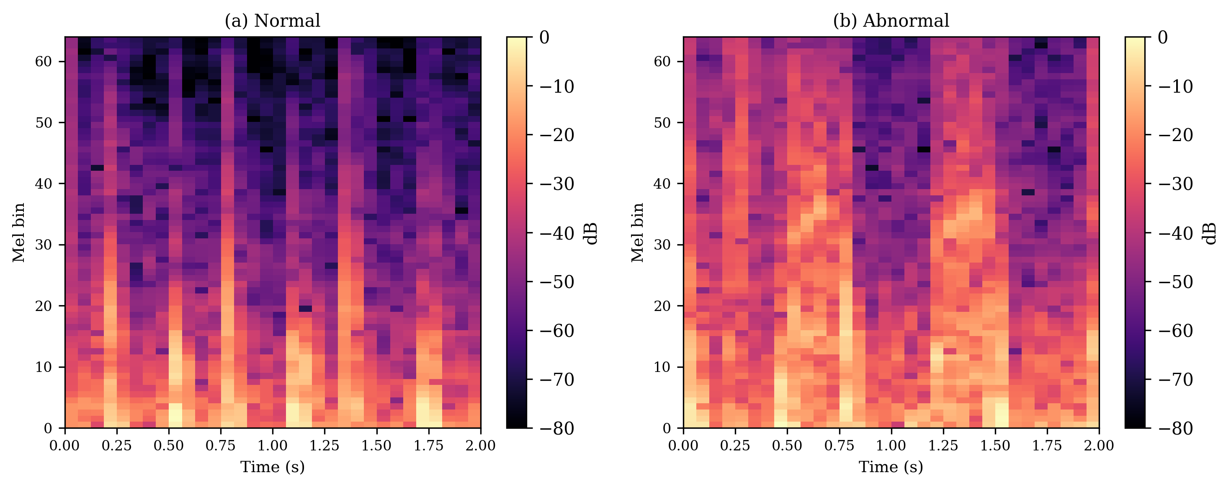

3.3 Signal Quality Assessment Dataset
- SQA 数据集构建（Good / Bad Quality 标注来源）
- 数据统计（8:1 不平衡）
The SQA model requires a quality-labelled dataset separate from the diagnostic labels. This is constructed from the same PhysioNet 2016 source using the REFERENCE-SQI.csv annotations, which are included for all six subsets. Each recording’s SQI score is binarised: score ≠ 0 is assigned Good Quality (label 1); score = 0 is assigned Bad Quality (label 0). Unlike the diagnostic dataset, no prior quality filtering is applied—Bad Quality recordings are retained, as they constitute the negative class for training.
The resulting dataset contains 3,240 recordings: 2,876 Good Quality (88.8%) and 364 Bad Quality (11.2%), an approximately 8:1 imbalance. The same 80/10/10 recording-level split strategy is applied, with augmentation enabled only on the training split.
For training, the labels are inverted relative to the raw annotation: Bad Quality is assigned label 1 (positive class) and Good Quality label 0. This inversion ensures that Sensitivity, as computed by M-Score, measures the Bad Quality detection rate—the operationally critical quantity, since undetected bad-quality segments propagate noise into the diagnostic model. All SQA Se/Sp figures reported in Chapter 5 follow this convention.

3.4 Data Augmentation and Class Balancing
- WeightedRandomSampler 策略
- 数据增强方法
Class balancing. Both datasets exhibit substantial class imbalance. A naive training setup would bias the model toward the majority class, yielding high accuracy but poor minority-class recall—exactly the failure mode that M-Score is designed to penalise. To counteract this, WeightedRandomSampler is applied at the DataLoader level: each sample is assigned a weight inversely proportional to its class frequency (weight = 1 / class_count), and the sampler draws from the training set with replacement according to these weights. This produces balanced mini-batches without duplicating data in memory or modifying the underlying dataset.
Waveform augmentation. Augmentation is applied stochastically to each training segment at load time and is disabled entirely for validation and test splits. Five independent augmentation operations are applied in sequence, each with its own trigger probability:
Operation | Description | Probability
Random gain | Amplitude scaling by a factor sampled uniformly from [0.8, 1.2] | 0.5
Gaussian noise | Additive white noise at SNR sampled uniformly from [20, 35] dB | 0.5
Time shift | Circular shift by up to ±10% of segment length | 0.5
Random resampling | Time-stretch by factor sampled from [0.9, 1.1], then re-padded to original length | 0.3
Polarity inversion | Multiply entire waveform by −1 | 0.5
Random gain and polarity inversion simulate variability in probe contact pressure and microphone orientation. Gaussian noise approximates ambient acoustic interference. Time shift and random resampling together increase robustness to recording start-point variability and heart rate fluctuations. All augmentations operate on the raw waveform before the Mel spectrogram is computed, ensuring that the feature extractor sees augmented signal characteristics rather than augmented spectrograms.

Chapter 4: Model Design

4.1 Overall Architecture
- 双模型设计思路（SQA + 诊断解耦）
- 输入格式（1×32×64 Log-Mel 频谱图）
The system deploys two independent model instances in a cascaded inference pipeline: a Signal Quality Assessment (SQA) model and a diagnostic model. Both share the same network architecture but are trained on separate datasets for distinct binary classification tasks.
The SQA model serves as a gating function. Before any cardiac recording reaches the diagnostic stage, the SQA model evaluates each 2-second segment for acoustic usability. Segments contaminated by motion artefacts, ambient noise, or insufficient probe contact are rejected; only segments classified as high-quality are forwarded for diagnosis. The final diagnostic decision is produced by aggregating predictions across all accepted segments via weighted averaging, reducing sensitivity to any single noisy window.
This decoupled design has two practical advantages. First, it prevents corrupted input from directly biasing the diagnostic output—a critical concern for a device used in uncontrolled home environments. Second, training the two models independently allows each to be optimised for its own class distribution and evaluation criterion, rather than forcing a single model to solve both problems jointly.
Both models accept a log-Mel spectrogram of shape 1×32×64 as input: one channel, 32 Mel frequency bins spanning 20–400 Hz, and 64 time frames corresponding to a 2-second segment at 2 kHz sampling rate with 96-sample hop length. The compact representation keeps inference memory within the constraints of the Raspberry Pi 4B while retaining the frequency-temporal structure that distinguishes normal S1/S2 patterns from pathological sounds.
Figure 4.1: Cascaded dual-model inference pipeline. An input recording is first evaluated by the SQA model (Model 0); segments of insufficient quality are rejected as “Unsure”, while high-quality segments are forwarded to the diagnostic model (Model 1) which produces a Normal or Abnormal classification. 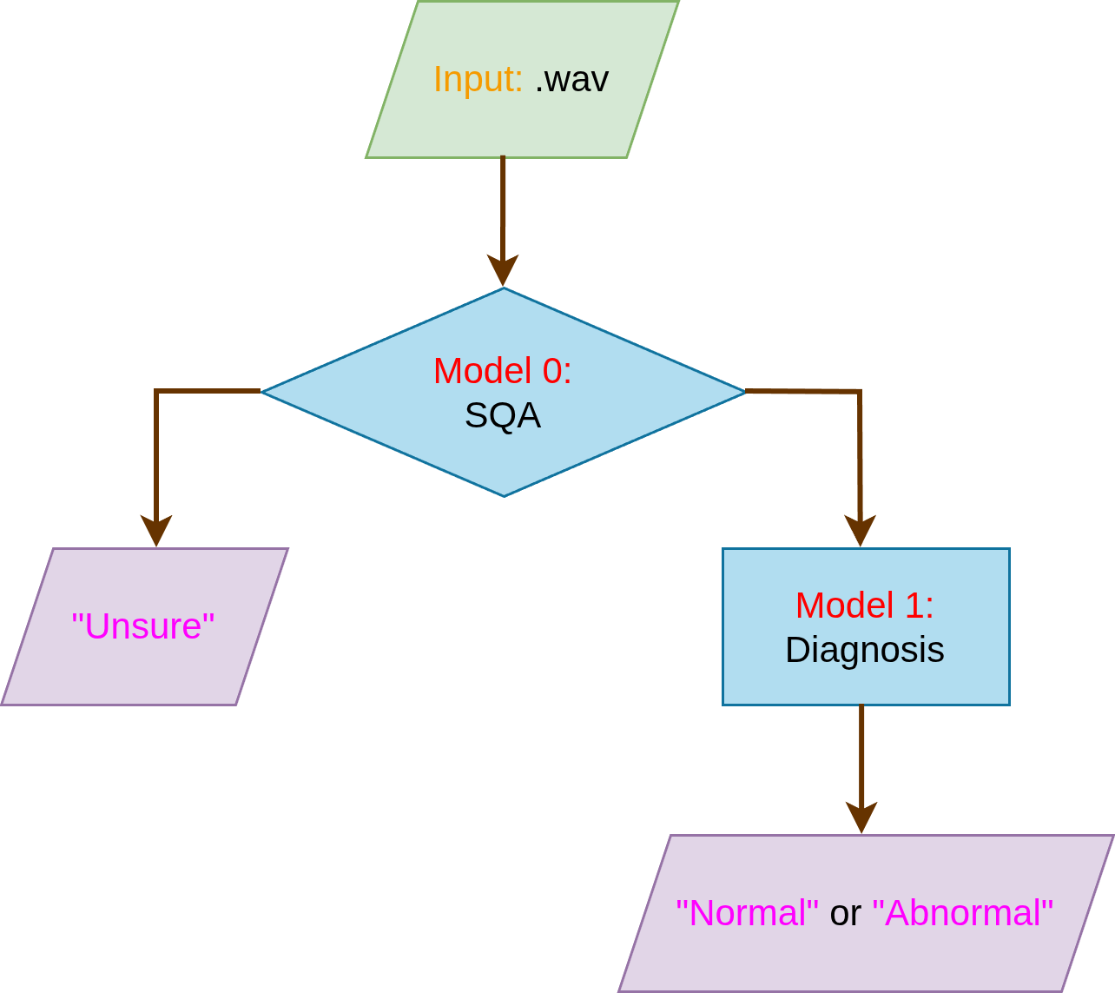

4.2 Lightweight CNN Backbone
- Depthwise Separable Convolution 结构
- 各层设计（通道数、卷积核大小）
- 参数量分析
The backbone is a four-stage convolutional network built around the depthwise separable convolution (DSC) primitive [CITE Howard et al., MobileNets, 2017]. A DSC block factorises a standard k×k convolution into two sequential operations: a depthwise convolution that filters each input channel independently with a k×k kernel, followed by a pointwise (1×1) convolution that mixes channels. For C_in input channels, C_out output channels, and kernel size k, this reduces the parameter count from C_in × C_out × k² to C_in × k² + C_in × C_out—a factor of approximately k² = 9 for 3×3 kernels. This makes DSC well-suited to edge deployment where model size directly determines both storage footprint and inference latency.
Figure 4.2: Standard convolution vs depthwise separable convolution. A standard k×k convolution (top) convolves all C_in input channels simultaneously; a DSC (bottom) factors this into a per-channel depthwise convolution followed by a 1×1 pointwise convolution that mixes channels, reducing the parameter count by a factor of approximately k². 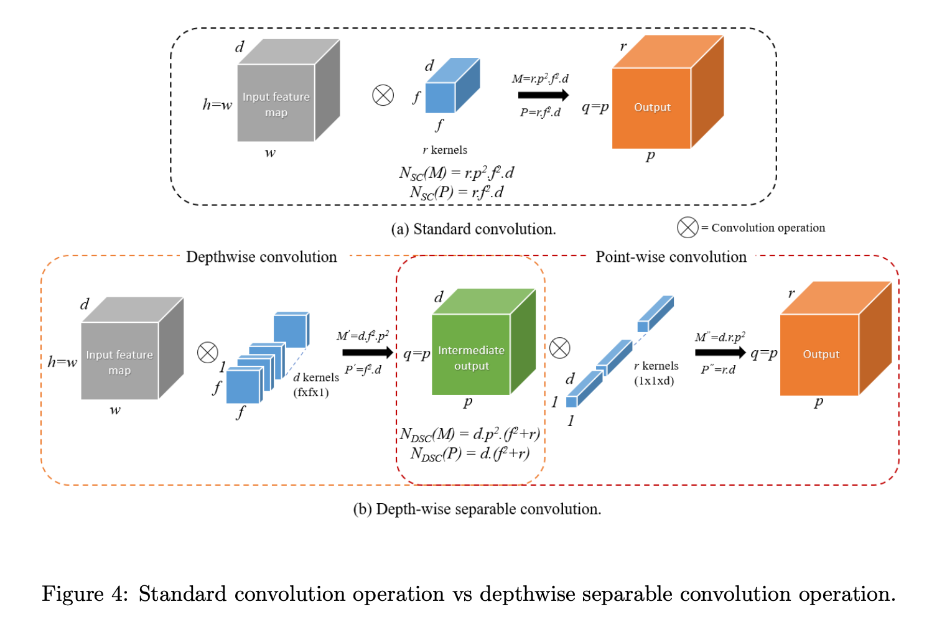
The network begins with a single standard 3×3 convolutional layer that projects the single-channel input to 32 feature maps. This initial layer uses a full convolution because the input has only one channel, making the depthwise factorisation trivial. Three subsequent DSC stages progressively double the channel count while halving the spatial resolution via 2×2 max-pooling. A global average pooling layer collapses the spatial dimensions to a 256-dimensional vector, which passes through a dropout layer (rate 0.3) and a linear classifier.
Table 4.1: LightweightCNN architecture. Spatial dimensions (H×W) are shown after each stage.
Stage | Operation | Channels (in→out) | Spatial (H×W)
conv1 | Conv2d 3×3, BN, ReLU | 1 → 32 | 32 × 64
layer2 | DSC 3×3 + CoordAtt, MaxPool2d | 32 → 64 | 16 × 32
layer3 | DSC 3×3 + CoordAtt, MaxPool2d | 64 → 128 | 8 × 16
layer4 | DSC 3×3 + CoordAtt, MaxPool2d | 128 → 256 | 4 × 8
global_pool | AdaptiveAvgPool2d(1,1) | 256 | 1 × 1
classifier | Dropout(0.3), Linear | 256 → 2 | —
The total trainable parameter count is approximately 64.2K. The quantized INT8 TFLite model occupies 145.7 KB on disk.
Figure 4.3: LightweightCNN architecture visualisation. Each block represents one convolutional stage; spatial dimensions decrease from left to right (32×64 → 16×32 → 8×16 → 4×8) while the number of feature channels doubles at each stage (32 → 64 → 128 → 256). CoordAtt is inserted after the pointwise convolution at each DSC stage. The final arrow denotes global average pooling followed by the linear classifier. 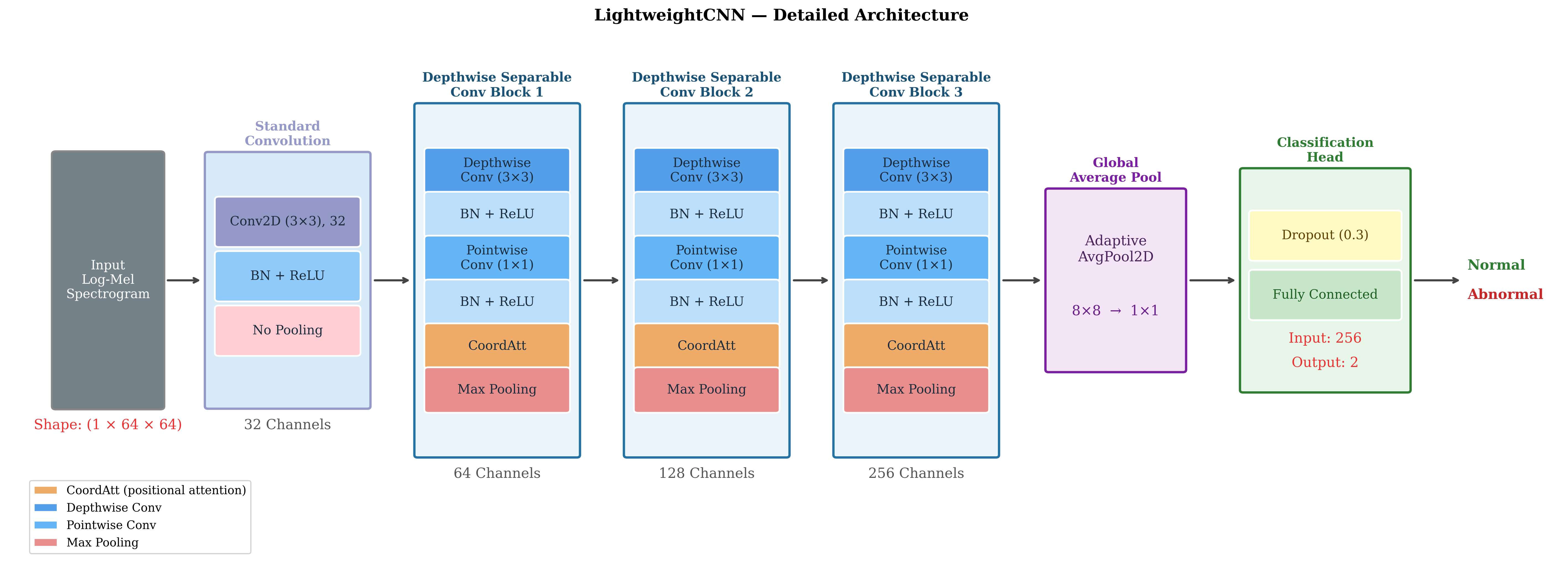

4.3 Coordinate Attention Module
- 设计动机（为什么用 CoordAtt 而不是 SE Block）
- 模块结构（H/W 方向分离的空间注意力）
- 在模型中的插入位置
Each DSC block in layers 2–4 integrates a Coordinate Attention (CoordAtt) module [CITE Hou et al., CVPR 2021] inserted after the pointwise convolution.
The design choice is motivated by a limitation of the Squeeze-and-Excitation (SE) block [CITE Hu et al., CVPR 2018], the most widely adopted channel attention mechanism. SE computes a global descriptor by average-pooling the entire spatial feature map into a single C-dimensional vector, then uses it to rescale channel responses. This operation is spatially blind: it encodes which channels matter globally but discards where within the feature map the relevant activations occur. For heart sound spectrograms, spatial position carries diagnostic information. S1 and S2 energy concentrates in specific frequency bands (predominantly below 200 Hz) and at characteristic temporal positions within the cardiac cycle; pathological murmurs occupy frequency ranges that differ from normal sounds. An attention mechanism that ignores spatial structure cannot selectively amplify these localised cues.
Figure 4.4: Comparison of channel and spatial attention mechanisms. (a) SE block: global average pooling collapses the entire spatial map into a single C-dimensional descriptor, discarding positional information. (b) CBAM: augments SE with a spatial branch that uses channel pooling and a 7×7 convolution. (c) CoordAtt: decomposes pooling independently along H and W axes, preserving positional context along each direction. Figure reproduced from Hou et al. [CITE Hou et al., CVPR 2021]. ![[Paper Photo/Comparison to Squeeze-and-Excitation block abd CBAM.png]]
CoordAtt retains positional information by decomposing spatial pooling along the two axes independently. Given a feature map $X∈R^{N×C×H×W}$, the module proceeds as follows:
- Directional pooling. $X$ is pooled along the width axis to produce $X_{h}∈R^{N×C×H×1}$ (encoding frequency-axis context) and along the height axis to produce $X_{w}∈R^{N×C×1×W}$ (encoding time-axis context). Unlike global average pooling, each element retains its position along the non-pooled axis.
- Joint encoding. $X_{h}$ and $X_{w}$ (transposed to align the spatial dimension) are concatenated along the height axis and passed through a shared 1×1 convolution followed by BatchNorm and ReLU. The intermediate channel dimension is $m=max(8,⌊C/16⌋)$, giving $m=8,8,16$ for $C=64,128,256$ at layers 2, 3, 4 respectively.
- Attention map generation. The encoded tensor is split back into height- and width-specific components. Each is projected by a separate 1×1 convolution and sigmoid to produce $a_{h}∈[0,1]^{N×C×H×1}$ and $a_{w}∈[0,1]^{N×C×1×W}$.
- Recalibration. The output is $X⋅a_{h}⋅a_{w}$. Because $a_{h}$ varies along the frequency axis and $a_{w}$ varies along the time axis, their elementwise product creates a 2D attention map that weights each spatial location according to both frequency and temporal position—without collapsing either axis.
Figure 4.5: Coordinate Attention mechanism structure. The input feature map is pooled along the height and width axes independently (X Avg Pool, Y Avg Pool), concatenated and jointly encoded via a shared 1×1 convolution, then split and projected with separate sigmoid activations to produce axis-specific attention weights. Figure reproduced from Hou et al. [CITE Hou et al., CVPR 2021]. ![[Paper Photo/Coordinate-Attention.png]]
Figure 4.6: Integration of Coordinate Attention into depthwise separable convolution blocks. (a) CA inserted after the depthwise convolution in an inverted residual block; (b) CA inserted after the depthwise convolution in a plain DSC block, as used in this work. Figure reproduced from Hou et al. [CITE Hou et al., CVPR 2021]. ![[Paper Photo/How to plug the proposed CA block in the inverted residual block abd the sunglass block.png]]
The additional parameter cost per CoordAtt block is small: approximately 1.6K, 3.1K, and 12.3K at layers 2, 3, and 4 respectively, modest relative to the DSC blocks they augment.

4.4 Signal Quality Assessment Model
- SQA 模型结构（与诊断模型的异同）
- 在推理 pipeline 中的作用
The SQA model is architecturally identical to the diagnostic model: the same four-stage backbone, the same CoordAtt integration at each DSC block, and the same classifier head. It is trained independently on a quality-labelled dataset of 3,240 recordings with an approximately 8:1 Good/Bad Quality class ratio, using the same WeightedRandomSampler strategy to compensate for class imbalance.
Sharing the architecture with the diagnostic model has a practical benefit beyond simplicity: both models are quantized, loaded, and executed under the same TFLite inference pipeline on the Raspberry Pi, with no additional engineering required to accommodate a structurally different gating network.
At inference time, the SQA model processes the same 1×32×64 log-Mel input as the diagnostic model. Rather than applying a binary accept/reject threshold, the SQA output probability P(Good) for each segment is used directly as a continuous weight in the final aggregation step. Across a recording session, the diagnostic model’s predicted Abnormal probability for each segment is weighted by its corresponding P(Good) score and averaged to produce the final diagnostic decision. Segments of low acoustic quality therefore contribute less to the final result rather than being hard-rejected, which avoids discarding borderline-quality segments entirely while still down-weighting their influence. This design eliminates the need for threshold tuning on the SQA output: the continuous probability is itself the operationally useful quantity.

4.5 Model Quantization
- FP32 → INT8 量化方案（Post-Training Quantization）
- TFLite 转换流程
- 量化对模型大小的影响
Both models are converted to TFLite format using the ai_edge_torch library, which compiles a PyTorch model directly to a TFLite flatbuffer without an intermediate ONNX step. Two variants are produced per model: an FP32 baseline and a quantized version using dynamic range quantization (tf.lite.Optimize.DEFAULT).
Dynamic range quantization statically converts all weight tensors from FP32 to INT8 at export time, reducing the weight storage footprint by approximately 4×. Activations are not statically quantized; instead, their ranges are computed dynamically per inference call. This approach requires no calibration dataset, making it straightforward to apply to any trained checkpoint. The trade-off relative to full integer quantization—where both weights and activations are fixed at INT8—is that activation quantization overhead occurs at runtime rather than being amortized.
The resulting quantized models each occupy 145.7 KB on disk. On the ARM Cortex-A72 of the Raspberry Pi 4B, weight-compressed INT8 models reduce memory bandwidth pressure during inference. Quantitative accuracy retention and latency comparisons between the FP32 and quantized variants are reported in Chapter 5.

Chapter 5: Training and Experiments

5.1 Training Configuration
- 数据划分（80/10/10，按 recording 分组）
- 超参数设置（Epoch、Batch Size、LR、Scheduler）
- 评估指标说明（Sensitivity、Specificity、M-Score）
All experiments use the same 80/10/10 recording-level split (seed = 42), with the test set filenames persisted to disk on the first run and held fixed throughout. Slices from the same recording never appear across splits, preventing any form of data leakage. WeightedRandomSampler is applied on the training set in all runs to counteract the 4:1 class imbalance.
The model is trained with Adam optimiser, learning rate 1×10⁻³, and a ReduceLROnPlateau scheduler (factor = 0.5, patience = 3, monitored on validation M-Score). Early stopping with patience = 10 is applied in all runs except Run 1. The model checkpoint with the highest validation M-Score is saved and used for test evaluation.
Evaluation metrics. The PhysioNet/CinC 2016 challenge defines the primary metric as:
$$M\text{-}Score=\frac{Se+Sp}{2}$$
where Sensitivity (Se) = TP / (TP + FN) measures the fraction of abnormal recordings correctly identified, and Specificity (Sp) = TN / (TN + FP) measures the fraction of normal recordings correctly identified. M-Score is preferred over accuracy because accuracy can reach 80% by predicting all recordings as Normal, while yielding Se = 0 and M-Score = 0.5. All models are saved and compared by M-Score.
Figure 5.1: Confusion matrix structure and evaluation metrics. TP: abnormal correctly identified; FN: abnormal misclassified as normal; FP: normal misclassified as abnormal; TN: normal correctly identified. Sensitivity (Se), Specificity (Sp), and M-Score are derived from these four quantities. 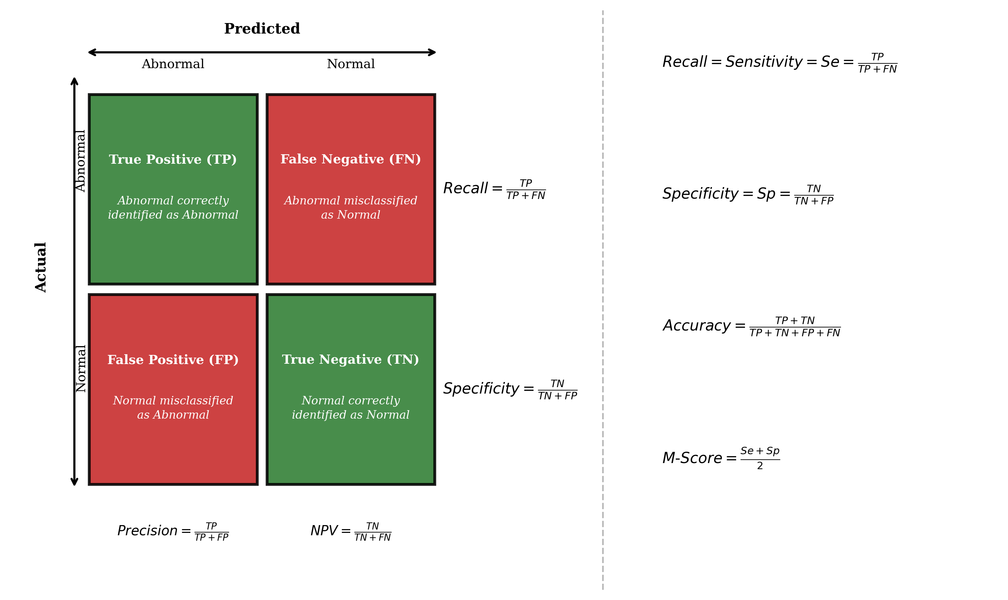

5.2 Diagnostic Model Results
- Run 1 基础训练结果
- Run 2（Label Smoothing + Early Stopping）对比
- 阈值分析

5.2.1 Training Progression
Seven training runs were conducted to isolate the effect of individual design decisions. All runs use the LightweightCNN + CoordAtt architecture (Group C in the ablation study) unless otherwise noted. Table 5.1 summarises the key configurations and test results.
Table 5.1: Training run comparison. All runs use the same test split. Bold = selected configuration.
Run | Batch | n_mels | hop | Label Smooth | Early Stop | Test M-Score | Test Se | Test Sp
1 | 16 | 32 | 96 | ✗ | ✗ | 0.8852 | 0.9569 | 0.8135
2 | 16 | 32 | 96 | ✓ | ✓ | 0.8816 | 0.9181 | 0.8452
3 | 16 | 32 | 96 | ✓ | ✓ | 0.8828 | 0.9105 | 0.8551
4 | 256 | 32 | 96 | ✗ | ✓ | 0.8835 | 0.9544 | 0.8125
5 | 256 | 64 | 128 | ✗ | ✓ | 0.8784 | 0.9409 | 0.8159
6 (sweep params) | 16 | 64 | 128 | ✗ | ✓ | 0.8903 | 0.9485 | 0.8322
7 | 16 | 32 | 96 | ✗ | ✓ | 0.8869 | 0.9383 | 0.8355
Run 3 uses overlap = 0.75 (vs 0.5 in others), held constant as a separate variable.
Several consistent patterns emerge across runs. First, label smoothing (Run 2 vs Run 4) shifts the Se/Sp balance toward higher Sp at the cost of Se—the Se/Sp gap narrows from 0.143 to 0.073—but produces no meaningful change in M-Score (0.8816 vs 0.8835). Since the home screening use case penalises missed abnormal cases more heavily than false alarms, label smoothing was excluded from subsequent runs. Second, batch size 16 consistently outperforms batch size 256 when holding all other parameters fixed (Run 6 vs Run 5: +0.012 M-Score; Run 7 vs Run 4: +0.003), likely because smaller batches provide noisier but more frequent gradient updates that regularise training. Third, overlap = 0.75 (Run 3) produces no meaningful improvement over overlap = 0.5 at the same configuration.
Run 6 achieves the highest test M-Score (0.8903) and is selected as the final model. Its preprocessing parameters (n_mels = 64, hop = 128) were identified by a 40-trial Bayesian hyperparameter search (Section 5.2.2), and the batch size was set to 16 based on the empirical comparison above.
Figure 5.2: Training loss and validation M-Score across epochs for Run 6 (final diagnostic model). 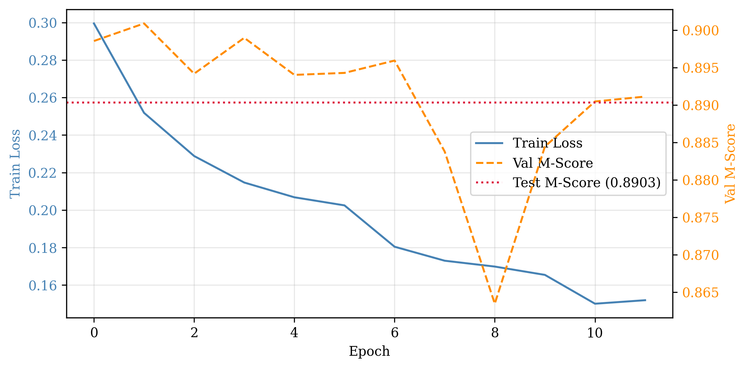
Figure 5.3: Confusion matrix for the final diagnostic model (Run 6) on the test set. Left: evaluated on Pi (INT8); Right: evaluated on training machine (FP32). 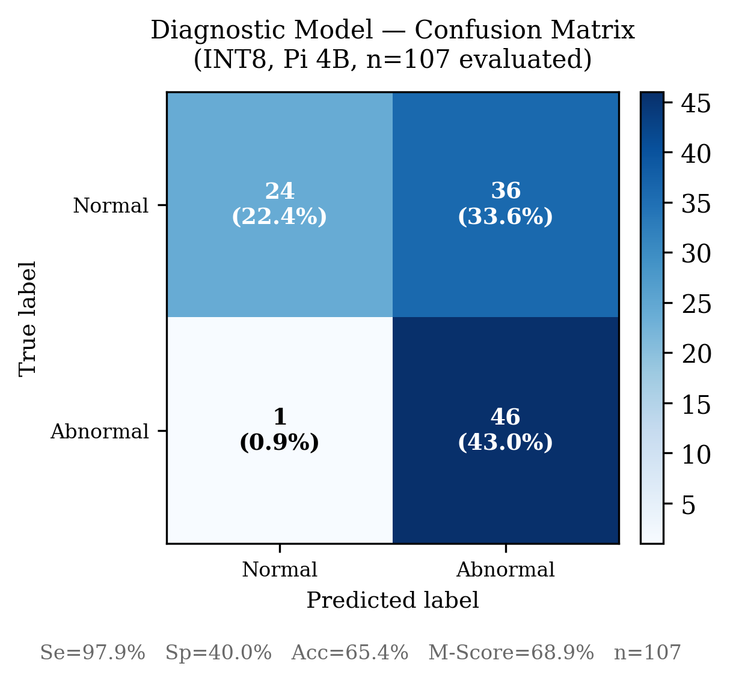 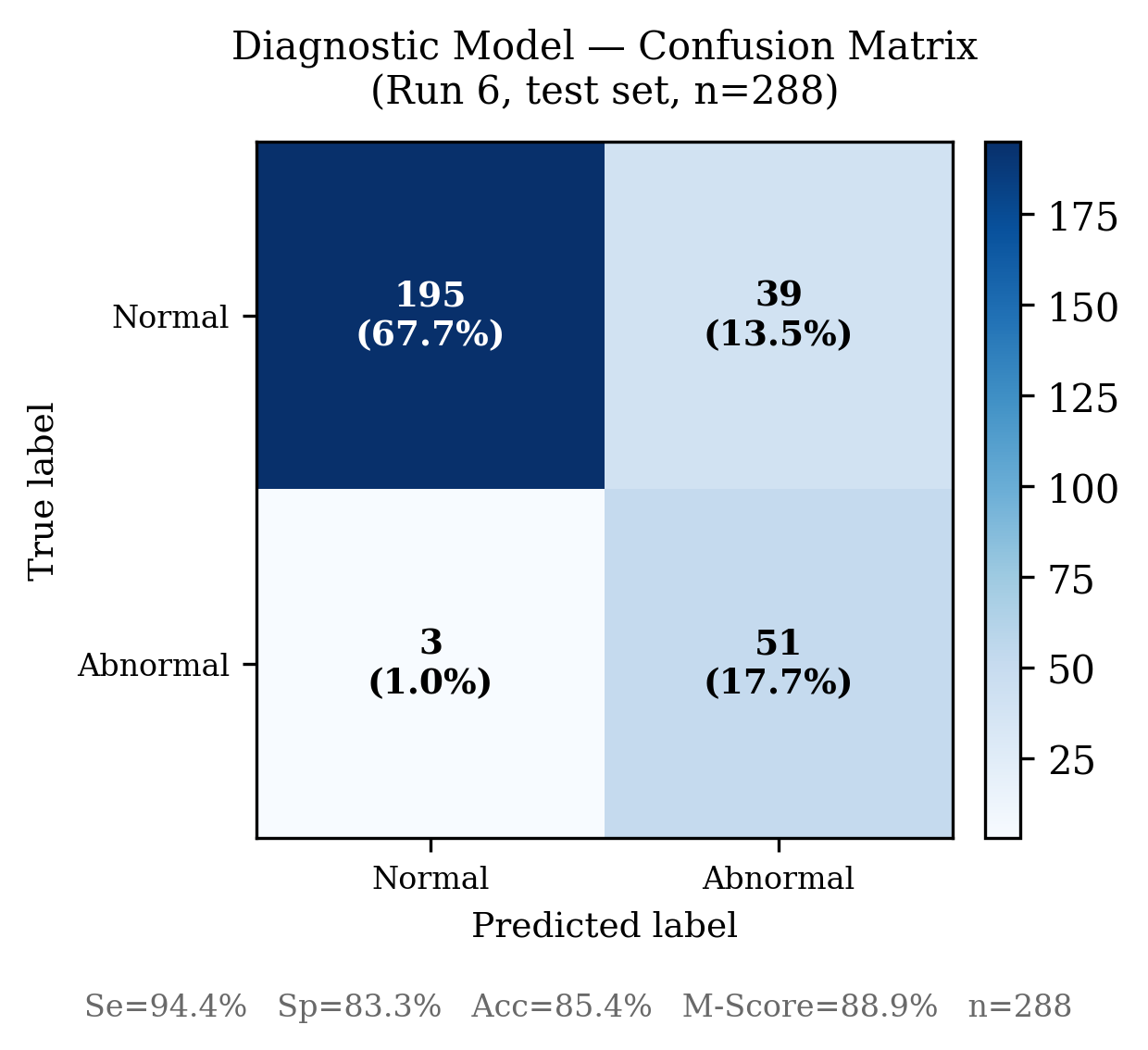

5.2.2 Hyperparameter Search
A Bayesian sweep over 40 trials was conducted using Weights & Biases, optimising for validation M-Score. The search space covered n_mels ∈ {32, 64}, hop_length ∈ {64, 96, 128}, n_fft ∈ {128, 256, 512}, overlap ∈ {0.25, 0.5, 0.75}, learning rate ∈ {3×10⁻⁴, 5×10⁻⁴, 1×10⁻³}, and weight_decay ∈ {1×10⁻⁴, 1×10⁻³}.
Table 5.2: Top 3 sweep trials (validation M-Score).
Rank | Val M-Score | Val Se | Val Sp | n_mels | hop | n_fft | overlap | lr | weight_decay
1 | 0.9033 | 0.9510 | 0.8556 | 64 | 128 | 256 | 0.75 | 1e-3 | 1e-3
2 | 0.9031 | 0.9677 | 0.8386 | 64 | 96 | 256 | 0.75 | 1e-3 | 1e-3
3 | 0.9000 | 0.9539 | 0.8462 | 64 | 128 | 256 | 0.75 | 1e-3 | 1e-3
The configuration n_mels = 64, n_fft = 256, overlap = 0.75, lr = 1×10⁻³ appears consistently across the top trials, indicating a stable optimal region. The selected parameters for the final model are n_mels = 64, hop = 128, n_fft = 256, weight_decay = 1×10⁻³.
Figure 5.4: Distribution of validation M-Score across all 40 hyperparameter sweep trials. 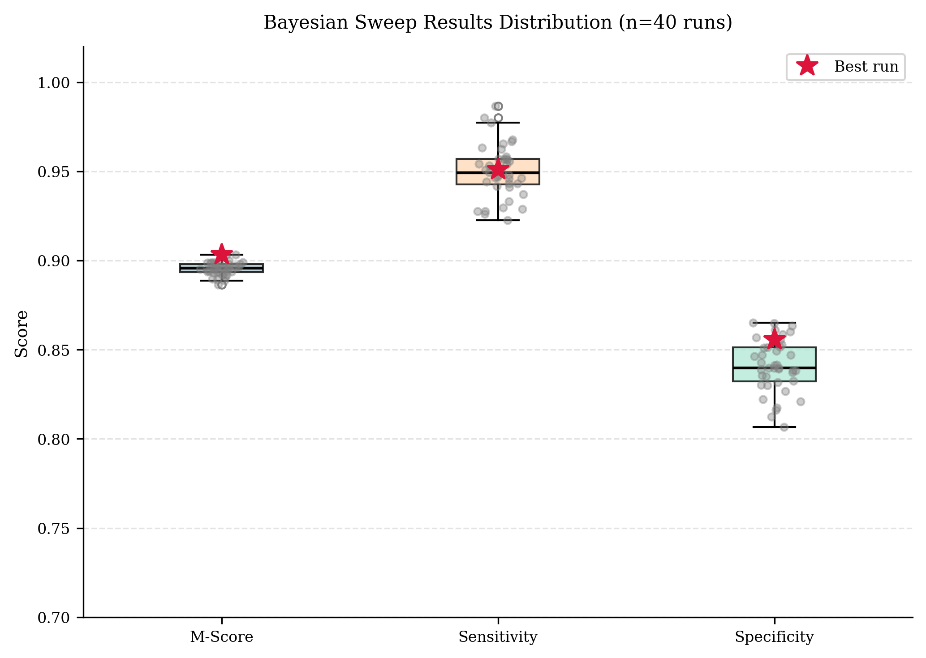
Figure 5.5: Validation M-Score for the top-performing sweep configurations. 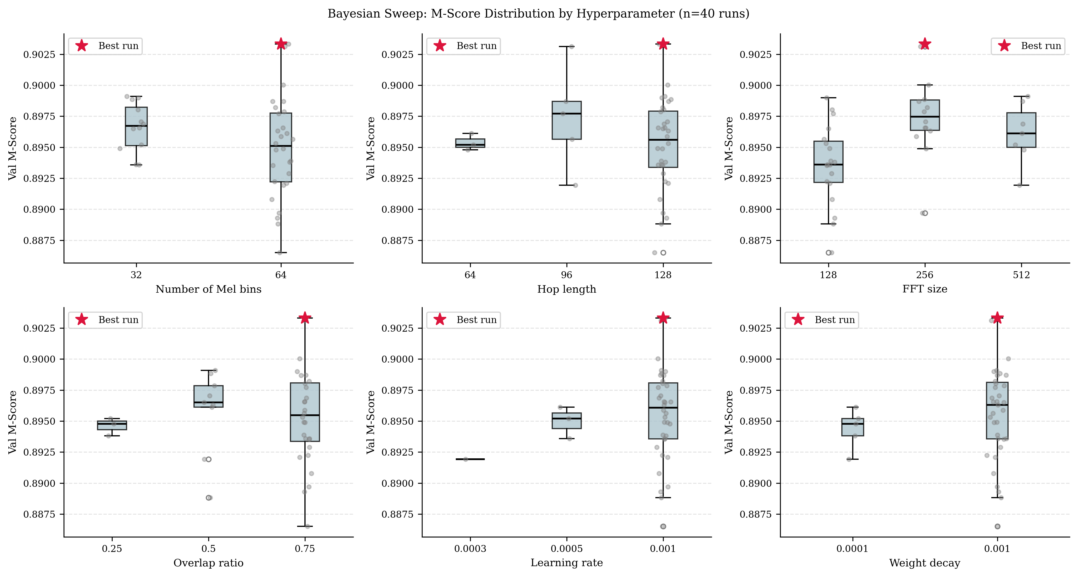

5.2.3 Decision Threshold Analysis
The default classification threshold of 0.5 was evaluated against a sweep from 0.30 to 0.80 on the Run 1 model. Results are shown in Table 5.3.
Table 5.3: Threshold sweep on Run 1 model (test set).
Threshold | Se | Sp | M-Score
0.30 | 0.9890 | 0.7787 | 0.8839
0.35 | 0.9840 | 0.7860 | 0.8850
0.40 | 0.9764 | 0.7947 | 0.8855
0.45 | 0.9688 | 0.8031 | 0.8859
0.50 | 0.9569 | 0.8135 | 0.8852
0.55 | 0.9417 | 0.8218 | 0.8817
0.60 | 0.9231 | 0.8332 | 0.8782
0.70 | 0.8547 | 0.8562 | 0.8554
0.80 | 0.7652 | 0.8915 | 0.8284
The optimal threshold (0.45) improves M-Score by only 0.0007 over the default 0.50, confirming that the Se/Sp imbalance is a property of the learned decision boundary rather than a post-processing artefact. The default threshold of 0.50 is retained for deployment, as it provides the highest Se (0.9569), which is the more clinically critical metric in a home screening context.
Figure 5.6: Se, Sp, and M-Score as a function of classification threshold on the Run 1 test set. 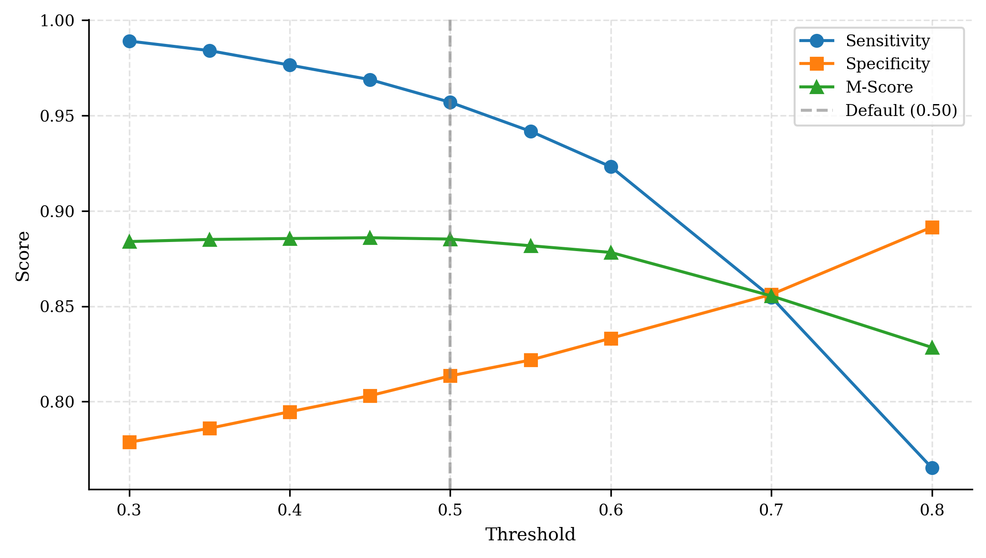

5.3 SQA Model Results
- 训练结果（Test M-Score / Se / Sp）
The SQA model shares the same LightweightCNN + CoordAtt architecture (65.12K parameters) and training hyperparameters as the final diagnostic model (batch = 16, early stopping patience = 10). The dataset is metadata_quality_reversed.csv (3,240 recordings, Bad:Good = 364:2,876), split 80/10/10 by recording, yielding 54,842 training, 6,536 validation, and 6,726 test segments. Preprocessing uses the final configuration (n_mels = 64, hop = 128). Three training runs were conducted to progressively address the Se deficit caused by the more severe 8:1 class imbalance.
Table 5.6: SQA model — validation M-Score across training epochs (Run 1 baseline).
Epoch | Val Se (Bad) | Val Sp (Good) | Val M-Score
1 | 0.7409 | 0.8592 | 0.8000
3 | 0.7263 | 0.8826 | 0.8044
9 | 0.7172 | 0.9036 | 0.8104
12 | 0.7281 | 0.9050 | 0.8165 ← best
22 | 0.6825 | 0.9377 | 0.8101 (early stop)
Run 1 (lr = 1×10⁻³, CrossEntropyLoss, dropout = 0.3) establishes the baseline. Validation M-Score oscillates noticeably across epochs (0.78–0.82), a sign of unstable training under the 8:1 imbalance. Test Se = 0.7173: 28.3% of bad-quality segments pass through to the diagnostic model undetected.
Run 2 adds an explicit class weight of [1, 8] to the loss function and reduces the learning rate to 5×10⁻⁴ (scheduler patience raised from 3 to 5). The loss weighting directly penalises missed Bad-class predictions more heavily. Val oscillation narrows (0.80–0.83), and test Se improves to 0.7651 (+0.048). Sp drops to 0.8554 as expected from the stronger minority-class bias.
Run 3 increases dropout from 0.3 to 0.5, retaining all other Run 2 changes. The heavier regularisation reduces overfitting on the small Bad-class population: test Se reaches 0.8274 (+0.062 over Run 2), and the train/val loss gap narrows. The best validation checkpoint now appears at Epoch 2—earlier convergence than Run 2—after which M-Score declines monotonically to early-stop at Epoch 12. Run 3 is selected as the final SQA model.
Table 5.7: SQA model — three-run progression.
Metric | Run 1 | Run 2 | Run 3 (final) | Run 1→3 change
Test M-Score | 0.8046 | 0.8102 | 0.8152 | +0.011
Test Se (Bad) | 0.7173 | 0.7651 | 0.8274 | +0.110
Test Sp (Good) | 0.8919 | 0.8554 | 0.8029 | −0.089
Test Accuracy | 0.8794 | 0.8489 | 0.8046 | —
Best Val Se | 0.7281 | 0.8120 | 0.8759 | +0.148
Val→Test Se gap | −0.011 | −0.047 | −0.048 | stable ~0.05
Early stop epoch | 22 | 22 | 12 | faster
Table 5.8: Final SQA model (Run 3) vs diagnostic model.
Metric | Diagnostic Model (Run 6) | SQA Model (Run 3)
Test M-Score | 0.8903 | 0.8152
Test Se | 0.9485 | 0.8274
Test Sp | 0.8322 | 0.8029
Test Accuracy | 0.8541 | 0.8046
Class imbalance | 4:1 | 8:1
Figure 5.7: SQA model M-Score, Se, and Sp across three training runs. 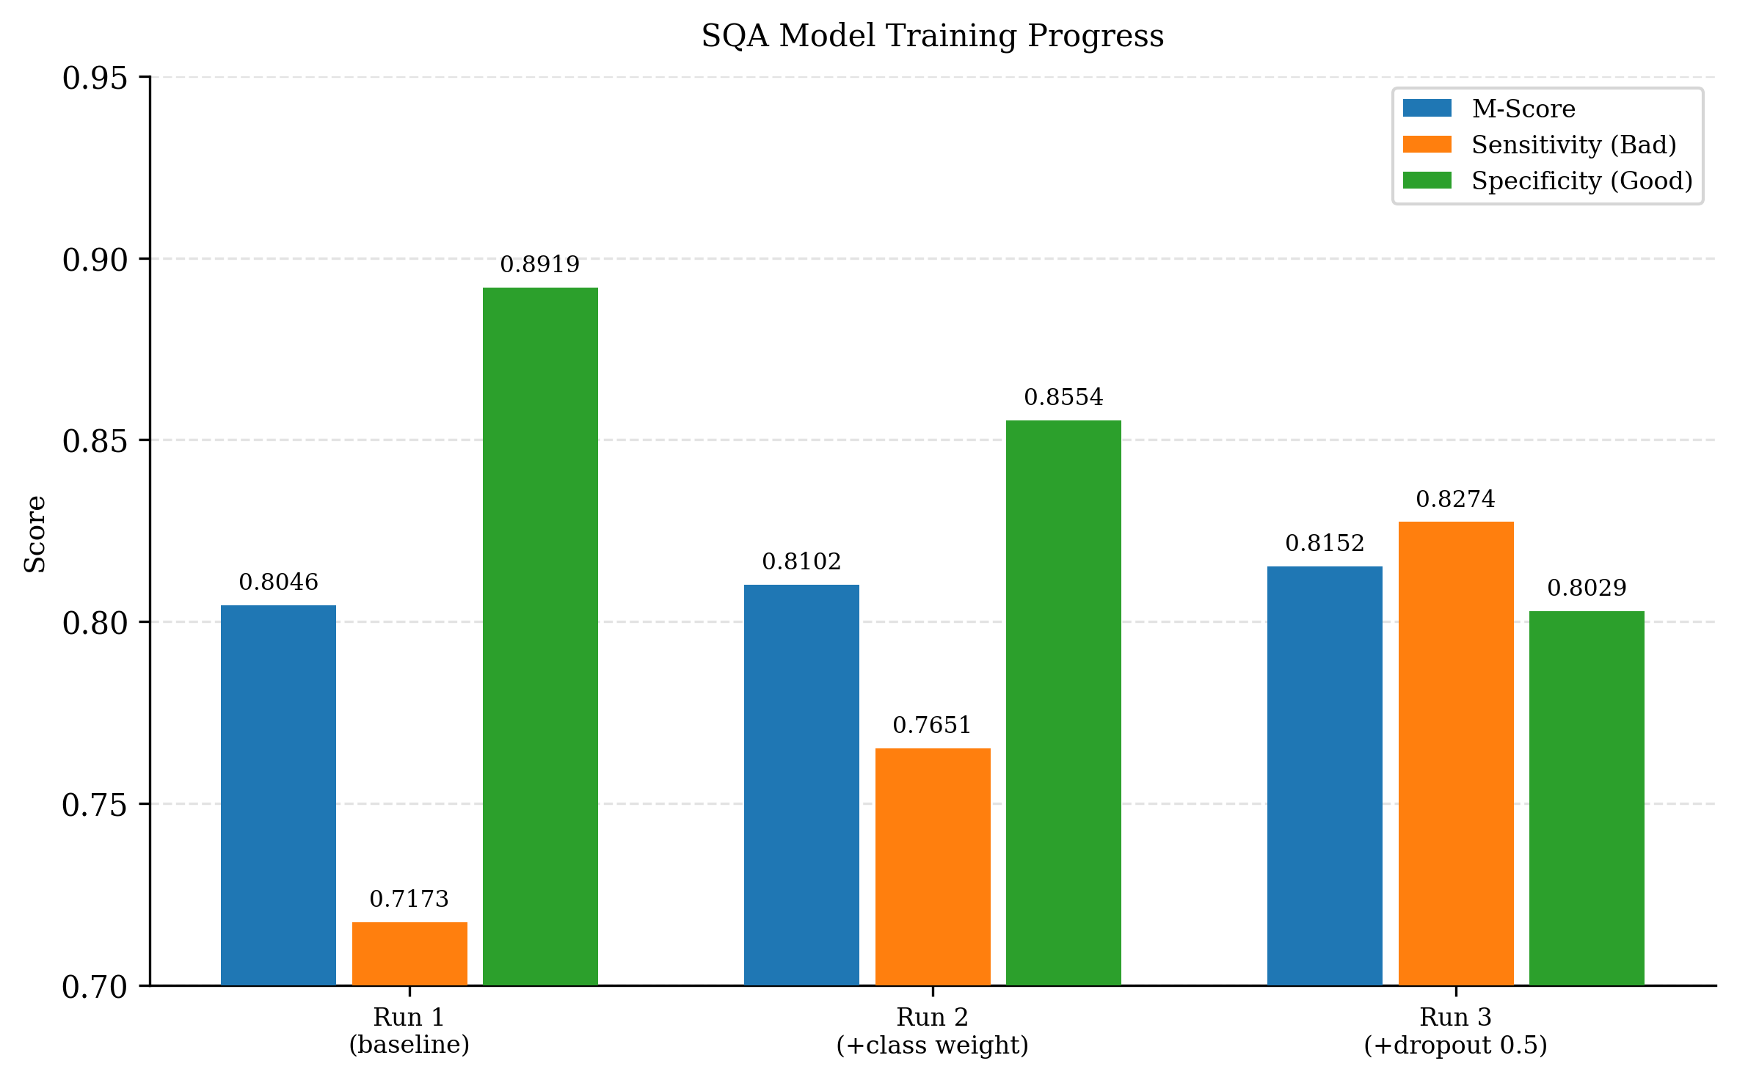
Figure 5.8: Confusion matrix for the final SQA model (Run 3) on the test set. Left: evaluated on Pi (INT8); Right: evaluated on training machine (FP32). 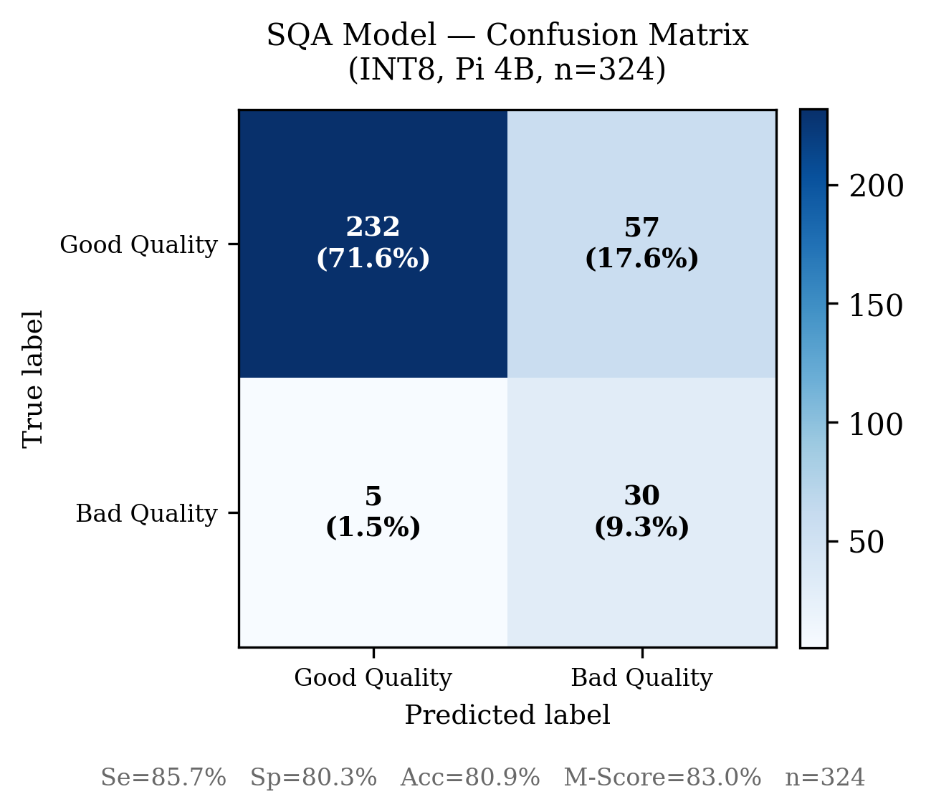 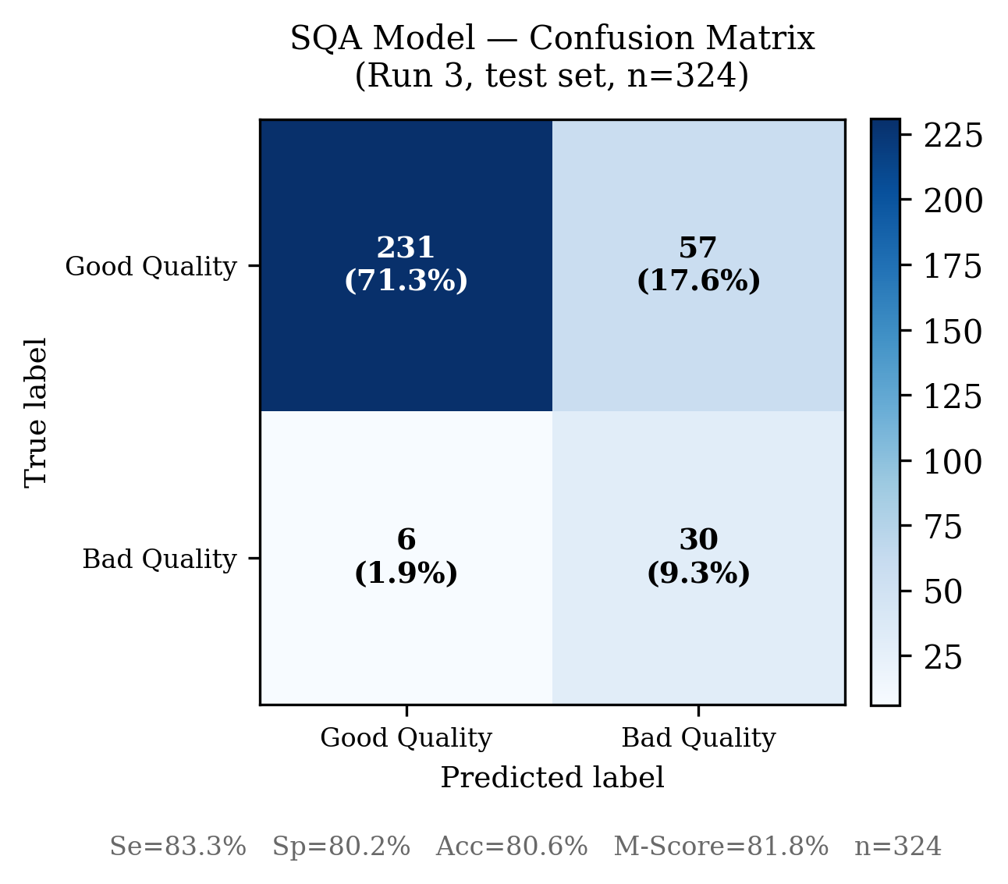
The persistent Val→Test Se gap of approximately 0.048 across Runs 2 and 3 indicates that the generalisation ceiling is constrained by the small Bad-class population (364 recordings total; roughly 36 recordings in the test split), rather than by the training configuration. Further Se improvement would require additional bad-quality data. The Sp of 0.8029 means approximately 20% of good-quality recordings receive a lower P(Good) weight in the inference aggregation; this reduces effective signal volume but does not introduce noise into the diagnostic stage, and is considered acceptable given the deployment context.

5.4 Ablation Study
- Baseline CNN（无注意力）

  - Coordinate Attention

  - Residual Connection
- 各步骤指标对比
To quantify the contribution of each architectural component, four model variants were trained under identical conditions: the same dataset split, preprocessing parameters (n_mels = 32, hop = 96, n_fft = 256, overlap = 0.5), training hyperparameters (batch = 16, lr = 1×10⁻³, weight_decay = 1×10⁻⁴, early stopping patience = 10), and class balancing strategy. The variants form a cumulative chain, each adding one modification to the previous.
Table 5.4: Ablation study results. All variants trained on the same fixed test split.
Config | Params | Test M-Score | Test Se | Test Sp | Test Acc | Best Epoch
A: Baseline (16→32→64→128, no attention) | 12.87K | 0.8851 | 0.9654 | 0.8049 | 0.8352 | 1
B: + Wider channels (32→64→128→256) | 47.23K | 0.8896 | 0.9595 | 0.8198 | 0.8462 | 1
C: + CoordAtt + Dropout(0.3) | 65.12K | 0.8869 | 0.9383 | 0.8355 | 0.8549 | 5
D: + Residual connections | 108.10K | 0.8912 | 0.9797 | 0.8027 | 0.8361 | 2
A → B: Wider channels. Doubling the channel width throughout (+0.005 M-Score) improves both Se and Sp marginally. The best epoch remains 1, indicating that the model still overfits rapidly and that increased capacity alone does not improve training dynamics.
B → C: CoordAtt + Dropout. Adding Coordinate Attention and Dropout (rate 0.3) produces the most notable change in training behaviour: the best validation epoch shifts from 1 to 5, indicating substantially better regularisation. M-Score decreases slightly (−0.003) relative to B, but Sp increases by +0.016 and the Se/Sp gap narrows from 0.134 to 0.103. The contribution of CoordAtt is therefore more accurately characterised as improved training stability and better Se/Sp balance than raw M-Score gain.
C → D: Residual connections. Residual connections yield the highest test M-Score (0.8912, +0.004 over C), driven by a large Se increase (+0.041). However, Sp drops to 0.8027—lower than any other variant—and the best epoch regresses to 2, suggesting that residual connections accelerate convergence at the cost of reinforcing the model’s tendency to over-predict Abnormal. The Se/Sp gap widens to 0.177.
Figure 5.9: Ablation study — M-Score, Sensitivity, and Specificity across four model configurations. 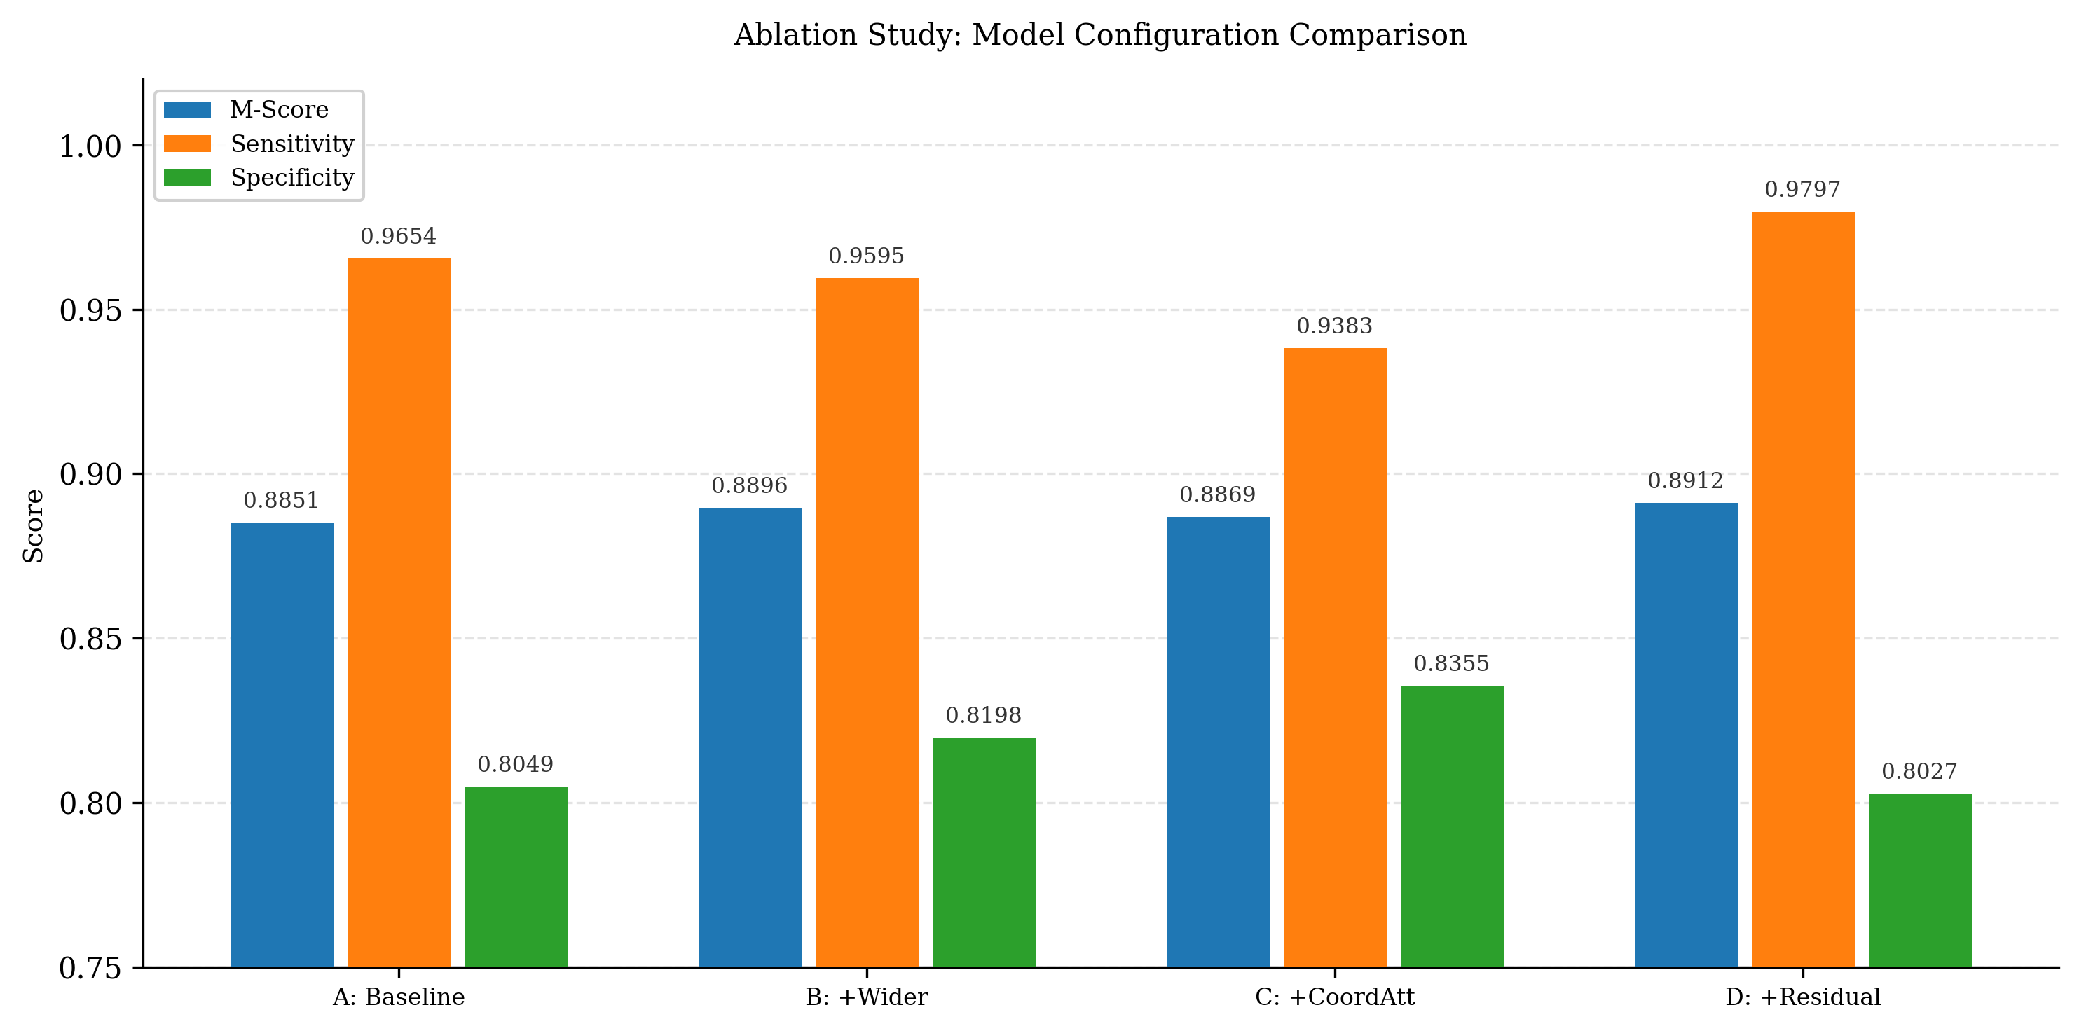
Architecture selection. Config C is selected as the final architecture. While D achieves the highest M-Score, its Se/Sp imbalance (0.177 gap) is worse than A (0.161) and substantially worse than C (0.103). In a home screening device where missed abnormal cases carry greater clinical risk than false alarms, Se is more important than Sp—but the magnitude of Sp degradation in D (0.8027, a 32.8% false alarm rate on normal recordings) is considered unacceptable for a practical device. Config C provides the best balance across all three criteria: Se/Sp balance, training stability, and parameter efficiency.

5.5 Quantization Impact
- FP32 vs INT8 准确率对比
- 模型大小对比
- 推理延迟对比
Table 5.5: FP32 vs quantized model comparison.
Metric | FP32 | Quantized (Dynamic Range INT8) | Change
Model size | 302.8 KB | 144.7 KB | −52.2%
Test M-Score | 68.9% | 68.9% | 0.0%
Test Se | 97.9% | 97.9% | 0.0%
Test Sp | 40.0% | 40.0% | 0.0%
Inference latency (Pi 4B) | 13.44 ms | 13.43 ms | −0.1%
Figure 5.10: FP32 vs INT8 model size comparison for diagnostic and SQA models. 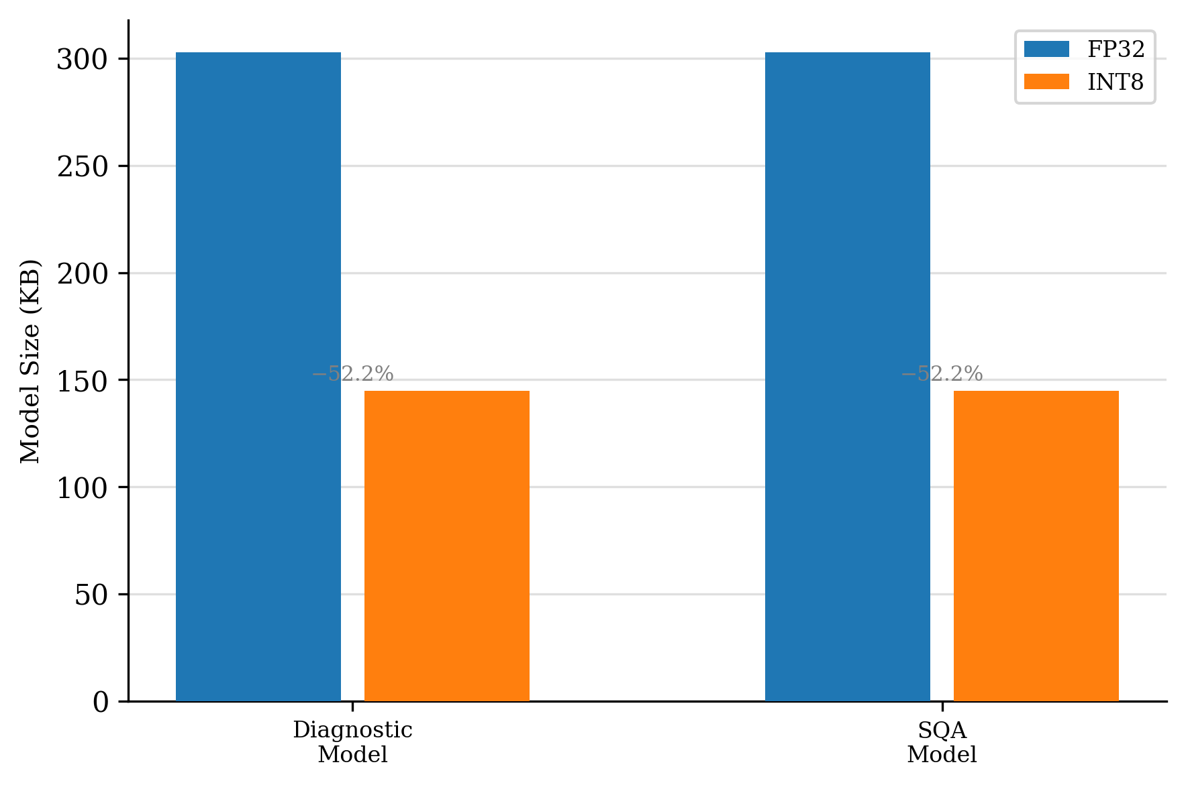
Note for writing: Dynamic range quantization only statically quantizes weights; activations are quantized at runtime per call. This means the latency reduction relative to FP32 may be modest compared to full INT8 quantization (where both weights and activations are fixed at INT8 and the hardware can execute true INT8 GEMM). If the benchmark shows limited speedup, this is the expected explanation—not a flaw in the implementation.

Chapter 6: Edge Deployment

6.1 System Architecture Overview
The deployed system consists of two physical units: an ESP32-based acquisition device and a Raspberry Pi 4B inference station, communicating exclusively over Bluetooth Low Energy (BLE). The separation of concerns between the two units is deliberate: the ESP32 handles only signal capture and wireless transmission, keeping its firmware simple and power-efficient, while all computation-intensive processing—filtering, feature extraction, and model inference—runs on the Pi.
┌─────────────────────────────────┐
│ ESP32 (acquisition) │
│ │
│ Microphone → ADC → PCM buffer │
│ → BLE GATT notification (128 B) │
└────────────────┬────────────────┘
│ BLE 2.4 GHz
┌────────────────▼────────────────┐
│ Raspberry Pi 4B (inference) │
│ │
│ BLE rx → preprocess → SQA → │
│ diagnostic → weighted average │
│ → result storage + display │
└────────────────┬────────────────┘
│ I2C / GPIO
┌────────────────▼────────────────┐
│ Peripherals │
│ OLED × 2 │ button │ LED │
└─────────────────────────────────┘
ESP32 (acquisition side). An analogue electret microphone feeds a signal conditioning amplifier whose output connects to ESP32 ADC pin GPIO34. The ADC samples at 2,000 Hz with 12-bit resolution; samples are cast to 16-bit signed PCM (little-endian) and placed into a ping-pong double buffer to avoid sampling gaps during BLE transmission. The double-buffer arrangement decouples the 2 kHz sampling timer from the BLE stack: one buffer fills while the other is transmitted, ensuring no samples are dropped at the boundaries of BLE notification packets. Each notification carries 128 bytes (64 samples), giving one packet every 32 ms at the operating sample rate. The ESP32 runs a GATT server exposing a single custom notify characteristic (UUID beb5483e-36e1-4688-b7f5-ea07361b26a8); after disconnect it immediately restarts advertisement, making reconnection transparent to the user.
Raspberry Pi 4B (inference side). The Pi runs a single asyncio event loop (main_pi.py) that manages BLE reception, preprocessing, inference, storage, and UI updates concurrently without multi-threading. A bleak BLE client subscribes to ESP32 notifications; received bytes accumulate in a bytearray ring buffer. Once 8,000 bytes (4,000 samples = 2 seconds of audio) have arrived, the segment is passed synchronously through the full preprocessing and inference pipeline (described in Section 6.2). The inference result triggers OLED updates and, for Abnormal outcomes, automatic raw audio archival. A background asyncio task refreshes the system-status display every 2 seconds independently of the inference cycle.

6.2 Real-Time Inference Pipeline
Acquisition protocol. Each diagnostic session consists of three fixed-length 2-second recordings separated by 30-second rest intervals (NUM_COLLECTIONS = 3, COLLECTION_INTERVAL = 30 s). The rest interval allows the user to reposition the stethoscope head between recordings and for residual motion artefacts from the previous placement to decay. Three recordings are used rather than one continuous stream because cardiac auscultation requires consistent probe contact; a single long recording is more likely to contain motion-corrupted windows, while multiple short recordings at stable positions improve the signal-to-noise ratio of the aggregated result.
Preprocessing on-device. Each 2-second PCM segment (4,000 int16 samples) is converted to float32 by dividing by 32,768. The same preprocessing pipeline used during training is then applied: a 5th-order Butterworth bandpass filter (25–400 Hz, zero-phase), followed by log-Mel spectrogram extraction (n_mels = 64, n_fft = 256, hop = 128, fmin = 20 Hz, fmax = 400 Hz, power 2.0). The resulting 2D feature map is reshaped to tensor shape (1, 1, 64, 128) for TFLite input.
Cascaded TFLite inference. Each segment is processed by two INT8 quantized TFLite models loaded at startup. The SQA model runs first, producing a Good-Quality probability P(Good) ∈ [0, 1]. The diagnostic model then runs on the same input, producing an Abnormal probability P(Abnormal). No hard SQA threshold is applied; instead, the P(Good) score for each segment is used directly as a weight in the final aggregation. Across the three segments of a session, the final diagnostic score is:
score=i​P(Good)i⋅P(Abnormal)ii​P(Good)i
This weighted average down-weights acoustically degraded segments without discarding them entirely, and degrades gracefully when all segments have low quality (in which case the system reports a noise result rather than an unreliable diagnosis). The final label is Normal if score < 0.5, Abnormal otherwise.
Data flow summary.
BLE notification (128 B) → accumulate in ring buffer
→ 8000 bytes complete (= 2 s segment)
→ int16 → float32 normalisation
→ bandpass filter (Butterworth 25–400 Hz)
→ log-Mel spectrogram (64 × 128)
→ reshape to (1, 1, 64, 128)
→ SQA TFLite → P(Good)
→ Diagnostic TFLite → P(Abnormal)
→ accumulate (weight, score) pairs
→ after 3 segments: weighted average → final label
→ OLED update + optional audio archive

6.3 Performance Evaluation
This section reports inference latency, resource utilisation, and quantization accuracy on the Raspberry Pi 4B ARM Cortex-A72. All measurements are taken on-device using benchmark.py and evaluate.py.
Table 6.1: Per-stage inference latency on Pi 4B (single 2-second segment, median of 100 runs).
Stage | FP32 (ms) | INT8 (ms)
Bandpass filter | 2.24 | 2.24
Log-Mel spectrogram | 4.73 | 4.73
SQA model | 13.51 | 13.46
Diagnostic model | 13.44 | 13.43
Total per segment | 33.92 | 33.87
The bandpass filter and Log-Mel spectrogram are implemented as NumPy operations and are not subject to TFLite quantization; their latency is identical across both configurations. Quantization reduces latency only for the two TFLite model stages, though the improvement is marginal (under 0.1 ms per stage) because dynamic range quantization quantizes weights statically but leaves activations at runtime float, yielding limited arithmetic speedup on the ARM Cortex-A72 compared to full integer quantization.
Figure 6.1: Per-stage inference latency on Pi 4B, FP32 vs INT8 (median of 100 runs). Preprocessing stages are unaffected by quantization. 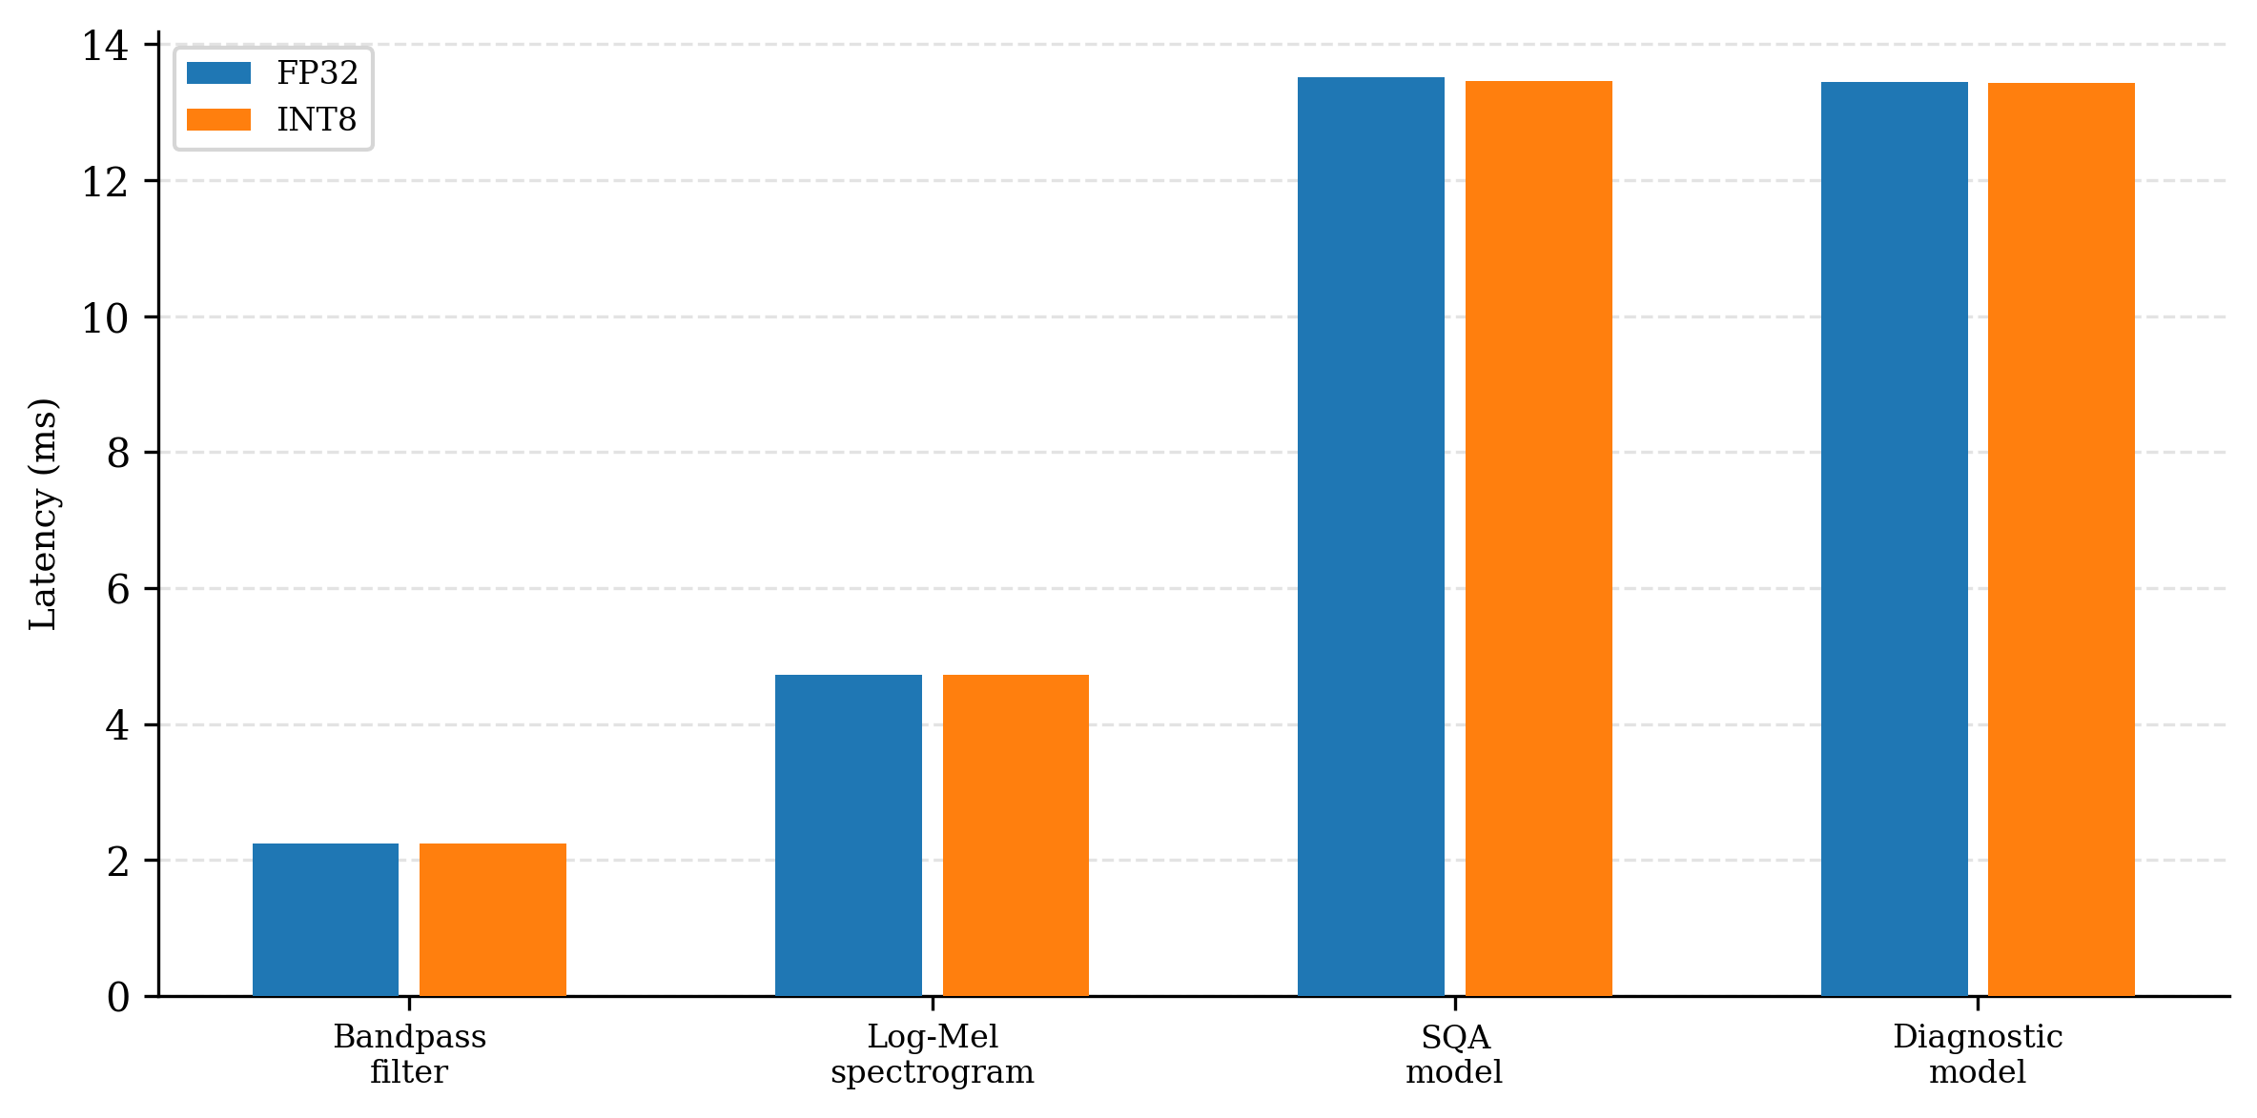
Table 6.2: Resource utilisation during a full 3-segment session.
Metric | Value
Peak CPU utilisation | 1.3%
Memory usage (RSS) | 249.9 MB
Model file size — SQA INT8 | 144.7 KB
Model file size — Diagnostic INT8 | 144.7 KB
Model file size — FP32 (each) | 302.8 KB
Realtime constraint. Each 2-second segment must be fully processed before the next segment is complete, i.e., total per-segment latency must remain under 2,000 ms. At the ARM Cortex-A72 clock speed (1.5 GHz) and given the lightweight model size (65.12K parameters, 144.7 KB INT8), the total per-segment latency of 33.9 ms satisfies the real-time constraint with a margin of approximately 59×.
Table 6.3: Quantization accuracy impact on Pi 4B (diagnostic model, test split).
Metric | FP32 | INT8 | Change
M-Score | 68.9% | 68.9% | 0.0%
Sensitivity | 97.9% | 97.9% | 0.0%
Specificity | 40.0% | 40.0% | 0.0%
Accuracy | 65.4% | 65.4% | 0.0%

6.4 User Interface
The device is designed for unsupervised home use: a user without technical expertise must be able to start a measurement, monitor its progress, and read the result using only the physical controls and onboard displays.
Physical button. A single tactile button on GPIO27 (internal pull-up, software debounce 20 ms) provides the sole user input. The interaction model is intentionally minimal:
Action | Effect
Short press (standby) | Start a diagnostic session (BLE connect → 3-segment acquisition)
Short press (during session) | Abort current session
Long press ≥ 3 s | Safe shutdown (OLED confirms → sudo shutdown -h now)
Primary OLED (128×64, SSD1306). Connected via hardware I2C (GPIO2/3, bus 1), this display presents diagnostic-facing information across three states:
- Standby: Project name, team members, and supervisor; a heart icon blinks at 1 Hz. Prompts the user to press the button.
- Connecting: “Connecting ESP32…” with a progress bar that fills over the BLE connection timeout and a live countdown in seconds.
- Running: Upper half shows the current chunk number, window progress (e.g., Win: 05/09), and the running Normal probability for the active segment; lower half shows the result and confidence from the previous segment. A heart icon blinks on each valid inference window.
Secondary OLED (128×32, SSD1306). Connected via software I2C (GPIO23/24, bus 4, configured via dtoverlay=i2c-gpio), this smaller display shows system health metrics (CPU usage, RAM utilisation, CPU temperature), refreshed every 2 seconds by a background asyncio task. It operates independently of the inference cycle and remains active throughout the session, allowing quick identification of resource pressure without interrupting the diagnostic display.
Both displays use the luma.oled library. An internal threading.Lock in each display class prevents concurrent draw calls from corrupting the framebuffer when the inference callback and the background sysinfo task write simultaneously.

6.5 System Reliability
Edge deployment introduces failure modes absent from server environments: intermittent BLE links, unclean power loss, and the absence of an operator to restart crashed processes. Three mechanisms address these.
Service auto-restart (systemd). The inference application runs as a systemd unit (heartbeat.service) with Restart=on-failure and a 10-second restart delay. The service starts after bluetooth.target and network.target, ensuring the BLE stack is initialised before the application attempts to connect. On boot, the service starts automatically; after any unhandled exception the process is respawned without user intervention.
Software watchdog. The main inference loop writes a heartbeat timestamp to /tmp/heartbeat.ts every 30 seconds. A separate lightweight watchdog process (src/watchdog.py, managed by watchdog.service) reads this file every 30 seconds; if the timestamp is more than 90 seconds old—indicating the main loop is frozen rather than merely idle—the watchdog restarts heartbeat.service via systemctl restart. The 90-second threshold is three times the heartbeat interval, tolerating transient delays from long BLE connection attempts without false positives.
BLE reconnection with exponential backoff. If the BLE link drops mid-session, the client catches the BleakDisconnectedError and re-enters the connection loop using an exponential backoff schedule: 1 s → 2 s → 4 s, capped at 30 s. This prevents the client from hammering the BLE stack during transient RF interference while still recovering promptly from brief dropouts. The ESP32 side mirrors this: on disconnect it immediately restarts advertisement, so reconnection completes as soon as the Pi retries.
Safe shutdown. SIGTERM and SIGINT are both caught by a signal handler that executes a graceful teardown sequence: stop BLE notifications → cancel pending asyncio tasks → flush log buffers → invoke sudo shutdown -h now. The same sequence is triggered by a 3-second button long press, giving the user a hardware-level shutdown path that does not risk SD card filesystem corruption from an abrupt power cut. During shutdown the primary OLED briefly displays “Shutting down…” to confirm the action was registered.

Chapter 7: Conclusion

7.1 Summary of Contributions

7.2 Limitations

7.3 Future Work

