Ex. Other renewable generation sources
1.Biomass 2. Hydro 3. Fuel Cell 4. Geothermal

1. 生物质能 Biomass
Ex. Biomass for Energy
Biomass can be burned directly for heat or converted to renewable liquid and gaseous fuels through various processes.

Ex. Advantages of Biomass
Renewable
Biomass energy is a renewable energy resource, which can be regenerated through photosynthesis of plants.
Widespread distribution
Regions lacking coal can make full use of biomass energy
Low polluting
• Low sulfur and nitrogen content of biomass, less SOX and NOX generated during combustion;
• When biomass is used as fuel, because the carbon dioxide it needs to grow is equal to the amount of carbon dioxide it emits, so the net emission of carbon dioxide to the atmosphere is approximately zero, which can effectively reduce the greenhouse effect;
The total amount is very rich
• Biomass energy is the world's fourth largest source of energy, after coal, oil and natural gas. Biologists estimate that the earth's landmasses produce between 100 and 125 billion tons of biomass annually; Oceans produce 50 billion tons of biomass a year.

Ex. Disadvantages of Biomass
• Construction and operation costs are relatively high
• Weak technology development capacity and industrial system
• Insufficient raw materials
• Agriculture and forestry biomass is dispersed and seasonal characteristics, the current raw material collection mainly rely on artificial and small machinery, transport rely mainly on general transport, it is difficult to meet the needs of the biomass energy scale use.

Q1. Describe how a Run-of-the-rive mini hydro power plant works.
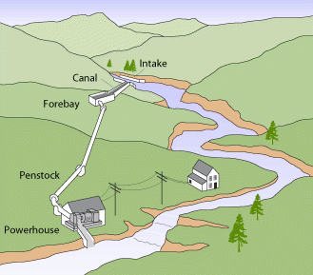

-A run-of-the-river mini hydro power plant captures the natural flow of a river, directing it through a pipe to spin turbines, which in turn generate electricity. The water then flows back into the river without being stored in a reservoir.

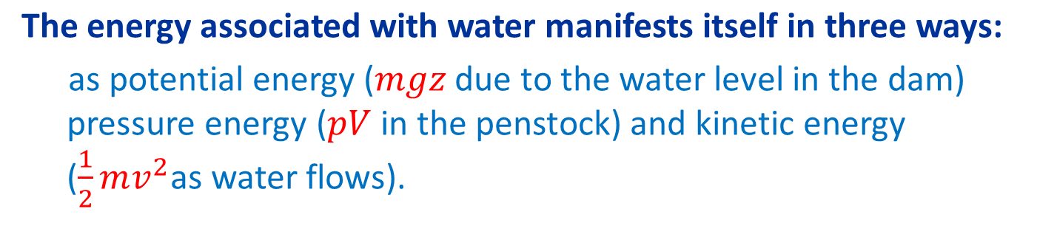
EX. 水能相关知识点
Transformation of energy from potential, to pressure, to kinetic.
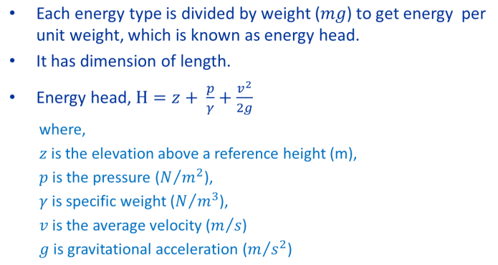

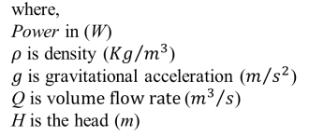

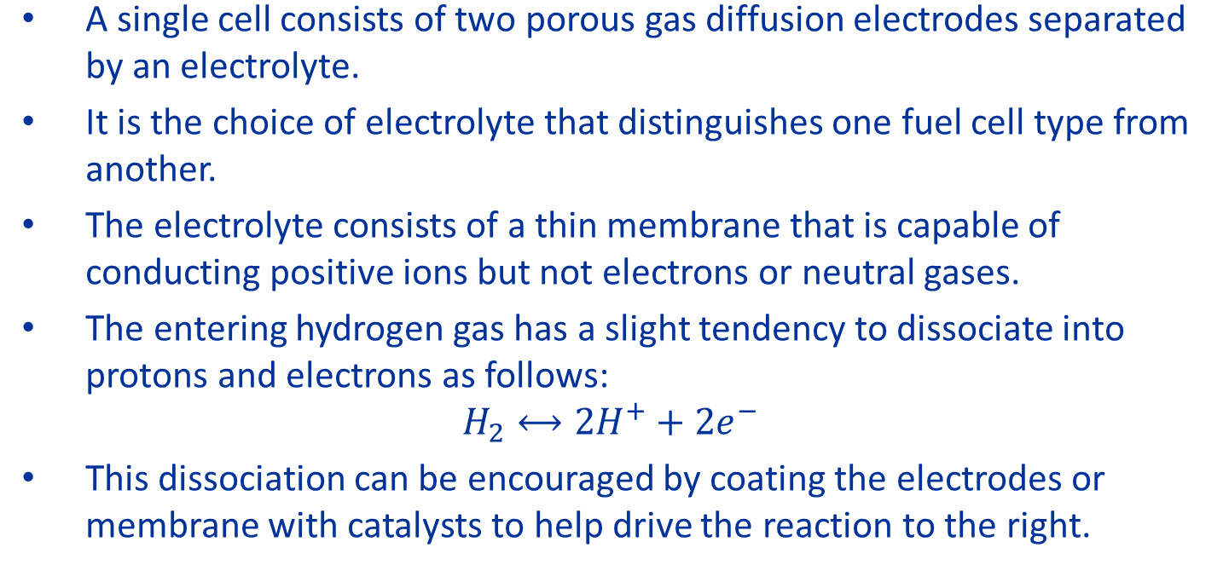
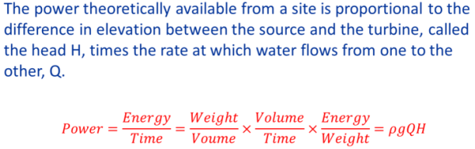

Q2. 计算水能
A Run-of-the-river mini hydro power plant has following operational parameters:
Water Flow rate = 1000 litres/min
Height difference between source of water and the location of the turbine/generator = 50 meter
Length of the PVC pipe = 100m
Diameter of the PVC pipe = 100mm
Efficiency of the turbine/generator combined = 50%
a) What is the power output of the plant neglecting the losses in the PVC pipe?
b) How much energy will be produced in a month if the PVC pipe friction loss is 20%?
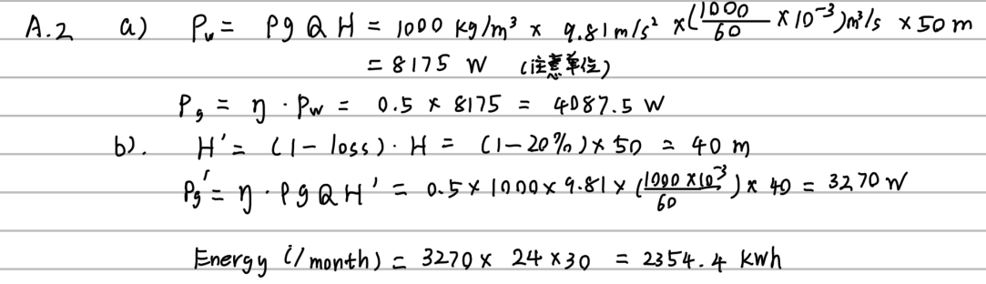

Q2 Ex.
Suppose a 10 cm diameter penstock delivers 450 litres per minute of water through an elevation change of 30 meter. The pressure in the pipe is 200 kN/m2 when it reaches the powerhouse.
i. What fraction of the available head is lost in the pipe?
ii. What power is available for the turbine?
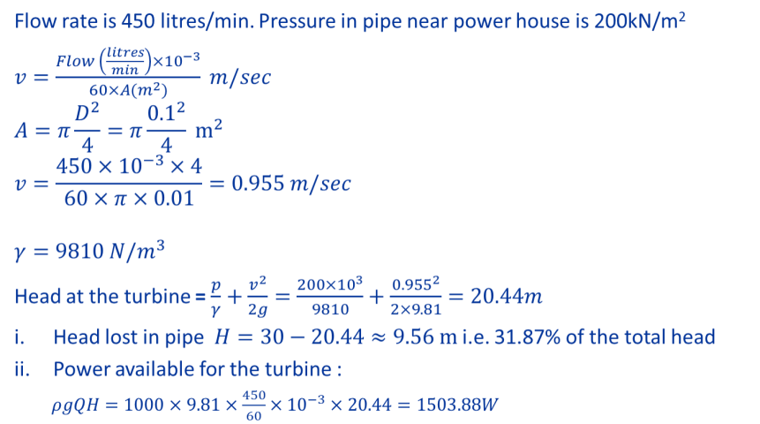

Ex. Home scale hydro plants and Turbines
With a high-head site, lower flow rates translate into smaller diameter piping, which is more readily available and a lot easier to work with, as well as smaller, less expensive turbines. Home-scale projects with modest flows and decent heads can lead to quick, simple, cost-effective systems. There will be pipe losses. PVC pipe has lower friction losses and it is also less expensive than polyethylene pipe. The cost of the piping is often a significant fraction of the total cost of a micro-hydro project. Efficiency of turbine-generator is about 50%.
Three different approaches to transforming that waterpower into the mechanical energy of the turbine
• Impulse turbines capture the kinetic energy of high-speed jets of water squirting onto buckets along the circumference of a wheel.
• In a reaction turbine it is mostly the pressure difference across the runners, or blades, of these turbines that create the desired torque.
• Waterwheel converts potential energy into mechanical energy. Due to its slowness, it is not used in the generation of electricity.

Ex. Electrical part of micro-hydro
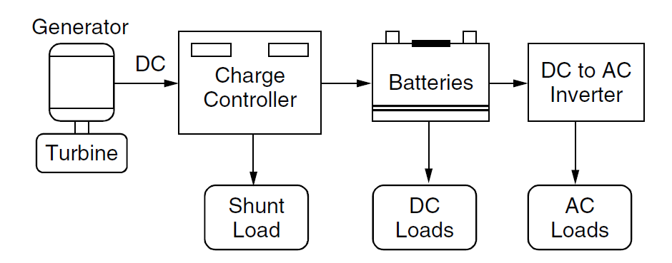

2. 燃料电池 Fuel Cells
Ex. Fuel Cells 燃料电池种类与原理
Fuel cells convert chemical energy contained in a fuel (hydrogen, natural gas, methanol, gasoline, etc.) directly into electrical power. Fuel-to-electric power efficiencies as high as 65% are likely, roughly twice as efficient as the average central thermal power stations. The usual combustion products (SOx, particulates, CO, and various unburned or partially burned hydrocarbons) are not emitted. They are inherently modular in nature, so that small amounts of generation capacity can be added as loads grow.
Types of Fuel Cells
• Proton Exchange Membrane Fuel Cells (PEMFC)
• Direct Methanol Fuel Cells (DMFC)
• Phosphoric Acid Fuel Cells (PAFC)
• Alkaline Fuel Cells (AFC)
• Molten-Carbonate Fuel Cells (MCFC)
• Solid Oxide Fuel Cells (SOFC)

Q3. PEM燃料电池的运作方式
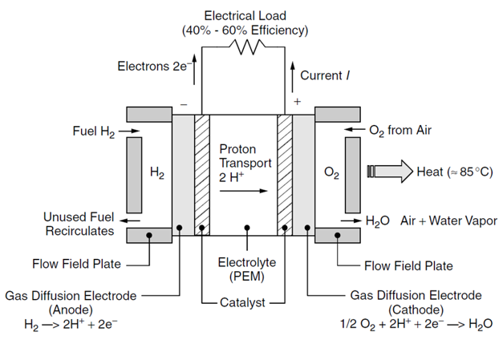
Using appropriate diagram and equation, describe the basic operation of a proton exchange membrane (PEM) fuel cell.
Basic Operation of Fuel Cells:

Q4. PEM燃料电池电气性质曲线
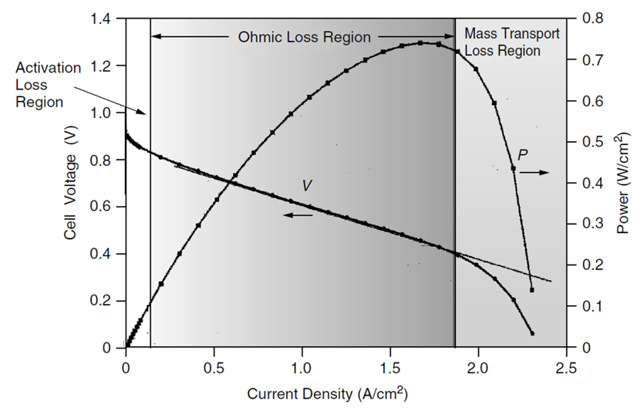
Draw the typical electrical characteristics of a PEM fuel cell, clearly marking different operating regions.

Q5. 燃料电池中存在的损失
Describe various types of losses in a Fuel cell which reduces its performance.
Losses in the Fuel Cell:
• Activation losses result from the energy required by the catalysts to initiate the reactions. The relatively slow speed of reactions at the cathode, where oxygen combines with protons and electrons to form water, tends to limit fuel cell power.
• Ohmic losses result from current passing through the internal resistance posed by the electrolyte membrane, electrodes, and various interconnections in the cell.
• Another loss, referred to as fuel crossover, results from fuel passing through the electrolyte without releasing its electrons to the external circuit.
• And finally, mass transport losses result when hydrogen and oxygen gases have difficulty reaching the electrodes. This is especially true at the cathode if water is allowed to build up, clogging the catalyst.
For these and other reasons, real fuel cells, in general, generate only about 60–70% of the theoretical maximum.

Q6. DM燃料电池相比于PEM的好处
What are the key advantages of Direct Methanol Fuel cell over PEM fuel cell?
--These cells use the same polymer electrolytes as PEM cells do, but they offer the significant advantage of being able to utilize a liquid fuel, methanol (CH3OH), instead of gaseous hydrogen. Liquid fuels are much more convenient for portable applications such as motor vehicles as well as small, portable power sources for everything from cell phones and laptop computers to replacements for diesel-engine generators.

Q7. 碱性电池的主要特征
Describe the key characteristics of Alkaline Fuel cell?
--Their electrolyte is potassium hydroxide (KOH), and the charge carrier is OH− rather than H+ ions. The two electrodes are separated by a porous matrix saturated with an aqueous alkaline solution, such as potassium hydroxide (KOH). Aqueous alkaline solutions do not reject carbon dioxide (CO2) so the fuel cell can become "poisoned" through the conversion of KOH to potassium carbonate (K2CO3). Because of this, alkaline fuel cells typically operate on pure oxygen. Since air is the source of O2 for the cathodic reactions, it is unlikely that these will be used in terrestrial applications.

Q8. 使用燃料电池的发电厂的关键优点
What are the key advantages of Fuel cell over fossil fuel based power plants?
•Fuel cells convert chemical energy contained in a fuel (hydrogen, natural gas, methanol, gasoline, etc.) directly into electrical power.
•Fuel-to-electric power efficiencies as high as 65% are likely, roughly twice as efficient as the average central thermal power stations.
•The usual combustion products (SOx, particulates, CO, and various unburned or partially burned hydrocarbons) are not emitted.
•They are inherently modular in nature, so that small amounts of generation capacity can be added as loads grow.

Q9. 水的电解产生氢气
Describe Electrolysis of water for production of Hydrogen
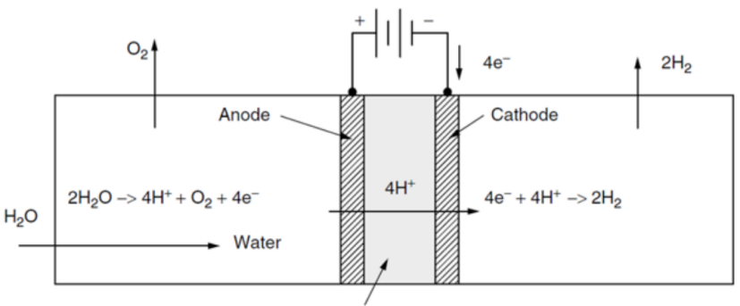

When an electrical current is forced through water added with an eletrolyte, water molecules can be broken apart, releasing hydrogen and oxygen gases: 2H2O →2H2 + O2
• De-ionized water introduced into the oxygen side of the cell dissociates into protons, electrons, and oxygen.
• The oxygen is liberated, the protons pass through the membrane, and the electrons take the external path through the power source to reach the cathode where they reunite with protons to form hydrogen gas.
• Overall efficiency can be as high as 85%.
• When the electricity for electrolysis is generated using a renewable energy system, such as wind, hydro, or photovoltaic power, hydrogen is produced without emission of any greenhouse gases.

3. 能源经济学
• The three cost components:
(1). capital cost of equipment,
(2). the operation and maintenance costs, and
(3). the fuel costs
must be combined in some manner so that a comparison may be made with the costs of not doing the project.
• Methods of checking economic viability
(1). Simple Payback Period
(2). Initial (Simple) Rate-of-Return
(3). Net Present Value
• Simple Payback Period 简单回收投资期限 (Q13)
This is just the ratio of the extra first cost △P to the annual savings, S.
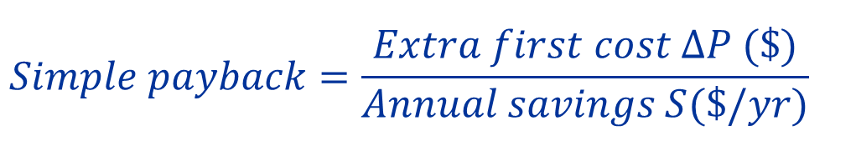

For example, an energy-efficient air conditioner that costs an extra$1000 and which saves $200/yr in electricity would have a simple payback of 5 years.
• Initial (Simple) Rate-of-Return

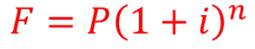
• Present Value and Future Value 现值与未来值
All future costs are converted to an equivalent present value or present worth. If you have amount P in your bank account today and earn annual interest at rate of (j) then after n years, it will grow to:
• Discount rate 贴现率
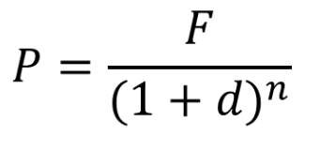
When converting a future value F into a present worth P, the interest term ‘i’ is usually referred to as a discount rate ‘d’
• Present value function (PVF) 现值函数
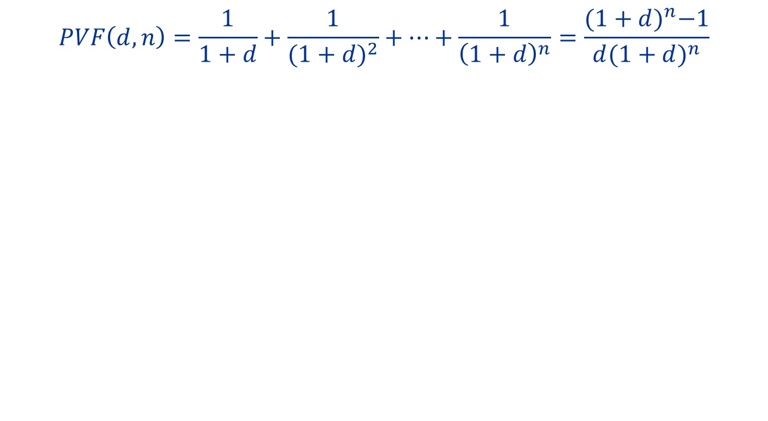
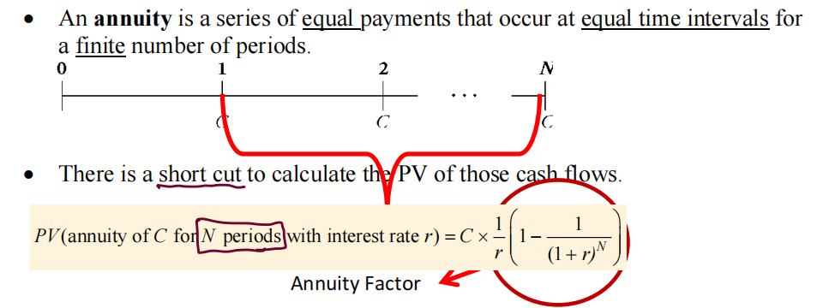
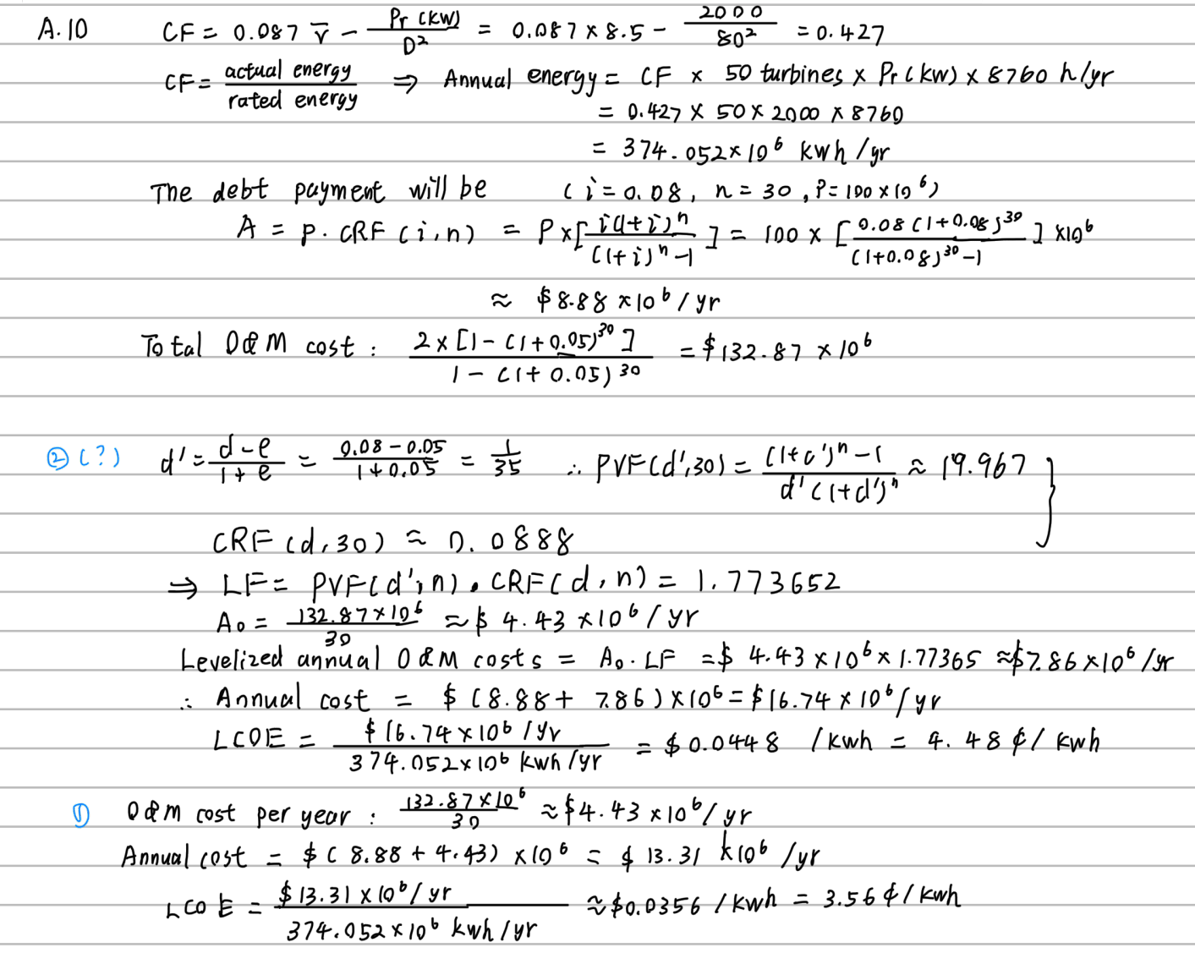
To find the present value P of a stream of annual cash flows A (Annuity 年金，每年固定现金流), for n years into the future, with a discount rate d
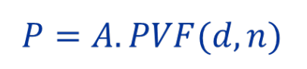

• Net present value (NPV) 净现值
The difference between the Present Value of the investment's benefits and the present value of its cost.
NPV = PV (benefits) – Initial investment (cost)
NPV = -C0 + C1/(1+r) + C2/(1+r)2 + C3 /(1+r)3 ..... + Cn /(1+r)n
NPV = A x PVF(d, n) - C0 (年金情况下)
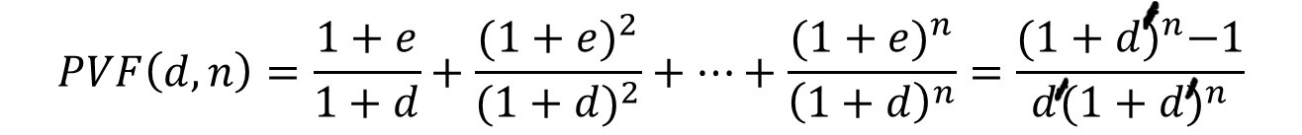
• PVF with Fuel Escalation
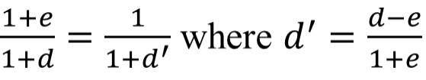
Fuel price escalation factor (e) is used in the present worth analysis:

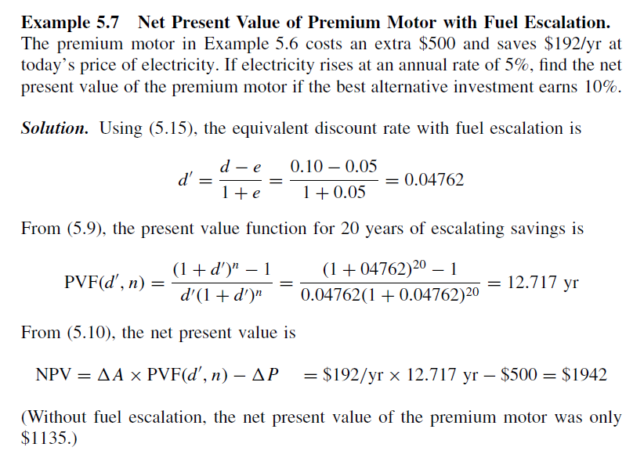
EX

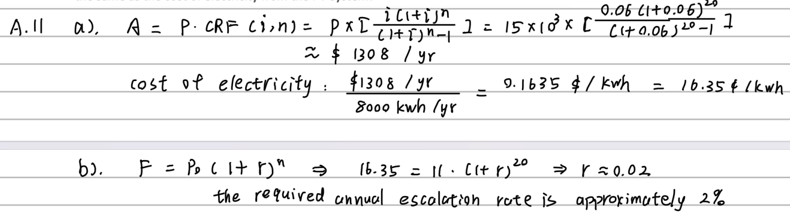

• Internal Rate of Return (IRR) 内部收益率
IRR is the discount rate that makes the net present value of the energy investment equal to zero. Any project with an IRR greater than its cost of capital should be a profitable one.
• Annualizing the Investment 借贷问题
Extra capital required for an energy investment will be borrowed from a lending company. The extra capital cost is converted into a series of n(year) equal payments (A) that eventually pay off the loan(P) with interest (i):
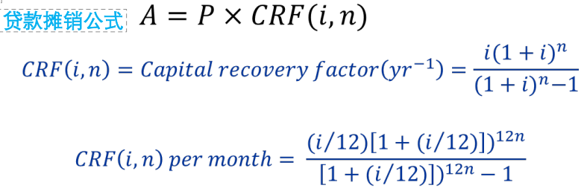

• levelized cost of electricity (LCOE) 平准化电力成本
The cost of a power plant has two key components - an up- front fixed cost to build the plant plus an assortment of costs that will be incurred in the future. In the usual approach to cost estimation, a present value calculation is first performed to find an equivalent initial cost, and then that amount is spread out into a uniform series of annual costs.
发电厂的成本主要由两部分组成：建造发电厂的前期固定成本和未来产生的各种成本。按照通常的成本估算方法，首先要进行现值计算，找出等值的初始成本，然后将该成本分摊到一系列统一的年度成本中。

The ratio of the equivalent annual cost ($/yr) to the annual electricity generated (kWh/year) is called the levelized cost of electricity (LCOE).
LCOE=
equivalent annual cost ($/yr) / annual electricity generated (KWh/yr)
• Levelizing Factor 平准化系数
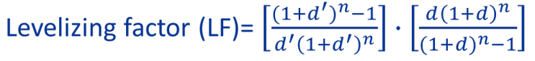

• example —— Price of Electricity from a Wind Farm
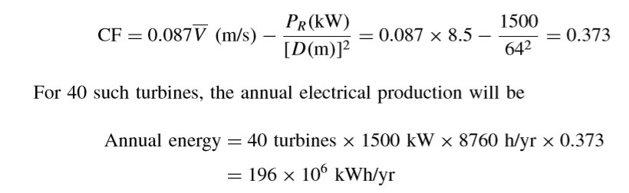
A wind farm project has 40 1500-kW turbines with 64-m blades. Capital costs are $60 million and the levelized O&M cost is $1.8 million/yr. The project will be financed with a $45 million, 20-yr loan at 7% plus an equity investment of $15 million that needs a 15% return. Turbines are exposed to Rayleigh winds averaging 8.5 m/s. What levelized price would the electricity have to sell for to make the project viable?

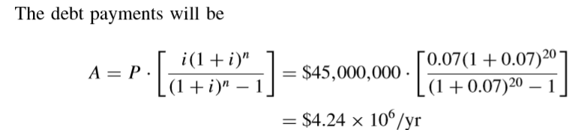
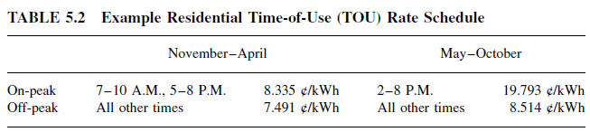

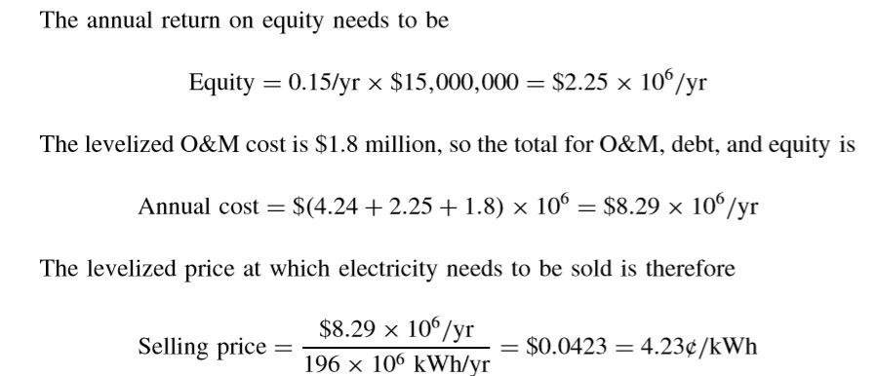

Q10. 风力发电厂的电费成本 A wind farm project has fifty (50) 2000-kW turbines with 80-m blades. Capital cost is $100 million and the O&M cost for the first year is $2 million. The O&M cost is escalating at the rate of 5% per year. The project will be ﬁnanced with a $100 million, 30-yr loan at 8% interest. Turbines are exposed to Rayleigh winds averaging 8.5 m/s. What is LCOE for the wind farm?

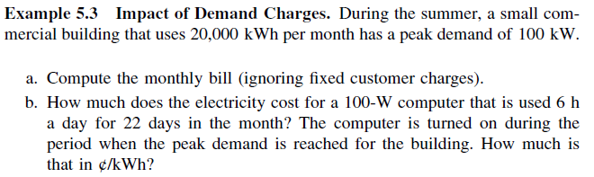

Q11. 贷款、电费成本、价格提高 A photovoltaic system that generates 8000 kWh/yr costs $15,000. It is paid for with a 6%, 20-year loan.
a) Ignoring any tax implications, what is the cost of electricity from the PV system?
b) With local utility electricity costing 11¢/kWh, at what rate would that price have to escalate over the 20-year period in order for the levelized cost of utility electricity be the same as the cost of electricity from the PV system?

5. 电费计算
• Rate variation for different types of customers
(1) Residential customer will typically include a basic fee to cover costs of billing, meters, and other equipment, plus an energy charge based on the number of kilowatt-hours of energy used.
(2) Commercial and industrial customers are usually billed not only for energy (kilowatt-hours) but also for the peak amount of power that they use (kilowatts) known as demand charge for power ($/mo per kW).
(3) Large industrial customers may also pay additional fees if their power factor—that is, the phase angle between the voltage supplied and the current drawn—is outside of certain bounds.

• energy charge
(1) Standard Residential Rates
Customers are categorised in terms of range of consumption. The rates increase with increasing demand – known as inverted block rate structure. It is designed to discourage excessive consumption.
example —— Standard Residential Rates:
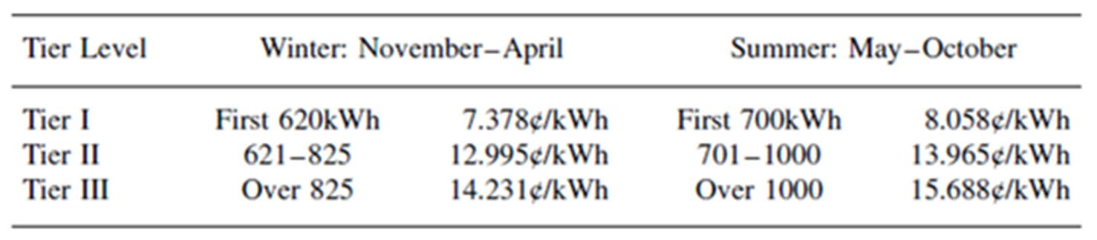
Suppose that a customer who uses 1200 kWh/month in summer and is subject to the rate structure as given below:

What would be the total cost of electricity ($/month) ignoring the monthly service charges?

(2) Residential Time-of-Use (TOU) Rates
In an effort to encourage customers to shift their loads away from the peak demand times, some utilities are beginning to offer residential time-of-use (TOU) rates. TOU rates in such circumstances charge more for electricity during summer afternoons when many air conditioners are used. Conversely, at night when there is idle capacity, rates may be significantly lower.
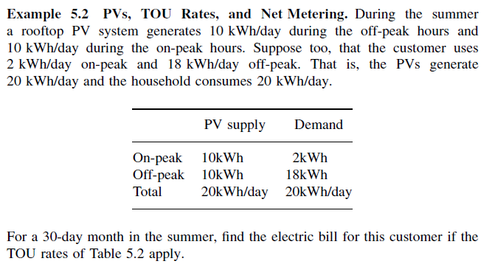
example —— TOU:

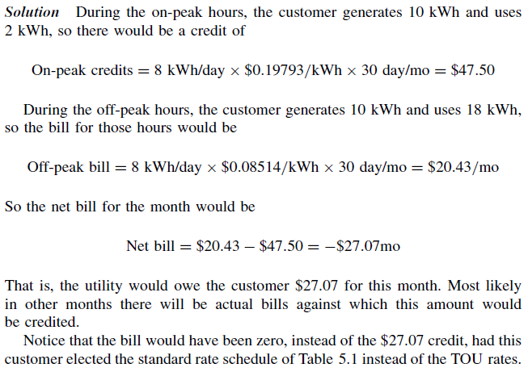

• Demand Charges
Along with fixed monthly fees, commercial electricity customers are typically billed for energy in two distinct ways:
Consumption charges (also known as energy charges), are applicable to residential customers as well, are for the volume of electricity consumed, and are measured in kilowatt-hours (kWh).
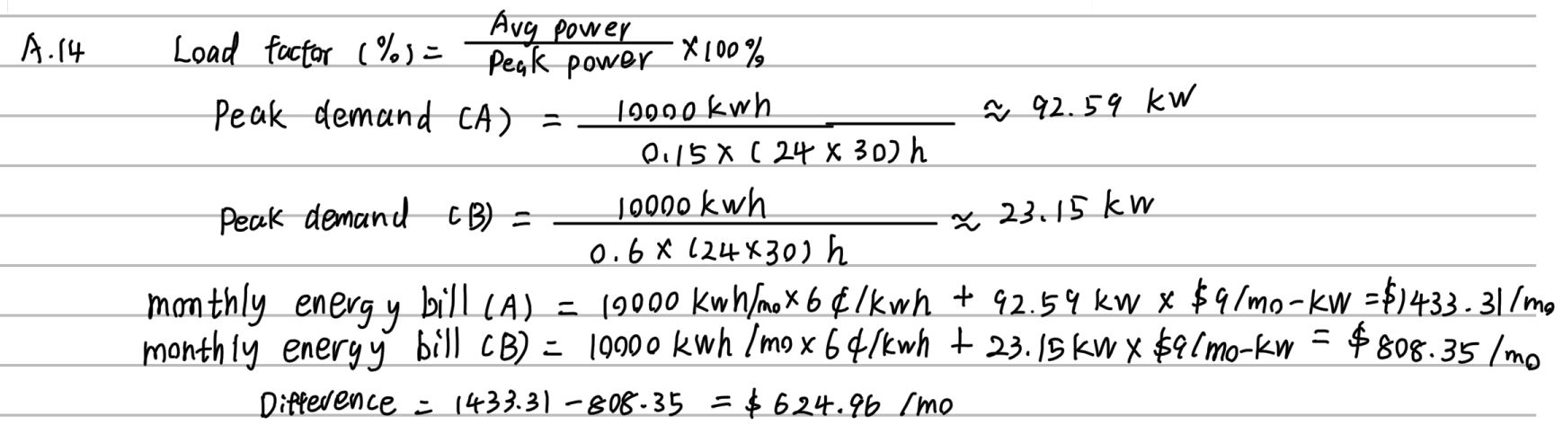
Demand charges, which are not usually applied to residential bills, are for the highest level of electricity demand during a billing period (“peak demand”) and are measured in kilowatts (kW).
example —— Standard Residential Rates:

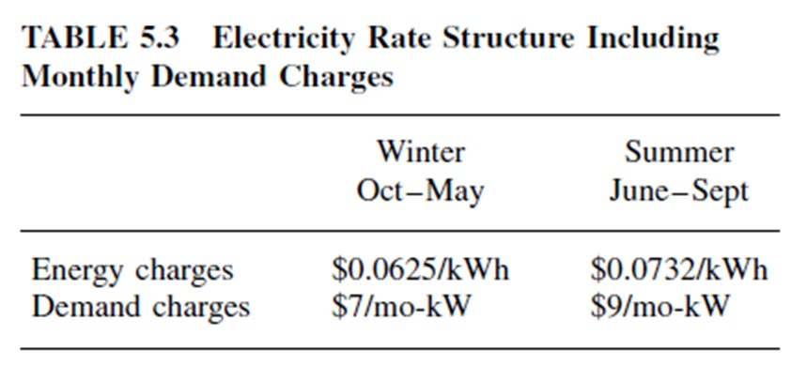
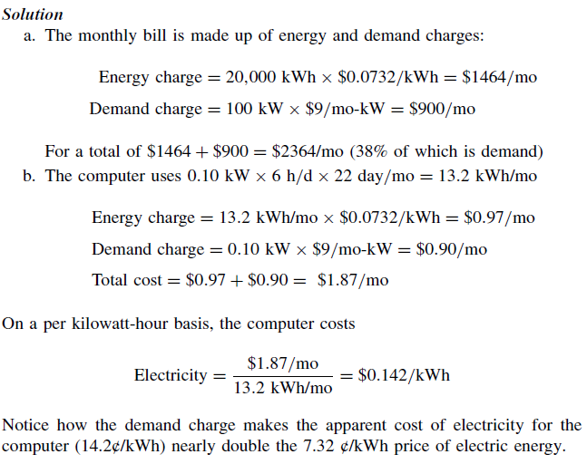

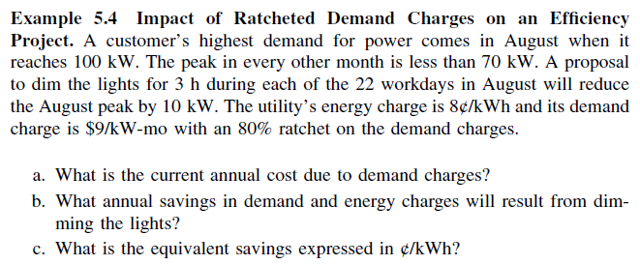

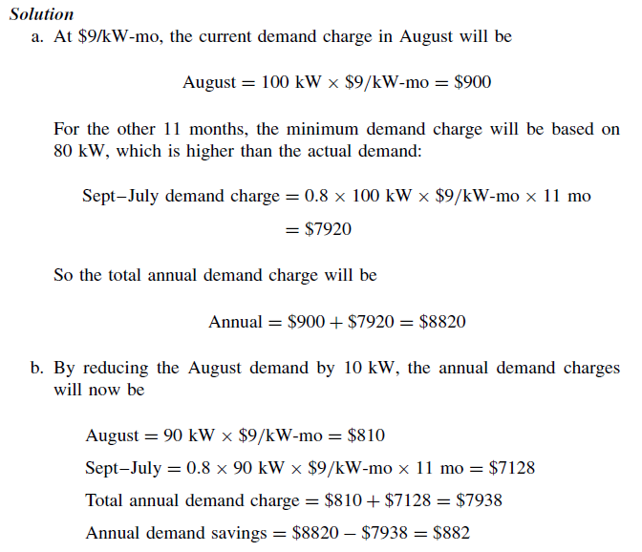
• Demand Charges with a Ratchet Adjustment
example:

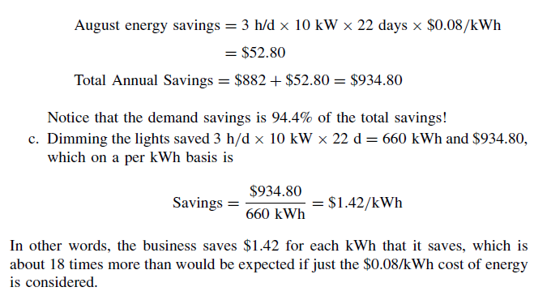

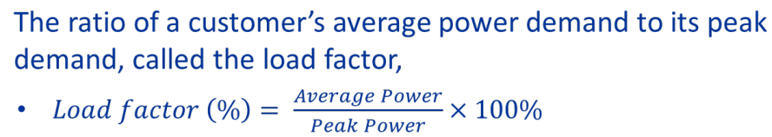
• Load Factor

example - Impact of Load Factor on Electricity Costs
Two customers each use 100,000 kWh/mo. Customer A has a load factor of 15% . Customer B has a 60% load factor. Using a rate structure with energy charges of $0.06/kWh and demand charges of $10/kW-mo, compare their monthly utility bills.
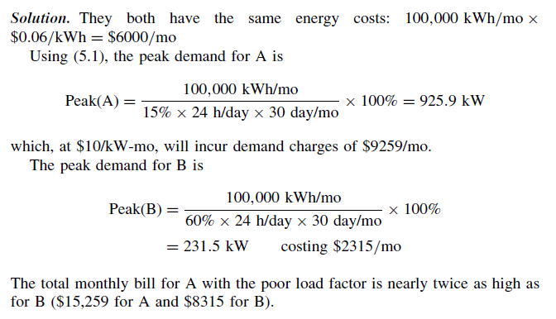

• Real-Time Pricing (RTP)
Real-time pricing (RTP) in which the true cost of energy is reflected in rates that change throughout the day, each and every day.
Q12. TOU与Demand charge电费计算 A small business uses 100 kW of power and 24,000 kWh/month during peak period. It uses 20 kW peak power and 10,000 kWh/month during off-peak period. Calculate its monthly electricity bill if:
a) Time of Use (TOU) rate schedule is used
On-peak : 12¢/kWh and Off-peak 7¢/kWh.
b) Demand Charge Schedule is used with
Energy charge 6¢/kWh and demand charge of $9/mo-kW.
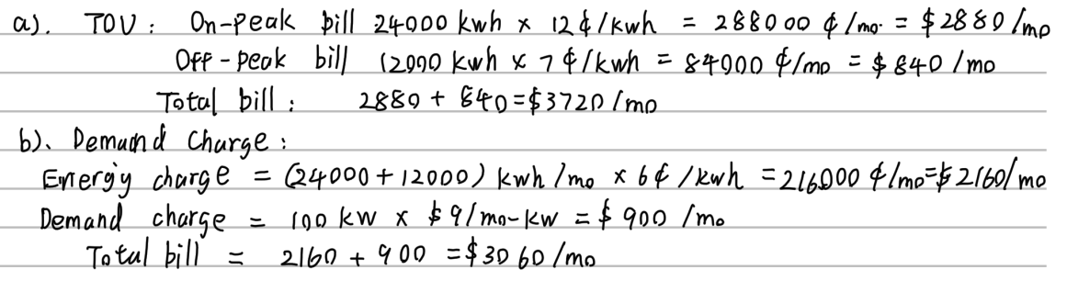

Q13. 省电电费、回报周期 A commercial customer uses demand charge schedule and consumes 20,000 kWh power month with a peak demand charge of 100kW. The rate schedule used is energy charge 6¢/kWh and demand charge of $9/mo-kW. A sales engineer proposes to install an equipment that would reduce the peak demand to 80kW and increase energy efficiency by 10%. What should be cost of the equipment if the pay-back period is less than 3 years?
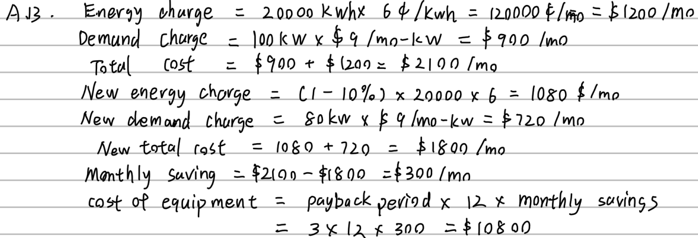

Q14. Load Factor相关电费计算 Two customers use 10,000kWh per month and pay according to a demand charge schedule with energy charge 6¢/kWh and demand charge of $9/mo-kW. One customer has a load factor of 15% whereas the other has a load factor of 60%. What is difference in their monthly energy bills?

