AI INNOVATORS
Weekly Progress Report
May 11 — May 17, 2026
Prepared by Rae Sarder, Founder

10  New / updated lessons | 2  Big challenge games built | 8  AI lessons in new course

This Week at a Glance
This was a big building week for AI Innovators! I focused on three things: launching a brand new AI course for younger kids, refreshing the Business 101 lessons so they teach better, and adding two interactive "Challenge" games that test everything a student has learned. Every new page uses the same Duolingo-style format the platform is built around — hearts, XP points, progress bar, and Nova the mascot cheering students on.
By the end of the week, the platform had 10 new or improved lessons, 2 brand-new challenge games, and a fully functional first course ("What is AI?") that a student can complete from start to finish.

The Front Door: Homepage
The homepage is the very first thing a student or parent sees when they visit AI Innovators. It introduces Nova — the friendly AI mascot — and explains in one line what the site does: "Real lessons that teach you what businesses are, how to make profit, and how to use AI tools — designed for your grade level." The page is kid-friendly but still looks like a real product, with a clear "Sign Up Free" button and a "Browse Courses" option.
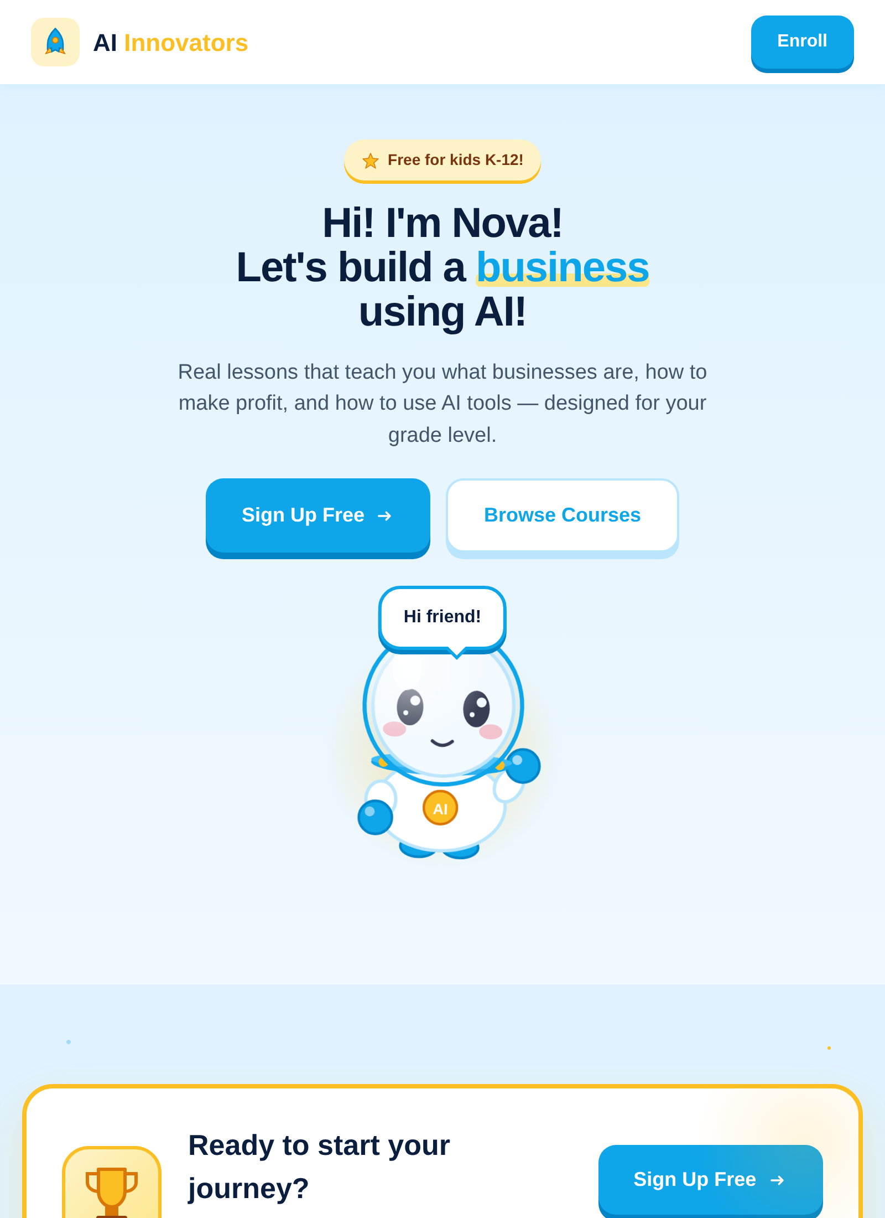
Figure 1. The AI Innovators homepage, featuring Nova the mascot.

New Course: "What is AI?"
On Monday I built a complete beginner-friendly AI course from scratch. It is aimed at younger learners (K–5) who have heard the words "artificial intelligence" but don't really know what it means. The course is split into three units:
- Unit 1 — What is AI? (what AI is, where you see it every day, and a Unit 1 quiz)
- Unit 2 — How AI Helps (AI as a helper, the different kinds of AI, and a matching activity)
- Unit 3 — Being Smart with AI (using AI responsibly and spotting AI mistakes)
Each lesson follows the same engaging pattern: Nova introduces the topic, the student answers a few multiple-choice or matching questions, and the lesson ends with XP points and a badge. If a student gets too many wrong they "run out of hearts" and have to try again — just like the apps kids already love.
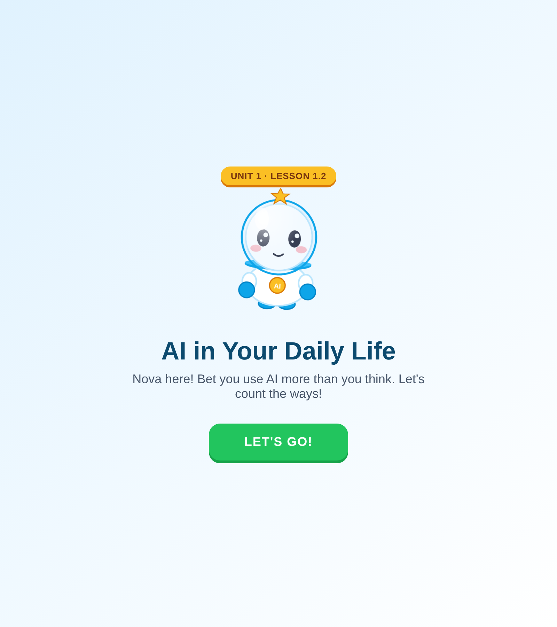
Figure 2. The welcome screen for "AI in Your Daily Life," one of eight new AI lessons.

New Interactive Features: Challenge Games
To keep students engaged after they finish a course, I added two brand-new "Challenge" games. A challenge is a tougher 10-question test that mixes every concept from the course. Students must pass it to earn the final trophy badge for that course.
- AI Basics Challenge — 10 questions covering the whole "What is AI?" course.
- Business 101 Challenge — 10 questions covering money, customers, cost, and marketing.
Challenges keep students coming back because they're harder, more rewarding, and unlock a trophy that shows up on the student's profile. This is the kind of feature that turns a one-time visit into a habit.
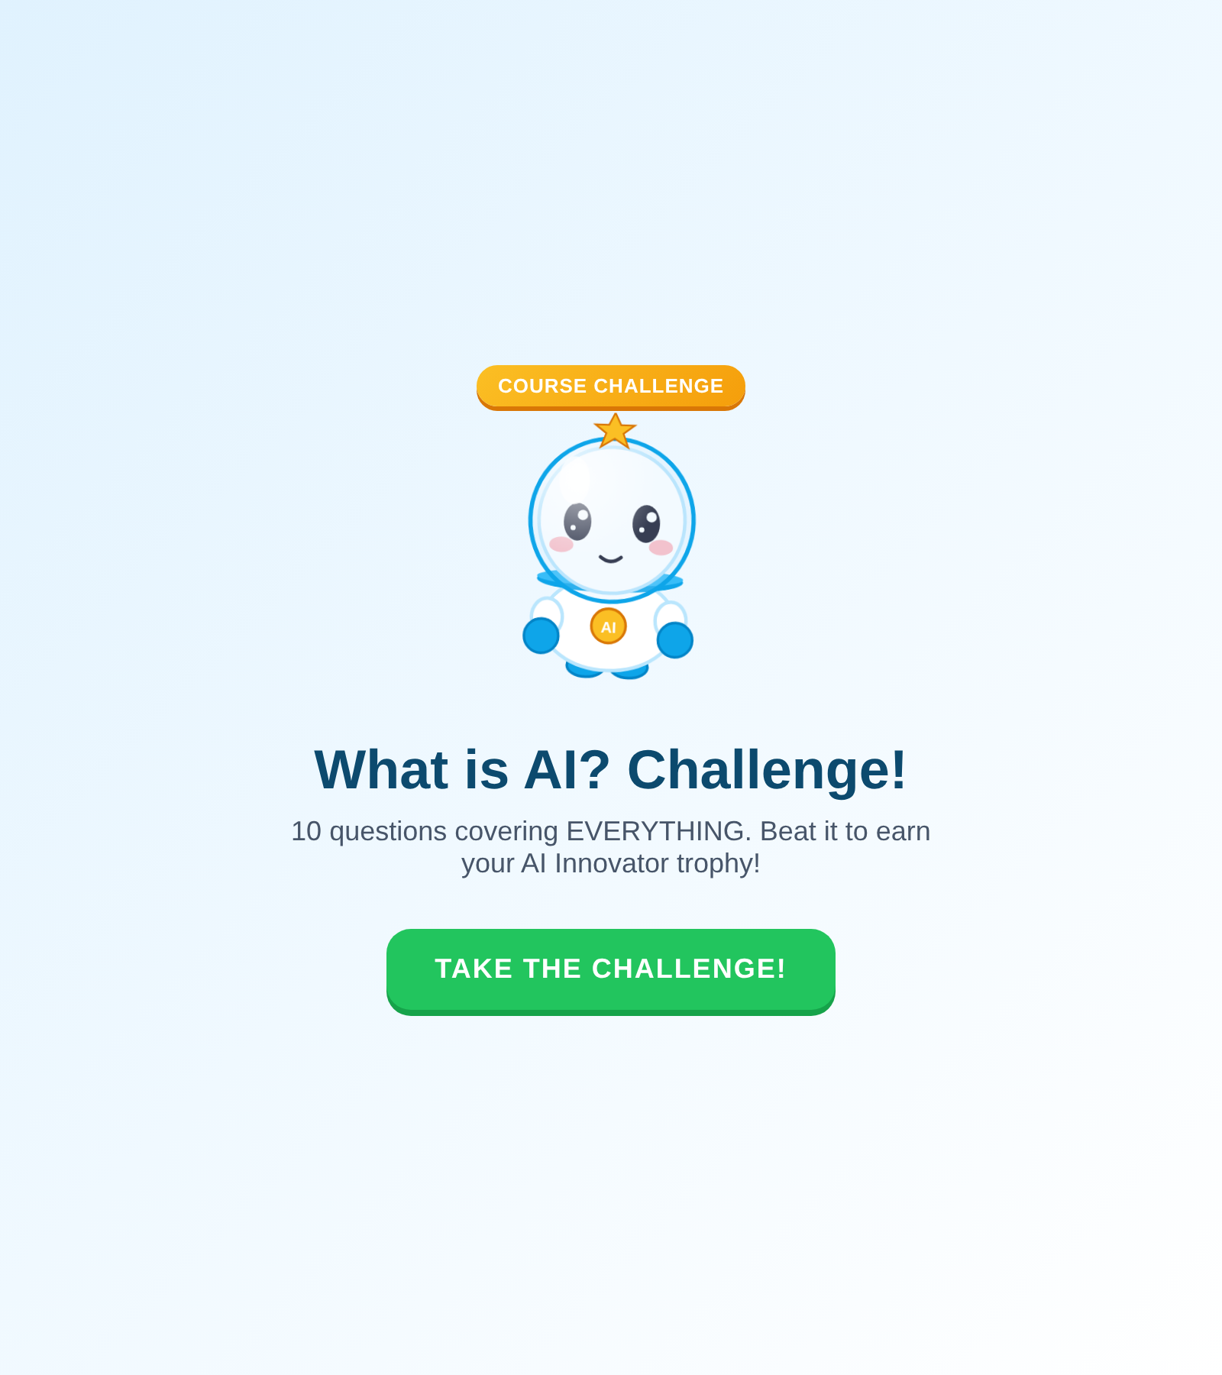
Figure 3. The new "What is AI? Challenge!" — 10 mixed questions and a trophy at the end.

Updated Business Lessons
On Saturday I rebuilt the Business 101 lessons so they all match the new visual style and use the same lesson engine. Four lessons were rewritten and polished: how to think like an entrepreneur, what costs are, who your customers are, and how marketing works. The introduction lesson ("Starting a Business 101") was also expanded — it is now the longest and most detailed lesson on the platform.
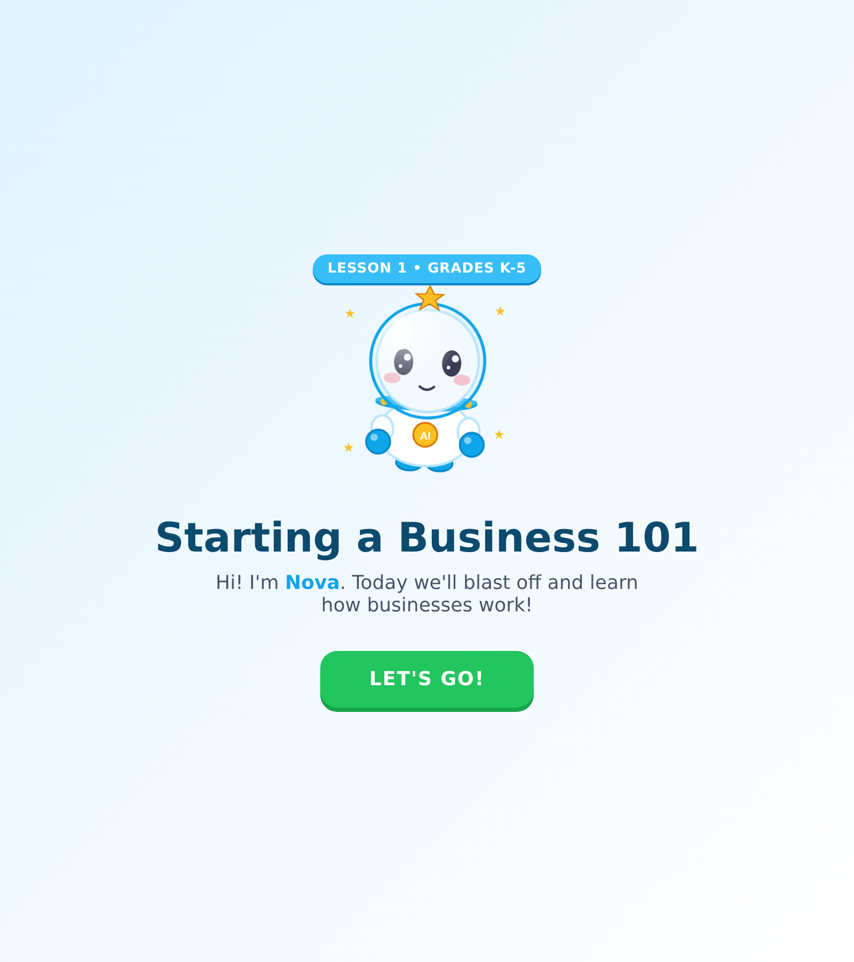
Figure 4. The refreshed "Starting a Business 101" lesson opening screen.

What's Next
Now that the format is locked in and two full courses exist, the next steps are about depth and reach:
- Add an achievements / badge collection page so students can see every trophy they've earned.
- Build the "Business Idea" course (where ideas come from, how to test them, how to pitch them).
- Add printable worksheets parents can use offline.
- Start collecting feedback from a few real students to find out what to improve.

Thanks for following along!
— Rae & Nova

