**23p-0685 Raqeeb Task 4**

**Question 1:**

#include<iostream>

using namespace std;

class Nodes

{

public:

Nodes *Next;

Nodes *Prev;

int ID;

string Name;

int Quantity;

int Price;

Nodes(int value, string name, int quantity, int price)

{

ID= value;

Name=name;

Quantity=quantity;

Next=NULL;

Prev=NULL;

Price= price;

}

};

class Double_Linked_list

{

private:

int length;

Nodes *head;

public:

Double_Linked_list()

{

length=0;

head=NULL;

}

void insertion(int value, string name, int quantity,int price)

{

//Insertion with sorting the ID's

Nodes *ptr1=head;

Nodes *ptr2=head;

Nodes *new_node= new Nodes(value,name,quantity,price);

bool checker=false;

if(head!=NULL)

{

for(int i=1;i<=length;i++)

{

if(ptr2->ID > new_node->ID)

{

new_node->Next=ptr2;

if(ptr2==head)

{

head= new_node;

ptr2->Prev=new_node;

}

else

{

ptr1->Next=new_node;

new_node->Prev=ptr1;

ptr2->Prev=new_node;

}

checker=true;

break;

}

ptr1=ptr2;

if(ptr2->Next !=NULL)

ptr2=ptr2->Next;

}

if(!checker)

{

ptr2->Next=new_node;

new_node->Prev=ptr2;

}

}

else

{

head=new_node;

}

length+=1;

}

void remove(int ID)

{

if(length==0)

{

cout<<"\nTheir is no product exist !!!!First add the products\n"<<endl;

return;

}

Nodes *Curr_ptr=head;

Nodes *Slow_ptr=head;

for(int i=1;i<length;i++)

{

if(Curr_ptr->ID == ID)

{

if(Curr_ptr == head)

{

head=Curr_ptr->Next;

delete Curr_ptr;

length-=1;

return;

}

else

{

Slow_ptr->Next= Curr_ptr->Next;

Curr_ptr->Next->Prev=Slow_ptr;

delete Curr_ptr;

length-=1;

return;

}

}

else

{

Slow_ptr=Curr_ptr;

Curr_ptr=Curr_ptr->Next;

}

}

if(Curr_ptr->Next == NULL)

{

cout<<"\nNo such ID exist!!!"<<endl;

return;

}

}

void Doubly_display()

{

if(length==0)

{

cout<<"Their are not products to show first add the products details!!!!!"<<endl;

return;

}

cout<<"\nAll Products Details:\n";

Nodes *Curr_ptr=head;

for (int i=1; i<=length;i++)

{

cout<<"ID:"<<Curr_ptr->ID<<endl;

cout<<"Name:"<<Curr_ptr->Name<<endl;

cout<<"Quantity:"<<Curr_ptr->Quantity<<endl;

cout<<"Price:"<<Curr_ptr->Price<<endl;

if(Curr_ptr->Next!=NULL)

Curr_ptr= Curr_ptr->Next;

cout<<endl;

}

}

void Update_price(int ID, int price)

{

if(length==0)

{

cout<<"\nTheir are no products yet !!!!\nAdd the products first!!!\n";

return;

}

Nodes *curr=head;

for(int i=1;i<=length;i++)

{

if(curr->ID==ID)

{

curr->Price=price;

cout<<"\n*********\nPrice is updated successfully !!!\n*********"<<endl;

return;

}

curr=curr->Next;

}

cout<<"Invalid ID"<<endl;

}

void find_product(int id)

{

if(length==0)

{

cout<<"\nTheir are no products to find !!!!\nFirst add the products!!!\n";

return;

}

Nodes *curr=head;

for(int i=1;i<=length;i++)

{ if(curr->ID==id)

{

cout<<"\nProduct Details:"<<endl;

cout<<"ID:"<<curr->ID<<endl;

cout<<"Product Name:"<<curr->Name<<endl;

cout<<"Quantity:"<<curr->Quantity<<endl;

cout<<"Price:"<<curr->Price<<endl;

return;

}

curr=curr->Next;

}

{

cout<<"Invalid Id such ID does not exist!!!"<<endl;

}

}

};

int main(void)

{

Double_Linked_list DL1;

int user_input;

int ID;

string name;

int quantity;

int price;

//Infinite loop to give end of program control to user

while(1)

{

cout<<"\n**************************"<<endl;

cout<<"1)Add New Product\n2)Remove Product\n3)Display Product\n4)Update Price\n5)Find Product\n6)Exit";

cout<<"\nUser input:";

cin>>user_input;

if(user_input==1)

{

cout<<"Enter Product ID in between (1-10):";

cin>>ID;

cout<<"Enter the Product Name:";

cin.ignore();

getline(cin,name);

cout<<"Enter Quantity of Product:";

cin>>quantity;

cout<<"Enter the price of the product:";

cin>>price;

DL1.insertion(ID,name,quantity,price);

}

else if(user_input==2)

{

cout<<"Enter the ID of the Product you want to remove:";

cin>>ID;

cout<<"\n*******************************\n";

DL1.remove(ID);

}

else if(user_input==3)

{

cout<<"\n*******************************\n";

DL1.Doubly_display();

}

else if(user_input==4)

{

cout<<"Enter the ID:";

cin>>ID;

cout<<"Enter the price you want to Update:";

cin>>price;

cout<<"\n*******************************\n";

DL1.Update_price(ID,price);

}

else if(user_input==5)

{

cout<<"Enter the ID:";

cin>>ID;

cout<<"\n*******************************\n";

DL1.find_product(ID);

}

else if(user_input==6)

{

cout<<"**********************************************"<<endl;

cout<<"Thanks for using our services. Have a nice day!"<<endl;

cout<<"**********************************************"<<endl;

break;

}

}

}

**Output Screen Shots:**

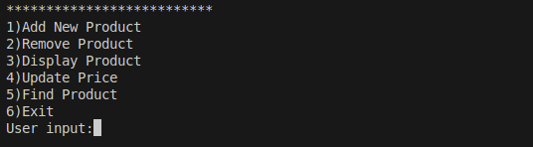

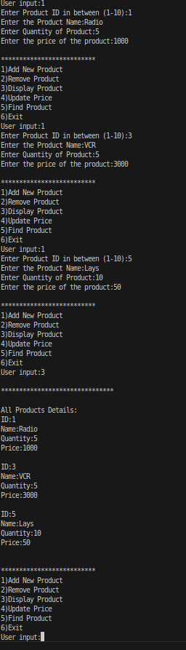

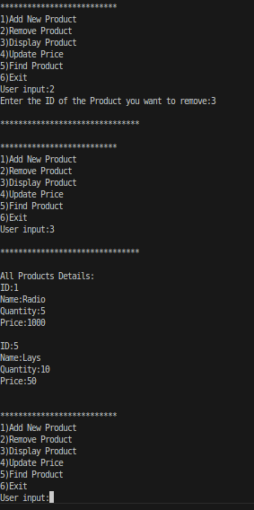

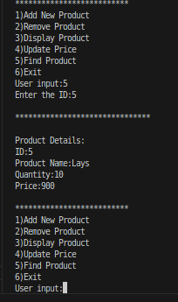

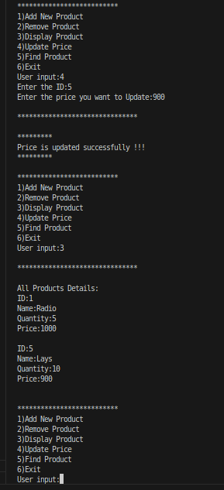

**Question 2:**

#include<iostream>

using namespace std;

class Nodes

{

public:

Nodes *next;

int info;

Nodes *prev;

Nodes(int value)

{

info=value;

next=NULL;

prev=NULL;

}

};

class LinkedList

{

private:

Nodes *head;

int length;

public:

LinkedList()

{

head=NULL;

length=0;

}

void insertion(int value, int position)

{

//Position check

if(position<0 || position> length+1)

{

cout<<"\nInvalid Position entered!!!!!"<<endl;

return;

}

Nodes *new_node= new Nodes(value);

if(position==1)

{

if(head!=NULL)

{

Nodes *Curr_ptr=head;

new_node->next=Curr_ptr;

Curr_ptr->prev=new_node;

head=new_node;

for(int i=1;i<length;i++)

{

Curr_ptr=Curr_ptr->next;

}

}

else

{

head=new_node;

}

}

else if(position!=length+1)

{

Nodes *Curr_ptr=head;

Nodes *slow2=head;

for (int i=1;i<position;i++)

{

slow2=Curr_ptr;

Curr_ptr=Curr_ptr->next;

}

new_node->next=Curr_ptr;

slow2->next=new_node;

Curr_ptr->prev=new_node;

new_node->prev=slow2;

}

else//For insertion at the end of the circular doubly linkedlist

{ Nodes*Curr_ptr=head;

Nodes *slow2=head;

for (int i=1;i<position-1;i++)

{

Curr_ptr=Curr_ptr->next;

}

Curr_ptr->next=new_node;

new_node->prev=Curr_ptr;

}

length+=1;

}

//To extract the odd values from the original list to the new list

void Odd_creator(LinkedList OL)

{

Nodes *Curr1=head;

Nodes *Curr2=OL.head;

for( int i=1;i<=OL.length;i++)

{

if(Curr2->info % 2 != 0)

{

Nodes *new_node= new Nodes(Curr2->info);

if(head==NULL)

{

head=new_node;

Curr1=new_node;

}

else

{

Curr1->next=new_node;

new_node->prev=Curr1;

Curr1= Curr1->next;

}

length+=1;

}

Curr2=Curr2->next;

}

Curr1->next=head;

}

//To extract the even values from the original list to the new list

void Even_creator(LinkedList OL)

{

Nodes *Curr1=head;

Nodes *Curr2=OL.head;

for( int i=1;i<=OL.length;i++)

{

if(Curr2->info % 2 == 0)

{

Nodes *new_node= new Nodes(Curr2->info);

if(head==NULL)

{

head=new_node;

Curr1=new_node;

}

else

{

Curr1->next=new_node;

new_node->prev=Curr1;

Curr1= Curr1->next;

}

length+=1;

}

Curr2=Curr2->next;

}

Curr1->next=head;

}

void Doubly_display()

{

Nodes *Curr_ptr=head;

for (int i=1; i<=length;i++)

{

cout<<Curr_ptr->info<<endl;

Curr_ptr= Curr_ptr->next;

}

}

};

int main(void)

{

LinkedList OL,L1,L2;

for(int i=1;i<=10;i++)

{

OL.insertion(i,i);

}

OL.Doubly_display();

L1.Odd_creator(OL);

L2.Even_creator(OL);

cout<<"Odd number linked list:"<<endl;

L1.Doubly_display();

cout<<"Even number linked list:"<<endl;

L2.Doubly_display();

return 0;

}

**Output Screen Shots:**

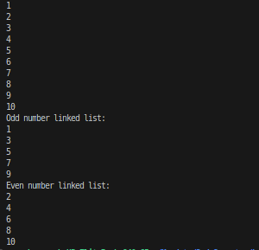

**Question 3:**

#include<iostream>

using namespace std;

class Nodes

{

public:

Nodes *Next;

string song_name;

Nodes(string name)

{

song_name= name;

Next=NULL;

}

};

class Circular_singly_Linked_list

{

private:

int length;

Nodes *head;

public:

Circular_singly_Linked_list()

{

length=0;

head=NULL;

}

void insertion(string value, int position)

{

//Position check

if(position<0 || position>length+1)

{

cout<<"INvalid position entered !!!"<<endl;

return;

}

Nodes *New_node= new Nodes(value);

if(position==1)

{

if(head!=NULL)

{

New_node->Next=head;

head=New_node;

Nodes *curr_ptr= head;

for (int i=1;i<=length;i++)

{

curr_ptr=curr_ptr->Next;

}

curr_ptr->Next=New_node;

}

else

{

head=New_node;

New_node->Next=head;

}

}

length+=1;

}

void display_linked_list()

{

Nodes *Curr_ptr=head;

if(length==0)

{

cout<<"\nPlaylist is empty!!!Enter the songs name first\n";

return;

}

for(int i=1;i<=length;i++)

{

cout<<i<<")"<<Curr_ptr->song_name<<endl;

Curr_ptr=Curr_ptr->Next;

}

}

//removing song from the end of playlist

string remove()

{

Nodes *curr1=head;

Nodes *slow=head;

if(length==0)

{

cout<<"\nThe playlist is empty! First add some songs"<<endl;

return " ";

}

for(int i=0;i<length-1;i++)

{

slow=curr1;

curr1=curr1->Next;

}

slow->Next=head;

string value=curr1->song_name;

length-=1;

delete curr1;

return value;

}

};

int main(void)

{

Circular_singly_Linked_list CSL1;

int user_input;

while(1)

{

cout<<"\n***********SONGS PLAYLIST**************\n";

cout<<"1)Add new song\n2)Remove Song from the end of the list\n3)Display all songs\n4)Quit";

cout<<"\nUser_input:";

cin>>user_input;

if(user_input==1)

{

cout<<"\nEnter the name of song you want to enter:";

string song_name;

cin.ignore();

getline(cin,song_name);

CSL1.insertion(song_name,1);

cout<<"Song Added successfully!"<<endl;

}

else if(user_input==2)

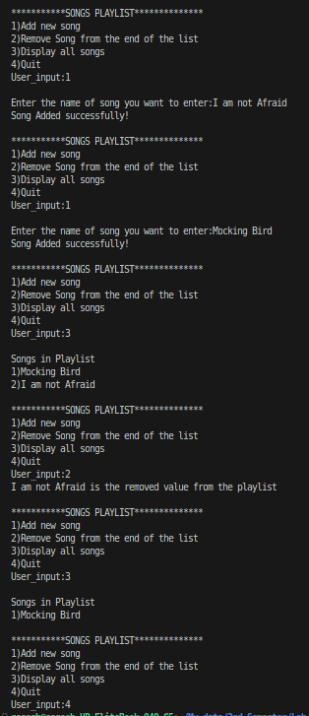{

string check=CSL1.remove();

if(check!=" ")

{

cout<<check<<" is the removed value from the playlist"<<endl;

}

}

else if(user_input==3)

{

cout<<"\nSongs in Playlist\n";

CSL1.display_linked_list();

}

else if(user_input==4)

{

break;

}

}

}

**Output Screen Shots:**