## **Employee Payroll System:**

An Employee Payroll System is a software solution designed to automate and manage the financial records of employees. This system allows for efficient handling of salary payments, deductions, bonuses, taxes, and other payroll-related transactions. It simplifies the payroll process by ensuring accuracy, transparency, and timely payment to employees, reducing the likelihood of human errors associated with manual payroll management.

**Features of the Project:**

* Employee salary management
* Tax and bonus calculations
* Payroll report generation
* User roles for HR and employees

REQUIREMENTS

* **Create the Database**

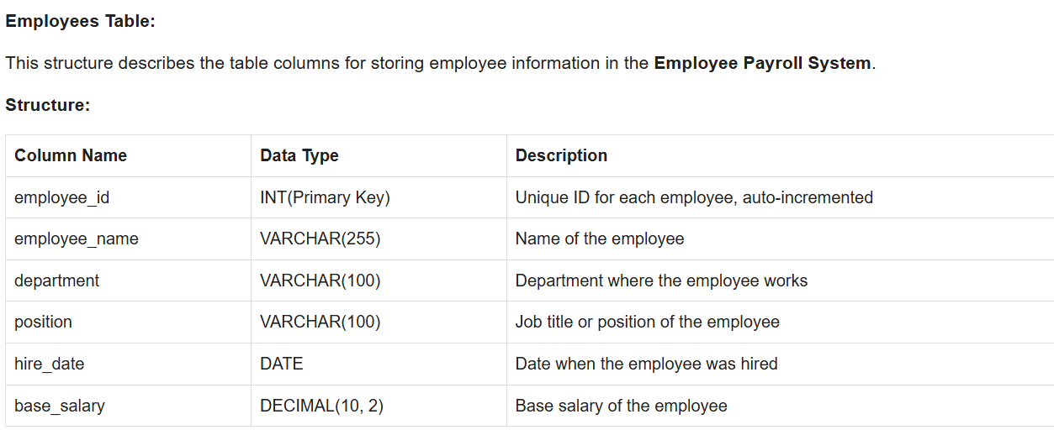

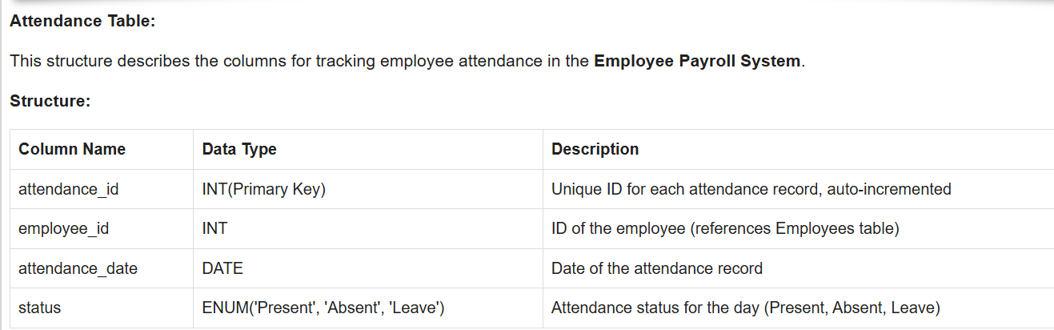

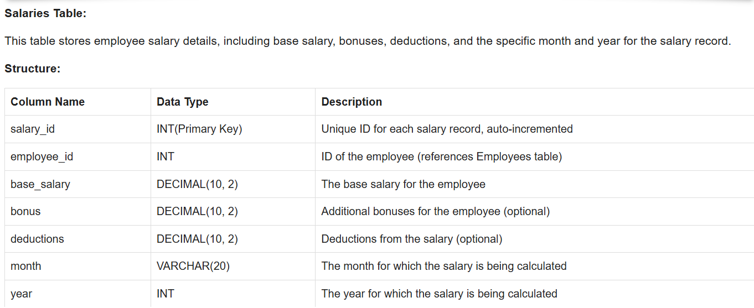

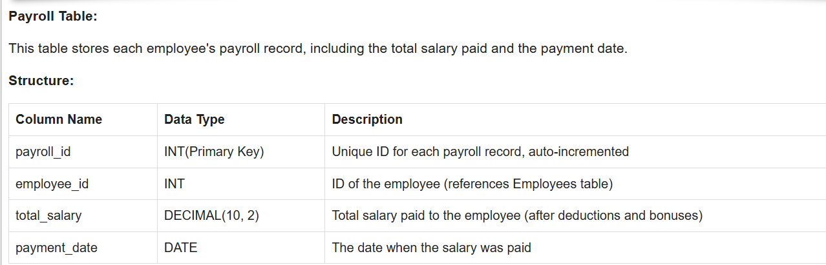

**Inserting Data:**

Add some sample data to the tables.

* **Add New Employees:**
  + Allow users to enter new employee records into the system (name, department, position, salary, etc.).
* **Update Employee Information:**
  + Provide functionality to update existing employee details (e.g., position, salary, department).
* **Delete Employee Records:**
  + Enable users to remove employee records when no longer needed or relevant.
* **Track Employee Attendance:**
  + Record daily attendance for employees, marking them as present, absent, or on leave.
* **Calculate Salary:**.
  + Automatically calculate employee salaries based on base salary, attendance, bonuses, and deductions.
* **Manage Deductions and Bonuses:**
  + Allow users to add or update bonuses and deductions for each employee.
* **Update Payroll Records:**
  + Calculate and store payroll data for each employee, including total salary and payment date.
* **Generate Pay Slips:**
  + Provide functionality to generate detailed pay slips for employees, showing salary breakdowns.
* **Update Stock Quantities:**
  + Allow manual updates to stock levels after receiving new inventory or making sales.
* **Generate Payroll Reports:**
  + Create payroll summaries and reports, such as overall salary expenses, employee attendance, or monthly payroll distributions.