CPCS 405 — Final Project Report
Online Exam System

Course | CPCS 405 — Java Programming
Semester | 2nd Semester, 2026
Due Date | Thursday, May 21, 2026 @ 11:59 pm
Group Members | Raef Alharbi · Mohanad Alqarni
Total Marks | 20 points

1. Project Overview
The Online Exam System is a distributed Java desktop application built with JavaFX for the user interface, Java Sockets (TCP/IP) for real-time client-server communication, and MySQL for persistent data storage.
The system supports two roles:
- Exam Administrator (Server): Creates exams from question files, monitors active students in real time, and manages the exam server.
- Student (Client): Connects to the server, selects an available exam, answers questions one at a time, and receives a final score.
Key Features:
- Real-time multi-student exam support via socket threads
- Question-by-question delivery — server never reveals answers to the client
- Exam resume after network interruption (progress saved per answer)
- 60-minute exam expiry enforced server-side
- MySQL result persistence in the required ExamResults table
- Timestamped text-file logging of all key events
- Full English ↔ Arabic internationalization on the main screen

2. Package & Class Structure
Package | Classes | Responsibility
app | MainApp, ModeSelectionController | Entry point, mode selection UI
server | ExamServer, ClientHandler, ServerController, NewExamController, DatabaseManager, LogManager | Server logic, DB, UI, logging
client | LoginController, ExamListController, ExamController | Student-side connection and exam flow
common | Exam, Question, QuestionTF, QuestionMCQ, QuestionDTO, ExamInfo, Result, Message | Shared serializable data objects

Required Class Design
All classes mandated by the project specification are implemented with the exact required fields:
Class | Required Fields | Status
Exam | courseName, year, semester, startDateTime, Collection<Question> | ✅ Met
Question | text (as questionText), implements Serializable | ✅ Met
QuestionTF | boolean answer | ✅ Met
QuestionMCQ | choice1..4, choice1Correct..4Correct | ✅ Met

Note: QuestionDTO is an additional class used as a Data Transfer Object. It contains only question text and choices — no correct answer — ensuring answers are never sent to clients.

3. Server-Side Implementation

3.1 Mode Selection Screen (Figure 1)
The application starts at the mode selection screen. It is loaded with a ResourceBundle for internationalization. Two buttons are displayed: 'Start Exam Server' and 'Join Exam'. A language toggle button switches between English and Arabic at runtime.
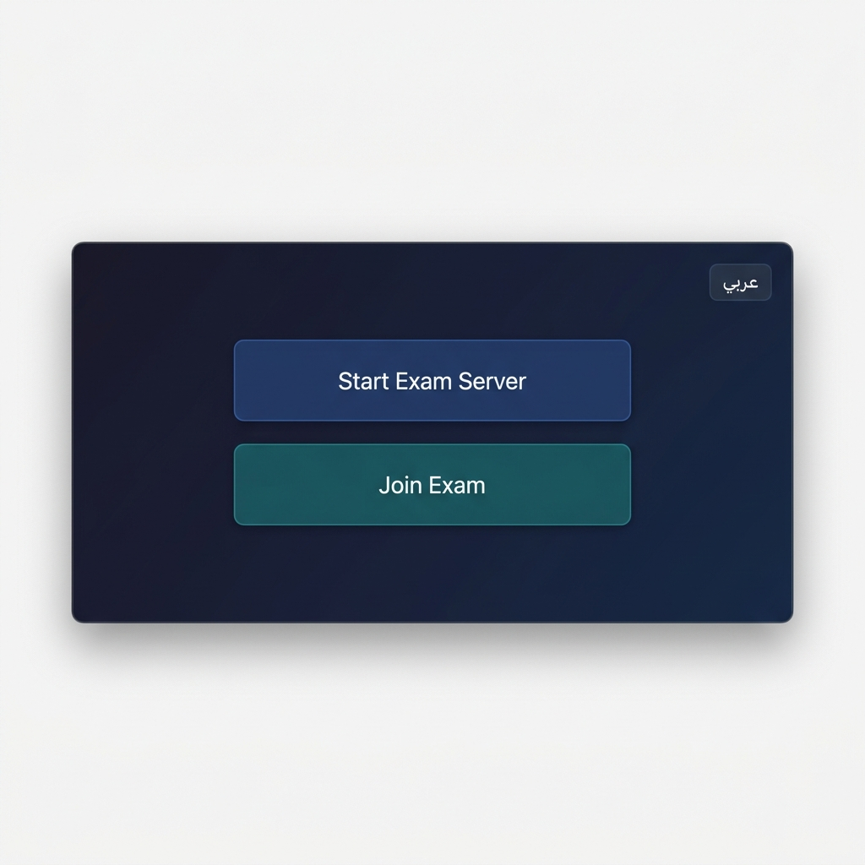
Figure 1 — Mode Selection Screen

3.2 Server Dashboard (Figure 2)
Clicking 'Start Exam Server' opens the dashboard and immediately starts the socket server on port 3000. A TableView displays all created exams with five columns as required:
Column | Source | Logic
Exam Name | exam.getExamName() + semester + year | String concatenation
Start Date/Time | exam.getStartDateTime() | Formatted yyyy-MM-dd HH:mm
Active Students | server.getActiveClients() | Filtered by exam name
Completed Students | db.getCompletedCount(examName) | MySQL COUNT query
Status | Duration since start | 'Active' < 60 min, else 'Ended'

The table auto-refreshes every 2 seconds using a JavaFX Timeline.
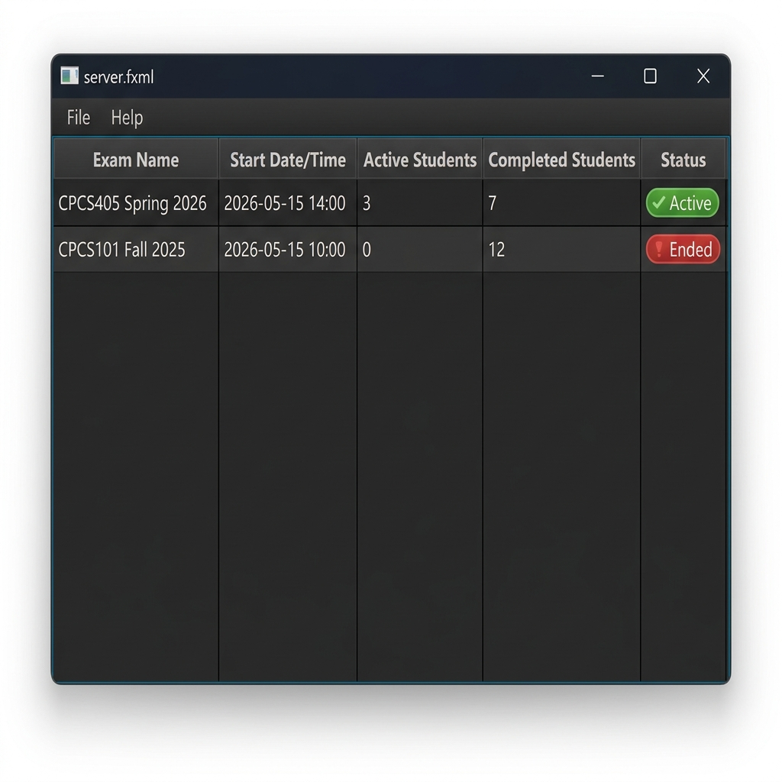
Figure 2 — Server Dashboard with exam table

3.3 New Exam Dialog (Figure 3)
The admin selects 'New Exam' from the menu. The dialog provides: a course name TextField, a Year ChoiceBox (dynamically populated with current year + 2 previous years), a Semester ChoiceBox ('Spring', 'Fall', 'Summer'), an 'Import File' button using FileChooser, and a 'Create Exam' button.
After importing a file, the dialog shows the count of MCQ and TF questions found.
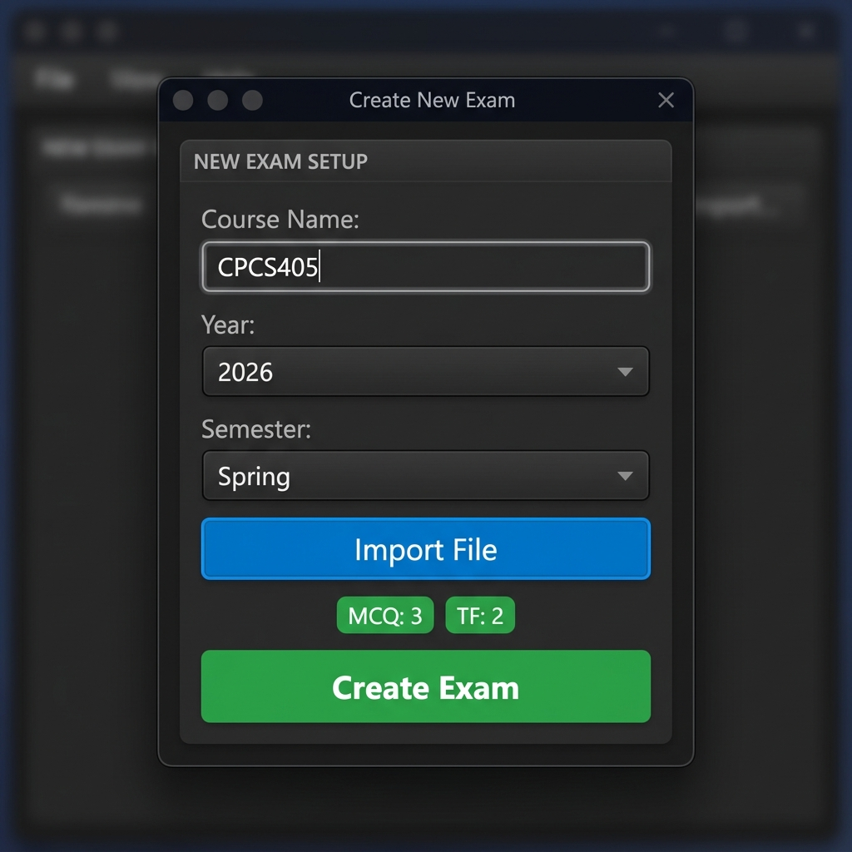
Figure 3 — New Exam creation dialog

3.4 Server Socket Engine
ExamServer runs a daemon thread on port 3000 accepting connections. For each client, a dedicated ClientHandler thread is spawned. The per-student session follows this flow:
- 1. Receive CONNECT message → extract and store student ID
- 2. Send EXAM_LIST (List<ExamInfo>) — only exams active < 60 min
- 3. Receive SELECT_EXAM (Integer examId)
- 4. Check hasCompleted() → send ERROR if student already finished this exam
- 5. Load resume progress from DB (current question index + current score)
- 6. Loop: send NEXT_QUESTION (QuestionDTO, no answers) → receive SUBMIT_ANSWER → update score → save progress
- 7. Send RESULT object with final score → save to ExamResults table

3.5 Exam Resume After Disconnect
After every answer, the server saves the student's progress (current question index and current score) to the PROGRESS table using an upsert query. On reconnection, the server restores from the saved state, allowing the student to continue from where they left off, provided the exam has not yet expired.

4. Client-Side Implementation

4.1 Client Login Screen (Figure 4)
The student enters their Student ID, Server IP address, and Port number (3000), then clicks Connect. The connection runs on a background thread to keep the UI responsive. On success, the exam list screen is shown.
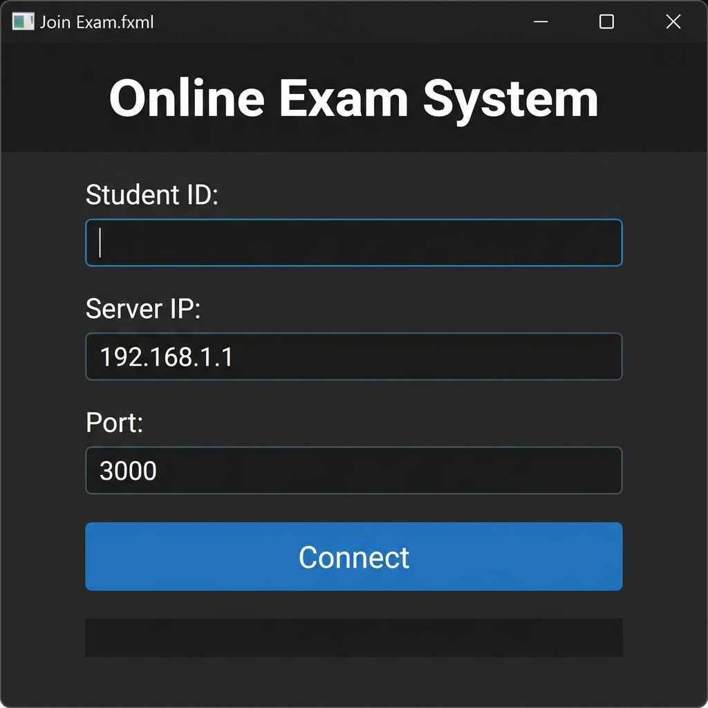
Figure 4 — Client Login Screen

4.2 Exam Selection Screen
After connecting, a ChoiceBox is populated with all available exams received from the server. The format is: 'CourseName - Year - Semester'. The student selects an exam and clicks 'Start Exam', which sends a SELECT_EXAM message and navigates to the exam screen.
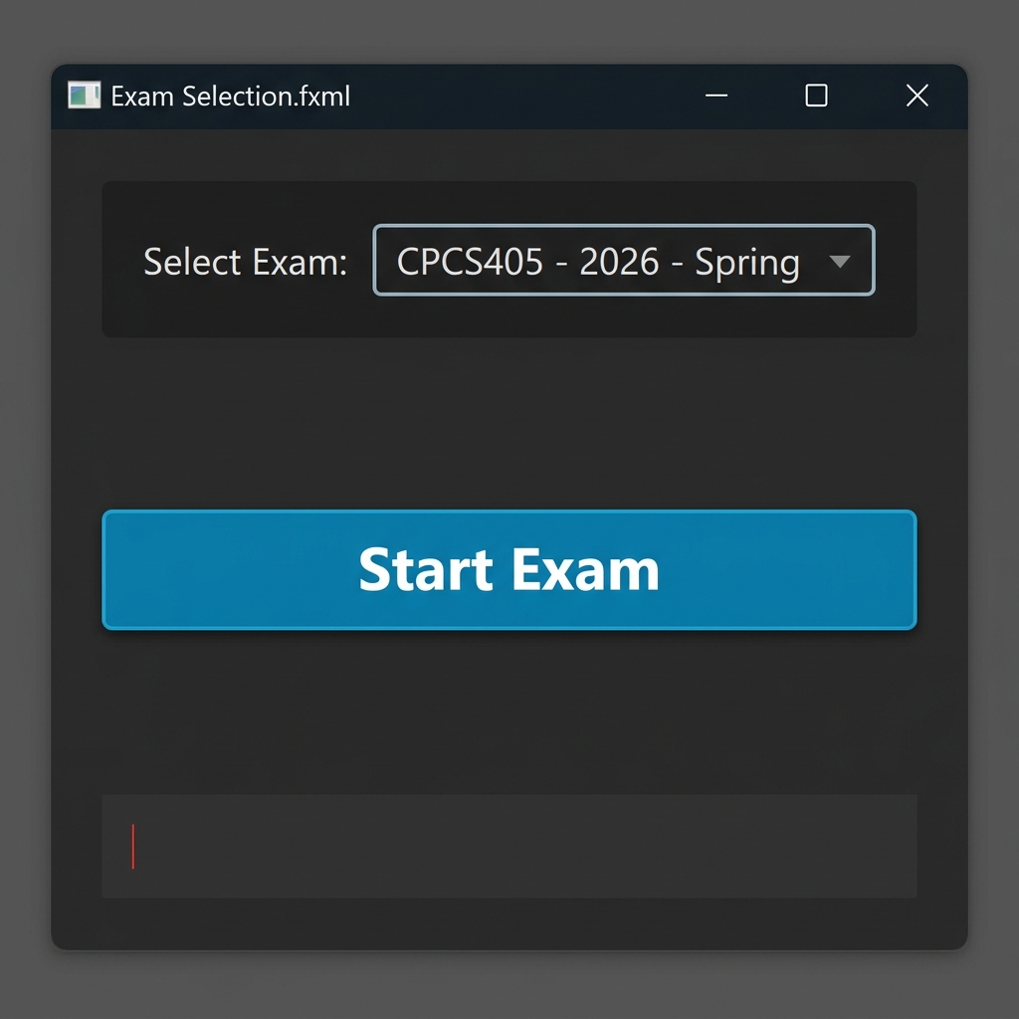
Figure 5 — Exam Selection with ChoiceBox

4.3 Exam Taking — MCQ Question
MCQ questions display the question text and four RadioButtons (A, B, C, D) grouped in a ToggleGroup. The student selects one and clicks 'Next'. The client sends the selected answer text to the server via SUBMIT_ANSWER and waits for the next question.
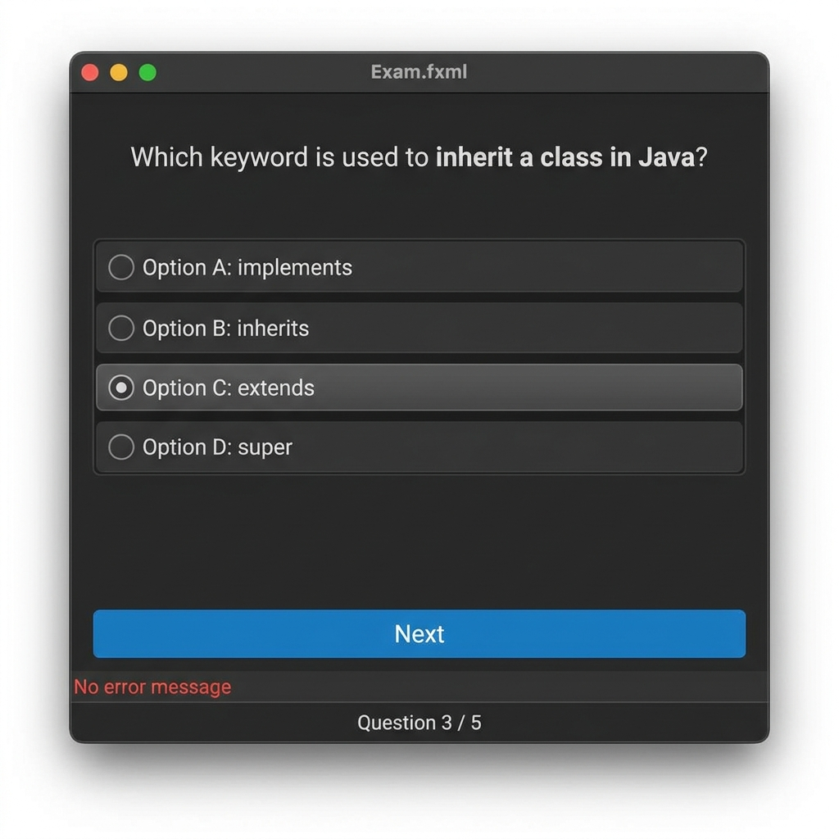
Figure 6 — MCQ Question Screen

4.4 Exam Taking — True/False Question
TF questions hide the MCQ panel and show two RadioButtons: 'True' and 'False'. Panel visibility is toggled using setVisible() and setManaged() so layout reflows correctly.
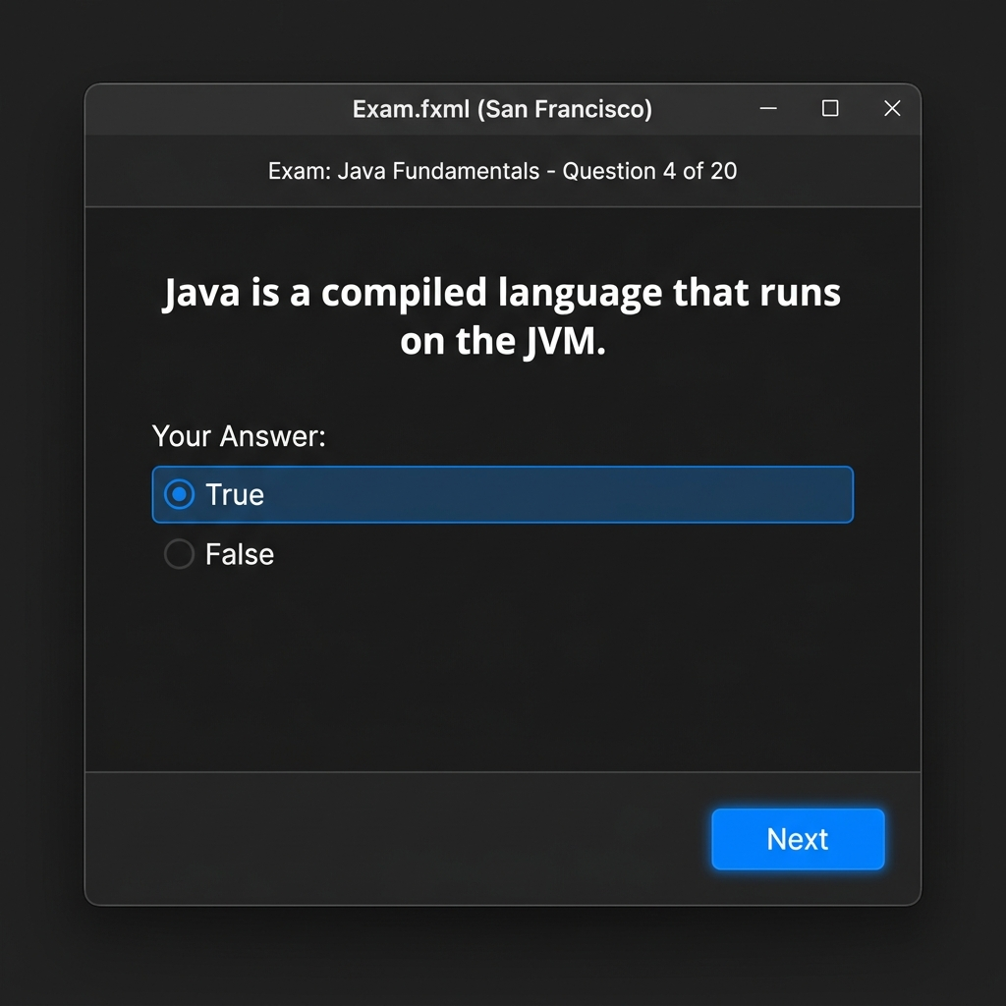
Figure 7 — True/False Question Screen

4.5 Final Result Dialog
After the last question, the server sends a RESULT message. The client displays a JavaFX Alert dialog showing the student's name and score. After clicking OK, the socket is closed and the window closes.
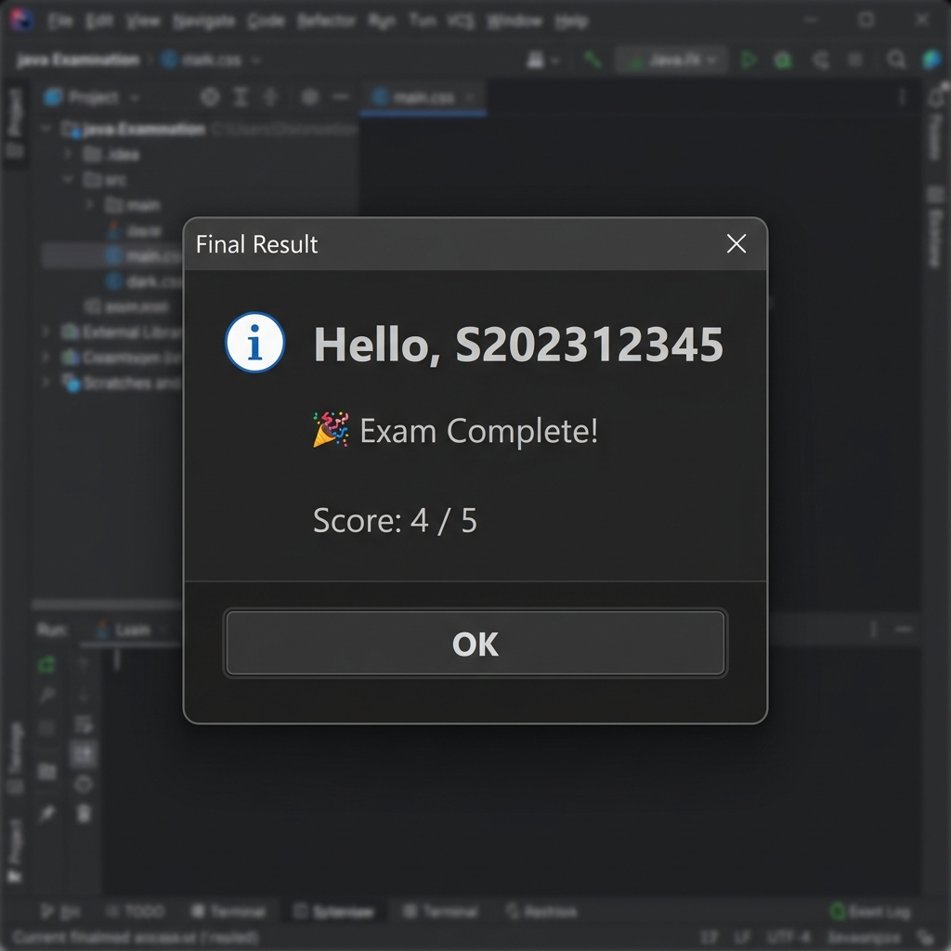
Figure 8 — Final Score Result Dialog

5. Communication Protocol
All messages use the serializable Message class, which wraps a typed enum and a data payload. This makes the protocol explicit and type-safe.
Message Type | Direction | Data Payload
CONNECT | Client → Server | String — student ID
EXAM_LIST | Server → Client | List<ExamInfo>
SELECT_EXAM | Client → Server | Integer — exam ID
EXAM_DATA | Server → Client | Exam (no questions)
NEXT_QUESTION | Server → Client | QuestionDTO (no correct answer)
SUBMIT_ANSWER | Client → Server | String — selected answer
RESULT | Server → Client | Result object
ERROR | Both directions | String — error message

Security note: QuestionDTO intentionally omits the correctAnswer field. Answer comparison is done exclusively on the server side.

6. Database Design
The project uses MySQL (installable via XAMPP). The database is named 'onlineexam'.

6.1 ExamResults Table (Required by Specification)
CREATE TABLE `ExamResults` (
`ID` INT(11) NOT NULL AUTO_INCREMENT,
`Student ID` TEXT NOT NULL,
`Course Name` TEXT NOT NULL,
`Year` TEXT NOT NULL,
`Semester` TEXT NOT NULL,
`Score` INT(11) NOT NULL,
PRIMARY KEY (`ID`)
) ENGINE=InnoDB DEFAULT CHARSET=utf8mb4;

6.2 Supporting Tables
EXAMS — stores metadata of created exams:
CREATE TABLE IF NOT EXISTS EXAMS (
id INT AUTO_INCREMENT PRIMARY KEY,
`name` VARCHAR(255), `year` VARCHAR(255),
`semester` VARCHAR(255), start_time TIMESTAMP,
question_count INT
);
PROGRESS — enables exam resume after disconnection:
CREATE TABLE IF NOT EXISTS PROGRESS (
id INT AUTO_INCREMENT PRIMARY KEY,
student_name VARCHAR(255), exam_id INT,
current_question INT DEFAULT 0,
current_score INT DEFAULT 0,
UNIQUE(student_name, exam_id)
);

6.3 Key Database Operations
Operation | Method | Description
Save exam | saveExam() | INSERT INTO EXAMS
Save result | saveResult() | INSERT INTO ExamResults
Save progress | saveProgress() | INSERT … ON DUPLICATE KEY UPDATE
Restore progress | getProgress() | SELECT current_question, current_score
Check completed | hasCompleted() | COUNT(*) FROM ExamResults WHERE Student ID=?
Count completions | getCompletedCount() | COUNT(*) FROM ExamResults WHERE Course Name=?

7. Logging
LogManager writes timestamped entries to exam_log.txt in the project directory, appending to any existing log. All 5 required events are logged:
Event | Log Entry
Exam created | EXAM_CREATED: <name> (<semester> <year>) with N questions
Client connects | Student connected: <id> from <ip>
Student selects exam | EXAM_SELECT: <id> -> <exam name>
Final score | EXAM_COMPLETE: <id> score=N / <id> scored N/T
Server start/stop | Server started on port 3000 / Server stopped.

Sample log output:
[2026-05-15 14:00:01] Server started on port 3000
[2026-05-15 14:05:22] Student connected: S202312345 from 192.168.1.5
[2026-05-15 14:05:25] EXAM_SELECT: S202312345 -> CPCS405
[2026-05-15 14:05:25] EXAM_CREATED: CPCS405 (Spring 2026) with 5 questions
[2026-05-15 14:32:11] S202312345 scored 4/5
[2026-05-15 14:32:11] EXAM_COMPLETE: S202312345 score=4

8. Internationalization
The mode selection screen (Figure 1) is fully internationalized using Java's ResourceBundle. The language toggle button cycles between English and Arabic at runtime without restarting the app.

Messages_en.properties
btn.server=Start Exam Server
btn.client=Join Exam
btn.lang=\u0639\u0631\u0628\u064a
msg.no_exams=No active exams available at this time.

Messages_ar.properties
btn.server=\u0628\u062f\u0621 \u062e\u0627\u062f\u0645 \u0627\u0644\u0627\u0645\u062a\u062d\u0627\u0646
btn.client=\u0627\u0644\u0627\u0646\u0636\u0645\u0627\u0645 \u0644\u0644\u0627\u0645\u062a\u062d\u0627\u0646
btn.lang=\u0627\u0646\u062c\u0644\u064a\u0632\u064a
msg.no_exams=\u0644\u0627 \u062a\u0648\u062c\u062f \u0627\u0645\u062a\u062d\u0627\u0646\u0627\u062a \u0645\u062a\u0627\u062d\u0629 \u062d\u0627\u0644\u064a\u0627\u064b.

9. Question File Format
Questions are stored in plain text files (.txt), one question per line, separated by semicolons.

True/False Format
TF;<question text>;<TRUE|FALSE>

MCQ Format
MCQ;<text>;<c1>;<CORRECT|INCORRECT>;<c2>;<CORRECT|INCORRECT>;<c3>;<CORRECT|INCORRECT>;<c4>;<CORRECT|INCORRECT>

sample_questions.txt
MCQ;What does OOP stand for?;Object-Oriented Programming;CORRECT;Object-Oriented Process;INCORRECT;Online Object Programming;INCORRECT;Operational Object Paradigm;INCORRECT
TF;Java is a compiled language that runs on the JVM.;TRUE
MCQ;Which keyword is used to inherit a class in Java?;implements;INCORRECT;inherits;INCORRECT;extends;CORRECT;super;INCORRECT
TF;A constructor can have a return type in Java.;FALSE
MCQ;Which collection is used to store key-value pairs?;ArrayList;INCORRECT;HashSet;INCORRECT;HashMap;CORRECT;LinkedList;INCORRECT
Scoring: Each question is worth 1 point. The total score equals the number of correctly answered questions. Invalid lines are skipped with an error message.

10. How to Run

Prerequisites
- Java 17+ with JavaFX SDK (included in javafx-sdk/)
- MySQL running locally (e.g., via XAMPP) — user: root, password: empty
- mysql-connector-j-8.4.0.jar in lib/ (included)

Steps
run.bat # from the OnlineExamSystem directory
run.bat performs three steps automatically:
- 1. Cleans the out/ directory
- 2. Compiles all Java source files with JavaFX and MySQL on the classpath
- 3. Launches MainApp — the mode selection screen appears

Starting a Server Session
- Click 'Start Exam Server' — dashboard opens, server starts on port 3000
- Go to File → New Exam, fill in course name, year, semester
- Click 'Import File' → select sample_questions.txt
- Click 'Create Exam' → exam appears in the dashboard table

Joining as a Student
- Click 'Join Exam' → login window opens
- Enter Student ID, Server IP (localhost if same machine), Port 3000
- Click Connect → exam list appears in a ChoiceBox
- Select an exam → click 'Start Exam'
- Answer each question and click 'Next'
- Receive final score in a dialog

11. Submitted Files
File / Folder | Description
src/ | Complete Java source code (all packages)
src/resources/ | FXML layouts, CSS, i18n properties files
sample_questions.txt | Sample exam file (3 MCQ + 2 TF questions)
Sample_Questions2.txt | Additional sample exam file (4 MCQ + 4 TF)
Database_Schema.sql | CREATE TABLE statement for ExamResults
run.bat | Windows build and run script
lib/mysql-connector-j-8.4.0.jar | MySQL JDBC driver
javafx-sdk/ | JavaFX runtime SDK

Report prepared by Raef Alharbi & Mohanad Alqarni — CPCS 405, 2nd Semester 2026

