Atria Institute of Technology



**Department of Information Science and Engineering**

**Big Data Analytics (18CS72)**

**Assignment-1**

**SUBMITTED BY**

Name: RAEHA SYED

USN: 1AT20IS064

Section: B

Submission Date: 27-11-2023

**Course Handling Faculty Name:**

Dr. K S Ananda Kumar

Associate Professor

Dept of ISE, Atria IT.

**Table of contents**

|  |  |
| --- | --- |
| **Sl. No** | **Description** |
| 1 | 1. create an **EC2 Linux** instance in AWS Cloud /Any cloud  INSTANCE NAME - **YOUR NAME**  INSTANCE TYPE - t2.micro/any other also.  key pair name- your name  storage - 10 GB  Take the screenshot of instance running status  Mention the private IP address and Public IP address.  (Execute this program/concept and take a screenshot of the output) |
| 2 | Execute the basic Linux commands/ simple program on the instance  (Execute this program and take a screenshot of the output) |
| 3 | Create the **GitHub** Account with your credentials, Same things stored in public repository in Github. Share the assignment in github link. |

**Note:**

1. Minimum 10 Screenshots with proper explanation
2. Minimum no of pages – 10
3. Submit your Assignment soft copy (Word & PDF) to [anandakumar.ks@atria.edu](mailto:anandakumar.ks@atria.edu).

**Subject Line in mail:** Student_Name_USN_BDA_Assignment1

1. Share your assignment Github link in Assignment Document.
2. Submit Assignment on or before **27th Nov 2023.**

**Instance Creation-01**

**SCREENSHOTS OF AWS INSTANCE**

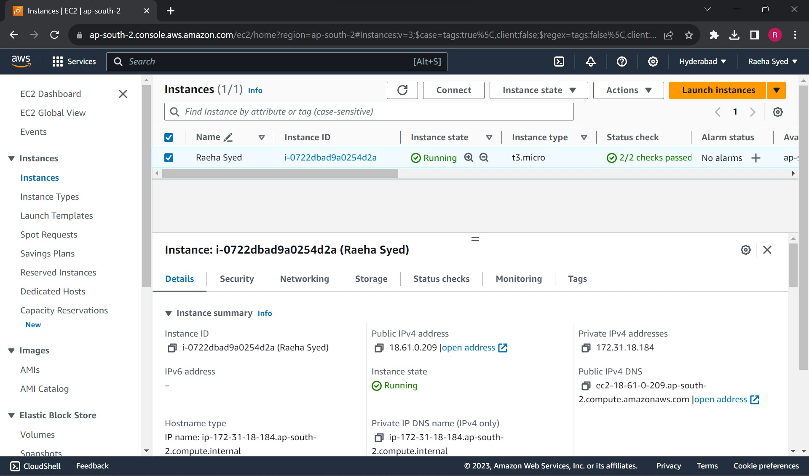

Public IPv4 Address: 18.61.0.209

Private IPv4 Address: 172.31.18.184

Instance Name: Raeha Syed

Instance ID: [i-0722dbad9a0254d2a](https://ap-south-2.console.aws.amazon.com/ec2/home?region=ap-south-2#InstanceDetails:instanceId=i-0722dbad9a0254d2a)

Instance State: Running

Instance Type: t3.micro

SCREENSHOTS OF AWS INSTANCE

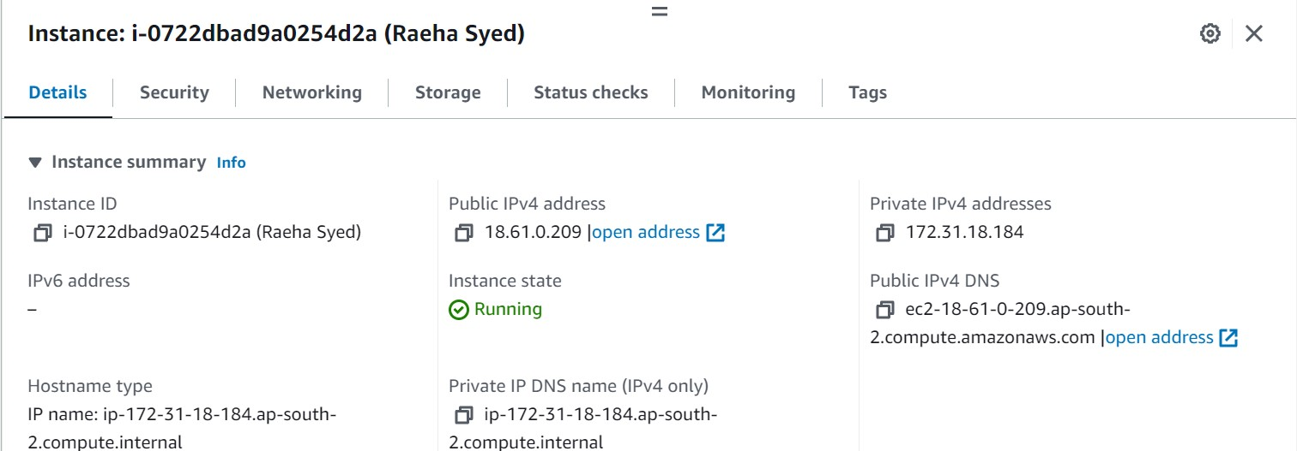

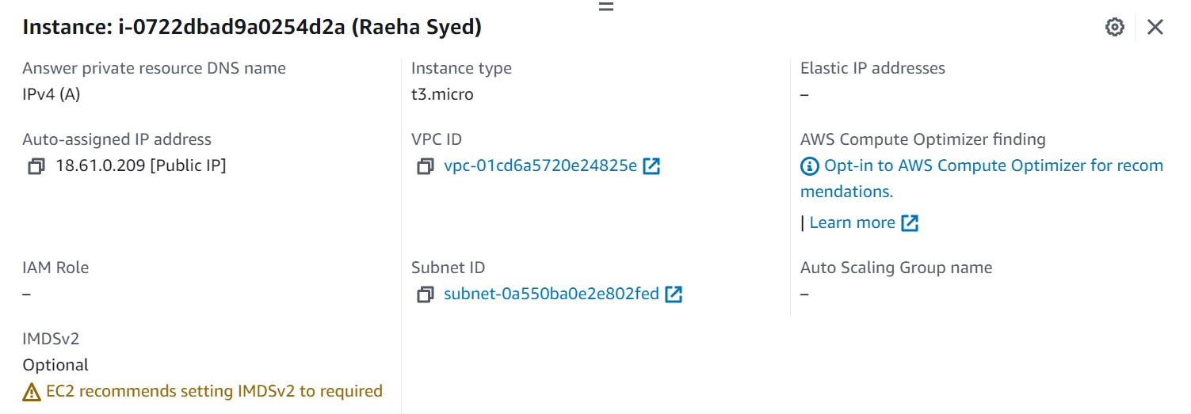

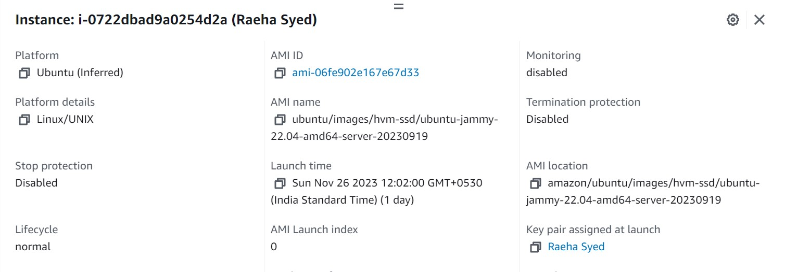

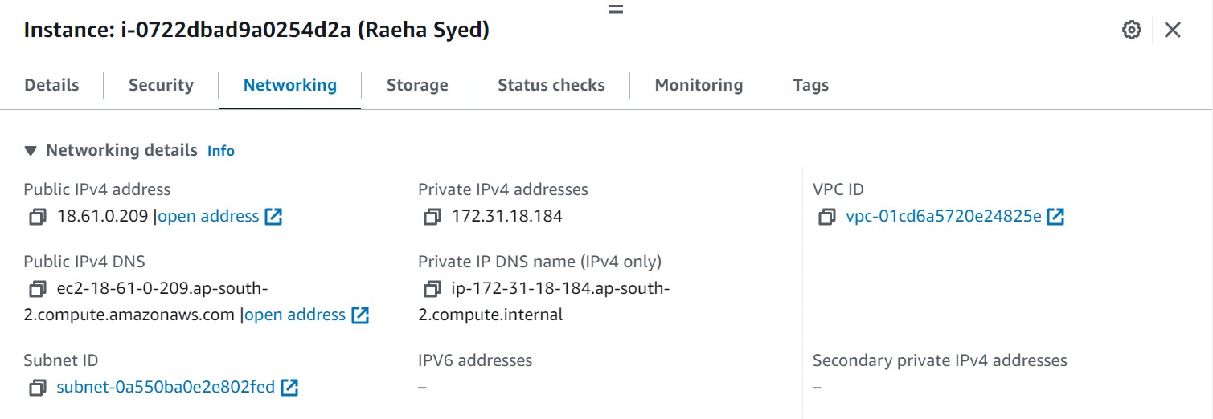

**Running sample Program on Linux Instance**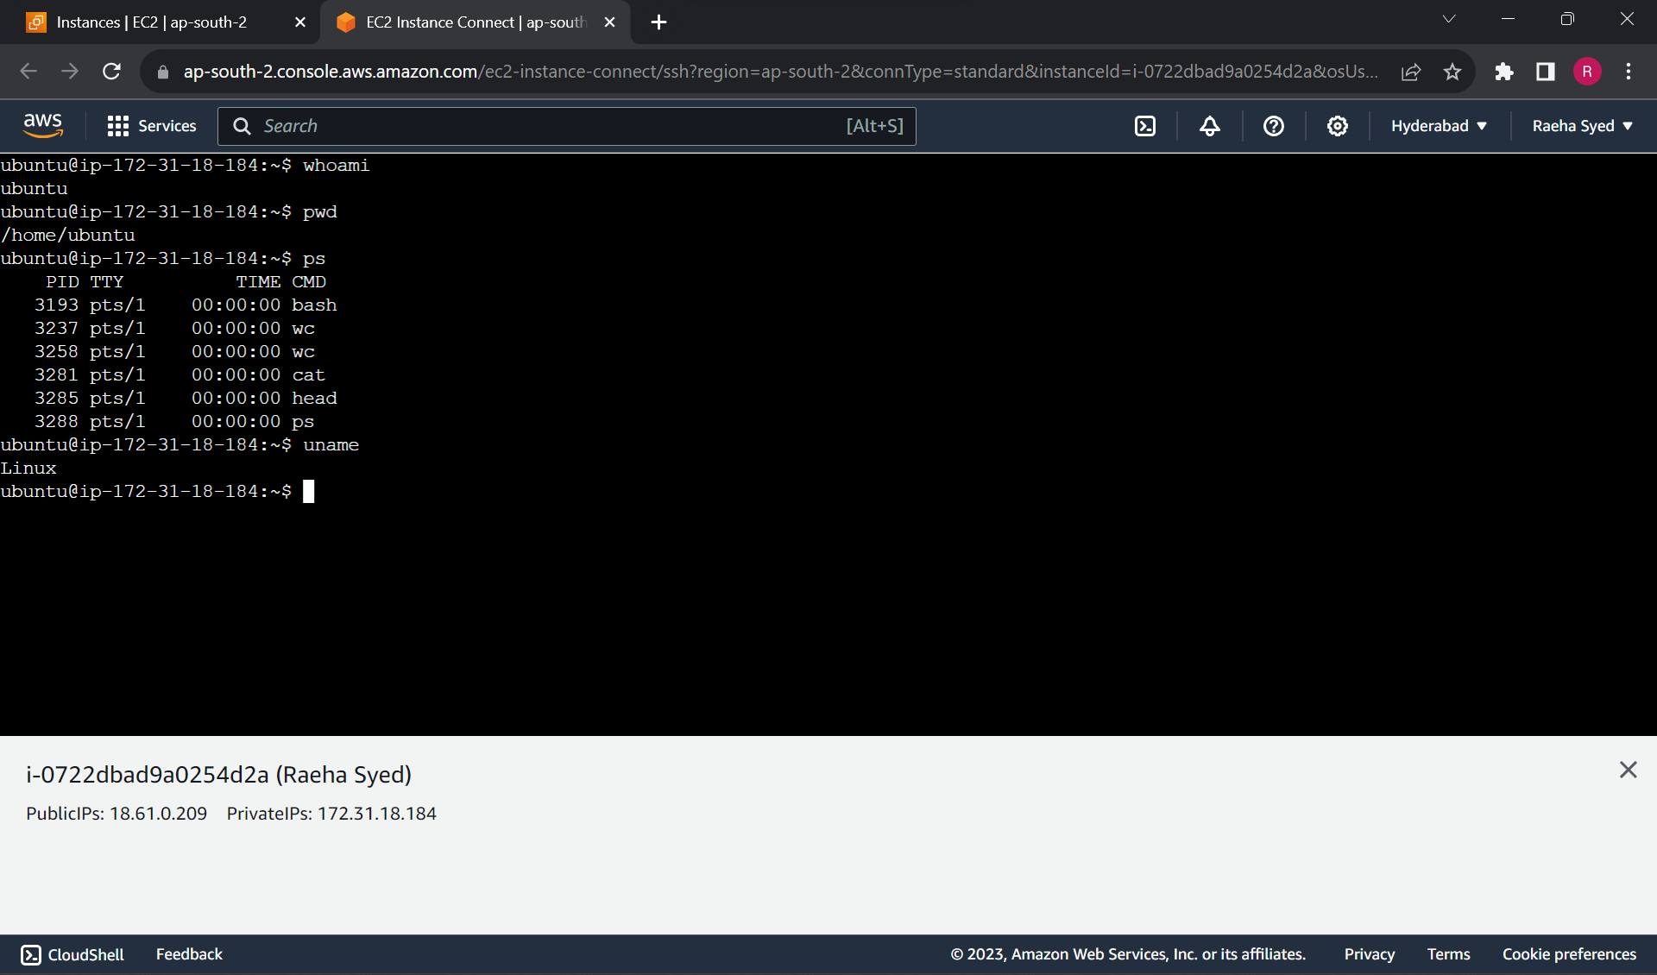

The above screenshot shows the set of Linux commands executed:

* whoami: This command outputs the username which is ubuntu in this case.
* pwd: This command prints the present working directory.
* ps: This command writes the status of active processes.
* uname: This command displays OS Information.

**Assignment GitHub Link:**

[**https://github.com/Raehaaaa/BDA--Assignment-1**](https://github.com/Raehaaaa/BDA--Assignment-1)