Part 1: Numbers

Binary numbers
--------------

What are numbers?
--> Numbers represent Quantities
--> WE write numbers using digits
--> The digits of a number can mean different things depending on what base they're written in

Quantities
-----------
(Picture of a vast quantity of 10 pencils)

Digits
----------
---> X (roman numeral)
--> Tally marks
--> 10

Decimal or base 10 --> 10 digits to represent numbers (0-9)
-----------------
10sub 10
1,000,000sub 10

Binary or base 2 --> 2 digits use to represent numbers (0-1)
---------------

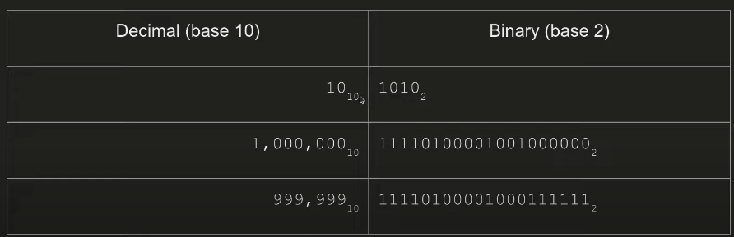

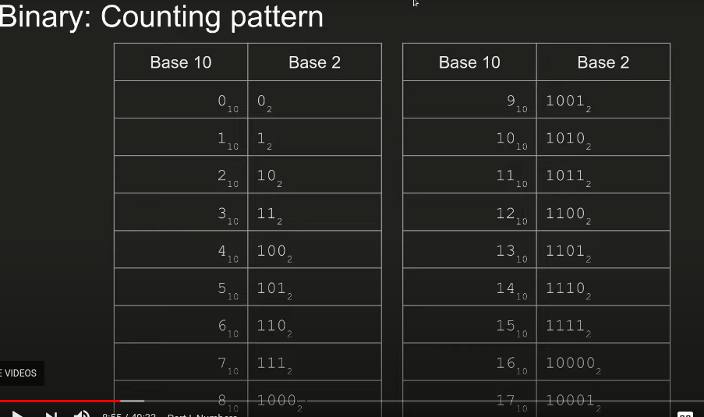
Calculating binary quantities

What is 110011 sub 2 in base 10?

1 1 0 1 1 1
2^5 2^4 2^3 2^2 2^1 2^0

2^5 + 2^4 + 2^3 + 2^2 + 2^1 + 2^0 = 55

Can get tedious. Use cyberchef

https://gchq.github.io/CyberChef/

Other common bases

- Base 16 (hexadecimal)
- Base 8 (Octal)

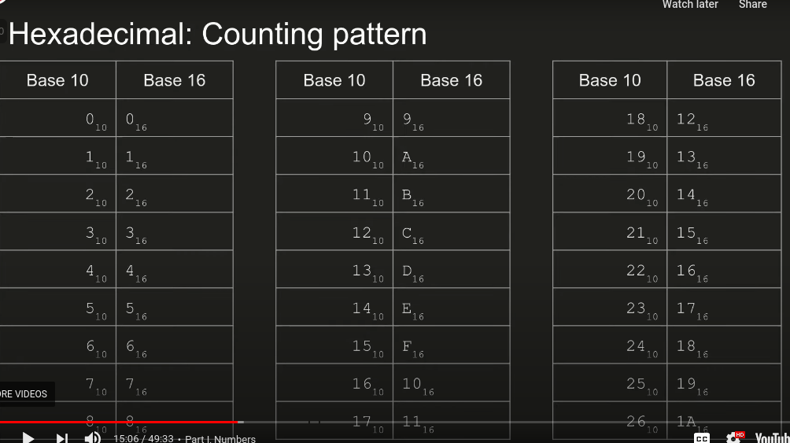

What is an encoding?
- A translation from a number to truly anything, an abstraction

Example encodings

SSN’s = number --> Person

Error codes = number --> Explanation

ASCII = number --> Keyboard key
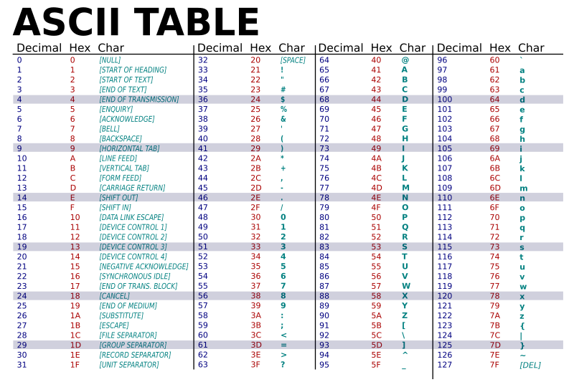

Problem set 1

1) 2Warm
2) Warmed Up
3) Lets warm Up

Part 2: The shell

The shell

A blank, black screen and blinking cursor. Lines and lines of scrolling text in front of that screen who seemingly understands an incomprehensible flow of information. That is the shell.
--the picoPrimer

Synonyms of the shell
- Terminal --> mac/ linux
- Command prompt --> Windows
-Bash --> Specific shell (linux)
- Powershell (windows specific)

Shell: The counterpart
- Graphical interfaces
- point and click
-desktops
-laptops
-Touch
-phones
-tablets

Why the shell?
-fast
-powerful
-automatable
-cool

Shell vs Graphical and commands

Create files / folders

ls -al --> shows all contents of a folder

mkdir newer-folder --> creates a folder called “newer-folder”

rm -rf new* --> deletes all folders that have “new” on them (no undo operations on here)

touch file.txt --> creates a new txt file

Start gimp
- with the

Installing gimp
- sudo apt install gimp

Editing text
nano file.txt

see stuff inside use “cat” then the files name0

wolfram alpha for graphical calculations

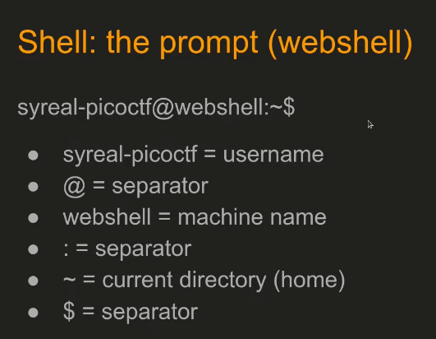
Entering commands

==> $<program>

- $yes (just by the name itself prints y forever)

- ctrl c stops the terminal process

-nano (invoked w/out arguments just makes a new file)

-python3 (gives you the python shell, terminated with ctrl d)

==> $<program><argument1>
-nano test.txt (makes a text file with the name test.txt
- ls -al (kist all cotents of a folder you’re in
- cd .. (leaves current directory to the directory above it)

==> $<program><argument1><argument2>

-echo “hello” > test.txt (redirect output to a file calles test.txt)
-grep “pattern” file.txt (find the line that contains “pattern” in a file)
-chmod +x bin (makes a file called bin to be executed)

Argument: Paths

==>Path
- An address to a file (can be relative or absolute)

==> Relative
- $ pwd (print working directory gives us the path)

==> Absolute
- starts with forward slash ‘/’

picoGym problem set 2
-Obedient cat (follow the hints and solve this challenge using the shell)
-wave a flag
-convertme.py
-whats a net cat

