General skills pt 2

Part 1: Navigation, Files, Misc

Remember that

==> ~ (means home)
==> most paths we will use are relative past (relative to your current directory)

Root
-highest directory
-All supervisor command

Commands for navigation

-ls
-cd
-pwd
-cat

File paths

-Relative
-Absolute

Webshell file demo manipulation

Commands for files
-cp --> copy file
-nano --> edit file
-rm --> remove
-mkdir --> make directory
-rmdir -->remove directory
- mv --> rename or move
-touch --> make empty files

Shortcut
- * grab all of that file

Webshell misc demo

Permissions

- Read (r), write (w), execute (x)

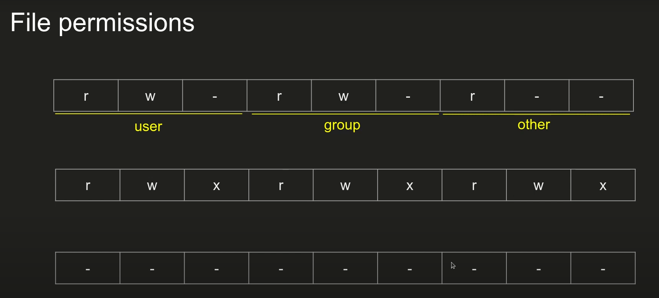

File permissions are sectioned off to users, groups, and others the last line shows that no one has any permissions to do anything to said file

Miscellaneous commands

- man
- echo
- wget
- unzip
- chmod
-./script.sh
- python3
- exit

problem set
- Nice netcat
-tab, tab attack
-python wrangling
-magikarp ground mission

Powertools of the shell

- less --> can take any input and divide up into pages where it can be easily scrolled

- history -->remembers all bash commands entered and reinvoke any commands used given you have the right number

-grep --> a command that has a lot of options / power, can take awhile to grasp. Basically look for a specific thing in a file

ex:
grep “picoCTF” monster.txt

grep -i “picoCTF” monster.txt --> ignores patterns

grep -i “picoCTF” * --> Looks at all files in the directory and searches for the flag

grep -i -r “picoCTF” * --> doesnt know what folder its in, the r makes it recursive

grep -v “monster” monster.txt--> Selects the non-matching lines of the provided input pattern.

-find --> acts exclusively on files rather than the contents of the files (kinda like grep)

-file --> it can tell the type of any kind of file by looking at the matching bytes in a file header, help linux treat files

- strings --> a filter that filters out binary information and instead only gives you the ascii or plain text, which is useful when searching for binary files.

-apt --> ???

-sudo --> super user do

picoGym problem set 2

-first grep
-first find
-big zip

Part 3 daisy chaining

Abstraction

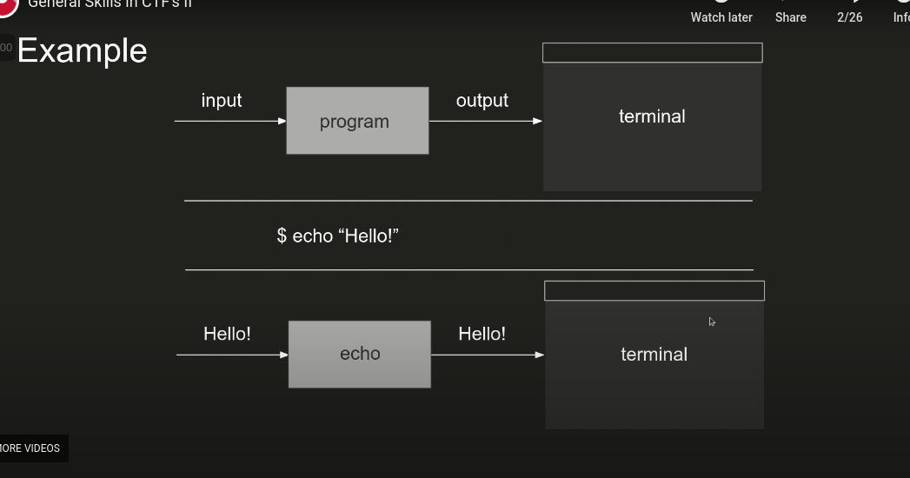

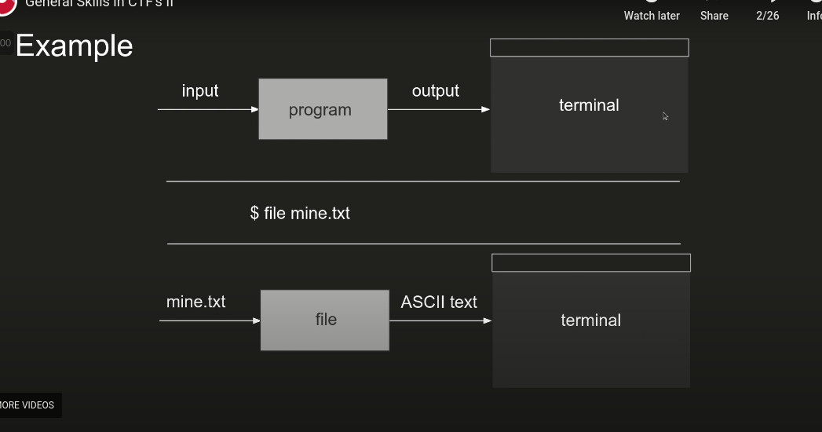

Nomenclature

Advance shell invocations
-file redirection
-pipes (daisy chaining)

File redirection
-save output of a command to a file
-accomplished with >
- ex: $ file mine.txt > output.txt

