Evaluating Heterogeneous LEED Spot-Tracking Methods under a Common Spot-Position Measurement Contract
  - Main manuscript
2026-08-02
Table of Contents

Draft status: venue-portable scientific revision. Experimental description, author information, submission metadata, and release authorization remain as explicitly deferred inputs.

Authors
TODO[AUTHOR]: author list, affiliations, corresponding author, ORCID identifiers.

Abstract
Quantitative low-energy electron diffraction (LEED) analysis requires persistent association between a measurement region and its target diffraction spot as patterns move and visibility changes. We compared five heterogeneous tracking strategies through a common position-measurement contract: each native output supplied a proposal for a 48 × 48-pixel ROI, and the same two-dimensional Gaussian estimator produced the reported spot position. Robustness was assessed with fixed opportunity sets for coverage and post-gap recovery, accepted-fit denominators for geometry inconsistency, and method-specific surviving $n$ for conditional residuals.
Validation combined known translations, a 701-image Cu(111) positive control, two independent Ag(111) energy scans with natural $I(V)$ gaps, and a controlled SAM2-family memory experiment. Translation errors were 0.0043–0.0265 px with 74/80–80/80 accepted measurements. All methods produced 2,804/2,804 Cu(111) measurements and 701/701 endpoints per primary pair. In the Ag(111) scans, coverage was 188/221–217/221, recovery 17/24–23/24, and conditional median pair-distance residuals 1.737–1.837 px ($n=68–91$). SAMURAI and DAM4SAM increased coverage over SAM2 but also increased geometry-inconsistent continuation; this mechanism result is not a general ranking.
Across 15 predeclared perturbations of ROI geometry and acceptance gates, absolute outcomes changed, but Lucas–Kanade retained the lowest coverage and the denominator-aware interpretation remained stable. The results assess measurement-chain robustness, not absolute tracking accuracy. Proposal differences were strongly suppressed when the target spot remained inside the common estimator’s capture region, making this a supporting mechanism rather than the primary contribution.

Keywords
Low-energy electron diffraction; spot tracking; quantitative image analysis; Gaussian localization; visibility gaps; measurement robustness.

1. Introduction

1.1 Quantitative LEED requires persistent spot association
Low-energy electron diffraction (LEED) probes the periodic structure of a surface through the energy-dependent diffraction of low-energy electrons (Pendry 1974). A recorded LEED pattern contains discrete diffraction spots whose positions, profiles, and integrated intensities can be extracted from image sequences (Mayer et al. 2012; Schmid et al. 2025a). Quantitative structural LEED most commonly uses intensity as a function of incident electron energy, $I(V)$ (Pendry 1974; Schmid et al. 2025a). In time- or temperature-dependent image series, localized spot centers and profiles can additionally support measurements of displacement, pair distance, and profile width. Each of these image-derived quantities requires the measurement region to remain associated with the same physical diffraction spot throughout the analysed sequence.
Tracking is therefore upstream of the physical measurement but is not itself the measurement. A tracker supplies a location at which image information can be evaluated; the quantitative position, width, or intensity is then obtained from the corresponding pixels. This distinction matters because a smooth trajectory can follow a background feature or a neighbouring diffraction spot, while an irregular proposal can still yield a valid position if the intended spot remains inside the downstream estimator’s capture region. Preservation of LEED spot identity consequently cannot be inferred from trajectory smoothness alone.
The tracking problem becomes more difficult when the diffraction pattern moves. Changes in the experimental state can translate or deform the observed pattern, and varying the electron energy produces an approximately radial motion proportional to $1/\sqrt{E}$. LEED-specific tracking systems already use this energy dependence to predict spot positions (Mayer et al. 2012; Schmid et al. 2025a). A position estimator must then accommodate both the expected physical motion and common-mode image motion caused by projection or apparatus drift.
Spot visibility introduces a separate challenge. Because diffraction intensity varies strongly with energy, a spot can fall below the measurement threshold and later become measurable again. We refer to an internal, intensity-driven interval bracketed by valid measurements of the same branch as an $I(V)$ visibility gap. Such a gap is not generic video occlusion: image evidence for the intended diffraction feature is temporarily insufficient even though other nearby spots or background structures may remain visible. A useful tracking strategy must therefore support recovery of the same physical branch without silently continuing on a distractor.

1.2 Existing LEED tracking and the remaining evaluation problem
Automated LEED spot tracking and localization have clear precedents. EasyLEED tracks individually initialized spots with a Kalman filter informed by an energy-dependent motion model and elliptical two-dimensional Gaussian image measurements. If an image measurement is rejected, its prediction can continue until a later update becomes available (Mayer et al. 2012). ViPErLEED-ImageJ instead identifies and tracks a complete diffraction pattern using reciprocal-lattice geometry, the expected energy scaling, and local corrections from neighbouring spots. It supports weak or temporarily missing beams and is designed for extraction and processing of LEED $I(V)$ curves (Schmid et al. 2025a). Thus, automated tracking, energy-dependent prediction, Gaussian localization, and propagation through low-visibility intervals are not introduced here.
General-purpose computer-vision methods provide different representations of the same association problem. These include propagated points based on local correspondence (Cho et al. 2024), transformer-based bounding-box tracking (Ye et al. 2022), classical optical flow (Lucas and Kanade 1981), and prompt-conditioned mask propagation with visual memory (Ravi et al. 2025; Yang et al. 2024; Videnovic et al. 2025). Their native outputs are heterogeneous: a point trajectory, updated bounding box, optical-flow displacement, Kalman state, or binary mask. The box center and mask centroid used in this study are local adapters that reduce those outputs to a TrackLEED tracking proposal; they are not native position estimates. Even after this reduction, the proposal coordinates do not have the same operational meaning or uncertainty. Directly ranking them would therefore conflate the proposal mechanism with the downstream position estimator.
This heterogeneity motivates a narrower evaluation question than whether LEED spots can be tracked automatically. The relevant question for quantitative analysis is when different proposal strategies lead to the same accepted physical measurement and when motion or loss of visibility causes missing or physically inconsistent results. A common downstream estimator makes that question testable by converting every native proposal into the same measurement ROI and deriving the reported position from the same image model. The comparison then concerns the complete measurement chain rather than the coordinate convention of a particular tracker.
Conditional localization error alone is insufficient for this purpose. A method can have a small residual on the subset of images for which it returns a proposal and the fit passes all gates, yet lose many measurable spots or resume on an incompatible diffraction branch after a visibility gap. These events disappear if only successful measurements enter the denominator. The evaluation must therefore keep measurement coverage, post-gap branch-consistent recovery, geometry-inconsistent continuation, and conditional position or pair-distance residuals as separate outcomes. Without an external image-by-image reference, such outcomes establish equivariance, reproducibility, and physical self-consistency rather than absolute tracking accuracy.

1.3 Study objective and contributions
This study evaluates whether heterogeneous spot-tracking strategies support an available and physically self-consistent quantitative LEED position under one common proposal-to-ROI-to-Gaussian measurement contract. The primary comparison keeps fixed opportunity sets for measurement coverage and post-gap branch-consistent recovery separate from accepted-fit geometry outcomes and conditional residuals with method-specific surviving $n$. We then test whether native proposal differences are suppressed when the target spot remains inside the common estimator’s capture region and whether the resulting measurements support the pairwise endpoint $ΔR/R=ΔD/D$. TrackLEED is the reference implementation and reproducibility vehicle; its graphical application and feature set are not the subject of the study.
The contributions are:
- A common proposal-to-ROI-to-Gaussian position-measurement contract for heterogeneous point, bounding-box, mask, optical-flow, and LEED-domain trackers.
- A denominator-aware assessment that retains fixed opportunity sets for coverage and recovery and outcome-specific surviving sets for conditional geometry and residual statistics.
- Controlled and case-based evidence for measurement-chain equivariance, endpoint agreement, motion and natural $I(V)$-gap robustness, and the continuity–consistency trade-off.
- A predeclared 15-variant sensitivity analysis that tests whether the claim boundary depends on measurement-window geometry or acceptance gates without selecting an optimal contract.
- A mechanistic account of when the common Gaussian estimator suppresses proposal differences inside its tested capture region.
The four evidence regimes are assigned distinct evidential roles rather than pooled into one composite ranking. Controlled translations test measurement-chain equivariance, Cu(111) provides a positive control for endpoint agreement, independent Ag(111) energy scans test motion and natural visibility gaps, and the matched SAM2-family panel examines a continuity–consistency trade-off. This design does not provide absolute spot-identity ground truth; it evaluates whether each strategy supports an available and physically self-consistent quantitative measurement under the frozen conditions.

2. Measurement chain and validation design

2.1 Tracking proposal and common measurement ROI
A tracker’s native output was treated as a tracking proposal: information used to place a downstream measurement region, not the reported spot position. Point and Kalman methods supplied a coordinate, box methods supplied a box center, mask methods supplied a mask centroid, and accepted optical flow supplied a displaced point. Native confidence, visibility, mask, and fit diagnostics could determine proposal availability under the frozen method contract, but they were not interpreted as diffraction intensity.
Every available proposal was mapped to the original image coordinate system, rounded to the nearest pixel, and used to place a 48 × 48-pixel region of interest (ROI) on the original-intensity image. An ROI outside the image was rejected rather than clipped or padded. Thus, methods could select different regions, but each selected raw-image region entered the same position estimator.

2.2 Gaussian-refined position and pairwise observable
Within the ROI, intensity was represented by a rotated elliptical Gaussian with a constant background,
$$I(x,y)=B+Aexp\left[−\frac{1}{2}\left(\frac{u^{2}}{σ_{x}^{2}}+\frac{v^{2}}{σ_{y}^{2}}\right)\right],$$
where
$$\left(\begin{matrix}u \\ v\end{matrix}\right)=\left(\begin{matrix}cosθ & −sinθ \\ sinθ & cosθ\end{matrix}\right)\left(\begin{matrix}x−x_{c} \\ y−y_{c}\end{matrix}\right).$$
The fitted amplitude $A$, center $(x_{c},y_{c})$, widths $(σ_{x},σ_{y})$, angle $θ$, and background $B$ defined the common image measurement. Adding the ROI origin to the local fitted center gave the reported global position,
$$p_{i,t}=(x_{i,t},y_{i,t}).$$
Regime-specific acceptance contracts were frozen before comparison and held constant across methods within a regime. They require finite fit diagnostics and apply predefined quality, amplitude, center, width, and proposal-to-center gates. Exact thresholds, bound semantics, and solver initialization are reported in Table S2. An unavailable proposal, out-of-image ROI, failed fit, or rejected fit produced an explicit missing position; rejected values were not interpolated or carried forward.
For a frozen pair $i,j$, the primary geometrical observable was
$$D_{ij}(t)={∥p_{i,t}−p_{j,t}∥}_{2}.$$
For an approximately diametric pair, $R=D_{ij}/2$, so at fixed beam energy and projection geometry,
$$\frac{ΔR}{R}=\frac{ΔD}{D}=\frac{D_{ij}(t)}{D_{ij,ref}}−1.$$
For an energy scan, the expected radial contraction and residual were
$$D_{ij,pred}(E)=D_{ij,ref}\sqrt{\frac{E_{ref}}{E}}, δD_{ij}(E)=D_{ij}(E)−D_{ij,pred}(E).$$
Pair distance cancels a common translation of both spots but not non-rigid distortion, sector-dependent behavior, or misassociation. The pair midpoint, $m_{ij}(E)=[p_{i}(E)+p_{j}(E)]/2$, was therefore retained as a separate apparatus-motion diagnostic and was not used to recenter the primary endpoint.

2.3 Measurement-chain outcomes
The validation separates branch-consistent measurement coverage, post-gap branch-consistent recovery, accepted measurements inconsistent with the expected branch geometry, and position or pair-distance residuals conditional on a valid branch-consistent measurement. Every predefined opportunity remains in its fixed denominator when a proposal is unavailable or a Gaussian fit is rejected. Conditional residuals are reported only with their method-specific surviving sample size and never replace missing or inconsistent outcomes.
The energy-scan baseline distinguished apparatus absence, terminal beam onset or disappearance, and an internal natural $I(V)$ visibility gap bracketed by visible measurements on the same branch. Only the last class entered the recovery denominator. Recovery required a valid Gaussian measurement on the expected branch in the first contiguous baseline-visible run after a gap, without manual reinitialization. An accepted fit beyond the frozen branch tolerance was recorded separately as geometry-inconsistent continuation. This is an operational physical-consistency outcome, not external identity-ground-truth proof of a particular misassociation. Table S2 records the gates, fixed opportunity sets, and conditional denominators.

2.4 Evidence roles and independence
Controlled translations test displacement equivariance against a known image transform; their four separately initialized source trials are not four acquisitions. The Cu(111) sequence is a positive control for agreement of the pairwise endpoint. Two independent Ag(111) energy scans provide four frozen scan–pair stress-test cases. A separate one-series, two-pair scan supports the controlled SAM2-family mechanism comparison, while the restricted EasyLEED–ViPErLEED check is a subset with its own initialization contract and denominator. Images, branches, pairs, series, and acquisitions are not treated as interchangeable replication units.
TODO[EXPERIMENT]: The experimental team will supply and approve the reader-facing description of the apparatus, sample preparation, acquisition conditions, and experimental parameters in a later revision. No missing value is inferred from filenames, retained metadata, or laboratory convention in the current manuscript.
Table 1. Data and evidence roles. Rows describe evidence roles, not five independent datasets. Controlled translations are derived from the Cu(111) sequence, and the external-reference row is a subset of the memory-analysis scan and outside the common five-method matrix. Outcomes remain separate rather than being reduced to a composite tracker ranking.

Scientific series label | Image count | Frozen spots/pairs | Opportunity set | Evidence role | Primary observable | Independence/replication unit
Cu(111) thermal-cycle positive control | 701 acquired images | Spots 1, 3, 5, and 6; pairs 1–6 and 3–5 | 2,804 spot and 1,402 pair opportunities per method (14,020 spot-method rows total) | Positive control for agreement of the five strategy-to-measurement chains | ΔR/R = ΔD/D | One sequence, stratified by two frozen pairs; no population-level interval
Controlled translations | 24 digital image states: four source trials × (one seed state + five displaced states) | Spots 1, 3, 5, and 6; pairs 1–6 and 3–5 | 80 displaced-spot and 40 displaced-pair evaluation opportunities per method after exclusion of four seed states | Equivariance and pair invariance under a known image transform | Gaussian-refined displacement error; maximum absolute ΔD/D | Four separately initialized source trials from the Cu(111) sequence; not four acquisitions
Ag(111) energy-scan stress test, Scans A and B | 81 acquired images (35 + 46) | Two disjoint pairs (four spots) per scan | 221 baseline-visible branch opportunities and 24 evaluable gaps per method | Principal five-strategy test of radial motion and natural I(V) visibility gaps | Measurement coverage; post-gap branch-consistent recovery; geometry-inconsistent continuation; conditional absolute pair-distance residual | Two independent series, stratified by four frozen scan–pair cases
Ag(111) memory-analysis scan | 69 acquired images | Two disjoint pairs (four spots) | 182 baseline-visible branch opportunities and 13 evaluable gaps per method | Controlled SAM2-family continuity–consistency mechanism test | Measurement coverage; post-gap branch-consistent recovery; geometry-inconsistent continuation; conditional D(E) residual | One series, stratified by two frozen pairs; supporting mechanism evidence
Restricted high-energy external reference | 15-image subset of the memory-analysis scan | Same two pairs; four branch coordinates | 60 frozen branch opportunities per method; 4 gap checks | EasyLEED/ViPErLEED domain-contract compatibility under the common Gaussian estimator | Accepted-measurement coverage; EasyLEED–ViPErLEED common-center distance | Subset of the memory-analysis scan with a separate initialization contract and denominator; not an independent replicate and outside the common five-method matrix

Four translation trials provide 80 displaced-spot and 40 displaced-pair evaluation opportunities per method after seed states are excluded; the oracle ROI is a measurement control rather than a sixth tracker. The Cu(111) positive control contributes 2,804 spot measurements per method and 701 endpoints for each primary pair. The principal Ag(111) stress test uses 221 baseline-visible branch opportunities and 24 evaluable gaps per method. The controlled SAM2-family test uses 182 branch opportunities and 13 gaps, and the restricted compatibility check uses a separate 60-opportunity denominator.
All results are descriptive. Successive images are repeated observations within propagated trajectories, and pairs within one series are retained as strata rather than promoted to independent acquisitions. Tables S3 and S5 report case- and trial-stratified summaries. No composite score, population-level interval, or absolute-accuracy ranking is constructed.

3. Tracking strategies and reproducible comparison contract
The comparison was organized by the representation propagated by each method rather than by treating all native coordinates as equivalent position measurements. The main panel comprised a point tracker, a bounding-box tracker, a mask tracker, optical flow, and a LEED-specific Kalman tracker. Each method received the prompt native to its family, derived from the same Gaussian-refined seed center: point methods received the center coordinate, whereas box- and mask-based methods received a 48 × 48 pixel box centered on that coordinate. The native output was reduced to one proposal coordinate and then passed to the common measurement chain defined in Section 2. Tracker scores and internal fit diagnostics could determine whether a native proposal was available according to the frozen method contract, but they never replaced the common Gaussian-refined position or served as a physical intensity.
The executed revisions, checkpoints, configuration hashes, prompt conventions, failure policies, propagation directions, and proposal-to-ROI adapters are retained in the committed provenance package. Table 2 gives the reader-facing comparison contract, while Table S1 records software, models, hashes, and execution environments. The upstream citations establish the published method designs; the frozen records establish the configurations used here.

3.1 Main five-strategy panel
Point. LocoTrack propagates a queried point and supplies native occlusion and distance diagnostics (Cho et al. 2024). Its finite point, subject to the frozen native availability rule, was used directly as the proposal.
Box. OSTrack propagates a single-object bounding box in a joint template–search transformer (Ye et al. 2022). A finite positive-area box was available, and its center was the proposal; the native score did not weight the downstream Gaussian fit.
Mask. DAM4SAM propagates a segmentation mask with distractor-aware memory and introspective updates (Videnovic et al. 2025). A finite nonempty mask was available, and its pixel centroid was the proposal. Mask scores, areas, and component diagnostics were not treated as physical intensity.
Optical flow. Lucas–Kanade estimates local displacement from image gradients (Lucas and Kanade 1981). A point passing the frozen native flow gates was the proposal. Rejection produced an explicit missing value; the last successful point remained the later anchor without interpolation.
LEED-domain single-spot tracking. EasyLEED combines an energy-dependent motion model, Kalman state, and internal Gaussian observation (Mayer et al. 2012). The exported finite Kalman coordinate was the proposal; its internal image measurement and intensity remained diagnostics and never replaced the common estimator.
The families retained their native inference representations upstream of the comparison. Each proposal was mapped to the original image coordinates before the common ROI was placed, so the controlled quantity was the downstream physical measurement rather than an assertion that the trackers’ internal representations were identical.

3.2 Controlled SAM2-family panel
SAM2, SAMURAI, and DAM4SAM form a related family of promptable mask propagators. SAM2 provides the reference streaming-memory architecture for promptable video segmentation (Ravi et al. 2025). SAMURAI adapts SAM2 to zero-shot visual object tracking by adding a Kalman motion model and motion-aware mask and memory selection (Yang et al. 2024). DAM4SAM instead uses distractor-aware memory and introspection-based updates (Videnovic et al. 2025).
All three methods used byte-identical backbone weights, the same single-object box prompt in the frozen reference image, the same ordered images in each propagation direction, and no later prompt or manual reset (Meta AI 2024; Yang et al. 2025; Videnovic et al. 2026). Each nonempty mask was reduced to its pixel centroid and entered the common ROI, Gaussian estimator, and physical-consistency gates. Exact configurations and hashes are in Table S1.
This matched design controls the backbone weights, prompt information, input sequence, proposal reduction, and downstream position measurement. It does not reduce the three trackers to a one-line ablation: their motion prediction, mask selection, visibility logic, and memory-update implementations are part of the strategies being compared. The panel is therefore interpreted as a mechanistic comparison of vanilla, motion-aware, and distractor-aware memory strategies under a matched measurement contract, not as proof that one isolated memory component caused every observed difference and not as a general ranking of SAM2-derived trackers.

3.3 LEED-domain references and reproducibility
EasyLEED participated in the common five-strategy panel because one independently initialized Kalman tracker yields one spot proposal and can therefore enter the same single-spot contract as the four general computer vision strategies. Its LEED-specific radial motion model makes it a physics-informed domain baseline rather than another generic point tracker.
ViPErLEED has a different purpose and input contract. It identifies and tracks a LEED pattern using reciprocal-lattice geometry, the expected $1/\sqrt{E}$ scaling, a global screen mapping, and local information from neighboring spots, and is designed primarily for extraction and processing of LEED $I(V)$ curves (Schmid et al. 2025a). Its frozen whole-pattern output was reduced to the coordinates corresponding to the two pairs and then passed to the same Gaussian measurement as the EasyLEED coordinates (Schmid et al. 2025b).
Because ViPErLEED received global pattern information rather than one seed per tracked spot, it was not inserted as a sixth row in the common strategy matrix. The restricted high-energy comparison instead asks whether the single-spot EasyLEED and whole-pattern ViPErLEED outputs place the intended spots within the capture region of the same downstream estimator. It does not use either output as external position ground truth.
Exact versions, revisions, checkpoints, and environments are retained in Table S1; its accompanying supplementary native-method contract records reader-facing preprocessing and thresholds. Frozen native payloads preserve the representation-specific outputs before proposal reduction, while the required headless reconstruction route starts from those payloads and rebuilds ROI placement, common measurements, outcomes, tables, and figures without tracker inference or the graphical application.
Table 2. Methods mapped to the common measurement contract. The first five rows form the common strategy matrix. The controlled SAM2-family rows used matched checkpoint weights and a common prompt. Every available proposal entered the same raw-image ROI and two-dimensional elliptical-Gaussian position estimator. ViPErLEED is a separate whole-pattern external reference, not a sixth row in the common five-method matrix. Exact versions, revisions, configurations, thresholds, hashes, preprocessing, and environments are reported in Table S1 and its accompanying supplementary native-method contract.

Method | Native output | Proposal adapter | Native availability | Shared downstream measurement | Reset policy | Study role
LocoTrack | Point plus occlusion and expected-distance diagnostics | Native point | Finite point; energy scans also require the frozen native visibility gate | 48 × 48 raw-image ROI → common elliptical-Gaussian position | Prohibited | General point tracker
OSTrack | Bounding box plus native score | Box center | Finite positive-area box | 48 × 48 raw-image ROI → common elliptical-Gaussian position | Prohibited | General bounding-box tracker
DAM4SAM | Binary mask plus native diagnostics | Mask centroid | Finite nonempty mask | 48 × 48 raw-image ROI → common elliptical-Gaussian position | Prohibited | General mask tracker with distractor-aware memory
Lucas–Kanade | Optical-flow point plus residual and closure diagnostics | Accepted point | Match passing the frozen native flow gates | 48 × 48 raw-image ROI → common elliptical-Gaussian position | Prohibited; last successful point remains the anchor | Classical motion baseline
EasyLEED | Kalman x,y plus native intensity and tracking radius | Kalman x,y | Finite exported Kalman x,y | 48 × 48 raw-image ROI → common elliptical-Gaussian position | Prohibited | LEED-domain single-spot baseline
SAM2.1 | Binary mask | Mask centroid | Finite nonempty mask | 48 × 48 raw-image ROI → common elliptical-Gaussian position | Prohibited | Vanilla streaming-memory control
SAMURAI | Binary mask plus motion-aware selection | Mask centroid | Finite nonempty mask | 48 × 48 raw-image ROI → common elliptical-Gaussian position | Prohibited | Motion-aware memory strategy
DAM4SAM | Binary mask plus distractor-aware diagnostics | Mask centroid | Finite nonempty mask | 48 × 48 raw-image ROI → common elliptical-Gaussian position | Prohibited | Distractor-aware memory strategy
ViPErLEED | Whole-pattern beam coordinate | Coordinate of corresponding beam | Finite pattern-associated coordinate for the corresponding beam | 48 × 48 raw-image ROI → common elliptical-Gaussian position | Prohibited | Separate whole-pattern reference

4. Results

4.1 Controlled translations isolate measurement-chain behavior
LocoTrack, OSTrack, and DAM4SAM each returned a proposal and a valid common Gaussian measurement for all 80 evaluated spot opportunities (Figure 2; Table S7). Lucas–Kanade returned 76/80 proposals, all of which produced valid Gaussian measurements. EasyLEED returned 80/80 Kalman proposals, but six did not yield an accepted common fit, giving 74/80 measurement coverage. The corresponding pairwise endpoint coverage was 40/40 for LocoTrack, OSTrack, and DAM4SAM, 36/40 for Lucas–Kanade, and 34/40 for EasyLEED. Missingness therefore arose at different stages of the measurement chain and was not absorbed into the displacement-error statistic.
Before Gaussian refinement, the median displacement-equivariance error was 0.433 px for LocoTrack, 2.183 px for OSTrack, 1.493 px for DAM4SAM, and 0.087 px for Lucas–Kanade. After refinement, the corresponding medians were 0.0043, 0.0048, 0.0060, and 0.0050 px. These values were of the same order as the 0.0053 px median of the oracle-ROI control, which includes interpolation and estimator error but no tracker. EasyLEED showed the same suppression at a larger scale: its median native error of 14.758 px was reduced to 0.0265 px after the common fit. Its 95th-percentile refined error nevertheless remained 0.382 px, compared with 0.0127–0.0168 px for the other four methods.
The pair-distance endpoint was also insensitive to a common translation when both spots remained measurable. The maximum absolute change in $ΔD/D$ was 0.001229 percentage points for LocoTrack, 0.001952 for OSTrack, 0.001869 for DAM4SAM, and 0.001042 for Lucas–Kanade, compared with 0.001147 for the oracle control. EasyLEED reached 0.062943 percentage points and had the lowest pair coverage. Thus, a successfully captured spot could be localized near the estimator floor even when the native proposal was much less accurate, but this conditional result did not eliminate differences in measurement availability. The experiment establishes equivariance of the complete measurement chain under a known image transform, not absolute tracking accuracy or identity ground truth. The four independently initialized trial-level summaries are retained separately in Table S5.

4.2 Cu(111) positive control establishes endpoint agreement
All five strategies completed the Cu(111) positive control without a missing proposal or rejected common fit: each method produced 2,804/2,804 Gaussian measurements, and each primary pair produced 701/701 valid $ΔR/R$ endpoints (Figure 5; Table S7). The largest separation between two native method proposals was 16.759 px, whereas the largest separation between the corresponding Gaussian-refined centers was 0.0502 px. At the endpoint level, the maximum between-method difference over the entire sequence was only 0.001710 percentage points for pair 1–6 and 0.002237 percentage points for pair 3–5.
The five methods also reproduced the same predefined sequence landmarks. Over the five-image plateau, their median $ΔR/R$ estimates ranged from $−0.686676\%$ to $−0.686244\%$ for pair 1–6 and from $−1.570833\%$ to $−1.570300\%$ for pair 3–5. All methods placed the post-plateau minimum of both pairs in the same image. The minimum values ranged from $−0.726482\%$ to $−0.726195\%$ for pair 1–6 and from $−1.580123\%$ to $−1.579795\%$ for pair 3–5. In the final state, pair 1–6 reached $+0.121606\%$ to $+0.121691\%$, whereas pair 3–5 reached $−0.152478\%$ to $−0.152338\%$. The contraction therefore largely reversed by the final state, but the two sectors retained different endpoint values. With only two primary pairs, this difference was not interpreted as crystallographic anisotropy or used to infer a thermal-expansion coefficient or structural transition. Exact method- and pair-specific landmark values are reported in Table S4.

4.3 Independent Ag(111) scans separate availability from conditional residuals
The independent Ag(111) energy scans separated the strategies in outcomes that were absent from the Cu(111) positive control (Figure 3; Table S7). LocoTrack had 217/221 branch-consistent measurements (98.19% coverage), followed by OSTrack and DAM4SAM with 216/221 each (97.74%), EasyLEED with 214/221 (96.83%), and Lucas–Kanade with 188/221 (85.07%). The denominators were identical and included every baseline-visible opportunity, so the 33 Lucas–Kanade measurements missing from the branch-consistent set were not discarded before comparison.
Post-gap branch-consistent recovery produced a similar but non-identical ordering. LocoTrack and DAM4SAM recovered 23/24 natural I(V) gaps (95.83%), EasyLEED recovered 22/24 (91.67%), OSTrack recovered 21/24 (87.50%), and Lucas–Kanade recovered 17/24 (70.83%). No method was manually reinitialized after a gap. The frozen difficult pair that failed the auxiliary coherent-energy-law check remained in these denominators. The single EasyLEED Kalman divergence was likewise retained as a failure rather than corrected.
Continuity did not always imply physical branch consistency. LocoTrack and DAM4SAM each produced 36 geometry-inconsistent accepted fits among 272 accepted measurements in all visibility regimes (13.24%). OSTrack produced 34/269 (12.64%), Lucas–Kanade 14/206 (6.80%), and EasyLEED 4/222 (1.80%). These events indicate that an image feature remained measurable outside the frozen radial branch; they do not constitute external ground-truth proof of a particular identity switch.
Among images on which both pair branches survived all proposal, fit, and geometry gates, the conditional median absolute pair-distance residuals occupied a narrow range: 1.737 px (n=84) for EasyLEED, 1.764 px (n=68) for Lucas–Kanade, 1.770 px (n=90) for OSTrack, 1.788 px (n=91) for DAM4SAM, and 1.837 px (n=91) for LocoTrack. In particular, Lucas–Kanade had a conditional residual similar to the other methods while losing substantially more visible measurements and gap recoveries. Conditional distance quality therefore did not summarize measurement-chain robustness; coverage, recovery, and geometry-inconsistent continuation remained separate outcomes.
The case-stratified results and leave-one-case-out analysis are reported in Table S3. Across omission of each frozen scan–pair case, coverage ranged from 97.4–98.8% for LocoTrack, 97.2–98.8% for OSTrack and DAM4SAM, 81.9–87.6% for Lucas–Kanade, and 95.5–97.5% for EasyLEED. The corresponding gap-recovery ranges were 94.1–100.0%, 84.2–88.9%, 94.1–100.0%, 63.2–76.5%, and 88.9–100.0%, respectively. Geometry-inconsistency ranges were 12.6–13.5%, 11.8–13.5%, 12.6–13.6%, 3.4–9.5%, and 0.0–2.4%. These ranges show how the pooled count summaries depend on any one predefined case; they are descriptive sensitivity results, not confidence intervals or population-level method rankings.

4.4 Predeclared measurement-window and capture-contract sensitivity
To test whether the Ag(111) conclusions depended on the central 48 × 48-pixel ROI and acceptance contract, we re-evaluated the stored tracker proposals under 15 predeclared measurement-window and capture-contract variants (Figure S2; Table S6). The set comprised nine ROI-side × proposal-to-fit combinations (32, 48, or 64 px × 12, 15, or 18 px), including the central 48 px × 15 px contract, and paired one-factor perturbations of branch tolerance (12 or 24 px), the Gaussian $R^{2}$ threshold (0.80 or 0.90), and the amplitude gate (0.75× or 1.25× its central value). Tracker inference and the reference opportunity sets were held fixed: coverage retained 221 baseline-visible opportunities and recovery retained 24 evaluable natural $I(V)$ gaps. Geometry inconsistency remained conditional on each variant’s accepted fits, and pair-distance residuals retained their method- and variant-specific surviving $n$.
The perturbations changed absolute outcomes. Across all methods and variants, branch-consistent coverage spanned 170–221/221, post-gap branch-consistent recovery 17–24/24, geometry-inconsistency fractions 1/222–69/272 (0.45–25.37%; accepted-fit denominators across all method–variant combinations, 187–286), and conditional median pair-distance residuals 1.499 px (n=79)–1.939 px (n=99; pair-frame n across all combinations, 54–104). The 64-pixel ROI and $R^{2}=0.90$ variants reduced coverage for every method relative to the central contract, while changing branch tolerance altered geometry classification and the surviving residual set by construction. Both amplitude-gate perturbations reproduced the reported central outcomes. Despite these numerical changes, Lucas–Kanade retained the lowest coverage in every variant, and the central conclusion remained: conditional residuals cannot summarize robustness without fixed-denominator coverage and recovery, geometry-consistency outcomes, and their own surviving $n$. These are sensitivity results for the tested contracts, not a parameter optimization or a comparative accuracy ranking.
The predeclared width-materiality trigger was not activated. No method produced a width-only rejection, and the counts of fits near the width gate remained below their method-specific trigger thresholds. Width sensitivity was therefore not run, no alternate width contract was generated, and the central measurement contract was not changed.

4.5 Controlled SAM2 family exposes a continuity-consistency trade-off
Under byte-identical checkpoint weights, vanilla SAM2 produced 126/182 branch-consistent measurements (69.23% coverage) and recovered 9/13 natural I(V) gaps (69.23%; Figure 4). SAMURAI increased coverage to 181/182 (99.45%) and DAM4SAM to 179/182 (98.35%); both memory-aware variants recovered all 13 gaps. The matched panel therefore associated the motion-aware and distractor-aware strategies with substantially greater continuity than the vanilla propagation contract.
The continuity gain was accompanied by more accepted measurements outside the frozen physical branch. SAM2 produced 8 such fits among 149 accepted measurements across all regimes (5.37%), compared with 36/236 for SAMURAI (15.25%) and 36/233 for DAM4SAM (15.45%). Thus, the variants that most consistently bridged visibility gaps also more often continued on a measurable but geometrically implausible feature. Because the implementations differ in motion prediction, mask selection, visibility handling, and memory update, the matched experiment supports a strategy-level continuity–false-persistence trade-off rather than attributing the entire effect to one isolated memory component. The result is supporting mechanism evidence from one series and two pairs, not a general ranking of SAM2-derived trackers.

4.6 Supporting compatibility and missingness checks
EasyLEED and ViPErLEED each produced all 60 expected branch proposals over the 15-image high-energy interval, despite using single-spot and whole-pattern initialization contracts, respectively (Figure S4). For both methods, the common Gaussian estimator accepted the same 38/60 branch measurements with the same per-branch counts: 13/15 and 7/15 for the two branches of pair 1, and 13/15 and 5/15 for pair 2. Both methods also passed all four predefined absence-to-recovery checks.
Across the 60 corresponding native proposals, the EasyLEED–ViPErLEED separation had a median of 0.626 px and a maximum of 1.696 px. For the 38 jointly accepted common measurements, the separation between Gaussian-refined centers fell to a median of 0.000986 px and a maximum of 0.0240 px. At the two terminal images, the returning branch of each pair yielded a valid fit for both methods, while the opposite branch failed the Gaussian gate. These events established branch recovery but did not provide a terminal pair-distance measurement.
The agreement after common refinement shows that both heterogeneous domain-specific outputs placed the corresponding high-energy spot features inside the capture region of the same estimator. It does not show equivalence outside this restricted interval or establish superiority of either native contract. This compatibility is not external absolute tracking accuracy or identity ground truth.
The separate saved-trajectory diagnostic for Cu(111) pair 2–4 produced 24 consecutive missing measurements despite a proposal being present in every image (Figure S6). All 24 candidates passed the $R^{2}$, center, and width gates and failed only the common amplitude threshold. This supporting check shows that proposal availability does not guarantee an accepted quantitative position. The trajectory was outside the five-method run and was neither used for strategy comparison nor treated as spot-identity ground truth.

5. Discussion

5.1 Proposal quality and measurement quality
Across the controlled translations and Cu(111) positive control, the common estimator reduced much larger native proposal differences to closely agreeing refined positions when the intended spot remained inside its capture region.
This convergence should not be interpreted as evidence that the trackers have equal absolute coordinate accuracy. The known-translation test subtracts each method’s own initial coordinate and therefore evaluates equivariance rather than a fixed position offset. The Cu(111) sequence, in turn, provides between-method agreement without an external position reference. Both results instead identify a practical capture-region effect: proposal errors smaller than the estimator’s effective capture range can have little influence on the refined center, whereas a proposal that excludes the intended spot cannot be repaired downstream. The appropriate unit of evaluation is consequently the combined proposal-to-ROI-to-fit chain, with proposal availability and fit acceptance retained alongside the conditional localization error.

5.2 Conditional residuals require coverage and consistency denominators
The independent Ag(111) energy scans exposed differences that were hidden in the positive-control sequence. Their radial motion and natural I(V) visibility gaps created opportunities for four distinct outcomes: absence of a native proposal, rejection of the downstream Gaussian measurement, recovery on the expected radial branch after a gap, and continuation on a measurable feature outside that branch. Combining these outcomes into a single successful-frame error would remove the events that most directly determine whether a quantitative time or energy series remains usable.
Lucas–Kanade combined the lowest fixed-denominator coverage and recovery with a conditional residual inside the narrow five-method range; the residual alone therefore concealed unavailable or inconsistent measurements.
Conversely, high proposal or fit availability does not by itself establish correct identity preservation. Accepted Gaussian fits outside the frozen energy-dependent branch occurred for every method and were most frequent in absolute count for LocoTrack and DAM4SAM in the independent scans. These events are operational evidence of physically inconsistent continuation, not external proof of a particular identity switch. They nevertheless show why measurement coverage must be paired with a geometry constraint. In the present comparison, a defensible report therefore requires coverage against the 221 visible opportunities, recovery against the 24 evaluable gaps, geometry-inconsistent fits relative to each method’s accepted-fit count, and the residual distribution only for pairs whose two branches passed all proposal, fit, and geometry gates.
The measurement-contract sensitivity qualifies rather than universalizes these conclusions. The common-estimator interpretation and the separation between fixed-denominator completeness and conditional residual quality survived all 15 predeclared variants, but the numerical envelopes changed with ROI geometry and acceptance gates. The central residual range is therefore not generalized to every contract: across the sensitivity set, medians spanned 1.499–1.939 px and retained method- and variant-specific $n$. Likewise, Lucas–Kanade’s consistently lowest coverage is a result for the four frozen case strata and tested contracts, not a population-level ranking. Sensitivity thus supports claims about denominator-aware measurement-chain robustness within the acquisition-closed case boundary; it does not select an optimal configuration or establish absolute tracking accuracy.

5.3 Visual persistence and physical consistency
Under matched weights and prompts, the memory-aware variants increased continuity while also increasing continuation outside the frozen physical branch.
This observation is particularly relevant to diffraction data because the temporary unmeasurability of a spot is often driven by the physical I(V) response rather than ordinary visual occlusion. During such an interval, image evidence for the intended feature may be insufficient even though nearby diffraction features remain visible. Under the frozen contract, the memory-aware strategies therefore showed a different balance between discontinuity and possible false persistence rather than an unconditional improvement. A physics-aware branch check supplies information that the visual memory mechanisms do not encode directly and makes the two outcomes separable.
The experiment does not isolate one internal memory component. SAM2, SAMURAI, and DAM4SAM also differ in motion prediction, mask selection, visibility handling, and update logic. Moreover, the comparison covers one energy scan and two pairs. The supported conclusion is therefore limited to a strategy-level continuity–consistency trade-off under the frozen contract, not a universal ordering of SAM2-derived methods or a causal attribution to one architectural operation.

5.4 Consequences for quantitative LEED observables
Complete Cu(111) measurement coverage yielded mutually consistent pairwise endpoints across all five proposal strategies, demonstrating an easy positive control rather than a tracker benchmark.
Pairwise distance is useful in both data regimes because it cancels a common translation of the observed pattern. In the energy scans, comparison with $D(E)∝1/\sqrt{E}$ then provides a physically constrained self-consistency test without requiring an image-by-image manual center. The separate pair-midpoint motion shows, however, that the ideal radial law is not an exact pixelwise ground truth for the apparatus. Pair distance cannot remove non-rigid distortion, sector-dependent projection effects, or an association with the wrong diffraction feature. Its role is therefore to test whether a measurement remains compatible with the frozen physical branch, not to supply absolute position labels.
Missingness must also be propagated explicitly to the endpoint. The separate Cu(111) pair 2–4 diagnostic showed that a tracking proposal can remain available while the common fit fails because the spot amplitude falls below the acceptance threshold. Interpolation or forward filling would hide this distinction and could create an apparently continuous physical curve without a supported position measurement. For the same reason, native tracker confidence, occlusion probability, or mask area cannot be interpreted as a LEED I(V) observable. An intensity curve, if analysed in future work, must be derived from the amplitude or integrated volume of the common image fit and validated separately from tracking continuity.
The pair 2–4 result has a narrower evidential role than the five-method positive control. It used an earlier saved YOLO proposal trajectory, lay outside the frozen five-method experiment, and did not provide ground truth for spot identity. It supports only the distinction between proposal availability and downstream quantitative-measurement availability.

5.5 Limitations and case scope
The study has no external image-by-image reference for absolute spot position or identity. Controlled translations provide an exact commanded displacement, but they test measurement-chain equivariance on transformed images rather than the full dynamics of an experiment. The physical branch model and pairwise geometry provide independent constraints in the energy scans, but a geometry-inconsistent fit is an indicator of possible false continuity rather than manually verified proof of misassociation. Accordingly, the results do not establish an absolute-accuracy ranking.
The number of independent experimental units is also limited. The principal stress test contains four pairs from two Ag(111) energy scans, while the controlled SAM2-family analysis contains two pairs from one additional scan. The Cu(111) sequence is an easy positive-control regime in which the endpoint did not discriminate the five strategies, not an additional difficult tracking comparison. Successive images are repeated observations within propagated trajectories and are not independent replicates. The reported rates and residuals should therefore be read as descriptive measurements of the frozen cases rather than population-level estimates for all LEED patterns, materials, instruments, or visibility regimes.
The comparison does not hold every implementation detail constant across all experiments. DAM4SAM used different frozen configurations across the Cu(111), translation, and independent energy-scan regimes; comparisons across those regimes cannot be attributed solely to the data. Only the controlled SAM2-family experiment used byte-identical checkpoint weights. EasyLEED and ViPErLEED also differ fundamentally in initialization: one tracks individually seeded spots, whereas the other registers a complete reciprocal-lattice pattern. Their restricted high-energy comparison demonstrates compatibility with the common estimator, not equivalence of the native tracking contracts.
Finally, the central Gaussian gates, 48 × 48-pixel ROI, seeds, and branch tolerance define the estimator capture contract and affect the observed balance between coverage and inconsistency. We tested 15 predeclared perturbations of ROI size, proposal-to-fit distance, branch tolerance, $R^{2}$, and amplitude acceptance using stored proposals from the Ag(111) stress test. This local sensitivity is not parameter optimization, a full capture-basin map, or evidence for untested detector geometries and data regimes; its claims remain limited to the observed numerical envelopes and outcome-specific denominators. Width sensitivity was not run because the predeclared materiality trigger was not activated, not because width limits were shown to be irrelevant. The study also does not test a full structural LEED $I(V)$ workflow. The Cu(111) endpoint is consequently limited to relative changes of the measured diffraction-pattern scale; it is not used to infer a thermal-expansion coefficient, structural transformation, or crystallographic anisotropy.

6. Conclusions
Across controlled translations and the Cu(111) positive control, the common Gaussian estimator strongly reduced the influence of differences between native point, bounding-box, mask, optical-flow, and LEED-specific proposals when the intended spot remained inside its capture region. The resulting pairwise $ΔR/R$ endpoints were mutually consistent across the five strategies. This establishes measurement-chain equivariance and agreement in the tested cases, not instrument-traceable absolute tracking accuracy or spot-identity ground truth.
Across four frozen pairs from two independent Ag(111) energy scans, similar conditional pair-distance residuals coexisted with substantial differences in measurement coverage, post-gap branch-consistent recovery, and geometry-inconsistent continuation. The controlled SAM2-family experiment further showed, in one series and two pairs, that greater visual continuity can coexist with more persistence outside the expected physical branch. Conditional residuals must therefore be reported with their method-specific surviving n, alongside coverage and recovery evaluated on fixed opportunity sets and the corresponding geometry-consistency outcomes.
The appropriate evaluation target for quantitative LEED is the complete chain from tracking proposal through the common measurement ROI and Gaussian-refined position to the physical endpoint. The case-based evidence supports separate, denominator-aware outcomes under the tested contracts; it does not support a single universal ranking, new surface physics, or a structural LEED $I(V)$ analysis.

7. Modular end matter

Reproducibility
The reproducibility record is organized around the frozen measurement chain, not the graphical application state. For the Cu(111) sequence and the three Ag(111) energy scans, the planned data record will contain the ordered raw-image inventory with relative paths, acquisition metadata, file sizes, and SHA-256 hashes. The controlled-translation experiment introduces no additional raw acquisition: its inputs are four frozen source states from the Cu(111) sequence, and its transform contract and source hashes are retained separately. The data record will also contain the frozen spot and pair definitions, initialization prompts, preprocessing inputs where applicable, complete method configurations, upstream code revisions, and checkpoint identifiers. Native tracker payloads will be retained before their reduction to a proposal coordinate, so that point coordinates, bounding boxes, masks, optical-flow diagnostics, and Kalman states can be audited independently of the common measurement step.
The processed record will preserve one explicit row for every expected method–spot–image combination. These records distinguish an unavailable proposal from an out-of-image ROI, failed fit, rejected fit, and accepted measurement rather than dropping or interpolating missing values. For accepted fits, the stored fields include the proposal and Gaussian-refined coordinates, fit parameters and diagnostics, acceptance outcome, and the information needed to reconstruct pair distances, $ΔD/D=ΔR/R$, post-gap branch-consistent recovery, and geometry-consistency outcomes. The completed Cu(111) run additionally links each reduced proposal to its saved native payload and records configuration, input-inventory, output-table, and summary hashes in its run manifest.
In the working manuscript, each main figure is stored with a self-contained source-data directory, an upstream-provenance record, a deterministic builder, validation tests, and manifests containing hashes of the source, code, and rendered outputs. The stratified supplementary tables likewise contain frozen source tables, a deterministic builder, tests, and a manifest recording source and output hashes. These committed display-level artifacts permit the results to be rebuilt and checked without rerunning tracker inference. Their provenance links remain necessary: the compact display tables are publication views of the frozen experiment outputs, not replacements for the complete per-image records.
The scientific core is reconstructed and validated from the repository root by python -m scripts.reconstruct_publication --clean --validate. The command starts from the saved native tracker payloads, validates their frozen hashes and schemas, reconstructs proposal reduction, ROI placement, Gaussian measurements, the central result and sensitivity, rebuilds all main and supplementary tables and figures, and checks the final claim boundary. It runs headless in the frozen CPU environment without the TrackLEED GUI, an inference GPU, third-party checkpoint files, or tracker inference. The final validation step checks a semantic fingerprint covering the prose, claim–evidence map, source data, builders, validators, displays, Supplementary Information inventory, central outcomes, sensitivity, denominators, limitations, and claim boundaries. The command cannot update that fingerprint automatically.
The public release remains planned as two linked, versioned records: a data record containing the raw images, native tracker payloads, processed measurements, and figure source data, and a code record containing the headless runner, artifact builders, validators, tests, and machine-readable environment records. Full tracker inference remains a separate optional path. Each required external checkpoint is identified by its official source, variant, version or upstream revision, and SHA-256 hash; checkpoint files will be redistributed only where their licenses permit.
TODO[RELEASE-AUTHORIZATION]: select and authorize the public data and code repositories, licenses, versioned release identifiers, DOI values, checkpoint redistribution permissions, and final release scope. Until those records are deposited, committed hashes document computational provenance but do not constitute a public data-availability statement.

Submission status
TODO[SUBMISSION]: apply the selected journal’s current article type, formatting, word-limit, declaration, and repository-access requirements after the scientific text is approved.

CRediT authorship contribution statement
TODO[AUTHOR].

Declaration of competing interest
TODO[AUTHOR].

Acknowledgements
TODO[AUTHOR]: funding, instrument access, computational resources, collaborators.

Data and code availability
The final archive statement and persistent identifiers are subject to the release authorization above.

References
Cho, Seokju, Jiahui Huang, Jisu Nam, Honggyu An, Seungryong Kim, and Joon-Young Lee. 2024. “Local All-Pair Correspondence for Point Tracking.” Computer Vision – ECCV 2024 15068: 306–25. https://doi.org/10.1007/978-3-031-72684-2_18.
Lucas, Bruce D., and Takeo Kanade. 1981. “An Iterative Image Registration Technique with an Application to Stereo Vision.” Proceedings of the 7th International Joint Conference on Artificial Intelligence 2: 674–79. https://publications.ri.cmu.edu/an-iterative-image-registration-technique-with-an-application-to-stereo-vision-ijcai.
Mayer, Andreas, Hanna Salopaasi, Katariina Pussi, and Renee D. Diehl. 2012. “A Novel Method for the Extraction of Intensity–Energy Spectra from Low-Energy Electron Diffraction Patterns.” Computer Physics Communications 183 (7): 1443–47. https://doi.org/10.1016/j.cpc.2012.02.019.
Meta AI. 2024. SAM 2: Official Implementation. GitHub repository. https://github.com/facebookresearch/sam2.
Pendry, John B. 1974. Low Energy Electron Diffraction: The Theory and Its Application to Determination of Surface Structure. Academic Press.
Ravi, Nikhila, Valentin Gabeur, Yuan-Ting Hu, et al. 2025. “SAM 2: Segment Anything in Images and Videos.” The Thirteenth International Conference on Learning Representations. https://openreview.net/forum?id=Ha6RTeWMd0.
Schmid, Michael, Florian Kraushofer, Alexander M. Imre, et al. 2025a. “ViPErLEED Package II: Spot Tracking, Extraction, and Processing of I(V) Curves.” Physical Review Research 7 (1): 013006. https://doi.org/10.1103/PhysRevResearch.7.013006.
Schmid, Michael, Florian Kraushofer, Alexander M. Imre, et al. 2025b. ViPErLEED-ImageJ: Official Implementation. GitHub repository. https://github.com/viperleed/viperleed-imagej.
Videnovic, Jovana, Alan Lukezic, and Matej Kristan. 2025. “A Distractor-Aware Memory for Visual Object Tracking with SAM2.” Proceedings of the IEEE/CVF Conference on Computer Vision and Pattern Recognition, 24255–64. https://openaccess.thecvf.com/content/CVPR2025/html/Videnovic_A_Distractor-Aware_Memory_for_Visual_Object_Tracking_with_SAM2_CVPR_2025_paper.html.
Videnovic, Jovana, Alan Lukezic, and Matej Kristan. 2026. DAM4SAM: Official Implementation. GitHub repository. https://github.com/jovanavidenovic/DAM4SAM.
Yang, Cheng-Yen, Hsiang-Wei Huang, Wenhao Chai, Zhongyu Jiang, and Jenq-Neng Hwang. 2024. “SAMURAI: Adapting Segment Anything Model for Zero-Shot Visual Tracking with Motion-Aware Memory.” arXiv Preprint arXiv:2411.11922, ahead of print. https://doi.org/10.48550/arXiv.2411.11922.
Yang, Cheng-Yen, Hsiang-Wei Huang, Wenhao Chai, Zhongyu Jiang, and Jenq-Neng Hwang. 2025. SAMURAI: Official Implementation. GitHub repository. https://github.com/yangchris11/samurai.
Ye, Botao, Hong Chang, Bingpeng Ma, Shiguang Shan, and Xilin Chen. 2022. “Joint Feature Learning and Relation Modeling for Tracking: A One-Stream Framework.” Computer Vision – ECCV 2022, 341–57. https://doi.org/10.1007/978-3-031-20047-2_20.

Main figures
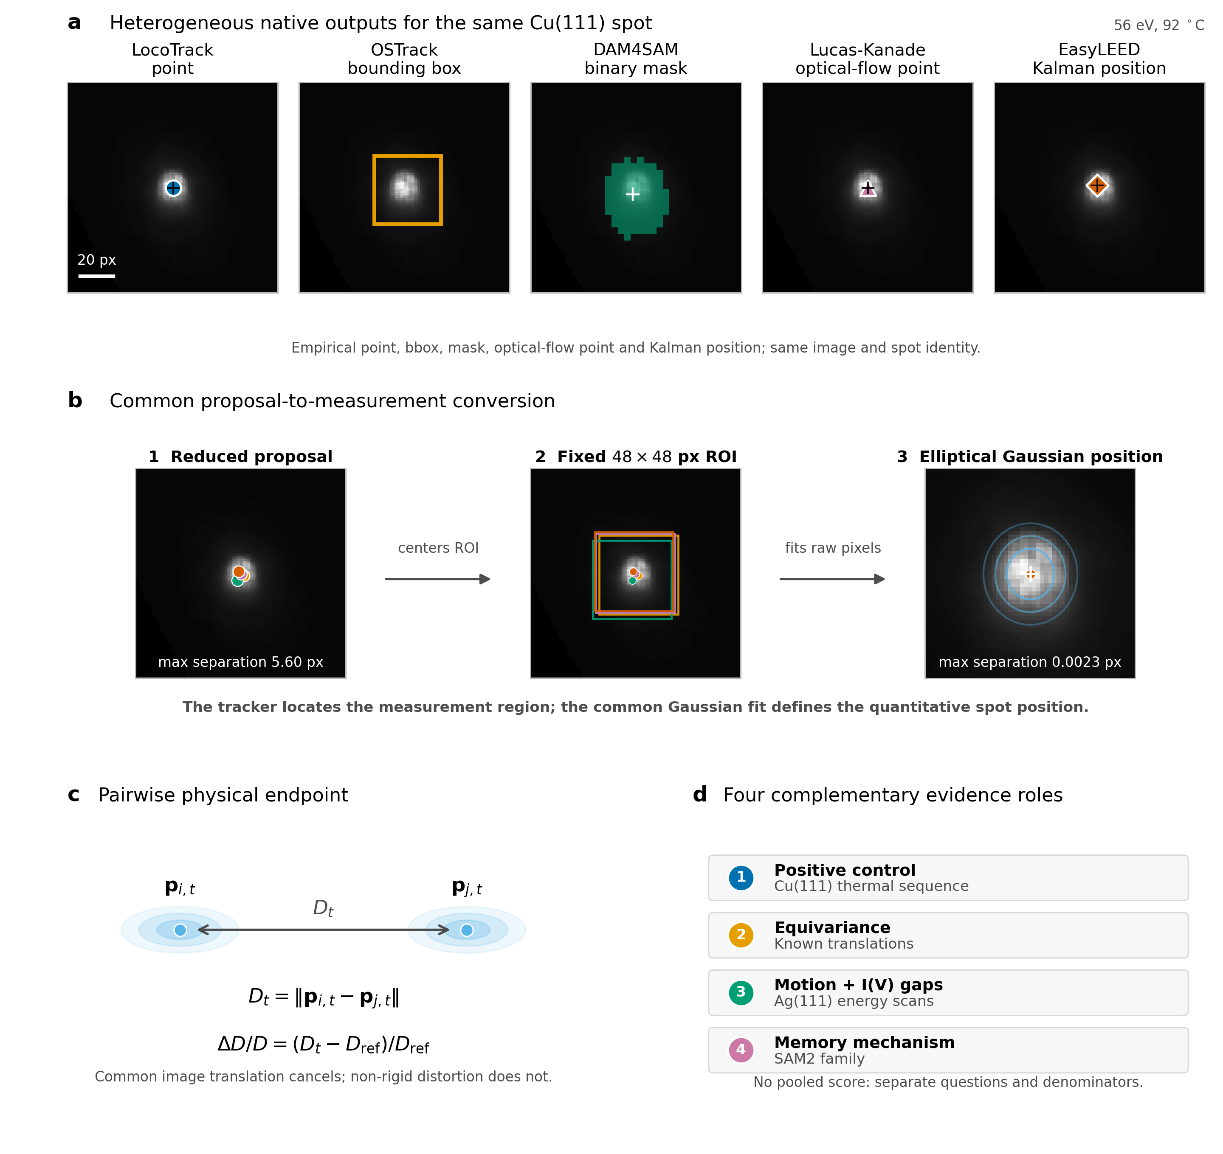
Figure 1. Tracking proposal, common position measurement, and evidence ladder. a, Native outputs of five strategies for the same Cu(111) spot: LocoTrack point, OSTrack box, DAM4SAM mask, Lucas–Kanade optical-flow point, and EasyLEED Kalman position. The view is the final image of the 701-image fixed-energy thermal cycle at 56 eV and 92 °C. The metadata-selected case used one sequence, spot, and seed without correction or reinitialization and was selected without inspecting tracker behavior; the empirical OSTrack box and unsmoothed DAM4SAM mask are retained. b, Each native output is reduced to a proposal coordinate centering the common 48 × 48-pixel ROI; one elliptical Gaussian fit to the raw pixels supplies the reported position. Proposal centers differ by at most 5.60 px and refined centers by 0.0023 px in this explanatory case, which was not selected from tracker outcomes and does not rank methods. c, Two refined positions define pair distance $D_{t}$ and $ΔD/D$; common translation cancels, whereas non-rigid distortion does not. d, Controlled translations, Cu(111), independent Ag(111) scans, and the controlled SAM2 family test equivariance, endpoint agreement, motion plus natural $I(V)$ gaps, and a memory mechanism, respectively. They retain separate denominators and do not form a composite ranking.

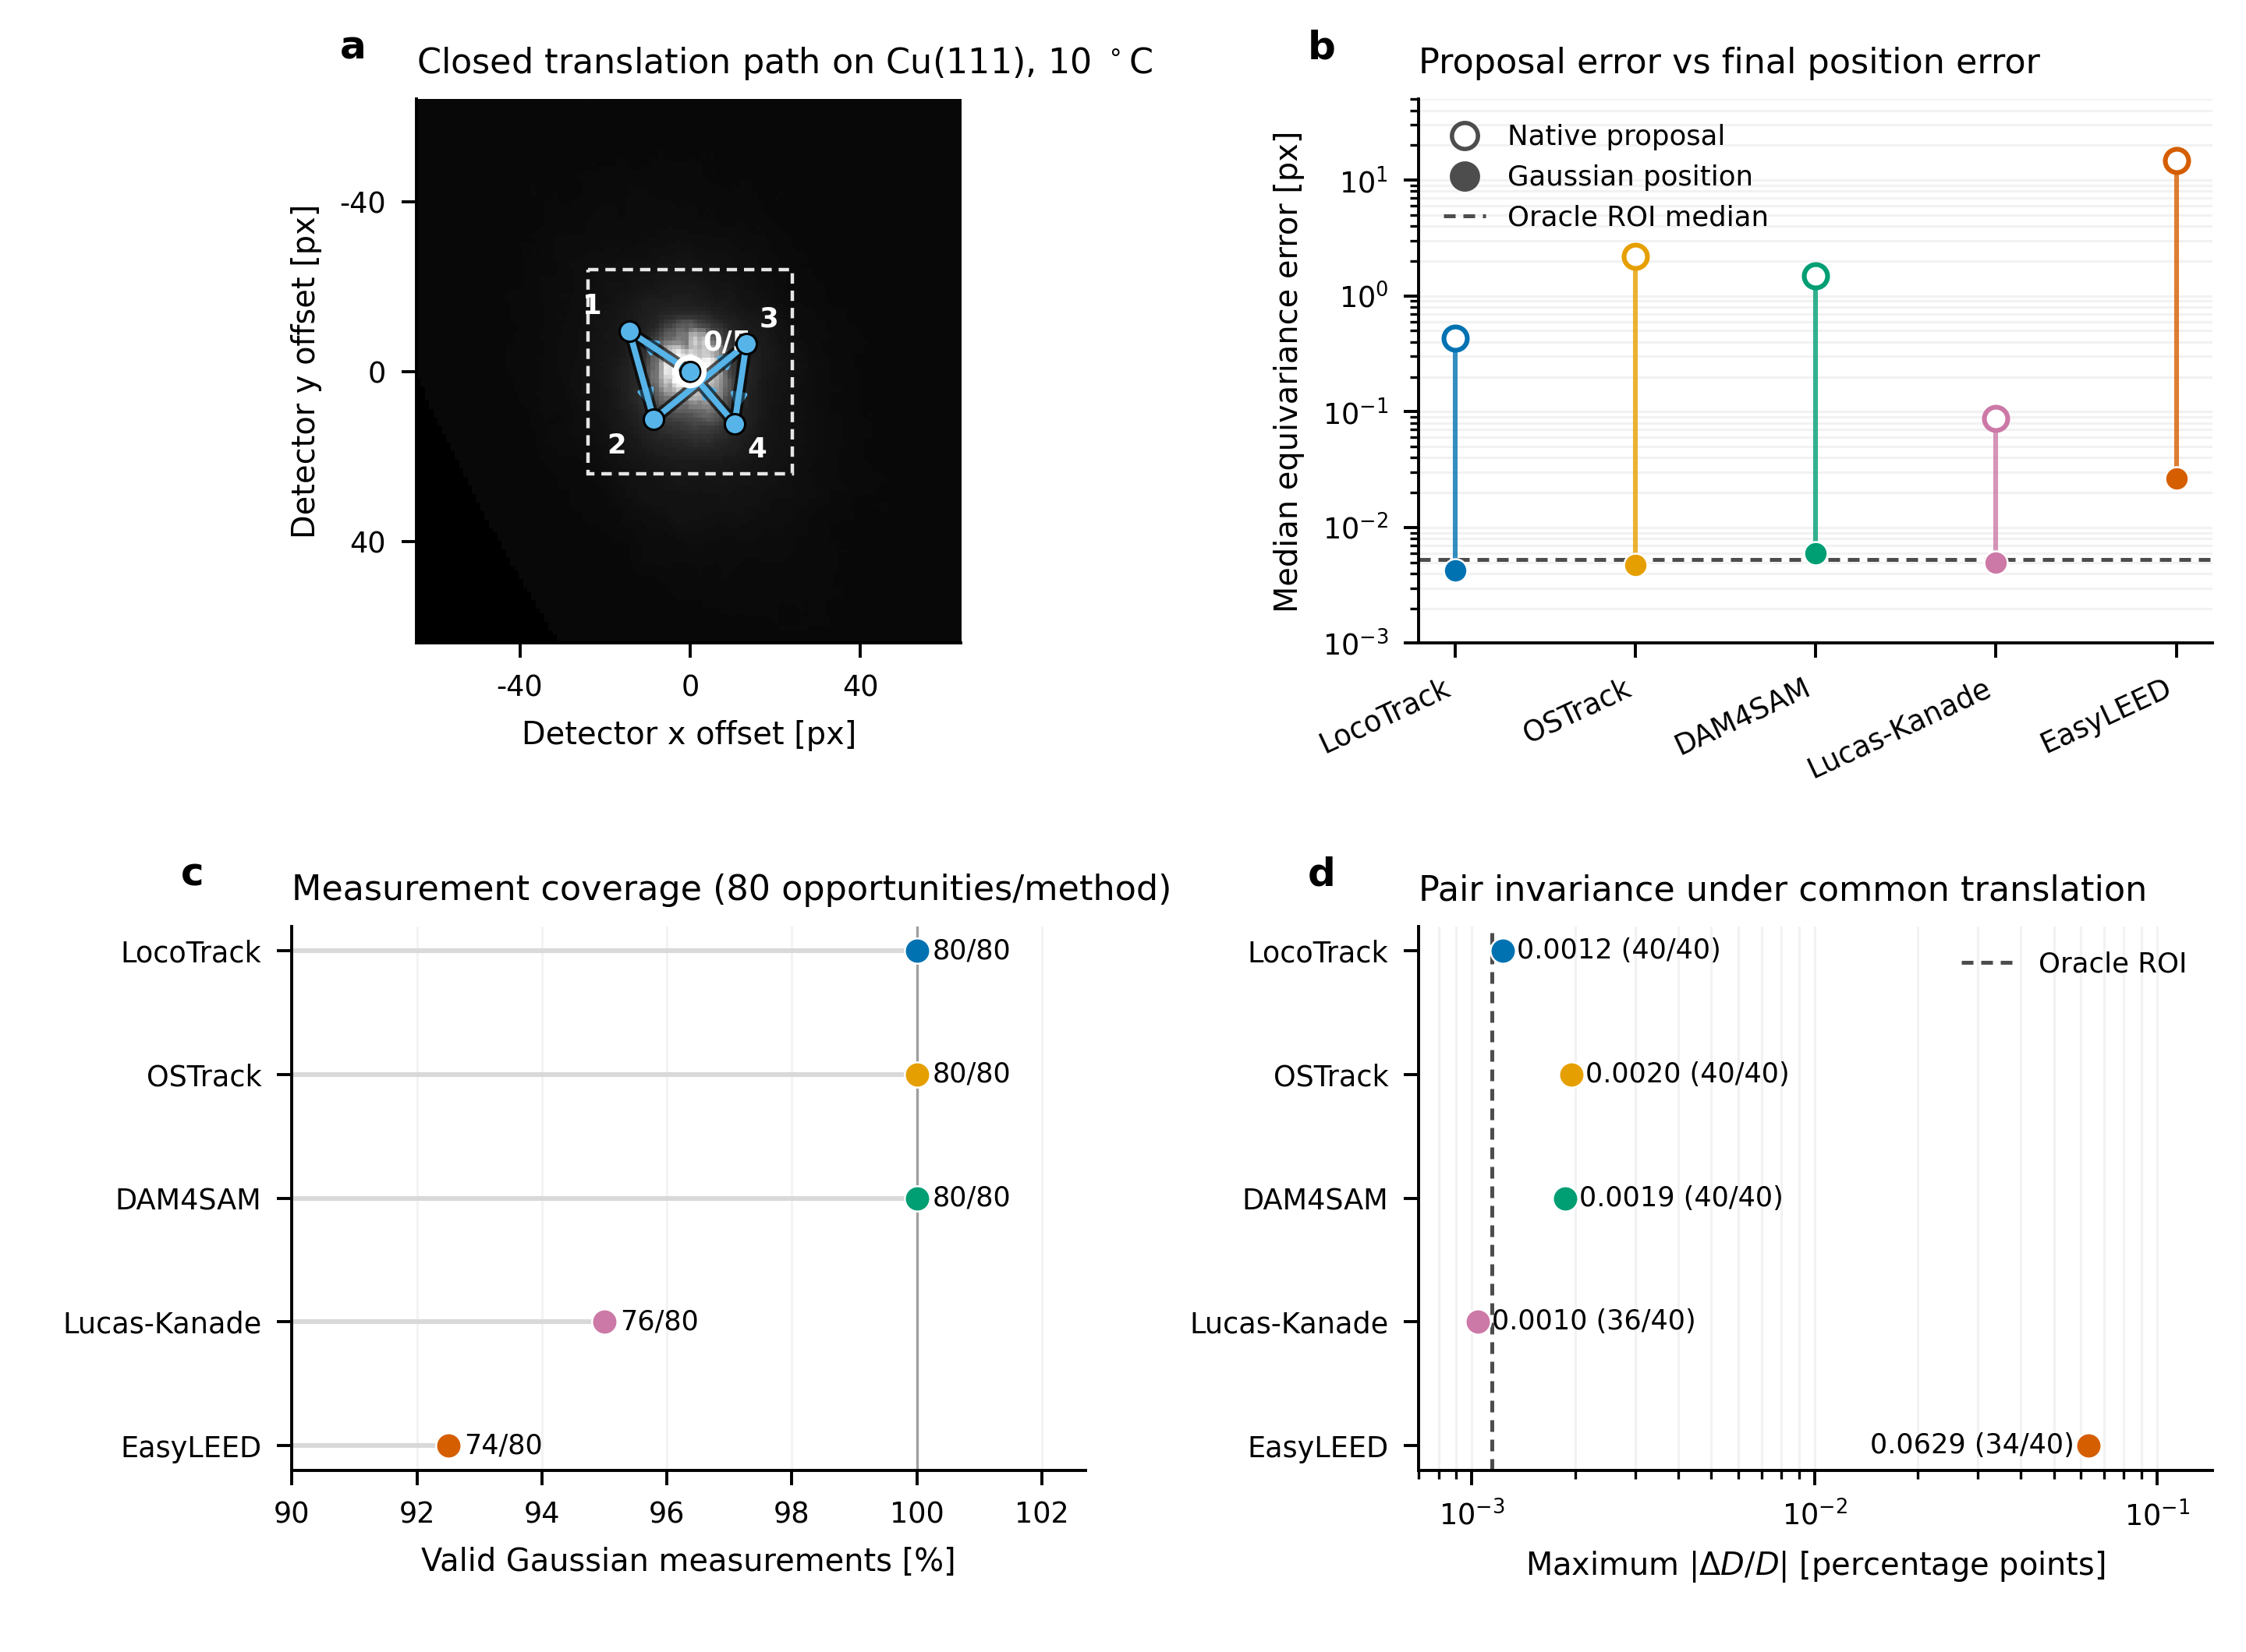
Figure 2. Controlled equivariance of the measurement chain. (a) Frozen closed translation path applied to four independently initialized Cu(111) states; the representative initial 10 °C image is shown. (b) Median displacement-equivariance error before and after the common two-dimensional Gaussian estimator. The oracle ROI estimates the interpolation-plus-estimator floor without a tracker. (c) Valid Gaussian measurements out of 80 predefined spot opportunities per method. (d) Maximum absolute pairwise relative-distance change under common image translation. Valid-pair counts out of 40 predefined opportunities are printed beside each method. Known translations assess measurement-chain equivariance and common- estimator behavior, not absolute tracking accuracy or identity ground truth.

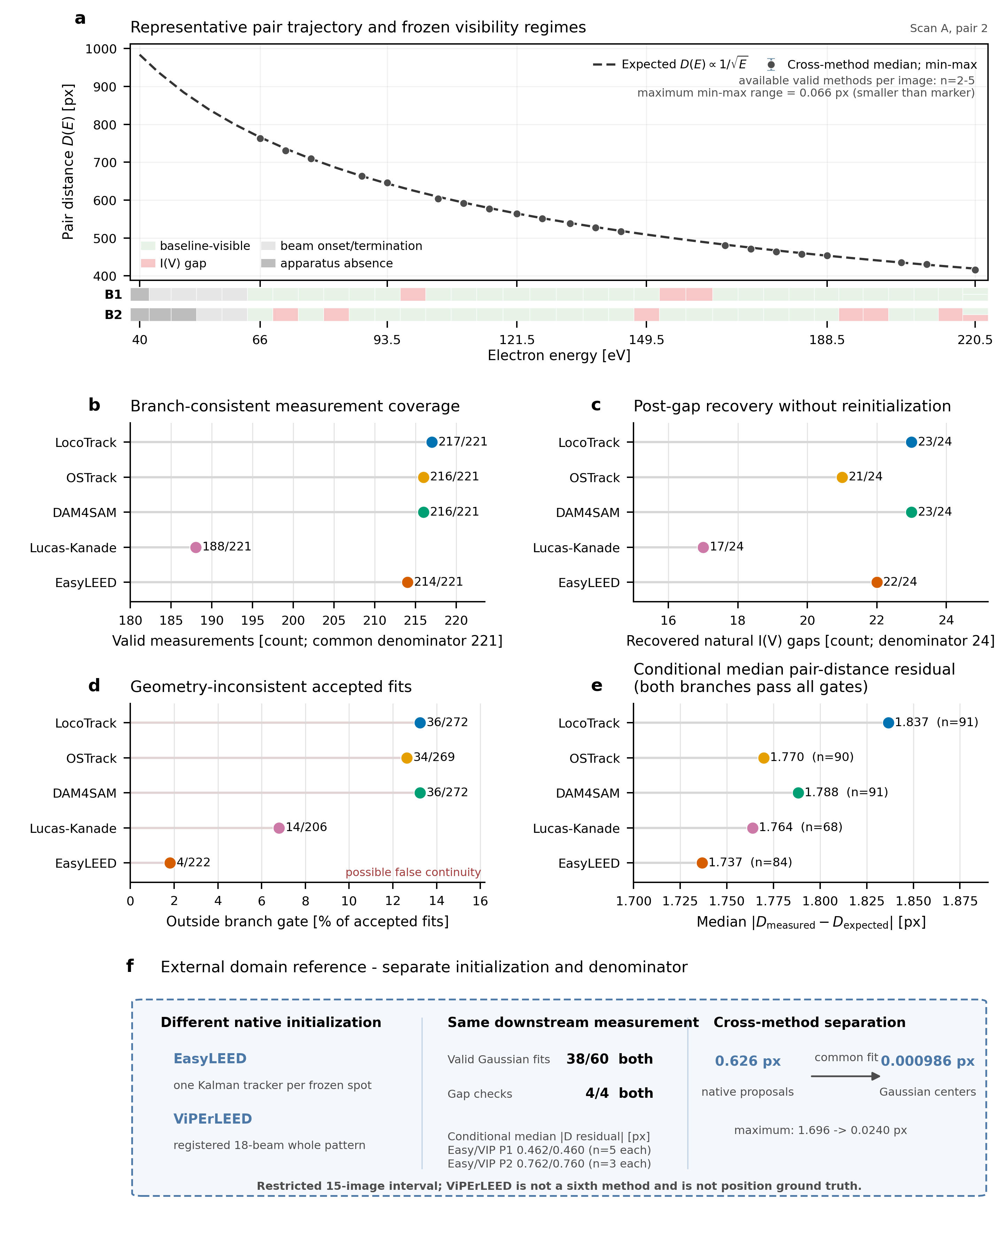
Figure 3. Independent Ag(111) energy-scan stress test. a, Pair distance as a function of electron energy for a representative frozen pair from Scan A. The case was selected by the predeclared physics rule before method outcomes were inspected: it is the first ordered case that passed the coherent pairwise energy-law check and contains natural I(V) visibility gaps. The dashed curve is the expected $D(E)∝1/\sqrt{E}$ trajectory and the neutral markers are framewise cross-method medians of the available valid Gaussian pair measurements. Vertical whiskers show the corresponding cross-method minimum-to-maximum range. Between two and five methods contribute per displayed image; the largest range is 0.066 px and is smaller than the marker at this scale. The two ribbons show the tracker-independent visibility regimes of the individual branches. Image identity is retained, so repeated terminal-energy acquisitions are not collapsed. b, Branch-consistent Gaussian measurement coverage among 221 baseline-visible spot opportunities per method. c, Recovery of the same physics-constrained branch after 24 evaluable natural I(V) gaps, without manual reinitialization. d, Accepted Gaussian measurements lying outside the frozen 18-pixel branch-consistency gate, reported over all accepted measurements in all visibility regimes. These events indicate possible false continuity but are not external ground-truth proof of an identity switch. e, Median absolute pair-distance residual conditional on both branches passing the proposal, Gaussian-fit, and geometry gates; the method-specific numbers of jointly consistent pair images are shown as $n$. This conditional quantity must be interpreted after coverage and recovery rather than as an overall accuracy ranking. f, Visually separated external domain reference over a restricted high-energy interval. EasyLEED uses one Kalman tracker per frozen spot, whereas ViPErLEED uses a registered 18-beam whole-pattern trajectory. Both supply proposals to the same Gaussian estimator. The inset has a separate 60-opportunity denominator and initialization contract; its pair-residual medians are conditional on 5 jointly valid P1 images and 3 jointly valid P2 images per method. ViPErLEED is neither a sixth method in the main matrix nor position ground truth.

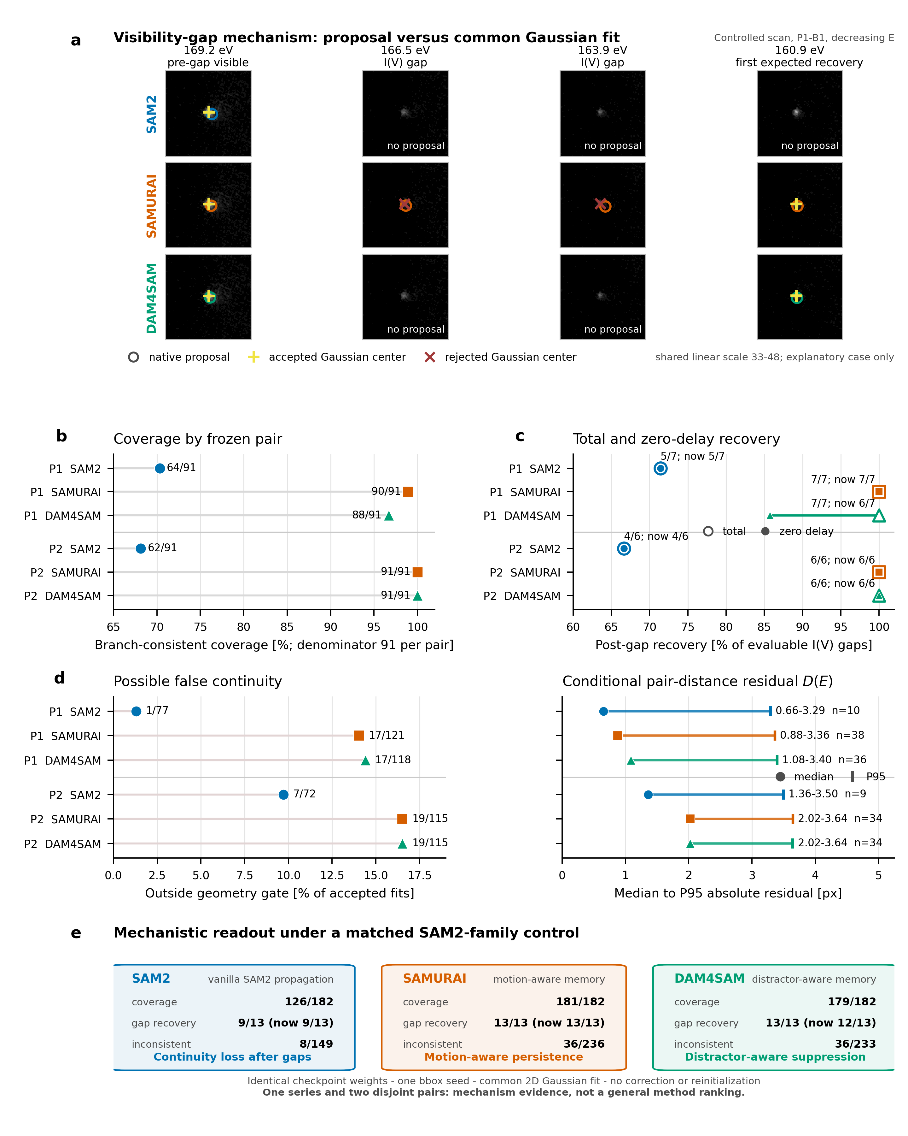
Figure 4. Controlled SAM2-family continuity–consistency trade-off under identical checkpoint weights. a, Four states around the first decreasing-energy B1 $I(V)$ gap with different recovery outcomes. SAM2, SAMURAI, and DAM4SAM receive the same bbox seed; circles are proposals, yellow plus signs accepted Gaussian centers, and red crosses rejected centers. All crops share the full 128 × 128 field and one linear intensity scale. The sequence is outcome-selected for mechanistic explanation and is not a representative-case estimate. b, Branch-consistent coverage for two disjoint pairs, each with 91 baseline-visible spot opportunities per method. c, Total and zero-delay recovery over seven and six evaluable gaps. d, Left, Gaussian fits outside the frozen geometry gate over each method’s accepted-fit denominator; right, median-to-P95 pair-distance residuals conditional on both branches passing proposal, fit, and geometry gates, with method-specific $n$. e, Motion- and distractor-aware memory increase coverage and recovery relative to vanilla propagation but also increase continuation outside the frozen branch. All methods use byte-identical SAM2.1 base-plus weights, the same 48 × 48-pixel prompt and measurement ROI, one Gaussian estimator, and no correction or reinitialization. One series and two pairs support a mechanism result, not a general ranking. Pair-specific denominators remain separate rather than pooled across the two cases. Conditional residuals summarize only surviving pairs and must follow fixed-denominator coverage, recovery, and geometry context.

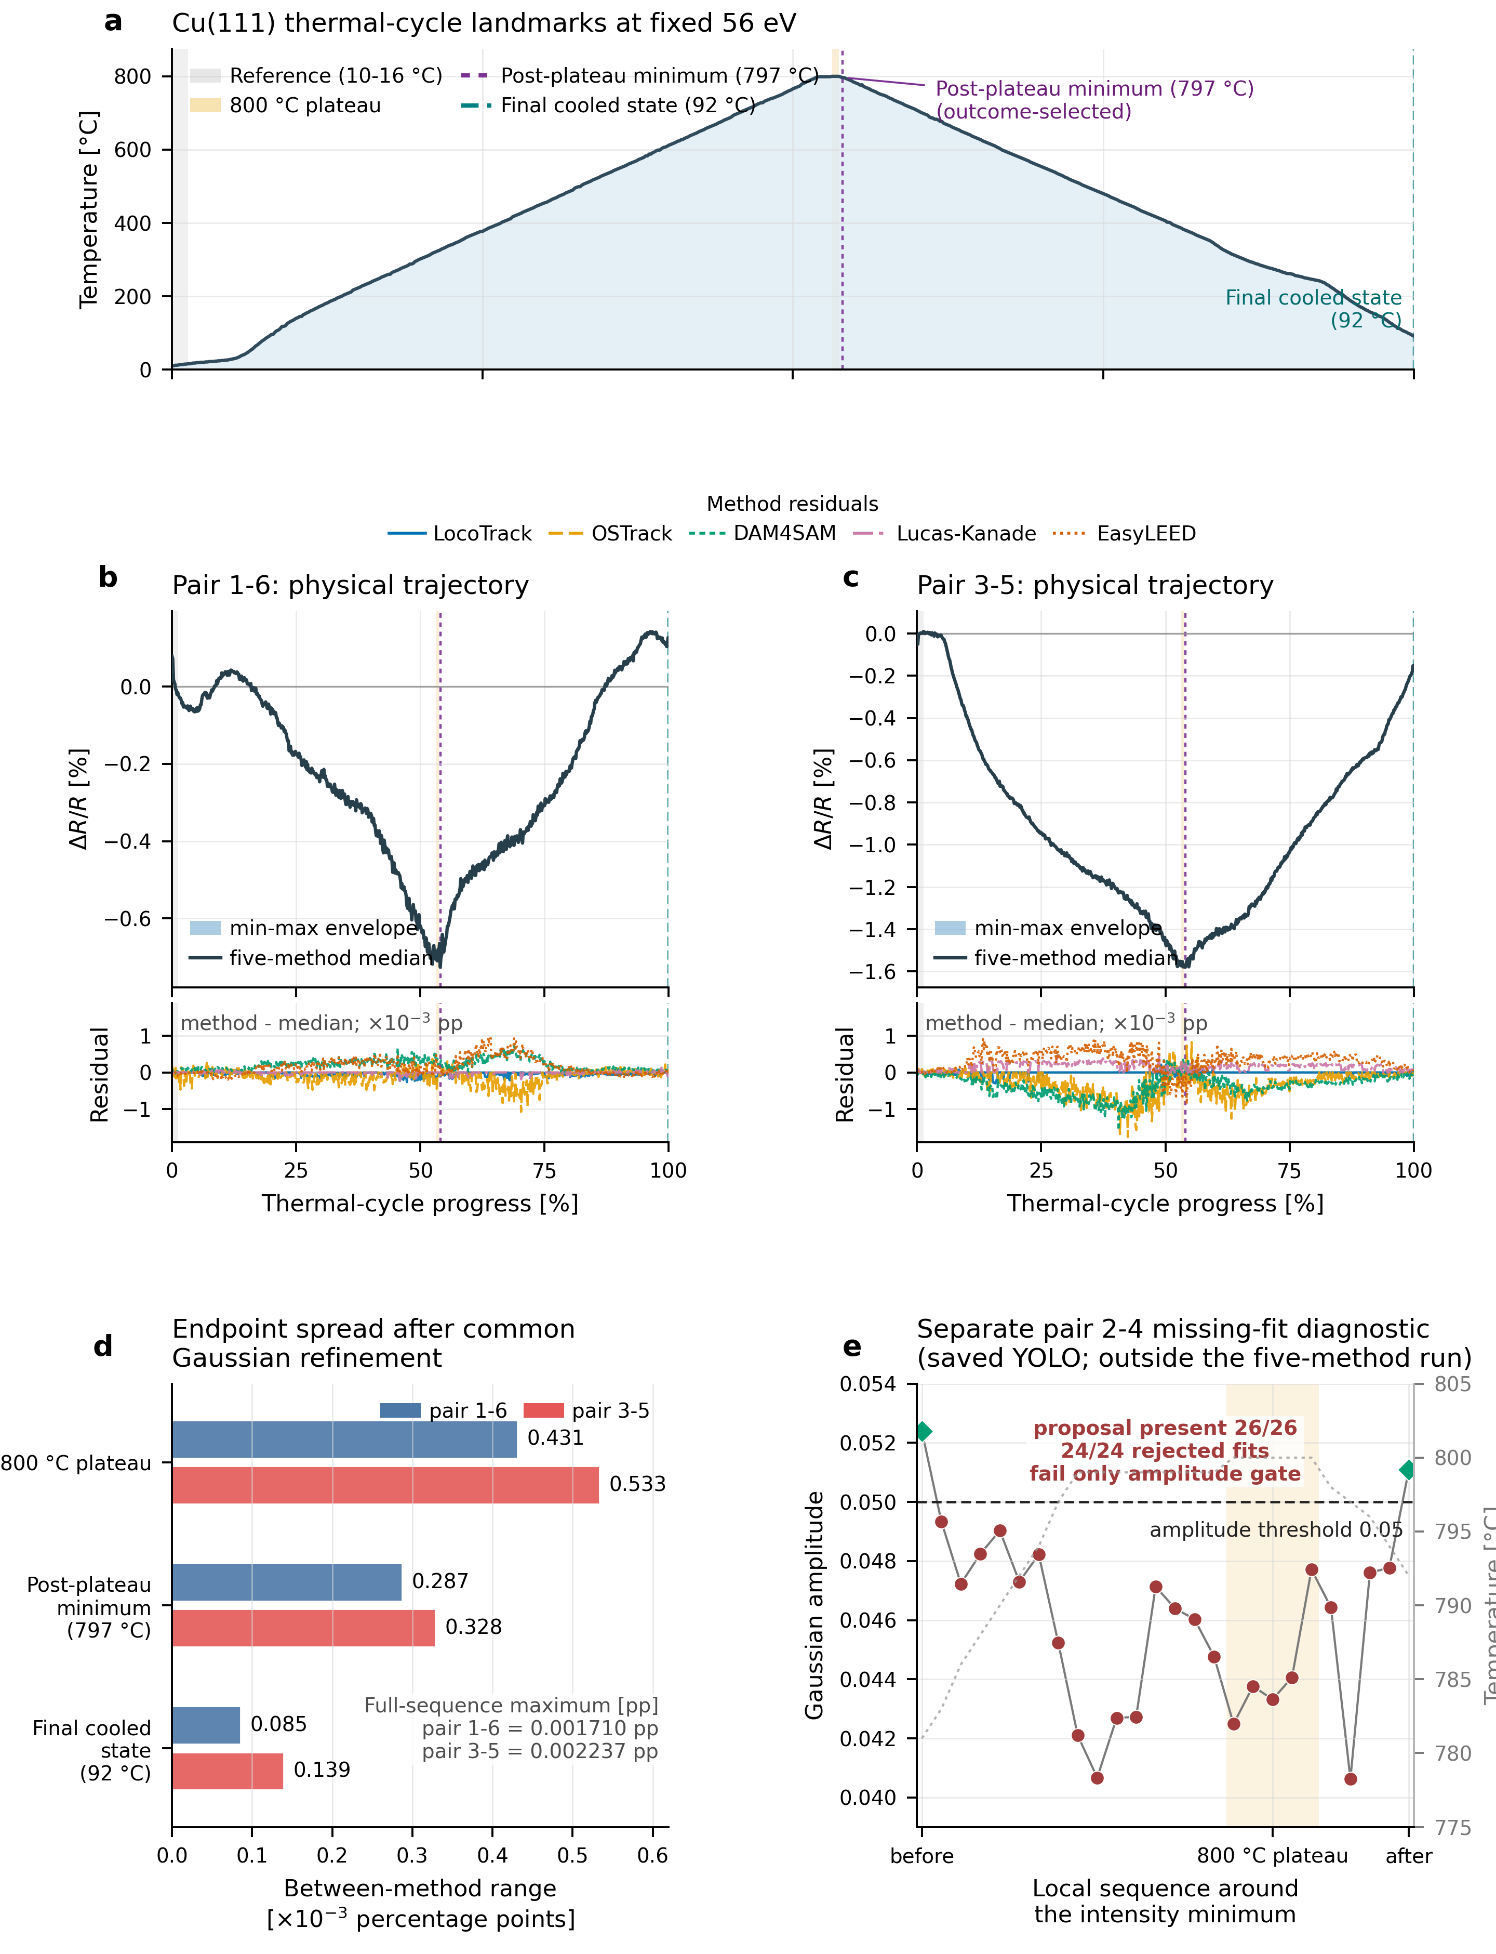
Figure 5. Common Gaussian refinement preserves the Cu(111) pairwise relative spot-radius endpoint across proposal strategies. a, Temperature profile of the 701-image constant-energy cycle with reference, 800 °C plateau, post-plateau minimum, and final cooled state; frame identifiers remain in source metadata. b,c, Pairwise $ΔR/R=ΔD/D$ for pairs 1–6 and 3–5 after five proposal strategies enter the same estimator. Upper axes show the cross-method median and range; lower axes magnify deviations from the median in ${10}^{−3}$ percentage points on a shared scale. Every method yields 701/701 endpoints per pair. Common image translation cancels in pair distance, whereas non-rigid distortion does not. d, Between-method endpoint range at the three predefined landmarks; maxima over the sequence are 0.001710 and 0.002237 percentage points. e, Separate saved-YOLO diagnostic for pair 2–4: proposals remain present throughout the displayed context while 24 consecutive Gaussian fits fail only the amplitude gate. This distinguishes proposal from measurement availability; it does not show identity loss or compare the five methods on that pair. The two primary pairs do not establish crystallographic anisotropy, thermal expansion, phase transition, or a structural mechanism.

