Evaluating Spot-Tracking Strategies for Quantitative LEED Analysis
  - Review manuscript
2026-07-30
Table of Contents

Draft status: working manuscript; Sections 1–8 are drafted. Author information, selected acquisition metadata, and final repository, license, and DOI details remain as explicit placeholders.

Authors
TODO[AUTHOR]: author list, affiliations, corresponding author, ORCID identifiers.

Abstract
Quantitative low-energy electron diffraction (LEED) analysis requires a measurement region to remain associated with its diffraction spot as the pattern moves and spot visibility changes. We evaluated how five heterogeneous tracking strategies affect a common position measurement rather than treating their native outputs as directly comparable positions. Each supplied a proposal to place a 48 × 48-pixel ROI; the reported spot center was obtained with the same two-dimensional Gaussian estimator. Validation combined known translations, a 701-image Cu(111) positive control, two independent Ag(111) energy scans with natural (I(V)) visibility gaps, and a controlled SAM2-family memory experiment. Under known translations, median full-chain displacement errors ranged from 0.0043 to 0.0265 px with 92.5–100% Gaussian-measurement coverage. In the Cu(111) positive control, every method produced 2,804/2,804 accepted spot measurements and 701/701 valid endpoints for each primary pair. Across four frozen pairs in the two Ag(111) scans, branch-consistent coverage ranged from 188/221 to 217/221 and post-gap recovery from 17/24 to 23/24, while conditional median pair-distance residuals among jointly branch-consistent pair images spanned a narrow range of 1.737–1.837 px. In a supporting single-series, two-pair memory experiment, SAMURAI and DAM4SAM increased coverage from 126/182 for SAM2 to 181/182 and 179/182, respectively, while also increasing geometry-inconsistent continuation; this mechanism result does not establish a general ranking. These experiments assess measurement-chain robustness rather than absolute tracking accuracy. The common Gaussian estimator strongly suppressed proposal differences when the intended spot remained inside its capture region; measurement coverage, post-gap identity recovery, and geometry-inconsistent continuation were more discriminating than conditional residuals alone.

Keywords
Low-energy electron diffraction; spot tracking; quantitative image analysis; Gaussian localization; visibility gaps; measurement robustness.

1. Introduction

1.1 Quantitative LEED requires persistent spot identity
Low-energy electron diffraction (LEED) probes the periodic structure of a surface through the energy-dependent diffraction of low-energy electrons (Pendry 1974). A recorded LEED pattern contains discrete diffraction spots whose positions, profiles, and integrated intensities can be extracted from image sequences (Mayer et al. 2012; Schmid et al. 2025a). Quantitative structural LEED most commonly uses intensity as a function of incident electron energy, (I(V)) (Pendry 1974; Schmid et al. 2025a). In time- or temperature-dependent image series, localized spot centers and profiles can additionally support measurements of displacement, pair distance, and profile width. Each of these image-derived quantities requires the measurement region to remain associated with the same physical diffraction spot throughout the analysed sequence.
Tracking is therefore upstream of the physical measurement but is not itself the measurement. A tracker supplies a location at which image information can be evaluated; the quantitative position, width, or intensity is then obtained from the corresponding pixels. This distinction matters because a smooth trajectory can follow a background feature or a neighbouring diffraction spot, while an irregular proposal can still yield a valid position if the intended spot remains inside the downstream estimator’s capture region. Preservation of LEED spot identity consequently cannot be inferred from trajectory smoothness alone.
The tracking problem becomes more difficult when the diffraction pattern moves. Changes in the experimental state can translate or deform the observed pattern, and varying the electron energy produces an approximately radial motion proportional to (1/). LEED-specific tracking systems already use this energy dependence to predict spot positions (Mayer et al. 2012; Schmid et al. 2025a). A position estimator must then accommodate both the expected physical motion and common-mode image motion caused by projection or apparatus drift.
Spot visibility introduces a separate challenge. Because diffraction intensity varies strongly with energy, a spot can fall below the measurement threshold and later become measurable again. We refer to an internal, intensity-driven interval bracketed by valid measurements of the same branch as an (I(V)) visibility gap. Such a gap is not generic video occlusion: image evidence for the intended diffraction feature is temporarily insufficient even though other nearby spots or background structures may remain visible. A useful tracking strategy must therefore support recovery of the same physical branch without silently continuing on a distractor.

1.2 Existing LEED tracking and the remaining evaluation problem
Automated LEED spot tracking and localization have clear precedents. EasyLEED tracks individually initialized spots with a Kalman filter informed by an energy-dependent motion model and elliptical two-dimensional Gaussian image measurements. If an image measurement is rejected, its prediction can continue until a later update becomes available (Mayer et al. 2012). ViPErLEED-ImageJ instead identifies and tracks a complete diffraction pattern using reciprocal-lattice geometry, the expected energy scaling, and local corrections from neighbouring spots. It supports weak or temporarily missing beams and is designed for extraction and processing of LEED (I(V)) curves (Schmid et al. 2025a). Thus, automated tracking, energy-dependent prediction, Gaussian localization, and propagation through low-visibility intervals are not introduced here.
General-purpose computer-vision methods provide different representations of the same association problem. These include propagated points based on local correspondence (Cho et al. 2024), transformer-based bounding-box tracking (Ye et al. 2022), classical optical flow (Lucas and Kanade 1981), and prompt-conditioned mask propagation with visual memory (Ravi et al. 2025; Yang et al. 2024; Videnovic et al. 2025). Their native outputs are heterogeneous: a point trajectory, updated bounding box, optical-flow displacement, Kalman state, or binary mask. The box center and mask centroid used in this study are local adapters that reduce those outputs to a TrackLEED tracking proposal; they are not native position estimates. Even after this reduction, the proposal coordinates do not have the same operational meaning or uncertainty. Directly ranking them would therefore conflate the proposal mechanism with the downstream position estimator.
This heterogeneity motivates a narrower evaluation question than whether LEED spots can be tracked automatically. The relevant question for quantitative analysis is when different proposal strategies lead to the same accepted physical measurement and when motion or loss of visibility causes missing or physically inconsistent results. A common downstream estimator makes that question testable by converting every native proposal into the same measurement ROI and deriving the reported position from the same image model. The comparison then concerns the complete measurement chain rather than the coordinate convention of a particular tracker.
Conditional localization error alone is insufficient for this purpose. A method can have a small residual on the subset of images for which it returns a proposal and the fit passes all gates, yet lose many measurable spots or resume on an incompatible diffraction branch after a visibility gap. These events disappear if only successful measurements enter the denominator. The evaluation must therefore keep measurement coverage, post-gap recovery, geometry-inconsistent continuation, and conditional position or pair-distance residuals as separate outcomes. Without an external image-by-image reference, such outcomes establish equivariance, reproducibility, and physical self-consistency rather than absolute tracking accuracy.

1.3 Study objective and contributions
This study evaluates how heterogeneous spot-tracking strategies affect a common quantitative LEED position measurement. We test the hypothesis that a shared Gaussian estimator suppresses method-specific proposal differences when the intended spot remains inside its capture region, whereas motion and visibility loss expose differences in measurement coverage, post-gap recovery, and physically inconsistent continuation. We additionally test whether those differences remain visible in the pairwise physical endpoint (R/R=D/D). TrackLEED serves as the reference implementation and reproducibility vehicle for these experiments; the graphical application and its software feature set are not the subject of the study.
The contributions are:
- A common proposal-to-ROI-to-Gaussian measurement contract for heterogeneous point, bounding-box, mask, optical-flow, and LEED-domain trackers.
- A controlled equivariance test of the complete measurement chain under known subpixel image translations.
- A five-strategy comparison on independent Ag(111) energy scans using common denominators for visible measurement opportunities and natural I(V) gaps.
- A controlled SAM2/SAMURAI/DAM4SAM comparison of memory-aware propagation strategies under byte-identical checkpoint weights.
- Propagation of tracker proposals to the pairwise physical endpoint Delta R/R = Delta D/D in a 701-image constant-energy Cu(111) sequence.
The four experimental regimes are assigned distinct evidential roles rather than pooled into one composite ranking. Controlled translations test measurement-chain equivariance, Cu(111) provides a positive control for endpoint agreement, independent Ag(111) energy scans test motion and natural visibility gaps, and the matched SAM2-family panel examines a continuity–consistency trade-off. This design does not provide absolute spot-identity ground truth; it evaluates whether each strategy supports an available and physically self-consistent quantitative measurement under the frozen conditions.

2. Data and physical measurement model

2.1 Data regimes
We used four data regimes with distinct evidential roles rather than pooling them into a single tracker ranking. The positive-control sequence comprised 701 Cu(111) diffraction images acquired at a constant electron energy of 56 eV during a thermal cycle. The recorded temperature ranged from 10 to 800 °C; the first image was acquired at 10 °C and the final image at 92 °C. Four spots (identifiers 1, 3, 5, and 6) and two predefined diametric pairs (1–6 and 3–5) formed the common five-method comparison. This sequence tests whether different proposal mechanisms lead to the same physical endpoint when all methods maintain the intended spot within the measurement region. It is therefore a positive control for agreement and not an absolute-accuracy benchmark.
Controlled translation experiments used four images representing the initial low-temperature state (10 °C), the first image of the five-image 800 °C plateau, the post-plateau (R/R) minimum (maximum contraction; 797 °C), and the final cooled state (92 °C). Each image was transformed by the same closed path of six subpixel translations. The four spots and two pairs used in the full Cu(111) sequence were retained. This regime provides a known image transformation and therefore evaluates equivariance of the complete proposal-to-measurement chain without requiring a manually annotated trajectory.
The principal stress test used two independently acquired Ag(111) energy scans, denoted Scan A and Scan B. Scan A contains 35 images spanning 40.0–220.5 eV, whereas Scan B contains 46 images spanning 40.0–220.4 eV. In both series, 188.5 eV was selected as the reference energy. Two disjoint diametric pairs were detected and frozen in each series before the compared trackers were evaluated. These data combine energy-dependent radial motion with intensity-driven disappearance and reappearance of diffraction spots.
A third Ag(111) energy scan, denoted the memory-analysis scan, was reserved for the controlled SAM2-family analysis. It contains 69 images spanning 45.0–220.2 eV, uses 187.9 eV as the reference energy, and contains two frozen diametric pairs. SAM2, SAMURAI, and DAM4SAM were compared on this series under identical checkpoint weights and a common downstream measurement contract. A restricted 15-image high-energy interval spanning 187.9–220.2 eV was also used to place EasyLEED and ViPErLEED under the same downstream estimator. That limited comparison is an external domain reference, not a row in the common five-method matrix.
For traceability, the archive identifiers of Scan A, Scan B, and the memory-analysis scan are 26a21_ScanE, 26a21b_ScanE, and 26a24_ScanE, respectively. These identifiers are used in the data manifests and repository paths, not as scientific descriptions of the experiments.
All numerical acquisition conditions stated here are taken from the frozen image inventories. TODO[TEXT]: add microscope, detector, sample-preparation, exposure, and heating-rate metadata when the corresponding experimental records are available; these quantities are not inferred from filenames.
Table 1. Data and evidence roles. Rows describe evidence roles, not five independent datasets. Controlled translations are derived from the Cu(111) sequence, and the external-reference row is a subset of the memory-analysis scan and outside the common five-method matrix. Outcomes remain separate rather than being reduced to a composite tracker ranking.
Scientific series label | Control variable/range | Image count | Frozen spots/pairs | Evidence role | Primary endpoint | Independence/replication unit
Cu(111) thermal-cycle positive control | Temperature 10–800 °C; constant 56 eV | 701 acquired images | Spots 1, 3, 5, and 6; pairs 1–6 and 3–5 | Positive control for agreement of the five strategy-to-measurement chains | ΔR/R = ΔD/D | One sequence, stratified by two frozen pairs; no population-level interval
Controlled translations | Known closed six-step path; Δx −14.25 to +13.25 px and Δy −9.50 to +12.25 px; constant 56 eV | 24 evaluation images (4 source states × 6 steps, including baseline) | Spots 1, 3, 5, and 6; pairs 1–6 and 3–5 | Equivariance and pair invariance under a known image transform | Gaussian-refined displacement error; maximum absolute ΔD/D | Four separately initialized source trials from the Cu(111) sequence; not four acquisitions
Ag(111) energy-scan stress test, Scans A and B | Scan A: 40.0–220.5 eV; Scan B: 40.0–220.4 eV | 81 acquired images (35 + 46) | Two disjoint pairs (four spots) per scan | Principal five-strategy test of radial motion and natural I(V) visibility gaps | Measurement coverage; post-gap identity recovery; geometry-inconsistent continuation; conditional absolute pair-distance residual | Two independent series, stratified by four frozen scan–pair cases
Ag(111) memory-analysis scan | 45.0–220.2 eV; reference 187.9 eV | 69 acquired images | Two disjoint pairs (four spots) | Controlled SAM2-family continuity–consistency mechanism test | Measurement coverage; post-gap identity recovery; geometry-inconsistent continuation; conditional D(E) residual | One series, stratified by two frozen pairs; supporting mechanism evidence
Restricted high-energy external reference | 187.9–220.2 eV | 15-image subset of the memory-analysis scan | Same two pairs; four branch coordinates; 18-beam whole-pattern initialization for ViPErLEED | EasyLEED/ViPErLEED domain-contract compatibility under the common Gaussian estimator | Accepted-measurement coverage; EasyLEED–ViPErLEED common-center distance | Subset of the memory-analysis scan with a separate initialization contract and denominator; not an independent replicate and outside the common five-method matrix

2.2 Tracking proposal and measurement ROI
The native output of a tracker was treated as a tracking proposal: a coordinate used to place the downstream measurement region, not the reported spot position. LocoTrack supplied a propagated point, OSTrack the center of its propagated bounding box, DAM4SAM the centroid of its propagated mask, Lucas–Kanade an accepted optical-flow point, and EasyLEED its Kalman-filtered position. In the controlled memory experiment, the centroid of the propagated mask was used for SAM2, SAMURAI, and DAM4SAM. Native visibility flags, confidence scores, mask areas, and component counts were retained as tracker diagnostics but were not interpreted as diffraction intensity.
Regardless of the inference resolution used by a method, its proposal was mapped back to the original 1000 × 1000 image coordinate system. The proposal coordinate was rounded to the nearest pixel and used to place a 48 × 48 pixel region of interest (ROI) on the original-intensity image. ROIs that extended beyond the image boundary were rejected rather than clipped or padded. Thus, different methods could place different ROIs, but every method within an experiment passed the selected raw-image region to the same position estimator.

2.3 Common Gaussian-refined position
Within an ROI, the intensity was represented by a rotated elliptical Gaussian with a constant background,
$$I(x,y)=B+Aexp\left[−\frac{1}{2}\left(\frac{u^{2}}{σ_{x}^{2}}+\frac{v^{2}}{σ_{y}^{2}}\right)\right],$$
where
$$\left(\begin{matrix}u \\ v\end{matrix}\right)=\left(\begin{matrix}cosθ & −sinθ \\ sinθ & cosθ\end{matrix}\right)\left(\begin{matrix}x−x_{c} \\ y−y_{c}\end{matrix}\right).$$
The fitted parameters were the amplitude (A), local center ((x_c,y_c)), principal widths ((_x,_y)), axial angle (), and background (B). Nonlinear least squares was initialized from the ROI intensity distribution. Adding the ROI origin to the local fitted center gave the reported global position of spot (i) in image (t),
$$p_{i,t}=(x_{i,t},y_{i,t}).$$
The estimator implementation was common to all methods, whereas acceptance gates were frozen separately for the Cu(111) and energy-scan regimes and then held constant across methods within each regime. In the Cu(111) sequence and controlled-translation experiment, a fit required finite diagnostics and center uncertainties, (R^2), (A), local center coordinates strictly between -2 and 50 pixels, and both fitted widths strictly between 0.5 and 48 pixels. In the energy-scan experiments, the gates were (R^2), (A), (0.6_x,_y) pixels, and a distance of at most 15 pixels between the proposal and refined center. The energy-scan solver used the same Gaussian model; its initial center was the smoothed intensity maximum within a 16.32-pixel radius of the ROI center, and its fitted center was bounded to ±16.32 pixels from that ROI center along each coordinate.
If the tracker did not return a proposal, the ROI lay outside the image, the fit failed, or any acceptance gate failed, the position was recorded as missing. Rejected values were neither interpolated nor carried forward. Gaussian amplitude and integrated volume were properties of the image fit and remained distinct from any native tracker confidence or visibility score. The complete gate contract, including strict versus inclusive bounds and the separate status of the energy-branch consistency test, is listed in Table S2.

2.4 Pairwise position endpoints
For a frozen pair of spots (i,j), the primary geometrical observable was their Euclidean separation,
$$D_{ij}(t)={∥p_{i,t}−p_{j,t}∥}_{2}.$$
For an approximately diametric pair, its diffraction radius is (R=D_{ij}/2). At constant beam energy and fixed projection geometry, the relative radial change can therefore be evaluated without estimating an image-specific pattern center:
$$\frac{ΔR}{R}=\frac{ΔD}{D}=\frac{D_{ij}(t)}{D_{ij,ref}}−1.$$
For an energy scan, the expected radial contraction was defined relative to the frozen reference energy (E_{}):
$$D_{ij,pred}(E)=D_{ij,ref}\sqrt{\frac{E_{ref}}{E}},$$
which is the pairwise form of (D(E)/). The corresponding distance residual was (D_{ij}(E)=D_{ij}(E)-D_{ij,}(E)). Pair distance is invariant to a common translation of both spots, but it does not eliminate non-rigid image distortion, incorrect spot association, or sector-dependent behavior.
The pair midpoint,
$$m_{ij}(E)=\frac{p_{i}(E)+p_{j}(E)}{2},$$
was consequently retained as a separate diagnostic of common image motion, apparatus geometry, and projection changes. It was not substituted for the pair distance and was not used to recenter the primary endpoint.

3. Tracking strategies and comparison contract
The comparison was organized by the representation propagated by each method rather than by treating all native coordinates as equivalent position measurements. The main panel comprised a point tracker, a bounding-box tracker, a mask tracker, optical flow, and a LEED-specific Kalman tracker. Each method received the prompt native to its family, derived from the same Gaussian-refined seed center: point methods received the center coordinate, whereas box- and mask-based methods received a 48 × 48 pixel box centered on that coordinate. The native output was reduced to one proposal coordinate and then passed to the common measurement chain defined in Section 2. Tracker scores and internal fit diagnostics could determine whether a native proposal was available according to the frozen method contract, but they never replaced the common Gaussian-refined position or served as a physical intensity.
Run-specific statements in this section were transcribed from the frozen five-method Cu(111) run manifest, controlled-translation contract, independent Ag(111) energy-scan artifact, SAM2-family artifact, and domain-baseline execution record. These records establish the executed revisions, checkpoints and hashes, input conversion, prompt convention, thresholds, failure policy, propagation direction, and proposal-to-ROI adapters; the upstream citations below establish the published method designs. The local links remain working-draft provenance; the committed software, model, configuration-hash, and retained-environment records are summarized in Table S1, which labels separately the configurations frozen during execution and the post-run normalized records derived from archived executed sources. The final submission will replace local artifact links with the archived dataset DOI.

3.1 Main five-strategy panel
LocoTrack. LocoTrack is a tracking-any-point model that combines local all-pair correspondence with temporal modeling to propagate queried points through a video (Cho et al. 2024). We used the Base model in offline mode from upstream revision 3385a23, with the published locotrack_base.ckpt checkpoint (Cho et al. 2025). A query consisted of the image index and the common seed point. The finite predicted point was the proposal coordinate. The model also returned occlusion and expected-distance logits. In the energy scans, the frozen adapter combined these outputs as
$$P_{vis}=\left[1−sigmoid(o)\right]\left[1−sigmoid(d)\right],$$
where (o) and (d) are the occlusion and expected-distance logits, respectively. A threshold of 0.5 defined native proposal availability. In the Cu(111) positive control and controlled translations, every finite point was passed to the common measurement and the same probability was retained only as a diagnostic. No visibility or uncertainty correction was applied to the point coordinate.
OSTrack. OSTrack is a single-object bounding-box tracker that unifies template and search-region feature extraction and their relation modeling in one transformer stream (Ye et al. 2022). We used upstream revision 33b5e12 and the ViT-B/256 MAE-CE configuration vitb_256_mae_ce_32x4_ep300 with its epoch-300 checkpoint (Ye et al. 2023). The initial 48 × 48 box was treated as the object template. A finite predicted box with positive width and height defined an available proposal; its arithmetic center, ((x+w/2,y+h/2)), was passed to the common ROI. The native box score was retained as a diagnostic and did not gate or weight the Gaussian fit.
DAM4SAM. DAM4SAM adapts the SAM2.1 video-segmentation architecture to visual object tracking by adding distractor-aware memory and an introspection-based memory-update strategy (Videnovic et al. 2025). We used upstream revision 9c95450 (Videnovic et al. 2026). The Cu(111) and controlled-translation experiments used sam21pp-L with the SAM2.1 Hiera Large checkpoint. The independent energy scans used sam21pp-B with the Hiera Base+ checkpoint so that the mask representative was also one member of the matched SAM2-family experiment described in Section 3.2. DAM4SAM received only the common initial box. An available proposal required a finite, nonempty binary mask, and the arithmetic centroid of its true pixels was used as the proposal coordinate. Native mask scores, areas, bounding boxes, and connected-component counts were retained as diagnostics.
Lucas–Kanade optical flow. The classical Lucas–Kanade method estimates a local image displacement from spatial intensity gradients (Lucas and Kanade 1981). We used the TrackLEED pyramidal skip-anchor implementation rather than a learned tracker. Its frozen settings were a 41 × 41 window, a maximum pyramid level of 4 (five levels including the base image), at most 50 iterations with a convergence tolerance of 0.01, and a minimum eigenvalue threshold of (10^{-5}). A match was accepted only if the native residual did not exceed 30 and the forward–backward closure error did not exceed 8 pixels. Normalized cross-correlation and centroid recentering were disabled. On a rejected image, the result was recorded as missing and the last successful image and position remained the anchor for a later attempt; no coordinate was interpolated. The Cu(111) and translation experiments used the common 256 × 256 grayscale cache. For the energy scans, the frozen TrackLEED implementation operated on the original image grid after its standard grayscale, high-pass, and white-top-hat preprocessing. The accepted optical-flow point was the proposal coordinate.
EasyLEED. EasyLEED is a LEED-specific tracker designed for automatic extraction of intensity–energy spectra (Mayer et al. 2012). Its tracker combines an energy-dependent radial motion model, a Kalman state containing position and velocity, and an internal elliptical-Gaussian image observation. If the internal observation is rejected, the Kalman prediction can remain available for a later update. We used EasyLEED 2.5.2 at upstream revision bbe4acd with one tracker per spot, a 12-pixel tracking radius in the method’s input grid, Gaussian initialization, window scaling enabled, and no manual correction (Mayer 2024). The exported Kalman (x,y) coordinate was the proposal. The adapter retained the native EasyLEED intensity and tracking radius and recorded its internal fit thresholds as diagnostics. In particular, the EasyLEED internal Gaussian observation was not substituted for the common TrackLEED Gaussian fit. The Cu(111) and translation runs used the common 256 × 256 cache, whereas the energy-scan adapter preserved every original image and its identity using EasyLEED’s native image loader.
Input resolution was method- and regime-specific rather than shared across the panel. LocoTrack and OSTrack used 256 × 256 input throughout; DAM4SAM, Lucas–Kanade, and EasyLEED used the regime-specific inputs stated above. This family-native inference was upstream of a common coordinate system: every proposal was returned to the original 1000 × 1000 grid before placement of the identical raw-image ROI. Thus, the experiment controls the physical measurement after proposal generation rather than claiming that the internal image representations of heterogeneous trackers are identical.

3.2 Controlled SAM2-family panel
SAM2, SAMURAI, and DAM4SAM form a related family of promptable mask propagators. SAM2 provides the reference streaming-memory architecture for promptable video segmentation (Ravi et al. 2025). SAMURAI adapts SAM2 to zero-shot visual object tracking by adding a Kalman motion model and motion-aware mask and memory selection (Yang et al. 2024). DAM4SAM instead uses distractor-aware memory and introspection-based updates (Videnovic et al. 2025).
The comparison used upstream revisions 2b90b9f for SAM2, 76ba195 for SAMURAI, and 9c95450 for DAM4SAM (Meta AI 2024; Yang et al. 2025; Videnovic et al. 2026). All three environments loaded byte-identical sam2.1_hiera_base_plus weights with SHA-256 a2345aede8715ab1d5d31b4a509fb160c5a4af1970f199d9054ccfb746c004c5. For every branch, the three methods received the same single-object 48 × 48 box at 187.9 eV, the same ordered images in each propagation direction, and no subsequent prompt or manual reset. Each nonempty mask was reduced to its pixel centroid and passed to the same 48 × 48 raw-image ROI, Gaussian estimator, and physical-consistency gates.
This matched design controls the backbone weights, prompt information, input sequence, proposal reduction, and downstream position measurement. It does not reduce the three trackers to a one-line ablation: their motion prediction, mask selection, visibility logic, and memory-update implementations are part of the strategies being compared. The panel is therefore interpreted as a mechanistic comparison of vanilla, motion-aware, and distractor-aware memory strategies under a matched measurement contract, not as proof that one isolated memory component caused every observed difference and not as a general ranking of SAM2-derived trackers.

3.3 Domain-specific references
EasyLEED participated in the common five-strategy panel because one independently initialized Kalman tracker yields one spot proposal and can therefore enter the same single-spot contract as the four general computer vision strategies. Its LEED-specific radial motion model makes it a physics-informed domain baseline rather than another generic point tracker.
ViPErLEED has a different purpose and input contract. It identifies and tracks a LEED pattern using reciprocal-lattice geometry, the expected (1/) scaling, a global screen mapping, and local information from neighboring spots, and is designed primarily for extraction and processing of LEED (I(V)) curves (Schmid et al. 2025a). We used ViPErLEED ImageJ plugin 1.03 from revision 2ed1044 with the frozen 18-beam Ag(111) pattern and a reciprocal-space-to-screen registration at 187.9 eV (Schmid et al. 2025b). Its whole-pattern output was reduced to the four coordinates corresponding to the two frozen pairs and then passed to the same Gaussian measurement as the EasyLEED coordinates.
Because ViPErLEED received global pattern information rather than one seed per tracked spot, it was not inserted as a sixth row in the common strategy matrix. The restricted high-energy comparison instead asks whether the single-spot EasyLEED and whole-pattern ViPErLEED outputs place the intended spots within the capture region of the same downstream estimator. It does not use either output as external position ground truth.
Table 2. Tracking methods and their reduction to the common measurement contract. The first five rows form the common strategy matrix. The controlled SAM2-family rows used byte-identical SAM2.1 Hiera Base+ checkpoint weights (SHA-256 a2345aede8715ab1d5d31b4a509fb160c5a4af1970f199d9054ccfb746c004c5). Every available proposal coordinate entered the same 48 × 48 raw-image measurement ROI and TrackLEED two-dimensional elliptical-Gaussian estimator. ViPErLEED is a separate whole-pattern external reference, not a sixth row in the common five-method matrix. Full revisions, available executed-configuration hashes, checkpoint hashes, and execution environments are retained in the frozen artifact and reported in Table S1.
Panel | Method | Family/representation | Checkpoint or algorithm configuration | Initialization | Native availability/output | Proposal coordinate | Manual reset/correction | Study role
Main | LocoTrack | Point | Base, offline mode | Common seed point | Finite point; energy scans additionally require combined native visibility probability > 0.5; point plus occlusion and expected-distance logits | Native point | Prohibited | General point tracker
Main | OSTrack | Box | ViT-B/256 MAE-CE, epoch 300 | Common 48 × 48 box | Finite positive-area box; box plus score | Box center | Prohibited | General bounding-box tracker
Main | DAM4SAM | Mask | sam21pp-L on Cu(111) and controlled translations; sam21pp-B on energy scans | Common 48 × 48 box | Finite nonempty binary mask; mask plus diagnostics | Mask centroid | Prohibited | General mask tracker with distractor-aware memory
Main | Lucas–Kanade | Point | Pyramidal skip-anchor; 41 × 41 window, four pyramid levels, forward–backward threshold 8 px | Common seed point | Match passing residual and forward–backward gates; accepted point or explicit missing value | Accepted point | Prohibited; last successful point remains the anchor | Classical motion baseline
Main | EasyLEED | Position | LEED motion model and Kalman filter | Common seed point, tracking radius, and pattern center | Finite exported Kalman x,y; position plus native intensity and radius | Kalman x,y | Prohibited | LEED-domain single-spot baseline
Controlled SAM2 family | SAM2.1 | Mask | Hiera Base+, vanilla propagation | Common 48 × 48 box | Finite nonempty mask; mask | Mask centroid | Prohibited | Vanilla streaming-memory control
Controlled SAM2 family | SAMURAI | Mask | Hiera Base+, motion-aware memory | Common 48 × 48 box | Finite nonempty mask; mask plus motion-aware selection | Mask centroid | Prohibited | Motion-aware memory strategy
Controlled SAM2 family | DAM4SAM | Mask | sam21pp-B, distractor-aware memory | Common 48 × 48 box | Finite nonempty mask; mask plus distractor-aware diagnostics | Mask centroid | Prohibited | Distractor-aware memory strategy
External reference | ViPErLEED | Whole-pattern LEED geometry | ViPErLEED ImageJ plugin 1.03 | Frozen 18-beam pattern and screen registration | Finite pattern-associated coordinate for the corresponding beam | Coordinate of corresponding beam | Prohibited | Separate whole-pattern reference

4. Validation protocol

4.1 Reporting principles
The validation separates four outcomes that answer different questions: physics-consistent measurement coverage, recovery after natural I(V) visibility gaps, accepted measurements that are inconsistent with the expected branch geometry, and position or pair-distance residuals conditional on a valid branch-consistent measurement. Every predefined opportunity remains in its denominator when a tracker proposal is unavailable or a Gaussian fit is rejected. Conditional residuals are reported only with their corresponding coverage and are not used to replace failures with favorable surviving-image statistics. Table S2 records both the fixed opportunity denominators and the method-dependent sample sizes of every conditional statistic.
All results are descriptive. Counts and rates retain their integer denominators, and continuous errors are summarized by medians, 95th percentiles, and maxima where specified in the frozen artifacts. We do not construct a composite score or claim an absolute-accuracy ranking. Successive images within one propagated trajectory are repeated observations of the same tracking event and are not treated as statistically independent replicates. All per-image outputs were calculated automatically and no individual proposal annotations were created. For the 701-image Cu(111) run, visual review was limited to a frozen set of 24 combined overlays selected independently of tracker output (12 temporal quantiles and 12 temperature-cycle anchors), rather than all 14,020 proposals. Visual review was not used to correct a trajectory or change an outcome.
We did not calculate inferential confidence intervals or (p)-values. The available between-unit structure comprised four separately initialized controlled-translation trials drawn from one Cu(111) sequence and two independently acquired series for the principal energy-scan experiment. The two frozen pairs within each energy scan were retained as stratified cases, not treated as additional independent series. The SAM2-family experiment and the Cu(111) positive control each contained one series and two pairs. These counts and their nested structure do not support stable population-level interval estimation. Binomial intervals over images, measurement opportunities, or gaps were also excluded because those observations are correlated within propagated trajectories.
Pooled counts are instead accompanied by descriptive stratification. Table S5 reports controlled-translation coverage and conditional error summaries for each independently initialized source trial. Table S3 reports the principal energy-scan outcomes for every frozen scan–pair case. A leave-one-case-out sensitivity analysis omits each of those four cases in turn and recomputes only count-based coverage, recovery, and geometry-inconsistency rates; it is not a confidence interval and does not reaggregate conditional case-median residuals. Gaussian center uncertainties are fit diagnostics for individual accepted image measurements, not estimates of sampling uncertainty in tracker performance.

4.2 Controlled translations
One image from each of the four frozen Cu(111) states—the initial low-temperature state, the first image of the five-image 800 °C plateau, the post-plateau (R/R) minimum (maximum contraction), and the final cooled state—was subjected to the closed translation path
$$(0,0), (−14.25,−9.5), (−8.5,11.25), (13.25,−6.5), (10.5,12.25), (0,0)$$
in original-image pixels. Transforms were generated with first-order interpolation, a constant zero-valued boundary, and no prefiltering. The same physical translation was applied independently on two frozen grids: the 1000 × 1000 floating-point raw image used for Gaussian measurement and the 256 × 256 tracker cache, with displacements scaled by 0.256 before conversion of the transformed cache to unsigned 8-bit values. Thus, the tracker cache was not generated by downsampling the already transformed raw image.
Each trial used the same four frozen seed centers. A seed was the coordinate-wise median of the five available common Gaussian centers from the completed Cu(111) comparison in that source image. Point-based methods received the corresponding seed coordinates, box- or mask-based methods received a symmetric 48 × 48 box derived from the same center, and EasyLEED used the same center with its frozen tracking-radius and Kalman contract. Seeds were inputs to the experiment and were not treated as ground truth. No correction or reinitialization was allowed within a six-image trial.
For either a native proposal or a Gaussian-refined center (_t), the displacement-equivariance error was
$$ϵ_{t}={∥(q_{t}−q_{0})−(Δx_{t},Δy_{t})∥}_{2}.$$
Subtracting each method’s own initial coordinate removes a constant initialization offset and tests recovery of the commanded displacement. The seed step was excluded from aggregation, leaving five evaluated steps for four trials and four spots, or 80 spot opportunities per method. Applying the same rule to two predefined pairs produced 40 pair opportunities per method. For each pair we additionally measured (|D_{ij}(t)-D_{ij}(0)|) and the corresponding change in (D_{ij}) relative to its initial value.
An oracle-ROI control placed the measurement ROI at the commanded translated seed without using a tracker. It estimates the combined interpolation and Gaussian-estimator floor under the same image transformations and acceptance gates. The oracle is a control, not a sixth tracking method.

4.3 Cu(111) positive control
Each of the five methods was initialized once on the first image with common seeds for spots 1, 3, 5, and 6 and then propagated forward through the full 701-image sequence. Manual corrections and reinitialization were prohibited. Every proposal was converted to the common 48 × 48 ROI and Gaussian measurement described in Section 2. The primary endpoints were evaluated for pairs 1–6 and 3–5 on all 701 images.
For each method and pair, (D_{ij,}) was the median of valid pair distances in the first 10 images, provided that at least 8 of the 10 distances were valid. If this criterion was not met, the entire method–pair relative endpoint was defined as unavailable. The thermal-cycle summaries were the median relative change over the predefined five-image 800 °C plateau, the post-plateau (R/R) minimum and its associated temperature, and the final-image value.
Pair 2–4 was not included in the five-method run because spots 2 and 4 were outside its frozen four-spot contract. It was retained as a separate missing-measurement diagnostic based on an earlier saved YOLO proposal trajectory. In that diagnostic, the proposal remained available while 24 consecutive Gaussian fits spanning the hottest part of the thermal cycle failed only the common amplitude gate. These missing endpoints were not interpolated. The diagnostic demonstrates that proposal availability and quantitative measurement availability are distinct; it is not evidence that all five methods behaved identically for pair 2–4.

4.4 Independent Ag(111) energy-scan stress test
The independent energy-scan comparison used Scan A and Scan B, with two disjoint frozen pairs per series, for four cases in total. Candidate spots were detected automatically in the 188.5 eV reference image, refined by the common Gaussian fit, combined into approximately diametric pairs, and frozen before method comparison. The two branches of each pair were tracked as independent single-object trajectories. From the reference image, propagation was performed separately toward lower and higher energies, with one seed per spot and no correction or reinitialization after a visibility gap. Equal-energy terminal images were retained as distinct records by image identifier.
A tracker-independent physics baseline assigned the evaluable status of each branch and image. It used the frozen reference center and the expected radial scaling
$$p_{pred}(E)=c+\left[p(E_{ref})−c\right]\sqrt{\frac{E_{ref}}{E}},$$
the active detector annulus, and the common energy-scan Gaussian gates. An accepted measurement was classified as branch-consistent when its distance from (_{}(E)) did not exceed the frozen tolerance of 18 pixels. This tolerance was an evaluation gate and did not move the tracker proposal or the fitted center.
Across the four cases, the baseline defined 221 visible spot opportunities and 24 evaluable natural I(V) gaps for every method. Physics-consistent measurement coverage was the number of baseline-visible opportunities with a valid, branch-consistent Gaussian measurement divided by 221. Geometry inconsistency was computed separately as the number of accepted Gaussian fits more than 18 pixels from the expected branch divided by all accepted fits in all visibility regimes. Pair-distance residuals were calculated only on images in which both branches were valid and branch-consistent, and were summarized as (|D_{ij}(E)-D_{ij,}(E)|).
One of the four frozen pairs, pair 1 in Scan A, did not pass the auxiliary coherent-pairwise-energy-law check. It was retained as a difficult case rather than removed after observing tracker results. The native EasyLEED Kalman tracker also diverged once in Scan A pair 2; the exception was retained as a failure and the tracker was not reset.

4.5 Controlled SAM2-family analysis
SAM2, SAMURAI, and DAM4SAM were evaluated on both frozen pairs of the memory-analysis scan. Each branch received the same single 48 × 48 bounding-box prompt at 187.9 eV and was propagated toward increasing energy and, in reversed image order, toward decreasing energy. The three environments used byte-identical SAM2.1 base-plus checkpoint weights. The methods differed in their propagation, mask-selection, visibility, and memory mechanisms, while the prompt, image sequence, mask-centroid proposal reduction, Gaussian estimator, acceptance gates, and physical-consistency evaluation were fixed.
The same coverage, gap-recovery, and geometry-inconsistency definitions used for the independent energy-scan comparison were applied. The pooled denominators were 182 baseline-visible spot opportunities and 13 evaluable natural I(V) gaps per method. Because the experiment contains one series and two pairs, it is interpreted as a controlled mechanism comparison rather than a general ranking of SAM2-family trackers.

4.6 Domain-specific external reference
The restricted EasyLEED–ViPErLEED comparison used the 15-image high-energy interval of the memory-analysis scan and the same two pairs as the controlled memory analysis. EasyLEED produced single-spot Kalman trajectories, whereas ViPErLEED supplied a whole-pattern LEED trajectory. Their native outputs were mapped to the same four branch coordinates and evaluated with the common 48 × 48 Gaussian contract.
EasyLEED was initialized once at 187.9 eV with one Kalman tracker at each of the four frozen branch centers and a 12-pixel native tracking radius. ViPErLEED was initialized once at the same reference image using the frozen 18-beam Ag(111) pattern and reciprocal-space-to-screen registration, after which it tracked the complete pattern. Both methods processed the 15-image segment toward non-decreasing energy without manual correction or reinitialization, giving 60 predefined branch-image opportunities per method. Image identity, rather than energy alone, was used as the record key so that the two distinct terminal images at 220.2 eV were preserved. This comparison tests whether the heterogeneous domain-specific outputs can enter the same measurement chain; it is not included in the five-method comparison matrix or used as external position ground truth.

4.7 Visibility regimes and recovery
The physics baseline distinguished three causes of an unavailable spot: apparatus absence when the predicted position fell outside the active detector annulus or inside an apparatus shadow; beam onset or termination when an unmeasurable run occurred before the first or after the last visible fit; and a natural I(V) visibility gap when an unmeasurable run was bracketed by visible fits on the same physical branch. Only the third class entered the gap-recovery denominator.
For a gap below the reference energy, recovery was sought while continuing toward lower energy; for a gap above the reference, it was sought toward higher energy. A gap was counted as recovered if a valid branch-consistent Gaussian measurement occurred in the first contiguous baseline-visible run after the gap, before another non-visible regime interrupted that run. Recovery delay in image steps was retained. No manual reinitialization was permitted.
An accepted Gaussian fit more than 18 pixels from its expected branch was reported as a geometry-inconsistent continuation. This is an operational indicator of possible false continuity: the tracker has maintained a measurable image feature, but the feature is not compatible with the frozen energy-dependent branch geometry. It is not, by itself, external identity-ground-truth proof of a specific misassociation.

5. Results

5.1 Known translations isolate the measurement-chain behavior
LocoTrack, OSTrack, and DAM4SAM each returned a proposal and a valid common Gaussian measurement for all 80 evaluated spot opportunities (Figure 2; Table 3). Lucas–Kanade returned 76/80 proposals, all of which produced valid Gaussian measurements. EasyLEED returned 80/80 Kalman proposals, but six did not yield an accepted common fit, giving 74/80 measurement coverage. The corresponding pairwise endpoint coverage was 40/40 for LocoTrack, OSTrack, and DAM4SAM, 36/40 for Lucas–Kanade, and 34/40 for EasyLEED. Missingness therefore arose at different stages of the measurement chain and was not absorbed into the displacement-error statistic.
Before Gaussian refinement, the median displacement-equivariance error was 0.433 px for LocoTrack, 2.183 px for OSTrack, 1.493 px for DAM4SAM, and 0.087 px for Lucas–Kanade. After refinement, the corresponding medians were 0.0043, 0.0048, 0.0060, and 0.0050 px. These values were of the same order as the 0.0053 px median of the oracle-ROI control, which includes interpolation and estimator error but no tracker. EasyLEED showed the same suppression at a larger scale: its median native error of 14.758 px was reduced to 0.0265 px after the common fit. Its 95th-percentile refined error nevertheless remained 0.382 px, compared with 0.0127–0.0168 px for the other four methods.
The pair-distance endpoint was also insensitive to a common translation when both spots remained measurable. The maximum absolute change in (D/D) was 0.001229 percentage points for LocoTrack, 0.001952 for OSTrack, 0.001869 for DAM4SAM, and 0.001042 for Lucas–Kanade, compared with 0.001147 for the oracle control. EasyLEED reached 0.062943 percentage points and had the lowest pair coverage. Thus, a successfully captured spot could be localized near the estimator floor even when the native proposal was much less accurate, but this conditional result did not eliminate differences in measurement availability. The experiment establishes equivariance of the complete measurement chain under a known image transform, not absolute spot-identity accuracy. The four independently initialized trial-level summaries are retained separately in Table S5.

5.2 Cu(111) is a positive control, not a tracker ranking
All five strategies completed the Cu(111) positive control without a missing proposal or rejected common fit: each method produced 2,804/2,804 Gaussian measurements, and each primary pair produced 701/701 valid (R/R) endpoints (Figure 5; Table 3). The largest separation between two native method proposals was 16.759 px, whereas the largest separation between the corresponding Gaussian-refined centers was 0.0502 px. At the endpoint level, the maximum between-method difference over the entire sequence was only 0.001710 percentage points for pair 1–6 and 0.002237 percentage points for pair 3–5.
The five methods also reproduced the same thermal-cycle features. Over the predefined five-image 800 °C plateau, their median (R/R) estimates ranged from (-0.686676%) to (-0.686244%) for pair 1–6 and from (-1.570833%) to (-1.570300%) for pair 3–5. All methods placed the post-plateau minimum of both pairs in the same image acquired at 797 °C. The minimum values ranged from (-0.726482%) to (-0.726195%) for pair 1–6 and from (-1.580123%) to (-1.579795%) for pair 3–5. In the final cooled image at 92 °C, pair 1–6 reached (+0.121606%) to (+0.121691%), whereas pair 3–5 reached (-0.152478%) to (-0.152338%). The contraction therefore largely reversed on cooling, but the two sectors retained different endpoint values. With only two primary pairs, this sector difference was not interpreted as crystallographic anisotropy or used to infer a thermal-expansion coefficient or structural transition. Exact method- and pair-specific landmark values are reported in Table S4.
The separate saved-trajectory diagnostic for pair 2–4 produced 24 consecutive missing measurements during the hottest part of the cycle despite a proposal being present in every image. Repeating the common Gaussian fit showed that all 24 candidates satisfied the (R^2), center, and width gates and failed only the amplitude threshold. This result demonstrates that a missing quantitative endpoint can arise from insufficient spot intensity rather than loss of a tracking proposal. Pair 2–4 was not part of the five-method run, and the diagnostic was not used to compare the five strategies.

5.3 Energy scans separate coverage, recovery, and geometric consistency
The independent Ag(111) energy scans separated the strategies in outcomes that were absent from the Cu(111) positive control (Figure 3; Table 3). LocoTrack had 217/221 branch-consistent measurements (98.19% coverage), followed by OSTrack and DAM4SAM with 216/221 each (97.74%), EasyLEED with 214/221 (96.83%), and Lucas–Kanade with 188/221 (85.07%). The denominators were identical and included every baseline-visible opportunity, so the 33 Lucas–Kanade measurements missing from the branch-consistent set were not discarded before comparison.
Post-gap recovery produced a similar but non-identical ordering. LocoTrack and DAM4SAM recovered 23/24 natural I(V) gaps (95.83%), EasyLEED recovered 22/24 (91.67%), OSTrack recovered 21/24 (87.50%), and Lucas–Kanade recovered 17/24 (70.83%). No method was manually reinitialized after a gap. The frozen difficult pair that failed the auxiliary coherent-energy-law check remained in these denominators. The single EasyLEED Kalman divergence was likewise retained as a failure rather than corrected.
Continuity did not always imply physical branch consistency. LocoTrack and DAM4SAM each produced 36 geometry-inconsistent accepted fits among 272 accepted measurements in all visibility regimes (13.24%). OSTrack produced 34/269 (12.64%), Lucas–Kanade 14/206 (6.80%), and EasyLEED 4/222 (1.80%). These events indicate that an image feature remained measurable outside the frozen radial branch; they do not constitute external ground-truth proof of a particular identity switch.
Among images on which both pair branches survived all proposal, fit, and geometry gates, the median absolute pair-distance residuals occupied a narrow range: 1.737 px for EasyLEED, 1.764 px for Lucas–Kanade, 1.770 px for OSTrack, 1.788 px for DAM4SAM, and 1.837 px for LocoTrack. In particular, Lucas–Kanade had a conditional residual similar to the other methods while losing substantially more visible measurements and gap recoveries. Conditional distance quality therefore did not summarize measurement-chain robustness; coverage, recovery, and geometry-inconsistent continuation remained separate outcomes.
The case-stratified results and leave-one-case-out analysis are reported in Table S3. Across omission of each frozen scan–pair case, coverage ranged from 97.4–98.8% for LocoTrack, 97.2–98.8% for OSTrack and DAM4SAM, 81.9–87.6% for Lucas–Kanade, and 95.5–97.5% for EasyLEED. The corresponding gap-recovery ranges were 94.1–100.0%, 84.2–88.9%, 94.1–100.0%, 63.2–76.5%, and 88.9–100.0%, respectively. Geometry-inconsistency ranges were 12.6–13.5%, 11.8–13.5%, 12.6–13.6%, 3.4–9.5%, and 0.0–2.4%. These ranges show how the pooled count summaries depend on any one predefined case; they are descriptive sensitivity results, not confidence intervals or population-level method rankings.
Table 3. Quantitative summary across evidence regimes. Each block answers a distinct validation question and retains its original denominators. Translation displacement errors are conditional on accepted Gaussian measurements, with coverage shown first. The energy-scan residual is conditional on jointly branch-consistent pair frames and is shown with its n. Cu endpoint deviations are agreement with the framewise five-method median, not absolute accuracy. DAM4SAM used sam21pp-L for Cu(111) and controlled translations, and sam21pp-B for the energy scans. No composite score or rank is calculated.
Controlled translation
Method | Proposal coverage | Measurement coverage | Median / P95 displacement error [px] | Pair coverage | Maximum absolute Delta D/D [pp]
LocoTrack | 80/80 (100.00%) | 80/80 (100.00%) | 0.0043 / 0.0130 | 40/40 (100.00%) | 0.001229
OSTrack | 80/80 (100.00%) | 80/80 (100.00%) | 0.0048 / 0.0168 | 40/40 (100.00%) | 0.001952
DAM4SAM | 80/80 (100.00%) | 80/80 (100.00%) | 0.0060 / 0.0154 | 40/40 (100.00%) | 0.001869
Lucas–Kanade | 76/80 (95.00%) | 76/80 (95.00%) | 0.0050 / 0.0127 | 36/40 (90.00%) | 0.001042
EasyLEED | 80/80 (100.00%) | 74/80 (92.50%) | 0.0265 / 0.3818 | 34/40 (85.00%) | 0.062943
Cu(111) positive control
Method | Gaussian measurement coverage | Valid endpoints (pair 1-6; pair 3-5) | Median / maximum endpoint deviation [pp]
LocoTrack | 2804/2804 (100.00%) | 701/701; 701/701 | 0.000004 / 0.000299
OSTrack | 2804/2804 (100.00%) | 701/701; 701/701 | 0.000134 / 0.001752
DAM4SAM | 2804/2804 (100.00%) | 701/701; 701/701 | 0.000242 / 0.001564
Lucas–Kanade | 2804/2804 (100.00%) | 701/701; 701/701 | 0.000037 / 0.000462
EasyLEED | 2804/2804 (100.00%) | 701/701; 701/701 | 0.000256 / 0.000949
Independent Ag(111) energy-scan stress test
Method | Branch-consistent measurement coverage | Post-gap identity recovery | Geometry-inconsistent continuation | Conditional median pair-distance residual [px] (n)
LocoTrack | 217/221 (98.19%) | 23/24 (95.83%) | 36/272 (13.24%) | 1.837 (n=91)
OSTrack | 216/221 (97.74%) | 21/24 (87.50%) | 34/269 (12.64%) | 1.770 (n=90)
DAM4SAM | 216/221 (97.74%) | 23/24 (95.83%) | 36/272 (13.24%) | 1.788 (n=91)
Lucas–Kanade | 188/221 (85.07%) | 17/24 (70.83%) | 14/206 (6.80%) | 1.764 (n=68)
EasyLEED | 214/221 (96.83%) | 22/24 (91.67%) | 4/222 (1.80%) | 1.737 (n=84)

5.4 Memory-aware strategies show a continuity–consistency trade-off
Under byte-identical SAM2.1 Base+ weights, vanilla SAM2 produced 126/182 branch-consistent measurements (69.23% coverage) and recovered 9/13 natural I(V) gaps (69.23%; Figure 4). SAMURAI increased coverage to 181/182 (99.45%) and DAM4SAM to 179/182 (98.35%); both memory-aware variants recovered all 13 gaps. The matched panel therefore associated the motion-aware and distractor-aware strategies with substantially greater continuity than the vanilla propagation contract.
The continuity gain was accompanied by more accepted measurements outside the frozen physical branch. SAM2 produced 8 such fits among 149 accepted measurements across all regimes (5.37%), compared with 36/236 for SAMURAI (15.25%) and 36/233 for DAM4SAM (15.45%). Thus, the variants that most consistently bridged visibility gaps also more often continued on a measurable but geometrically implausible feature. Because the implementations differ in motion prediction, mask selection, visibility handling, and memory update, the matched experiment supports a strategy-level continuity–false-persistence trade-off rather than attributing the entire effect to one isolated memory component. The result is supporting mechanism evidence from one series and two pairs, not a general ranking of SAM2-derived trackers.

5.5 Domain-specific external reference
EasyLEED and ViPErLEED each produced all 60 expected branch proposals over the 15-image high-energy interval, despite using single-spot and whole-pattern initialization contracts, respectively (Figure 3f). For both methods, the common Gaussian estimator accepted the same 38/60 branch measurements with the same per-branch counts: 13/15 and 7/15 for the two branches of pair 1, and 13/15 and 5/15 for pair 2. Both methods also passed all four predefined absence-to-recovery checks.
Across the 60 corresponding native proposals, the EasyLEED–ViPErLEED separation had a median of 0.626 px and a maximum of 1.696 px. For the 38 jointly accepted common measurements, the separation between Gaussian-refined centers fell to a median of 0.000986 px and a maximum of 0.0240 px. At the two terminal images acquired at 220.2 eV, the returning branch of each pair yielded a valid fit for both methods, while the opposite branch failed the Gaussian gate. These events established branch recovery but did not provide a terminal pair-distance measurement.
The agreement after common refinement shows that both heterogeneous domain-specific outputs placed the corresponding high-energy spot features inside the capture region of the same estimator. It does not show equivalence outside this restricted interval, provide external position ground truth, or establish superiority of either the single-spot or whole-pattern contract.

6. Discussion

6.1 Tracker performance is mediated by the estimator capture region
The controlled translations and Cu(111) positive control show that the native tracker coordinate and the reported quantitative position are distinct stages of the measurement chain. Point, bounding-box, mask, optical-flow, and LEED-specific proposals could differ appreciably while still placing the intended diffraction spot inside the 48 × 48 pixel measurement ROI. Once that condition was met, the common Gaussian estimator fitted the same local diffraction feature and strongly reduced the effect of proposal placement. In the translation experiment, the method-wise median full-chain errors of 0.0043–0.0265 px approached the 0.0053 px oracle-ROI level despite much larger native proposal errors. In the Cu(111) sequence, the largest native between-method separation was 16.759 px, whereas the largest separation between the corresponding Gaussian-refined centers was 0.0502 px.
This convergence should not be interpreted as evidence that the trackers have equal absolute coordinate accuracy. The known-translation test subtracts each method’s own initial coordinate and therefore evaluates equivariance rather than a fixed position offset. The Cu(111) sequence, in turn, provides between-method agreement without an external position reference. Both results instead identify a practical capture-region effect: proposal errors smaller than the estimator’s effective capture range can have little influence on the refined center, whereas a proposal that excludes the intended spot cannot be repaired downstream. The appropriate unit of evaluation is consequently the combined proposal-to-ROI-to-fit chain, with proposal availability and fit acceptance retained alongside the conditional localization error.

6.2 Coverage and identity failures cannot be replaced by conditional error
The independent Ag(111) energy scans exposed differences that were hidden in the positive-control sequence. Their radial motion and natural I(V) visibility gaps created opportunities for four distinct outcomes: absence of a native proposal, rejection of the downstream Gaussian measurement, recovery on the expected radial branch after a gap, and continuation on a measurable feature outside that branch. Combining these outcomes into a single successful-frame error would remove the events that most directly determine whether a quantitative time or energy series remains usable.
This selection effect is visible in the relation between coverage and the conditional pair-distance residual. Lucas–Kanade retained 188/221 branch-consistent measurements and recovered 17/24 gaps, compared with 214–217/221 measurements and 21–23/24 recoveries for the other strategies. Nevertheless, its median pair-distance residual on the surviving, branch-consistent pairs was 1.764 px and therefore lay inside the narrow 1.737–1.837 px range of all five methods. Reporting only this conditional residual would make the methods appear more similar by excluding the measurements that were unavailable or inconsistent.
Conversely, high proposal or fit availability does not by itself establish correct identity preservation. Accepted Gaussian fits outside the frozen energy-dependent branch occurred for every method and were most frequent in absolute count for LocoTrack and DAM4SAM in the independent scans. These events are operational evidence of physically inconsistent continuation, not external proof of a particular identity switch. They nevertheless show why measurement coverage must be paired with a geometry constraint. In the present comparison, a defensible report therefore requires coverage against the 221 visible opportunities, recovery against the 24 evaluable gaps, geometry-inconsistent fits relative to each method’s accepted-fit count, and the residual distribution only for pairs whose two branches passed all proposal, fit, and geometry gates.

6.3 Memory has a measurable continuity trade-off
The controlled SAM2-family experiment gives a mechanistic example of this distinction. With byte-identical SAM2.1 Base+ weights and the same prompts, SAMURAI and DAM4SAM produced substantially greater measurement continuity than vanilla SAM2: both recovered all 13 evaluable gaps, whereas SAM2 recovered 9/13. Coverage was 181/182 for SAMURAI and 179/182 for DAM4SAM, compared with 126/182 for SAM2. The same variants also produced more accepted fits outside the expected branch: 36/236 for SAMURAI and 36/233 for DAM4SAM, compared with 8/149 for SAM2. In this experiment, the strategies that most often preserved the desired association through weak visibility also more often persisted on a measurable feature outside the frozen physical branch.
This observation is particularly relevant to diffraction data because the temporary unmeasurability of a spot is often driven by the physical I(V) response rather than ordinary visual occlusion. During such an interval, image evidence for the intended feature may be insufficient even though nearby diffraction features remain visible. Under the frozen contract, the memory-aware strategies therefore showed a different balance between discontinuity and possible false persistence rather than an unconditional improvement. A physics-aware branch check supplies information that the visual memory mechanisms do not encode directly and makes the two outcomes separable.
The experiment does not isolate one internal memory component. SAM2, SAMURAI, and DAM4SAM also differ in motion prediction, mask selection, visibility handling, and update logic. Moreover, the comparison covers one energy scan and two pairs. The supported conclusion is therefore limited to a strategy-level continuity–consistency trade-off under the frozen contract, not a universal ordering of SAM2-derived methods or a causal attribution to one architectural operation.

6.4 Consequences for quantitative LEED observables
The practical consequence of proposal behavior is determined by the downstream physical observable. In the Cu(111) positive control, all five strategies maintained complete Gaussian-measurement coverage and produced nearly identical pairwise (R/R=D/D) curves, including the high-temperature plateau, post-plateau minimum, and final cooled state. This agreement demonstrates that the endpoint can be insensitive to the native proposal representation when both members of a pair remain inside the estimator’s capture region. It does not turn the Cu(111) sequence into a tracker benchmark; rather, the heterogeneous proposal mechanisms yielded mutually consistent endpoints in this particular easy positive-control sequence.
Pairwise distance is useful in both data regimes because it cancels a common translation of the observed pattern. In the energy scans, comparison with (D(E)/) then provides a physically constrained self-consistency test without requiring an image-by-image manual center. The separate pair-midpoint motion shows, however, that the ideal radial law is not an exact pixelwise ground truth for the apparatus. Pair distance cannot remove non-rigid distortion, sector-dependent projection effects, or an association with the wrong diffraction feature. Its role is therefore to test whether a measurement remains compatible with the frozen physical branch, not to supply absolute position labels.
Missingness must also be propagated explicitly to the endpoint. The separate Cu(111) pair 2–4 diagnostic showed that a tracking proposal can remain available while the common fit fails because the spot amplitude falls below the acceptance threshold. Interpolation or forward filling would hide this distinction and could create an apparently continuous physical curve without a supported position measurement. For the same reason, native tracker confidence, occlusion probability, or mask area cannot be interpreted as a LEED I(V) observable. An intensity curve, if analysed in future work, must be derived from the amplitude or integrated volume of the common image fit and validated separately from tracking continuity.
The pair 2–4 result has a narrower evidential role than the five-method positive control. It used an earlier saved YOLO proposal trajectory, lay outside the frozen five-method experiment, and did not provide ground truth for spot identity. It supports only the distinction between proposal availability and downstream quantitative-measurement availability.

6.5 Limitations
The study has no external image-by-image reference for absolute spot position or identity. Controlled translations provide an exact commanded displacement, but they test measurement-chain equivariance on transformed images rather than the full dynamics of an experiment. The physical branch model and pairwise geometry provide independent constraints in the energy scans, but a geometry-inconsistent fit is an indicator of possible false continuity rather than manually verified proof of misassociation. Accordingly, the results do not establish an absolute-accuracy ranking.
The number of independent experimental units is also limited. The principal stress test contains four pairs from two Ag(111) energy scans, while the controlled SAM2-family analysis contains two pairs from one additional scan. The Cu(111) sequence is an easy positive-control regime in which the endpoint did not discriminate the five strategies, not an additional difficult tracking comparison. Successive images are repeated observations within propagated trajectories and are not independent replicates. The reported rates and residuals should therefore be read as descriptive measurements of the frozen cases rather than population-level estimates for all LEED patterns, materials, instruments, or visibility regimes.
The comparison does not hold every implementation detail constant across all experiments. DAM4SAM used the Large configuration in the Cu(111) and translation regimes but the Base+ configuration in the independent energy scans; comparisons across those regimes cannot be attributed solely to the data. Only the internal SAM2-family experiment used byte-identical checkpoint weights. EasyLEED and ViPErLEED also differ fundamentally in initialization: one tracks individually seeded spots, whereas the other registers a complete reciprocal-lattice pattern. Their restricted high-energy comparison demonstrates compatibility with the common estimator, not equivalence of the native tracking contracts.
Finally, the selected Gaussian gates, 48 × 48 ROI, seeds, and branch tolerance were frozen for this study but define the estimator capture region and can affect the observed balance between coverage and inconsistency. The present work does not test other ROI sizes, detector geometries, or a full structural LEED I(V) workflow. The Cu(111) endpoint is consequently limited to relative changes of the measured diffraction-pattern scale; it is not used to infer a thermal-expansion coefficient, structural transformation, or crystallographic anisotropy.

7. Reproducibility
The reproducibility record is organized around the frozen measurement chain, not the graphical application state. For the Cu(111) sequence and the three Ag(111) energy scans, the planned data record will contain the ordered raw-image inventory with relative paths, acquisition metadata, file sizes, and SHA-256 hashes. The controlled-translation experiment introduces no additional raw acquisition: its inputs are four frozen source states from the Cu(111) sequence, and its transform contract and source hashes are retained separately. The data record will also contain the frozen spot and pair definitions, initialization prompts, preprocessing inputs where applicable, complete method configurations, upstream code revisions, and checkpoint identifiers. Native tracker payloads will be retained before their reduction to a proposal coordinate, so that point coordinates, bounding boxes, masks, optical-flow diagnostics, and Kalman states can be audited independently of the common measurement step.
The processed record will preserve one explicit row for every expected method–spot–image combination. These records distinguish an unavailable proposal from an out-of-image ROI, failed fit, rejected fit, and accepted measurement rather than dropping or interpolating missing values. For accepted fits, the stored fields include the proposal and Gaussian-refined coordinates, fit parameters and diagnostics, acceptance outcome, and the information needed to reconstruct pair distances, (D/D=R/R), post-gap identity recovery, and geometry-consistency outcomes. The completed Cu(111) run additionally links each reduced proposal to its saved native payload and records configuration, input-inventory, output-table, and summary hashes in its run manifest.
In the working manuscript, each main figure is stored with a self-contained source-data directory, an upstream-provenance record, a deterministic builder, validation tests, and manifests containing hashes of the source, code, and rendered outputs. The stratified supplementary tables likewise contain frozen source tables, a deterministic builder, tests, and a manifest recording source and output hashes. These committed display-level artifacts permit the results to be rebuilt and checked without rerunning tracker inference. Their provenance links remain necessary: the compact display tables are publication views of the frozen experiment outputs, not replacements for the complete per-image records.
The public release is planned as two linked, versioned records: a data record containing the raw images, native tracker payloads, processed measurements, and figure source data, and a code record containing a small headless runner, artifact builders, validators, tests, and machine-readable environment records. The required reproduction path will start from the saved native tracker payloads and reconstruct proposal reduction, ROI placement, Gaussian measurements, physical endpoints, tables, and figures without the TrackLEED GUI, an inference GPU, or third-party checkpoint files. Full tracker inference will be documented as a separate optional path. Each required external checkpoint will be identified by its official source, variant, version or upstream revision, and SHA-256 hash; checkpoint files will be redistributed only where their licenses permit.
TODO[DECISION]: select the public data and code repositories, licenses, versioned release identifiers, DOI values, and final release scope. Until those records are deposited, local artifact paths and hashes document computational provenance but do not constitute a public data-availability statement.

8. Conclusions
Across controlled translations and the Cu(111) positive control, the common Gaussian estimator strongly reduced the influence of differences between native point, bounding-box, mask, optical-flow, and LEED-specific proposals when the intended spot remained inside its capture region. The resulting pairwise (R/R) endpoints were mutually consistent across the five strategies in the positive-control sequence. This result establishes measurement-chain equivariance and agreement under the tested conditions, not absolute tracking accuracy or spot-identity ground truth.
Across four frozen pairs from two independently acquired Ag(111) energy scans, similar conditional pair-distance residuals, calculated only when both branches were valid and consistent with the expected geometry, coexisted with substantial differences in measurement coverage, post-gap recovery, and geometry-inconsistent continuation. The controlled SAM2-family experiment further showed, within one scan and two pairs, that increased continuity can accompany more frequent persistence outside the expected physical branch. Conditional localization quality must therefore be reported together with its coverage and physical-consistency outcomes.
The appropriate evaluation target for quantitative LEED is consequently the complete chain from tracking proposal through the common measurement ROI and Gaussian-refined position to the physical endpoint. A single composite ranking of native tracker coordinates would obscure both downstream recovery by the estimator and failures of measurement availability or physical consistency. Tracking strategies should instead be assessed by whether they support a complete, physically consistent quantitative measurement under the motion and visibility changes relevant to the experiment.

CRediT authorship contribution statement
TODO[AUTHOR].

Declaration of competing interest
TODO[AUTHOR].

Acknowledgements
TODO[AUTHOR]: funding, instrument access, computational resources, collaborators.

Data and code availability
TODO[DECISION]: final archive statement and persistent identifiers.

References
Cho, Seokju, Jiahui Huang, Jisu Nam, Honggyu An, Seungryong Kim, and Joon-Young Lee. 2024. “Local All-Pair Correspondence for Point Tracking.” Computer Vision – ECCV 2024 15068: 306–25. https://doi.org/10.1007/978-3-031-72684-2_18.
Cho, Seokju, Jiahui Huang, Jisu Nam, Honggyu An, Seungryong Kim, and Joon-Young Lee. 2025. LocoTrack: Official Implementation. GitHub repository. https://github.com/cvlab-kaist/locotrack.
Lucas, Bruce D., and Takeo Kanade. 1981. “An Iterative Image Registration Technique with an Application to Stereo Vision.” Proceedings of the 7th International Joint Conference on Artificial Intelligence 2: 674–79. https://publications.ri.cmu.edu/an-iterative-image-registration-technique-with-an-application-to-stereo-vision-ijcai.
Mayer, Andreas. 2024. EasyLEED: Automated Extraction of Intensity–Energy Spectra from LEED Patterns. GitHub repository. https://github.com/andim/easyleed.
Mayer, Andreas, Hanna Salopaasi, Katariina Pussi, and Renee D. Diehl. 2012. “A Novel Method for the Extraction of Intensity–Energy Spectra from Low-Energy Electron Diffraction Patterns.” Computer Physics Communications 183 (7): 1443–47. https://doi.org/10.1016/j.cpc.2012.02.019.
Meta AI. 2024. SAM 2: Official Implementation. GitHub repository. https://github.com/facebookresearch/sam2.
Pendry, John B. 1974. Low Energy Electron Diffraction: The Theory and Its Application to Determination of Surface Structure. Academic Press.
Ravi, Nikhila, Valentin Gabeur, Yuan-Ting Hu, et al. 2025. “SAM 2: Segment Anything in Images and Videos.” The Thirteenth International Conference on Learning Representations. https://openreview.net/forum?id=Ha6RTeWMd0.
Schmid, Michael, Florian Kraushofer, Alexander M. Imre, et al. 2025a. “ViPErLEED Package II: Spot Tracking, Extraction, and Processing of I(V) Curves.” Physical Review Research 7 (1): 013006. https://doi.org/10.1103/PhysRevResearch.7.013006.
Schmid, Michael, Florian Kraushofer, Alexander M. Imre, et al. 2025b. ViPErLEED-ImageJ: Official Implementation. GitHub repository. https://github.com/viperleed/viperleed-imagej.
Videnovic, Jovana, Alan Lukezic, and Matej Kristan. 2025. “A Distractor-Aware Memory for Visual Object Tracking with SAM2.” Proceedings of the IEEE/CVF Conference on Computer Vision and Pattern Recognition, 24255–64. https://openaccess.thecvf.com/content/CVPR2025/html/Videnovic_A_Distractor-Aware_Memory_for_Visual_Object_Tracking_with_SAM2_CVPR_2025_paper.html.
Videnovic, Jovana, Alan Lukezic, and Matej Kristan. 2026. DAM4SAM: Official Implementation. GitHub repository. https://github.com/jovanavidenovic/DAM4SAM.
Yang, Cheng-Yen, Hsiang-Wei Huang, Wenhao Chai, Zhongyu Jiang, and Jenq-Neng Hwang. 2024. “SAMURAI: Adapting Segment Anything Model for Zero-Shot Visual Tracking with Motion-Aware Memory.” arXiv Preprint arXiv:2411.11922, ahead of print. https://doi.org/10.48550/arXiv.2411.11922.
Yang, Cheng-Yen, Hsiang-Wei Huang, Wenhao Chai, Zhongyu Jiang, and Jenq-Neng Hwang. 2025. SAMURAI: Official Implementation. GitHub repository. https://github.com/yangchris11/samurai.
Ye, Botao, Hong Chang, Bingpeng Ma, Shiguang Shan, and Xilin Chen. 2022. “Joint Feature Learning and Relation Modeling for Tracking: A One-Stream Framework.” Computer Vision – ECCV 2022, 341–57. https://doi.org/10.1007/978-3-031-20047-2_20.
Ye, Botao, Hong Chang, Bingpeng Ma, Shiguang Shan, and Xilin Chen. 2023. OSTrack: Official Implementation. GitHub repository. https://github.com/botaoye/OSTrack.

Main figures
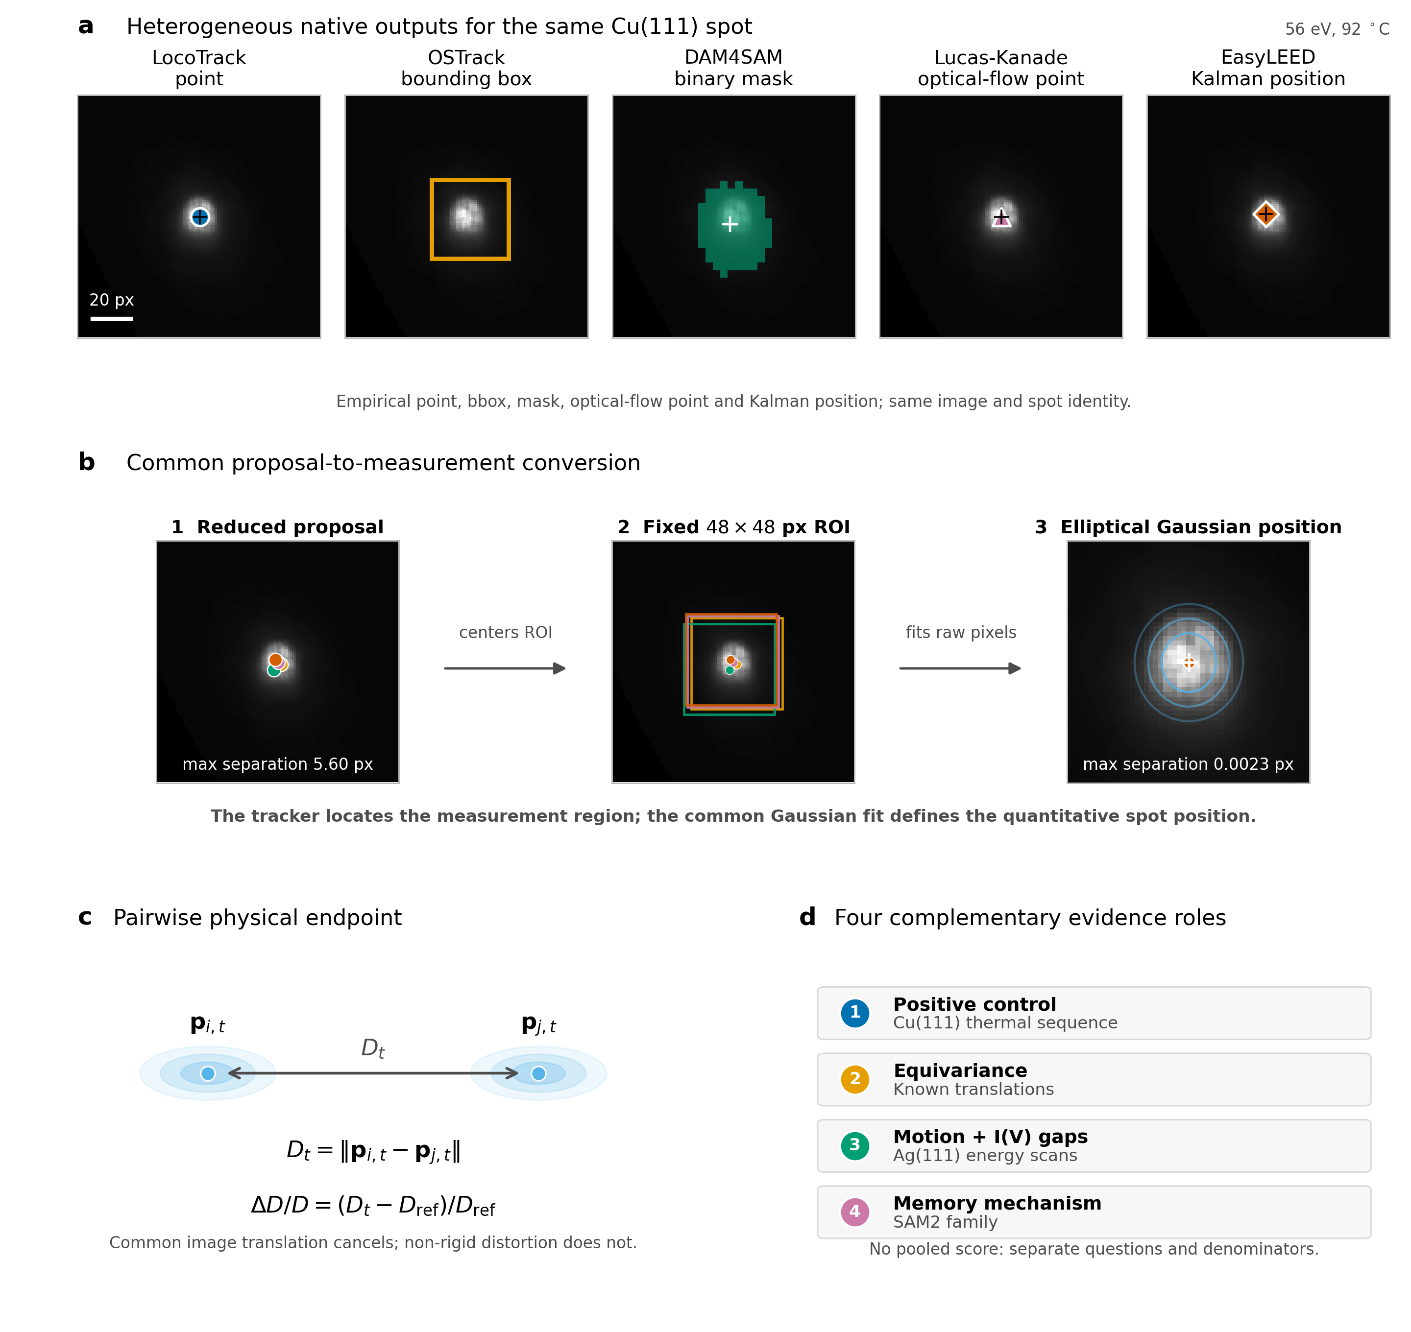
Figure 1. Tracking proposal, common position measurement, and evidence ladder. a, Empirical native outputs of the five tracking strategies for the same diffraction spot in the final image of the fixed-energy Cu(111) thermal sequence (56 eV, 92 °C): the LocoTrack point, OSTrack bounding box, DAM4SAM binary mask, Lucas-Kanade optical-flow point, and EasyLEED Kalman position. The case was selected from the acquisition metadata without inspecting tracker behavior; all methods used the same image sequence, spot, and seed and received no correction or reinitialization. The OSTrack box and the unsmoothed DAM4SAM mask are the frozen empirical native geometries. b, Each native output is reduced to a proposal coordinate that centers an identically sized 48 x 48 pixel measurement ROI. A common elliptical two-dimensional Gaussian fit to the raw pixels supplies the quantitative spot position. In this explanatory case, the maximum separation among the five proposal coordinates is 5.60 pixels and that among the five Gaussian centers is 0.0023 pixels; these values were not used for case selection and do not rank the methods. c, Two Gaussian-refined positions define the pair distance (D_t) and its normalized change (D/D). Common image translation cancels in the pair distance, whereas non-rigid distortion does not. d, The Cu(111) thermal sequence, known translations, Ag(111) energy scans, and controlled SAM2 family serve as a positive control, equivariance test, motion-plus-I(V)-gap stress test, and memory-mechanism analysis, respectively. These regimes answer separate questions with separate denominators rather than forming a composite tracker ranking.

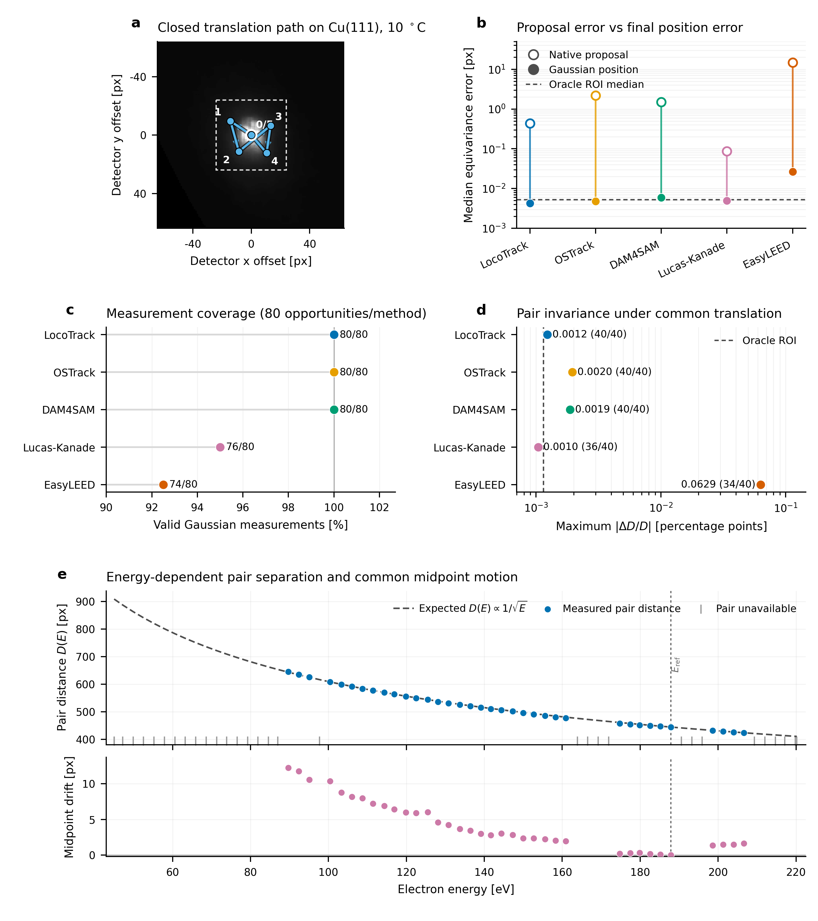
Figure 2. Controlled equivariance of the measurement chain and energy-dependent pair geometry. (a) Frozen closed translation path applied to four independently initialized Cu(111) states; the representative initial 10 °C image is shown. (b) Median displacement-equivariance error before and after the common two-dimensional Gaussian estimator. The oracle ROI estimates the interpolation-plus-estimator floor without a tracker. (c) Valid Gaussian measurements out of 80 predefined spot opportunities per method. (d) Maximum absolute pairwise relative-distance change under common image translation. Valid-pair counts out of 40 predefined opportunities are printed beside each method. (e) Measured pair distance compared with the expected 1/sqrt(E) contraction, with the pair midpoint drift retained as a separate apparatus/projection diagnostic. Gray marks denote unavailable pair measurements. Controlled translations test measurement-chain equivariance, not experimental dynamics or absolute spot identity.

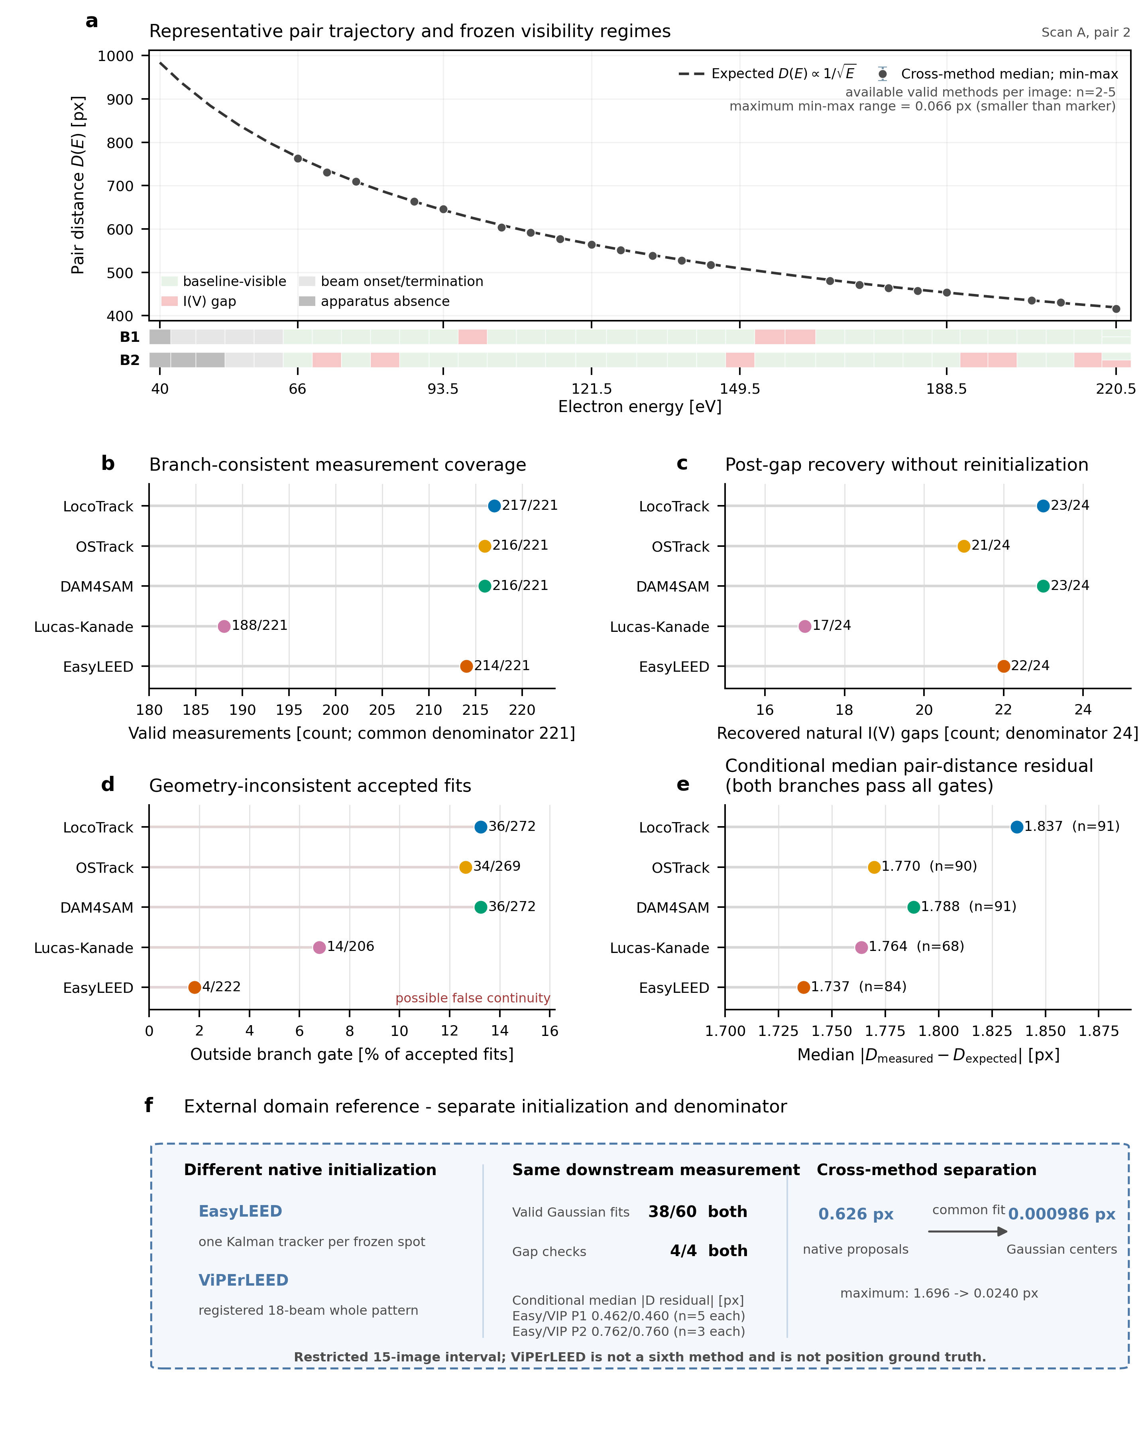
Figure 3. Independent Ag(111) energy-scan stress test. a, Pair distance as a function of electron energy for a representative frozen pair from Scan A. The case was selected by the predeclared physics rule before method outcomes were inspected: it is the first ordered case that passed the coherent pairwise energy-law check and contains natural I(V) visibility gaps. The dashed curve is the expected (D(E)/) trajectory and the neutral markers are framewise cross-method medians of the available valid Gaussian pair measurements. Vertical whiskers show the corresponding cross-method minimum-to-maximum range. Between two and five methods contribute per displayed image; the largest range is 0.066 px and is smaller than the marker at this scale. The two ribbons show the tracker-independent visibility regimes of the individual branches. Image identity is retained, so repeated terminal-energy acquisitions are not collapsed. b, Branch-consistent Gaussian measurement coverage among 221 baseline-visible spot opportunities per method. c, Recovery of the same physics-constrained branch after 24 evaluable natural I(V) gaps, without manual reinitialization. d, Accepted Gaussian measurements lying outside the frozen 18-pixel branch-consistency gate, reported over all accepted measurements in all visibility regimes. These events indicate possible false continuity but are not external ground-truth proof of an identity switch. e, Median absolute pair-distance residual conditional on both branches passing the proposal, Gaussian-fit, and geometry gates; the method-specific numbers of jointly consistent pair images are shown as (n). This conditional quantity must be interpreted after coverage and recovery rather than as an overall accuracy ranking. f, Visually separated external domain reference over a restricted high-energy interval. EasyLEED uses one Kalman tracker per frozen spot, whereas ViPErLEED uses a registered 18-beam whole-pattern trajectory. Both supply proposals to the same Gaussian estimator. The inset has a separate 60-opportunity denominator and initialization contract; its pair-residual medians are conditional on 5 jointly valid P1 images and 3 jointly valid P2 images per method. ViPErLEED is neither a sixth method in the main matrix nor position ground truth.

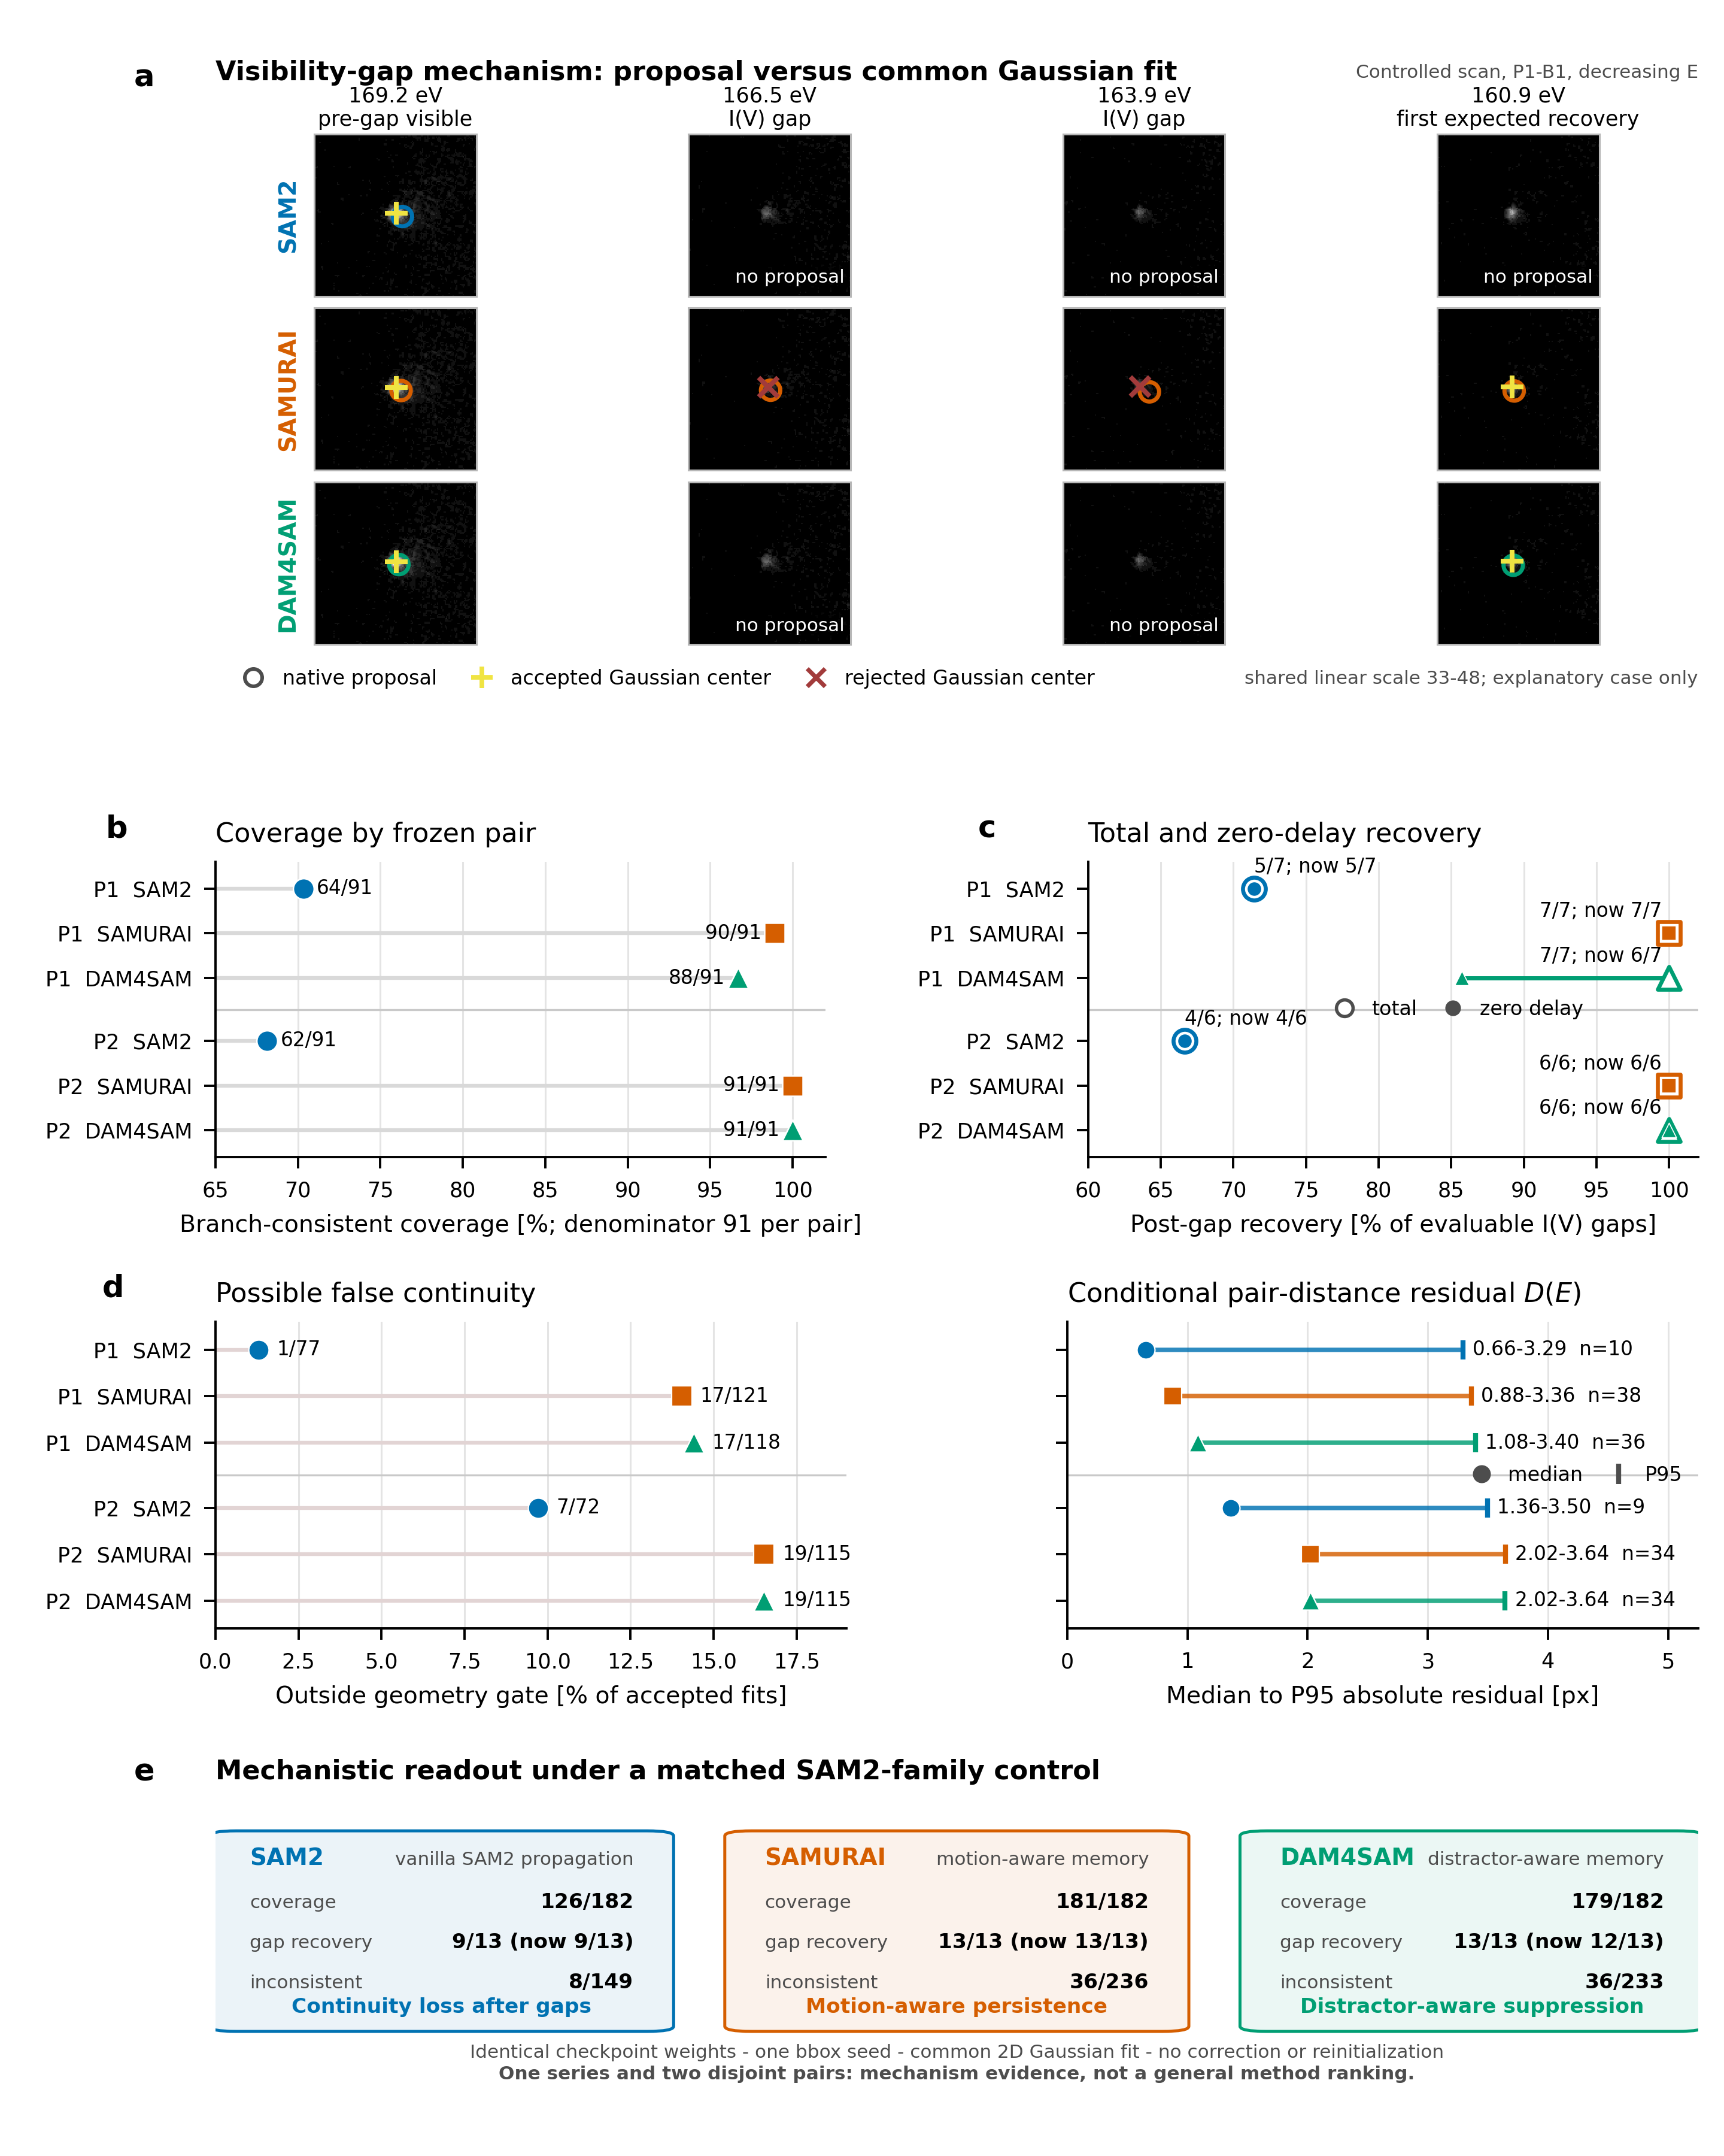
Figure 4. Controlled SAM2-family memory trade-off under identical checkpoint weights. a, Four states around a natural B1 I(V) visibility gap in the controlled scan. SAM2, SAMURAI, and DAM4SAM receive the same single-object bbox seed; open circles denote native proposals, yellow plus symbols accepted centers from the common two-dimensional Gaussian fit, and red crosses rejected Gaussian centers. All twelve views render the complete frozen 128 x 128 pixel crops with one shared linear intensity scale. The sequence is the first decreasing-energy gap with different recovery outcomes and is outcome-selected for mechanistic explanation only. b, Branch-consistent Gaussian measurement coverage for two disjoint frozen pairs, each with 91 baseline-visible spot opportunities per method. c, Total and zero-delay recovery of the same physics-constrained branch after natural I(V) gaps, with seven evaluable gaps in pair 1 and six in pair 2. d, Left: accepted Gaussian measurements outside the frozen geometry gate, reported over each method’s accepted measurements in all visibility regimes. Right: median-to-P95 absolute pair-distance residual (D(E)), conditional on both branches passing proposal, Gaussian-fit, and geometry gates; the method-specific numbers of jointly consistent pair frames are shown as (n). e, Aggregate mechanistic readout. Motion-aware and distractor-aware memory increase coverage and post-gap recovery relative to vanilla propagation, while also increasing geometry-inconsistent accepted fits. All methods use byte-identical SAM2.1 base-plus checkpoint weights, the same 48 x 48 pixel prompt and measurement ROI, the same Gaussian estimator, and no correction or reinitialization. The comparison contains one series and two pairs and is mechanism evidence, not a general ranking of SAM2-family methods. Conditional residuals must be interpreted together with coverage, recovery, and possible false continuity.

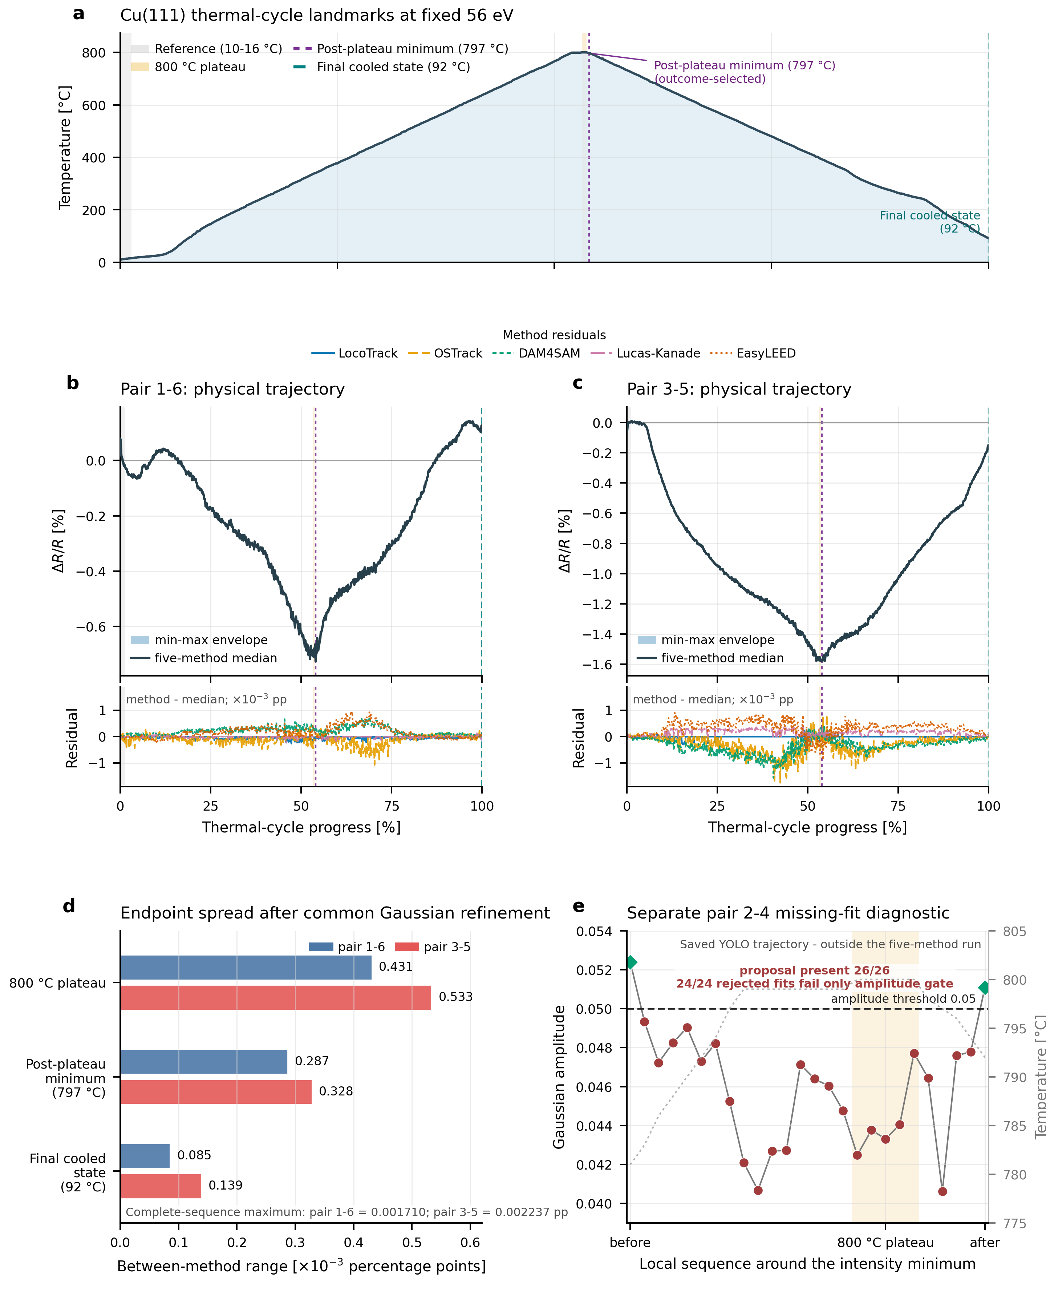
Figure 5. Tracker proposal differences do not materially alter the Cu(111) pairwise relative spot-radius endpoint after common Gaussian refinement. a, Temperature profile of the 701-image, constant-energy thermal cycle with reader-facing reference, 800 °C plateau, post-plateau minimum, and final cooled-state landmarks; frame identifiers are retained only in the source metadata. b,c, Pairwise Delta R/R = Delta D/D for pairs 1-6 and 3-5, respectively, after proposals from LocoTrack, OSTrack, DAM4SAM, Lucas-Kanade, and EasyLEED were passed through the same Gaussian estimator. The upper axes show the cross-method median and min-max envelope; the lower axes magnify each method’s deviation from the median in 10^-3 percentage points using a shared scale. Every method produced 701/701 valid endpoints for each pair. d, Between-method endpoint range at the predefined plateau, the common post-plateau minimum, and the final cooled state. Maximum separation over the complete sequence was 0.001710 percentage points for pair 1-6 and 0.002237 percentage points for pair 3-5. e, Separate saved-YOLO-trajectory diagnostic for pair 2-4. A proposal remained present throughout the displayed context, while 24 consecutive Gaussian fits failed only the amplitude gate. This panel demonstrates that proposal availability and quantitative measurement availability are distinct; it neither demonstrates tracker identity loss nor compares the five methods on spots 2 and 4. The two primary pairs do not establish crystallographic anisotropy, a thermal-expansion coefficient, a phase transition, or a structural mechanism.

