Evaluating Heterogeneous LEED Spot-Tracking Methods under a Common Spot-Position Measurement Contract
  - Venue-neutral scientific-content review manuscript
Scientific-content review draft. Journal-specific formatting is intentionally not applied. Author and experimental-team inputs remain deferred.

Authors
[Author information intentionally omitted at this review stage.]

Abstract
Quantitative low-energy electron diffraction (LEED) analysis requires a measurement region to remain associated with its diffraction spot as the pattern moves and spot visibility changes. We evaluated how five heterogeneous tracking strategies affect a common position measurement rather than treating their native outputs as directly comparable positions. Each supplied a proposal to place a 48 × 48-pixel ROI; the reported spot center was obtained with the same two-dimensional Gaussian estimator. Validation combined known translations, a 701-image Cu(111) positive control, two independent Ag(111) energy scans with natural (I(V)) visibility gaps, and a controlled SAM2-family memory experiment. Under known translations, median full-chain displacement errors ranged from 0.0043 to 0.0265 px with 92.5–100% Gaussian-measurement coverage. In the Cu(111) positive control, every method produced 2,804/2,804 accepted spot measurements and 701/701 valid endpoints for each primary pair. Across four frozen pairs in the two Ag(111) scans, branch-consistent coverage ranged from 188/221 to 217/221 and post-gap branch-consistent recovery from 17/24 to 23/24, while conditional median pair-distance residuals among jointly branch-consistent pair images spanned a narrow range of 1.737–1.837 px. In a supporting single-series, two-pair memory experiment, SAMURAI and DAM4SAM increased coverage from 126/182 for SAM2 to 181/182 and 179/182, respectively, while also increasing geometry-inconsistent continuation; this mechanism result does not establish a general ranking. These experiments assess measurement-chain robustness rather than absolute tracking accuracy. The common Gaussian estimator strongly suppressed proposal differences when the intended spot remained inside its capture region; measurement coverage, post-gap branch-consistent recovery, and geometry-inconsistent continuation were more discriminating than conditional residuals alone.

Keywords
Low-energy electron diffraction; spot tracking; quantitative image analysis; Gaussian localization; visibility gaps; measurement robustness.

1. Introduction

1.1 Quantitative LEED requires persistent spot identity
Low-energy electron diffraction (LEED) probes the periodic structure of a surface through the energy-dependent diffraction of low-energy electrons (Pendry 1974). A recorded LEED pattern contains discrete diffraction spots whose positions, profiles, and integrated intensities can be extracted from image sequences (Mayer et al. 2012; Schmid et al. 2025a). Quantitative structural LEED most commonly uses intensity as a function of incident electron energy, (I(V)) (Pendry 1974; Schmid et al. 2025a). In time- or temperature-dependent image series, localized spot centers and profiles can additionally support measurements of displacement, pair distance, and profile width. Each of these image-derived quantities requires the measurement region to remain associated with the same physical diffraction spot throughout the analysed sequence.
Tracking is therefore upstream of the physical measurement but is not itself the measurement. A tracker supplies a location at which image information can be evaluated; the quantitative position, width, or intensity is then obtained from the corresponding pixels. This distinction matters because a smooth trajectory can follow a background feature or a neighbouring diffraction spot, while an irregular proposal can still yield a valid position if the intended spot remains inside the downstream estimator’s capture region. Preservation of LEED spot identity consequently cannot be inferred from trajectory smoothness alone.
The tracking problem becomes more difficult when the diffraction pattern moves. Changes in the experimental state can translate or deform the observed pattern, and varying the electron energy produces an approximately radial motion proportional to (1/). LEED-specific tracking systems already use this energy dependence to predict spot positions (Mayer et al. 2012; Schmid et al. 2025a). A position estimator must then accommodate both the expected physical motion and common-mode image motion caused by projection or apparatus drift.
Spot visibility introduces a separate challenge. Because diffraction intensity varies strongly with energy, a spot can fall below the measurement threshold and later become measurable again. We refer to an internal, intensity-driven interval bracketed by valid measurements of the same branch as an (I(V)) visibility gap. Such a gap is not generic video occlusion: image evidence for the intended diffraction feature is temporarily insufficient even though other nearby spots or background structures may remain visible. A useful tracking strategy must therefore support recovery of the same physical branch without silently continuing on a distractor.

1.2 Existing LEED tracking and the remaining evaluation problem
Automated LEED spot tracking and localization have clear precedents. EasyLEED tracks individually initialized spots with a Kalman filter informed by an energy-dependent motion model and elliptical two-dimensional Gaussian image measurements. If an image measurement is rejected, its prediction can continue until a later update becomes available (Mayer et al. 2012). ViPErLEED-ImageJ instead identifies and tracks a complete diffraction pattern using reciprocal-lattice geometry, the expected energy scaling, and local corrections from neighbouring spots. It supports weak or temporarily missing beams and is designed for extraction and processing of LEED (I(V)) curves (Schmid et al. 2025a). Thus, automated tracking, energy-dependent prediction, Gaussian localization, and propagation through low-visibility intervals are not introduced here.
General-purpose computer-vision methods provide different representations of the same association problem. These include propagated points based on local correspondence (Cho et al. 2024), transformer-based bounding-box tracking (Ye et al. 2022), classical optical flow (Lucas and Kanade 1981), and prompt-conditioned mask propagation with visual memory (Ravi et al. 2025; Yang et al. 2024; Videnovic et al. 2025). Their native outputs are heterogeneous: a point trajectory, updated bounding box, optical-flow displacement, Kalman state, or binary mask. The box center and mask centroid used in this study are local adapters that reduce those outputs to a TrackLEED tracking proposal; they are not native position estimates. Even after this reduction, the proposal coordinates do not have the same operational meaning or uncertainty. Directly ranking them would therefore conflate the proposal mechanism with the downstream position estimator.
This heterogeneity motivates a narrower evaluation question than whether LEED spots can be tracked automatically. The relevant question for quantitative analysis is when different proposal strategies lead to the same accepted physical measurement and when motion or loss of visibility causes missing or physically inconsistent results. A common downstream estimator makes that question testable by converting every native proposal into the same measurement ROI and deriving the reported position from the same image model. The comparison then concerns the complete measurement chain rather than the coordinate convention of a particular tracker.
Conditional localization error alone is insufficient for this purpose. A method can have a small residual on the subset of images for which it returns a proposal and the fit passes all gates, yet lose many measurable spots or resume on an incompatible diffraction branch after a visibility gap. These events disappear if only successful measurements enter the denominator. The evaluation must therefore keep measurement coverage, post-gap branch-consistent recovery, geometry-inconsistent continuation, and conditional position or pair-distance residuals as separate outcomes. Without an external image-by-image reference, such outcomes establish equivariance, reproducibility, and physical self-consistency rather than absolute tracking accuracy.

1.3 Study objective and contributions
This study evaluates how heterogeneous spot-tracking strategies affect a common quantitative LEED position measurement. We test the hypothesis that a shared Gaussian estimator suppresses method-specific proposal differences when the intended spot remains inside its capture region, whereas motion and visibility loss expose differences in measurement coverage, post-gap branch-consistent recovery, and physically inconsistent continuation. We additionally test whether those differences remain visible in the pairwise physical endpoint (R/R=D/D). TrackLEED serves as the reference implementation and reproducibility vehicle for these experiments; the graphical application and its software feature set are not the subject of the study.
The contributions are:
- A common proposal-to-ROI-to-Gaussian measurement contract for heterogeneous point, bounding-box, mask, optical-flow, and LEED-domain trackers.
- A controlled equivariance test of the complete measurement chain under known subpixel image translations.
- A five-strategy comparison on independent Ag(111) energy scans using common denominators for visible measurement opportunities and natural I(V) gaps.
- A controlled SAM2/SAMURAI/DAM4SAM comparison of memory-aware propagation strategies under byte-identical checkpoint weights.
- Propagation of tracker proposals to the pairwise physical endpoint Delta R/R = Delta D/D in a 701-image constant-energy Cu(111) sequence.
The four evidence regimes are assigned distinct evidential roles rather than pooled into one composite ranking. Controlled translations test measurement-chain equivariance, Cu(111) provides a positive control for endpoint agreement, independent Ag(111) energy scans test motion and natural visibility gaps, and the matched SAM2-family panel examines a continuity–consistency trade-off. This design does not provide absolute spot-identity ground truth; it evaluates whether each strategy supports an available and physically self-consistent quantitative measurement under the frozen conditions.

2. Measurement chain and validation design

2.1 Tracking proposal and common measurement ROI
A tracker’s native output was treated as a tracking proposal: information used to place a downstream measurement region, not the reported spot position. Point and Kalman methods supplied a coordinate, box methods supplied a box center, mask methods supplied a mask centroid, and accepted optical flow supplied a displaced point. Native confidence, visibility, mask, and fit diagnostics could determine proposal availability under the frozen method contract, but they were not interpreted as diffraction intensity.
Every available proposal was mapped to the original image coordinate system, rounded to the nearest pixel, and used to place a 48 × 48-pixel region of interest (ROI) on the original-intensity image. An ROI outside the image was rejected rather than clipped or padded. Thus, methods could select different regions, but each selected raw-image region entered the same position estimator.

2.2 Gaussian-refined position and pairwise observable
Within the ROI, intensity was represented by a rotated elliptical Gaussian with a constant background,
$$I(x,y)=B+Aexp\left[-\frac{1}{2}\left(\frac{u^{2}}{σ_{x}^{2}}+\frac{v^{2}}{σ_{y}^{2}}\right)\right],$$
where
$$\left(\begin{matrix}u \\ v\end{matrix}\right)=\left(\begin{matrix}cosθ & -sinθ \\ sinθ & cosθ\end{matrix}\right)\left(\begin{matrix}x-x_{c} \\ y-y_{c}\end{matrix}\right).$$
The fitted amplitude (A), center ((x_c,y_c)), widths ((_x,_y)), angle (), and background (B) defined the common image measurement. Adding the ROI origin to the local fitted center gave the reported global position,
$$p_{i,t}=(x_{i,t},y_{i,t}).$$
Regime-specific acceptance contracts were frozen before comparison and held constant across methods within a regime. They require finite fit diagnostics and apply predefined quality, amplitude, center, width, and proposal-to-center gates. Exact thresholds, bound semantics, and solver initialization are reported in Table S2. An unavailable proposal, out-of-image ROI, failed fit, or rejected fit produced an explicit missing position; rejected values were not interpolated or carried forward.
For a frozen pair (i,j), the primary geometrical observable was
$$D_{ij}(t)={∥p_{i,t}-p_{j,t}∥}_{2}.$$
For an approximately diametric pair, (R=D_{ij}/2), so at fixed beam energy and projection geometry,
$$\frac{ΔR}{R}=\frac{ΔD}{D}=\frac{D_{ij}(t)}{D_{ij,ref}}-1.$$
For an energy scan, the expected radial contraction and residual were
$$D_{ij,pred}(E)=D_{ij,ref}\sqrt{\frac{E_{ref}}{E}}, δD_{ij}(E)=D_{ij}(E)-D_{ij,pred}(E).$$
Pair distance cancels a common translation of both spots but not non-rigid distortion, sector-dependent behavior, or misassociation. The pair midpoint, (_{ij}(E)=[_i(E)+_j(E)]/2), was therefore retained as a separate apparatus-motion diagnostic and was not used to recenter the primary endpoint.

2.3 Measurement-chain outcomes
The validation separates branch-consistent measurement coverage, post-gap branch-consistent recovery, accepted measurements inconsistent with the expected branch geometry, and position or pair-distance residuals conditional on a valid branch-consistent measurement. Every predefined opportunity remains in its fixed denominator when a proposal is unavailable or a Gaussian fit is rejected. Conditional residuals are reported only with their method-specific surviving sample size and never replace missing or inconsistent outcomes.
The energy-scan baseline distinguished apparatus absence, terminal beam onset or disappearance, and an internal natural (I(V)) visibility gap bracketed by visible measurements on the same branch. Only the last class entered the recovery denominator. Recovery required a valid Gaussian measurement on the expected branch in the first contiguous baseline-visible run after a gap, without manual reinitialization. An accepted fit beyond the frozen branch tolerance was recorded separately as geometry-inconsistent continuation. This is an operational physical-consistency outcome, not external identity-ground-truth proof of a particular misassociation. Table S2 records the gates, fixed opportunity sets, and conditional denominators.

2.4 Evidence roles and independence
Controlled translations test displacement equivariance against a known image transform; their four separately initialized source trials are not four acquisitions. The Cu(111) sequence is a positive control for agreement of the pairwise endpoint. Two independent Ag(111) energy scans provide four frozen scan–pair stress-test cases. A separate one-series, two-pair scan supports the controlled SAM2-family mechanism comparison, while the restricted EasyLEED–ViPErLEED check is a subset with its own initialization contract and denominator. Images, branches, pairs, series, and acquisitions are not treated as interchangeable replication units.

2.5 Experimental conditions
[Reserved for text supplied and approved by the experimental team.]
Table 1. Data and evidence roles. Rows describe evidence roles, not five independent datasets. Controlled translations are derived from the Cu(111) sequence, and the external-reference row is a subset of the memory-analysis scan and outside the common five-method matrix. Outcomes remain separate rather than being reduced to a composite tracker ranking.
Scientific series label | Image count | Frozen spots/pairs | Opportunity set | Evidence role | Primary observable | Independence/replication unit
Cu(111) thermal-cycle positive control | 701 acquired images | Spots 1, 3, 5, and 6; pairs 1–6 and 3–5 | 2,804 spot and 1,402 pair opportunities per method (14,020 spot-method rows total) | Positive control for agreement of the five strategy-to-measurement chains | ΔR/R = ΔD/D | One sequence, stratified by two frozen pairs; no population-level interval
Controlled translations | 24 evaluation images (4 source states × 6 steps, including baseline) | Spots 1, 3, 5, and 6; pairs 1–6 and 3–5 | 96 spot and 48 pair evaluations per method (4 trials x 6 states) | Equivariance and pair invariance under a known image transform | Gaussian-refined displacement error; maximum absolute ΔD/D | Four separately initialized source trials from the Cu(111) sequence; not four acquisitions
Ag(111) energy-scan stress test, Scans A and B | 81 acquired images (35 + 46) | Two disjoint pairs (four spots) per scan | 221 baseline-visible branch opportunities and 24 evaluable gaps per method | Principal five-strategy test of radial motion and natural I(V) visibility gaps | Measurement coverage; post-gap branch-consistent recovery; geometry-inconsistent continuation; conditional absolute pair-distance residual | Two independent series, stratified by four frozen scan–pair cases
Ag(111) memory-analysis scan | 69 acquired images | Two disjoint pairs (four spots) | 182 baseline-visible branch opportunities and 13 evaluable gaps per method | Controlled SAM2-family continuity–consistency mechanism test | Measurement coverage; post-gap branch-consistent recovery; geometry-inconsistent continuation; conditional D(E) residual | One series, stratified by two frozen pairs; supporting mechanism evidence
Restricted high-energy external reference | 15-image subset of the memory-analysis scan | Same two pairs; four branch coordinates | 60 frozen branch opportunities per method; 4 gap checks | EasyLEED/ViPErLEED domain-contract compatibility under the common Gaussian estimator | Accepted-measurement coverage; EasyLEED–ViPErLEED common-center distance | Subset of the memory-analysis scan with a separate initialization contract and denominator; not an independent replicate and outside the common five-method matrix
Four translation trials provide 80 displaced-spot and 40 displaced-pair evaluation opportunities per method after seed states are excluded; the oracle ROI is a measurement control rather than a sixth tracker. The Cu(111) positive control contributes 2,804 spot measurements per method and 701 endpoints for each primary pair. The principal Ag(111) stress test uses 221 baseline-visible branch opportunities and 24 evaluable gaps per method. The controlled SAM2-family test uses 182 branch opportunities and 13 gaps, and the restricted compatibility check uses a separate 60-opportunity denominator.
All results are descriptive. Successive images are repeated observations within propagated trajectories, and pairs within one series are retained as strata rather than promoted to independent acquisitions. Tables S3 and S5 report case- and trial-stratified summaries. No composite score, population-level interval, or absolute-accuracy ranking is constructed.

3. Tracking strategies and reproducible comparison contract
The comparison was organized by the representation propagated by each method rather than by treating all native coordinates as equivalent position measurements. The main panel comprised a point tracker, a bounding-box tracker, a mask tracker, optical flow, and a LEED-specific Kalman tracker. Each method received the prompt native to its family, derived from the same Gaussian-refined seed center: point methods received the center coordinate, whereas box- and mask-based methods received a 48 × 48 pixel box centered on that coordinate. The native output was reduced to one proposal coordinate and then passed to the common measurement chain defined in Section 2. Tracker scores and internal fit diagnostics could determine whether a native proposal was available according to the frozen method contract, but they never replaced the common Gaussian-refined position or served as a physical intensity.
The executed revisions, checkpoints, configuration hashes, prompt conventions, failure policies, propagation directions, and proposal-to-ROI adapters are retained in the committed provenance package. Table 2 gives the reader-facing comparison contract, while Table S1 records software, models, hashes, and execution environments. The upstream citations establish the published method designs; the frozen records establish the configurations used here.

3.1 Main five-strategy panel
Point. LocoTrack propagates a queried point and supplies native occlusion and distance diagnostics (Cho et al. 2024). Its finite point, subject to the frozen native availability rule, was used directly as the proposal.
Box. OSTrack propagates a single-object bounding box in a joint template–search transformer (Ye et al. 2022). A finite positive-area box was available, and its center was the proposal; the native score did not weight the downstream Gaussian fit.
Mask. DAM4SAM propagates a segmentation mask with distractor-aware memory and introspective updates (Videnovic et al. 2025). A finite nonempty mask was available, and its pixel centroid was the proposal. Mask scores, areas, and component diagnostics were not treated as physical intensity.
Optical flow. Lucas–Kanade estimates local displacement from image gradients (Lucas and Kanade 1981). A point passing the frozen native flow gates was the proposal. Rejection produced an explicit missing value; the last successful point remained the later anchor without interpolation.
LEED-domain single-spot tracking. EasyLEED combines an energy-dependent motion model, Kalman state, and internal Gaussian observation (Mayer et al. 2012). The exported finite Kalman coordinate was the proposal; its internal image measurement and intensity remained diagnostics and never replaced the common estimator.
The families retained their native inference representations upstream of the comparison. Each proposal was mapped to the original image coordinates before the common ROI was placed, so the controlled quantity was the downstream physical measurement rather than an assertion that the trackers’ internal representations were identical.

3.2 Controlled SAM2-family panel
SAM2, SAMURAI, and DAM4SAM form a related family of promptable mask propagators. SAM2 provides the reference streaming-memory architecture for promptable video segmentation (Ravi et al. 2025). SAMURAI adapts SAM2 to zero-shot visual object tracking by adding a Kalman motion model and motion-aware mask and memory selection (Yang et al. 2024). DAM4SAM instead uses distractor-aware memory and introspection-based updates (Videnovic et al. 2025).
All three methods used byte-identical backbone weights, the same single-object box prompt in the frozen reference image, the same ordered images in each propagation direction, and no later prompt or manual reset (Meta AI 2024; Yang et al. 2025; Videnovic et al. 2026). Each nonempty mask was reduced to its pixel centroid and entered the common ROI, Gaussian estimator, and physical-consistency gates. Exact configurations and hashes are in Table S1.
This matched design controls the backbone weights, prompt information, input sequence, proposal reduction, and downstream position measurement. It does not reduce the three trackers to a one-line ablation: their motion prediction, mask selection, visibility logic, and memory-update implementations are part of the strategies being compared. The panel is therefore interpreted as a mechanistic comparison of vanilla, motion-aware, and distractor-aware memory strategies under a matched measurement contract, not as proof that one isolated memory component caused every observed difference and not as a general ranking of SAM2-derived trackers.

3.3 LEED-domain references and reproducibility
EasyLEED participated in the common five-strategy panel because one independently initialized Kalman tracker yields one spot proposal and can therefore enter the same single-spot contract as the four general computer vision strategies. Its LEED-specific radial motion model makes it a physics-informed domain baseline rather than another generic point tracker.
ViPErLEED has a different purpose and input contract. It identifies and tracks a LEED pattern using reciprocal-lattice geometry, the expected (1/) scaling, a global screen mapping, and local information from neighboring spots, and is designed primarily for extraction and processing of LEED (I(V)) curves (Schmid et al. 2025a). Its frozen whole-pattern output was reduced to the coordinates corresponding to the two pairs and then passed to the same Gaussian measurement as the EasyLEED coordinates (Schmid et al. 2025b).
Because ViPErLEED received global pattern information rather than one seed per tracked spot, it was not inserted as a sixth row in the common strategy matrix. The restricted high-energy comparison instead asks whether the single-spot EasyLEED and whole-pattern ViPErLEED outputs place the intended spots within the capture region of the same downstream estimator. It does not use either output as external position ground truth.
Exact versions, revisions, checkpoints, and environments are retained in Table S1; its accompanying supplementary native-method contract records reader-facing preprocessing and thresholds. Frozen native payloads preserve the representation-specific outputs before proposal reduction, while the required headless reconstruction route starts from those payloads and rebuilds ROI placement, common measurements, outcomes, tables, and figures without tracker inference or the graphical application.
Table 2. Methods mapped to the common measurement contract. The first five rows form the common strategy matrix. The controlled SAM2-family rows used matched checkpoint weights and a common prompt. Every available proposal entered the same raw-image ROI and two-dimensional elliptical-Gaussian position estimator. ViPErLEED is a separate whole-pattern external reference, not a sixth row in the common five-method matrix. Exact versions, revisions, configurations, thresholds, hashes, preprocessing, and environments are reported in Table S1 and its accompanying supplementary native-method contract.
Method | Native output | Proposal adapter | Native availability | Shared downstream measurement | Reset policy | Study role
LocoTrack | Point plus occlusion and expected-distance diagnostics | Native point | Finite point; energy scans also require the frozen native visibility gate | 48 × 48 raw-image ROI → common elliptical-Gaussian position | Prohibited | General point tracker
OSTrack | Bounding box plus native score | Box center | Finite positive-area box | 48 × 48 raw-image ROI → common elliptical-Gaussian position | Prohibited | General bounding-box tracker
DAM4SAM | Binary mask plus native diagnostics | Mask centroid | Finite nonempty mask | 48 × 48 raw-image ROI → common elliptical-Gaussian position | Prohibited | General mask tracker with distractor-aware memory
Lucas–Kanade | Optical-flow point plus residual and closure diagnostics | Accepted point | Match passing the frozen native flow gates | 48 × 48 raw-image ROI → common elliptical-Gaussian position | Prohibited; last successful point remains the anchor | Classical motion baseline
EasyLEED | Kalman x,y plus native intensity and tracking radius | Kalman x,y | Finite exported Kalman x,y | 48 × 48 raw-image ROI → common elliptical-Gaussian position | Prohibited | LEED-domain single-spot baseline
SAM2.1 | Binary mask | Mask centroid | Finite nonempty mask | 48 × 48 raw-image ROI → common elliptical-Gaussian position | Prohibited | Vanilla streaming-memory control
SAMURAI | Binary mask plus motion-aware selection | Mask centroid | Finite nonempty mask | 48 × 48 raw-image ROI → common elliptical-Gaussian position | Prohibited | Motion-aware memory strategy
DAM4SAM | Binary mask plus distractor-aware diagnostics | Mask centroid | Finite nonempty mask | 48 × 48 raw-image ROI → common elliptical-Gaussian position | Prohibited | Distractor-aware memory strategy
ViPErLEED | Whole-pattern beam coordinate | Coordinate of corresponding beam | Finite pattern-associated coordinate for the corresponding beam | 48 × 48 raw-image ROI → common elliptical-Gaussian position | Prohibited | Separate whole-pattern reference

4. Results

4.1 Controlled translations isolate measurement-chain behavior
LocoTrack, OSTrack, and DAM4SAM each returned a proposal and a valid common Gaussian measurement for all 80 evaluated spot opportunities (Figure 2; Table S7). Lucas–Kanade returned 76/80 proposals, all of which produced valid Gaussian measurements. EasyLEED returned 80/80 Kalman proposals, but six did not yield an accepted common fit, giving 74/80 measurement coverage. The corresponding pairwise endpoint coverage was 40/40 for LocoTrack, OSTrack, and DAM4SAM, 36/40 for Lucas–Kanade, and 34/40 for EasyLEED. Missingness therefore arose at different stages of the measurement chain and was not absorbed into the displacement-error statistic.
Before Gaussian refinement, the median displacement-equivariance error was 0.433 px for LocoTrack, 2.183 px for OSTrack, 1.493 px for DAM4SAM, and 0.087 px for Lucas–Kanade. After refinement, the corresponding medians were 0.0043, 0.0048, 0.0060, and 0.0050 px. These values were of the same order as the 0.0053 px median of the oracle-ROI control, which includes interpolation and estimator error but no tracker. EasyLEED showed the same suppression at a larger scale: its median native error of 14.758 px was reduced to 0.0265 px after the common fit. Its 95th-percentile refined error nevertheless remained 0.382 px, compared with 0.0127–0.0168 px for the other four methods.
The pair-distance endpoint was also insensitive to a common translation when both spots remained measurable. The maximum absolute change in (D/D) was 0.001229 percentage points for LocoTrack, 0.001952 for OSTrack, 0.001869 for DAM4SAM, and 0.001042 for Lucas–Kanade, compared with 0.001147 for the oracle control. EasyLEED reached 0.062943 percentage points and had the lowest pair coverage. Thus, a successfully captured spot could be localized near the estimator floor even when the native proposal was much less accurate, but this conditional result did not eliminate differences in measurement availability. The experiment establishes equivariance of the complete measurement chain under a known image transform, not absolute tracking accuracy or identity ground truth. The four independently initialized trial-level summaries are retained separately in Table S5.

4.2 Cu(111) positive control establishes endpoint agreement
All five strategies completed the Cu(111) positive control without a missing proposal or rejected common fit: each method produced 2,804/2,804 Gaussian measurements, and each primary pair produced 701/701 valid (R/R) endpoints (Figure 3; Table S7). The largest separation between two native method proposals was 16.759 px, whereas the largest separation between the corresponding Gaussian-refined centers was 0.0502 px. At the endpoint level, the maximum between-method difference over the entire sequence was only 0.001710 percentage points for pair 1–6 and 0.002237 percentage points for pair 3–5.
The five methods also reproduced the same predefined sequence landmarks. Over the five-image plateau, their median (R/R) estimates ranged from (-0.686676%) to (-0.686244%) for pair 1–6 and from (-1.570833%) to (-1.570300%) for pair 3–5. All methods placed the post-plateau minimum of both pairs in the same image. The minimum values ranged from (-0.726482%) to (-0.726195%) for pair 1–6 and from (-1.580123%) to (-1.579795%) for pair 3–5. In the final state, pair 1–6 reached (+0.121606%) to (+0.121691%), whereas pair 3–5 reached (-0.152478%) to (-0.152338%). The contraction therefore largely reversed by the final state, but the two sectors retained different endpoint values. With only two primary pairs, this difference was not interpreted as crystallographic anisotropy or used to infer a thermal-expansion coefficient or structural transition. Exact method- and pair-specific landmark values are reported in Table S4.

4.3 Independent Ag(111) scans separate availability from conditional residuals
The independent Ag(111) energy scans separated the strategies in outcomes that were absent from the Cu(111) positive control (Figure 4; Table S7). LocoTrack had 217/221 branch-consistent measurements (98.19% coverage), followed by OSTrack and DAM4SAM with 216/221 each (97.74%), EasyLEED with 214/221 (96.83%), and Lucas–Kanade with 188/221 (85.07%). The denominators were identical and included every baseline-visible opportunity, so the 33 Lucas–Kanade measurements missing from the branch-consistent set were not discarded before comparison.
Post-gap branch-consistent recovery produced a similar but non-identical ordering. LocoTrack and DAM4SAM recovered 23/24 natural I(V) gaps (95.83%), EasyLEED recovered 22/24 (91.67%), OSTrack recovered 21/24 (87.50%), and Lucas–Kanade recovered 17/24 (70.83%). No method was manually reinitialized after a gap. The frozen difficult pair that failed the auxiliary coherent-energy-law check remained in these denominators. The single EasyLEED Kalman divergence was likewise retained as a failure rather than corrected.
Continuity did not always imply physical branch consistency. LocoTrack and DAM4SAM each produced 36 geometry-inconsistent accepted fits among 272 accepted measurements in all visibility regimes (13.24%). OSTrack produced 34/269 (12.64%), Lucas–Kanade 14/206 (6.80%), and EasyLEED 4/222 (1.80%). These events indicate that an image feature remained measurable outside the frozen radial branch; they do not constitute external ground-truth proof of a particular identity switch.
Among images on which both pair branches survived all proposal, fit, and geometry gates, the median absolute pair-distance residuals occupied a narrow range: 1.737 px for EasyLEED, 1.764 px for Lucas–Kanade, 1.770 px for OSTrack, 1.788 px for DAM4SAM, and 1.837 px for LocoTrack. In particular, Lucas–Kanade had a conditional residual similar to the other methods while losing substantially more visible measurements and gap recoveries. Conditional distance quality therefore did not summarize measurement-chain robustness; coverage, recovery, and geometry-inconsistent continuation remained separate outcomes.
The case-stratified results and leave-one-case-out analysis are reported in Table S3. Across omission of each frozen scan–pair case, coverage ranged from 97.4–98.8% for LocoTrack, 97.2–98.8% for OSTrack and DAM4SAM, 81.9–87.6% for Lucas–Kanade, and 95.5–97.5% for EasyLEED. The corresponding gap-recovery ranges were 94.1–100.0%, 84.2–88.9%, 94.1–100.0%, 63.2–76.5%, and 88.9–100.0%, respectively. Geometry-inconsistency ranges were 12.6–13.5%, 11.8–13.5%, 12.6–13.6%, 3.4–9.5%, and 0.0–2.4%. These ranges show how the pooled count summaries depend on any one predefined case; they are descriptive sensitivity results, not confidence intervals or population-level method rankings.

4.4 Controlled SAM2 family exposes a continuity-consistency trade-off
Under byte-identical checkpoint weights, vanilla SAM2 produced 126/182 branch-consistent measurements (69.23% coverage) and recovered 9/13 natural I(V) gaps (69.23%; Figure 5). SAMURAI increased coverage to 181/182 (99.45%) and DAM4SAM to 179/182 (98.35%); both memory-aware variants recovered all 13 gaps. The matched panel therefore associated the motion-aware and distractor-aware strategies with substantially greater continuity than the vanilla propagation contract.
The continuity gain was accompanied by more accepted measurements outside the frozen physical branch. SAM2 produced 8 such fits among 149 accepted measurements across all regimes (5.37%), compared with 36/236 for SAMURAI (15.25%) and 36/233 for DAM4SAM (15.45%). Thus, the variants that most consistently bridged visibility gaps also more often continued on a measurable but geometrically implausible feature. Because the implementations differ in motion prediction, mask selection, visibility handling, and memory update, the matched experiment supports a strategy-level continuity–false-persistence trade-off rather than attributing the entire effect to one isolated memory component. The result is supporting mechanism evidence from one series and two pairs, not a general ranking of SAM2-derived trackers.

4.5 Supporting compatibility and missingness checks
EasyLEED and ViPErLEED each produced all 60 expected branch proposals over the 15-image high-energy interval, despite using single-spot and whole-pattern initialization contracts, respectively (Figure S4). For both methods, the common Gaussian estimator accepted the same 38/60 branch measurements with the same per-branch counts: 13/15 and 7/15 for the two branches of pair 1, and 13/15 and 5/15 for pair 2. Both methods also passed all four predefined absence-to-recovery checks.
Across the 60 corresponding native proposals, the EasyLEED–ViPErLEED separation had a median of 0.626 px and a maximum of 1.696 px. For the 38 jointly accepted common measurements, the separation between Gaussian-refined centers fell to a median of 0.000986 px and a maximum of 0.0240 px. At the two terminal images, the returning branch of each pair yielded a valid fit for both methods, while the opposite branch failed the Gaussian gate. These events established branch recovery but did not provide a terminal pair-distance measurement.
The agreement after common refinement shows that both heterogeneous domain-specific outputs placed the corresponding high-energy spot features inside the capture region of the same estimator. It does not show equivalence outside this restricted interval or establish superiority of either native contract. This compatibility is not external absolute tracking accuracy or identity ground truth.
The separate saved-trajectory diagnostic for Cu(111) pair 2–4 produced 24 consecutive missing measurements despite a proposal being present in every image (Figure S6). All 24 candidates passed the (R^2), center, and width gates and failed only the common amplitude threshold. This supporting check shows that proposal availability does not guarantee an accepted quantitative position. The trajectory was outside the five-method run and was neither used for strategy comparison nor treated as spot-identity ground truth.

5. Discussion

5.1 Proposal quality and measurement quality
The controlled translations and Cu(111) positive control show that the native tracker coordinate and the reported quantitative position are distinct stages of the measurement chain. Point, bounding-box, mask, optical-flow, and LEED-specific proposals could differ appreciably while still placing the intended diffraction spot inside the 48 × 48 pixel measurement ROI. Once that condition was met, the common Gaussian estimator fitted the same local diffraction feature and strongly reduced the effect of proposal placement. In the translation experiment, the method-wise median full-chain errors of 0.0043–0.0265 px approached the 0.0053 px oracle-ROI level despite much larger native proposal errors. In the Cu(111) sequence, the largest native between-method separation was 16.759 px, whereas the largest separation between the corresponding Gaussian-refined centers was 0.0502 px.
This convergence should not be interpreted as evidence that the trackers have equal absolute coordinate accuracy. The known-translation test subtracts each method’s own initial coordinate and therefore evaluates equivariance rather than a fixed position offset. The Cu(111) sequence, in turn, provides between-method agreement without an external position reference. Both results instead identify a practical capture-region effect: proposal errors smaller than the estimator’s effective capture range can have little influence on the refined center, whereas a proposal that excludes the intended spot cannot be repaired downstream. The appropriate unit of evaluation is consequently the combined proposal-to-ROI-to-fit chain, with proposal availability and fit acceptance retained alongside the conditional localization error.

5.2 Conditional residuals require coverage and consistency denominators
The independent Ag(111) energy scans exposed differences that were hidden in the positive-control sequence. Their radial motion and natural I(V) visibility gaps created opportunities for four distinct outcomes: absence of a native proposal, rejection of the downstream Gaussian measurement, recovery on the expected radial branch after a gap, and continuation on a measurable feature outside that branch. Combining these outcomes into a single successful-frame error would remove the events that most directly determine whether a quantitative time or energy series remains usable.
This selection effect is visible in the relation between coverage and the conditional pair-distance residual. Lucas–Kanade retained 188/221 branch-consistent measurements and recovered 17/24 gaps, compared with 214–217/221 measurements and 21–23/24 recoveries for the other strategies. Nevertheless, its median pair-distance residual on the surviving, branch-consistent pairs was 1.764 px and therefore lay inside the narrow 1.737–1.837 px range of all five methods. Reporting only this conditional residual would make the methods appear more similar by excluding the measurements that were unavailable or inconsistent.
Conversely, high proposal or fit availability does not by itself establish correct identity preservation. Accepted Gaussian fits outside the frozen energy-dependent branch occurred for every method and were most frequent in absolute count for LocoTrack and DAM4SAM in the independent scans. These events are operational evidence of physically inconsistent continuation, not external proof of a particular identity switch. They nevertheless show why measurement coverage must be paired with a geometry constraint. In the present comparison, a defensible report therefore requires coverage against the 221 visible opportunities, recovery against the 24 evaluable gaps, geometry-inconsistent fits relative to each method’s accepted-fit count, and the residual distribution only for pairs whose two branches passed all proposal, fit, and geometry gates.

5.3 Visual persistence and physical consistency
The controlled SAM2-family experiment gives a mechanistic example of this distinction. With byte-identical checkpoint weights and the same prompts, SAMURAI and DAM4SAM produced substantially greater measurement continuity than vanilla SAM2: both recovered all 13 evaluable gaps, whereas SAM2 recovered 9/13. Coverage was 181/182 for SAMURAI and 179/182 for DAM4SAM, compared with 126/182 for SAM2. The same variants also produced more accepted fits outside the expected branch: 36/236 for SAMURAI and 36/233 for DAM4SAM, compared with 8/149 for SAM2. In this experiment, the strategies that most often preserved the desired association through weak visibility also more often persisted on a measurable feature outside the frozen physical branch.
This observation is particularly relevant to diffraction data because the temporary unmeasurability of a spot is often driven by the physical I(V) response rather than ordinary visual occlusion. During such an interval, image evidence for the intended feature may be insufficient even though nearby diffraction features remain visible. Under the frozen contract, the memory-aware strategies therefore showed a different balance between discontinuity and possible false persistence rather than an unconditional improvement. A physics-aware branch check supplies information that the visual memory mechanisms do not encode directly and makes the two outcomes separable.
The experiment does not isolate one internal memory component. SAM2, SAMURAI, and DAM4SAM also differ in motion prediction, mask selection, visibility handling, and update logic. Moreover, the comparison covers one energy scan and two pairs. The supported conclusion is therefore limited to a strategy-level continuity–consistency trade-off under the frozen contract, not a universal ordering of SAM2-derived methods or a causal attribution to one architectural operation.

5.4 Consequences for quantitative LEED observables
The practical consequence of proposal behavior is determined by the downstream physical observable. In the Cu(111) positive control, all five strategies maintained complete Gaussian-measurement coverage and produced nearly identical pairwise (R/R=D/D) curves, including the high-temperature plateau, post-plateau minimum, and final cooled state. This agreement demonstrates that the endpoint can be insensitive to the native proposal representation when both members of a pair remain inside the estimator’s capture region. It does not turn the Cu(111) sequence into a tracker benchmark; rather, the heterogeneous proposal mechanisms yielded mutually consistent endpoints in this particular easy positive-control sequence.
Pairwise distance is useful in both data regimes because it cancels a common translation of the observed pattern. In the energy scans, comparison with (D(E)/) then provides a physically constrained self-consistency test without requiring an image-by-image manual center. The separate pair-midpoint motion shows, however, that the ideal radial law is not an exact pixelwise ground truth for the apparatus. Pair distance cannot remove non-rigid distortion, sector-dependent projection effects, or an association with the wrong diffraction feature. Its role is therefore to test whether a measurement remains compatible with the frozen physical branch, not to supply absolute position labels.
Missingness must also be propagated explicitly to the endpoint. The separate Cu(111) pair 2–4 diagnostic showed that a tracking proposal can remain available while the common fit fails because the spot amplitude falls below the acceptance threshold. Interpolation or forward filling would hide this distinction and could create an apparently continuous physical curve without a supported position measurement. For the same reason, native tracker confidence, occlusion probability, or mask area cannot be interpreted as a LEED I(V) observable. An intensity curve, if analysed in future work, must be derived from the amplitude or integrated volume of the common image fit and validated separately from tracking continuity.
The pair 2–4 result has a narrower evidential role than the five-method positive control. It used an earlier saved YOLO proposal trajectory, lay outside the frozen five-method experiment, and did not provide ground truth for spot identity. It supports only the distinction between proposal availability and downstream quantitative-measurement availability.

5.5 Limitations and case scope
The study has no external image-by-image reference for absolute spot position or identity. Controlled translations provide an exact commanded displacement, but they test measurement-chain equivariance on transformed images rather than the full dynamics of an experiment. The physical branch model and pairwise geometry provide independent constraints in the energy scans, but a geometry-inconsistent fit is an indicator of possible false continuity rather than manually verified proof of misassociation. Accordingly, the results do not establish an absolute-accuracy ranking.
The number of independent experimental units is also limited. The principal stress test contains four pairs from two Ag(111) energy scans, while the controlled SAM2-family analysis contains two pairs from one additional scan. The Cu(111) sequence is an easy positive-control regime in which the endpoint did not discriminate the five strategies, not an additional difficult tracking comparison. Successive images are repeated observations within propagated trajectories and are not independent replicates. The reported rates and residuals should therefore be read as descriptive measurements of the frozen cases rather than population-level estimates for all LEED patterns, materials, instruments, or visibility regimes.
The comparison does not hold every implementation detail constant across all experiments. DAM4SAM used different frozen configurations across the Cu(111), translation, and independent energy-scan regimes; comparisons across those regimes cannot be attributed solely to the data. Only the controlled SAM2-family experiment used byte-identical checkpoint weights. EasyLEED and ViPErLEED also differ fundamentally in initialization: one tracks individually seeded spots, whereas the other registers a complete reciprocal-lattice pattern. Their restricted high-energy comparison demonstrates compatibility with the common estimator, not equivalence of the native tracking contracts.
Finally, the selected Gaussian gates, 48 × 48 ROI, seeds, and branch tolerance were frozen for this study but define the estimator capture region and can affect the observed balance between coverage and inconsistency. The present work does not test other ROI sizes, detector geometries, or a full structural LEED I(V) workflow. The Cu(111) endpoint is consequently limited to relative changes of the measured diffraction-pattern scale; it is not used to infer a thermal-expansion coefficient, structural transformation, or crystallographic anisotropy.

6. Conclusions
Across controlled translations and the Cu(111) positive control, the common Gaussian estimator strongly reduced the influence of differences between native point, bounding-box, mask, optical-flow, and LEED-specific proposals when the intended spot remained inside its capture region. The resulting pairwise (R/R) endpoints were mutually consistent across the five strategies. This establishes measurement-chain equivariance and agreement in the tested cases, not instrument-traceable absolute tracking accuracy or spot-identity ground truth.
Across four frozen pairs from two independent Ag(111) energy scans, similar conditional pair-distance residuals coexisted with substantial differences in measurement coverage, post-gap branch-consistent recovery, and geometry-inconsistent continuation. The controlled SAM2-family experiment further showed, in one series and two pairs, that greater visual continuity can coexist with more persistence outside the expected physical branch. Conditional localization quality must therefore remain attached to its fixed opportunity denominator and physical-consistency outcomes.
The appropriate evaluation target for quantitative LEED is the complete chain from tracking proposal through the common measurement ROI and Gaussian-refined position to the physical endpoint. The case-based evidence supports separate, denominator-aware outcomes under the tested contracts; it does not support a single universal ranking, new surface physics, or a structural LEED (I(V)) analysis.

7. Modular end matter

Reproducibility
The reproducibility record is organized around the frozen measurement chain, not the graphical application state. For the Cu(111) sequence and the three Ag(111) energy scans, the planned data record will contain the ordered raw-image inventory with relative paths, acquisition metadata, file sizes, and SHA-256 hashes. The controlled-translation experiment introduces no additional raw acquisition: its inputs are four frozen source states from the Cu(111) sequence, and its transform contract and source hashes are retained separately. The data record will also contain the frozen spot and pair definitions, initialization prompts, preprocessing inputs where applicable, complete method configurations, upstream code revisions, and checkpoint identifiers. Native tracker payloads will be retained before their reduction to a proposal coordinate, so that point coordinates, bounding boxes, masks, optical-flow diagnostics, and Kalman states can be audited independently of the common measurement step.
The processed record will preserve one explicit row for every expected method–spot–image combination. These records distinguish an unavailable proposal from an out-of-image ROI, failed fit, rejected fit, and accepted measurement rather than dropping or interpolating missing values. For accepted fits, the stored fields include the proposal and Gaussian-refined coordinates, fit parameters and diagnostics, acceptance outcome, and the information needed to reconstruct pair distances, (D/D=R/R), post-gap branch-consistent recovery, and geometry-consistency outcomes. The completed Cu(111) run additionally links each reduced proposal to its saved native payload and records configuration, input-inventory, output-table, and summary hashes in its run manifest.
In the working manuscript, each main figure is stored with a self-contained source-data directory, an upstream-provenance record, a deterministic builder, validation tests, and manifests containing hashes of the source, code, and rendered outputs. The stratified supplementary tables likewise contain frozen source tables, a deterministic builder, tests, and a manifest recording source and output hashes. These committed display-level artifacts permit the results to be rebuilt and checked without rerunning tracker inference. Their provenance links remain necessary: the compact display tables are publication views of the frozen experiment outputs, not replacements for the complete per-image records.
The scientific core is reconstructed and validated from the repository root by python -m scripts.reconstruct_publication --clean --validate. The command starts from the saved native tracker payloads, validates their frozen hashes and schemas, reconstructs proposal reduction, ROI placement, Gaussian measurements, the central result and sensitivity, rebuilds all main and supplementary tables and figures, and checks the final claim boundary. It runs headless in the frozen CPU environment without the TrackLEED GUI, an inference GPU, third-party checkpoint files, or tracker inference. The final validation step checks a semantic fingerprint covering the prose, claim–evidence map, source data, builders, validators, displays, Supplementary Information inventory, central outcomes, sensitivity, denominators, limitations, and claim boundaries. The command cannot update that fingerprint automatically.
The public release remains planned as two linked, versioned records: a data record containing the raw images, native tracker payloads, processed measurements, and figure source data, and a code record containing the headless runner, artifact builders, validators, tests, and machine-readable environment records. Full tracker inference remains a separate optional path. Each required external checkpoint is identified by its official source, variant, version or upstream revision, and SHA-256 hash; checkpoint files will be redistributed only where their licenses permit.
[Repository identifiers, licences, and release scope will be added after approval of the scientific text.]

Submission status
[Journal-specific adaptation intentionally deferred.]

CRediT authorship contribution statement
[Author-supplied information intentionally omitted at this review stage.]

Declaration of competing interest
[Author-supplied information intentionally omitted at this review stage.]

Acknowledgements
[Author-supplied information intentionally omitted at this review stage.]

Data and code availability
The final archive statement and persistent identifiers are subject to the release authorization above.

References
Cho, Seokju, Jiahui Huang, Jisu Nam, Honggyu An, Seungryong Kim, and Joon-Young Lee. 2024. “Local All-Pair Correspondence for Point Tracking.” Computer Vision – ECCV 2024 15068: 306–25. https://doi.org/10.1007/978-3-031-72684-2_18.
Lucas, Bruce D., and Takeo Kanade. 1981. “An Iterative Image Registration Technique with an Application to Stereo Vision.” Proceedings of the 7th International Joint Conference on Artificial Intelligence 2: 674–79. https://publications.ri.cmu.edu/an-iterative-image-registration-technique-with-an-application-to-stereo-vision-ijcai.
Mayer, Andreas, Hanna Salopaasi, Katariina Pussi, and Renee D. Diehl. 2012. “A Novel Method for the Extraction of Intensity–Energy Spectra from Low-Energy Electron Diffraction Patterns.” Computer Physics Communications 183 (7): 1443–47. https://doi.org/10.1016/j.cpc.2012.02.019.
Meta AI. 2024. SAM 2: Official Implementation. GitHub repository. https://github.com/facebookresearch/sam2.
Pendry, John B. 1974. Low Energy Electron Diffraction: The Theory and Its Application to Determination of Surface Structure. Academic Press.
Ravi, Nikhila, Valentin Gabeur, Yuan-Ting Hu, et al. 2025. “SAM 2: Segment Anything in Images and Videos.” The Thirteenth International Conference on Learning Representations. https://openreview.net/forum?id=Ha6RTeWMd0.
Schmid, Michael, Florian Kraushofer, Alexander M. Imre, et al. 2025a. “ViPErLEED Package II: Spot Tracking, Extraction, and Processing of I(V) Curves.” Physical Review Research 7 (1): 013006. https://doi.org/10.1103/PhysRevResearch.7.013006.
Schmid, Michael, Florian Kraushofer, Alexander M. Imre, et al. 2025b. ViPErLEED-ImageJ: Official Implementation. GitHub repository. https://github.com/viperleed/viperleed-imagej.
Videnovic, Jovana, Alan Lukezic, and Matej Kristan. 2025. “A Distractor-Aware Memory for Visual Object Tracking with SAM2.” Proceedings of the IEEE/CVF Conference on Computer Vision and Pattern Recognition, 24255–64. https://openaccess.thecvf.com/content/CVPR2025/html/Videnovic_A_Distractor-Aware_Memory_for_Visual_Object_Tracking_with_SAM2_CVPR_2025_paper.html.
Videnovic, Jovana, Alan Lukezic, and Matej Kristan. 2026. DAM4SAM: Official Implementation. GitHub repository. https://github.com/jovanavidenovic/DAM4SAM.
Yang, Cheng-Yen, Hsiang-Wei Huang, Wenhao Chai, Zhongyu Jiang, and Jenq-Neng Hwang. 2024. “SAMURAI: Adapting Segment Anything Model for Zero-Shot Visual Tracking with Motion-Aware Memory.” arXiv Preprint arXiv:2411.11922, ahead of print. https://doi.org/10.48550/arXiv.2411.11922.
Yang, Cheng-Yen, Hsiang-Wei Huang, Wenhao Chai, Zhongyu Jiang, and Jenq-Neng Hwang. 2025. SAMURAI: Official Implementation. GitHub repository. https://github.com/yangchris11/samurai.
Ye, Botao, Hong Chang, Bingpeng Ma, Shiguang Shan, and Xilin Chen. 2022. “Joint Feature Learning and Relation Modeling for Tracking: A One-Stream Framework.” Computer Vision – ECCV 2022, 341–57. https://doi.org/10.1007/978-3-031-20047-2_20.

Main figures
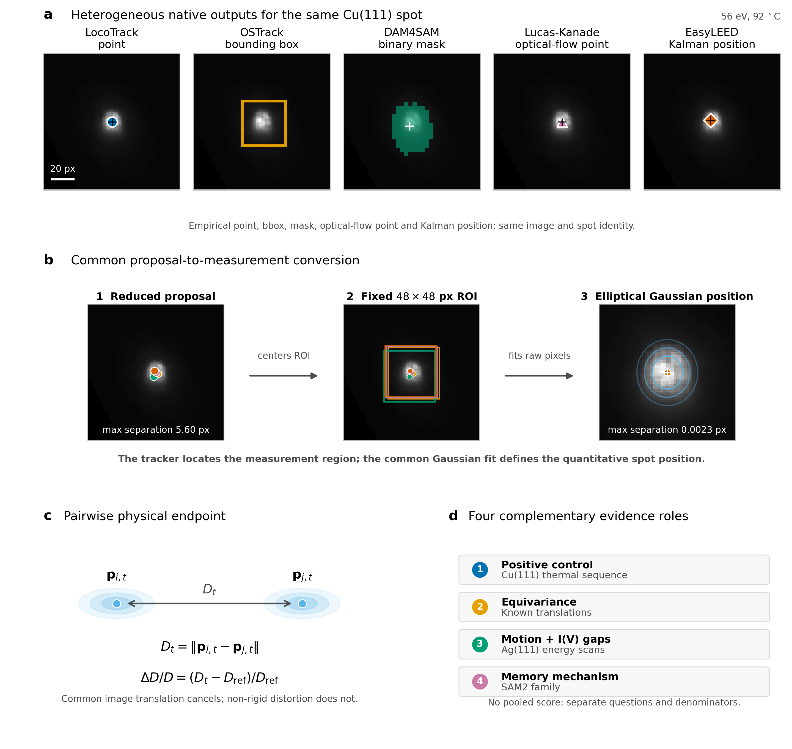
Figure 1. Tracking proposal, common position measurement, and evidence ladder. a, Empirical native outputs of the five tracking strategies for the same diffraction spot in the final image of the fixed-energy Cu(111) thermal sequence (56 eV, 92 °C): the LocoTrack point, OSTrack bounding box, DAM4SAM binary mask, Lucas-Kanade optical-flow point, and EasyLEED Kalman position. The case was selected from the acquisition metadata without inspecting tracker behavior; all methods used the same image sequence, spot, and seed and received no correction or reinitialization. The OSTrack box and the unsmoothed DAM4SAM mask are the frozen empirical native geometries. b, Each native output is reduced to a proposal coordinate that centers an identically sized 48 x 48 pixel measurement ROI. A common elliptical two-dimensional Gaussian fit to the raw pixels supplies the quantitative spot position. In this explanatory case, the maximum separation among the five proposal coordinates is 5.60 pixels and that among the five Gaussian centers is 0.0023 pixels; these values were not used for case selection and do not rank the methods. c, Two Gaussian-refined positions define the pair distance (D_t) and its normalized change (D/D). Common image translation cancels in the pair distance, whereas non-rigid distortion does not. d, The Cu(111) thermal sequence, known translations, Ag(111) energy scans, and controlled SAM2 family serve as a positive control, equivariance test, motion-plus-I(V)-gap stress test, and memory-mechanism analysis, respectively. These regimes answer separate questions with separate denominators rather than forming a composite tracker ranking.
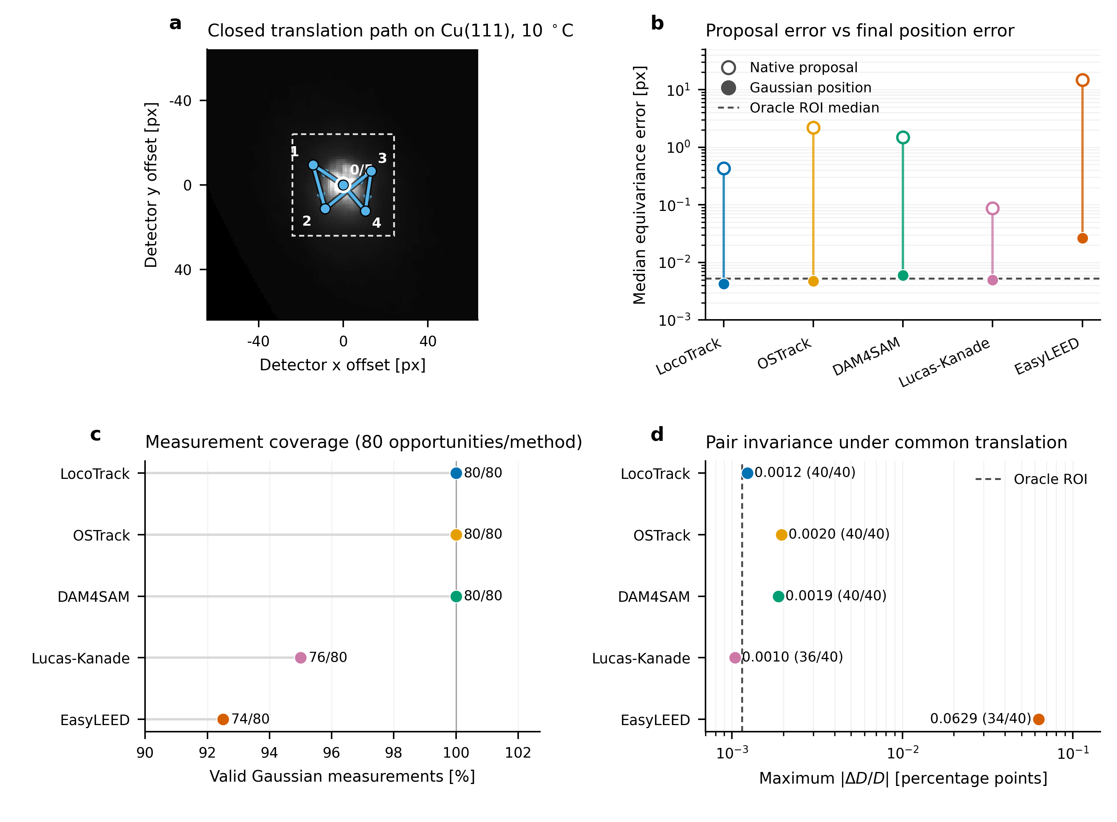
Figure 2. Controlled equivariance of the measurement chain. (a) Frozen closed translation path applied to four independently initialized Cu(111) states; the representative initial 10 °C image is shown. (b) Median displacement-equivariance error before and after the common two-dimensional Gaussian estimator. The oracle ROI estimates the interpolation-plus-estimator floor without a tracker. (c) Valid Gaussian measurements out of 80 predefined spot opportunities per method. (d) Maximum absolute pairwise relative-distance change under common image translation. Valid-pair counts out of 40 predefined opportunities are printed beside each method. Known translations assess measurement-chain equivariance and common- estimator behavior, not absolute tracking accuracy or identity ground truth.
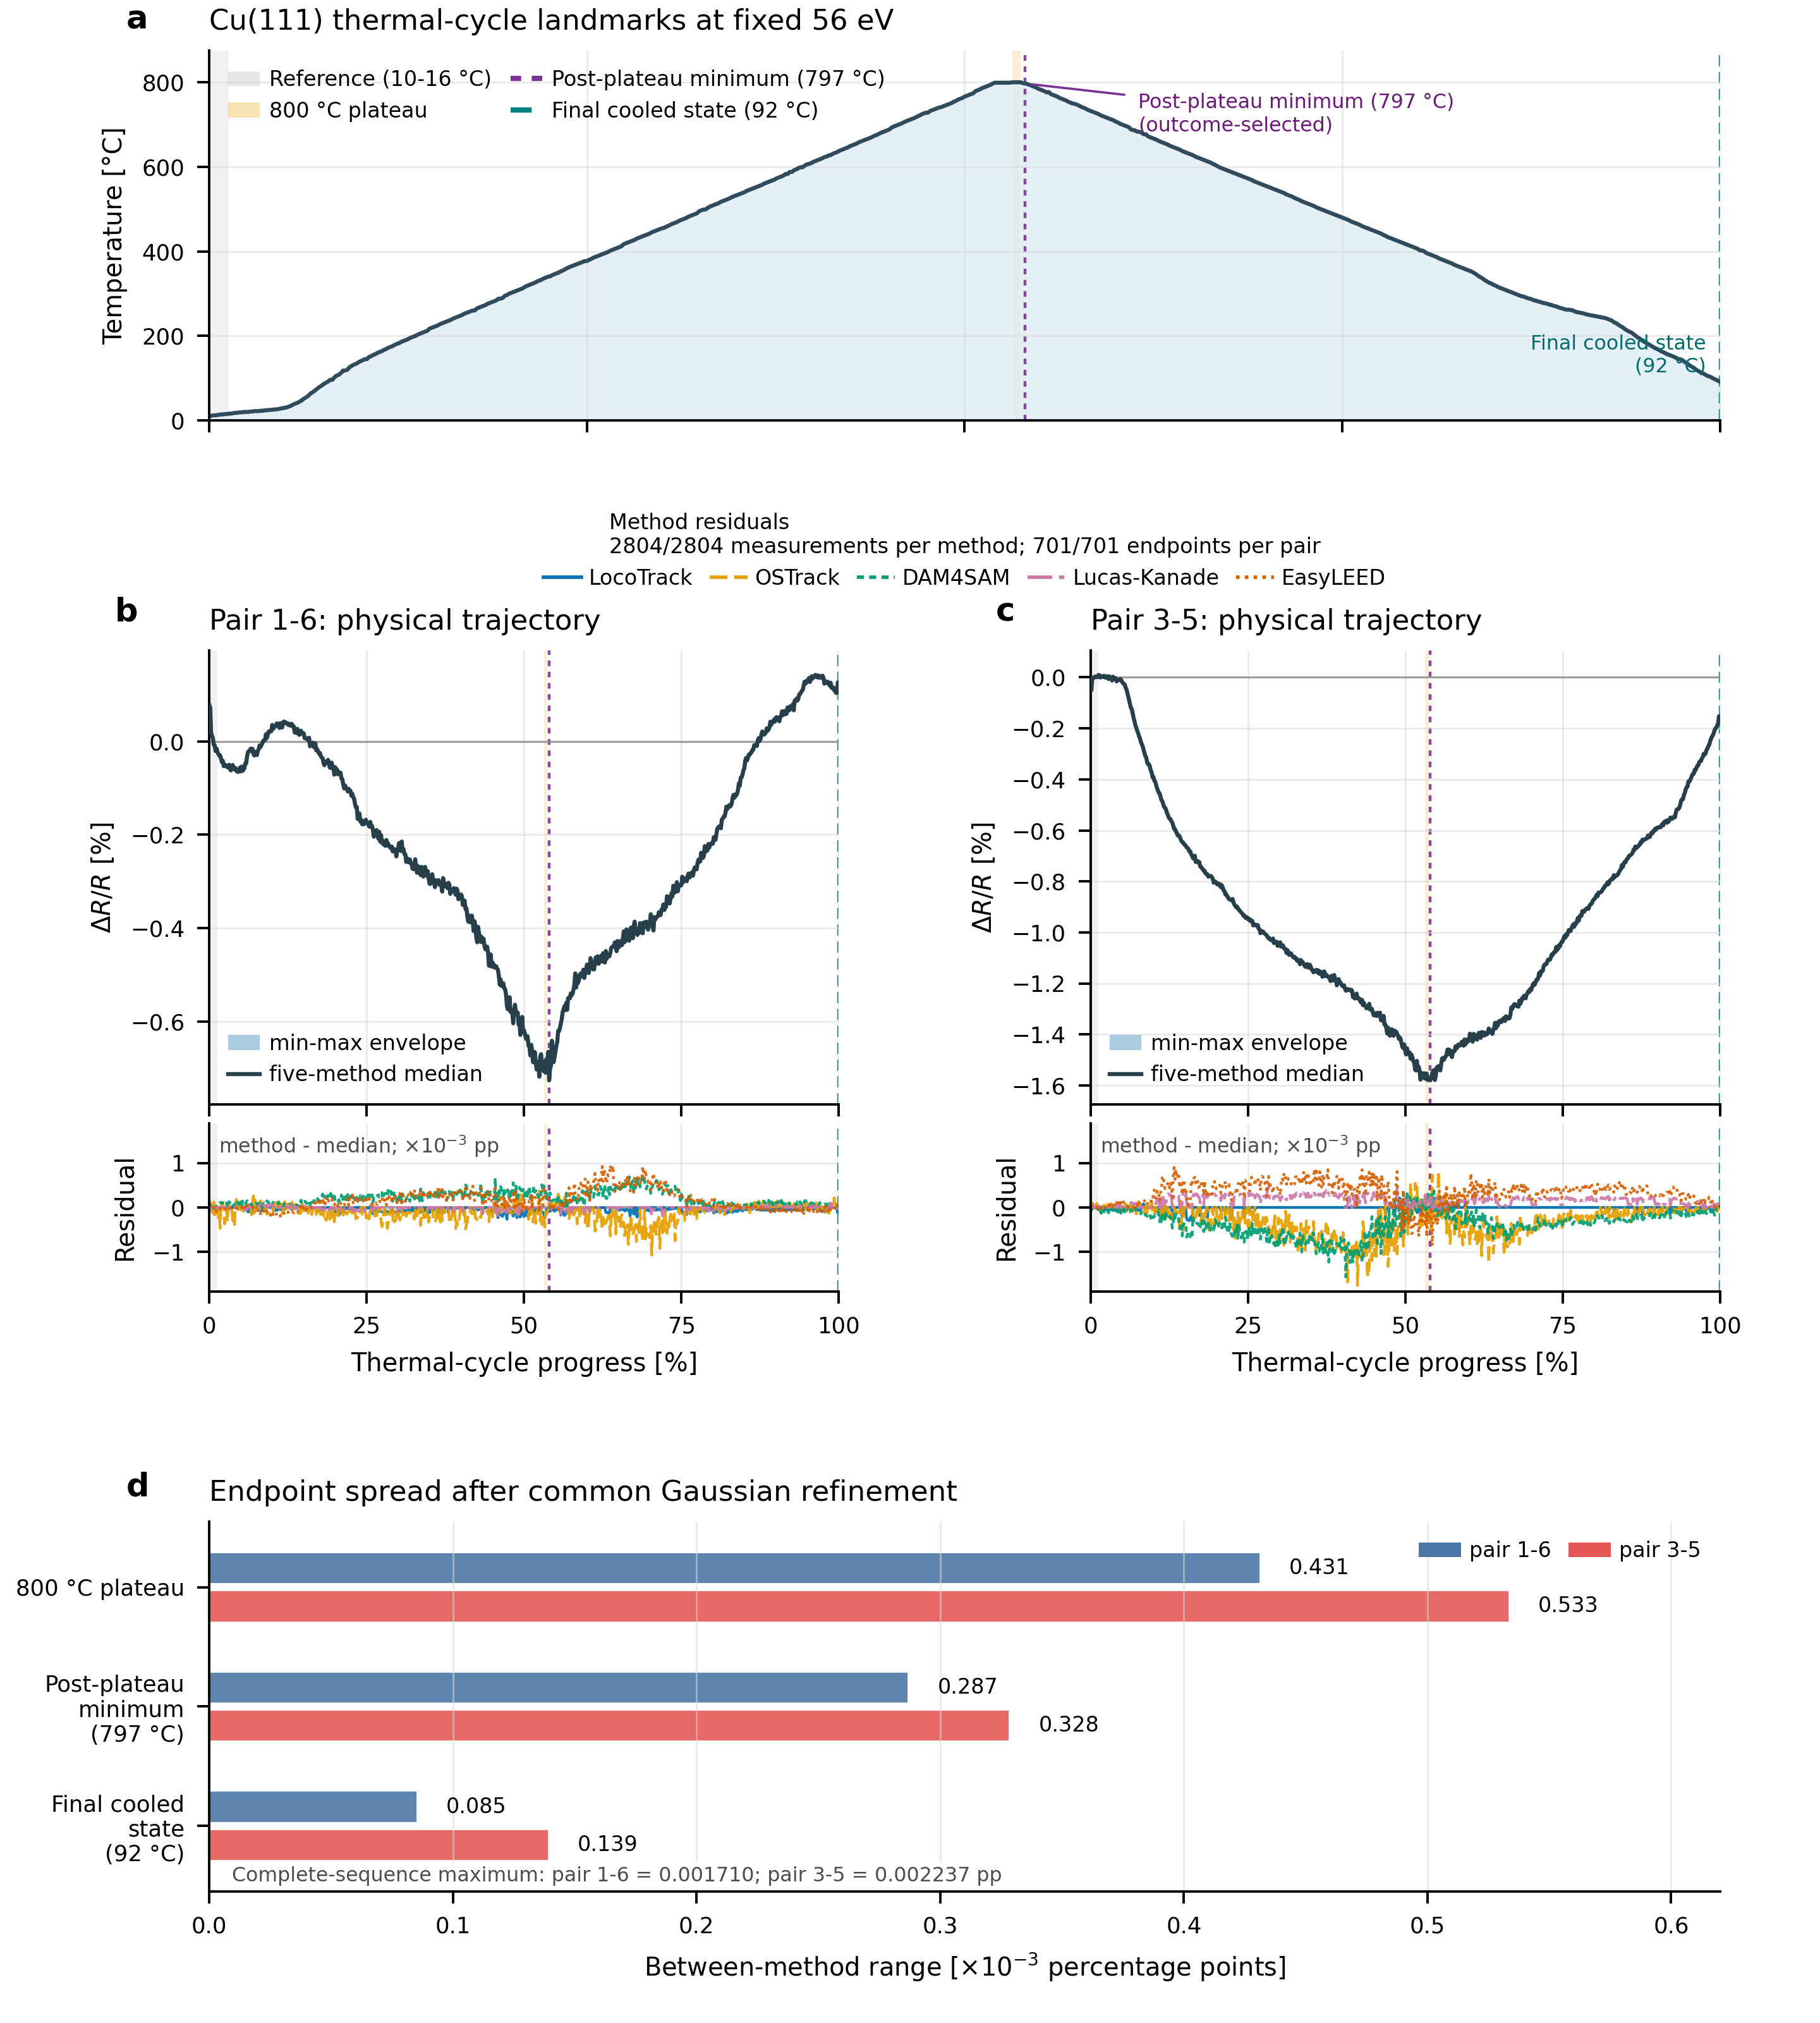
Figure 3. Tracker proposal differences do not materially alter the Cu(111) pairwise relative spot-radius endpoint after common Gaussian refinement. a, Temperature profile of the 701-image constant-energy thermal cycle. b,c, Pairwise Delta R/R = Delta D/D after proposals from LocoTrack, OSTrack, DAM4SAM, Lucas-Kanade, and EasyLEED were passed through the same Gaussian estimator. Every method produced 2804/2804 accepted Gaussian measurements and 701/701 valid endpoints for each pair. d, Between-method endpoint range at the predefined plateau, the common post-plateau minimum, and the final cooled state. Maximum separation over the complete sequence was 0.001710 percentage points for pair 1-6 and 0.002237 percentage points for pair 3-5. This agreement is evidence from one positive-control sequence, not absolute accuracy or a tracker ranking. The two pairs do not establish crystallographic anisotropy, a calibrated thermal-expansion coefficient, a phase transition, or a structural mechanism.
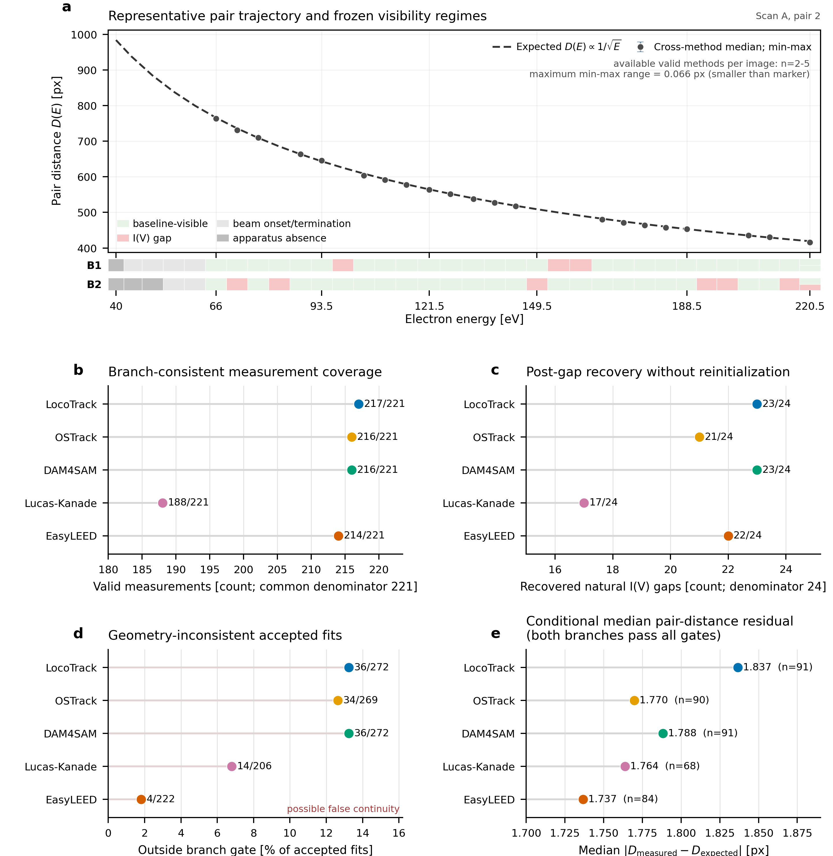
Figure 4. Ag(111) motion and visibility-gap stress test. a, Expected pair-distance contraction, framewise cross-method median and min–max range for the predeclared representative Scan A pair, with the two frozen branch visibility regimes shown separately. The expected D(E) ∝ 1/sqrt(E) curve is a physics-consistency reference rather than absolute ground truth. b, Branch-consistent Gaussian measurement coverage among 221 baseline-visible spot opportunities per method. c, Return to the same frozen radial branch after 24 evaluable natural I(V) gaps, without manual reinitialization. d, Accepted Gaussian fits outside the 18 px branch-consistency gate, reported over each method’s accepted-fit denominator; these events indicate possible false continuity but do not prove identity switches. e, Median absolute pair-distance residual conditional on both branches passing proposal, Gaussian-fit and geometry gates, with the method-specific conditional n. Coverage and recovery precede inconsistency and conditional residual so the conditional metric cannot hide missing measurements.
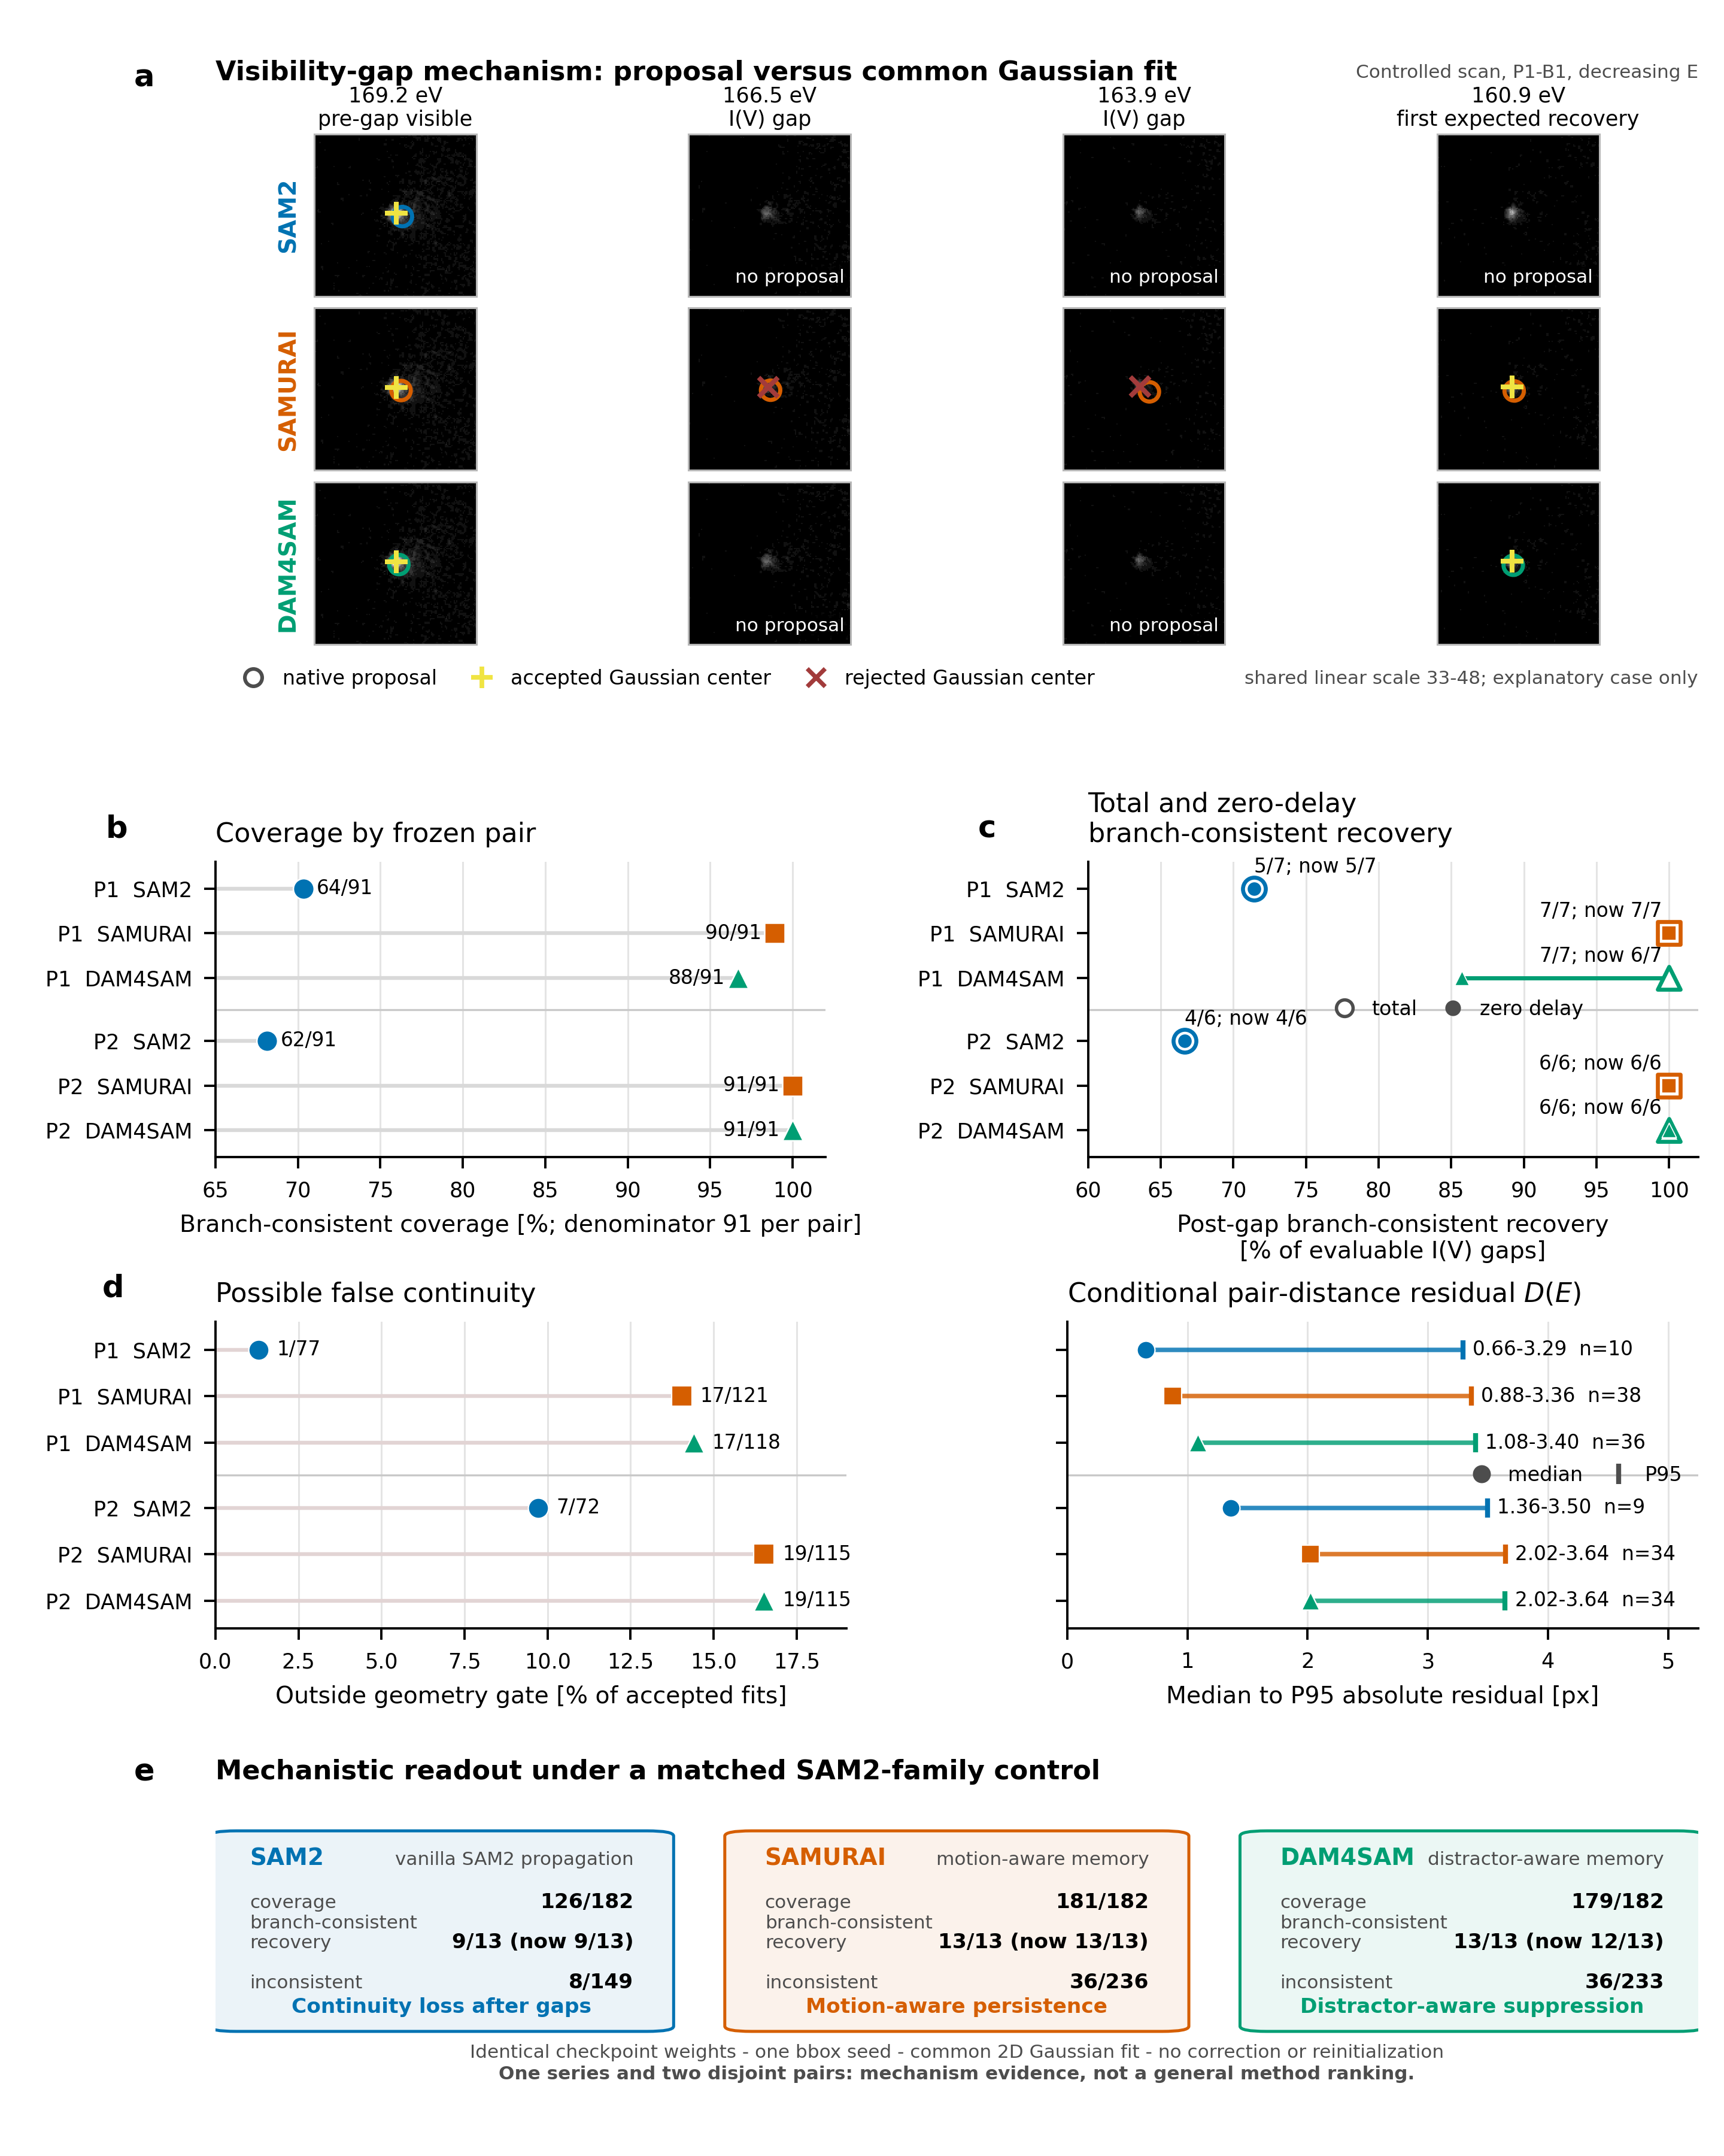
Figure 5. Controlled SAM2-family continuity–consistency trade-off under identical checkpoint weights. a, Four states around a natural B1 I(V) visibility gap in the controlled scan. SAM2, SAMURAI, and DAM4SAM receive the same single-object bbox seed; open circles denote native proposals, yellow plus symbols accepted centers from the common two-dimensional Gaussian fit, and red crosses rejected Gaussian centers. All twelve views render the complete frozen 128 x 128 pixel crops with one shared linear intensity scale. The sequence is the first decreasing-energy gap with different recovery outcomes and is outcome-selected for mechanistic explanation only. b, Branch-consistent Gaussian measurement coverage for two disjoint frozen pairs, each with 91 baseline-visible spot opportunities per method. c, Total and zero-delay recovery of the same physics-constrained branch after natural I(V) gaps, with seven evaluable gaps in pair 1 and six in pair 2. d, Left: accepted Gaussian measurements outside the frozen geometry gate, reported over each method’s accepted measurements in all visibility regimes. Right: median-to-P95 absolute pair-distance residual (D(E)), conditional on both branches passing proposal, Gaussian-fit, and geometry gates; the method-specific numbers of jointly consistent pair frames are shown as (n). e, Aggregate mechanistic readout. Motion-aware and distractor-aware memory increase coverage and post-gap branch-consistent recovery relative to vanilla propagation, while also increasing geometry-inconsistent accepted fits. All methods use byte-identical SAM2.1 base-plus checkpoint weights, the same 48 x 48 pixel prompt and measurement ROI, the same Gaussian estimator, and no correction or reinitialization. The comparison contains one series and two pairs and is mechanism evidence, not a general ranking of SAM2-family methods. Conditional residuals must be interpreted together with coverage, recovery, and possible false continuity.

