Supplementary material
  - Supplementary information
2026-08-02
Table of Contents

This working supplement contains deterministic display items linked from the main manuscript. Internal archive identifiers and machine-specific paths are kept in committed provenance records rather than reader-facing tables.

Figure S1 — Controlled-translation detail
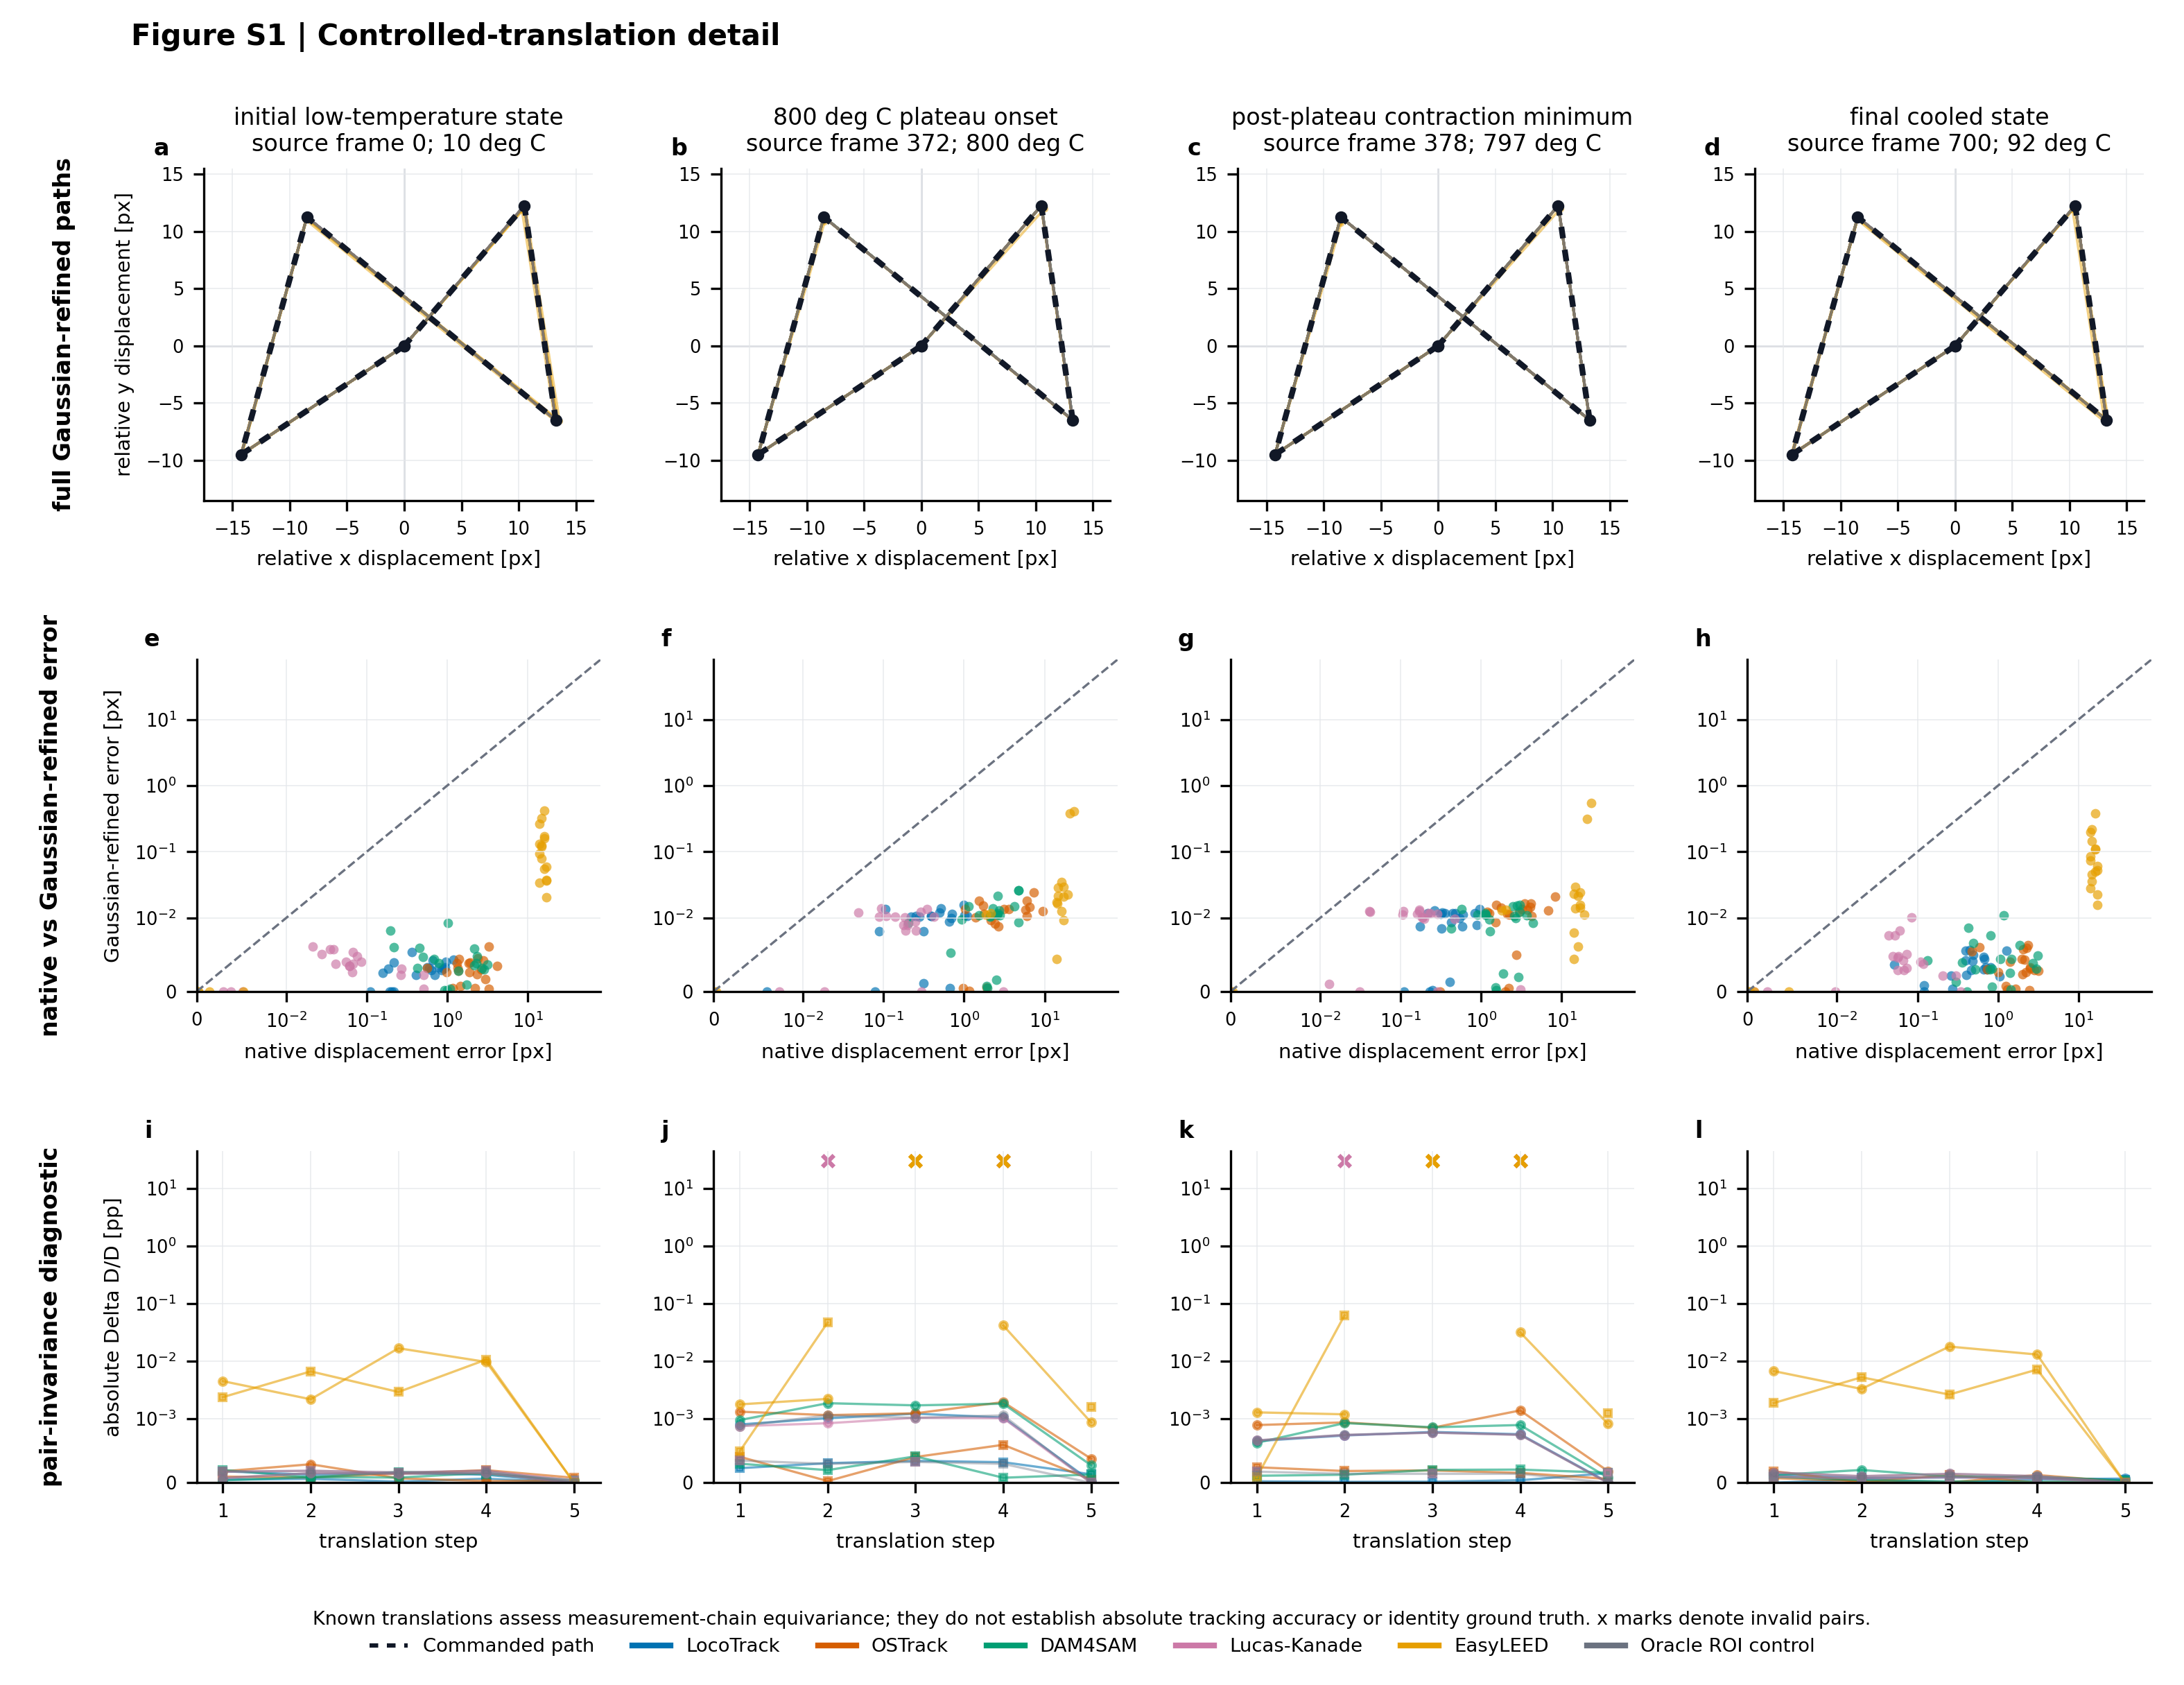
Complete controlled-translation trial paths and diagnostics
Figure S1. Controlled-translation detail. Columns are the four independently initialized source states from one Cu(111) series. The top row overlays the commanded path and every accepted Gaussian-refined spot path for all five trackers and the oracle ROI measurement control. The middle row retains every available native-versus-refined displacement-error observation. The bottom row shows both pair-invariance trajectories; crosses mark invalid pair measurements, whose fixed and conditional denominators are reported in Table S5. Known translations assess measurement-chain equivariance and common-estimator behavior, not absolute tracking accuracy or identity ground truth.

Table S1 — Software, models, versions, hashes and environments
Table S1. Software, models, versions, hashes and environments. Software and model identities and the run-frozen records in blocks A and B come from the completed execution contracts. Where a method-level configuration was not frozen during a run, block B instead reports a post-run normalized record derived from the archived executed source; the status column distinguishes these cases. The package inventories in block C were captured on 2026-07-29 after the completed runs from the retained local environments; they document the preserved runtimes, but this record does not establish bitwise reproducibility of GPU inference. The retained execution host was Microsoft Windows NT 10.0.26200.0, 64-bit with an NVIDIA GeForce RTX 4070 Laptop GPU (8188 MiB, driver 610.62).
A. Software and model identity

Component | Study role/regime | Software version | Upstream revision | Configuration/variant | Frozen artifact | Artifact type | Artifact SHA-256 | Environment
TrackLEED common measurement | All regimes and reported positions | Source files identified by SHA-256 | not recorded separately | 48 × 48 raw-image ROI; two-dimensional elliptical-Gaussian estimator | peak_analyzer.py; common-measurement adapter | implementation source | 5d6af3da893300f4f8bb36196b73e7ad1584566d1f12f5db9a93bf2bb7013416; c4f41ad5debdd5a6e932345553e3127570d83da08045682b8a9b3940efd55364 | netcat
LocoTrack | Main five-method matrix | not tagged | 3385a233a270160b253a69050c6a3934527f7775 | Base, offline mode | locotrack_base.ckpt | model checkpoint | 8a5adbaeb610d1f06adfbc7c9076b66f727d674c0fd1d668890201cf3339736c | locotrack-pytorch
OSTrack | Main five-method matrix | not tagged | 33b5e12586216b7fd0e95d255bd01ba44cbec759 | ViT-B/256 MAE-CE, epoch 300 | OSTrack_ep0300.pth.tar | model checkpoint | 30c2147dd5799c7d78f5c114bf9ebaf00fa69638568865e6ade3d8cb04ea380f | ostrack
DAM4SAM Large | Cu(111) and controlled translations | not tagged | 9c954504b39ebca4c412f207be0787c26bfac85a | sam21pp-L / Hiera Large | sam2.1_hiera_large.pt | model checkpoint | 2647878d5dfa5098f2f8649825738a9345572bae2d4350a2468587ece47dd318 | dam4sam
Lucas–Kanade | Main five-method matrix | TrackLEED implementation | not applicable | Pyramidal skip-anchor; 41 × 41 window; four pyramid levels; forward–backward threshold 8 px | trackleed/analysis/tracking.py | implementation source | 554bc16ec6c2ebc0493b3eac65ccd8180b0f52cc65e56702ba2d60ff12c1275e | netcat
EasyLEED | Main five-method matrix and restricted external reference | 2.5.2 | bbe4acd2b5eeb0f5d50a8d018780ace3afd7ff73 | LEED motion model and Kalman filter; 12 px tracking radius in the method input grid | TrackLEED EasyLEED adapters | implementation source | be5701c5a3f86736ae096ad3321980756e532ef457af13059ebf916ebb07e288 | easyleed
SAM2.1 | Controlled SAM2 family | 2.1 | 2b90b9f5ceec907a1c18123530e92e794ad901a4 | Hiera Base+ vanilla propagation | sam2.1_hiera_base_plus.pt | model checkpoint | a2345aede8715ab1d5d31b4a509fb160c5a4af1970f199d9054ccfb746c004c5 | sam2
SAMURAI | Controlled SAM2 family | not tagged | 76ba195984892b0d1e3db5d9c9f90bb62175680a | Hiera Base+ with motion-aware memory | sam2.1_hiera_base_plus.pt | model checkpoint | a2345aede8715ab1d5d31b4a509fb160c5a4af1970f199d9054ccfb746c004c5 | samurai
DAM4SAM Base+ | Independent energy scans and controlled SAM2 family | not tagged | 9c954504b39ebca4c412f207be0787c26bfac85a | sam21pp-B / Hiera Base+ | sam2.1_hiera_base_plus.pt | model checkpoint | a2345aede8715ab1d5d31b4a509fb160c5a4af1970f199d9054ccfb746c004c5 | dam4sam
ViPErLEED | Restricted whole-pattern external reference | 1.03 | 2ed1044b72bb43a936f9456cdb8b9846e0d23e96 | Frozen 18-beam pattern and screen registration at 187.9 eV | ViPErLEED plugin JAR | runtime plugin | dd058af9ea79eaf6bea837efc6188b8f9b67dadf980b540d84826a33062c8a2d | viperleed-imagej

B. Configuration and implementation hashes

Component | Configuration-record SHA-256 | Configuration-record status | Upstream configuration SHA-256 | Implementation/adapter SHA-256
TrackLEED common measurement | not recorded separately | not recorded separately | not applicable | c4f41ad5debdd5a6e932345553e3127570d83da08045682b8a9b3940efd55364
LocoTrack | 056238541ea2b81555857fd7746b4872e7f2dbfe9fe5418973bcef47b05446df; 111f6c16214e51ac3f0838e587c8a6f564c389594c874966c5bfa554717d7b97 | run-frozen for Cu(111)/translations; post-run normalized from executed source for independent energy scans | b8cd20e5d5bc1bc5988ecde26ea182bc94de7a8d594bbf868e0f80defa9c86a7 | 23cf5087bb90e874e8de20f33f3bd48142a83bcadec8862c162fd11e5e0923e4; fc8e2aa3de8e1d7c24ad2d69c6bcb8c05151c9b8a540a1379134d1ba8bbb3eee
OSTrack | dc9bd17199ffc0aaea78fc00d0f68ba0b2b3047ef15fac30ec1c4997ed973736; d834f2be2cfb6f96bafee9fe2fef8b819e85bf69f8b6389d2b188e6d67d8fa4f | run-frozen for Cu(111)/translations; post-run normalized from executed source for independent energy scans | 7eff86b7bef5082378d3daadf54decaa9d00cf95b02687c6b3bf1a79b56da701 | 33755330d3328801a42a807c35442302cb1438fad0167a39ab609dbafc52919c; fc8e2aa3de8e1d7c24ad2d69c6bcb8c05151c9b8a540a1379134d1ba8bbb3eee
DAM4SAM Large | d2ffbdc023b7c5be3238a2dca229ebd0bcb980d994b11ca85a2b124d1c85daa1 | run-frozen executed configuration | 742e07598bcab0b09012b3fdf0ed15fec2928c750916c7b226571e9deb3ec563 | ee20f7898d6e74a6f9fc953c806b8e52cab1ba651772049b88849ea8c18c8586
Lucas–Kanade | e755aca300764ee823973948744fcdd1802a8a26d0009b00ef49911b6229e99e; bb4bbb2a166371124e37be32f43fd67dc3785dc5035ecd830ec8df50450a83d3 | run-frozen for Cu(111)/translations; post-run normalized from executed source for independent energy scans | not applicable | 554bc16ec6c2ebc0493b3eac65ccd8180b0f52cc65e56702ba2d60ff12c1275e; fc8e2aa3de8e1d7c24ad2d69c6bcb8c05151c9b8a540a1379134d1ba8bbb3eee
EasyLEED | 54049d3d51c53f33ac8581366a4a979e4a25c2718d69f2b94e60970d6f99aecc; cbb16fba737a2c4fadea7643dc3cbfa5908603382adfee116002149b875a5494; 1ffc0c5e429095e78ac8d7d086e733661cc303fa6bdcec290c10b322e694c8ca | run-frozen for Cu(111)/translations; post-run normalized from executed sources and outputs for energy scans/external reference | not applicable | be5701c5a3f86736ae096ad3321980756e532ef457af13059ebf916ebb07e288; d11818a491ed44aa045622d06f6ccc5b4f2d1acb577e02b76b1d758b473ac31c; aea4de426b7c307d9230c3994ee88cc59579a95ae8bf0ce8079690e485f90933; 29ceb1e22e89a177a68c2af3f14ef6f331e2656daa83e71611dd4e9edcfbc23b
SAM2.1 | 123c6defcfc619877b0969ce23595998cfd6b95cac2e70e9dd5369560be78c46 | post-run normalized from executed source | not recorded separately | 2f6b6442e3aafafa913f78400dab15d4c7c715d93bb7577009dc75beb7b31797; c95eb72343da954378e083233b943e79beed78328e3695dc71b4a5f51aaa9547
SAMURAI | 79d70dbb54fbc200bdace10d9b7117ded66e88219572e7791d28bf9486274cac | post-run normalized from executed source | not recorded separately | bf2933f3f3fc5ef31c0fc0e530d5f270469be83a8858552f04d2989c32f8ae21; c95eb72343da954378e083233b943e79beed78328e3695dc71b4a5f51aaa9547
DAM4SAM Base+ | 62e9316adac13b4b5fa72ec8b656668590d48bc150e387734373715b04b2b301 | post-run normalized from executed source | not recorded separately | ee20f7898d6e74a6f9fc953c806b8e52cab1ba651772049b88849ea8c18c8586; c95eb72343da954378e083233b943e79beed78328e3695dc71b4a5f51aaa9547; fc8e2aa3de8e1d7c24ad2d69c6bcb8c05151c9b8a540a1379134d1ba8bbb3eee
ViPErLEED | not recorded separately | not recorded separately | not applicable | not applicable

C. Retained execution environments

Environment | Used for | Runtime | Core package versions | Execution mode/runtime | Frozen snapshot SHA-256
netcat | TrackLEED common Gaussian measurement, Lucas–Kanade, and result assembly | Python 3.12.9 | NumPy 2.2.5; SciPy 1.15.2; OpenCV 4.11.0.86; scikit-image 0.25.2 | CPU | 14f756ccfe8c2f2781aa1ad8ea405d7c58151529ff476ae58b88efe0629e5668
locotrack-pytorch | LocoTrack inference | Python 3.11.15 | PyTorch 2.11.0+cu128; torchvision 0.26.0+cu128; NumPy 2.4.4; OpenCV 4.13.0.92 | CUDA; PyTorch build CUDA 12.8 | 812c5c9af7cd60058cd6b3bcdde8aac4dd90c4bc46568444f64c9f722d4b5bd5
ostrack | OSTrack inference | Python 3.8.20 | PyTorch 1.13.1+cu117; torchvision 0.14.1+cu117; NumPy 1.24.4; OpenCV 4.13.0.92; timm 0.5.4 | CUDA; PyTorch build CUDA 11.7 | a4b9193c9cf4829f0f697ba35a2112d58011c4056b924a5976022226c3882b11
dam4sam | DAM4SAM Large and Base+ inference | Python 3.10.20 | PyTorch 2.1.0+cu121; torchvision 0.16.0+cu121; NumPy 1.26.4; OpenCV 4.11.0.86; Hydra 1.3.2 | CUDA; PyTorch build CUDA 12.1 | 1b14a78e06eff162d756fbbae9753f84371814d53639abc4275165aeb012147e
sam2 | Vanilla SAM2.1 controlled-family inference | Python 3.10.20 | PyTorch 2.5.1+cu121; torchvision 0.20.1+cu121; NumPy 2.2.6; OpenCV 4.13.0.92; Hydra 1.3.2 | CUDA; PyTorch build CUDA 12.1 | 22d4b6254ba42b3391c3df2c468b1fe8142cb86b6ffab67a0ce0026f0afc5bef
samurai | SAMURAI controlled-family inference | Python 3.10.20 | PyTorch 2.5.1+cu121; torchvision 0.20.1+cu121; NumPy 1.26.4; OpenCV 4.11.0.86; Hydra 1.3.2 | CUDA; PyTorch build CUDA 12.1 | c2d2c6b2156ba94dd08b7a8cb68e99e6342d655b07431ebfd639010347a5d11a
easyleed | EasyLEED Kalman tracking | Python 3.11.15 | NumPy 1.26.4; SciPy 1.17.1; scikit-image 0.26.0; PyQt5 5.15.11 | CPU | e2f4a155c8696dd250f41b9cccb287c76be9fe88da9b3e77aee5dab3577f1539
viperleed-imagej | ViPErLEED whole-pattern tracking | ImageJ 1.54u; OpenJDK 1.8.0_345; ViPErLEED ImageJ plugin 1.03 | not applicable | JVM/CPU | e64540325636048157605336981c63f3680b31b1c5808a1e1d49803f893d6ac3

Native proposal availability and preprocessing contract
This reader-facing contract complements the identity and hash inventory in Table S1. Records labelled as post-run normalized in Table S1 were transcribed from the archived executed source and outputs; that status is not upgraded to a run-frozen method configuration.
- LocoTrack: inference used the Base offline model on a 256 × 256 input. For the independent energy scans, native availability combined the returned occlusion logit $o$ and expected-distance logit $d$ as $P_{vis}=[1−sigmoid(o)][1−sigmoid(d)]$, with $P_{vis}>0.5$ required. In the Cu(111) and translation regimes every finite point was available and this probability remained diagnostic only.
- OSTrack: inference used the frozen 256-pixel configuration. A finite box with positive width and height was available; its center was the proposal. The native box score was retained but did not gate or weight the common fit.
- DAM4SAM and the controlled SAM2 family: a finite nonempty mask was available and its pixel centroid was the proposal. The controlled SAM2, SAMURAI, and DAM4SAM paths used byte-identical checkpoint weights, the same one-object box prompt, the same bidirectional image order, and no later prompt or reset. Table S1 identifies the distinct DAM4SAM configurations used across regimes.
- Lucas–Kanade: the pyramidal skip-anchor implementation used a 41 × 41 window, maximum pyramid level 4, at most 50 iterations, convergence tolerance 0.01, and minimum eigenvalue ${10}^{−5}$. Native acceptance required residual $≤30$ and forward–backward closure error $≤8$ px; normalized cross-correlation and centroid recentering were disabled. For the energy scans, each image was normalized to grayscale, high-pass filtered by subtracting a Gaussian blur with $σ=5$, processed by a white top-hat with a disk of radius 5, renormalized, and converted to 8-bit input. A rejected image remained missing and the last successful image and point stayed as the later anchor without interpolation.
- EasyLEED: the native energy-scan contract used a 12-pixel tracking radius, input precision 2 px, native Gaussian $R^{2}$ threshold 0.8, validation parameter $γ=8$, and window scaling. The exported finite Kalman coordinate was the proposal; native intensity and internal Gaussian output remained diagnostics and did not replace the common measurement.
- ViPErLEED: the restricted compatibility check used the frozen whole-pattern initialization recorded in Table S1. Its corresponding beam coordinates were proposal inputs to the common estimator, not external position ground truth.

Table S2 — Gaussian gates, fixed opportunity sets and conditional denominators
Table S2. Gaussian gates, fixed opportunity sets and conditional denominators. Block A lists the run-frozen acceptance contract and separates Gaussian acceptance from the subsequent energy-branch consistency classification. Block B retains every predefined opportunity in its fixed denominator, including unavailable proposals and rejected fits. Block C gives the method-dependent n used only for statistics conditional on available native outputs, accepted Gaussian measurements, or jointly branch-consistent pairs. Counts pool repeated observations of propagated trajectories; images, spot opportunities, pair images, and gaps are not statistically independent replicates.
A. Gaussian measurement and evaluation gates

Regime | Stage | Frozen criterion | Boundary and role | Failure handling
All experiments | Proposal-to-ROI conversion | Map the proposal to the original 1000 × 1000 image; round to the nearest pixel; place a 48 × 48 raw-intensity ROI. | The ROI must lie completely inside the image; it is rejected rather than clipped or padded. | No proposal or an out-of-bounds ROI produces a missing measurement.
Cu(111) and controlled translations | Numerical fit validity | Fit result, R², fitted parameters, and center uncertainties must be finite; center uncertainties must be nonnegative. | Gaussian-acceptance gate applied identically to all compared methods in this regime. | Failure produces a missing measurement.
Cu(111) and controlled translations | Fit quality | R² ≥ 0.85 and amplitude A ≥ 0.05. | Both thresholds are inclusive. | Failure produces a missing measurement.
Cu(111) and controlled translations | Fitted-center and width geometry | −2 < x_c,y_c < 50 px and 0.5 < σ_x,σ_y < 48 px. | All four bounds are strict; coordinates are local to the 48 × 48 ROI. | Failure produces a missing measurement.
Energy scans | Fit initialization and solver bounds | Initialize the center at the smoothed intensity maximum within 16.32 px of the ROI center; bound each fitted center coordinate to ±16.32 px from the ROI center. | Solver constraint, not a post-fit performance metric. | Fit failure produces a missing measurement.
Energy scans | Fit quality and widths | R² ≥ 0.85; amplitude A ≥ 0.012; 0.6 ≤ σ_x,σ_y ≤ 13 px. | All threshold bounds are inclusive. | Failure produces a missing measurement.
Energy scans | Proposal-to-fit consistency | Euclidean distance between the proposal and Gaussian-refined center ≤ 15 px. | Gaussian-acceptance gate applied identically to all compared methods in this regime. | Failure produces a missing measurement.
Energy scans | Branch consistency | Euclidean distance between an accepted Gaussian center and the frozen expected radial branch ≤ 18 px. | Evaluation gate applied after Gaussian acceptance; it does not move the proposal or fitted center. | A fit beyond 18 px remains an accepted Gaussian fit but is classified as geometry-inconsistent.
All experiments | Missing-value policy | No interpolation, carry-forward, manual correction, or within-run reinitialization. | Applies after unavailable proposals, out-of-bounds ROIs, fit failures, or gate failures. | The predefined opportunity remains in its fixed denominator.
Cu(111) primary pairs | Relative-endpoint reference | D_ref is the median of valid pair distances in the first 10 images, requiring at least 8 valid distances. | Eligibility rule for each method–pair relative endpoint, not a Gaussian-acceptance gate. | If fewer than 8 of 10 distances are valid, the entire relative endpoint is unavailable.

B. Fixed opportunity denominators

Regime | Metric | Denominator class | Denominator per method | Unit | Construction | Replication/stratification | Scope note
Controlled translations | Spot proposal and Gaussian-measurement coverage | Fixed opportunity | 80 | spot–step opportunities | 4 source-state trials × 4 spots × 5 non-seed steps | Four separately initialized trials drawn from one Cu(111) sequence | Failures remain in 80.
Controlled translations | Pair coverage and pair-invariance endpoint | Fixed opportunity | 40 | pair–step opportunities | 4 source-state trials × 2 pairs × 5 non-seed steps | Four separately initialized trials drawn from one Cu(111) sequence | Failures remain in 40.
Cu(111) positive control | Spot proposal and Gaussian-measurement coverage | Fixed opportunity | 2,804 | spot–image opportunities | 701 images × 4 frozen spots | One sequence; four spots | Failures remain in 2,804.
Cu(111) positive control | Primary relative pair endpoint | Fixed opportunity | 701 per pair | pair–image opportunities | 701 images for each of pairs 1–6 and 3–5 | One sequence; two frozen pairs | The two pair strata are not independent series.
Cu(111) positive control | D_ref eligibility window | Fixed eligibility window | 10 per method–pair | initial pair–image opportunities | First 10 images; at least 8 valid pair distances required | Applied separately to every method–pair endpoint | This gate determines whether the relative endpoint exists.
Cu(111) pair 2–4 diagnostic | Consecutive amplitude-only fit failures | Separate diagnostic | 24 | rejected Gaussian candidates | 24 consecutive proposal-present candidates; all passed R², center, and width gates but failed amplitude | Earlier saved YOLO proposal trajectory; outside the five-method matrix | Diagnostic count, not a denominator for comparing the five methods.
Independent energy scans | Branch-consistent measurement coverage | Fixed opportunity | 221 | baseline-visible spot opportunities | Frozen tracker-independent baseline across four scan–pair cases | Two independently acquired series; four frozen scan–pair cases | Every method uses the same 221 opportunities.
Independent energy scans | Post-gap branch-consistent recovery | Fixed opportunity | 24 | evaluable natural I(V) gaps | Baseline gaps bracketed by visible measurements on the same branch | Two independently acquired series; four frozen scan–pair cases | Every method uses the same 24 gaps.
Controlled SAM2 family | Branch-consistent measurement coverage | Fixed opportunity | 182 | baseline-visible spot opportunities | Frozen baseline for two pairs in one memory-analysis scan | One series; two frozen pairs | Mechanism experiment, not a population ranking.
Controlled SAM2 family | Post-gap branch-consistent recovery | Fixed opportunity | 13 | evaluable natural I(V) gaps | Baseline gaps bracketed by visible measurements on the same branch | One series; two frozen pairs | Mechanism experiment, not a population ranking.
Restricted external reference | Branch-image coverage | Fixed opportunity | 60 | branch–image opportunities | 15 images × 4 frozen branches | Subset of the memory-analysis scan; two pairs | 60 opportunities for EasyLEED and 60 for ViPErLEED.
Restricted external reference | Predefined branch-gap checks | Fixed opportunity | 4 | branch-gap checks | One check for each frozen branch | Subset of the memory-analysis scan; two pairs | Compatibility check, not external position ground truth.
Cu(111) frozen visual audit | Combined overlay review | Audit sample | 24 | combined overlays | 12 temporal quantiles + 12 temperature-cycle anchors selected independently of method output | One Cu(111) sequence | Audit only; not a metric denominator and not used to correct outcomes.

C. Method-dependent conditional denominators

Regime | Metric | Denominator class | Unit | Method-specific or paired n | Conditioning basis | Conditioning rule
Controlled translations | Native-proposal displacement error | Conditional available proposals | available native spot–step proposals | LocoTrack=80; OSTrack=80; DAM4SAM=80; Lucas–Kanade=76; EasyLEED=80 | Only opportunities with an available native proposal | Reported only alongside fixed proposal-coverage denominator 80.
Controlled translations | Gaussian-refined displacement error | Conditional accepted measurements | accepted spot–step measurements | LocoTrack=80; OSTrack=80; DAM4SAM=80; Lucas–Kanade=76; EasyLEED=74; Oracle ROI=80 | Only opportunities with an accepted Gaussian measurement | Reported only alongside fixed measurement-coverage denominator 80.
Controlled translations | Pair-invariance error | Conditional jointly valid pairs | jointly valid pair–step measurements | LocoTrack=40; OSTrack=40; DAM4SAM=40; Lucas–Kanade=36; EasyLEED=34; Oracle ROI=40 | Only pair opportunities with both Gaussian measurements accepted | Reported only alongside fixed pair denominator 40.
Independent energy scans | Geometry-inconsistent continuation | Conditional accepted fits | accepted Gaussian fits in all visibility regimes | LocoTrack=272; OSTrack=269; DAM4SAM=272; Lucas–Kanade=206; EasyLEED=222 | Accepted Gaussian fits more than 18 px from the expected branch divided by all accepted fits | This denominator is not the 221 baseline-visible coverage denominator.
Independent energy scans | Absolute pair-distance residual | Conditional branch-consistent pairs | jointly valid and branch-consistent pair images | LocoTrack=91; OSTrack=90; DAM4SAM=91; Lucas–Kanade=68; EasyLEED=84 | Both branches must pass proposal, Gaussian, and 18 px branch-consistency gates | Residual n is reported with the conditional statistic.
Controlled SAM2 family | Geometry-inconsistent continuation | Conditional accepted fits | accepted Gaussian fits in all visibility regimes | SAM2=149; SAMURAI=236; DAM4SAM=233 | Accepted Gaussian fits more than 18 px from the expected branch divided by all accepted fits | This denominator is not the 182 baseline-visible coverage denominator.
Controlled SAM2 family | Pair-stratified absolute pair-distance residual | Conditional branch-consistent pairs | jointly valid and branch-consistent pair images | SAM2: pair 1=10, pair 2=9; SAMURAI: pair 1=38, pair 2=34; DAM4SAM: pair 1=36, pair 2=34 | Both branches must pass proposal, Gaussian, and 18 px branch-consistency gates | Each pair-specific residual statistic is reported with its own n.
Restricted external reference | Native cross-method coordinate agreement | Conditional paired native outputs | paired branch–image correspondences | EasyLEED–ViPErLEED=60 paired correspondences | Both methods provide the predefined corresponding native branch coordinate | Native-output comparison precedes Gaussian refinement.
Restricted external reference | Common-Gaussian center agreement | Conditional jointly accepted fits | jointly accepted common centers | EasyLEED–ViPErLEED=38 jointly accepted centers | Both native outputs yield an accepted common Gaussian center for the same branch image | Reported alongside fixed branch-image denominator 60 per method.

Table S3 — Ag(111) outcomes by scan–pair and leave-one-case-out
Table S3. Ag(111) outcomes by scan–pair and leave-one-case-out. Coverage is branch-consistent measurements / baseline-visible opportunities; post-gap branch-consistent recovery is recovered / evaluable natural I(V) gaps; geometry inconsistency is accepted Gaussian fits more than 18 px from the expected branch / all accepted Gaussian fits across all visibility regimes. The conditional residual is the median absolute pair-distance residual and is evaluated only when both branches are valid and branch-consistent, with its surviving pair-frame n shown separately. The four scan–pair cases are descriptive strata from two independently acquired scans, not four independent acquisitions.
A. Outcomes by frozen scan–pair case

Scan | Pair | Method | Branch-consistent coverage | Post-gap branch-consistent recovery | Geometry-inconsistent accepted fits | Conditional median absolute pair-distance residual [px] | Conditional n
Scan A | pair 1 | LocoTrack | 44/44 | 5/5 | 9/57 | 1.983 | 18
Scan A | pair 1 | OSTrack | 44/44 | 5/5 | 9/58 | 1.822 | 19
Scan A | pair 1 | DAM4SAM | 44/44 | 5/5 | 9/58 | 1.825 | 19
Scan A | pair 1 | Lucas-Kanade | 43/44 | 5/5 | 5/49 | 1.983 | 16
Scan A | pair 1 | EasyLEED | 42/44 | 5/5 | 0/42 | 1.526 | 15
Scan A | pair 2 | LocoTrack | 48/50 | 7/7 | 7/57 | 1.561 | 19
Scan A | pair 2 | OSTrack | 49/50 | 6/7 | 7/58 | 1.647 | 20
Scan A | pair 2 | DAM4SAM | 49/50 | 7/7 | 7/58 | 1.650 | 20
Scan A | pair 2 | Lucas-Kanade | 40/50 | 4/7 | 0/40 | 1.560 | 14
Scan A | pair 2 | EasyLEED | 48/50 | 5/7 | 0/48 | 1.650 | 18
Scan B | pair 1 | LocoTrack | 58/60 | 5/6 | 10/78 | 1.336 | 26
Scan B | pair 1 | OSTrack | 57/60 | 5/6 | 10/77 | 1.166 | 25
Scan B | pair 1 | DAM4SAM | 57/60 | 5/6 | 10/77 | 1.164 | 25
Scan B | pair 1 | Lucas-Kanade | 47/60 | 4/6 | 9/59 | 1.131 | 15
Scan B | pair 1 | EasyLEED | 57/60 | 6/6 | 0/58 | 1.131 | 23
Scan B | pair 2 | LocoTrack | 67/67 | 6/6 | 10/80 | 2.068 | 28
Scan B | pair 2 | OSTrack | 66/67 | 5/6 | 8/76 | 1.990 | 26
Scan B | pair 2 | DAM4SAM | 66/67 | 6/6 | 10/79 | 2.035 | 27
Scan B | pair 2 | Lucas-Kanade | 58/67 | 4/6 | 0/58 | 2.034 | 23
Scan B | pair 2 | EasyLEED | 67/67 | 6/6 | 4/74 | 2.065 | 28

B. Leave-one-case-out sensitivity
Each of the four frozen scan–pair cases is omitted once. The remaining three cases are pooled and only the count-based coverage, post-gap branch-consistent recovery, and geometry-inconsistency rates are recomputed. The displayed extrema across the four omissions are a sensitivity check, not a confidence interval. Conditional case-median residuals are not reaggregated.

Method | Coverage range | Post-gap branch-consistent recovery range | Geometry-inconsistency range
LocoTrack | 97.4–98.8% | 94.1–100.0% | 12.6–13.5%
OSTrack | 97.2–98.8% | 84.2–88.9% | 11.8–13.5%
DAM4SAM | 97.2–98.8% | 94.1–100.0% | 12.6–13.6%
Lucas-Kanade | 81.9–87.6% | 63.2–76.5% | 3.4–9.5%
EasyLEED | 95.5–97.5% | 88.9–100.0% | 0.0–2.4%

Table S4 — Cu(111) pairwise physical endpoints
Table S4. Cu(111) pairwise physical endpoints. Values are ΔR/R = ΔD/D in percent after the native proposal from each method entered the common Gaussian measurement. Every method produced 701/701 valid endpoints for each primary pair. The 800 °C plateau is the median of a predefined five-image interval. The post-plateau minimum was selected as the lowest value after that interval; it occurred in the common image acquired at 797 °C and is therefore outcome-selected. The final cooled state is the predefined final image acquired at 92 °C. D_ref is the median valid pair distance in the first ten images, with at least eight required. Cross-method concordance after common refinement is not external absolute accuracy or an overall tracker ranking. The two pairs come from one series, are not independent replicates, and do not establish crystallographic anisotropy.

Pair | Method | Valid endpoints | 800 °C plateau median ΔR/R [%] | Post-plateau minimum (797 °C) ΔR/R [%] | Final cooled state (92 °C) ΔR/R [%]
1–6 | LocoTrack | 701/701 | −0.686595 | −0.726452 | 0.121606
1–6 | OSTrack | 701/701 | −0.686676 | −0.726482 | 0.121625
1–6 | DAM4SAM | 701/701 | −0.686244 | −0.726195 | 0.121691
1–6 | Lucas–Kanade | 701/701 | −0.686551 | −0.726440 | 0.121609
1–6 | EasyLEED | 701/701 | −0.686375 | −0.726389 | 0.121681
3–5 | LocoTrack | 701/701 | −1.570535 | −1.579948 | −0.152413
3–5 | OSTrack | 701/701 | −1.570833 | −1.579795 | −0.152417
3–5 | DAM4SAM | 701/701 | −1.570300 | −1.579962 | −0.152478
3–5 | Lucas–Kanade | 701/701 | −1.570362 | −1.579880 | −0.152338
3–5 | EasyLEED | 701/701 | −1.570755 | −1.580123 | −0.152343

Table S5 — Controlled translations by source trial
Table S5. Controlled translations by source trial. Each deterministic six-image trial contains one seed and five evaluation steps on the same closed path, providing 20 spot-step and 10 pair-step fixed opportunities per method. Displacement summaries are conditional on accepted Gaussian measurements; pair invariance is conditional on jointly valid pairs, and both conditional n values are shown. The four source trials are descriptive strata drawn from one Cu(111) series, not four independent acquisitions. The oracle ROI is a measurement control, not a tracker. Known translations assess measurement-chain equivariance and common-estimator behavior, not absolute tracking accuracy and not identity ground truth.

Trial | T [deg C] | Method | Proposal / constructed-ROI coverage | Gaussian measurement coverage | Conditional median / P95 / max displacement error [px] (n) | Pair coverage | Max absolute Delta D/D [pp] (n)
initial low-temperature state | 10 | LocoTrack | 20/20 | 20/20 | 0.0031 / 0.0044 / 0.0054 (n=20) | 10/10 | 0.000181 (n=10)
initial low-temperature state | 10 | OSTrack | 20/20 | 20/20 | 0.0031 / 0.0046 / 0.0061 (n=20) | 10/10 | 0.000290 (n=10)
initial low-temperature state | 10 | DAM4SAM | 20/20 | 20/20 | 0.0037 / 0.0084 / 0.0094 (n=20) | 10/10 | 0.000201 (n=10)
initial low-temperature state | 10 | Lucas-Kanade | 20/20 | 20/20 | 0.0036 / 0.0058 / 0.0062 (n=20) | 10/10 | 0.000188 (n=10)
initial low-temperature state | 10 | EasyLEED | 20/20 | 20/20 | 0.0695 / 0.3250 / 0.4187 (n=20) | 10/10 | 0.016820 (n=10)
initial low-temperature state | 10 | Oracle ROI control | 20/20 | 20/20 | 0.0036 / 0.0058 / 0.0062 (n=20) | 10/10 | 0.000188 (n=10)
800 deg C plateau onset | 800 | LocoTrack | 20/20 | 20/20 | 0.0106 / 0.0141 / 0.0159 (n=20) | 10/10 | 0.001229 (n=10)
800 deg C plateau onset | 800 | OSTrack | 20/20 | 20/20 | 0.0121 / 0.0186 / 0.0244 (n=20) | 10/10 | 0.001952 (n=10)
800 deg C plateau onset | 800 | DAM4SAM | 20/20 | 20/20 | 0.0110 / 0.0261 / 0.0261 (n=20) | 10/10 | 0.001869 (n=10)
800 deg C plateau onset | 800 | Lucas-Kanade | 18/20 | 18/20 | 0.0099 / 0.0136 / 0.0140 (n=18) | 8/10 | 0.001042 (n=8)
800 deg C plateau onset | 800 | EasyLEED | 20/20 | 17/20 | 0.0176 / 0.3880 / 0.4066 (n=17) | 7/10 | 0.047021 (n=7)
800 deg C plateau onset | 800 | Oracle ROI control | 20/20 | 20/20 | 0.0104 / 0.0137 / 0.0140 (n=20) | 10/10 | 0.001147 (n=10)
post-plateau contraction minimum | 797 | LocoTrack | 20/20 | 20/20 | 0.0107 / 0.0130 / 0.0136 (n=20) | 10/10 | 0.000794 (n=10)
post-plateau contraction minimum | 797 | OSTrack | 20/20 | 20/20 | 0.0125 / 0.0170 / 0.0211 (n=20) | 10/10 | 0.001397 (n=10)
post-plateau contraction minimum | 797 | DAM4SAM | 20/20 | 20/20 | 0.0109 / 0.0154 / 0.0159 (n=20) | 10/10 | 0.000934 (n=10)
post-plateau contraction minimum | 797 | Lucas-Kanade | 18/20 | 18/20 | 0.0114 / 0.0129 / 0.0134 (n=18) | 8/10 | 0.000784 (n=8)
post-plateau contraction minimum | 797 | EasyLEED | 20/20 | 17/20 | 0.0139 / 0.3598 / 0.5412 (n=17) | 7/10 | 0.062943 (n=7)
post-plateau contraction minimum | 797 | Oracle ROI control | 20/20 | 20/20 | 0.0106 / 0.0128 / 0.0134 (n=20) | 10/10 | 0.000784 (n=10)
final cooled state | 92 | LocoTrack | 20/20 | 20/20 | 0.0033 / 0.0056 / 0.0057 (n=20) | 10/10 | 0.000130 (n=10)
final cooled state | 92 | OSTrack | 20/20 | 20/20 | 0.0031 / 0.0060 / 0.0063 (n=20) | 10/10 | 0.000182 (n=10)
final cooled state | 92 | DAM4SAM | 20/20 | 20/20 | 0.0039 / 0.0087 / 0.0109 (n=20) | 10/10 | 0.000201 (n=10)
final cooled state | 92 | Lucas-Kanade | 20/20 | 20/20 | 0.0039 / 0.0084 / 0.0102 (n=20) | 10/10 | 0.000161 (n=10)
final cooled state | 92 | EasyLEED | 20/20 | 20/20 | 0.0520 / 0.2251 / 0.3810 (n=20) | 10/10 | 0.017988 (n=10)
final cooled state | 92 | Oracle ROI control | 20/20 | 20/20 | 0.0039 / 0.0084 / 0.0102 (n=20) | 10/10 | 0.000161 (n=10)

Table S6 — Measurement-window and capture-contract sensitivity
Table S6. Measurement-window and capture-contract sensitivity. For the independent Ag(111) stress test, coverage uses the fixed denominator 221 and post-gap branch-consistent recovery uses the fixed denominator 24. Geometry inconsistency is conditional on all accepted fits, while the pair-distance residual retains its method- and variant-specific conditional n. Reader-facing residuals are rounded to three decimals; full-precision values remain in the accompanying CSV and XLSX exports. No comparative rank or automatic configuration selection is implied. The asterisk marks only the frozen central contract.
Variant codebook.
- R32-P12: ROI 32 px; proposal-to-fit 12 px.
- R32-P15: ROI 32 px; proposal-to-fit 15 px.
- R32-P18: ROI 32 px; proposal-to-fit 18 px.
- R48-P12: ROI 48 px; proposal-to-fit 12 px.
- R48-P15*: frozen central contract.
- R48-P18: ROI 48 px; proposal-to-fit 18 px.
- R64-P12: ROI 64 px; proposal-to-fit 12 px.
- R64-P15: ROI 64 px; proposal-to-fit 15 px.
- R64-P18: ROI 64 px; proposal-to-fit 18 px.
- B12: branch tolerance 12 px.
- B24: branch tolerance 24 px.
- R2-80: R² minimum 0.80.
- R2-90: R² minimum 0.90.
- A0.75: amplitude gate multiplier 0.75.
- A1.25: amplitude gate multiplier 1.25.

Variant | Method | Contract change | Coverage | Recovery | Geometry inconsistency | Conditional median / P95 [px] (n)
R32-P12 | EasyLEED | R32, P12; B18, R2-85, A1.00 | 209/221 | 21/24 | 2/223 | 1.627 / 3.659 (n=93)
R32-P12 | LocoTrack | R32, P12; B18, R2-85, A1.00 | 220/221 | 24/24 | 38/286 | 1.776 / 5.759 (n=103)
R32-P12 | OSTrack | R32, P12; B18, R2-85, A1.00 | 212/221 | 21/24 | 36/275 | 1.691 / 5.591 (n=95)
R32-P12 | DAM4SAM | R32, P12; B18, R2-85, A1.00 | 217/221 | 24/24 | 38/285 | 1.755 / 5.784 (n=102)
R32-P12 | Lucas–Kanade | R32, P12; B18, R2-85, A1.00 | 190/221 | 17/24 | 14/215 | 1.678 / 3.990 (n=77)
R32-P15 | EasyLEED | R32, P15; B18, R2-85, A1.00 | 212/221 | 21/24 | 4/234 | 1.627 / 3.659 (n=93)
R32-P15 | LocoTrack | R32, P15; B18, R2-85, A1.00 | 220/221 | 24/24 | 38/286 | 1.776 / 5.759 (n=103)
R32-P15 | OSTrack | R32, P15; B18, R2-85, A1.00 | 215/221 | 21/24 | 36/279 | 1.711 / 5.567 (n=99)
R32-P15 | DAM4SAM | R32, P15; B18, R2-85, A1.00 | 217/221 | 24/24 | 38/285 | 1.755 / 5.784 (n=102)
R32-P15 | Lucas–Kanade | R32, P15; B18, R2-85, A1.00 | 190/221 | 17/24 | 14/215 | 1.678 / 3.990 (n=77)
R32-P18 | EasyLEED | R32, P18; B18, R2-85, A1.00 | 212/221 | 21/24 | 4/239 | 1.627 / 3.659 (n=93)
R32-P18 | LocoTrack | R32, P18; B18, R2-85, A1.00 | 220/221 | 24/24 | 38/286 | 1.776 / 5.759 (n=103)
R32-P18 | OSTrack | R32, P18; B18, R2-85, A1.00 | 216/221 | 22/24 | 36/280 | 1.722 / 5.561 (n=100)
R32-P18 | DAM4SAM | R32, P18; B18, R2-85, A1.00 | 217/221 | 24/24 | 38/285 | 1.755 / 5.784 (n=102)
R32-P18 | Lucas–Kanade | R32, P18; B18, R2-85, A1.00 | 190/221 | 17/24 | 14/215 | 1.678 / 3.990 (n=77)
R48-P12 | EasyLEED | R48, P12; B18, R2-85, A1.00 | 206/221 | 21/24 | 2/209 | 1.650 / 3.662 (n=82)
R48-P12 | LocoTrack | R48, P12; B18, R2-85, A1.00 | 217/221 | 23/24 | 36/272 | 1.837 / 5.973 (n=91)
R48-P12 | OSTrack | R48, P12; B18, R2-85, A1.00 | 211/221 | 20/24 | 34/262 | 1.737 / 5.650 (n=84)
R48-P12 | DAM4SAM | R48, P12; B18, R2-85, A1.00 | 216/221 | 23/24 | 36/272 | 1.788 / 5.973 (n=91)
R48-P12 | Lucas–Kanade | R48, P12; B18, R2-85, A1.00 | 188/221 | 17/24 | 14/206 | 1.764 / 4.442 (n=68)
R48-P15* | EasyLEED | central: R48, P15, B18, R2-85, A1.00 | 214/221 | 22/24 | 4/222 | 1.737 / 3.719 (n=84)
R48-P15* | LocoTrack | central: R48, P15, B18, R2-85, A1.00 | 217/221 | 23/24 | 36/272 | 1.837 / 5.973 (n=91)
R48-P15* | OSTrack | central: R48, P15, B18, R2-85, A1.00 | 216/221 | 21/24 | 34/269 | 1.770 / 5.937 (n=90)
R48-P15* | DAM4SAM | central: R48, P15, B18, R2-85, A1.00 | 216/221 | 23/24 | 36/272 | 1.788 / 5.973 (n=91)
R48-P15* | Lucas–Kanade | central: R48, P15, B18, R2-85, A1.00 | 188/221 | 17/24 | 14/206 | 1.764 / 4.442 (n=68)
R48-P18 | EasyLEED | R48, P18; B18, R2-85, A1.00 | 219/221 | 22/24 | 6/237 | 1.837 / 5.595 (n=90)
R48-P18 | LocoTrack | R48, P18; B18, R2-85, A1.00 | 217/221 | 23/24 | 36/272 | 1.837 / 5.973 (n=91)
R48-P18 | OSTrack | R48, P18; B18, R2-85, A1.00 | 218/221 | 22/24 | 35/273 | 1.822 / 5.937 (n=93)
R48-P18 | DAM4SAM | R48, P18; B18, R2-85, A1.00 | 216/221 | 23/24 | 36/272 | 1.788 / 5.973 (n=91)
R48-P18 | Lucas–Kanade | R48, P18; B18, R2-85, A1.00 | 192/221 | 18/24 | 14/212 | 1.835 / 5.569 (n=73)
R64-P12 | EasyLEED | R64, P12; B18, R2-85, A1.00 | 184/221 | 20/24 | 2/187 | 1.550 / 3.582 (n=65)
R64-P12 | LocoTrack | R64, P12; B18, R2-85, A1.00 | 199/221 | 23/24 | 36/254 | 1.883 / 6.300 (n=77)
R64-P12 | OSTrack | R64, P12; B18, R2-85, A1.00 | 191/221 | 20/24 | 34/241 | 1.725 / 6.009 (n=67)
R64-P12 | DAM4SAM | R64, P12; B18, R2-85, A1.00 | 197/221 | 23/24 | 36/252 | 1.777 / 6.371 (n=75)
R64-P12 | Lucas–Kanade | R64, P12; B18, R2-85, A1.00 | 170/221 | 17/24 | 14/188 | 1.774 / 5.171 (n=54)
R64-P15 | EasyLEED | R64, P15; B18, R2-85, A1.00 | 192/221 | 21/24 | 4/200 | 1.634 / 3.685 (n=67)
R64-P15 | LocoTrack | R64, P15; B18, R2-85, A1.00 | 199/221 | 23/24 | 36/254 | 1.883 / 6.300 (n=77)
R64-P15 | OSTrack | R64, P15; B18, R2-85, A1.00 | 196/221 | 21/24 | 34/248 | 1.755 / 6.437 (n=73)
R64-P15 | DAM4SAM | R64, P15; B18, R2-85, A1.00 | 197/221 | 23/24 | 36/252 | 1.777 / 6.371 (n=75)
R64-P15 | Lucas–Kanade | R64, P15; B18, R2-85, A1.00 | 170/221 | 17/24 | 14/188 | 1.774 / 5.171 (n=54)
R64-P18 | EasyLEED | R64, P18; B18, R2-85, A1.00 | 197/221 | 21/24 | 5/213 | 1.778 / 5.727 (n=73)
R64-P18 | LocoTrack | R64, P18; B18, R2-85, A1.00 | 199/221 | 23/24 | 36/254 | 1.883 / 6.300 (n=77)
R64-P18 | OSTrack | R64, P18; B18, R2-85, A1.00 | 198/221 | 22/24 | 35/252 | 1.814 / 6.329 (n=76)
R64-P18 | DAM4SAM | R64, P18; B18, R2-85, A1.00 | 197/221 | 23/24 | 36/252 | 1.777 / 6.371 (n=75)
R64-P18 | Lucas–Kanade | R64, P18; B18, R2-85, A1.00 | 172/221 | 18/24 | 14/192 | 1.882 / 5.968 (n=57)
B12 | EasyLEED | R48, P15; B12, R2-85, A1.00 | 206/221 | 20/24 | 16/222 | 1.650 / 3.662 (n=82)
B12 | LocoTrack | R48, P15; B12, R2-85, A1.00 | 203/221 | 20/24 | 69/272 | 1.550 / 3.568 (n=79)
B12 | OSTrack | R48, P15; B12, R2-85, A1.00 | 204/221 | 20/24 | 64/269 | 1.527 / 3.542 (n=81)
B12 | DAM4SAM | R48, P15; B12, R2-85, A1.00 | 202/221 | 20/24 | 69/272 | 1.499 / 3.548 (n=79)
B12 | Lucas–Kanade | R48, P15; B12, R2-85, A1.00 | 183/221 | 17/24 | 23/206 | 1.736 / 3.555 (n=66)
B24 | EasyLEED | R48, P15; B24, R2-85, A1.00 | 214/221 | 22/24 | 1/222 | 1.789 / 5.433 (n=87)
B24 | LocoTrack | R48, P15; B24, R2-85, A1.00 | 217/221 | 23/24 | 19/272 | 1.939 / 7.670 (n=99)
B24 | OSTrack | R48, P15; B24, R2-85, A1.00 | 216/221 | 21/24 | 19/269 | 1.829 / 7.034 (n=96)
B24 | DAM4SAM | R48, P15; B24, R2-85, A1.00 | 216/221 | 23/24 | 19/272 | 1.873 / 7.670 (n=99)
B24 | Lucas–Kanade | R48, P15; B24, R2-85, A1.00 | 188/221 | 17/24 | 9/206 | 1.764 / 4.442 (n=68)
R2-80 | EasyLEED | R48, P15; B18, R2-80, A1.00 | 214/221 | 22/24 | 4/230 | 1.650 / 3.694 (n=92)
R2-80 | LocoTrack | R48, P15; B18, R2-80, A1.00 | 221/221 | 24/24 | 37/286 | 1.834 / 5.779 (n=104)
R2-80 | OSTrack | R48, P15; B18, R2-80, A1.00 | 217/221 | 22/24 | 34/278 | 1.743 / 5.725 (n=99)
R2-80 | DAM4SAM | R48, P15; B18, R2-80, A1.00 | 217/221 | 24/24 | 37/281 | 1.788 / 5.832 (n=99)
R2-80 | Lucas–Kanade | R48, P15; B18, R2-80, A1.00 | 190/221 | 17/24 | 14/215 | 1.733 / 3.901 (n=77)
R2-90 | EasyLEED | R48, P15; B18, R2-90, A1.00 | 194/221 | 21/24 | 4/202 | 1.569 / 3.656 (n=69)
R2-90 | LocoTrack | R48, P15; B18, R2-90, A1.00 | 200/221 | 23/24 | 36/255 | 1.837 / 6.221 (n=79)
R2-90 | OSTrack | R48, P15; B18, R2-90, A1.00 | 195/221 | 21/24 | 34/247 | 1.743 / 6.437 (n=73)
R2-90 | DAM4SAM | R48, P15; B18, R2-90, A1.00 | 196/221 | 23/24 | 36/251 | 1.788 / 6.365 (n=75)
R2-90 | Lucas–Kanade | R48, P15; B18, R2-90, A1.00 | 170/221 | 17/24 | 14/188 | 1.788 / 5.107 (n=55)
A0.75 | EasyLEED | R48, P15; B18, R2-85, A0.75 (threshold 0.009) | 214/221 | 22/24 | 4/222 | 1.737 / 3.719 (n=84)
A0.75 | LocoTrack | R48, P15; B18, R2-85, A0.75 (threshold 0.009) | 217/221 | 23/24 | 36/272 | 1.837 / 5.973 (n=91)
A0.75 | OSTrack | R48, P15; B18, R2-85, A0.75 (threshold 0.009) | 216/221 | 21/24 | 34/269 | 1.770 / 5.937 (n=90)
A0.75 | DAM4SAM | R48, P15; B18, R2-85, A0.75 (threshold 0.009) | 216/221 | 23/24 | 36/272 | 1.788 / 5.973 (n=91)
A0.75 | Lucas–Kanade | R48, P15; B18, R2-85, A0.75 (threshold 0.009) | 188/221 | 17/24 | 14/206 | 1.764 / 4.442 (n=68)
A1.25 | EasyLEED | R48, P15; B18, R2-85, A1.25 (threshold 0.015) | 214/221 | 22/24 | 4/222 | 1.737 / 3.719 (n=84)
A1.25 | LocoTrack | R48, P15; B18, R2-85, A1.25 (threshold 0.015) | 217/221 | 23/24 | 36/272 | 1.837 / 5.973 (n=91)
A1.25 | OSTrack | R48, P15; B18, R2-85, A1.25 (threshold 0.015) | 216/221 | 21/24 | 34/269 | 1.770 / 5.937 (n=90)
A1.25 | DAM4SAM | R48, P15; B18, R2-85, A1.25 (threshold 0.015) | 216/221 | 23/24 | 36/272 | 1.788 / 5.973 (n=91)
A1.25 | Lucas–Kanade | R48, P15; B18, R2-85, A1.25 (threshold 0.015) | 188/221 | 17/24 | 14/206 | 1.764 / 4.442 (n=68)

Table S7 — Cross-regime numerical summary
Table S7. Cross-regime numerical summary. Each block answers a distinct validation question and retains its original denominators. The translation block uses 80 displaced-spot and 40 displaced-pair evaluation opportunities per method; the four initialization states reported in Table 1 are not displacement evaluations. Translation errors are conditional on accepted Gaussian measurements, with coverage shown first. The energy-scan residual is conditional on jointly branch-consistent pair frames and is shown with its n. Cu endpoint deviations are agreement with the framewise five-method median, not absolute accuracy. DAM4SAM used sam21pp-L for Cu(111) and controlled translations, and sam21pp-B for the energy scans. No composite score or rank is calculated.
Controlled translation

Method | Proposal coverage | Measurement coverage | Median / P95 displacement error [px] | Pair coverage | Maximum absolute Delta D/D [pp]
LocoTrack | 80/80 (100.00%) | 80/80 (100.00%) | 0.0043 / 0.0130 | 40/40 (100.00%) | 0.001229
OSTrack | 80/80 (100.00%) | 80/80 (100.00%) | 0.0048 / 0.0168 | 40/40 (100.00%) | 0.001952
DAM4SAM | 80/80 (100.00%) | 80/80 (100.00%) | 0.0060 / 0.0154 | 40/40 (100.00%) | 0.001869
Lucas–Kanade | 76/80 (95.00%) | 76/80 (95.00%) | 0.0050 / 0.0127 | 36/40 (90.00%) | 0.001042
EasyLEED | 80/80 (100.00%) | 74/80 (92.50%) | 0.0265 / 0.3818 | 34/40 (85.00%) | 0.062943

Cu(111) positive control

Method | Gaussian measurement coverage | Valid endpoints (pair 1-6; pair 3-5) | Median / maximum endpoint deviation [pp]
LocoTrack | 2804/2804 (100.00%) | 701/701; 701/701 | 0.000004 / 0.000299
OSTrack | 2804/2804 (100.00%) | 701/701; 701/701 | 0.000134 / 0.001752
DAM4SAM | 2804/2804 (100.00%) | 701/701; 701/701 | 0.000242 / 0.001564
Lucas–Kanade | 2804/2804 (100.00%) | 701/701; 701/701 | 0.000037 / 0.000462
EasyLEED | 2804/2804 (100.00%) | 701/701; 701/701 | 0.000256 / 0.000949

Independent Ag(111) energy-scan stress test

Method | Branch-consistent measurement coverage | Post-gap branch-consistent recovery | Geometry-inconsistent continuation | Conditional median pair-distance residual [px] (n)
LocoTrack | 217/221 (98.19%) | 23/24 (95.83%) | 36/272 (13.24%) | 1.837 (n=91)
OSTrack | 216/221 (97.74%) | 21/24 (87.50%) | 34/269 (12.64%) | 1.770 (n=90)
DAM4SAM | 216/221 (97.74%) | 23/24 (95.83%) | 36/272 (13.24%) | 1.788 (n=91)
Lucas–Kanade | 188/221 (85.07%) | 17/24 (70.83%) | 14/206 (6.80%) | 1.764 (n=68)
EasyLEED | 214/221 (96.83%) | 22/24 (91.67%) | 4/222 (1.80%) | 1.737 (n=84)

Additional supplementary figures
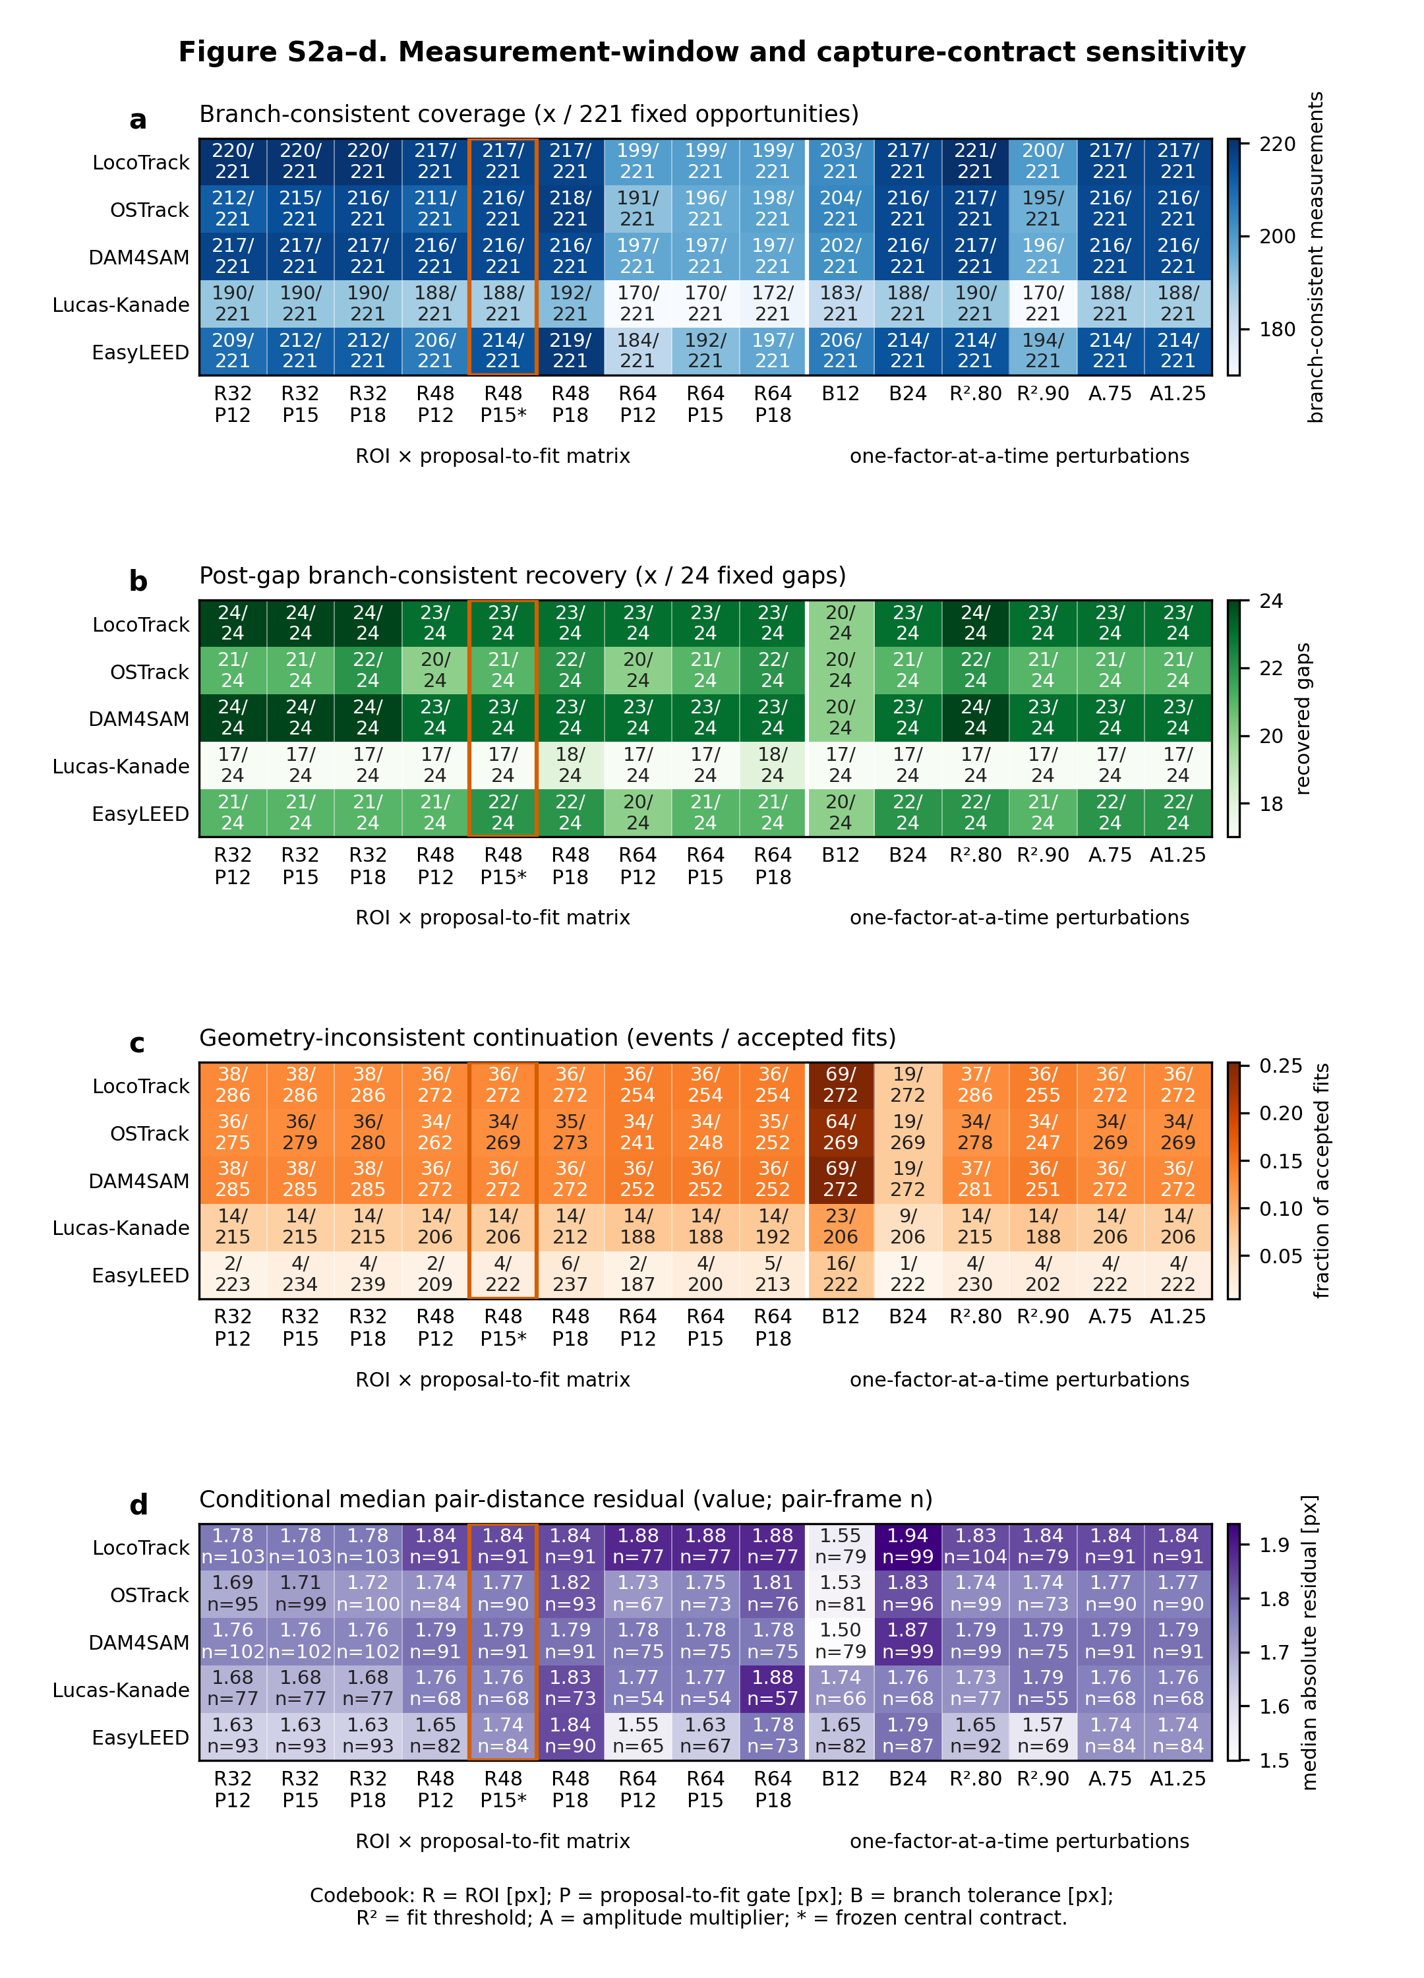
Figure S2. Panels a–d show the nine-element ROI × proposal-to-fit matrix and six one-factor-at-a-time perturbations for coverage, recovery, geometry inconsistency, and conditional pair-distance residual. Panel e shows the signed fifth-percentile central-contract margin for every acceptance gate, with negative counts and finite-margin n; its color uses the frozen gate-specific normalizer and is clipped only for display. Panel f shows the predefined per-method width-trigger thresholds and the validated decision not to run the conditional width sweep. The orange outline and asterisk mark the frozen central contract (48 px ROI and 15 px proposal-to-fit gate). The figure is descriptive and does not select a new central configuration.
Figure S2 remains one numbered display item with one caption. Its a–d and

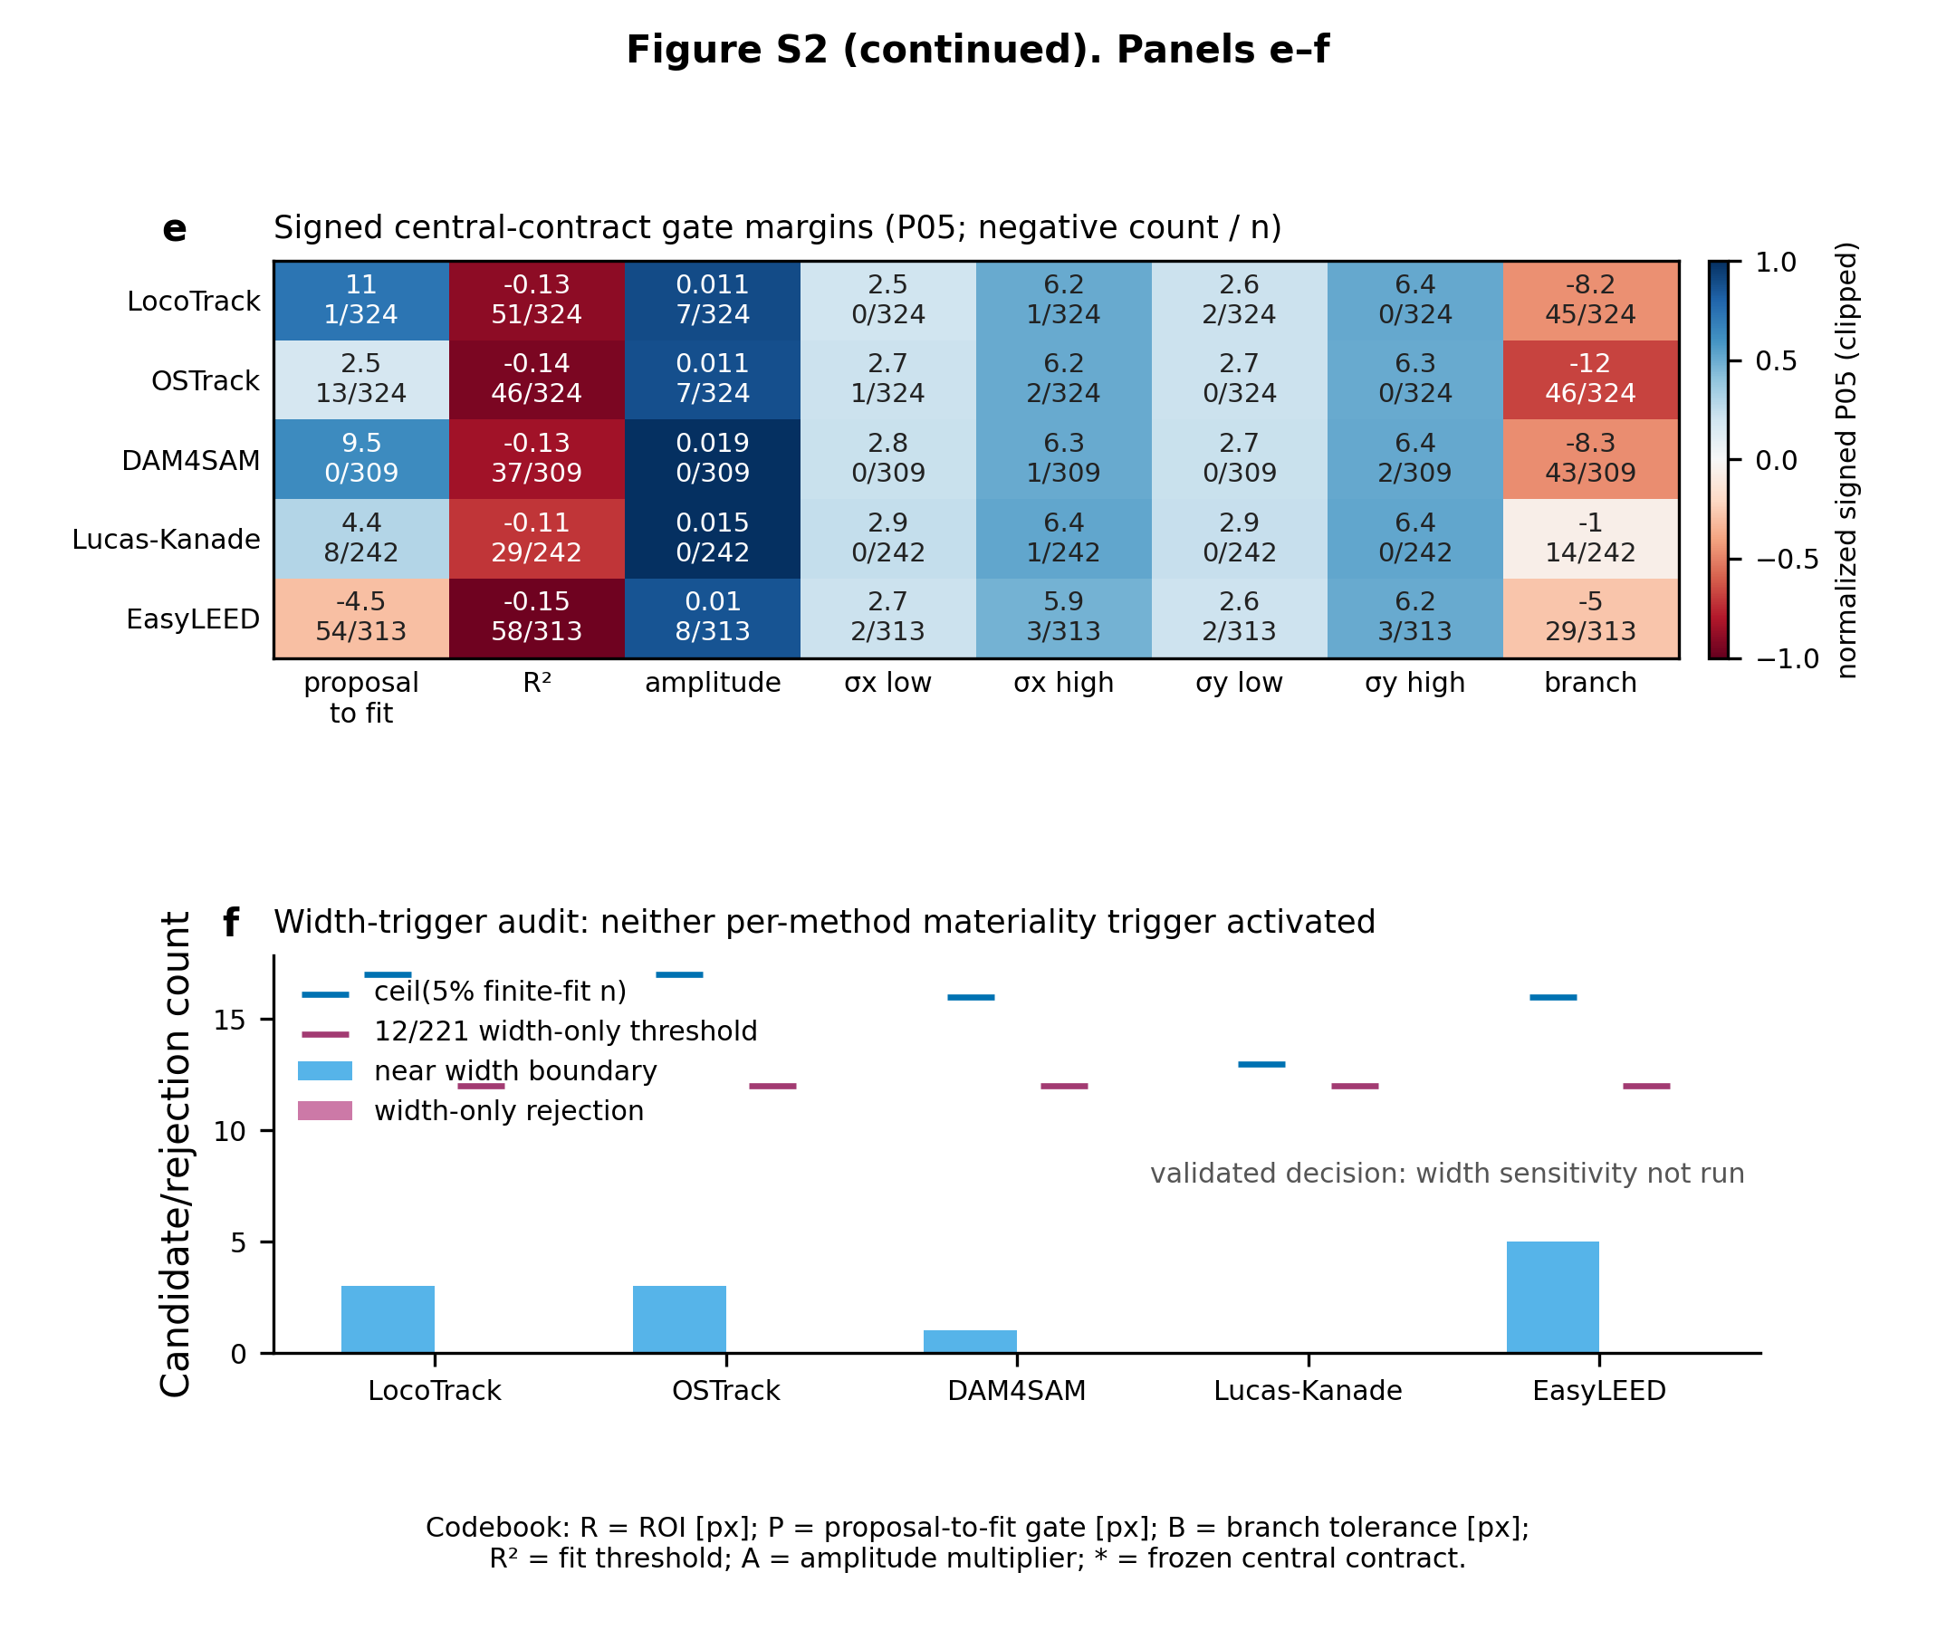
Figure S2 (continued).

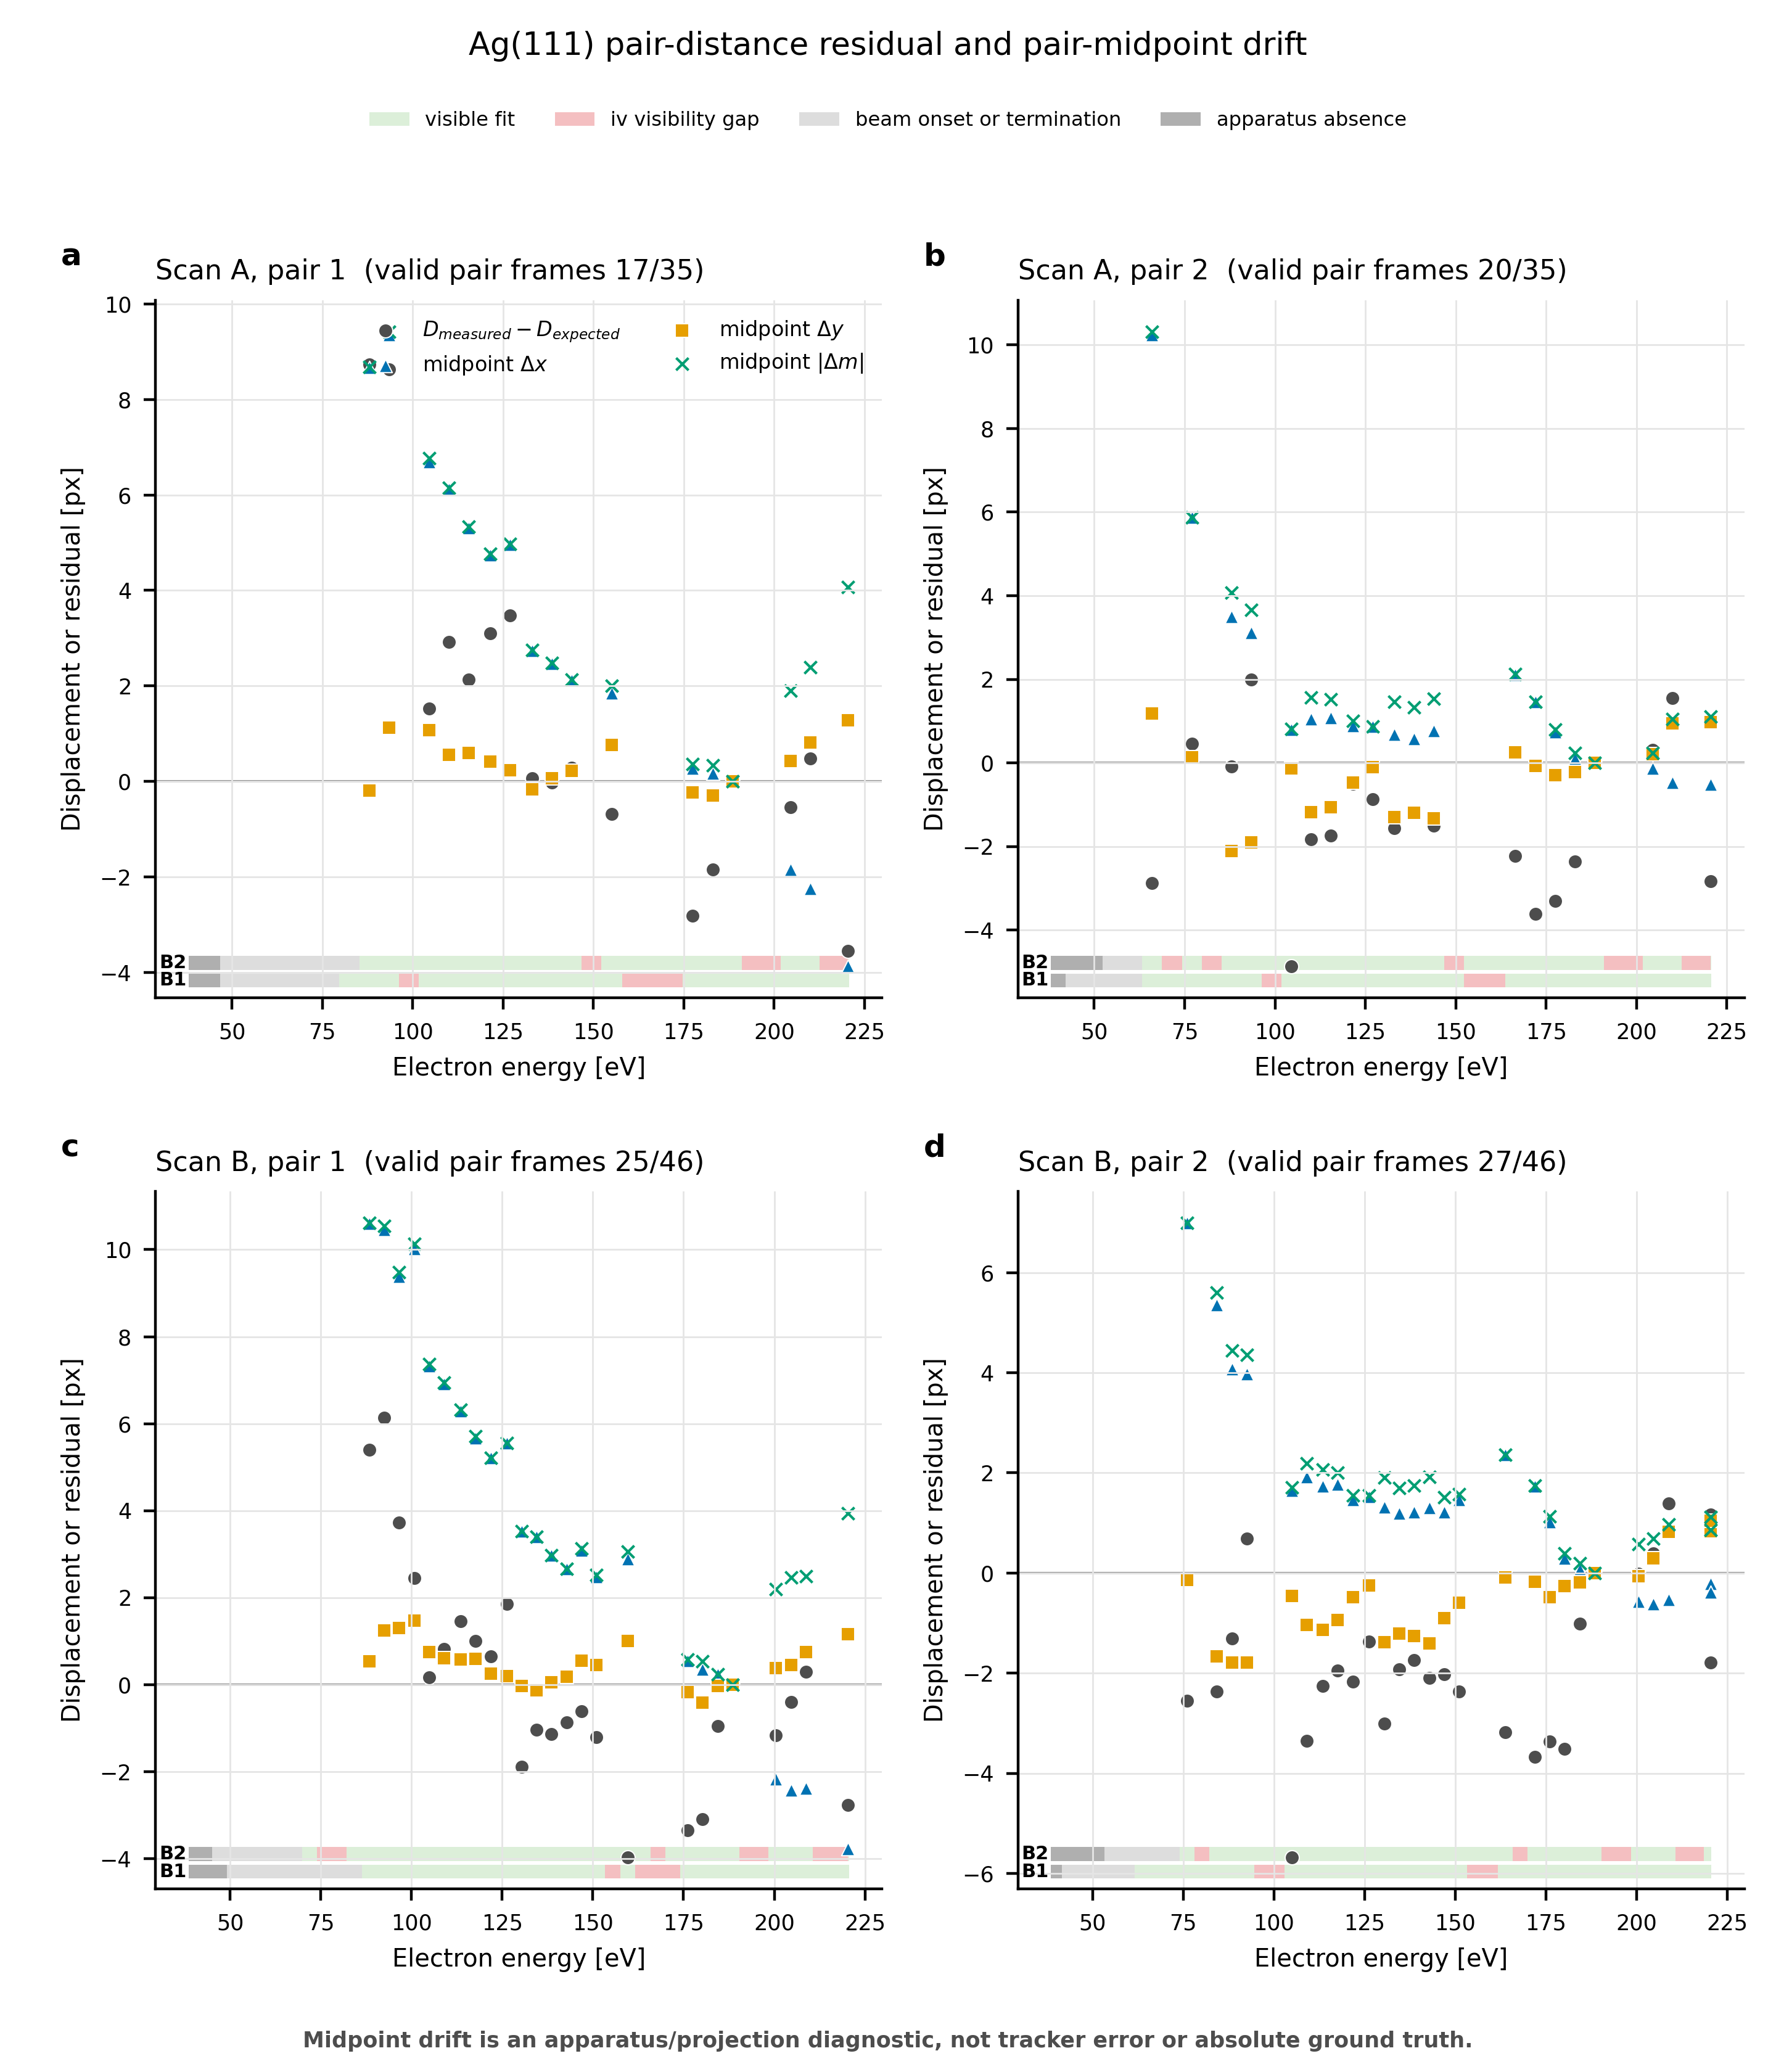
Figure S3. a–d, Pair-distance residual relative to the frozen radial law and pair-midpoint displacement for Scan A pair 1, Scan A pair 2, Scan B pair 1 and Scan B pair 2, respectively. Colored B1/B2 ribbons retain apparatus absence, beam onset/termination, baseline-visible and true I(V)-gap regimes. Midpoint motion is an apparatus/projection nuisance diagnostic kept separate from the translation-invariant pair-distance outcome; it is not absorbed into tracker error and does not turn the radial law into absolute position ground truth.

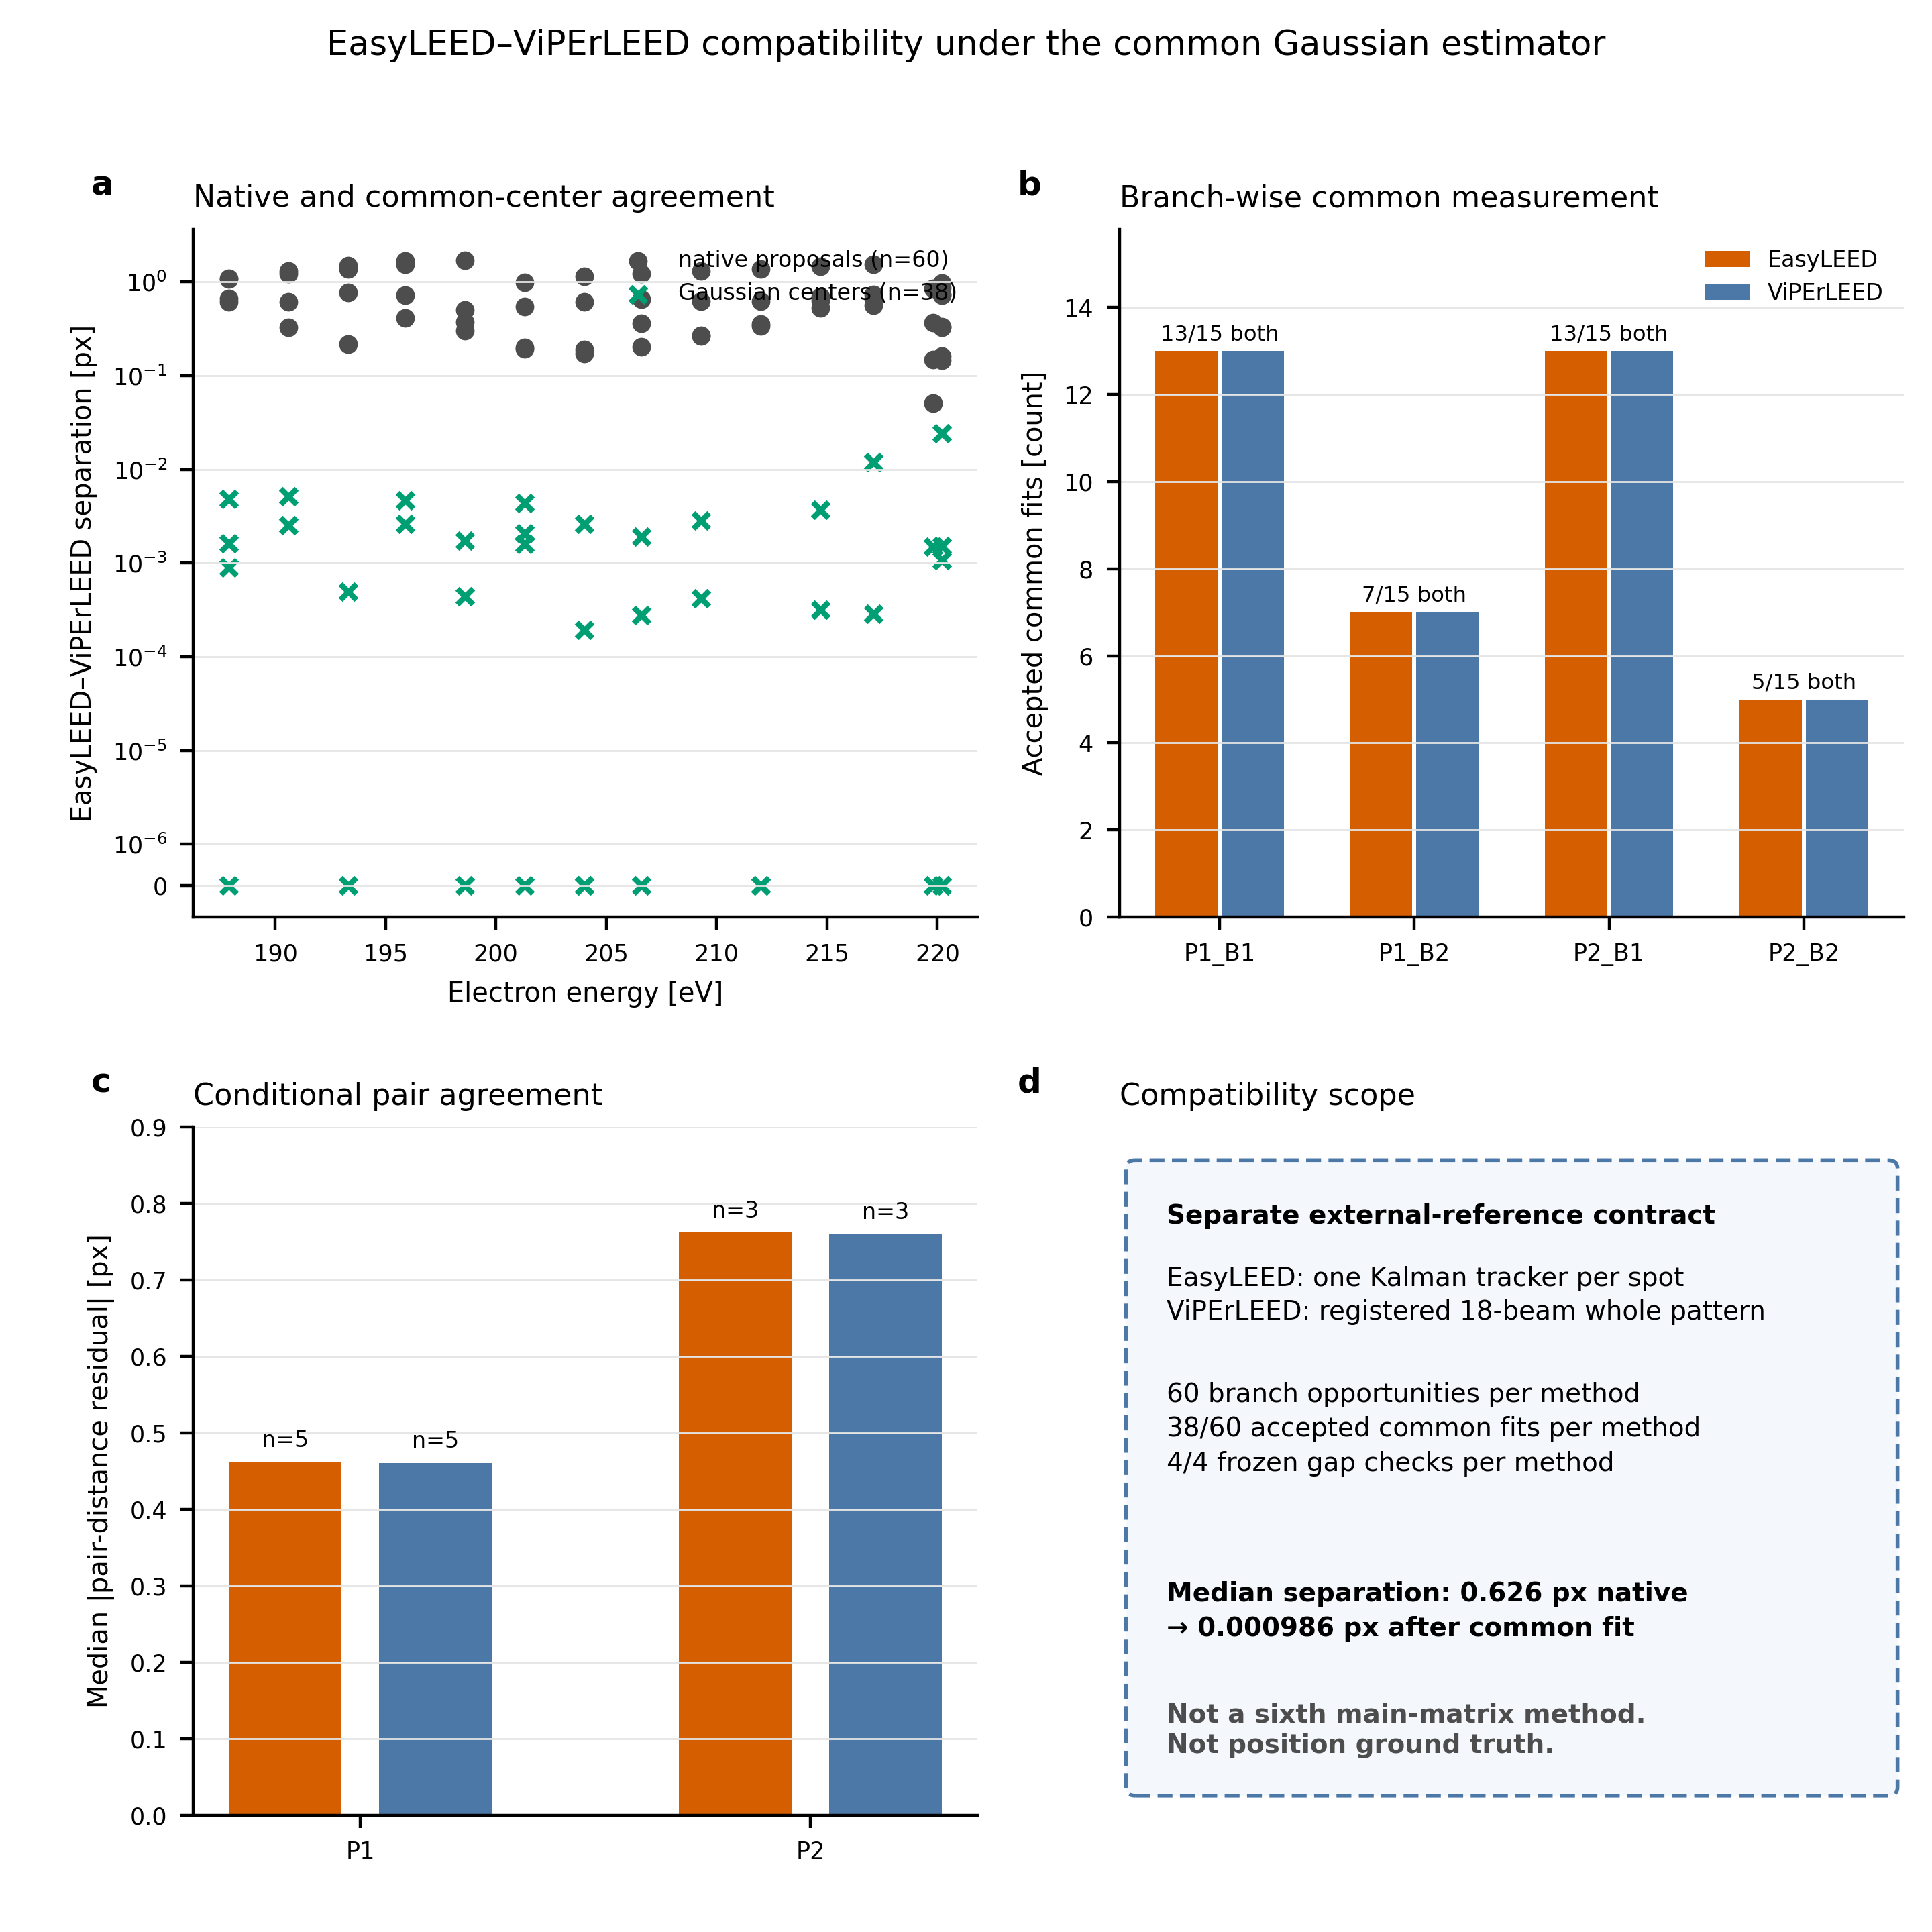
Figure S4. a, EasyLEED–ViPErLEED separation before and after common Gaussian refinement for matched branch/frame records. b, Accepted common fits for the four branches, each over 15 images. c, Conditional median absolute pair-distance residual with n=5 for P1 and n=3 for P2. d, Initialization, denominator and interpretation contract. ViPErLEED is not a sixth method in the main five-strategy matrix, and neither method supplies position or identity ground truth.
The source package is a byte-identical freeze of the completed high-energy compatibility artifact plus a normalized contract and hash provenance.

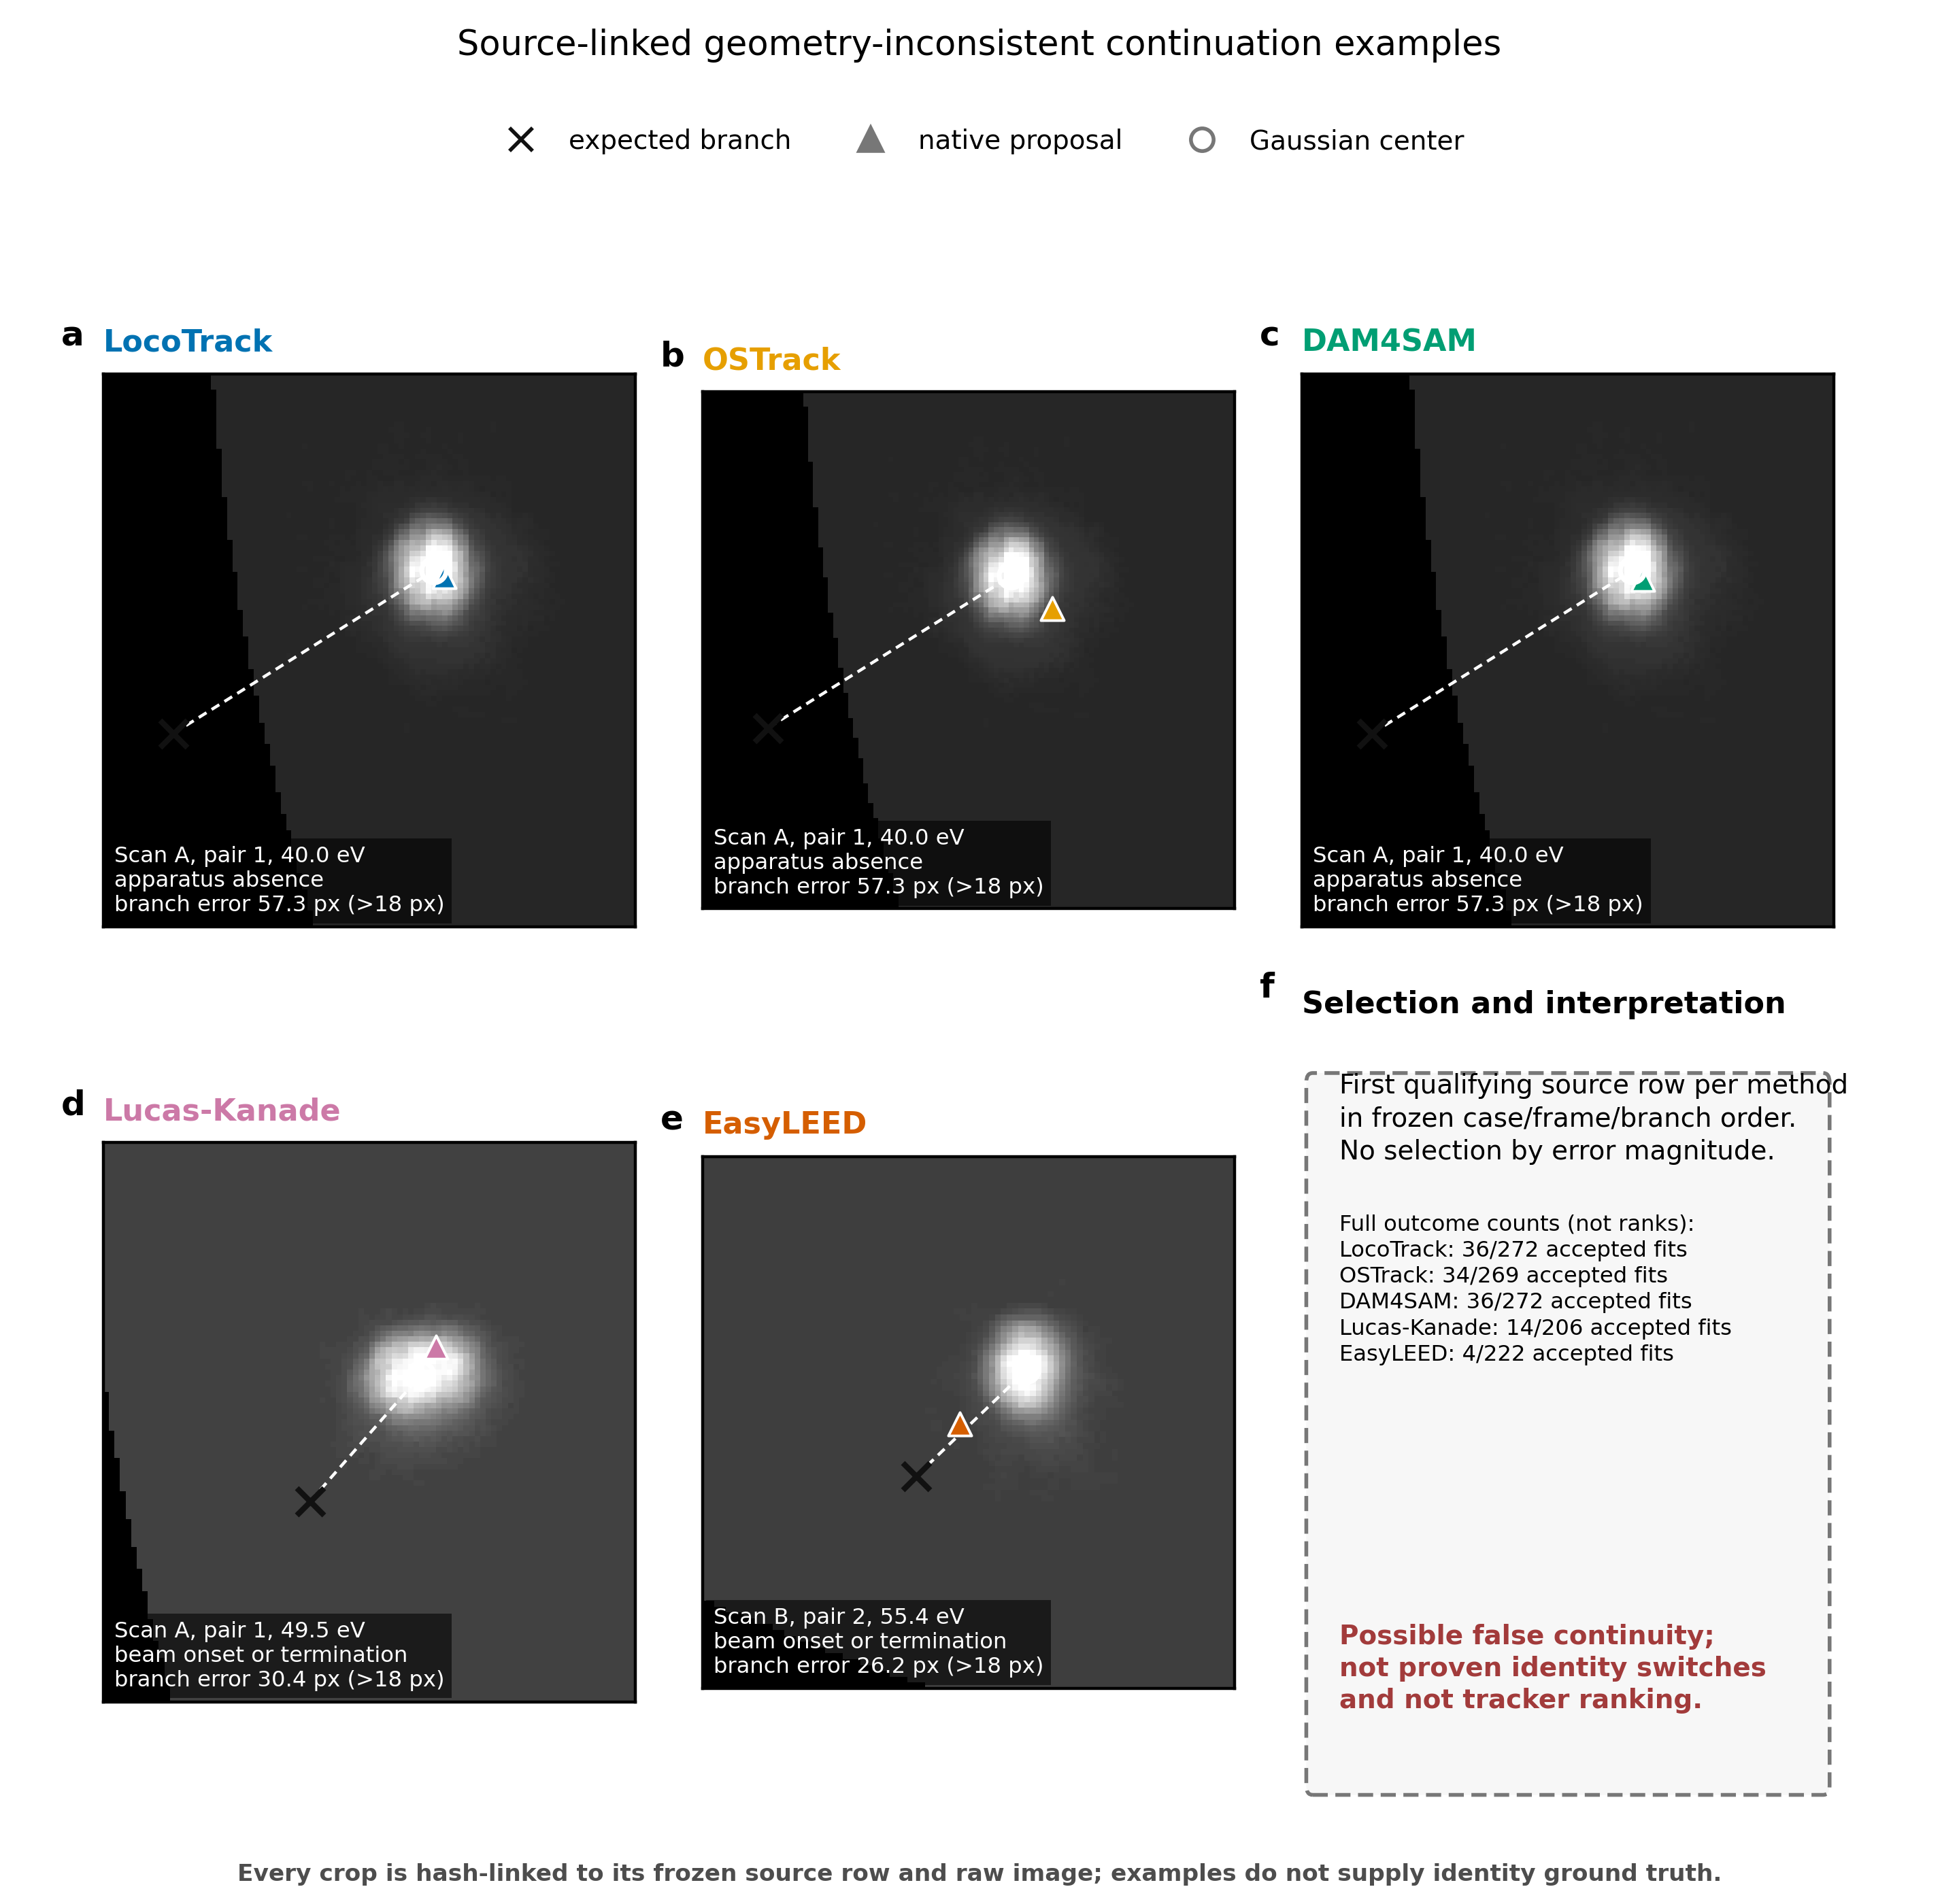
Figure S5. a–e, LocoTrack, OSTrack, DAM4SAM, Lucas–Kanade and EasyLEED examples, respectively. The black cross is the frozen expected branch coordinate, the colored triangle is the native tracking proposal, and the white circle is the accepted common Gaussian center. f, Selection rule and the full method-specific geometry-inconsistent/accepted-fit counts. The examples are operational evidence of possible false continuity. They are not externally proven identity switches, do not constitute a ranking and are not selected to maximize a method’s branch error.

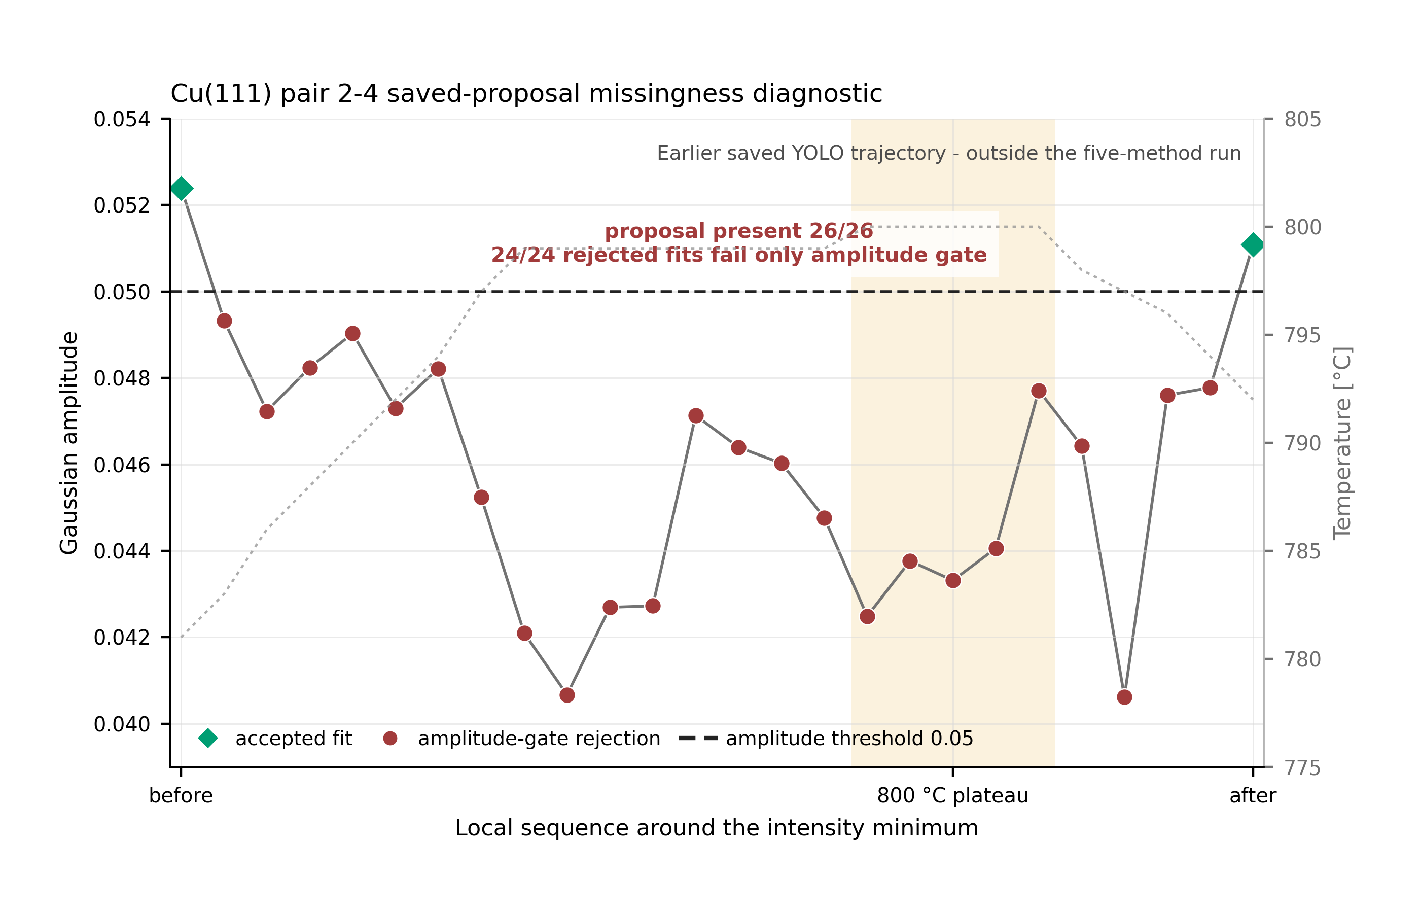
Figure S6. A saved Cu(111) pair 2-4 proposal can remain available while the common quantitative position measurement is rejected. Gaussian amplitude and the fixed acceptance threshold are shown across the 26-image context around the 800 °C plateau; accepted endpoints bracket 24 consecutive rejected fits. All rejected candidates pass the R^2, center, and width gates and fail only the uncalibrated amplitude gate. The grey dotted curve gives temperature context. This diagnostic uses an earlier saved YOLO proposal trajectory outside the frozen five-method run. It supports only the distinction between proposal availability and quantitative-measurement availability; it does not show identity loss, compare the five methods on spots 2 and 4, or define a physical LEED I(V) observable.

