Continuity is not consistency: Cross-contract observability in LEED spot measurement chains
  - Scientific draft - not submission-ready

Abstract
Continuous tracker output is useful for quantitative low-energy electron diffraction only when the associated measurement remains observable and physically consistent. We asked whether those properties were stable across a local TrackLEED Gaussian measurement contract and an external native whole-pattern ViPErLEED contract. Two principal energy scans supplied 324 predeclared branch-frame opportunities per method. All opportunities were retained. Every method produced more ViPErLEED-only than Gaussian-only states (43-100 versus 0-10), while the contracts yielded 114 Gaussian-contract gaps and two ViPEr-native visibility gaps. Among 124 accepted Gaussian out-of-branch continuations, native evidence classified 83 as branch-model disagreement, 16 as Cross-contract target inconsistency, and 25 as Unresolved cross-contract outcomes. Fixed branch-consistent coverage used 221 reference opportunities per method, whereas conditional out-of-branch fractions used 206-272 accepted Gaussian fits. Neither contract was treated as visibility, position, or spot-identity ground truth. These results show that continuity alone is insufficient: measurement-chain robustness requires a cross-contract, denominator-aware assessment of observability and failure semantics.
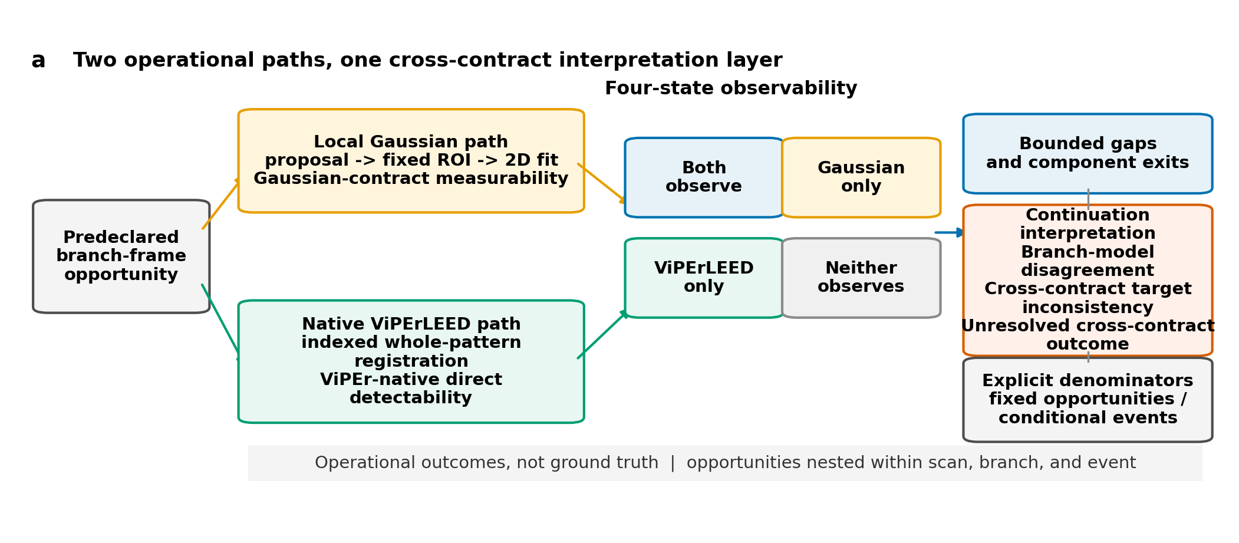
Figure 1. Two predeclared operational paths evaluate each branch-frame opportunity: local proposal-to-Gaussian refinement and native indexed whole-pattern detection. Their four-state outcome layer supports contract-specific gap and continuation interpretation with explicit denominators; neither path is position, visibility, or spot-identity ground truth.

1. Introduction
Figure 1 summarizes the two measurement contracts and their interpretation boundary.

1.1 Measurement continuity is not a physical conclusion
Low-energy electron diffraction (LEED) derives surface-structure information from energy-dependent diffraction patterns. Quantitative analysis commonly uses the intensity of indexed beams as a function of incident energy, but spot position, shape, and pair geometry are also informative image-derived quantities (Pendry 1974; Mayer et al. 2012; Schmid et al. 2025). Each quantity depends on an association between a target diffraction spot and the pixels from which the measurement is obtained. When a pattern moves, contracts, or changes intensity, a continuous coordinate sequence can preserve that association, lose it, or continue through frames in which the intended spot is not directly measurable.
This distinction separates tracking continuity from measurement validity. A tracker can return coordinates in every frame even if the local image no longer supports an accepted measurement. Conversely, a native whole-pattern method can directly detect an indexed beam when a local proposal-to-Gaussian pathway rejects its fit. A smooth trajectory is therefore not itself evidence that the intended spot remained observable, and a missing local result is not itself evidence that the diffraction feature physically disappeared. Both statements depend on the measurement contract that converts an image and a tracking output into an operational state.

The problem is especially important in an energy scan. Reciprocal-space geometry predicts an approximately radial contraction of a LEED pattern as electron energy increases, while intensity variations can make individual beams weak or temporarily undetectable. A local measurement chain may use a proposal to place a small region of interest and then refine a spot center. A whole-pattern chain can instead identify the indexed lattice, register the pattern, and estimate the native beam position from information distributed across the screen. Both pathways are scientifically meaningful, but they do not have interchangeable endpoints. Their agreement or disagreement must be reported without elevating either endpoint to an unobserved ground truth.

1.2 Two established LEED pathways create a cross-contract question
EasyLEED and ViPErLEED demonstrate that automated LEED spot association, energy-aware motion models, and quantitative image extraction have established precedents. EasyLEED combines an energy-informed Kalman prediction with local image measurement for individually initialized spots (Mayer et al. 2012). ViPErLEED-ImageJ registers an indexed diffraction pattern using reciprocal lattice geometry, energy scaling, aperture measurements, and local pattern corrections to support native beam tracking and I(V) extraction (Schmid et al. 2025). The present work does not claim to invent LEED spot tracking, radial scaling, aperture measurement, or gap bridging.
Their different architectures motivate the present comparison. Within the local TrackLEED Gaussian contract, EasyLEED is one of five proposal sources. Its saved state indicates where the common local region should be measured; the reported endpoint is the finite Gaussian-refined spot position that passes the same frozen acceptance gates used for the other four proposal methods. In contrast, ViPErLEED is retained as an external indexed whole-pattern measurement contract. Its native significance and raw beam-position deviations are evaluated directly and are not passed through the TrackLEED Gaussian estimator. ViPErLEED is therefore neither a sixth equivalent tracker in the local comparison nor a ground-truth label for it.
General-purpose methods can still probe the proposal side of the local chain. The tested set comprises point correspondence, bounding-box tracking, mask-based propagation, classical optical flow, and EasyLEED’s physics-informed state estimate (Cho et al. 2024; Ye et al. 2022; Videnovic et al. 2025; Lucas and Kanade 1981). Their native outputs differ, but each is reduced to the same limited role: placing a local measurement region. This design avoids ranking heterogeneous native coordinate conventions as if they were commensurate position measurements. It instead asks whether complete measurement chains preserve the availability and physical consistency needed for quantitative use.
Most tracking evaluations condition error on successful output. Such a surviving set can hide the cases that matter most to measurement robustness. Coverage can fall while conditional residuals appear stable; a local fit can remain accepted while its position departs from a predeclared physical branch; and a method can return after a bounded gap without establishing that the same spot identity was recovered. These outcomes require different denominators. Fixed opportunities are needed for coverage, event-specific components for gap exits, accepted fits for conditional continuation fractions, and direct native observations for cross-contract positional interpretation. Pooling frames, branches, methods, or contracts as independent experimental replicates would erase that structure.

1.3 Objective and bounded contribution
We ask whether LEED spot measurability, bounded gap recovery, and physical consistency remain stable across the local Gaussian and native ViPErLEED measurement contracts. The analysis retains every predeclared branch-frame opportunity, assigns four joint observability states, compares bounded gap events within their method, scan, and branch nesting, and uses direct native evidence to interpret accepted local continuations outside a frozen radial branch model. A limited predeclared threshold and positional-tolerance grid tests whether the conclusions depend on one nominal setting.
The contribution is a cross-contract, denominator-aware assessment of failure semantics in LEED spot-tracking measurement chains. It is not a universal tracker ranking and not a claim of absolute tracking accuracy. The principal result is that observability and gap attribution depend strongly on the measurement contract, while a continuous accepted local output can represent branch-model disagreement, Cross-contract target inconsistency, or an Unresolved cross-contract outcome. This framing turns continuity from a presumed success criterion into one input to an explicitly qualified physical interpretation.
Supplementary Information Figure S1, Figure S2, Table S1, and Table S2 document calibration and sensitivity checks.

2. Methods

2.1 Acquisition-closed study design and opportunity set
The study used existing-acquisition-only evidence from two principal energy scans. No new LEED acquisition, detector calibration, sample preparation, or instrument measurement was introduced for this analysis. The first scan contained 35 retained source frames and the second contained 46. Four predeclared radial branches were mapped in each frame, giving 4 x (35 + 46) = 324 branch-frame opportunities. The opportunity key joined scan, source frame, energy, and mapped branch. Duplicate terminal energies remained separate source frames rather than being collapsed.
Five local proposal methods were evaluated at every opportunity: EasyLEED, LocoTrack, OSTrack, DAM4SAM, and Lucas-Kanade optical flow. This produced 1,620 method-opportunity rows. The native ViPErLEED state belonged to the mapped indexed branch at the same scan, source frame, and energy and was reused across the five method strata; it was not counted as five independent native observations. Opportunities were nested within scan and branch, and bounded gap events added a further nesting level. All counts are consequently descriptive within these strata. Frames, branches, methods, and the two contracts applied to the same acquisition are not experimental replicates.
The existing scientific panel supplied the frozen local candidate and evaluation records. The native principal-scan package supplied the immutable ViPErLEED exports and their lossless four-branch reduction. Both packages were joined one-to-one under a contract committed before the cross-contract counts were computed. Missing, rejected, subthreshold, inferred, and edge observations remained in the matrix. No opportunity was removed because one pathway lacked an accepted result.
TODO[EXPERIMENT] Supply and approve the complete experimental description.
This placeholder is limited to author-approved sample, instrument, preparation, and acquisition reporting. It does not authorize changes to the frozen opportunity set, measurement contracts, analysis thresholds, or result denominators.

2.2 Local Gaussian measurement contract
Each local method first produced a tracking proposal in its native representation. LocoTrack supplied a propagated point, OSTrack a tracked box, DAM4SAM a propagated mask, Lucas-Kanade an optical-flow displacement, and EasyLEED an energy-informed state estimate. Frozen adapters converted those outputs into a location for a common local measurement region. The adapters did not redefine a method’s native output as the reported physical position.
The selected raw-image region entered the same two-dimensional Gaussian spot estimator for all five methods. A record satisfied Gaussian-contract measurability (G=1) only when the estimator returned a finite Gaussian-refined spot position and every frozen local acceptance gate passed. The state is an operational endpoint of the complete proposal, region, fit, and acceptance pathway. It is not physical visibility, native tracker success, or absolute position accuracy. A rejected fit was retained as G=0; deliberate tracker abstention was not inferred from rejection alone.
Physical branch consistency was evaluated separately from measurability. The local physics baseline defined reference-visible opportunities and an allowed radial branch. An accepted Gaussian position could therefore be measurable yet classified as out of branch. This separation prevents coverage and physical consistency from being combined into one generic score. It also preserves the possibility that a simplified radial model and an independently observed native target disagree for reasons that do not imply loss of spot identity.

2.3 Native whole-pattern ViPErLEED measurement contract
The external contract used ViPErLEED-ImageJ 1.03 through its native indexed whole-pattern pathway. A restricted pilot froze the pattern, screen geometry, beam mapping, mask, and tracking settings before the principal native outcomes were available. The final pilot screen fit was transferred unchanged to each principal scan. The pilot served as calibration evidence and was not treated as an independent confirmation dataset.
The full native exports retained 18 indexed beams across all frames. Four preregistered branches were reduced without loss for the cross-contract join. A mapped beam satisfied ViPEr-native direct detectability (V=1) only when its native significance met the nominal threshold of 2.5 and both raw position deviations were finite. A smoothed, extrapolated, or final native coordinate alone did not qualify. All 19 non-direct branch observations were retained among the 324 opportunities, even where a final native position was available.
Native raw deviations were transformed through the declared coordinate alignment to obtain the mapped direct target used for cross-contract distance. The native output was not cropped into a local region and was not refitted by the TrackLEED Gaussian estimator. This preserves the scientific contrast: local evidence depends on a proposal-specific region and accepted local image fit, whereas native evidence depends on indexed pattern registration and a direct beam observation. Neither endpoint supplies absolute position or spot-identity ground truth.

2.4 Four-state observability and denominator rules
For every method-opportunity row, the binary contract states defined four mutually exclusive outcomes: both contracts observe (G=1, V=1), Gaussian only (G=1, V=0), ViPErLEED only (G=0, V=1), and neither contract observes (G=0, V=0). Each method retained the fixed denominator of 324. Counts were reported separately by method because the five local proposal pathways are strata applied to the same acquisitions, not independent repetitions that can be pooled into a denominator of 1,620.
Three additional denominators answer different questions. First, branch-consistent measurement coverage uses the fixed set of 221 physics-baseline-visible opportunities for each method. Its numerator is the number with an accepted Gaussian measurement on the predeclared radial branch. Second, the all-frame conditional out-of-branch fraction uses all accepted Gaussian fits for the method, which ranges from 206 to 272, as its denominator; its numerator is the accepted out-of-branch count. Third, continuation classification is conditional on the 124 accepted out-of-branch events across method strata, not on all 324 opportunities and not on the fixed set of 221.
Percentages are reported only after these numerators and denominators are named. Fixed coverage and conditional continuation fractions are not summed, averaged, or treated as components of a composite method score. A method can have high fixed branch-consistent coverage while also contributing more accepted out-of-branch events because it returns more accepted fits overall. The two quantities describe different properties of the measurement chain.

2.5 Bounded gaps and comparison components
A Gaussian-contract gap was a maximal contiguous run of G=0 for one method, scan, and branch, bounded immediately before and after by G=1 for the same stratum. A ViPEr-native visibility gap was the corresponding maximal bounded run of V=0 for one indexed beam within one scan, with direct native detections on both sides. Runs reaching an edge without both boundaries were retained as non-direct observations but were not relabeled as bounded gaps. Neither gap definition establishes physical disappearance or an estimator-independent I(V) visibility gap.
Gap intervals from the two contracts were compared separately within each method, scan, and branch. Overlapping closed intervals were joined into a comparison component. A component was Gaussian-only, ViPErLEED-only, or shared according to the contracts represented. Exact boundary agreement required one gap from each contract with identical first and last gap frames. At the first frame after each component, the analysis recorded whether each contract observed. This quantity is described as joint observation at component exit, not proven recovery of physical spot identity.

2.6 Interpreting accepted out-of-branch continuations
An accepted local fit outside the predeclared radial branch was retained as an accepted out-of-branch event. If the mapped indexed beam had a direct native observation, the aligned Gaussian-to-native distance determined one of two interpretations at the nominal positional tolerance of 1.0 px. A distance at or below tolerance was branch-model disagreement: the local measurement departed from the simplified branch model but remained consistent with the direct native target. A distance above tolerance was Cross-contract target inconsistency. Such inconsistency is compatible with possible false persistence, but it does not prove a ground-truth identity switch, a local tracking error, or a native failure.
An event without the required direct native observation was retained as an Unresolved cross-contract outcome. A final or smoothed native position did not resolve it. Unresolved cross-contract outcomes were neither assigned to branch-model disagreement nor Cross-contract target inconsistency, and were not removed from the conditional denominator. These rules separate lack of direct evidence from evidence of positional disagreement.

2.7 Predeclared sensitivity and reporting
The nominal analysis used native significance 2.5 and positional tolerance 1.0 px. A limited Cartesian sensitivity grid used significance thresholds 2.0, 2.5, and 3.0 and tolerances 0.5, 1.0, and 2.0 px. All nine variants were reported for all five method strata, producing 45 method-variant rows. No variant was selected, and the grid was not used to optimize a method ranking.
All analyses were descriptive. The nested opportunities and comparison components do not support treating row counts as independent sample size for hypothesis tests. We therefore report exact counts, explicit fixed or conditional denominators, and bounded sensitivity ranges rather than pooled confidence intervals or significance tests. Machine-readable per-opportunity records, configurations, and hashes remain repository artifacts rather than reader-facing main-text displays.

3. Results

3.1 Observability differed across measurement contracts
Figure 2 shows the observability states and bounded-gap components.
The native contract directly detected 305 of 324 mapped branch opportunities and retained 19 non-direct states. The local measurable count varied with the proposal method: 222 for EasyLEED, 272 for LocoTrack, 269 for OSTrack, 272 for DAM4SAM, and 206 for Lucas-Kanade. Combining these states showed a consistent directional asymmetry. Every method contained more ViPErLEED-only than Gaussian-only opportunities.
For EasyLEED, the both/Gaussian-only/ViPErLEED-only/neither counts were 222/0/83/19. The corresponding counts were 262/10/43/9 for LocoTrack, 259/10/46/9 for OSTrack, 262/10/43/9 for DAM4SAM, and 205/1/100/18 for Lucas-Kanade. Each four-number set sums to the fixed denominator of 324. The five method rows were not pooled because the shared native state and common acquisitions would make a pooled 1,620-row percentage appear more independent than the design permits.
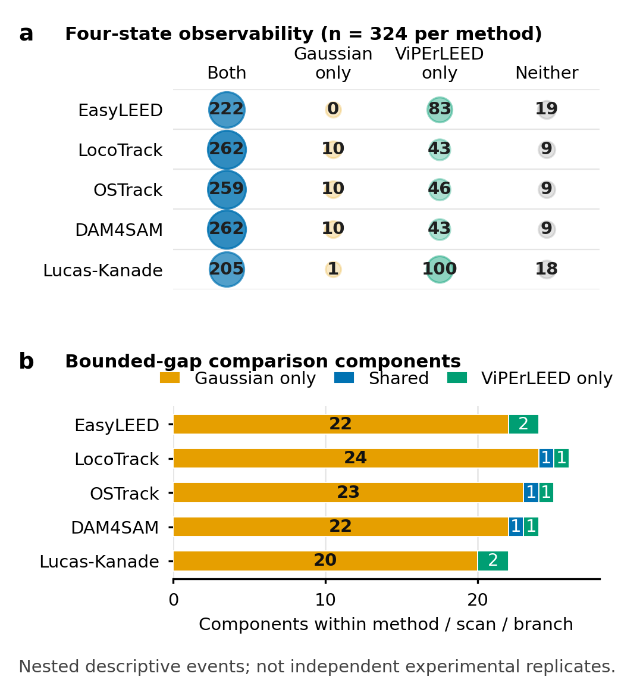
Figure 2. Cross-contract observability and bounded-gap comparison. Each measurability row retains 324 fixed opportunities per method. Gap bars count overlap-connected components formed within method, scan, and branch; these nested descriptive events are not independent experimental replicates.

3.2 Bounded gap attribution was strongly contract specific
The local chains produced 114 Gaussian-contract gaps: 22 for EasyLEED, 25 for LocoTrack, 24 for OSTrack, 23 for DAM4SAM, and 20 for Lucas-Kanade. The native contract produced two ViPEr-native visibility gaps. Other native non-direct states occurred at unbounded edges or runs and remained explicit without being promoted to bounded events.
Comparison within method, scan, and branch yielded 121 overlap-connected components. Of these, 111 were Gaussian-only, seven were ViPErLEED-only, and three were shared. All three shared components contained one gap from each contract with exactly matching boundaries. The component counts are larger than the 114 local gap count because the two native intervals are compared separately within each method stratum, and overlap connectivity can partition or combine the represented intervals according to their boundaries. They are descriptive event components, not 121 independent experiments.
Both contracts observed at the first frame after 118 of 121 comparison components. The method-stratified values were 23/24 for EasyLEED, 26/26 for LocoTrack, 24/25 for OSTrack, 24/24 for DAM4SAM, and 21/22 for Lucas-Kanade. The three non-joint exits remained in the denominator. This high frequency of joint observation at component exit does not make the gap definitions equivalent: most components contained a gap from only one contract.

3.3 Continuous accepted output separated into three interpretations
Figure 3 shows the conditional continuation classifications.
Across method strata, 124 accepted Gaussian fits were outside the predeclared radial branch. Direct native evidence classified 83 as branch-model disagreement. In these events, the Gaussian measurement differed from the simplified radial model but remained within 1.0 px of the mapped direct native target. Sixteen events met the definition of Cross-contract target inconsistency because the aligned direct targets differed by more than 1.0 px. The remaining 25 were Unresolved cross-contract outcomes because no direct native observation was available.
The method-specific conditional denominators were 4, 36, 34, 36, and 14 for EasyLEED, LocoTrack, OSTrack, DAM4SAM, and Lucas-Kanade, respectively. EasyLEED contributed 4/0/0 branch-model disagreement/Cross-contract target inconsistency/Unresolved cross-contract outcome events; LocoTrack 23/5/8; OSTrack 21/5/8; DAM4SAM 23/5/8; and Lucas-Kanade 12/1/1. These values sum within method to its accepted out-of-branch denominator and across methods to 83/16/25.
This split changes the meaning of continuity. The 83 branch-model disagreements show that leaving the predeclared radial branch does not necessarily imply disagreement with the independently mapped native target. The 16 Cross-contract target inconsistencies provide evidence of contract-level positional disagreement and are compatible with possible false persistence, but neither contract can establish which target represents ground-truth identity. The 25 Unresolved cross-contract outcomes support neither interpretation. Retaining them prevents missing direct evidence from being silently converted into agreement or failure.
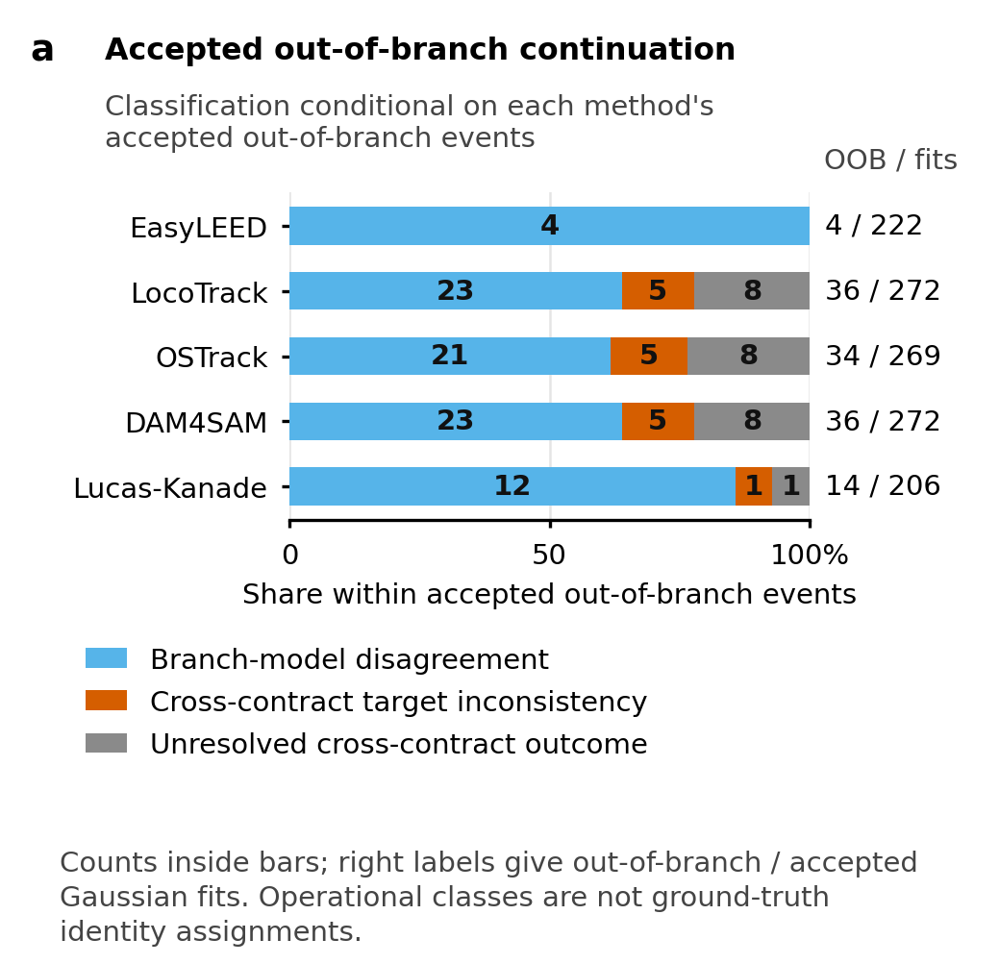
Figure 3. Interpretation of accepted Gaussian out-of-branch continuations. Each method-specific bar is conditional on its accepted out-of-branch events (4, 36, 34, 36, and 14), not on all 324 opportunities or the fixed 221 reference-visible set. Cross-contract target inconsistency is not proof of a ground-truth identity switch, and events without direct native evidence remain Unresolved cross-contract outcomes.

3.4 Fixed coverage and conditional continuation answer different questions
Branch-consistent measurement coverage used 221 fixed physics-baseline-visible opportunities per method. The numerators were 214 for EasyLEED, 217 for LocoTrack, 216 for OSTrack, 216 for DAM4SAM, and 188 for Lucas-Kanade. These correspond to 96.8%, 98.2%, 97.7%, 97.7%, and 85.1% after the common denominator has been stated. The result describes how often each local chain produced an accepted position on the predeclared branch within the fixed reference set.
The all-frame conditional out-of-branch fraction used a different denominator: all accepted Gaussian fits for the method. The counts were 4/222 (1.8%) for EasyLEED, 36/272 (13.2%) for LocoTrack, 34/269 (12.6%) for OSTrack, 36/272 (13.2%) for DAM4SAM, and 14/206 (6.8%) for Lucas-Kanade. These conditional fractions cannot replace fixed coverage. In particular, a method can have a larger conditional numerator because it retained more accepted fits, while another method can have a smaller numerator partly because fewer fits survived the local contract. The measurements do not support collapsing the two outcomes into a universal score.

3.5 Limited sensitivity preserved observability but bounded interpretation
All nine predeclared combinations of native significance and positional tolerance reproduced the nominal four-state observability counts. Changing the native threshold over 2.0-3.0 did not change those method totals within the tested data. The central conclusion that observability differed between the two contracts therefore did not depend on selecting one favorable variant.
Positional tolerance did affect how direct out-of-branch events were interpreted. EasyLEED remained fixed at four branch-model disagreements and zero Cross-contract target inconsistencies. Across variants, the branch-model disagreement and Cross-contract target inconsistency counts ranged from 17-26 and 2-11 for LocoTrack, 15-24 and 2-11 for OSTrack, 17-26 and 2-11 for DAM4SAM, and 7-13 and 0-6 for Lucas-Kanade. The Unresolved cross-contract outcome count remained fixed within each method because tolerance cannot create a direct native observation where none exists.
Thus, the sensitivity grid supports the contract-dependence of observability and the need for three continuation categories. It also bounds the stronger interpretation: the allocation between branch-model disagreement and Cross-contract target inconsistency depends on the declared tolerance. The grid is not a complete capture-basin analysis, parameter optimization, or basis for choosing a preferred method.

4. Discussion

4.1 Observability belongs to a measurement chain
The dominant result is not that one contract found more spots in an intrinsic sense. It is that the operational availability of a LEED spot measurement changed with the pathway used to construct it. The local contract required a method-specific proposal, a valid region, a finite two-dimensional Gaussian fit, and all local acceptance gates. The native contract required an indexed whole-pattern registration, sufficient native significance, and finite raw beam-position deviations. Because those endpoints test different evidence, their four-state disagreement is scientifically expected rather than an error to be averaged away.
The large number of ViPErLEED-only states illustrates this point. Whole-pattern registration can retain direct indexed evidence when a local region or fit does not satisfy its acceptance contract. That does not establish physical visibility outside the native definition, and it does not show that the local tracker failed in isolation: proposal placement, image content, fitting, and acceptance all contribute to G=0. Conversely, Gaussian-only states show that the local image model can produce an accepted position when the native direct criterion is not met. They do not validate the local target against an external identity reference.
The gap comparison reinforces the same boundary at an event scale. The local contract produced many more bounded gaps, yet both contracts usually observed at the comparison-component exit. A simple statement that the spot “disappeared and recovered” would conflate operational rejection, direct native detectability, and physical beam intensity. The terms Gaussian-contract gap and ViPEr-native visibility gap preserve which evidence was absent and how the run was bounded. Joint observation at exit records a useful measurement fact without claiming recovery of ground-truth physical identity.

4.2 Native evidence changes the interpretation of continuity
The continuation analysis shows why a returned coordinate cannot be treated as success by default. All 124 events had an accepted Gaussian-refined position, so a local availability-only analysis would retain them as measurements. However, their physical interpretation differed. Most were consistent with a direct native target despite leaving the simplified radial branch. These 83 events identify a branch-model limitation rather than direct cross-contract target disagreement. Treating every out-of-branch position as tracking failure would therefore overstate what the radial model can decide.
The 16 Cross-contract target inconsistencies are a narrower warning. They identify an accepted local continuation that differs beyond the frozen tolerance from a direct observation of the mapped native beam. The pattern is compatible with possible false persistence because continuity can be maintained on a target inconsistent with the indexed native position. Yet the native contract is not spot-identity ground truth, so the evidence cannot prove an identity switch or assign a unique causal failure to the tracker, adapter, local fit, native registration, or coordinate alignment. The appropriate claim is disagreement between complete measurement contracts.
The 25 Unresolved cross-contract outcomes are equally informative for claim discipline. Without a direct native observation, the analysis cannot decide whether the accepted local position agrees with the indexed target. Using a smoothed native coordinate would replace a frozen direct-evidence rule with an inference selected after the event. Dropping the records would make the conditional result appear more complete than the evidence permits. Keeping an explicit Unresolved cross-contract outcome class makes the denominator and epistemic limit visible.

4.3 EasyLEED and ViPErLEED have related but non-equivalent roles
Both EasyLEED and ViPErLEED are prior LEED-domain systems that incorporate energy-dependent pattern behavior. Their appearance in this study does not make them interchangeable. EasyLEED participates in the five-method local comparison because its state estimate is used as a proposal for the common TrackLEED Gaussian measurement. Its outcome therefore includes the shared local fit and acceptance contract. ViPErLEED remains outside that common estimator and supplies the indexed whole-pattern native endpoint.
This relationship is central to the novelty boundary. The work does not introduce LEED-specific tracking, Kalman prediction, aperture-based extraction, whole-pattern registration, or I(V) processing. It also does not claim that preserving native ViPErLEED outputs makes them an absolute reference. The new contribution is the explicit cross-contract join: every predefined opportunity is retained, operational states are compared without forcing a common endpoint, and failure semantics are limited by the evidence each contract can provide.
The five local methods likewise should not be read as a comprehensive tracker benchmark. They span useful proposal representations, but the reported counts belong to the tested scans, adapters, frozen acceptance gates, and existing outputs. Method-specific differences help expose denominator effects and local capture behavior. They do not support a universal best-method claim, and the analysis deliberately computes no composite ranking.

4.4 Denominator discipline prevents incompatible claims
Separating denominators is more than a reporting preference. Fixed branch-consistent coverage asks whether the local chain returned an accepted measurement on the physical branch for each reference-visible opportunity. The all-frame conditional fraction asks how frequently accepted local fits were out of branch. Gap components ask whether bounded absence under one contract overlaps bounded absence under the other. Continuation classification asks what direct native evidence says about a selected set of accepted out-of-branch fits. These are distinct estimands.
Combining them would create several biases. Conditioning every analysis on accepted fits would remove local non-measurability from view. Using 324 as the denominator for the out-of-branch interpretation would mix accepted and unaccepted local states. Using 221 for all-frame continuation would exclude events outside the reference-visible baseline. Pooling five method rows would repeat the same native opportunity and inflate apparent sample size. Treating 121 nested components as independent experiments would ignore their shared scans and branches. The frozen reporting rules prevent each substitution.

4.5 Limitations and scope
The study has no instrument-traceable absolute position reference and no framewise spot-identity ground truth. Cross-contract agreement can support consistency between operational pathways, and branch geometry can support physical self-consistency, but neither establishes absolute accuracy. A direct native beam observation is independent of the local Gaussian endpoint in its measurement construction, not infallible in physical identity.
The evidence is acquisition closed. It covers two existing principal energy scans and four preregistered branches under one frozen local contract and one frozen native contract. The native pilot calibrated settings and therefore cannot serve as independent confirmation. The five local proposal methods do not exhaust possible trackers, and the selected region, fit gates, native threshold, coordinate alignment, and radial baseline bound the results. Different validated contracts could redistribute operational outcomes.
The sensitivity analysis is deliberately narrow. It establishes that the observability counts were stable across the predeclared threshold grid and shows that direct-event interpretation changes with positional tolerance. It does not optimize parameters, map every capture regime, or validate a method ranking. In particular, the nominal count of Cross-contract target inconsistencies should be read together with the sensitivity envelopes and the non-ground-truth limitation.
Complete experimental reporting and bibliography verification remain explicit Authorized deferred publication inputs. Their absence prevents the draft from being submission-ready, but does not license inferred instrument or sample details. The scientific draft is complete only within the frozen cross-contract question, evidence packages, and claim boundary. A later integration step must preserve these constraints when producing journal-formatted editable and rendered documents.

4.6 Implications for measurement-chain evaluation
The framework suggests a general order for evaluating quantitative tracking chains. First define the endpoint produced by each measurement contract. Second retain a fixed opportunity inventory before examining successful outputs. Third separate operational availability from physical-consistency checks. Fourth give each conditional statistic its actual surviving denominator. Finally, preserve an Unresolved cross-contract outcome category wherever the comparison contract lacks direct evidence. These steps make it possible to compare heterogeneous pathways without pretending that their native outputs or errors are commensurate.

5. Conclusions
Across the two principal energy scans, LEED spot observability and gap attribution were not stable across a local Gaussian measurement contract and an external native whole-pattern ViPErLEED contract. Of 121 bounded gap comparison components, 111 contained only Gaussian-contract gaps. These patterns are operational differences between complete pathways, not evidence that either path reveals physical visibility or spot identity as ground truth.
Continuity also did not determine consistency. The 124 accepted Gaussian out-of-branch events separated into 83 branch-model disagreements, 16 Cross-contract target inconsistencies, and 25 Unresolved cross-contract outcomes. The categories remained denominator bound: fixed branch-consistent coverage used 221 reference opportunities per method, conditional out-of-branch fractions used 206-272 accepted fits, and interpretation used only the accepted out-of-branch events. Limited sensitivity preserved the observability result while showing that the split between direct-event interpretations depends on positional tolerance.
The resulting contribution is a cross-contract, denominator-aware assessment of failure semantics in LEED spot-tracking measurement chains. It preserves the established roles of EasyLEED and ViPErLEED, avoids a universal tracker ranking, and keeps cases without direct evidence unresolved. Measurement-chain robustness in this setting therefore requires explicit assessment of both continuity and physical consistency under named operational contracts.

References
Cho, Seokju, Jiahui Huang, Jisu Nam, Honggyu An, Seungryong Kim, and Joon-Young Lee. 2024. “Local All-Pair Correspondence for Point Tracking.” Computer Vision – ECCV 2024 15068: 306–25. https://doi.org/10.1007/978-3-031-72684-2_18.
Lucas, Bruce D., and Takeo Kanade. 1981. “An Iterative Image Registration Technique with an Application to Stereo Vision.” Proceedings of the 7th International Joint Conference on Artificial Intelligence 2: 674–79. https://publications.ri.cmu.edu/an-iterative-image-registration-technique-with-an-application-to-stereo-vision-ijcai.
Mayer, Andreas, Hanna Salopaasi, Katariina Pussi, and Renee D. Diehl. 2012. “A Novel Method for the Extraction of Intensity–Energy Spectra from Low-Energy Electron Diffraction Patterns.” Computer Physics Communications 183 (7): 1443–47. https://doi.org/10.1016/j.cpc.2012.02.019.
Pendry, John B. 1974. Low Energy Electron Diffraction: The Theory and Its Application to Determination of Surface Structure. Academic Press.
Schmid, Michael, Florian Kraushofer, Alexander M. Imre, et al. 2025. “ViPErLEED Package II: Spot Tracking, Extraction, and Processing of I(V) Curves.” Physical Review Research 7 (1): 013006. https://doi.org/10.1103/PhysRevResearch.7.013006.
Videnovic, Jovana, Alan Lukezic, and Matej Kristan. 2025. “A Distractor-Aware Memory for Visual Object Tracking with SAM2.” Proceedings of the IEEE/CVF Conference on Computer Vision and Pattern Recognition, 24255–64. https://openaccess.thecvf.com/content/CVPR2025/html/Videnovic_A_Distractor-Aware_Memory_for_Visual_Object_Tracking_with_SAM2_CVPR_2025_paper.html.
Ye, Botao, Hong Chang, Bingpeng Ma, Shiguang Shan, and Xilin Chen. 2022. “Joint Feature Learning and Relation Modeling for Tracking: A One-Stream Framework.” Computer Vision – ECCV 2022, 341–57. https://doi.org/10.1007/978-3-031-20047-2_20.
The provisional citation keys in this draft resolve to the repository’s existing bibliography and identify established LEED, tracking, and whole-pattern sources. They are not represented as a submission-complete reference list.
TODO[SUBMISSION] Complete and verify the bibliography from primary sources before submission.

