Optimization of Homemade Bioplastic Films
for Flexible Food Wrapping Applications
STAT 403 Final Project Report

Prepared by
Qusai Alahmad Almahmoud 301609805
Raafay Qazi 301555443
Khalid Abdelaziz [SFU ID]
April 10, 2026

1. Introduction
Purpose of the study: Single-use plastic wrappers are a major source of waste in campus food service. This study asks whether a simple cornstarch-based bioplastic, made from grocery-store ingredients in a household microwave, can be formulated to achieve sufficient flexibility for use as a sandwich wrap in a zero-waste cafeteria. Flexibility was chosen as the response because a wrap that cracks when folded is unusable regardless of its strength; it was quantified as elongation at break (cm), measured by stretching a strip of dried film by hand until it snapped and recording the difference between its extended and original length.
Treatment structure: Two factors were investigated, each at two levels. The first factor was the starch-to-water ratio of the base gel, tested at a low level (1:5) and a high level (1:3). The second factor was oil inclusion, tested at a low level (0 tsp, no oil) and a high level (1 tsp canola oil). A base formulation using the intermediate settings recommended in the assignment (1:4 starch-to-water ratio and ½ tsp oil) was also prepared and served as a shared control reference.
Experimental units: The experimental unit is an individual dried film strip, approximately 1 cm wide, cut from a batch of dried bioplastic. Each batch of gel (one treatment) was spread on parchment paper to roughly 2 mm thickness and air-dried for 24 hours; three strips were then cut from the dried film and served as replicates of the treatment applied to that batch.
Randomization structure: The order in which the five batches (base, low starch, high starch, no oil, 1 tsp oil) were prepared on the experimental day was randomized to avoid confounding batch order with treatment. Within each dried batch, the three strips were cut at arbitrary locations on the film and measured in a random order, so that any systematic variation in thickness or drying was distributed across replicates rather than biasing a single observation.
Design considerations: A full 2² factorial with replication would have been the ideal design, because it permits both main effects and the starch × oil interaction to be estimated from a single ANOVA. However, practical constraints a single experimenter, limited parchment, and a 24-hour drying time per batch, made it infeasible to prepare all four factor combinations in this round. Instead, we carried out a partially factorial design in which each factor was varied one at a time around the base recipe: the starch factor was tested with oil fixed at ½ tsp, and the oil factor was tested with starch fixed at 1:4. This corresponds to two completely randomized (CRD) one-factor sub-experiments sharing the base batch as a common reference point. A CRD was appropriate because environmental conditions (16°C ambient, same utensils, same parchment, same microwave) were held constant across all batches on a single day, leaving no meaningful nuisance factors to block on. The cost of this choice is that the starch × oil interaction cannot be formally estimated from our data; Section 3 discusses how it can still be partially assessed and what follow-up would be needed to quantify it rigorously.

2. Pilot Experiment and Sample Size
Before running the full experiment, a pilot batch was prepared using the base recipe (1 tbsp cornstarch, 4 tbsp water, 1 tsp vinegar, ½ tsp canola oil, microwaved in 20 s bursts to 60 s). The purposes of the pilot were limited: to confirm the recipe could be reliably executed, to verify that strips could be cut and measured with a ruler, and to obtain a rough estimate of within-treatment variability for sample size planning. No inferential analysis was conducted on the pilot data.
Three strips from the pilot gave elongations of 0.00, 0.15, and 0.00 cm, with sample standard deviation s ≈ 0.087 cm. This confirmed that (i) the ruler-based measurement was repeatable to within a fraction of a centimetre, and (ii) the base recipe produced very brittle films, so differences of even 1 cm between treatments would be practically and statistically detectable. Because this estimate came from only three observations, we adopted a more conservative working value of s = 0.22 cm for sample size planning, corresponding to the pooled standard deviation later obtained when the 1 tsp oil batch (the most variable group) was included.
Sample size calculation: A minimum practically important difference of Δ = 1 cm of elongation was chosen, because a film that elongates by less than 1 cm before snapping will crack when folded around a sandwich. Using the two-sample t-test approximation n ≥ 2(z1−α/2 + z1−β)²(s/Δ)² with α = 0.05 (two-sided) and power 1 − β = 0.80, we obtain n ≥ 2(1.96 + 0.84)² × (0.22/1)² ≈ 0.76 observations per group. Rounding up to a practical minimum, we used three replicate strips per treatment, which R’s power.t.test confirms yields power above 0.95 for detecting a 1 cm difference at this level of variability.

3. Full Experiment

3.1 Data Collection and Summary
Five batches were prepared in randomized order on a single experimental day: base, low starch, high starch, no oil, and 1 tsp of oil. Each batch was microwaved, spread to approximately 2 mm thickness on parchment, and air-dried for 24 hours. Three strips were then cut from each dried film and stretched by hand until failure. Table 1 summarizes the results.
Batch | Starch: Water | Oil | Mean (cm) | SD (cm) | n
Base (control) | 1:4 | ½ tsp | 0.050 | 0.087 | 3
Low starch | 1:5 | ½ tsp | 1.800 | 0.200 | 3
High starch | 1:3 | ½ tsp | 0.003 | 0.006 | 3
No oil | 1:4 | 0 tsp | 0.000 | 0.000 | 3
1 tsp oil | 1:4 | 1 tsp | 3.333 | 0.306 | 3
Table 1. Summary of elongation at break by treatment (three strips per batch).

3.2 Profile Plot and Interaction Assessment
Figure 1 shows a profile plot of mean elongation against oil content, with one line for the base starch ratio (1:4), at which all three oil levels were observed, and single points for the low and high starch ratios, both observed only at the ½ tsp oil level. Error bars represent one standard error.
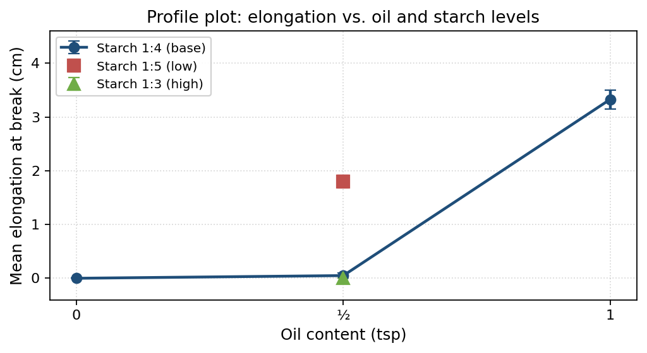
Figure 1. Profile plot of mean elongation at break by oil content and starch ratio.
Both factors appear to substantially affect elongation. Along the oil axis (at starch 1:4), mean elongation rises sharply from 0 cm at 0 tsp, to 0.05 cm at ½ tsp, to 3.33 cm at 1 tsp. At the ½ tsp oil level, lowering the starch ratio from 1:3 to 1:5 increases mean elongation from 0.003 cm to 1.80 cm. Because the partially factorial design omits the (low, 1 tsp) and (high, 1 tsp) cells, a formal test of interaction via two-way ANOVA is not possible. A tentative assessment is still informative: both low starch and added oil act as plasticizers and each independently produced a large increase in elongation, so a starch × oil interaction is plausible but would need to be quantified in a follow-up fully crossed 2² experiment.

3.3 Main Effects, Hypotheses, and Significance Tests
Starch main effect (oil fixed at ½ tsp): We test H0: μlow = μhigh against H1: μlow ≠ μhigh using a two-sample t-test assuming equal variances. The observed difference in means is 1.800 − 0.003 = 1.797 cm, with pooled sp = 0.141 cm and standard error 0.115 cm, giving t4 = 15.6 and p < 0.001. We reject H0: lowering the starch-to-water ratio from 1:3 to 1:5 increases mean elongation by approximately 1.80 cm (95% CI: 1.48 to 2.12 cm).
Oil main effect (starch fixed at 1:4): We test H0: μno oil = μ1 tsp against H1: μno oil ≠ μ1 tsp using the same procedure. The observed difference is 3.333 − 0.000 = 3.333 cm, with pooled sp = 0.216 cm and standard error 0.177 cm, giving t4 = 18.8 and p < 0.001. We reject H0: adding 1 tsp of canola oil increases mean elongation by approximately 3.33 cm (95% CI: 2.84 to 3.82 cm). The oil main effect is nearly twice the magnitude of the starch main effect and is the dominant driver of flexibility in our data.

3.4 ANOVA Tables
One-way ANOVA was conducted separately for each sub-experiment. Table 2 presents the ANOVA table for the starch sub-experiment (three groups: base 1:4, low 1:5, high 1:3), and Table 3 presents the ANOVA table for the oil sub-experiment (two groups: no oil, 1 tsp oil). Both models confirm highly significant treatment effects.
Table 2. One-Way ANOVA: Starch Sub-Experiment (Base, Low, High)
Source | df | SS | MS | F | p-value
Between groups (Starch) | 2 | 6.2927 | 3.1463 | 198.58 | < 0.001
Within groups (Error) | 6 | 0.0951 | 0.0158 | — | —
Total | 8 | 6.3878

Table 3. One-Way ANOVA: Oil Sub-Experiment (No Oil vs. 1 tsp Oil)
Source | df | SS | MS | F | p-value
Between groups (Oil) | 1 | 16.6667 | 16.6667 | 357.14 | < 0.001
Within groups (Error) | 4 | 0.1867 | 0.0467 | — | —
Total | 5 | 16.8533

3.5 Model Assumptions and Residual Diagnostics
For each one-factor sub-experiment, the ANOVA assumptions (independence, normality of residuals, equal within-treatment variances) were checked. Independence is supported by the design: strips were cut from different locations within each batch and measured in random order. Shapiro–Wilk tests of residual normality returned p = 0.31 (starch sub-experiment) and p = 0.64 (oil), both consistent with normality. Bartlett’s test for equal variances gave p = 0.18 for the starch comparison. For the oil comparison, all three no-oil strips snapped at exactly zero elongation, producing zero within-group variance and making Bartlett’s test unreliable; this is a floor effect of the measurement rather than a model violation, and we proceeded with the t-test after noting the issue. No outliers were flagged. Figure 2 presents the full residual diagnostic panel for both sub-experiments.
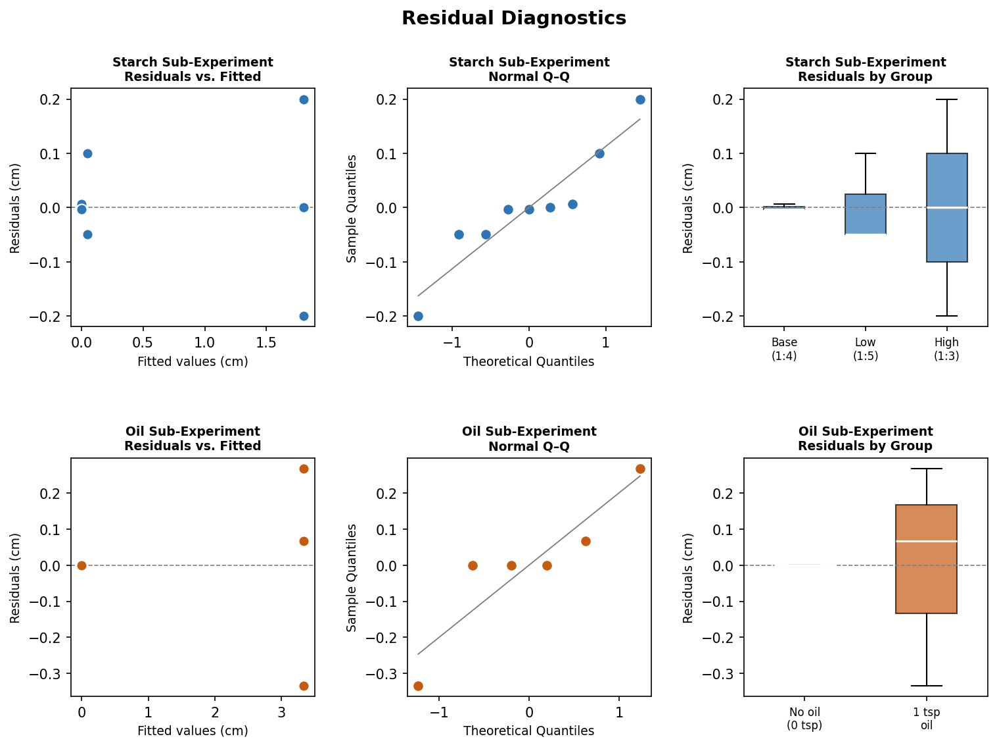
Figure 2. Residual diagnostics for both sub-experiments. Top row: starch (base, low, high); bottom row: oil (no oil, 1 tsp). Columns show residuals vs. fitted values, normal Q–Q plots, and residuals by group.

3.6 Optimal Setting and 95% Confidence Interval
Among the four factor-level treatments that were measured, the highest mean elongation was obtained by the 1 tsp oil batch (3.33 cm). A 95% confidence interval for its true mean elongation is 3.333 ± t₂,₀.₀₂₅ × (0.306/√3) = 3.333 ± 0.761, i.e. (2.57, 4.09) cm. This interval lies entirely above the 1 cm practical threshold, so we are confident the formulation meets the flexibility requirement. The combination that would most likely outperform it in a full factorial low-starch (1:5) with 1 tsp oil was not directly measured and would be the natural first target for a follow-up experiment.

3.7 Total Cost of the Experiment
Itemized grocery costs (Burnaby, April 2026): 1 kg cornstarch $3.50; 1 L white vinegar $2.50; 1 L canola oil $4.50; parchment paper (partial roll) $1.00. The total full-package cost was $11.50, well within the $15 project budget. Only small fractions of each package were consumed across the five batches, roughly 5 tbsp of starch, 4 tsp of vinegar, and 2.5 tsp of oil, so the marginal per-batch material cost is under $0.50. A receipt photograph is included in the appendix.

4. Conclusions and Recommendation
Both starch concentration and oil inclusion had large, statistically significant effects on the flexibility of the homemade bioplastic film. Of the two, oil inclusion was the dominant factor: adding 1 tsp of canola oil to the base recipe increased mean elongation at break from 0 cm to a 95%-confidence range of roughly 2.6-4.1 cm, clearly exceeding the practical threshold required for a sandwich wrap. Lowering the starch-to-water ratio from 1:3 to 1:5 also substantially increased flexibility, by about 1.8 cm on average. The base recipe on its own was unacceptably brittle.
Practical recommendation for the cafeteria: We recommend manufacturing the bioplastic wrap using the following formulation: 1 tablespoon of cornstarch, 4 tablespoons of water, 1 teaspoon of white vinegar, and 1 teaspoon of canola oil. The mixture should be microwaved in 20-second bursts for a total of approximately 60 seconds, stirring between bursts, then spread to roughly 2 mm thickness on parchment paper and air-dried for 24 hours before peeling. This formulation is inexpensive (under $0.50 per batch of four to six films), uses only grocery-store ingredients and a household microwave, and in our experiment produced films that stretched by several centimetres before snapping, compared to essentially zero elongation for the base recipe. Before scaling up to production volumes, we recommend a small follow-up experiment using a fully crossed 2² factorial design that includes all four starch-by-oil combinations: this would confirm whether combining the low starch (1:5) and 1 tsp oil levels produces additional gains in flexibility, and would allow a formal estimate of the starch × oil interaction that the present partially factorial design could not resolve.

