**Banglashoppers.com**

**Issue**: Accept wrong email address for signup

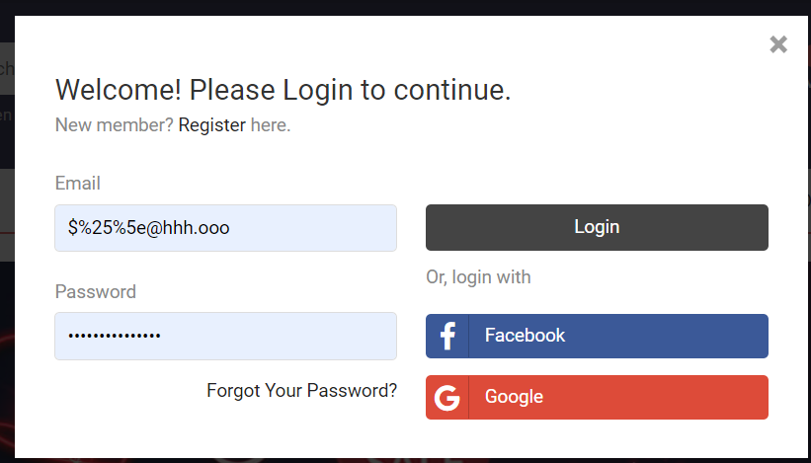

**Description:**Go to URL = <https://www.banglashoppers.com/>   
Click on the login button.  
Click on continue with email.  
Click on the sign-up button.  
Enter the wrong email address  
Enter valid data for other fields.  
Click on the sign-up button to create an account.

**Observation:** It accepts the wrong email to create a new account

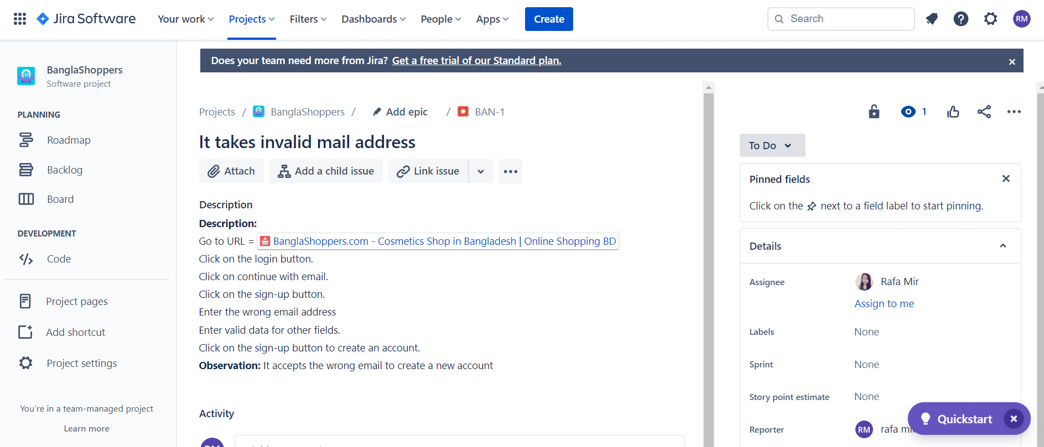

**Action 1:** The work was assigned to Rafa Mir for solving the issue.

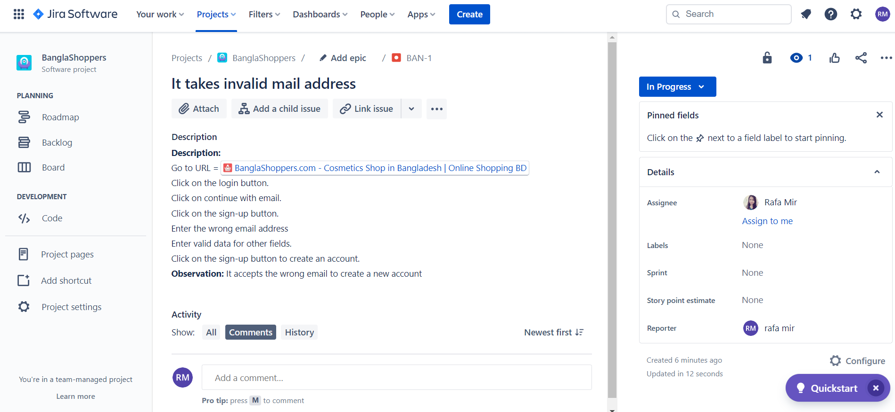

**Action 2:** The developer was working and it was in progress stage.

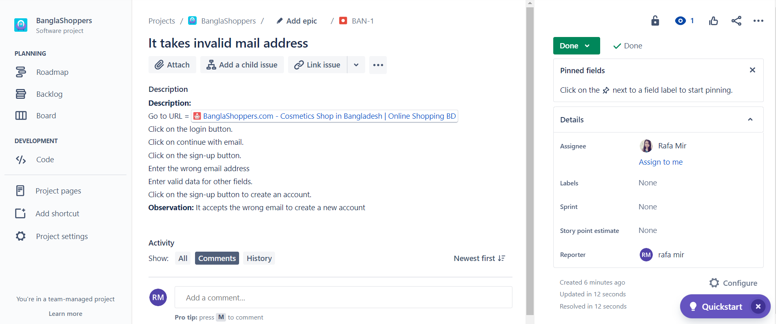

**Action 3:** Developer completed the work and the work is done