MatchMind
AI Tennis Performance App
Design Mockups

MYP Personal Project
Prototype design — 8 core screens
Created 12 June 2026
“MatchMind” is a working title and may change.

About these mockups
MatchMind helps junior and amateur tennis players understand their matches — both on the court and in their head. Someone courtside records the match in a few quick taps, the player completes a short mental reflection afterwards, and an AI generates a personalised report that connects how the player felt to what actually happened during the match.
These are the first interactive design mockups. The eight core screens are:
- Home & Match History. Landing screen: quick career snapshot, recent matches with result + a mini momentum sparkline, and one big …
- New Match Setup. Minimal setup: names, surface, and the flexible format/scoring chips (best-of-3, pro set, match tiebreak, n…
- Live Scouting — the fast screen. The speed-critical screen.
- Momentum & Stats. The signature feature.
- Mental Reflection. Quick post-match check-in: mostly 1–10 sliders and tap-faces, one multiple-choice, and one optional text box.
- AI Match Report. The payoff.
- Welcome — Sign up & Log in. New.
- Profiles & Linking. New.
Each screen is shown full-size on the following pages.

01 · Home & Match History
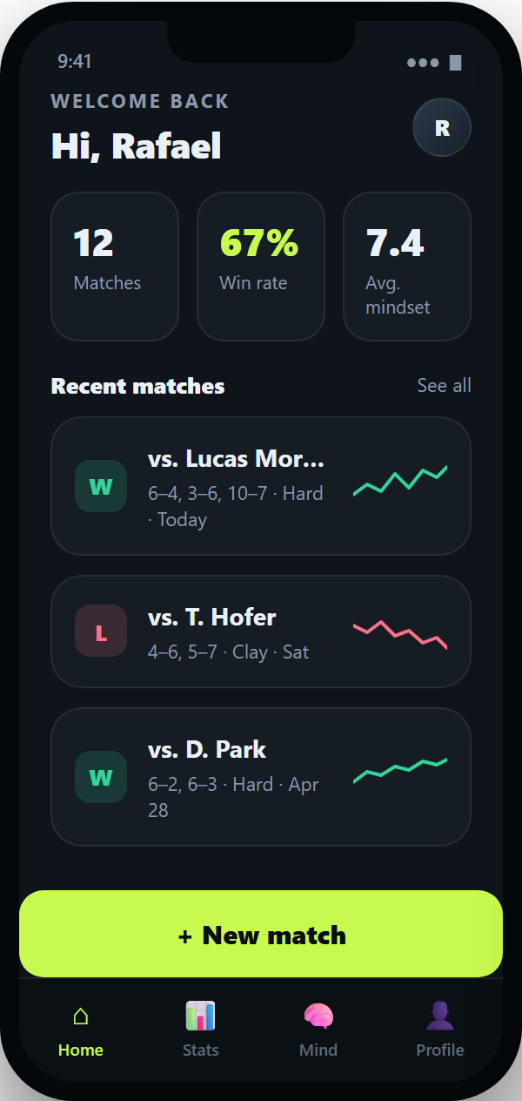
Landing screen: quick career snapshot, recent matches with result + a mini momentum sparkline, and one big New match button.

02 · New Match Setup
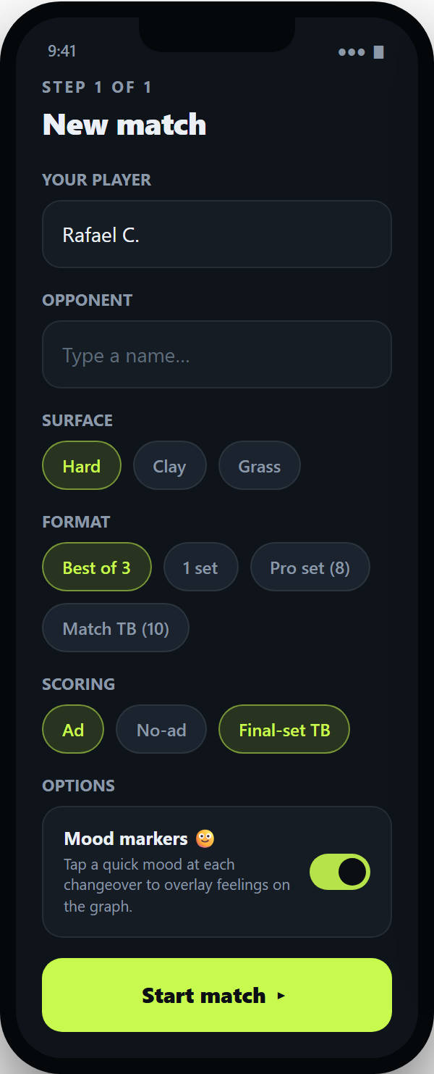
Minimal setup: names, surface, and the flexible format/scoring chips (best-of-3, pro set, match tiebreak, no-ad). The optional mood-marker toggle lives here.

03 · Live Scouting — the fast screen
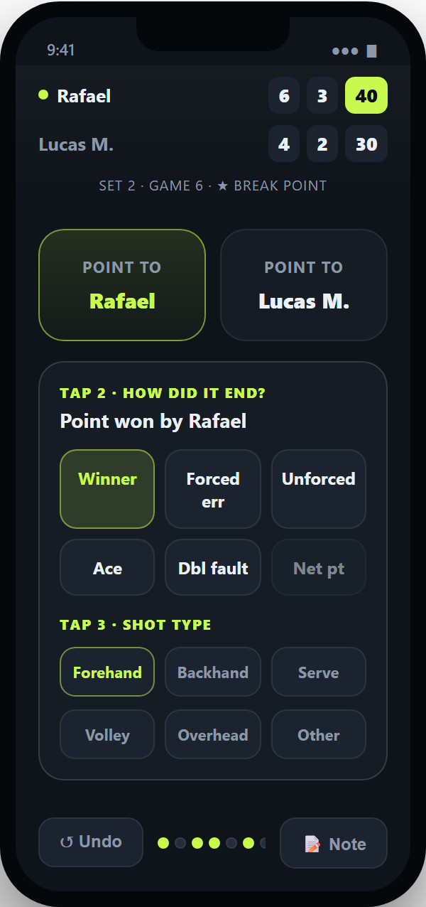
The speed-critical screen. Every point is 3 taps: who won (big zones) → how it ended → shot type (now required). Ace/double-fault auto-fill the winner, and an "Other" shot option keeps entry quick when a shot doesn't fit a category.

04 · Momentum & Stats
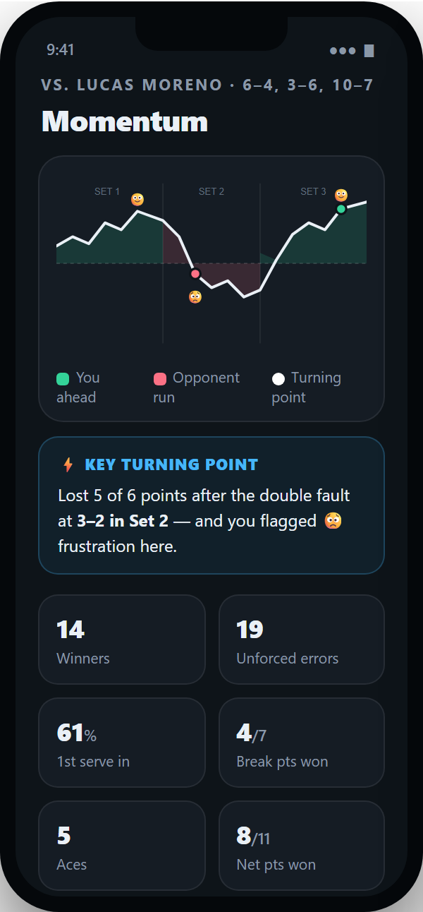
The signature feature. The line rises on your runs, dips on the opponent's, with turning points marked and optional mood emojis on the same timeline. Key stats auto-calculated below.

05 · Mental Reflection
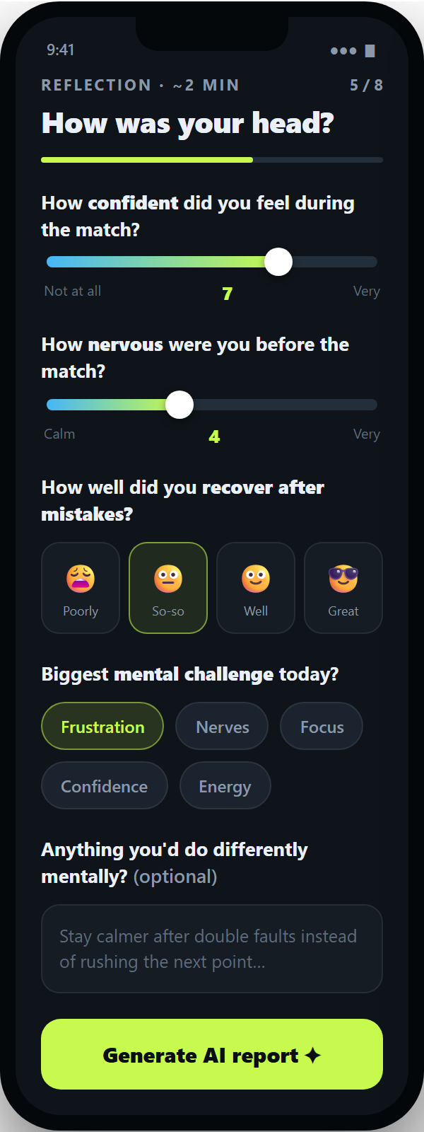
Quick post-match check-in: mostly 1–10 sliders and tap-faces, one multiple-choice, and one optional text box. Designed to take about two minutes.

06 · AI Match Report
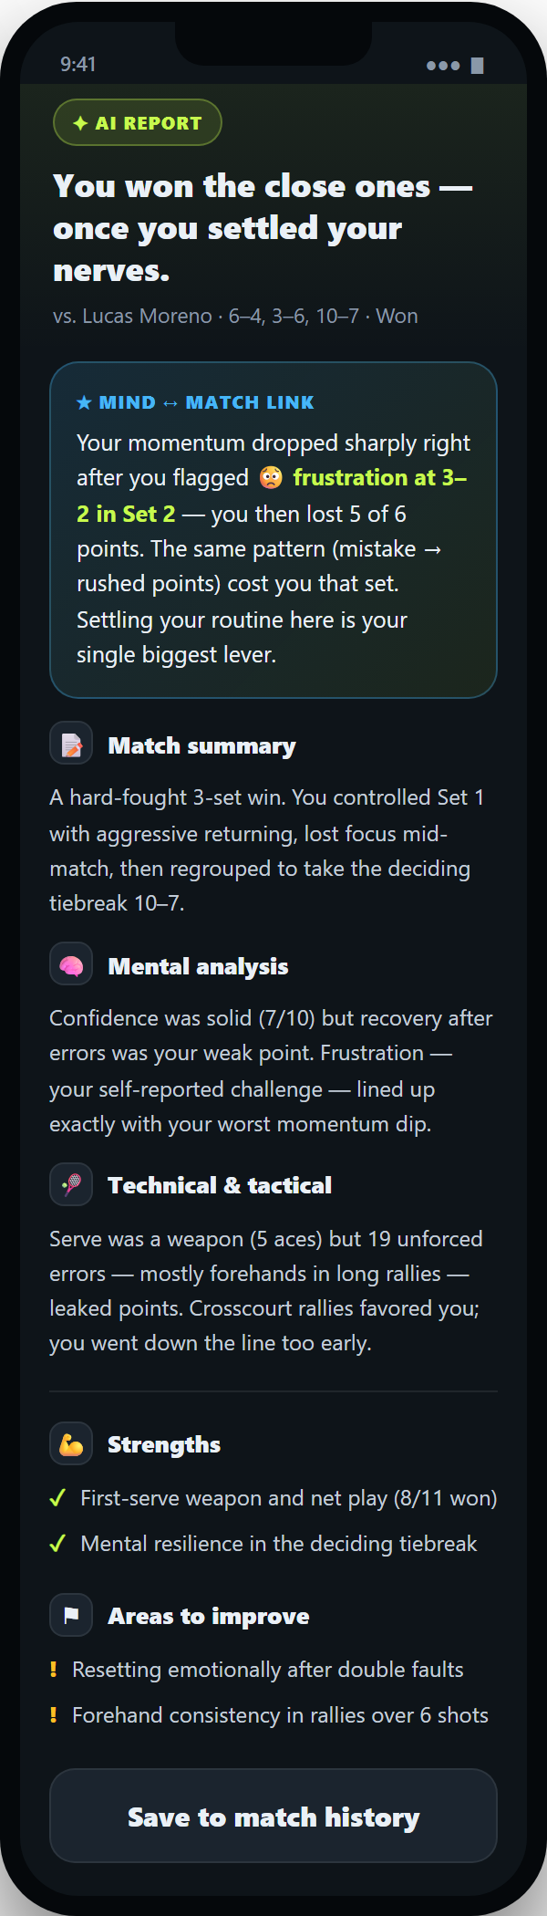
The payoff. A scrollable report led by the standout Mind ↔ Match insight that connects mood to momentum — then match summary, mental/technical/tactical analysis, strengths, and areas to improve.

07 · Welcome — Sign up & Log in
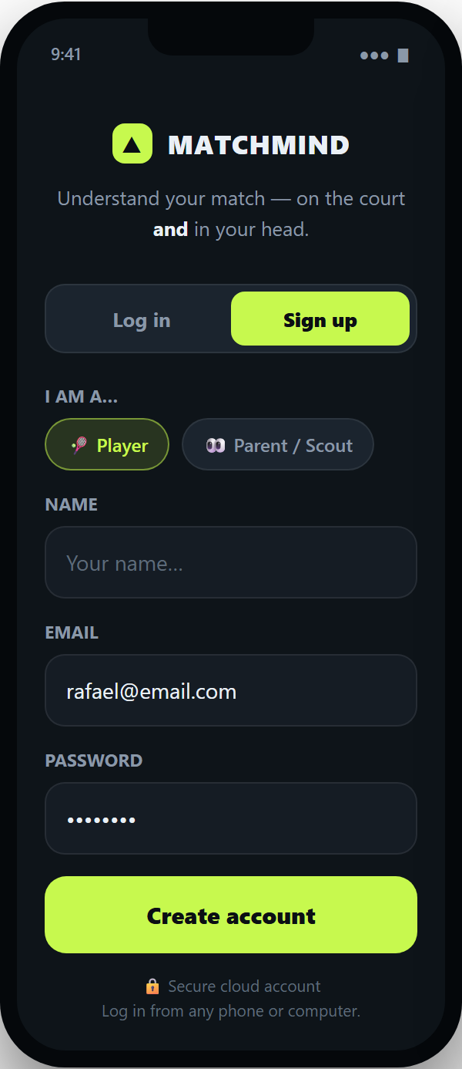
New. The first screen in the real app. Create an account or log in with email + password and pick your role — Player or Parent/Scout. Accounts are secured in the cloud (Supabase), so you can log in from any device.

08 · Profiles & Linking
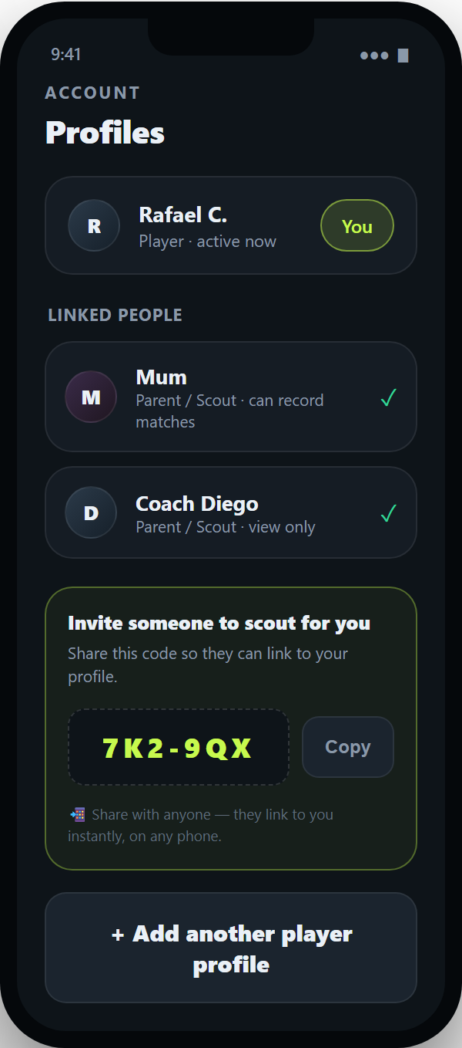
New. A player links the people who help them and shares an invite code so a parent/scout can connect and record matches from their own phone. Manage who can record vs view-only here.

