 | Modified date:  Status:  Info type: |  | 2018-11-14  UCC  EDS |  |  | Document name:  D000389395-01-EDS-001
Program/Machine type: |  |  |  | Project/Group:
Yieldstar / 350E |  |  |  | Yieldstar Machine Software
Title:
EDS IlluminationHorizontalVerticalOutputAdjustment
Summary: |  |  |  |  |  |  |  | Company Secret
This is a template for a (sub-)Function SW EDS. A System-Function (e.g. Metrology) consists of 1 or more Functions (e.g. Leveling, Image Align, see system decomposition). These Functions are usually decomposed in sub-Functions, subsub-Functions and so-on.
(sub-)Functions have a Functional part and SW/HW parts which have to be specified and designed. This documentation is sometimes combined (e.g. for SW-only Functions like FaFi) and sometimes not (e.g. Metrology or Mechatronics Functions).This (sub-)Function SW-EDS template is intended for translating a Functional Description (EPS&EDS) to a SW design. The design is then further described in component-SW-EPSs and component-SW-EDSs or refined in subsub-Function SW-EDSs (where applicable, e.g. a CPD test).

The following rules apply to this template:
Help text is provided in style InfoBlue, make use of it and apply style HiddenText to it when your document is ready.
If a section is not applicable, it must be present with the text: "Not applicable, or N/A". Sub-sections may then be removed.
Additional Chapters may be added as an appendix.
It is allowed to subdivide sections into further subsections to improve readability.
To change the Field codes; modify the document properties via File->Info->Properties->Advanced Properties->Custom

The controlling documents for this design document are:
(sub-)Function EPS
(sub-)Function EDS at higher level
Architecture books (Yellow Book, Function SW SDS, Product SW SDS)
Optionally a SIA, during the lifetime of the project.

This is a template for a Software EDS document. . The following rules apply to this template:
Additional sections may be added as an appendix.
It is allowed to subdivide sections into further subsections to improve readability.
This documents describes the software design (EDS) of the task Illumination Horizontal Vertical Output Adjustment task.
No sections may be omitted. If a section is not applicable, it must be present wit

h the text: "Not applicable".

For optimal use of this template, configure MS-Word:
Set “Field shading” to “Always” in the “Tools / Options / View” menu.
Enable “Update fields” in the “Tools / Options / Print” menu.
Set the language to English (United States) in the “Tools / Language / Set Language” menu.
Fill in your name in the “Name” field in the “Tools / Options / User Information” menu.
After updating this document, re-configure it by invoking the “File / File Summary Info” option and update:
Doc ID/Version: Consists of two elements: Document ID = the Doc ID issued by TANGO for your document,
Version nr = initial value: 00, increase with every new issue of document,
Title: The title of this document,
Maintainer: The name of the person who maintains this document,
Last update: Last update of this document,
Status: Status of the document: Draft = initial issue, document is subject to uncontrolled changes,
Concept = document is ready for review, no changes allowed,
Under change control = changes under control of Change Controllers,
Obsolete = document should not be used anymore (give in the summary a reference to the replacement document.
Do’s/Don’ts
Do not edit grey marked text (known as ‘fields’); they are updated automatically whenever you update (shortcut keys: CTRL A, F9) or print the document.
Various styles are available through buttons in the toolbar below this document. Use the defined styles instead of defining something of your own; look at this template to see which styles are in use, e.g.:
Body body text
Heading 1..7 chapter headings 1..7
TableHeader table header text
TableBody table body text.

For change control |  | Reviewers |  |  |  |  | For info
Albert-Jan Nijsten <GL> |  | Rutger de Graaf <TL>  Rob Beks < Dev> |  |  |  |  | Mark van Kemenade <PL>  Marcel Peeters <FCA>
Maintainer : Dijck, Jurgen van (jdijck) |  |  |  |  | Template information:  Version: 1  Owner: Rob Beks
Pages incl. cover : 18
Word processor : MS Word 2010
© ASML 2015. All rights reserved.
Reproduction in whole or in part is prohibited without the prior written consent of ASML.

TEMPLATE CHANGE & HISTORY RECORD

CONTRIBUTING AUTHORS
Name author | Part(s) of this document

OPEN ITEMS
ID | Description | Action holder | Resolution Date

For each open issue have an owner and a planned date for resolving the issue, which is mandatory to get documents UCC.Open issues are issues which cannot be resolved before the start of the review, but must be resolved before end of development because the outcome has an impact on the functionality to be delivered.
Therefore, for each open issue a separate IP or AIR issue must be issued, to be able to manage open issues. A document cannot be accepted if there are open issues without a IP or AIR issue.
All open issues should be listed in the table above.
All once open but now closed issues can be marked with strike-through font.
New or changed functionality, to be implemented in some future release, is not regarded an open issue: this should be placed in an appendix.

DOCUMENT CHANGE & HISTORY RECORD
Maintainer | Last update | Status | Version | SPS/IP/ECR, AIR-ID | Comment
Jurgen van Dijck | 24-06-2015 | Draft | 0 |  | Initial version

More information about how to write an EDS can be found in the SW EDS Process description, see Make Function Requirements and Design for a System.

Applicable documents
A Controlling document is a document at a higher hierarchical level than the document you are writing now (your document). If a controlling document changes, it is required to check whether there are changes which do influence your document and if this is the case, to implement the consequences of these changes inside your document.

A Subsidiary document is a document at a lower hierarchical level than the document you are writing now (your document). If your document changes then it is required to investigate whether there are changes inside your document which do influence the subsidiary document and if this is the case, to implement the consequences of these changes inside the subsidiary document.

A Reference document is a document which:
- provides background information (information not controlling the design specified by your document)
- provides sources of the information which you mention in your document
- contains ‘nice to have’ information (not essential to know).

Controlling documents 10
Ref. | Title | Author | Modified date

Reference documents 20
Ref. | Title | Author | Modified date

The controlling/subsidiary/reference documents in the template have Bookmarks already defined as Ref11,..Ref37.
- A reference to these bookmark may be made at any required point in the document by selecting 'Insert->Reference->Cross-reference...'. Then select 'Reference type': 'Bookmark', select the required bookmark and click on 'Insert'.
More reference documents can be made as follows:
Add a row in the tables, copy the contents of one of the ‘Ref.’ cells to the first cell of the newly created row. Initially the number will be the same as in the cell where the contents was copied from, but after performing update fields (Ctrl-A, F9 or after printing the document) the Ref. number will be correct.
More bookmarks may be made as follows:
- select the required reference, e.g. [1.8].
- Select 'Insert->Bookmark...'.
- Type a unique name in the 'Bookmark name' field, e.g. the first part of the file name that belongs to [1.8], e.g. Ref18, and click on 'Add'.

TCE Controlling documents (auto generated, do not change)
Ref. | Title | Author | Modified date
TCE Reference documents (auto generated, do not change)
Ref. | Title | Author | Modified date
D000323862 | EDS AdjustmentRedesignR3 | Linden, Bas van der | 10-Oct-2014
D000350053 | EDS EPDS YS350E H/V Output Adjustment and Performance Tasks | Smeets, Ralph | 08-May-2015
D000389397 | TDL IlluminationHorizontalVerticalOutputAdjustment | Dijck, Jurgen van | 25-Jun-2015
D000389468 | FSS IlluminationHorizontalVerticalOutputAdjustment | Dijck, Jurgen van | 16-Jul-2015
TCE Documents 12NC (auto generated, do not change)
12NC | Name | Owner | Modified date

Abbreviations
Abbreviation | Description
ROI | Region Of Interest
PTS | Production Test Stand
OCAP | Out of Control Action Plan
NA | Numerical Aperture
FAT | Factory Acceptance Test
SPC | Statistical Process Control
SDT | System Diagnostic Tool
EP | Entrance Pupil
All non-trivial definitions and abbreviations (both ordered alphabetically) that are used in the document need to be explained, either in the document itself, or in the ASML Terminology and Definitions pages on Netscanner.

Guidelines for abbreviations and definitions:
- new terms, abbreviations and definitions should be submitted to the Terminology Committee
- the author decides which abbreviations and definitions should be put in the document itself:
- if there are "new" abbreviations and definitions (that are not yet part of the terminology site), it should be part of the document, but also the author should submit this to the terminology committee, to have it incorporated into the terminology site, for future reference.
- if there are crucial abbreviations and definitions that are very specific for the document, but have little meaning outside the scope of the document, it could be explained only in the document, and not submitted to the terminology site.
Additional abbreviations can be found on the ASML Terminology Wiki and ASML Glossary on Netscanner

Definitions
Definition | Description
Additional abbreviations can be found on the ASML Terminology Wiki and ASML Glossary on Netscanner

USEFUL LINKS
Link | Description

Table of Contents
1 Introduction 6
1.1 Goal of this document 6
2 Logical View 7
2.1 Measurement sequence 7
2.2 Class diagram 7
3 Development View 8
3.1 Deployment Diagram [optional] 8
3.2 User interface specifications [optional] 8
3.2.1 Input/output 8
3.2.2 User interface 8
Appendix A – Sensor Settings [optional] 9
Appendix B – Input parameters [optional] 10
Appendix C – Output report parameters [optional] 11
Appendix D – SDT parameters [optional] 12
Appendix E – SPC parameters [optional] 13
Appendix F – Spec Checker parameters [optional] 14
Appendix G – Diagnostic parameters [optional] 15
Appendix H – EC parameters [optional] 16
Appendix I – Error handling and OCAP 17
Appendix J – Not implemented interfaces and functionality. 18

LIST OF FIGURES
Figure 1: Class diagram 8

LIST OF TABLES
Table 1: Task output parameters overview 9

Introduction

Goal of this document
This EDS describes the high level software design of task D000350053 [EDS EPDS YS350E H/V Output Adjustment and Performance Tasks], complementary to the functional specification as specified in reference document [D000350053]. The task is compatible with the R3 task framework as described in reference document [Add ref here D000323862].

Logical View

Measurement sequence
Describe the measurement sequence if it helps in clarifying the A4 spec or EDS. Might also be a sequence diagram.

Sequence number | Action
 | Shoot individual Darkfield images with H/V polarization
 | Determine average intensity levels on Darkfield wedge image positive First Order and negative first order.
 | Calculate relative difference between average intensity levels determined in step 2

Add data flow diagram if it helps in clarifying the A4 spec or EDS.

Class diagram
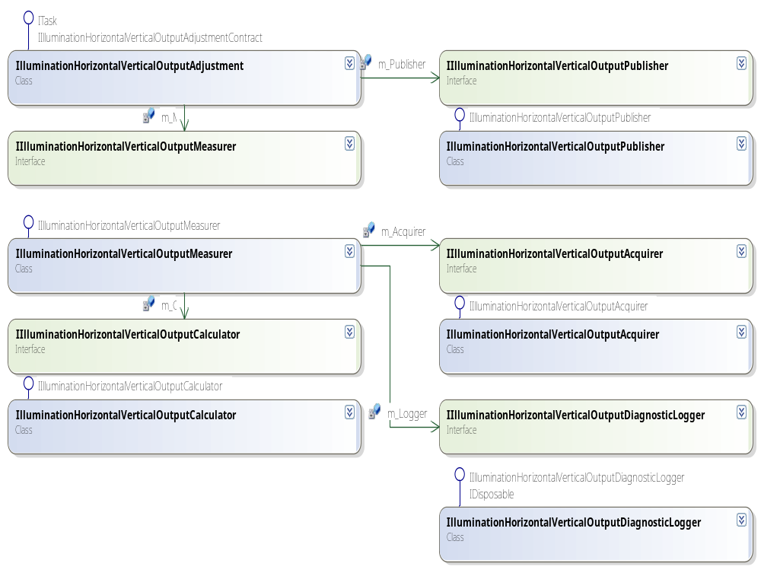
Provide a high level class diagram for the sw task also showing the relations with the used external sw interfaces and where these are used for.

Figure 1: Class diagram

Development View

Deployment Diagram [optional]
Add deployment diagrams. Show processes and libraries and other targets (artifacts such as files) that the (sub-)Function consists of. Do not describe standard artefacts of the task framework.

User interface specifications [optional]
All external interfaces are included in the FSS.

Input/output
Provide an output parameter overview to give a short overview to which output a parameter is written.
Table 1: Task output parameters overview
Output Parameter | Report | Calibration ECs | Spec checker | SPC | SDT | Diagnostics
Max intensity measured for H polarization | X
Max intensity measured for V polarization | X
Final Intensity H polarization | X |  |  |  |  | X
Final Intensity V polarization | X |  |  |  |  | X
Relative Intensity Difference | X |  | X |  |  | X

Details included in FSS.
If helpful in clarifying the A4 spec or EDS the external user interfaces can be described in the appendices.
The input definition is described in document [A4 spec] and summarized in Appendix B – Input parameters [optional]
The output definition is described in document [A4 spec]Error: Reference source not found and summarized in Appendix C – Output report parameters
The SDT definition is described in document [A4 spec] and summarized in Appendix D – SDT parameters
The SPC definition is described in document [A4 spec] and summarized in Appendix E – SPC parameters
The specchecker definition is described in document [A4 spec] and summarized in Appendix F – Spec Checker parameters
The Diagnostic definition is described in document [A4 spec] and summarized in Appendix G – Diagnostic parameters
The EC definition is described in document [A4 spec] and summarized in Appendix H – EC parameters
The Error Handling definition is described in document [A4 spec] and summarized in There are no EC values for this task.

User interface
Included in FSS see D000389468.
Describe/show the User Interface if it helps in clarifying the A4 spec or EDS

Appendix A – Sensor Settings [optional]
The Sensor Settings are described in D000350053 [EDS EPDS YS350E H/V Output Adjustment and Performance Tasks].

Appendix B – Input parameters [optional]
The Input definitions are described in the document D000350053 [EDS EPDS YS350E H/V Output Adjustment and Performance Tasks].

Appendix C – Output report parameters [optional]
The output definitions are described in the document D000350053 [EDS EPDS YS350E H/V Output Adjustment and Performance Tasks].

Appendix D – SDT parameters [optional]
The interface ISdtOutputHandlerTarget is available but not implemented for the YS350.
The SDT parameters can be found in Appendix C – Output report parameters.

Appendix E – SPC parameters [optional]
The interface ISpcOutputHandlerTarget is available but not implemented for the YS350.
The SPC parameters can be found in Appendix C – Output report parameters.

Appendix F – Spec Checker parameters [optional]
The interface ISpecOutputHandlerTarget is available but not implemented for the YS350.
Output parameter | Description | Default value | Unit | Variable name | Variable type
Relative Difference  H/V polarization as  Measured on darkfield  camera |  | - | m | RelativeIntensityDiffHpolVpol | double

Appendix G – Diagnostic parameters [optional]
The diagnostics can be written via the ILog interface. The default file storage location can be found in <Drive>\LocalData\Diagnostics\<Timestamp_Task_Taskname>.
Diagnostic output parameters(SaveTaskDiagnostics) | File Storage location
Optimal integration time | Default
Intensity H/V polarization | Default
Number of H/V images taken | Default
Relative intensity difference calculated | Default

Appendix H – EC parameters [optional]
There are no EC values for this task.

Appendix I – Error handling and OCAP
Event messages
NA

OCAP
Problem | Cause | Solution

Appendix J – Not implemented interfaces and functionality.
NA

