Feb 2020

Linux notes

# File system

## Mount

* **mount** –t ext3 /dev/sdb1 mnt/mymountpoint
  + **parted** can be used to show file system type
* **blkid**, show uuid of partitions.

[Here](https://help.ubuntu.com/community/Fstab) is excellent tutorial about mount.

## LVM

* **pvcreate** /dev/hdd
* **vgextend** /dev/MyVG01 /dev/hdd
* **lvcreate** -L +50G --name Stuff MyVG01
* **lvextend** -L +50G /dev/MyVG01/Stuff
* **mkfs** -t ext4 /dev/MyVG01/Stuff
* **resize2fs** /dev/MyVG01/Stuff
* **e2label** /dev/MyVG01/Stuff Stuff
  + [Might be used to give label for any ext* partition. Very usefull]
* **pvs**, info about physical volumes (pvdisplay – more details)
* **vgs**, info about volume groups (vgdisplay – more details)
* **lvs**, info about logical volumes (lvdisplay – more details)

# General

## View system logs:

tail /var/log/syslog

and in context of specific service:

sudo journalctl –u cron

for live log (like tail)

sudo journalctl –u cron –f

## target/runlevel

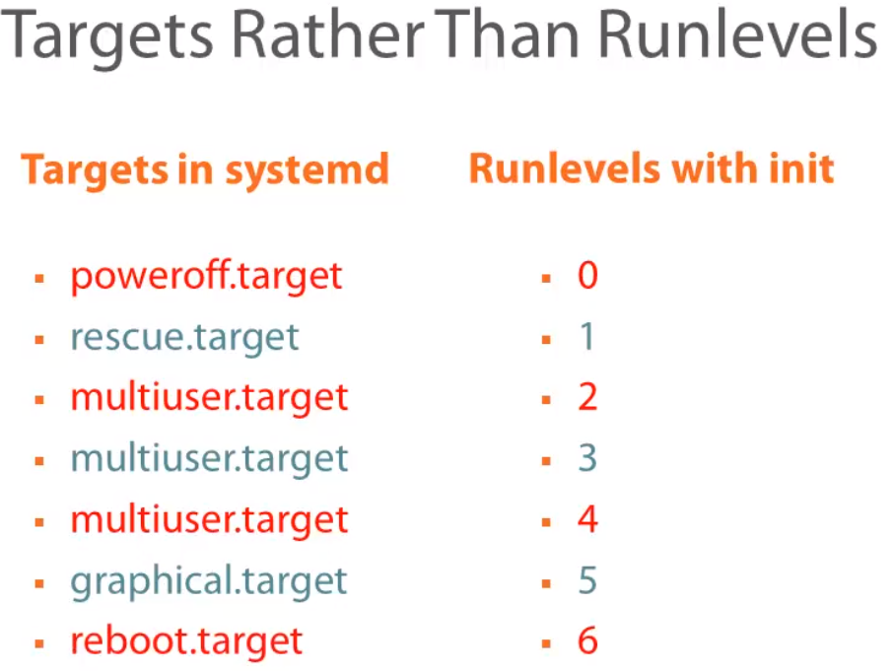

PS: Linux Kernel and System Startup

systemctl get-default

systemctl set-default multiuser.target

systemctl status multiuser.target

systemctl status

systemctl isolate multiuser.target // apply runlevel

systemctl isolate poweroff.target