**Atmospheric Scattering**

**University of Minho**

**Master in Informatics Engineering**

Computer Graphics

Display and Lighting I

February 2016

Bruno Miguel da Silva Barbosa 67646

Carlos Manuel Magalhães Gonçalves 67650

Carlos Rafael Cruz Antunes 67711

**Table of Contents**

Abstract 3

Introduction 3

Atmospheric Scattering 3

Rayleigh Scattering 3

Mie Scattering 4

Result Comparison 4

Conclusion 4

References 5

**Table of Figures**

Figure 1 - Atmospheric scattering effect 4

# Abstract

In this work assignment we picked up an already existent project developed in ®Unity 3D and tried to replicate it on tool we used on our classes, the Nau3D. The report describes the whole replication process since the analysis of the atmospheric effects responsible for the atmospheric effects until the final results.

# Introduction

Our atmosphere is a mixture of several processes which result in various effects that are noticeable throughout the day, these effects can cause sun’s light reflection, refraction or absorption. One of the most important is the scattering effect. Scattering is the process by which small particles in the atmosphere diffuse a portion of the incident radiation emanated from the sun. The scattering of sunlight in the atmosphere causes diffuse sky radiation, which is the reason for the blue color of the sky and the yellow tone of the sun itself, or even the clouds’ white color.

This phenomenon has been simulated using computer graphics, mostly to achieve a certain realism in a virtual world. This problem ban be studied from two different angles: the view from the Earth’s surface, or the view from space. A project with this features already existed for the Unity 3D engine, with both angles mentioned before. On this work assignment a new version for Nau3D engine was developed based on the previous mentioned project, although only the latter angle was focused on. The objective is to mimic atmospheric effects that a person would be able to see if they were in space, looking at Earth. The scene created is constituted by only two concentric spheres, one simulates the Earth and the other slightly bigger the atmosphere.

# Atmospheric Scattering

As mentioned before, scattering is the redirection of electromagnetic energy by the suspended particles in the atmosphere. Depending on the size of the particle which the light reached the type of scattering will be different: if the size is smaller than the wavelength of visible light, the effect is Rayleigh scattering, if it’s about the same size, the effect is applied is Mie scattering. Rayleigh scattering influences the color of the sky, from the usual blue to the sunset red/yellow shades, due to the very small size of the average atmosphere particle (smaller that the wavelength reaching it). Mie scattering is responsible for the white/grey clouds’ colors which contain water droplets with a similar size as the wavelength reaching it.

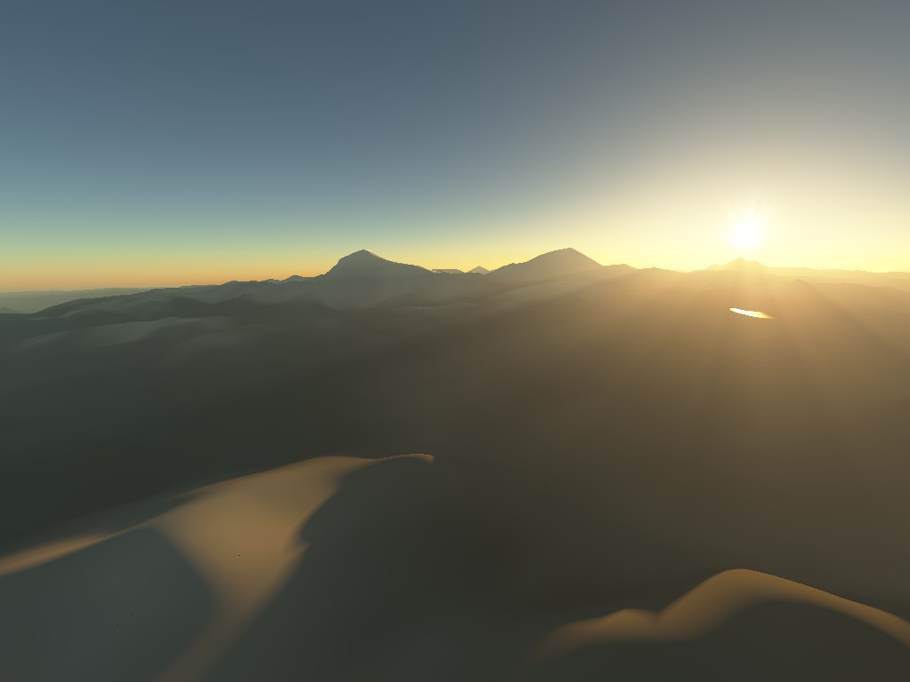

Figure - Atmospheric scattering effect

## Rayleigh Scattering

The blue color of sky and the yellow tone of the sun are two phenomenon that happen due to the Rayleigh scattering effect. This kind of scattering occurs in light or other electromagnetic radiation where the particles are much smaller than the wavelength of the radiation. Those particles can be individual atoms or molecules and don’t change its state once this is a parametric process. It can also ensue through solids or liquids but it is most common in gases. The Rayleigh scattering effects come from the electric polarizability of the particles by the electric field oscillation, causing them to move at the same frequency.

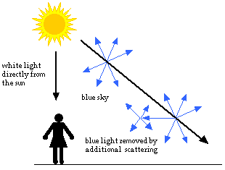 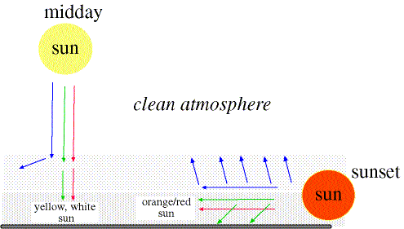

Figure . Rayleigh scattering

Down below we will show some formulas that allowed us the production of the Rayleigh scattering light effect. We didn’t implemented just like they are because that would have resulted on a huge load of computing and we pretend to have results in an acceptable framing rate. So, we wrote a simplification of those formulas that don’t produce the precise effect we need but they gives us a good look and simultaneously a great efficiency.

The first one we show is the size of a scattering particle. This value is frequently parametrized by the following formula

$$x=\frac{2πr}{γ}$$

Where $r$ is the particle’s length (radius) and $γ$ is the wavelength of the light. Objects with $x≫1$ act like a geometry shape, scattering light according to their projected area. When $x≅1$ we apply the Mie scattering as we will talk on the next section. The Rayleigh scattering is applied when $x≪1$, or by other word, when the particle is small. This means that the particle size (radius) is nearly ten times smaller than the length of the light and the entire surface re-radiates with the same phase. Since the particles are randomly positioned, the scattered light can assume many different phases depending to the point it arrives.

The next formula calculates the intensity $I$ of light scatter by any sphere with a small diameter $d$ and refractive index $n$ from a not polarized beam light of wavelength $γ$ and intensity $I_{o}$.

$$I=I_{0}\frac{1+\cos^{2}{θ}}{2R^{2}} {\left(\frac{2π}{γ}\right)}^{4}{\left(\frac{n^{2}-1}{n^{2}+2 }\right)}^{2}{\left(\frac{d}{2}\right)}^{6}$$

Where $R$ is the distance to the particle and $θ$ is the scattering angle. The Rayleigh scattering cross-section is calculated by averaging this over all angles. See the equation below

$$σ_{s}=\frac{2π^{5}}{3}\frac{d^{6}}{γ^{4}}{\left(\frac{n^{2}-1}{n^{2}+2}\right)}^{2}$$

For example, let’s imagine a group of scattering particles. The fraction of light scattered is the number of particles per volume unit N times the cross-section. Most of Earth’s atmosphere is constituted by nitrogen (nearly 78%). Its cross-section is 5.1x10-31 m2 at a wavelength of 532 nm (green light). Thus, at atmospheric pressure, we have nearly 2x1025­­ molecules per cubic meter which results on a fraction about 10-5 of the light that will be scattered for every meter it travels. The dependence of strong wavelength means that shorter wavelengths (implies more frequency, which means blue color) are scattered more powerfully than longer wavelengths (means less frequency, so it belongs to red color). Figure 3 illustrate exactly what we referenced above.

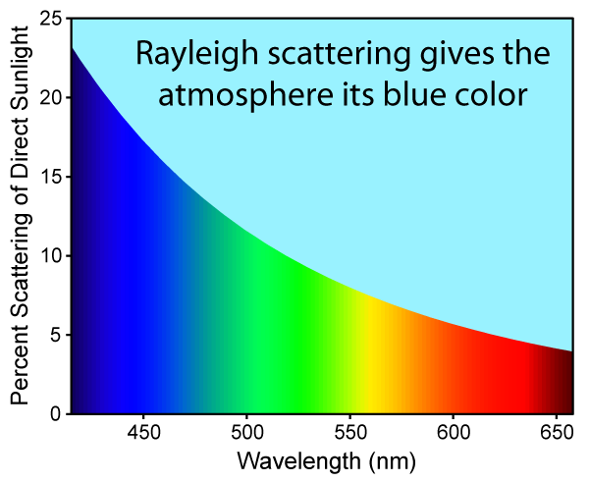 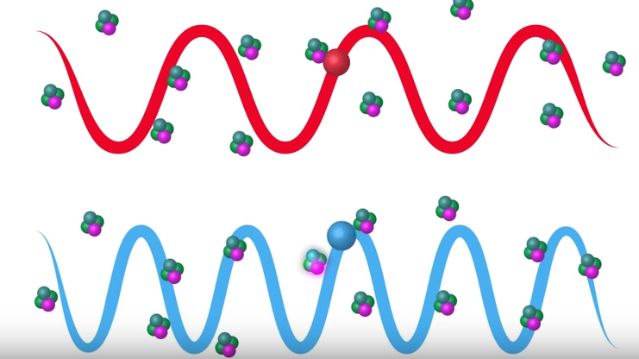

Figure . Proportion of light scattered at the atmosphere

If we could animate Figure 3 we would see that the blue ball (that represents the blue color once it has bigger frequency and consequently less wavelength) hit the atmosphere particles many times more than the red one. From this state we can explain the reason why the sky is blue.

The previous light equation was adapted to single particles as atoms. The following approach was designed to produce the same lighting effects now on molecules. Basically, the equation converts into something like

$$I=I_{0}\frac{8π^{4}α^{2}}{γ^{4}R^{2}} (1+\cos^{2}{θ)}$$

Where $α$ represents the molecular polarizability factor.

## Mie Scattering

<https://en.wikipedia.org/wiki/Mie_scattering>

# Result Comparison

Mostrar imagens do unity e da NAU3D

Podemos também mostrar as do “dentro” da atmosfera”

# Conclusion

Baseado nos shaders de um projeto do Unity

“sucesso” no shader da atmosfera

Referir erros nos shaders da terra

Possivelmente devido à má escala, valores de constants não aplicáveis à escala…

# References

|  |  |
| --- | --- |
| [1] | "Atmospheric Radiation," Weather Edge, [Online]. Available: http://www.severewx.com/Radiation/scattering.html. |