**Cornell Caustic**

**University of Minho**

**Master in Informatics Engineering**

Computer Graphics

Display and Lighting II

June 2016

Bruno Miguel da Silva Barbosa 67646

Carlos Rafael Cruz Antunes 67711

Tomás Moreira Ferreira 67701

**Table of Contents**

Abstract 3

Introduction 3

Experiments 4

Hypotheses 4

Results 4

Conclusion 5

**Table of Figures**

Figure 1. Default scene, rendered with path tracing. 3

# Abstract

# Introduction

This project pretends to evaluate different global illumination algorithms’ performance and quality. To do this, the group was given a scene to work with (represented on Figure 1). This image’s resolution is 1024 by 1024 and was rendered using PBRT version 2 (using the surface integrator “path”). The PBRT will also be used to fulfil the purpose of this project, by rendering the various experiments. The scene to be studied has various typical surfaces seen on global illumination demos, such as a glossy teapot and ceiling, a mirror, and a crystal-like “killeroo” model. Out particular focus will be on the “killeroo” model, by trying to get the best caustic shadow possible.

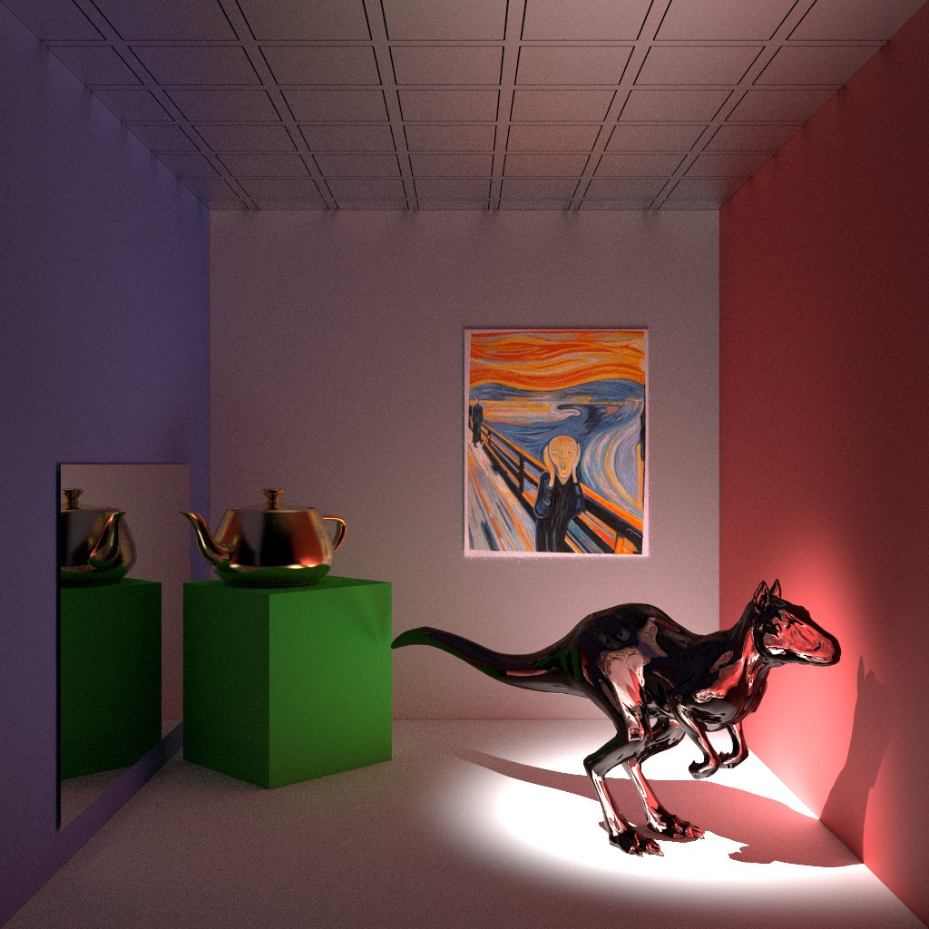

Figure 1. Default scene, rendered with path tracing.

# Experiments

In order to achieve the best result, and have a basis for comparison, there were selected some renderers / surface integrators and samplers to test. Each surface integrator is tested with a different sampler. The planned elements are shown on Table 1.

Table 1. Planned experiments.

|  |  |
| --- | --- |
| Surface Integrators / Renderers | Samplers |
| Metropolis | Adaptive |
| Path | Best Candidate |
| Photon Map | Halton |
|  | Low Discrepancy |
|  | Random |
|  | Stratified |

The result of each connection should generate an image, and the time it took to render, for example, the path surface integrator with an unknown sampler generated Figure 1, which as given to the group to present the scene. The imagens to be rendered will have a width and a height of 800 pixels. The samplers’ “pixelsamples” argument will be 256, at the exception of the adaptive (“minsamples” set to 128 and “maxsamples” set to 256) and stratified samplers (“xsamples” and “ysamples” set to 16, with jitter). The Photon Map surface integrator receives the argument “causticphotons” as 10.000 and the “indirectphotons” as 20.000.

# Hypotheses

Caustics are the consequence of light rays being focused in specific regions as a result of refraction (light rays passing through the “killeroo” model on this case). In the current case study, it is believed that the photon map surface integrator will produce a better result than the rest. This is simply because the path tracing is unable to produce a caustic, due to its random nature, when a ray hits a point that should be a caustic, a random ray is generated, and the probability of this ray being on the right direction (the “killeroo” model) is very low (shown in Figure 2 as red rays). And so the caustic would be no more than a normal shadow using path tracing. The photon map, on the other hand, is the ideal algorithm for this scene, and can generate very realistic caustics.

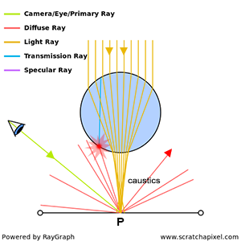

Figure . How a caustic shadow is formed.

# Results

* meter imagens!
* contar tempo

# Conclusion

* espirito critico!
* trade of entre X e Y
* refletir sobre os resultados obtidos e porque