**Work Assignment Summary**

**University of Minho**

**Master in Informatics Engineering**

Distributed Parallel Computing

Advanced Architectures

Carlos Rafael Cruz Antunes

Nuno André da Silva Oliveira

a67711

a67649

# Summary

On this work assignment we characterized in full the testing environment, and created a roofline model for the computer in which the code was developed and performance was tested.

It was created a single-threaded function in C that computes the dot product of two square matrices (in single precision and no block optimization). To this function was added performance counters using PAPI to measure the cache misses and number of instructions. This function was later changed to match the index order given (j-i-k), and then we were able to compare this two versions, to which we detected very little difference. All the tests were for four different matrix sizes: 40x40, 120x120, 600x600 and 1000x1000, so that they would fit in different levels of cache or even RAM (last case). This tests followed the k-best scheme with k=3 with 5% tolerance. All test were executed 8 times. RAM accesses, number of floating point operations and miss rate were also calculated in each execution, such as GFLOP/s.

Later, we changed matrix B to have only ones in all its positions. And we tested the difference of an AxB operation and BxA operation, to which no big changes were detected on the tests results.

The code was not yet vectorized. As soon as it is vectorized a comparison will be made.

# Roofline

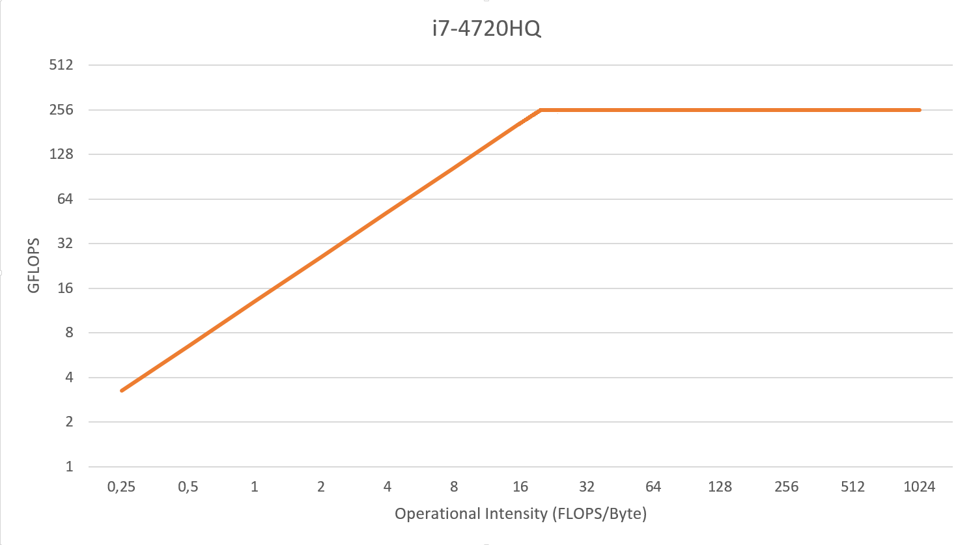

# Index Order

|  |  |  |
| --- | --- | --- |
|  | i j k | j i k |
| 40 | 0,000047 | 0,000045 |
| 120 | 0,001351 | 0,001378 |
| 600 | 0,203983 | 0,203078 |
| 1000 | 2,999203 | 2,955397 |

# AxB comparison with BxA

|  |  |  |
| --- | --- | --- |
|  | AxB | BxA |
| 40 | 0,000045 | 0,000046 |
| 120 | 0,001384 | 0,001368 |
| 600 | 0,206226 | 0,20378 |
| 1000 | 2,984113 | 2,960999 |