CorePAM: a 24-gene PAM50-derived expression score with cross-platform external validation for breast cancer prognosis
Rafael de Negreiros Botan¹, João Batista de Sousa²
¹ Department of Oncology, Universidade de Brasília, Brazil
² Department of Proctology, Universidade de Brasília, Brazil

Abstract
Background: The PAM50 classifier predicts breast cancer prognosis but requires 50 genes and specialised platforms. We derived CorePAM, the smallest data-driven PAM50 subset maintaining non-inferior prognostic performance relative to a full 50-gene Cox elastic-net model, without pre-specifying gene count.
Methods: Cox elastic-net regression ( = 0.5) with deterministic 10-fold cross-validation was applied in the SCAN-B cohort (N = 3,069; GSE96058). Gene selection followed a pre-specified non-inferiority margin (ΔC-index = 0.010). External validation used four independent cohorts: TCGA-BRCA (N = 1,072; RNA-seq), METABRIC (N = 1,978; microarray; disease-specific survival), GSE20685 (N = 327; microarray), and GSE1456 (N = 159; microarray). Incremental value over a clinical model (CORE-A: age and ER status) was assessed by bootstrap ΔC-index. Secondary analyses evaluated pathologic complete response (pCR) prediction in four neoadjuvant cohorts (N = 697) plus I-SPY2 (N = 986).
Results: CorePAM comprises 24 genes with an out-of-fold C-index of 0.670 (gap vs 50-gene maximum: 0.009). The score was independently associated with survival in all validation cohorts: TCGA-BRCA (HR = 1.20), METABRIC DSS (HR = 1.41), GSE20685 (HR = 1.40), GSE1456 (HR = 1.71); all p < 0.02. Random-effects meta-analysis (K = 4) yielded pooled HR = 1.37 (95\
Conclusions: CorePAM—a 24-gene PAM50-derived score—met the pre-specified ΔC-index non-inferiority criterion relative to a 50-gene Cox elastic-net comparator in derivation and retained prognostic discrimination across four external RNA-seq and microarray cohorts, remained significant after anatomical staging adjustment, and was associated with pCR in secondary neoadjuvant analyses. This reduction from 50 to 24 genes may simplify future assay development, although platform-specific analytical validation is required before clinical deployment.
Keywords: Breast cancer Gene expression Prognostic signature PAM50 Elastic-net regression Survival analysis Pathologic complete response Cross-platform validation

Background
The PAM50 intrinsic subtype gene expression test classifies breast tumours into five molecular subtypes—Luminal A, Luminal B, HER2-enriched, Basal-like, and Normal-like—and underpins the Prosigna prognostic assay. Its prognostic utility is well established across multiple independent cohorts and it is widely used for adjuvant chemotherapy decision-making in hormone receptor-positive, HER2-negative early breast cancer.
Despite its clinical validation, PAM50 requires simultaneous measurement of all 50 genes with calibrated reference samples. Its commercial implementation (Prosigna assay) is analytically validated exclusively on the NanoString nCounter platform, with substantial per-sample costs. These requirements create barriers in settings where RNA quality is limited (e.g., formalin-fixed paraffin-embedded tissue), platforms are unavailable, or per-sample costs are prohibitive. A reduced panel measurable by targeted RT-PCR or small targeted RNA-seq assays could extend the reach of molecular stratification to resource-limited settings. Existing reduced-gene assays such as the OncotypeDX Recurrence Score (21 genes) and the MammaPrint 70-gene signature were developed with different gene pools and endpoints; a PAM50-specific reduction has not been systematically attempted with modern penalised regression.
Previous attempts to reduce gene panels have typically pre-specified the target gene count before analysis, selected genes by threshold on univariate statistics, or used cohorts that mixed RNA-seq and microarray expression without platform-specific preprocessing. These approaches either introduce analytical circularity (optimising for the assumed answer) or ignore the multi-platform generalizability that clinical deployment demands.
We present CorePAM, a data-driven reduction of the PAM50 gene set derived from the complete SCAN-B RNA-seq cohort (N = 3,069) using elastic-net Cox regression with deterministic cross-validation and a pre-specified non-inferiority criterion relative to a full 50-gene Cox elastic-net model. Critically, the gene count was not pre-specified: it was derived entirely from the data and the pre-specified (a priori) and frozen ΔC-index = 0.010 non-inferiority boundary. Validation was performed across four independent cohorts spanning one RNA-seq and three microarray platforms, including the largest publicly available microarray breast cancer cohort (METABRIC, N = 1,978). We further assessed whether CorePAM predicts pathologic complete response (pCR) to neoadjuvant chemotherapy—a clinical endpoint entirely distinct from the derivation analysis—in four independent neoadjuvant cohorts and the large I-SPY2 platform trial.

Methods

Study design
This is a retrospective multicohort study exclusively using publicly available de-identified data, reported following the TRIPOD guideline. No new data were collected. All analytical parameters were pre-specified and frozen before any analysis (see Analytical Freeze). External validation followed established principles for prognostic model assessment.

Cohorts
Discovery cohort: SCAN-B (GSE96058; N = 3,069 primary operable breast cancers) provided RNA-seq data (Illumina paired-end sequencing) with matched clinical follow-up. All SCAN-B samples with eligible data were used for model development; no predefined training/validation split was provided in the public metadata.
Validation cohorts (OS/DSS block):
• TCGA-BRCA (N = 1,072): RNA-seq (STAR aligner; GDC release); primary endpoint overall survival (OS).
• METABRIC (N = 1,978; cBioPortal): Illumina HT-12 microarray; primary endpoint disease-specific survival (DSS). Deaths from other causes were censored at time of death. OS was assessed as a sensitivity analysis.
• GSE20685 (N = 327): Affymetrix HG-U133 Plus 2.0 microarray (GPL570); primary endpoint OS.
• GSE1456 (N = 159; Stockholm cohort): Affymetrix HGU133A/B microarray; primary endpoint OS. Clinical covariates (age, ER status) were not available in the public annotation; CORE-A adjustment was not performed for this cohort.
pCR block cohorts (secondary analysis, independent of OS block):
• GSE25066 (N = 508), GSE20194 (N = 278), GSE32646 (N = 154), I-SPY1/GSE22226 (N = 149): GEO microarray cohorts with pCR data from neoadjuvant chemotherapy trials. After applying eligibility criteria (available pCR outcome and expression data for CorePAM genes), 697 samples were included in the primary pCR analysis.
• I-SPY2/GSE194040 (N = 986): exploratory external cohort; pre-treatment RNA-seq biopsies; multi-arm neoadjuvant trial; batch-corrected by the original consortium using ComBat.
All cohorts underwent independent harmonisation; no expression or clinical data were pooled across cohorts.

Analytical freeze
The following parameters were pre-specified and frozen before any analysis was performed, archived in the study repository (Table Table freeze).
[TABLE: CorePAM derivation parameters and frozen analytical settings.]
Parameter & Value
Non-inferiority margin (ΔC-index) & 0.010
Elastic-net mixing parameter (α) & 0.5
Cross-validation folds (K) & 10
Fold assignment & Deterministic (SHA-256 of patient ID)
Minimum gene coverage (validation) & 80\
Time unit & months (days / 30.4375)
Gene count & Not pre-specified (derived from data)

Expression preprocessing
All preprocessing was performed independently per cohort with no inter-cohort pooling or batch correction.
RNA-seq cohorts (SCAN-B, TCGA-BRCA): Raw counts were filtered with edgeR::filterByExpr, normalised by TMM, and transformed to log-CPM (prior.count = 1). Ensembl identifiers were mapped to official HGNC symbols via org.Hs.eg.db (offline annotation). In the case of multiple Ensembl IDs mapping to the same HGNC symbol, the identifier with the highest intra-cohort variance was retained.
Microarray cohorts (METABRIC, GSE20685, GSE1456): Log2-scaled intensities from GEO Series Matrix files (pre-processed by the original data submitters) were used without additional normalisation. METABRIC identifiers were mapped via org.Hs.eg.db; GSE20685 (Affymetrix HG-U133 Plus 2.0, GPL570) via hgu133plus2.db; GSE1456 (Affymetrix HGU133A/B, GPL96) via hgu133a.db. GSE20685 achieves full CorePAM coverage (24/24 = 100\
Score completeness: When fewer than 24 CorePAM genes are available (e.g., GSE1456: 21/24 genes, 87.5\
[TABLE: CorePAM gene coverage by validation cohort.]
Cohort & Platform & Genes present & Coverage (\
SCAN-B & RNA-seq (Illumina) & 24/24 & 100 & —
TCGA-BRCA & RNA-seq (STAR/GDC) & 23/24 & 95.8 & MIA
METABRIC & Illumina HT-12 microarray & 24/24 & 100 & —
GSE20685 & Affymetrix HG-U133 Plus 2.0 & 24/24 & 100 & —
GSE1456 & Affymetrix HGU133A/B & 21/24 & 87.5 & GPR160, CXXC5, KRT17

CorePAM derivation
Cox elastic-net regression ( = 0.5; glmnet package) was fitted in SCAN-B using a 10-fold cross-validation scheme. Fold assignment was deterministic, based on the first eight hexadecimal digits of the SHA-256 hash of each patient identifier, with event-stratification. This deterministic fold assignment ensures exact reproducibility from first principles without dependence on a random seed as driver of gene selection.
Out-of-fold (OOF) C-index was computed for each degree-of-freedom level (df = number of non-zero genes) along the regularisation path. CorePAM was defined as the smallest df satisfying: OOF C-index(df) ≥ OOF C-index(max) − 0.010. The non-inferiority margin of 0.010 was chosen because it is less than half of one approximate standard error of the OOF C-index in the training cohort (SE ≈ 0.026 for N = 3,069 with 322 events), representing a clinically negligible loss in discrimination. Sensitivity analysis confirmed robustness: margins of 0.005, 0.015, and 0.020 would have selected 31, 18, and 16 genes respectively, demonstrating that the selected panel is not brittle to the choice of margin. Final model coefficients were extracted from the full-data path at the selected λ.

Score calculation
For each cohort, the CorePAM score was computed as:
= w_i z_i}{_{i} |w_i|}
where the summation runs over the set of CorePAM genes present in the cohort (G_{}), z_i is the intra-cohort z-score of gene i, and w_i is its elastic-net Cox regression weight from the frozen model. The score was subsequently standardised intra-cohort (score_z = scale(score)) for proportional hazards regression, yielding hazard ratios per 1 SD. Score direction (positive = higher risk) was established in the SCAN-B training cohort (training HR = 1.92, confirming positive orientation); the same directional convention was confirmed to hold in all four external validation cohorts (all univariate HRs > 1) without requiring sign inversion in any cohort.

Survival analysis
Univariate Cox: score_z as the sole predictor; HR per 1 SD with Wald confidence intervals.
Multivariate Cox (CORE-A model): score_z adjusted for age (continuous) and ER status (binary), when ER was available in harmonised clinical data. CORE-A covariates by cohort: SCAN-B—age + ER status; METABRIC—age + ER status; TCGA-BRCA—age alone (ER status was not recoverable from the GDC-harmonised clinical file); GSE20685—age alone (ER status absent from the GSE Series Matrix clinical annotation). CORE-A denotes the clinical-only model (age ± ER).
C-index: Harrell's C-index with 95\
Kaplan–Meier: dichotomised at the intra-cohort median. Cox HR for the dichotomised groups (High vs Low) with 95\
Proportional hazards assumption: The proportional hazards assumption was assessed graphically via scaled Schoenfeld residual plots and formally tested using the Grambsch–Therneau global test for each cohort. No significant departures were detected in SCAN-B, GSE20685, or GSE1456 (all global p > 0.05). METABRIC DSS showed marginal non-proportionality (p = 0.04), expected given its 159-month follow-up; the Fine–Gray competing-risks analysis and the concordance-based C-index (which does not assume proportional hazards) mitigate this concern (Additional file 2: Figure S2).
Fine–Gray competing risks: applied to METABRIC DSS (deaths from other causes as competing event).
Incremental value: ΔC-index = C(CORE-A + score_z) − C(CORE-A); bootstrap 95\
Meta-analysis: Random-effects model using REML estimator for the OS/DSS block; DerSimonian–Laird for the pCR block (metafor package). Heterogeneity was quantified using I². Four independent validation cohorts were included (K = 4: TCGA-BRCA, METABRIC, GSE20685, GSE1456); SCAN-B excluded as training cohort. Hartung–Knapp adjustment applied as sensitivity analysis.
Calibration: Formal calibration was assessed via logistic recalibration at the cohort-specific time horizon. Calibration intercept (α; ideal = 0) and slope (β; ideal = 1) were obtained by regressing the binary outcome indicator Y_H (event before horizon H) on the logit of the Cox-predicted risk at H. The expected-to-observed (E/O) ratio and Brier score were also computed.
Frozen z-score sensitivity: As a sensitivity analysis addressing single-sample scoring feasibility, the mean and standard deviation per gene were frozen from the SCAN-B training cohort and applied to all external validation cohorts instead of computing intra-cohort z-scores. No cohort-level re-standardisation (i.e.\ no scale()) was applied to the composite score, ensuring that each patient's score depends only on their own expression values and the frozen SCAN-B reference—as would occur in clinical deployment with a single specimen. Cox HR and C-index were compared between frozen and intra-cohort approaches on the same raw-score scale.
Subgroup analysis: ER-stratified Cox HR, C-index, and formal score×ER interaction tests were performed in SCAN-B (OS; ER available in 94\
Full clinical baseline: As a secondary analysis, CorePAM was tested for incremental value beyond a comprehensive 6-variable clinical model (age + ER status + T-stage + N-status + grade + HER2 status) in SCAN-B and METABRIC—the two cohorts where all covariates were available. Complete-case analysis was used; reported sample sizes reflect patients with all six covariates available (SCAN-B: 2,649/3,069; METABRIC: 1,792/1,978). Incremental value was quantified by ΔC-index (bootstrap B = 1{,}000) and a likelihood ratio test (LRT) comparing the clinical-only versus clinical + CorePAM models. This analysis was also performed restricted to ER-positive patients.
Decision curve analysis (DCA): Net benefit at clinically relevant probability thresholds using dcurves::dca (OS: 60-month horizon for SCAN-B, METABRIC, GSE20685; 24 months for TCGA-BRCA).
Clinical baseline model scope: CORE-A was pre-specified as the minimum clinical baseline (age and ER status) for consistency across cohorts, avoiding post-hoc covariate selection decisions. T-stage and nodal status were reserved for exploratory sensitivity analyses (Additional file 3: Table S1), as their harmonisation quality varied across public data sources and their inclusion in the primary model would have introduced cohort-specific modelling decisions incompatible with a uniform validation framework.

pCR analysis
Logistic regression: pCR score_z (univariate); adjusted for age and ER/HER2 status where available. OR per 1 SD with Wald CI. AUC by DeLong method. Bootstrap CI (B = 1{,}000, seed = 42). I-SPY2 sensitivity analysis restricted to the paclitaxel control arm (N = 179).

Quality control
Comprehensive QC comprised: (i) off-diagonal score correlation between cohorts via percentile-based Pearson r (Additional file 4: Figure S3); (ii) forensic PCA of METABRIC expression for batch effects and outliers (Additional file 5: Figure S4); (iii) schema/range hard-checks on all analysis-ready files; (iv) automated anti-hardcoding assertions verifying all reported values against source CSV/JSON files.

Data and code availability
All raw data are publicly available (GEO, GDC, cBioPortal). Analysis code is available at https://github.com/RafaelBotan/CorePAM-Study. All results are reproducible from the repository.

Computational assistance
A large language model (Claude, Anthropic) was used as a coding assistant for directory organisation, script development, and manuscript formatting. All code was reviewed and validated by the authors before use.

Statistical software
R version 4.5.2. Key packages: glmnet (elastic-net), survival/survminer (Cox, KM), metafor (meta-analysis), dcurves (DCA), edgeR (RNA-seq normalisation), genefu (signature comparison), survC1 (Uno's C-statistic), timeROC (time-dependent AUC).

Results

CorePAM derivation
Out-of-fold Cox elastic-net regression in SCAN-B identified 24 genes as the minimum set satisfying the pre-specified non-inferiority criterion (ΔC = 0.010). The selected model achieved an OOF C-index of 0.670, compared to the maximum OOF C-index achievable with all 50 PAM50 candidates (0.679), with a gap of 0.009—within the 0.010 boundary. The selected 24 genes and their elastic-net Cox weights are illustrated in Additional file 6: Figure S5 and listed in Additional file 7: Table S2.
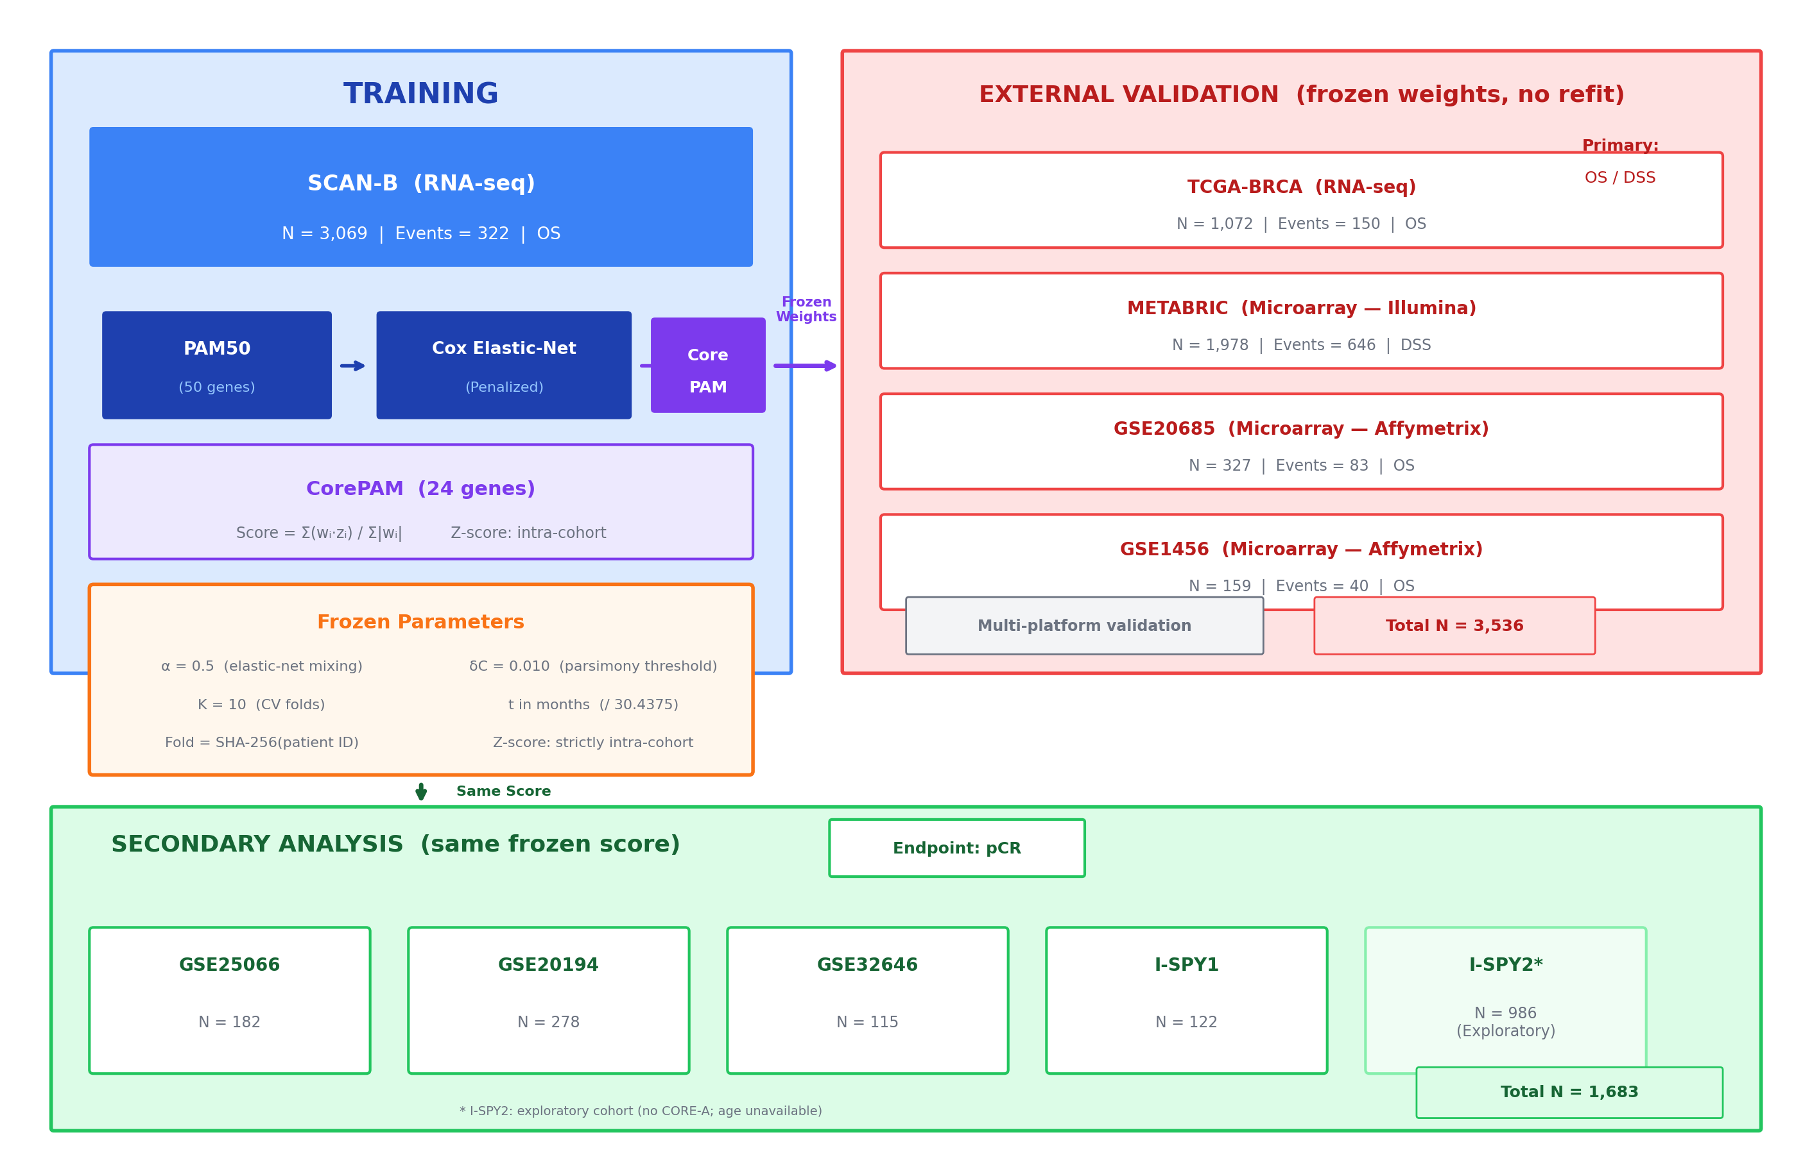
Study design overview. CorePAM: a 24-gene prognostic signature derived from the PAM50 gene set via elastic-net Cox regression in SCAN-B (N = 3,069; RNA-seq) and validated in four independent cohorts (TCGA-BRCA, METABRIC, GSE20685, GSE1456; total N = 3,536) spanning RNA-seq and microarray platforms, plus five neoadjuvant chemotherapy cohorts for pCR prediction. All analytical parameters were pre-specified and frozen before analysis.
The 24 genes span luminal differentiation (ESR1, PGR, NAT1), proliferation (MYBL2, PTTG1, EXO1, MYC), basal phenotype (KRT5, KRT17, FOXC1), and HER2-enriched markers (ERBB2, GRB7, MIA), with full gene list in Additional file 7: Table S2. The Pareto frontier (Additional file 8: Figure S6) shows diminishing returns beyond approximately 15 genes, with the non-inferiority boundary crossed at df = 24. Bootstrap resampling (B = 200) confirmed that 15 of 24 CorePAM genes were selected in at least 70\

Prognostic validation
The CorePAM score was independently associated with survival in all four external validation cohorts (Table Table 1). In TCGA-BRCA (RNA-seq), HR per 1 SD = 1.20 (95\
[TABLE: CorePAM prognostic performance across cohorts.]
Cohort & Endpoint & N & Events & Univariate HR & Adjusted HR & C-index
SCAN-B & OS & 3,069 & 322 & 1.92 (1.74–2.13) & 1.86 (1.64–2.12) & 0.698 (0.668–0.729)
TCGA-BRCA & OS & 1,072 & 150 & 1.20 (1.04–1.40) & 1.27 (1.09–1.48) & 0.624 (0.572–0.678)
METABRIC & DSS & 1,978 & 646 & 1.41 (1.31–1.52) & 1.36 (1.24–1.48) & 0.638 (0.615–0.659)
GSE20685 & OS & 327 & 83 & 1.40 (1.12–1.75) & 1.40 (1.12–1.75) & 0.626 (0.565–0.684)
GSE1456 & OS & 159 & 40 & 1.71 (1.23–2.38) & — & 0.661 (0.582–0.741)

Kaplan–Meier survival curves across all five cohorts, stratified at the intra-cohort median CorePAM score (High vs Low risk). {A.
TCGA-BRCA has shorter follow-up (median 32 months), attenuating the HR; a 24-month sensitivity analysis yielded HR = 1.64 (95\
Multivariate Cox regression including the CORE-A clinical model (age and ER status where available) yielded adjusted HRs of 1.27 (TCGA-BRCA), 1.36 (METABRIC), and 1.40 (GSE20685), indicating that CorePAM provides prognostic information independent of clinical covariates. GSE1456 lacked clinical covariates for CORE-A adjustment; the univariate HR of 1.71 nonetheless confirms cross-platform generalizability on an independent Affymetrix dataset. The training cohort (SCAN-B; panel A of Figure Figure 2) showed an in-sample C-index of 0.698 (OOF C-index = 0.670).

Meta-analysis
Random-effects meta-analysis across four validation cohorts yielded a pooled HR of 1.37 (95\
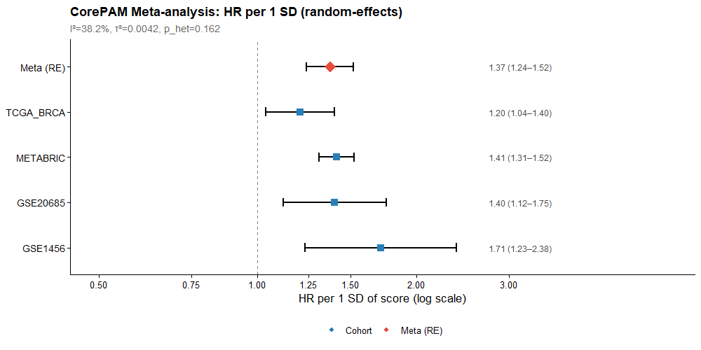
Forest plot of random-effects meta-analysis. HR per 1 SD CorePAM score across four validation cohorts plus pooled RE estimate (K = 4; REML estimator).
[TABLE: Random-effects meta-analysis of CorePAM prognostic association (K = 4 validation cohorts).]
Analysis & HR (95\
Primary RE (REML) & 1.37 (1.24–1.52) & 1.6 10^{-9} & 38.2\
Hartung–Knapp & 1.37 (1.15–1.64) & 0.011 & 38.2\
OS-harmonised & 1.36 (1.13–1.64) & <0.001 & 50.5\

Incremental value beyond clinical predictors
The CorePAM score improved the C-index over the CORE-A clinical model in all four cohorts (Table Table 3). CORE-A covariates were: age and ER status in SCAN-B and METABRIC; age alone in TCGA-BRCA and GSE20685 (where ER status was absent from harmonised clinical files). The largest increment was observed in GSE20685 (ΔC = +0.093), consistent with the long follow-up and high event rate in that cohort (Figure Figure 4a). Calibration at clinically relevant horizons showed adequate concordance between predicted and observed event rates in the training cohort, with expected under-confidence in external validation cohorts (Figure Figure 4b). Decision curve analysis confirmed net clinical benefit across a range of probability thresholds in all cohorts (Additional file 10: Figure S8). Sensitivity analysis comparing age-only versus age + ER baselines confirmed that the CorePAM HR remains significant under both definitions (Additional file 11: Figure S9).
[TABLE: Incremental C-index of CorePAM score over the CORE-A clinical model.]
Cohort & CORE-A covariates & N & C (CORE-A) & C (CORE-A + CorePAM) & ΔC (95\
SCAN-B & age + ER & 3,069 & 0.750 & 0.780 & +0.030 (0.014–0.049)
TCGA-BRCA & age & 1,072 & 0.638 & 0.676 & +0.038 (0.011–0.086)
METABRIC & age + ER & 1,978 & 0.603 & 0.646 & +0.043 (0.025–0.066)
GSE20685 & age & 327 & 0.536 & 0.630 & +0.094 (0.021–0.175)
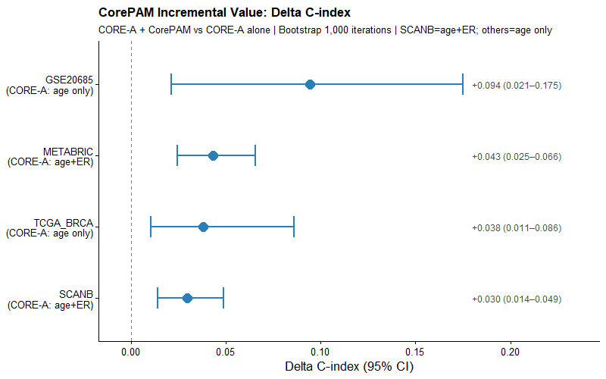
Incremental C-index (ΔC) of CorePAM score added to the CORE-A clinical model (age ± ER status) across five cohorts. Error bars: 95\
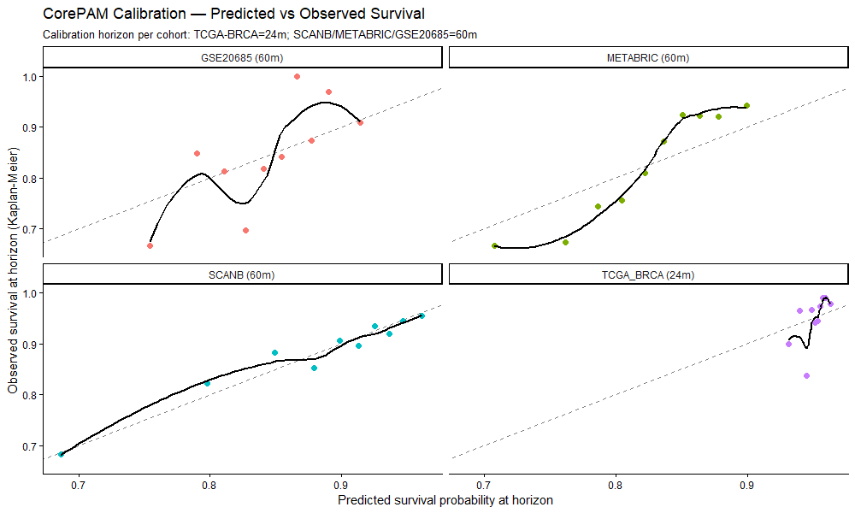
Calibration curves: predicted versus observed event rates at 60 months (SCAN-B, METABRIC, GSE20685) and 24 months (TCGA-BRCA). Diagonal: ideal calibration. Loess smoother with 95\

Sensitivity analyses
Frozen z-score (single-sample scoring feasibility). When the SCAN-B training cohort mean and standard deviation per gene were frozen and applied to external validation cohorts—without any cohort-level re-standardisation—the C-index was preserved in RNA-seq and array cohorts sharing a similar dynamic range: TCGA-BRCA ΔC = +0.0002 (Pearson r = 0.999); METABRIC ΔC = +0.0007 (r = 0.958). In the Affymetrix microarray cohorts, which have a markedly different intensity distribution from the RNA-seq training reference, discrimination was attenuated: GSE20685 ΔC = −0.036 (r = 0.923); GSE1456 ΔC = −0.040 (r = 0.916). These results suggest that frozen single-sample scoring is feasible when the assay platform is compatible with the training reference, but that platform-specific recalibration would be needed for Affymetrix-based deployment (Additional file 12: Table S3).
Uno's C-statistic and time-dependent AUC. IPCW-based discrimination metrics confirmed the Harrell's C-index findings: Uno's C ranged from 0.668 (GSE20685) to 0.681 (METABRIC); time-dependent AUC at the cohort-specific horizon ranged from 0.675 (GSE20685, 60m) to 0.695 (METABRIC, 60m). These concordance estimates are robust to heterogeneous censoring (Additional file 13: Table S4).
Formal calibration. Logistic recalibration at the cohort-specific horizon yielded calibration slopes ranging from 0.96 (SCAN-B, near-ideal) to 2.74 (TCGA-BRCA), with corresponding intercepts of 0.56 (SCAN-B) to 5.40 (TCGA-BRCA). The training cohort showed a near-ideal calibration slope (β = 0.96), though the non-zero intercept (α = 0.56) indicates moderate systematic underprediction of absolute risk. External validation cohorts showed miscalibration that was mild in METABRIC (β = 1.77) and GSE20685 (β = 1.57) but substantial in TCGA-BRCA (β = 2.74), the latter consistent with its short follow-up and low event rate at the 24-month horizon (Additional file 14: Table S5).
ER-stratified subgroup analysis. In SCAN-B (N = 2,870; OS), CorePAM was significantly associated with survival in both ER-positive (HR = 1.92; 95\

Independence from clinical-pathological staging
To address whether CorePAM retains prognostic value after adjustment for standard clinical-pathological variables, we fitted expanded multivariable Cox models adjusting for age, ER status (where available), pathological T-stage, and nodal status. T-stage and nodal status were available in 96–100\
In a comprehensive secondary analysis including all six standard clinical-pathological variables (age, ER status, T-stage, nodal status, histological grade, and HER2 status), CorePAM retained independent significance in both SCAN-B (adjusted HR = 1.75; 95\

Pathologic complete response (secondary analysis)
In four independent neoadjuvant cohorts (N = 697 total), the CorePAM score showed a positive association with pCR in all four cohorts, reaching statistical significance in three of four (Table Table pcr). GSE25066 showed a positive but non-significant trend (OR = 1.44; p = 0.060). ORs ranged from 1.44 to 2.10 per 1 SD. The AUC ranged from 0.576 to 0.716, indicating moderate to good discriminative ability for pCR prediction.
[TABLE: CorePAM score predicts pCR in neoadjuvant chemotherapy cohorts.]
Cohort & N & pCR, n (\
GSE25066 & 182 & 42 (23.1\
GSE20194 & 278 & 56 (20.1\
GSE32646 & 115 & 27 (23.5\
I-SPY1 & 122 & 32 (26.2\
Random-effects meta-analysis yielded a pooled OR of 1.69 (95\
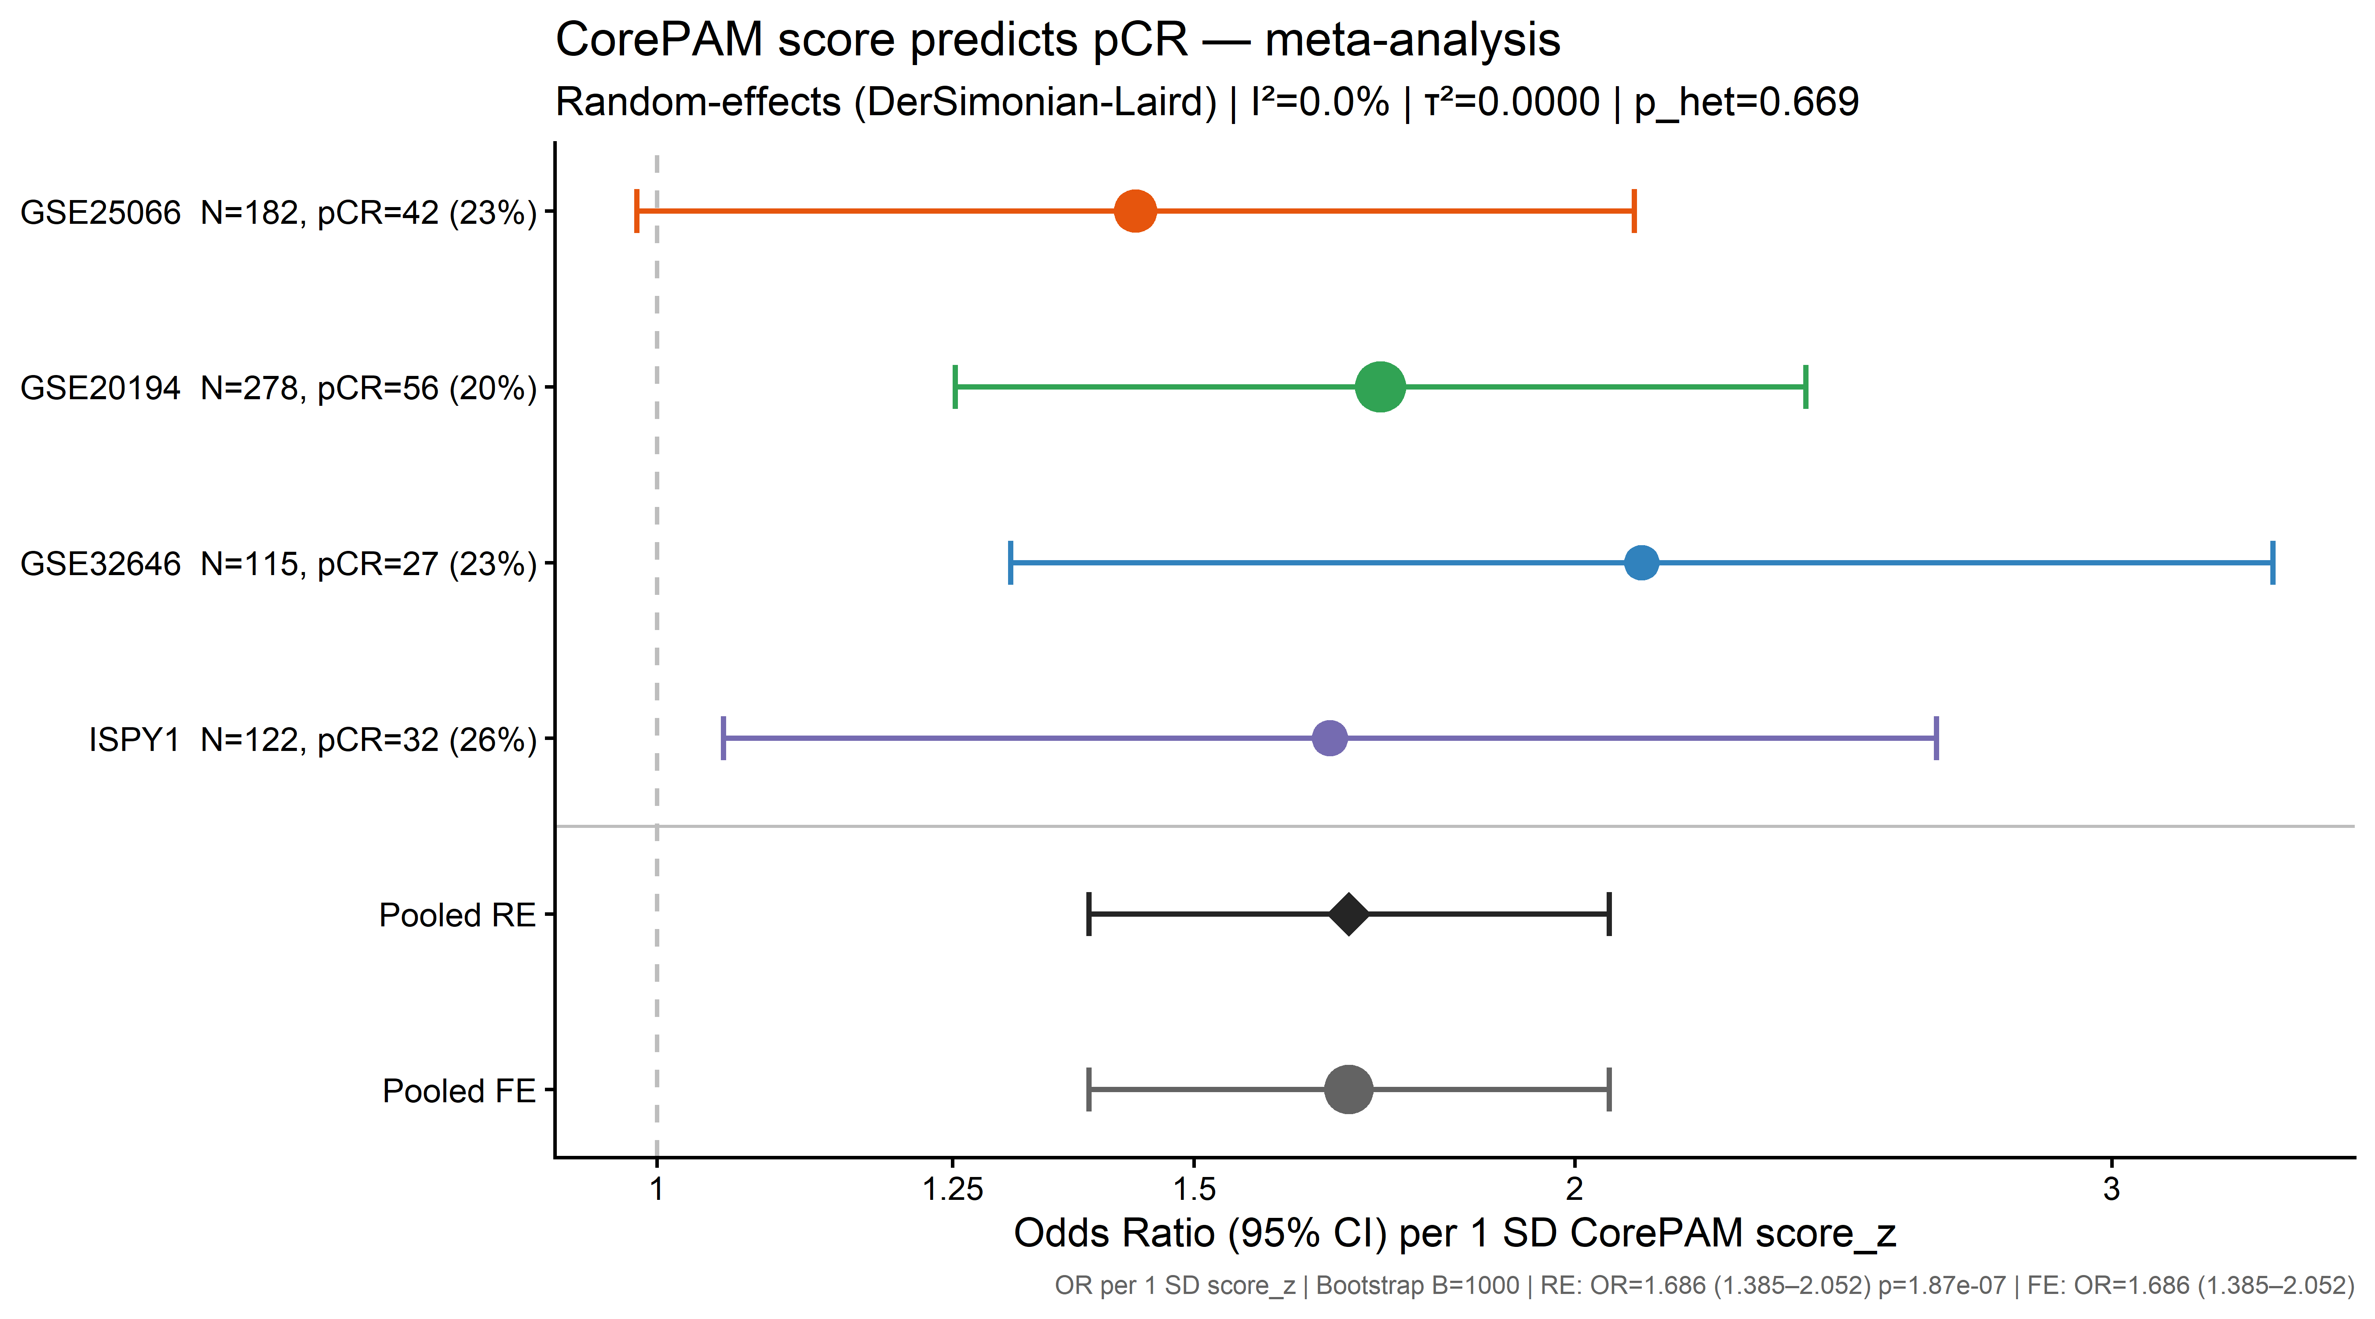
Forest plot of CorePAM and pathologic complete response (pCR). OR per 1 SD CorePAM score (univariate logistic regression) in four independent neoadjuvant chemotherapy cohorts (GSE25066, GSE20194, GSE32646, I-SPY1; total N = 697), with random-effects pooled estimate (DerSimonian–Laird; I² = 0\
I-SPY2 exploratory analysis. In the I-SPY2 external exploratory cohort (GSE194040; N = 986; pCR rate = 32.4\

Discussion
CorePAM is a data-driven 24-gene reduction of PAM50 selected within a pre-specified ΔC-index framework relative to a full 50-gene elastic-net comparator. In newly added direct paired external comparisons, discrimination was similar in TCGA-BRCA and favoured the reduced model in METABRIC, GSE20685, and GSE1456 under both cohort-standardised and frozen-reference scoring (Additional file 18: Table S8). These findings support the robustness of the reduced model within the present elastic-net framework. However, external calibration and frozen-reference single-sample performance remained platform-dependent, so these results should not be interpreted as evidence of platform-agnostic deployment or equivalence with commercial PAM50-based assays (Prosigna). No claims of therapeutic equivalence or clinical decision-making impact are made.
Reproducible derivation. Fold assignment was deterministic (SHA-256 of patient identifiers), eliminating random seeds as a driver of gene selection and ensuring exact reproducibility from first principles. The gene count (N = 24) was not pre-specified; it was derived from the Pareto frontier of model complexity versus OOF C-index (Additional file 8: Figure S6), where performance plateaus well before 50 genes.
Gene selection stability. Bootstrap resampling (B = 200 refits on SCAN-B) confirmed that 15 of 24 CorePAM genes were selected in at least 70\
Heterogeneity is expected and informative. The moderate I² in the OS/DSS meta-analysis reflects two structural sources: endpoint divergence (DSS in METABRIC vs.\ OS in the other cohorts) and differential follow-up duration (32 months in TCGA-BRCA vs.\ 91–159 months elsewhere). The OS-harmonised sensitivity analysis (substituting METABRIC OS for DSS) reduced I² substantially, confirming the pooled estimate is not driven by endpoint choice. The key finding is the consistency of direction—a positive HR in all four validation cohorts—rather than effect magnitude. The Hartung–Knapp sensitivity analysis confirmed significance under conservative inference.
Biological coherence. The retained genes recapitulate core PAM50 biology: luminal differentiation (ESR1, PGR, BCL2, NAT1), proliferation (MYBL2, PTTG1, EXO1, MYC), basal phenotype (KRT5, KRT17, FOXC1), and HER2-enriched markers (ERBB2, GRB7). The proliferation genes also explain the pCR signal, as these pathways are targeted by anthracycline-taxane regimens. The 26 excluded genes received zero weight at the selected λ, consistent with functional redundancy under the elastic-net grouping property.
Cross-platform consistency in pCR prediction. The pCR block showed no heterogeneity (I² = 0\
Calibration and transportability. Calibration at clinically relevant horizons (60 months for SCAN-B, METABRIC, GSE20685; 24 months for TCGA-BRCA) showed adequate concordance between predicted and observed event rates in the training cohort (Figure Figure 4b). Formal logistic recalibration confirmed a near-ideal calibration slope in the training cohort (β = 0.96; intercept α = 0.56, indicating moderate underprediction of absolute risk) with further miscalibration in external cohorts (slopes 1.57–2.74), consistent with model under-confidence when applying scores cross-platform without recalibration—a structural property of intra-cohort z-scoring. Exploratory decision curve analysis suggested positive net benefit across a range of probability thresholds (Additional file 10: Figure S8).
Frozen z-score sensitivity. A key reviewer concern was whether the intra-cohort z-score normalisation—appropriate for retrospective multi-cohort validation—could support single-sample scoring. Our frozen z-score sensitivity analysis applied SCAN-B reference mean/SD per gene to each external cohort without any cohort-level re-standardisation, ensuring that each patient's score depends only on their own expression values and the frozen reference. Discrimination was preserved in TCGA-BRCA (ΔC = +0.0002; r = 0.999) and METABRIC (ΔC = +0.0007; r = 0.958). In the Affymetrix cohorts, frozen scoring showed measurable attenuation (GSE20685: ΔC = −0.036, r = 0.923; GSE1456: ΔC = −0.040, r = 0.916), consistent with the larger distributional gap between RNA-seq and these microarray platforms. These findings support platform-conditional rather than platform-agnostic fixed-reference scoring and indicate that platform-specific recalibration would be required before deployment.
Uno's C-statistic confirms robustness to censoring. IPCW-based concordance metrics (Uno's C, time-dependent AUC) yielded estimates consistent with Harrell's C-index, confirming that the observed discrimination is not an artefact of heterogeneous censoring distributions across cohorts.
ER subgroup analysis. CorePAM is prognostic in unselected cohorts overall, with the clinically meaningful signal concentrated in ER-positive disease. In both SCAN-B and METABRIC, the ER-positive HR was robust (1.92 and 1.59, respectively; both p < 0.001). In ER-negative patients, SCAN-B showed an apparent effect (HR = 2.53) that was not replicated in the better-powered METABRIC analysis (HR = 0.97; N = 439, 186 events). Bootstrap analysis confirmed that the SCAN-B ER-negative estimate is highly unstable (95\
Independence from clinical-pathological staging. CorePAM retained independent prognostic value after adjustment for all six standard clinical-pathological variables (age, ER, T-stage, N-status, grade, HER2) in both SCAN-B (LRT p = 4.9 10^{-13}) and METABRIC (LRT p = 6.1 10^{-6}). The ΔC of +0.015 to +0.017 over this comprehensive baseline—and +0.032 in ER-positive METABRIC—confirms that CorePAM captures molecular heterogeneity not accessible through routine clinical-pathological assessment.
Comparison with established signatures. An exploratory head-to-head comparison against research-based implementations (genefu R package) of the PAM50-derived Risk of Recurrence score (ROR-S, 50 genes) and the OncotypeDX Recurrence Score (ODX-RS, 21 genes) showed that CorePAM (24 genes) performs competitively (Additional file 17: Table S7). CorePAM showed advantages in the RNA-seq cohorts (its training domain) and small deficits (ΔC < 0.03) in the microarray cohorts (the development domain of those signatures). This comparison involves research-based score implementations—not commercial assays—and should be interpreted as evidence of competitive performance, not clinical equivalence.
Clinical implications. A smaller gene set may simplify future assay development, but analytical validation on specific deployment platforms and prospective clinical validation were beyond the scope of this study.
Limitations. Study design and data. This is a retrospective study using public data, and no prospective validation was performed. TCGA-BRCA has structurally short follow-up (median 32 months), which may attenuate the detectable HR; the 24-month sensitivity analysis (Additional file 9: Figure S7) partially mitigates this concern. METABRIC uses DSS as the primary endpoint, following established precedent for that dataset. Endpoint heterogeneity across cohorts is reflected in the moderate meta-analytic I² and should be considered when interpreting pooled estimates. HER2 status was not available in sufficient cohorts to permit HER2-stratified subgroup analysis.
Analytical choices. The primary CORE-A clinical baseline was restricted to age and ER status—the two variables consistently available in harmonised form—although expanded models including T-stage and nodal status confirmed independent prognostic value (Additional file 3: Table S1). ER status was unavailable in TCGA-BRCA and GSE20685, restricting CORE-A to age alone in those cohorts. The primary score formulation relied on cohort-wise z-score standardisation, which limits direct transportability of absolute risk estimates. In frozen-reference analyses, discrimination remained stable in TCGA-BRCA and METABRIC (ΔC < 0.001) but was attenuated in the Affymetrix cohorts (GSE20685: ΔC = −0.036; GSE1456: ΔC = −0.040), indicating that fixed-reference single-sample scoring is currently platform-dependent rather than platform-agnostic. Gene coverage remained high across validation cohorts (24/24 in METABRIC and GSE20685; 23/24 in TCGA-BRCA; 21/24 in GSE1456), and leave-one-gene-out sensitivity analysis confirmed that the score is robust to the absence of any single gene (Additional file 1: Figure S1). Comparisons with ROR-S and ODX-RS used research-based implementations, not commercial assays.
Clinical translation. A smaller gene set may simplify future assay development, but analytical validation on specific deployment platforms and platform-specific housekeeping-gene calibration were beyond the scope of this study and are the subject of planned technical validation work.

Conclusions
CorePAM is a reproducible 24-gene reduction of the PAM50 panel selected within a pre-specified ΔC-index framework relative to a full 50-gene elastic-net comparator. Across four external RNA-seq and microarray cohorts, the reduced model retained prognostic discrimination. In cohorts with sufficient clinicopathological annotation, it also provided incremental value beyond a comprehensive six-variable clinical baseline (age, ER, T-stage, N-status, grade, HER2; LRT p < 10^{-5}), with the clinically meaningful signal concentrated in ER-positive disease. In direct paired external comparisons, discrimination was similar to or higher than the fuller comparator (Additional file 18). CorePAM was also associated with pathologic complete response in secondary neoadjuvant analyses (I² = 0\
AUC: Area under the curve;
CI: Confidence interval;
CORE-A: Clinical baseline model (age ± ER status);
CPM: Counts per million;
CV: Cross-validation;
DCA: Decision curve analysis;
DL: DerSimonian–Laird;
DSS: Disease-specific survival;
ER: Estrogen receptor;
FFPE: Formalin-fixed paraffin-embedded;
GDC: Genomic Data Commons;
GEO: Gene Expression Omnibus;
HER2: Human epidermal growth factor receptor 2;
HGNC: HUGO Gene Nomenclature Committee;
HR: Hazard ratio;
KM: Kaplan–Meier;
LLM: Large language model;
OOF: Out-of-fold;
OR: Odds ratio;
OS: Overall survival;
PAM50: Prediction Analysis of Microarray 50;
PCA: Principal component analysis;
pCR: Pathologic complete response;
RE: Random effects;
REML: Restricted maximum likelihood;
ROR-S: Risk of Recurrence score (subtype-based);
SD: Standard deviation;
SE: Standard error;
TMM: Trimmed mean of M-values.

Supplementary information
Additional files 1–18 are available as supplementary material. See the Additional files section at the end of this article for descriptions.

Acknowledgements
The authors thank the SCAN-B, TCGA, METABRIC, I-SPY, and Stockholm (GSE1456) consortia for making their data publicly available.
•[Ethics approval and consent to participate] Not applicable. This study uses exclusively publicly available de-identified data (GEO, GDC, cBioPortal). No new human subjects research was conducted.
•[Consent for publication] Not applicable.
•[Availability of data and materials] All raw data are available through GEO (GSE96058, GSE25066, GSE20194, GSE32646, GSE22226, GSE194040, GSE1456), GDC (TCGA-BRCA), and cBioPortal (METABRIC). Analysis code, frozen analytical parameters, and a single-command reproducibility script are available at https://github.com/RafaelBotan/CorePAM-Study (release tagged at submission). All results can be reproduced from raw public data using the provided pipeline.
•[Competing interests] The authors declare no competing interests.
•[Funding] No external funding was received. This study was conducted independently by the authors.
•[Authors' contributions] RB designed the study, performed all analyses, and wrote the manuscript. JBS supervised the study and reviewed the manuscript. Both authors read and approved the final manuscript.
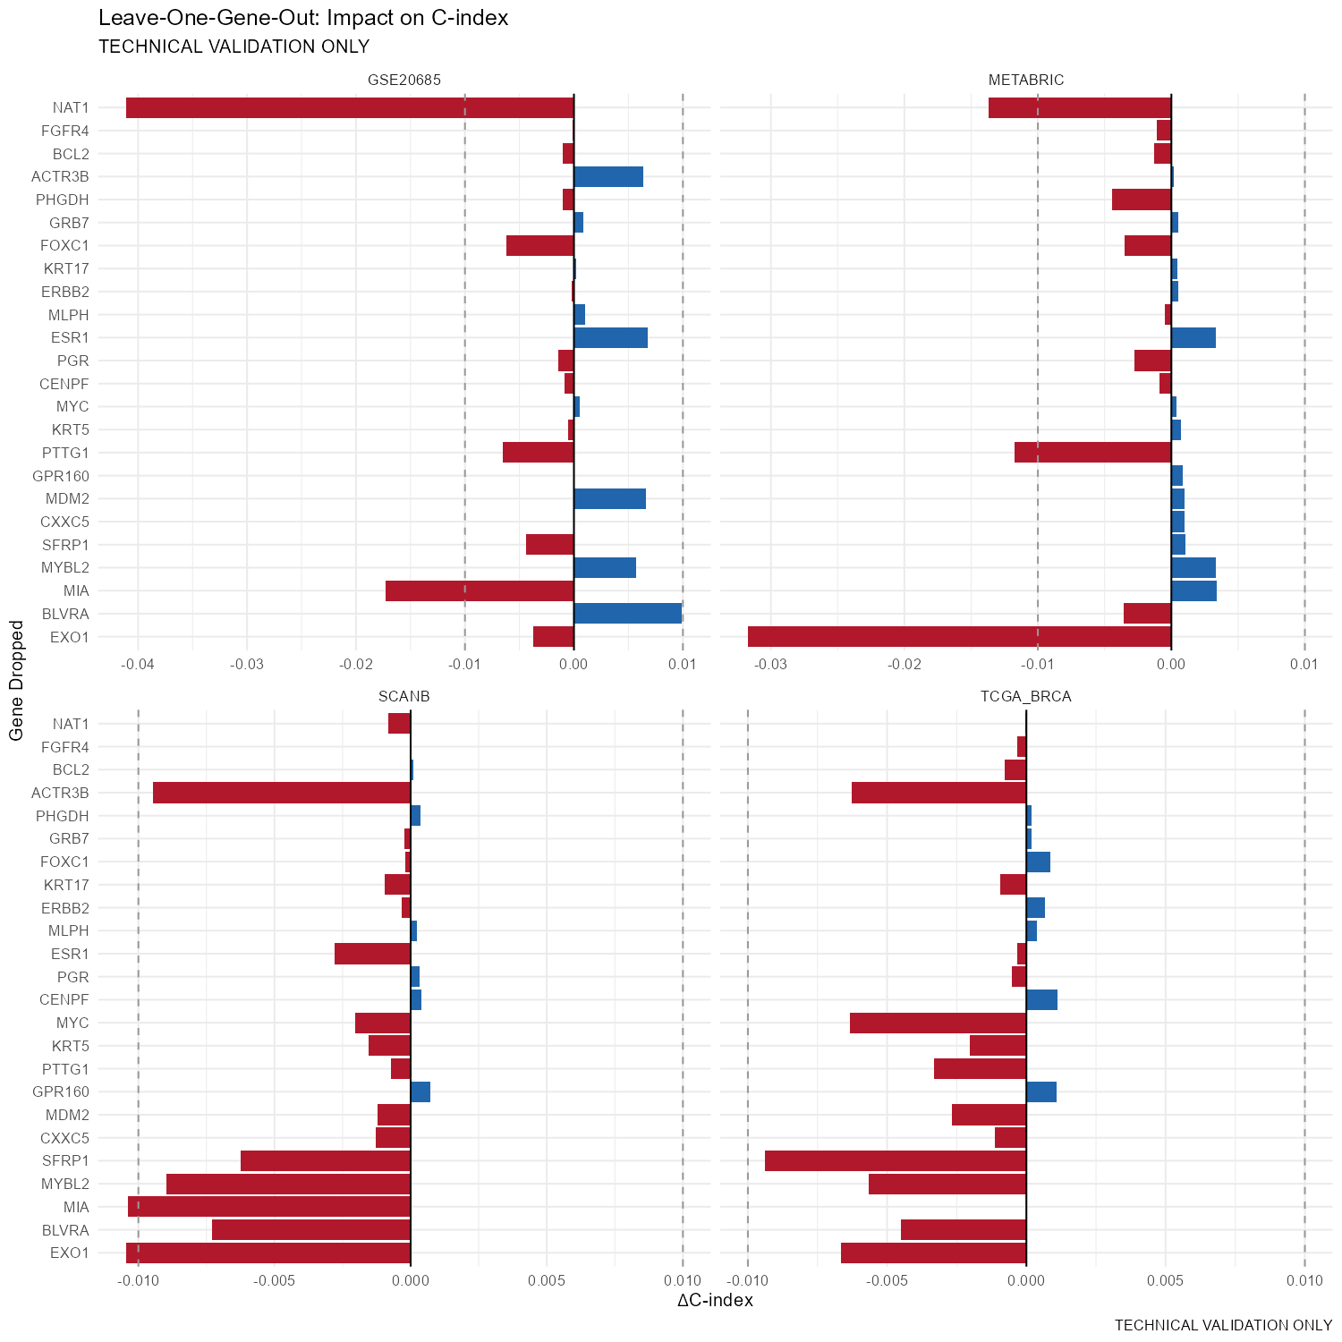
{Additional file 1: Figure S1.
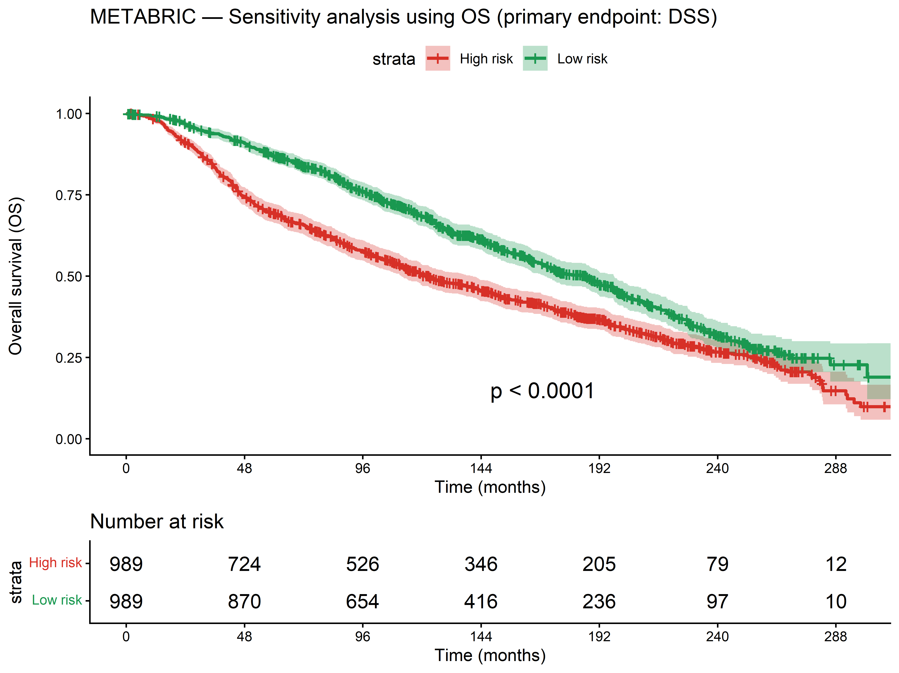
{Additional file 2: Figure S2.
[TABLE: {Additional file 3: Table S1.]
Cohort & N & Covariates & HR (95\
SCAN-B & 2,948 & age+ER+T+N & 1.79 (1.57–2.05) & <0.001 & 0.766 & 0.788 & +0.022
TCGA-BRCA & 1,054 & age+T+N & 1.35 (1.15–1.58) & <0.001 & 0.719 & 0.746 & +0.027
METABRIC & 1,883 & age+ER+T+N & 1.34 (1.23–1.46) & <0.001 & 0.663 & 0.688 & +0.026
GSE20685 & 327 & age+T+N & 1.45 (1.15–1.84) & 0.002 & 0.697 & 0.724 & +0.026
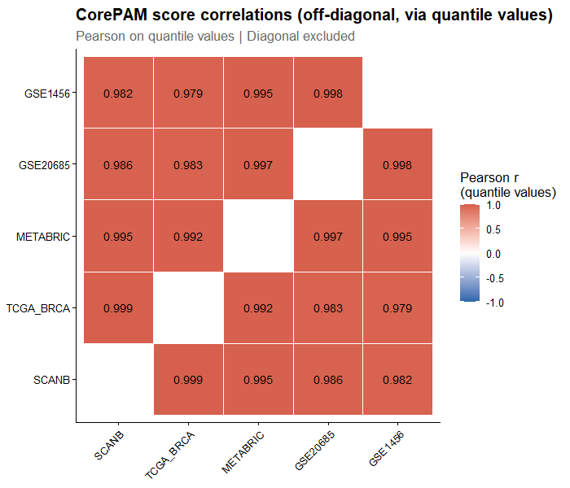
{Additional file 4: Figure S3.
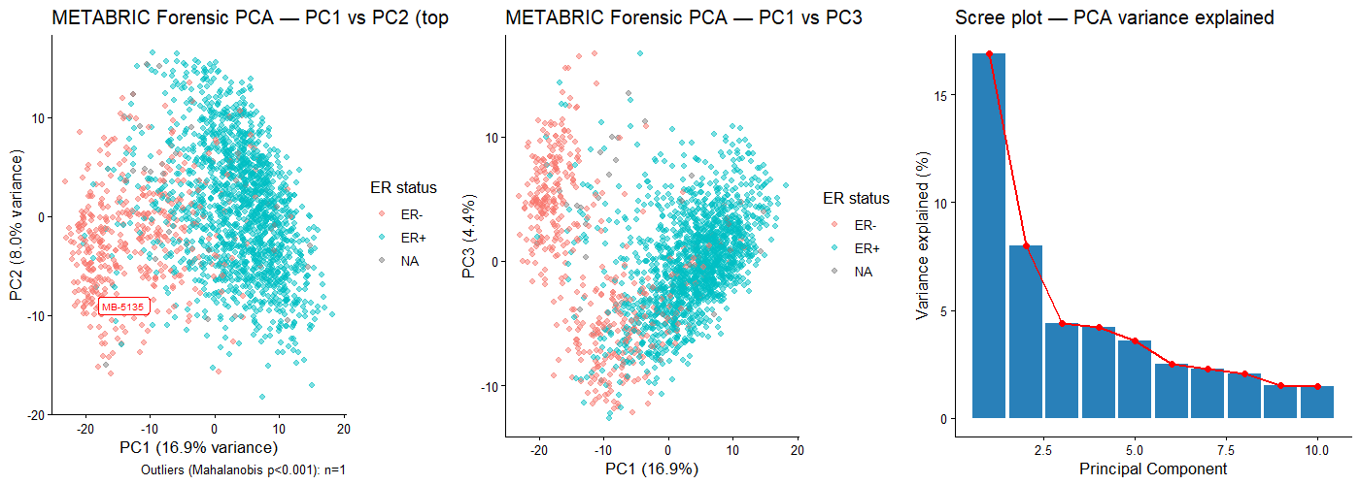
{Additional file 5: Figure S4.
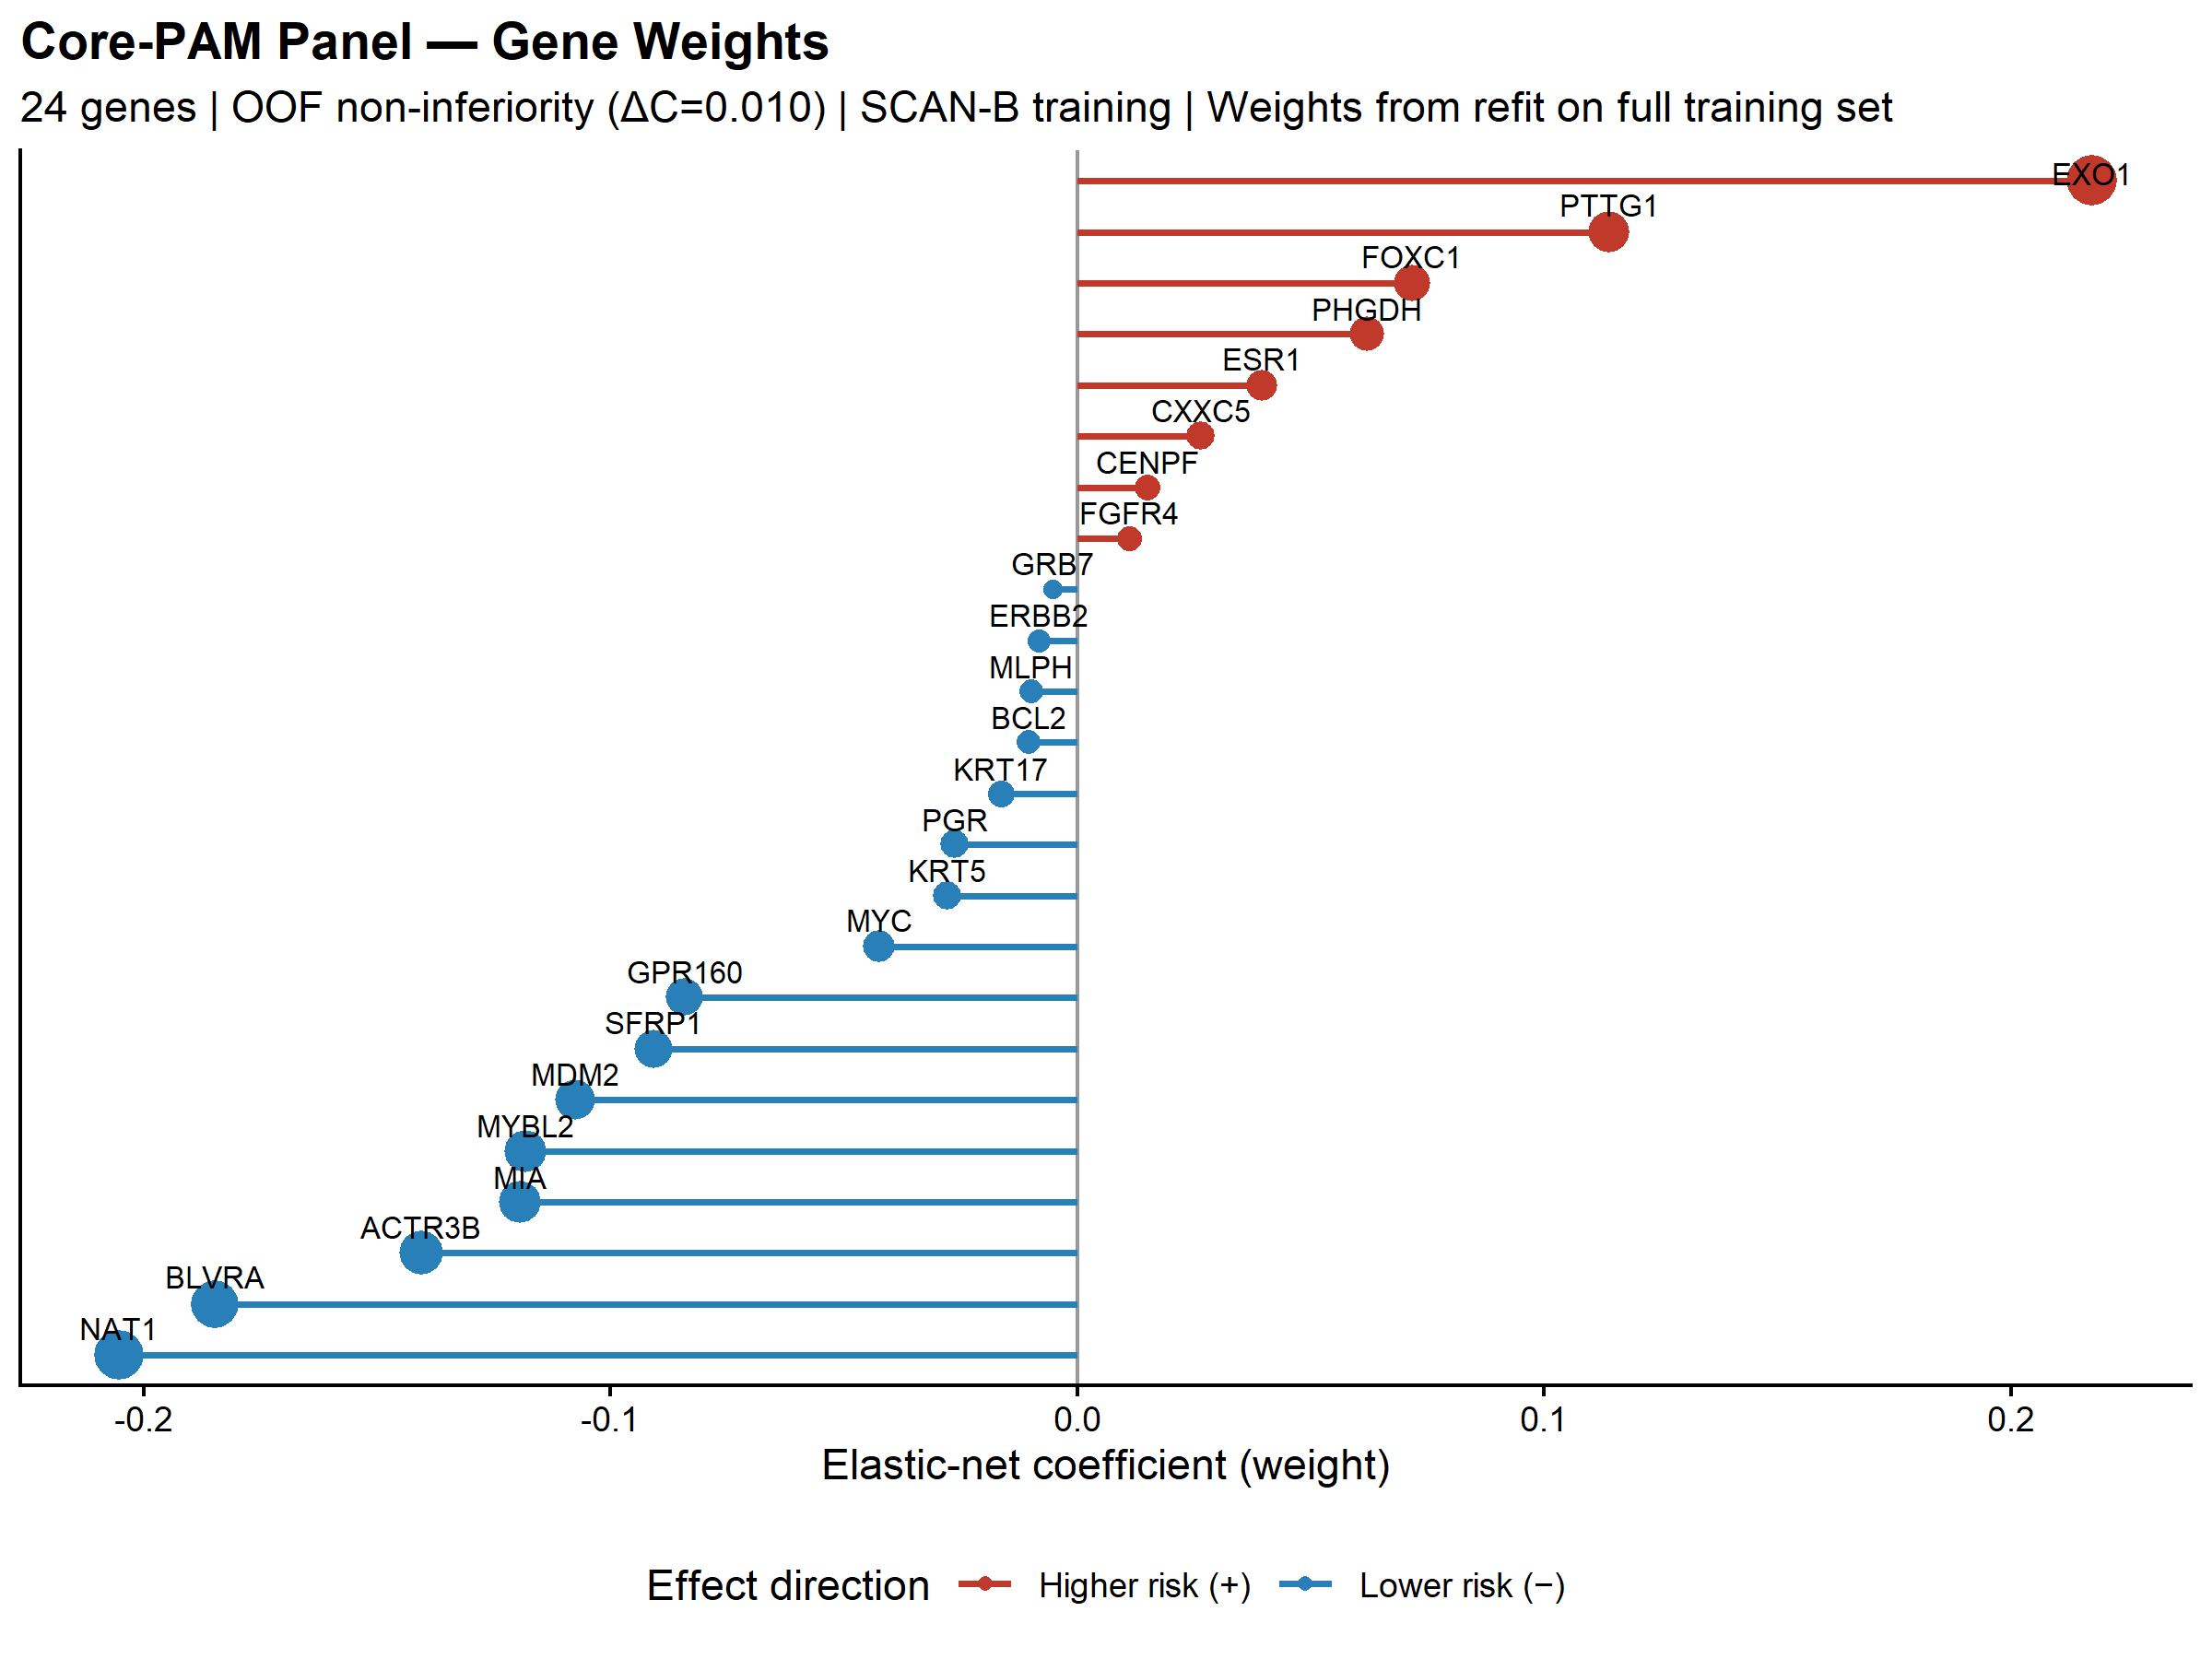
{Additional file 6: Figure S5.
[TABLE: {Additional file 7: Table S2.]
Gene & Weight & Direction
EXO1 & 0.2174 & Risk (+)
NAT1 & −0.2052 & Protective (−)
BLVRA & −0.1848 & Protective (−)
ACTR3B & −0.1405 & Protective (−)
MIA & −0.1193 & Protective (−)
MYBL2 & −0.1183 & Protective (−)
PTTG1 & 0.1140 & Risk (+)
MDM2 & −0.1074 & Protective (−)
SFRP1 & −0.0907 & Protective (−)
GPR160 & −0.0841 & Protective (−)
FOXC1 & 0.0717 & Risk (+)
PHGDH & 0.0620 & Risk (+)
MYC & −0.0424 & Protective (−)
ESR1 & 0.0396 & Risk (+)
KRT5 & −0.0277 & Protective (−)
CXXC5 & 0.0266 & Risk (+)
PGR & −0.0262 & Protective (−)
KRT17 & −0.0163 & Protective (−)
CENPF & 0.0150 & Risk (+)
FGFR4 & 0.0110 & Risk (+)
BCL2 & −0.0105 & Protective (−)
MLPH & −0.0099 & Protective (−)
ERBB2 & −0.0082 & Protective (−)
GRB7 & −0.0053 & Protective (−)
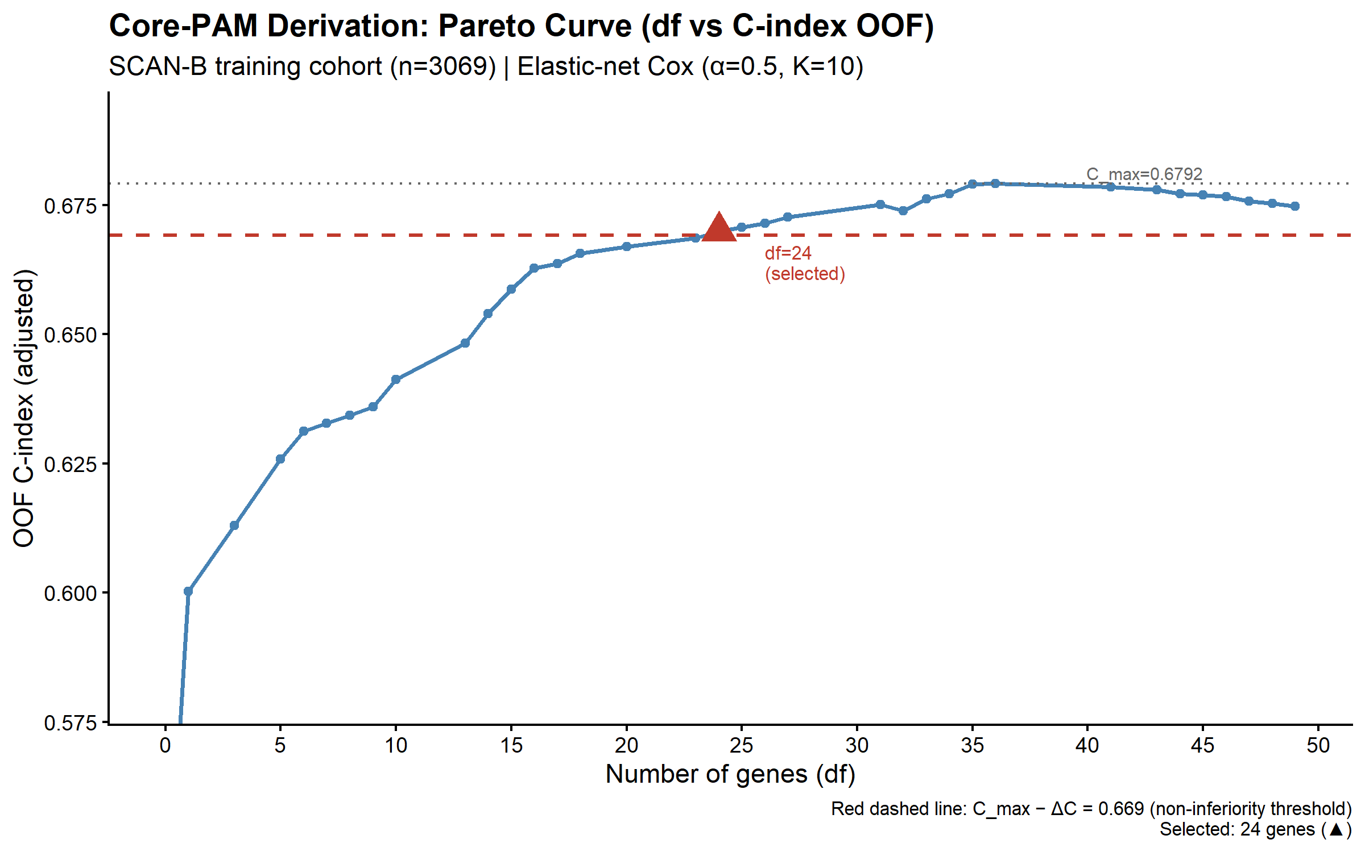
{Additional file 8: Figure S6.
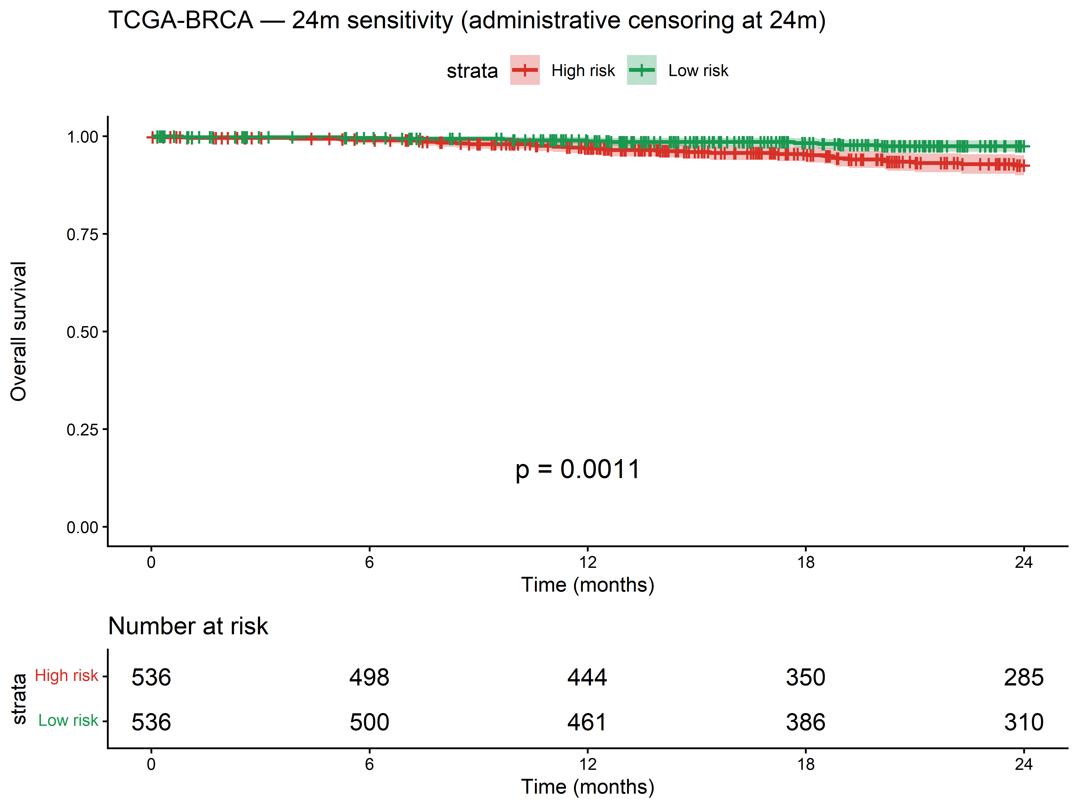
{Additional file 9: Figure S7.
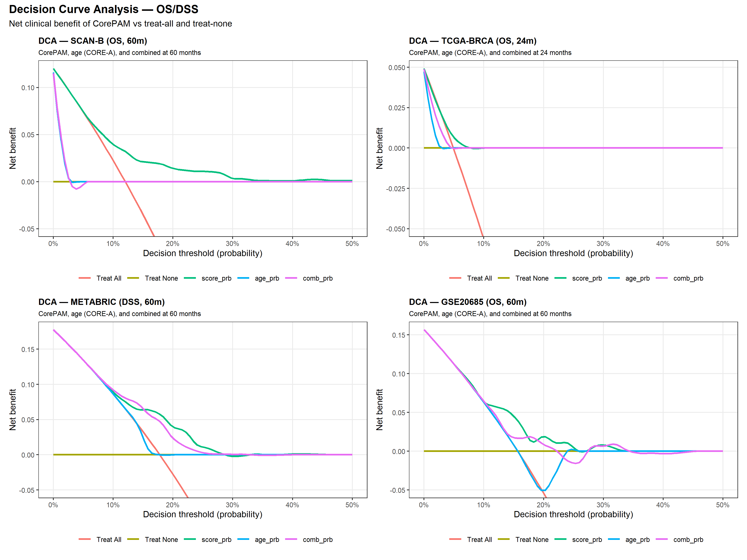
{Additional file 10: Figure S8.
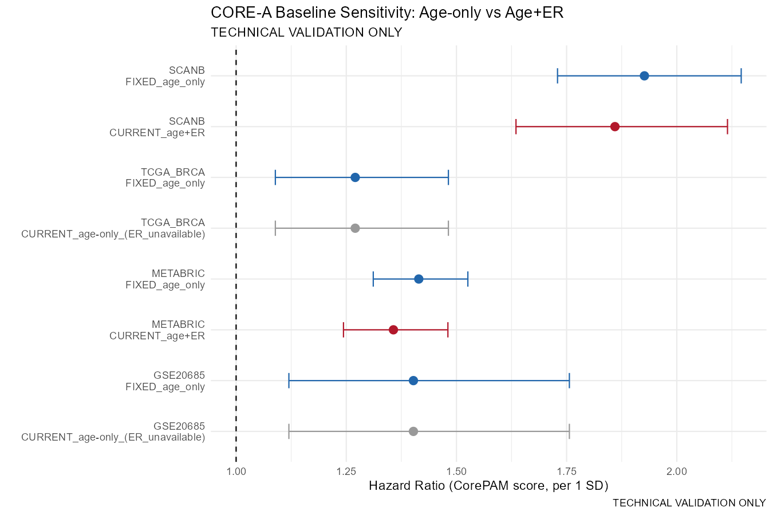
{Additional file 11: Figure S9.
[TABLE: {Additional file 12: Table S3.]
Cohort & N & Platform & C frozen & C intra & ΔC & r
SCAN-B & 3,069 & RNA-seq & 0.698 & 0.698 & 0.0000 & 1.000
TCGA-BRCA & 1,072 & RNA-seq & 0.624 & 0.624 & +0.0002 & 0.999
METABRIC & 1,978 & Microarray & 0.638 & 0.638 & +0.0007 & 0.958
GSE20685 & 327 & Microarray & 0.591 & 0.626 & −0.036 & 0.923
GSE1456 & 159 & Microarray & 0.622 & 0.661 & −0.040 & 0.916
[TABLE: {Additional file 13: Table S4.]
Cohort & N & Horizon & Uno's C & tdAUC (95\
SCAN-B & 3,069 & 60m & 0.674 & 0.679 (0.643–0.715) & 0.698
TCGA-BRCA & 1,072 & 24m & 0.669 & 0.673 (0.598–0.748) & 0.624
METABRIC & 1,978 & 60m & 0.681 & 0.695 (0.665–0.725) & 0.638
GSE20685 & 327 & 60m & 0.668 & 0.675 (0.596–0.754) & 0.626
[TABLE: {Additional file 14: Table S5.]
Cohort & N & Horizon & α (SE) & β (SE) & E/O & Brier
SCAN-B & 3,069 & 60m & 0.56 (0.18) & 0.96 (0.09) & 0.61 & 0.158
TCGA-BRCA & 1,072 & 24m & 5.40 (2.29) & 2.74 (0.79) & 0.74 & 0.061
METABRIC & 1,978 & 60m & 1.15 (0.25) & 1.77 (0.17) & 0.97 & 0.143
GSE20685 & 327 & 60m & 0.93 (0.75) & 1.57 (0.46) & 0.98 & 0.130
[TABLE: {Additional file 15: Table S6.]
Cohort & Population & N & C clinical & C clin+CorePAM & ΔC & HR_{} & LRT p
SCAN-B (OS) & All & 2,649 & 0.770 & 0.787 & +0.017 & 1.75 & 4.9 10^{-13}
SCAN-B (OS) & ER+ & 2,450 & 0.770 & 0.784 & +0.014 & 1.68 & 1.1 10^{-10}
METABRIC (DSS) & All & 1,792 & 0.678 & 0.693 & +0.015 & 1.25 & 6.1 10^{-6}
METABRIC (DSS) & ER+ & 1,377 & 0.674 & 0.707 & +0.032 & 1.47 & 1.0 10^{-10}
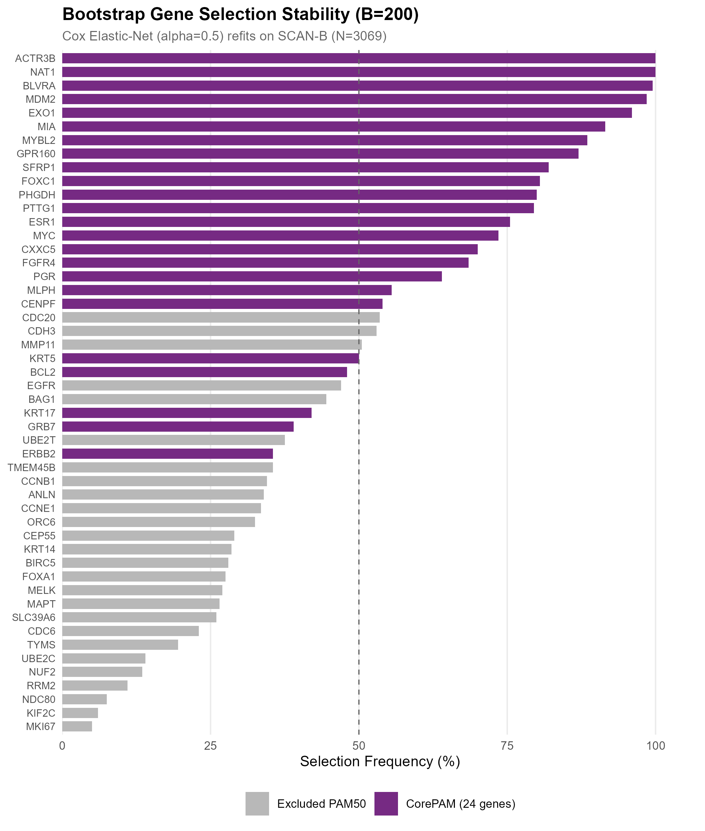
{Additional file 16: Figure S10.
[TABLE: {Additional file 17: Table S7.]
Cohort & N & CorePAM C & ROR-S C & ODX-RS C & CorePAM HR & ROR-S HR & ODX-RS HR
SCAN-B & 3,069 & 0.698 & 0.641 & 0.607 & 1.92 & 1.56 & 1.40
TCGA-BRCA & 1,072 & 0.624 & 0.602 & 0.586 & 1.20 & 1.25 & 1.13
METABRIC & 1,978 & 0.638 & 0.643 & 0.665 & 1.41 & 1.53 & 1.51
GSE20685 & 327 & 0.626 & 0.646 & 0.651 & 1.40 & 1.55 & 1.61
[TABLE: {Additional file 18: Table S8.]
Cohort & Mode & N & C_{24} & C_{49} & ΔC & 95\
TCGA-BRCA & intra & 1,072 & 0.624 & 0.631 & −0.008 & (−0.038, +0.022) & 0.853
TCGA-BRCA & frozen & 1,072 & 0.624 & 0.634 & −0.010 & (−0.039, +0.020) & 0.864
METABRIC & intra & 1,978 & 0.638 & 0.616 & +0.022 & (+0.011, +0.032) & 0.902
METABRIC & frozen & 1,978 & 0.638 & 0.622 & +0.017 & (+0.007, +0.027) & 0.914
GSE20685 & intra & 327 & 0.626 & 0.571 & +0.055 & (+0.010, +0.101) & 0.823
GSE20685 & frozen & 327 & 0.591 & 0.544 & +0.047 & (+0.007, +0.085) & 0.843
GSE1456 & intra & 159 & 0.661 & 0.564 & +0.097 & (+0.032, +0.166) & 0.697
GSE1456 & frozen & 159 & 0.622 & 0.510 & +0.111 & (+0.045, +0.181) & 0.617

