Routine pathology cannot reliably reproduce 4-class PAM50 intrinsic subtypes in breast cancer: a multicohort in silico study defining the luminal grey zone

Rafael de Negreiros Botan ^{1,*}, João Batista de Sousa ²

¹ Department of Oncology, Universidade de Brasília, Brasília, Brazil
² Department of Proctology, Universidade de Brasília, Brasília, Brazil
* Corresponding author: Rafael de Negreiros Botan – oncologista@gmail.com

Abstract
Background: Immunohistochemistry-based surrogate classification is widely used to approximate intrinsic breast cancer subtypes in routine care, but its agreement with PAM50 is incomplete. We tested whether machine-learning models applied to routine clinicopathological variables could improve on the conventional surrogate and quantified the information ceiling imposed by these variables.
Methods: Four public datasets with 4-class PAM50 labels were analysed (GSE81538, n=383; GSE96058, n=2,867; TCGA-BRCA, n=519; METABRIC, n=1,608; total n=5,377). Logistic regression, random forest, and XGBoost were trained on the SCAN-B cohorts using nested feature sets of increasing complexity: ER/PR/HER2 (Set 1), + grade (Set 2), and + Ki-67 (Set 3). External validation was performed in TCGA-BRCA and METABRIC. Head-to-head comparisons with the immunohistochemical surrogate used identical evaluable subsets, and performance was estimated with bootstrap 95% confidence intervals.
Results: No machine-learning model outperformed the surrogate in any external comparison. On METABRIC head-to-head analysis (n=1,554), the surrogate achieved macro-F1 0.646 (95% CI 0.623–0.669) versus 0.559 (0.533–0.584) for the best model (XGBoost, Set 2). The dominant source of error was the Luminal A/Luminal B boundary: 42.5% of molecular Luminal B tumours received a Luminal A-like surrogate label. Collapsing both luminal classes increased macro-F1 to 0.767. A low-confidence grey zone comprised 13.5% of cases, was 73.6% luminal, and showed only 15.9% machine-learning accuracy.
Conclusions: Routine clinicopathological variables impose an information ceiling that prevents reliable reproduction of 4-class PAM50 subtypes. The irreducible uncertainty concentrates at the Luminal A/Luminal B boundary, defining a clinically relevant grey zone in which molecular testing adds the greatest value.
1. Introduction
Breast cancer is a biologically heterogeneous disease. Gene-expression profiling established the major intrinsic subtypes—Luminal A, Luminal B, HER2-enriched, and Basal-like—which differ in prognosis, proliferation, endocrine sensitivity, and treatment responsiveness [1,2]. Among available molecular classifiers, PAM50 remains the most widely adopted framework for intrinsic subtyping and is deeply embedded in translational research and clinical decision-making [3].
In routine practice, however, true molecular subtyping is often unavailable. Most centres instead rely on immunohistochemical surrogates based on ER, PR, HER2, and Ki-67, as popularised by the St Gallen consensus [4]. This approach is pragmatic, inexpensive, and globally scalable, but it is only an approximation of intrinsic biology. Discordance between immunohistochemical surrogates and PAM50 is well recognised, particularly in hormone receptor-positive disease, where the Luminal A/Luminal B distinction reflects a continuous proliferative axis that routine markers capture only imperfectly [5,6].
An intuitive next question is whether machine-learning methods can recover additional molecular information from the same routine variables and improve on the rule-based surrogate. If successful, a purely computational approach could refine subtype approximation without additional laboratory cost. If unsuccessful, the negative result is still clinically meaningful: it would indicate that routine pathology data contain an information ceiling that no algorithm can overcome, and that molecular testing remains irreplaceable in specific patient subgroups.
We therefore asked two linked questions. First, how accurately does the conventional immunohistochemical surrogate reproduce 4-class PAM50 intrinsic subtypes across multiple independent cohorts? Second, can machine-learning models built from the same routine clinicopathological variables improve on that approximation? Our aim was not to replace PAM50, but to define the practical limit of routine-data recoverability and identify the subtype boundary at which molecular testing provides the greatest incremental value.
2. Materials and methods
2.1 Study design
This was a retrospective, purely in silico, multicohort diagnostic-accuracy study. The index tests were the conventional immunohistochemical surrogate and each machine-learning classifier. The reference standard was the published 4-class PAM50 label in each cohort. No new biological samples were generated or analysed. The study was designed and reported according to TRIPOD principles for multivariable prediction model studies [7].
2.2 Data sources and cohorts
Four public breast cancer datasets were analysed (Table 1, Fig. 1).
Development cohorts: GSE81538 (SCAN-B; source n=405, analysable 4-class subset n=383) comprised RNA-seq data with multi-observer pathology consensus for ER, PR, HER2, Ki-67, and Nottingham histological grade (NHG) [8]. GSE96058 (SCAN-B; source n=3,069, analysable 4-class subset n=2,867) comprised RNA-seq data with binary immunohistochemical status and NHG grade [8].
External validation cohorts: TCGA-BRCA (clinical source n=1,108, analysable 4-class subset n=519) included RNA-seq data and routine ER, PR, and HER2 assessment, with HER2-equivocal cases resolved by FISH when available; histological grade was unavailable [9]. METABRIC (clinical source n=2,509, analysable 4-class subset n=1,608) included microarray-based expression data and routine ER, PR, HER2, and NHG grade [10].
Normal-like and claudin-low labels were excluded to ensure a uniform 4-class endpoint across cohorts. Publicly available processed data were obtained from NCBI GEO and cBioPortal.
Table 1. Cohort characteristics and evaluable sample sizes by feature set.
Cohort | N (4-class PAM50) | N (Set 1 complete) | N (Set 2 complete) | N (Surrogate classifiable) | N (Head-to-head Set 1 vs Surrogate)
GSE81538 | 383 | 381 | 381 | 381 | 381
GSE96058 | 2867 | 2467 | 2429 | 2597 | 2464
TCGA-BRCA | 519 | 435 | 0 | 162 | 162
METABRIC | 1608 | 1608 | 1544 | 1554 | 1554

2.3 Variable harmonisation
ER and PR were coded as binary positive/negative variables across all cohorts. HER2 was harmonised as binary positive/negative; equivocal cases were resolved using in situ hybridisation when available. Ki-67 was available as a continuous percentage in GSE81538 and as a binary high/low variable in GSE96058; it was unavailable in TCGA-BRCA and METABRIC. Histological grade (NHG 1–3) was available in GSE81538, GSE96058, and METABRIC, but not in TCGA-BRCA. Because variable granularity differed across cohorts, analyses were organised into prespecified feature sets rather than forcing a single complete-case dataset across all platforms.
2.4 Conventional surrogate classification
The baseline comparator was a St Gallen-like immunohistochemical surrogate [4]. Luminal A-like was defined as HR-positive/HER2-negative with low proliferation; Luminal B-like as HR-positive/HER2-negative with high proliferation or HR-positive/HER2-positive; HER2-positive non-luminal as HR-negative/HER2-positive; and triple-negative as HR-negative/HER2-negative. Proliferation was defined as Ki-67 ≥20% when available, or grade 3 when Ki-67 was not available. Cases missing ER, PR, or HER2 were excluded from surrogate classification.
2.5 Feature sets
Three nested feature sets were evaluated to reflect increasing real-world data availability: Set 1 (core IHC): ER, PR, HER2. Set 2 (IHC + grade): Set 1 plus histological grade. Set 3 (IHC + grade + Ki-67): Set 2 plus Ki-67. Set 3 was not available in external validation cohorts because Ki-67 was absent or not sufficiently granular in TCGA-BRCA and METABRIC.
2.6 Machine-learning models
Three supervised multiclass classifiers were trained on the combined GSE81538 and GSE96058 development cohorts: multinomial logistic regression with balanced class weights, random forest (500 trees), and XGBoost (500 rounds, maximum depth 6, learning rate 0.1). Hyperparameters were fixed before external validation. No optimisation was performed on validation cohorts.
2.7 Outcomes and statistical analysis
The primary endpoint was macro-averaged F1-score for 4-class PAM50 prediction. Secondary metrics were Cohen’s kappa and balanced accuracy. All performance estimates are reported with bootstrap 95% confidence intervals derived from 1,000 stratified resamples. Head-to-head comparisons between machine-learning models and the immunohistochemical surrogate were restricted to the exact intersection of cases classifiable by both methods, ensuring identical denominators.
Prespecified sensitivity analyses included: (1) a 3-class formulation in which Luminal A and Luminal B were collapsed into a single luminal class; and (2) a grey-zone analysis based on the maximum predicted class probability, using low (<0.50), intermediate (0.50–0.70), and high (>0.70) confidence bins.
3. Results
3.1 Cohort characteristics
After exclusions, 5,377 tumours with 4-class PAM50 labels were included: 3,250 in the development cohorts and 2,127 in external validation cohorts. Luminal A was the most prevalent subtype in every cohort, followed by Luminal B, with smaller HER2-enriched and Basal-like fractions. ER positivity ranged from 77% to 92%, and HER2 positivity from 13% to 22%. Histological grade distributions were broadly comparable across the three cohorts in which grade was available (Fig. 1). These between-cohort differences created a realistic and deliberately stringent validation setting spanning two molecular platforms and heterogeneous biomarker availability.
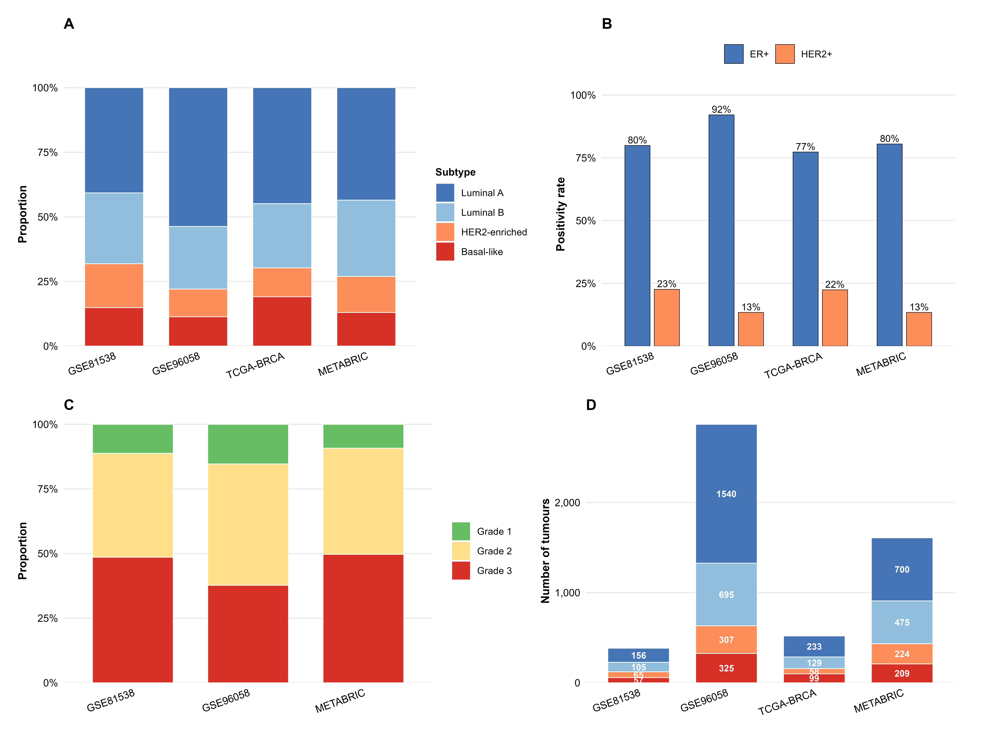
Fig. 1. Cohort characteristics. (A) PAM50 subtype distribution by cohort. (B) ER and HER2 positivity rates. (C) Histological grade distribution. (D) Absolute counts by subtype.
3.2 Baseline performance of the immunohistochemical surrogate
The immunohistochemical surrogate was classifiable in 4,694 of 5,377 tumours (87.3%). In METABRIC head-to-head analysis (n=1,554), it achieved macro-F1 0.646 (95% CI 0.623–0.669) and kappa 0.471 (0.436–0.506). Concordance was highest for Basal-like and HER2-enriched tumours and clearly lower for luminal disease.
The dominant error pattern was crossover at the Luminal A/Luminal B boundary. In METABRIC, 42.5% of molecular Luminal B tumours received a Luminal A-like surrogate label, while 26.9% of molecular Luminal A tumours were overcalled as Luminal B-like (Fig. 2, Table 2). The same general pattern was observed across all cohorts, although TCGA-BRCA showed an unstable extreme due to small evaluable luminal subsets and the absence of grade.
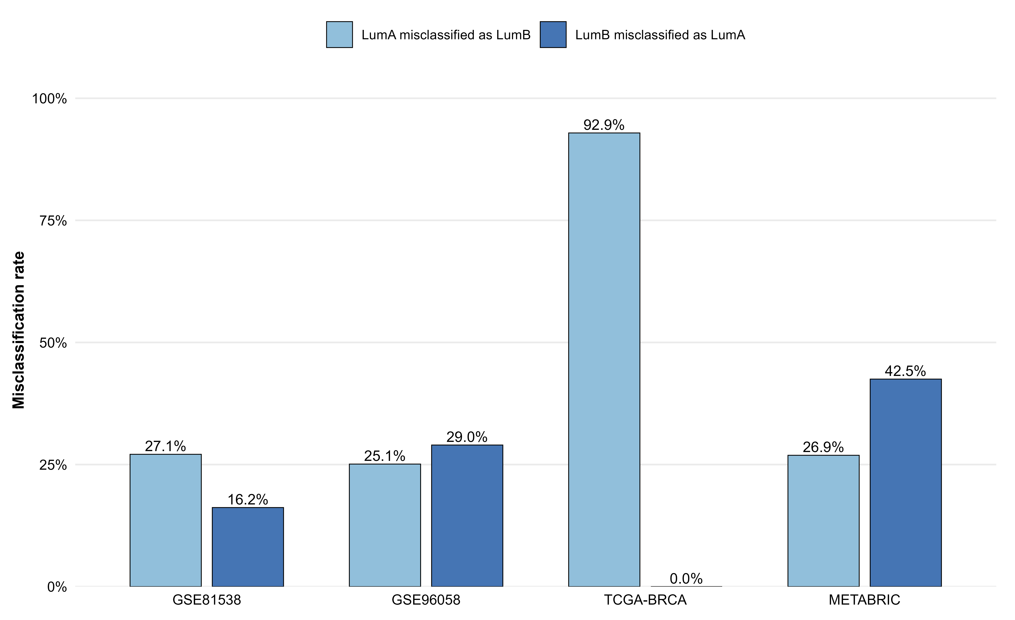
Fig. 2. Luminal A/B crossover by IHC surrogate across cohorts.
Table 2. Luminal A/Luminal B crossover rates by cohort.
Cohort | True LumA (N) | LumA misclassified as LumB | True LumB (N) | LumB misclassified as LumA
GSE81538 | 155 | 42 (27.1%) | 105 | 17 (16.2%)
GSE96058 | 1469 | 369 (25.1%) | 676 | 196 (29.0%)
TCGA-BRCA | 28 | 26 (92.9%) | 25 | 0 (0.0%)
METABRIC | 669 | 180 (26.9%) | 457 | 194 (42.5%)

3.3 Machine-learning models did not outperform the surrogate
No machine-learning model outperformed the immunohistochemical surrogate in any external head-to-head comparison (Fig. 3).
In METABRIC, the best Set 1 model (XGBoost) achieved macro-F1 0.523 (95% CI 0.503–0.544), substantially below the surrogate. Adding grade improved performance modestly: the best Set 2 model (XGBoost) reached 0.559 (0.533–0.584), but still remained inferior to the surrogate value of 0.644–0.646 depending on the matched subset.
In TCGA-BRCA, the surrogate achieved macro-F1 0.485 (0.431–0.541) in the head-to-head subset (n=162), whereas the best machine-learning model reached 0.368. Across both external cohorts, the pattern was consistent: grade added some recoverable signal, but the gain was insufficient to match the conventional surrogate.
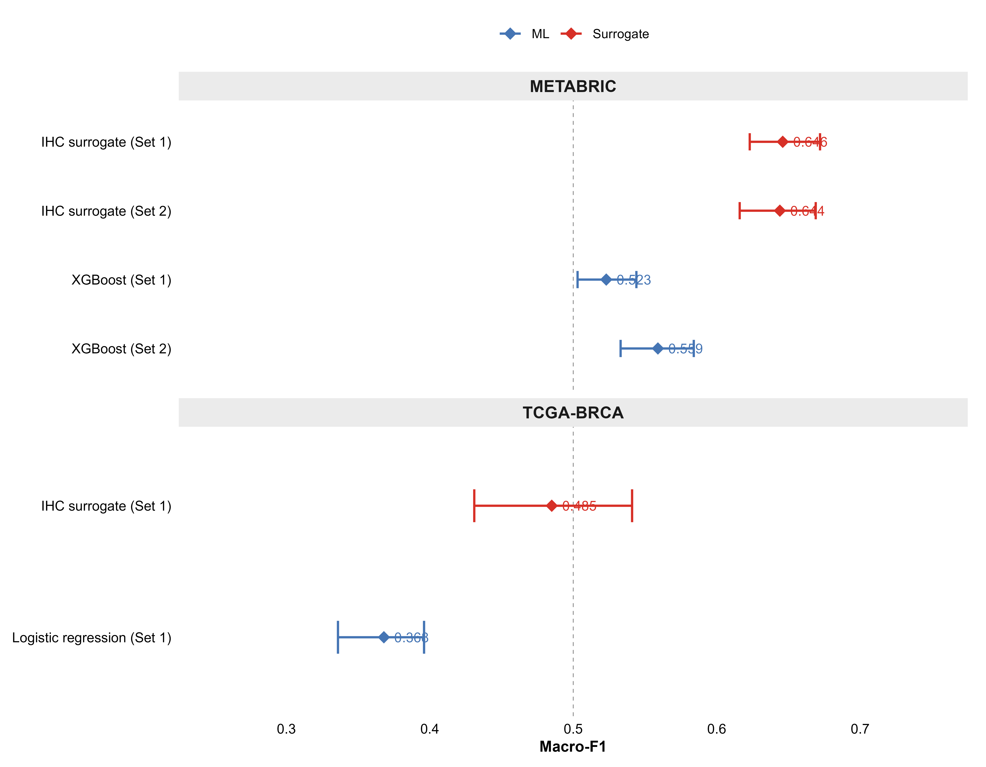
Fig. 3. Head-to-head macro-F1 comparison with bootstrap 95% confidence intervals.
3.4 Confusion-matrix analysis
Normalised confusion matrices in METABRIC (Fig. 4) showed that both approaches captured broad non-luminal biology better than fine luminal subclassification. The surrogate identified Basal-like and HER2-enriched tumours with relatively high sensitivity, but remained poor at separating Luminal A from Luminal B. XGBoost with grade modestly improved Luminal B capture at the cost of reduced Luminal A specificity, indicating a trade-off rather than a net increase in recoverable information.
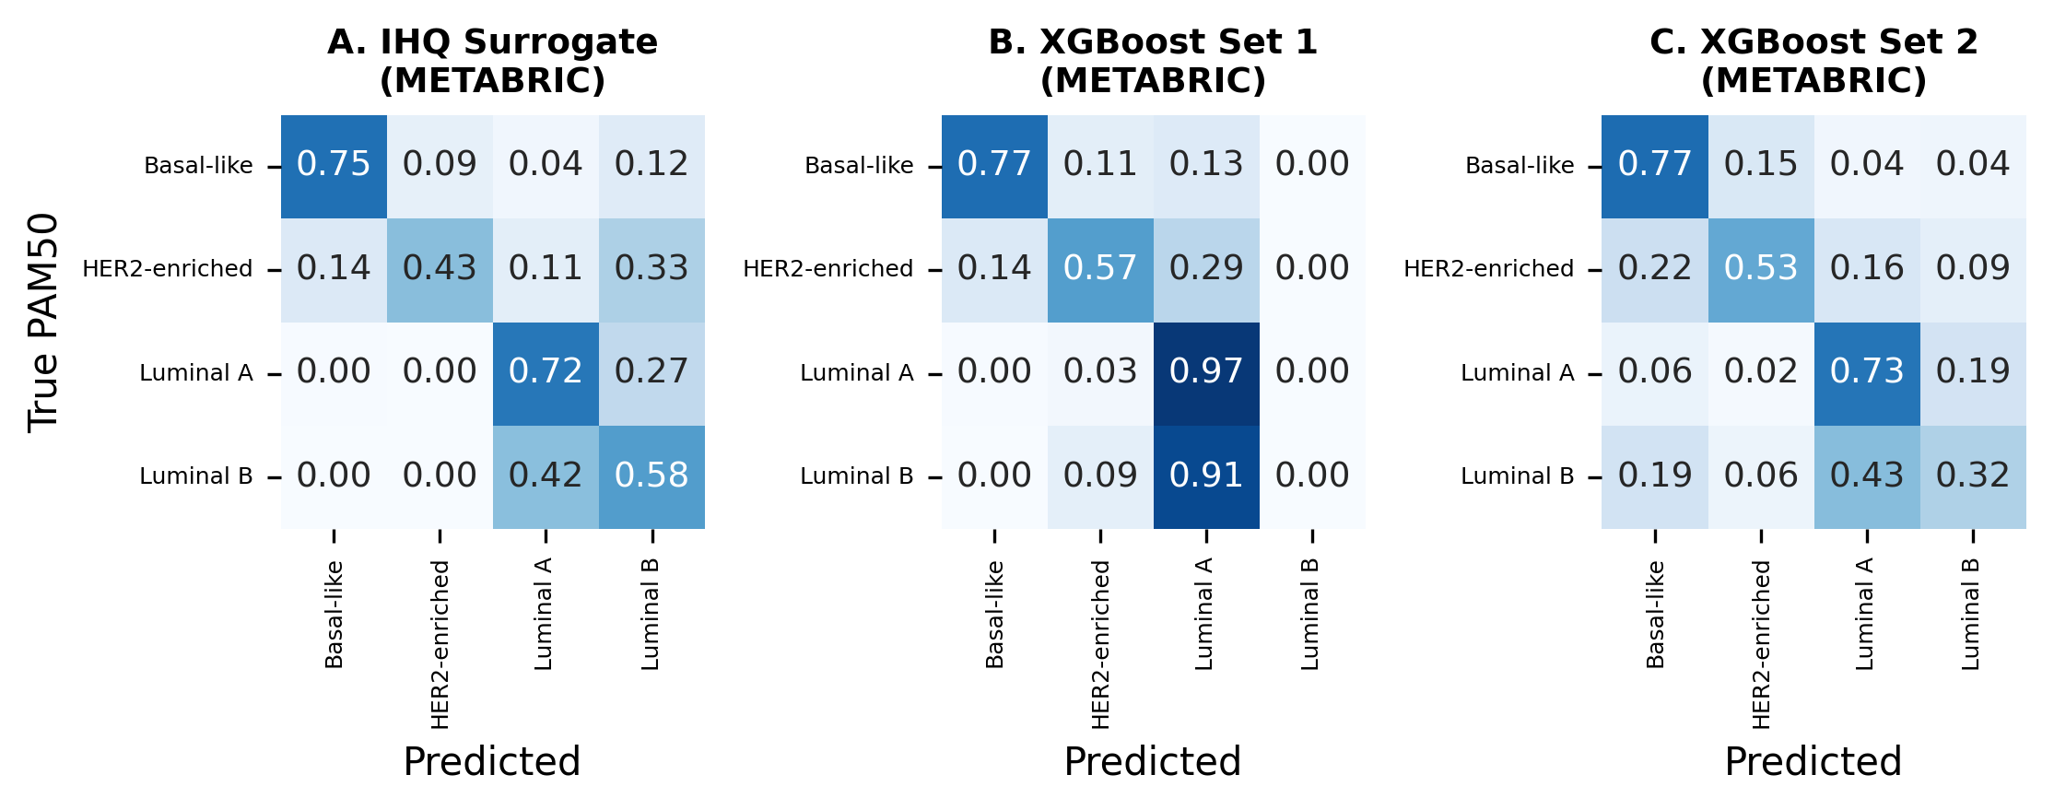
Fig. 4. Normalised confusion matrices on METABRIC. (A) IHC surrogate. (B) XGBoost Set 1 (ER, PR, HER2). (C) XGBoost Set 2 (+ grade).
3.5 Grey-zone analysis
Prediction confidence revealed a clinically meaningful low-certainty subgroup. In METABRIC, 13.5% of cases (n=208) had a maximum class probability <0.50. These tumours were predominantly luminal (73.6%) and showed only 15.9% machine-learning accuracy, while the surrogate still reached 54.8% accuracy (Fig. 5, Table 3).
By contrast, in the high-confidence zone (>0.70; 58.2% of cases), machine learning and the surrogate performed similarly (73.1% versus 73.8%). The grey-zone framework therefore identifies a specific subgroup—predominantly HR-positive/HER2-negative disease—in which routine-data-based approximation is least reliable and molecular testing is most likely to add value.
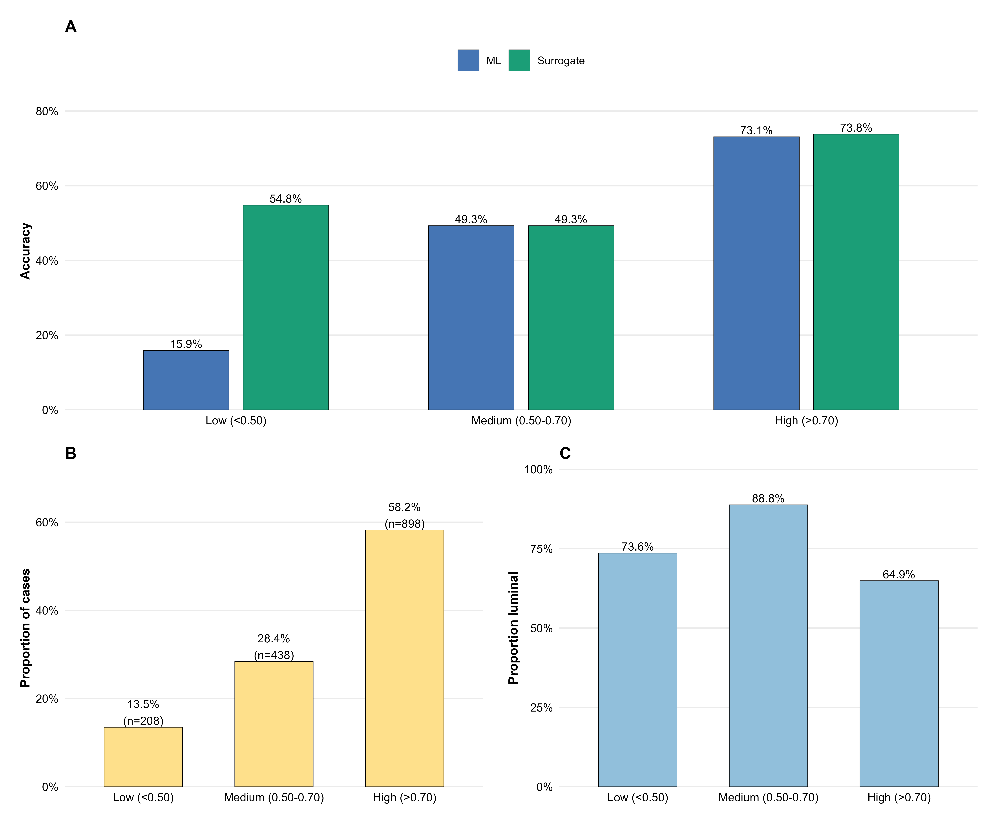
Fig. 5. Grey-zone analysis on METABRIC. (A) Accuracy by confidence zone. (B) Distribution of cases. (C) Luminal A+B proportion by confidence zone.
Table 3. Grey-zone analysis by confidence tier.
Confidence Zone | N | N (%) | ML Accuracy | Surrogate Accuracy | Luminal A+B proportion
Low (<0.50) | 208 | 208 (13.5%) | 0.159 | 0.548 | 73.6%
Medium (0.50-0.70) | 438 | 438 (28.4%) | 0.493 | 0.493 | 88.8%
High (>0.70) | 898 | 898 (58.2%) | 0.731 | 0.738 | 64.9%

3.6 Sensitivity analysis: 3-class collapse
Collapsing Luminal A and Luminal B into a single luminal class substantially improved performance. Macro-F1 increased from 0.514 to 0.777 in TCGA-BRCA and from 0.522 to 0.767 in METABRIC (Table 4). This result is central to interpretation: most of the classification deficit resides within the luminal boundary rather than in the broader separation of luminal, HER2-enriched, and Basal-like disease.
Table 4. Sensitivity analysis: 4-class versus 3-class performance.
Analysis | Cohort | N | Macro F1 | F1 95% CI | Kappa
3-class (Luminal grouped) | TCGA-BRCA | 435 | 0.777 | (0.720-0.826) | 0.705
3-class (Luminal grouped) | METABRIC | 1608 | 0.767 | (0.739-0.796) | 0.692
4-class (primary) | TCGA-BRCA | 435 | 0.514 | (0.477-0.547) | 0.404
4-class (primary) | METABRIC | 1608 | 0.522 | (0.501-0.542) | 0.376

3.7 Information ceiling
Taken together, the results indicate an information ceiling imposed by routine clinicopathological variables (Fig. 6). Adding grade and, where available, Ki-67 produced incremental gains, but these gains plateaued below the surrogate and well below molecular classification. The limiting factor was therefore not model choice, but information content in the inputs.
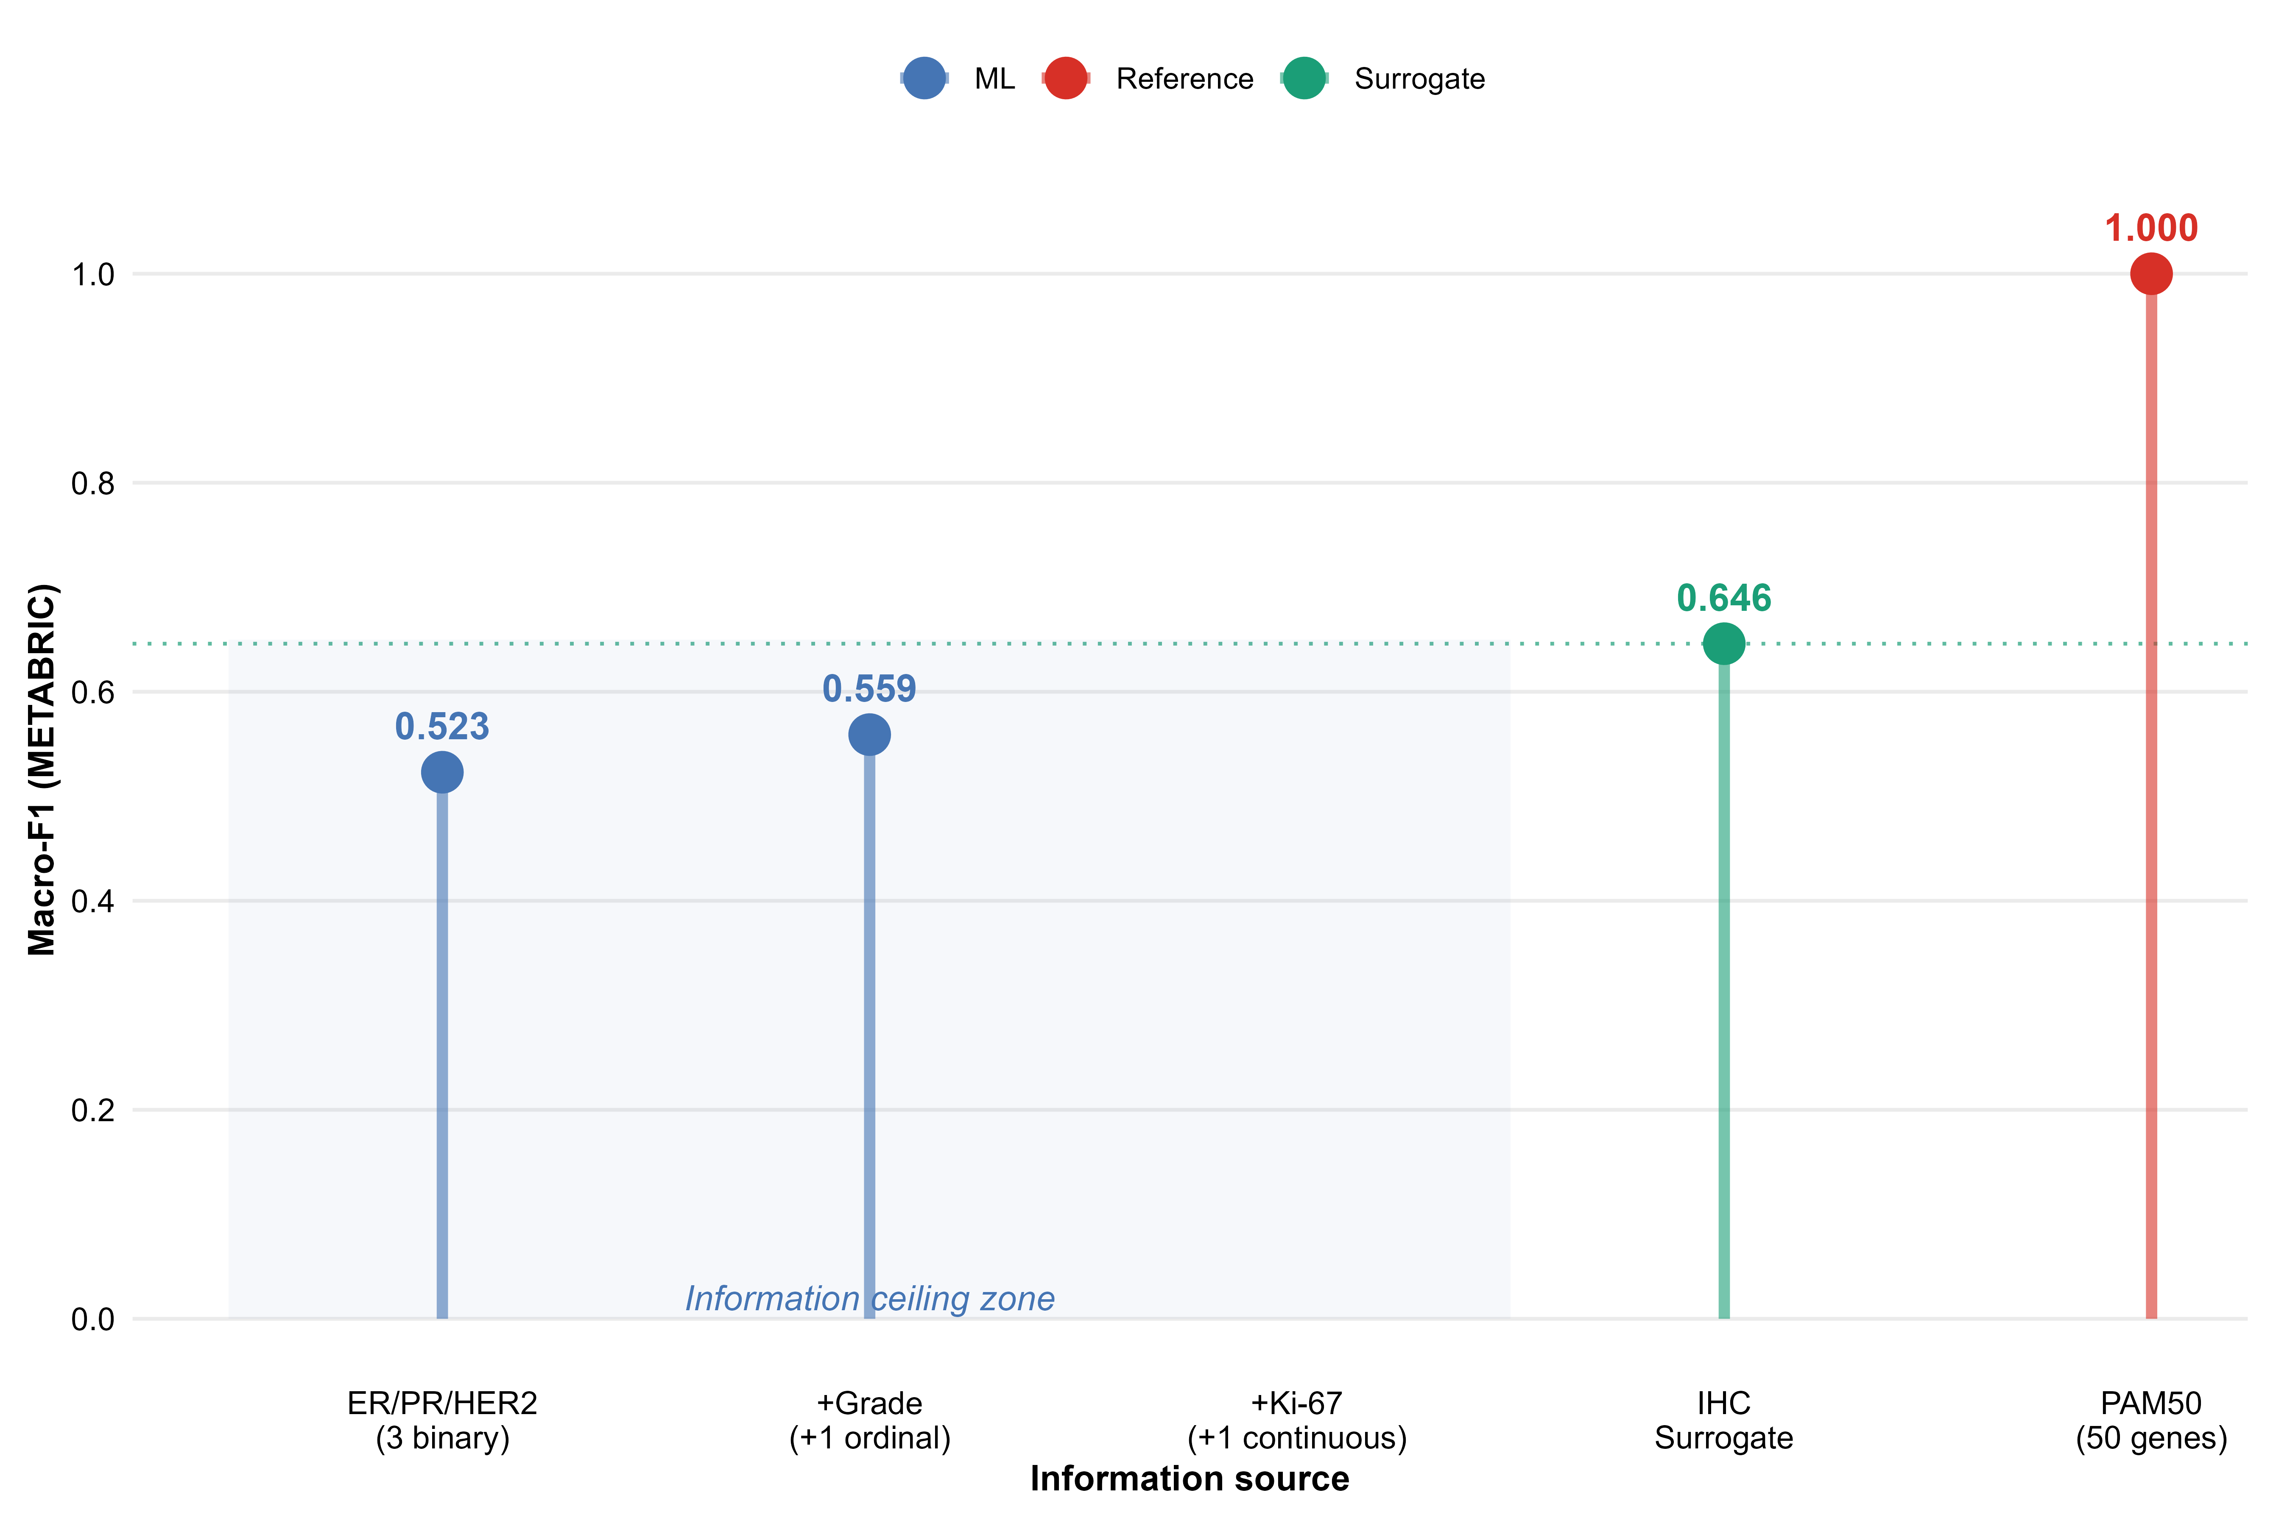
Fig. 6. The information ceiling concept. ML performance improves with feature complexity but plateaus below the IHC surrogate.
4. Discussion
This multicohort in silico study shows that routine pathology variables do not contain enough stable information to reliably reproduce 4-class PAM50 intrinsic subtypes across independent cohorts. Three findings define this conclusion: the conventional immunohistochemical surrogate misclassified approximately one-third of tumours; most errors concentrated at the Luminal A/Luminal B boundary; and machine-learning models did not consistently improve on the surrogate in external validation.
The negative result is therefore the main result. Machine learning did not fail because the algorithms were intrinsically inadequate; rather, the routine variables themselves appear insufficiently informative for stable 4-class reconstruction of intrinsic biology. This distinction matters. It shifts the interpretation away from model optimisation and toward the practical limit of what routine pathology can encode.
The luminal boundary was the key bottleneck. Biologically, the distinction between Luminal A and Luminal B reflects a continuous proliferative gradient driven by coordinated gene-expression programs [1]. In contrast, routine pathology compresses this axis into much coarser markers such as Ki-67 and histological grade. Even when both variables were available, the gap was narrowed only modestly. The sensitivity analysis supports this interpretation: once Luminal A and Luminal B were collapsed, performance rose sharply in both validation cohorts, indicating that broad luminal versus non-luminal separation is recoverable, while fine luminal subclassification is not.
This finding has direct clinical implications. The practical value of molecular subtyping is unlikely to be uniform across all patients. Tumours with clearly non-luminal phenotypes, especially triple-negative and HER2-driven disease, are already reasonably well captured by routine biomarkers. By contrast, hormone receptor-positive/HER2-negative tumours near the Luminal A/Luminal B boundary remain the true zone of irreducible uncertainty [11]. In this context, the grey-zone analysis is useful not because it produces a better classifier, but because it helps identify where routine methods are least trustworthy and where molecular testing is most likely to alter biological interpretation.
Our study also offers a broader methodological lesson. Algorithmic complexity cannot fully compensate for information-poor inputs. In this setting, the difference between logistic regression, random forest, and XGBoost was less important than the limited granularity of ER, PR, HER2, grade, and Ki-67 across public cohorts. This suggests that future efforts should focus less on increasingly complex classifiers built on the same routine variables and more on identifying what additional information—continuous biomarker measures, digital pathology, morphology-derived features, or true molecular data—is required to break the ceiling.
4.1 Relation to prior work
Prior studies have shown incomplete concordance between immunohistochemical surrogates and PAM50, particularly in luminal disease [5,6,12]. Our results are aligned with that literature, but extend it in three ways: first, by testing multiple machine-learning approaches rather than only rule-based surrogates; second, by requiring strict external validation across independent cohorts and platforms; and third, by using head-to-head comparisons on identical evaluable subsets. These design choices make the negative result more rigorous and, in our view, more clinically informative.
4.2 Strengths and limitations
Strengths include the use of four independent cohorts spanning two molecular platforms, strict external validation, matched-denominator comparisons between the surrogate and machine-learning models, bootstrap confidence intervals for all core metrics, and a grey-zone framework that translates prediction uncertainty into potential clinical utility.
The study also has limitations. First, most routine biomarkers were available only in simplified categorical format, especially ER, PR, and HER2, likely underestimating the potential contribution of more granular pathology data. Second, continuous Ki-67 was available only in the smaller SCAN-B cohort, and histological grade was absent in TCGA-BRCA, limiting portability of enriched feature sets. Third, PAM50 labels were obtained from public resources with cohort-specific implementations. Fourth, this was a purely in silico study without outcome-based confirmation of the clinical consequences of discordant luminal assignments.
These limitations do not weaken the core conclusion. If anything, they reflect the conditions under which routine surrogate subtyping is commonly used in practice.
5. Conclusions
Routine clinicopathological variables impose an information ceiling that prevents reliable reproduction of 4-class PAM50 intrinsic subtypes. Machine-learning models do not overcome this limitation because the main constraint lies in the input data, not in the classifier. The irreducible uncertainty concentrates at the Luminal A/Luminal B boundary, defining a clinically relevant grey zone in which molecular testing is most likely to add value. These findings support a selective, rather than indiscriminate, use of molecular subtyping in breast cancer.
Funding
This research did not receive any specific grant from funding agencies in the public, commercial, or not-for-profit sectors.
Declaration of competing interest
The authors declare that they have no known competing financial interests or personal relationships that could have appeared to influence the work reported in this paper.
CRediT authorship contribution statement
Rafael de Negreiros Botan: Conceptualisation, Methodology, Software, Formal analysis, Data curation, Writing – original draft, Visualisation. João Batista de Sousa: Supervision, Writing – review & editing.
Declaration of generative AI and AI-assisted technologies in the manuscript preparation process
During the preparation of this work the author(s) used Claude 3.5 Sonnet and Claude Opus 4 (Anthropic) in order to assist with Python and R code development for data acquisition, statistical modelling, bootstrap analysis, and publication-quality figure generation. The author(s) also used ChatGPT-4o (OpenAI) in order to support language editing and structural refinement of the manuscript text. After using these tools, the author(s) reviewed and edited the content as needed and take(s) full responsibility for the content of the published article.
Data availability
All data used in this study are publicly available. GSE81538 and GSE96058 are available through NCBI GEO; TCGA-BRCA and METABRIC clinical data were accessed through cBioPortal. Complete analysis code and reproducibility materials are available at: https://github.com/oncologista/pam50-ihc-ml
References
[1] Parker JS, Mullins M, Cheang MC, et al. Supervised risk predictor of breast cancer based on intrinsic subtypes. J Clin Oncol 2009;27(8):1160–7.
[2] Perou CM, Sorlie T, Eisen MB, et al. Molecular portraits of human breast tumours. Nature 2000;406(6797):747–52.
[3] Prat A, Fan C, Fernandez A, et al. Clinical implications of the intrinsic molecular subtypes of breast cancer. Breast 2015;24(Suppl 2):S26–35.
[4] Goldhirsch A, Winer EP, Coates AS, et al. Personalizing the treatment of women with early breast cancer: highlights of the St Gallen International Expert Consensus 2013. Ann Oncol 2013;24(9):2206–23.
[5] Bastien RR, Rodriguez-Lescure A, Ebbert MT, et al. PAM50 breast cancer subtyping by RT-qPCR and concordance with standard clinical molecular markers. BMC Med Genomics 2012;5:44.
[6] Prat A, Cheang MC, Martin M, et al. Prognostic significance of progesterone receptor-positive tumor cells within immunohistochemically defined luminal A breast cancer. J Clin Oncol 2013;31(2):203–9.
[7] Collins GS, Reitsma JB, Altman DG, Moons KG. Transparent reporting of a multivariable prediction model for individual prognosis or diagnosis (TRIPOD). BMJ 2015;350:g7594.
[8] Brueffer C, Vallon-Christersson J, Grabau D, et al. Clinical value of RNA sequencing-based classifiers for prediction of the five conventional breast cancer biomarkers: a SCAN-B report. JCO Precis Oncol 2018;2:1–18.
[9] Cancer Genome Atlas Network. Comprehensive molecular portraits of human breast tumours. Nature 2012;490(7418):61–70.
[10] Curtis C, Shah SP, Chin SF, et al. The genomic and transcriptomic architecture of 2,000 breast tumours reveals novel subgroups. Nature 2012;486(7403):346–52.
[11] Cardoso F, van’t Veer LJ, Bogaerts J, et al. 70-gene signature as an aid to treatment decisions in early-stage breast cancer. N Engl J Med 2016;375(8):717–29.
[12] Chia SK, Bramwell VH, Tu D, et al. A 50-gene intrinsic subtype classifier for prognosis and prediction of benefit from adjuvant tamoxifen. Clin Cancer Res 2012;18(16):4465–72.

Supplementary Material
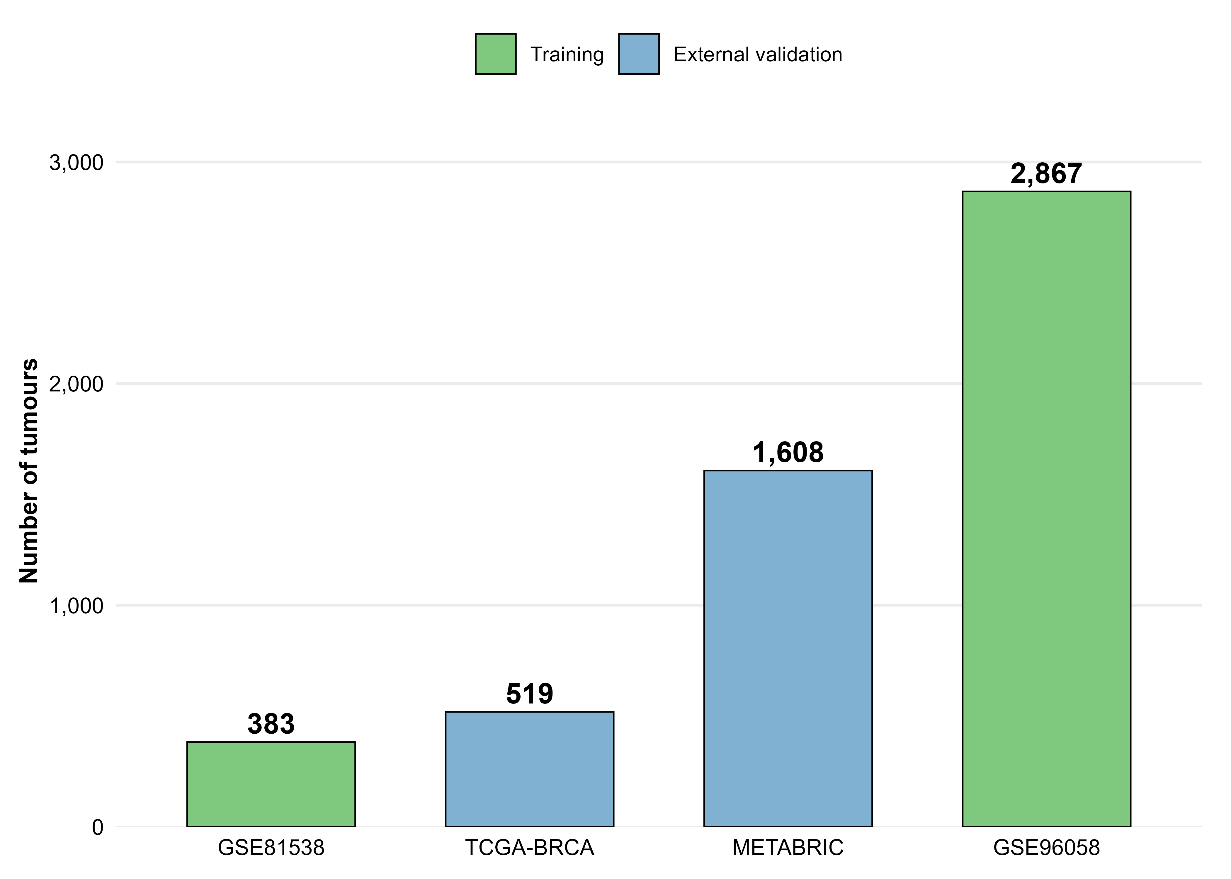
Supplementary Fig. S1. Study design and sample flow across cohorts.
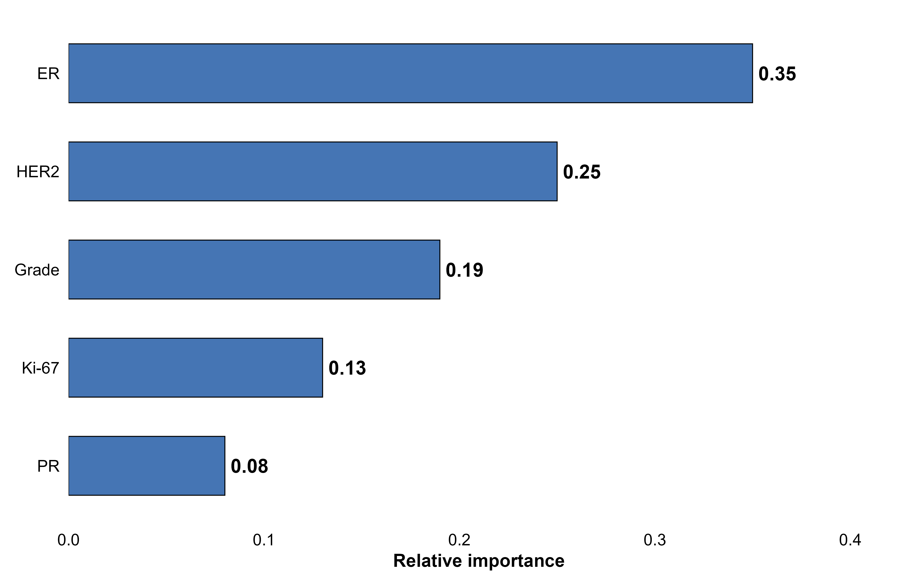
Supplementary Fig. S2. Feature importance (Random Forest and XGBoost).
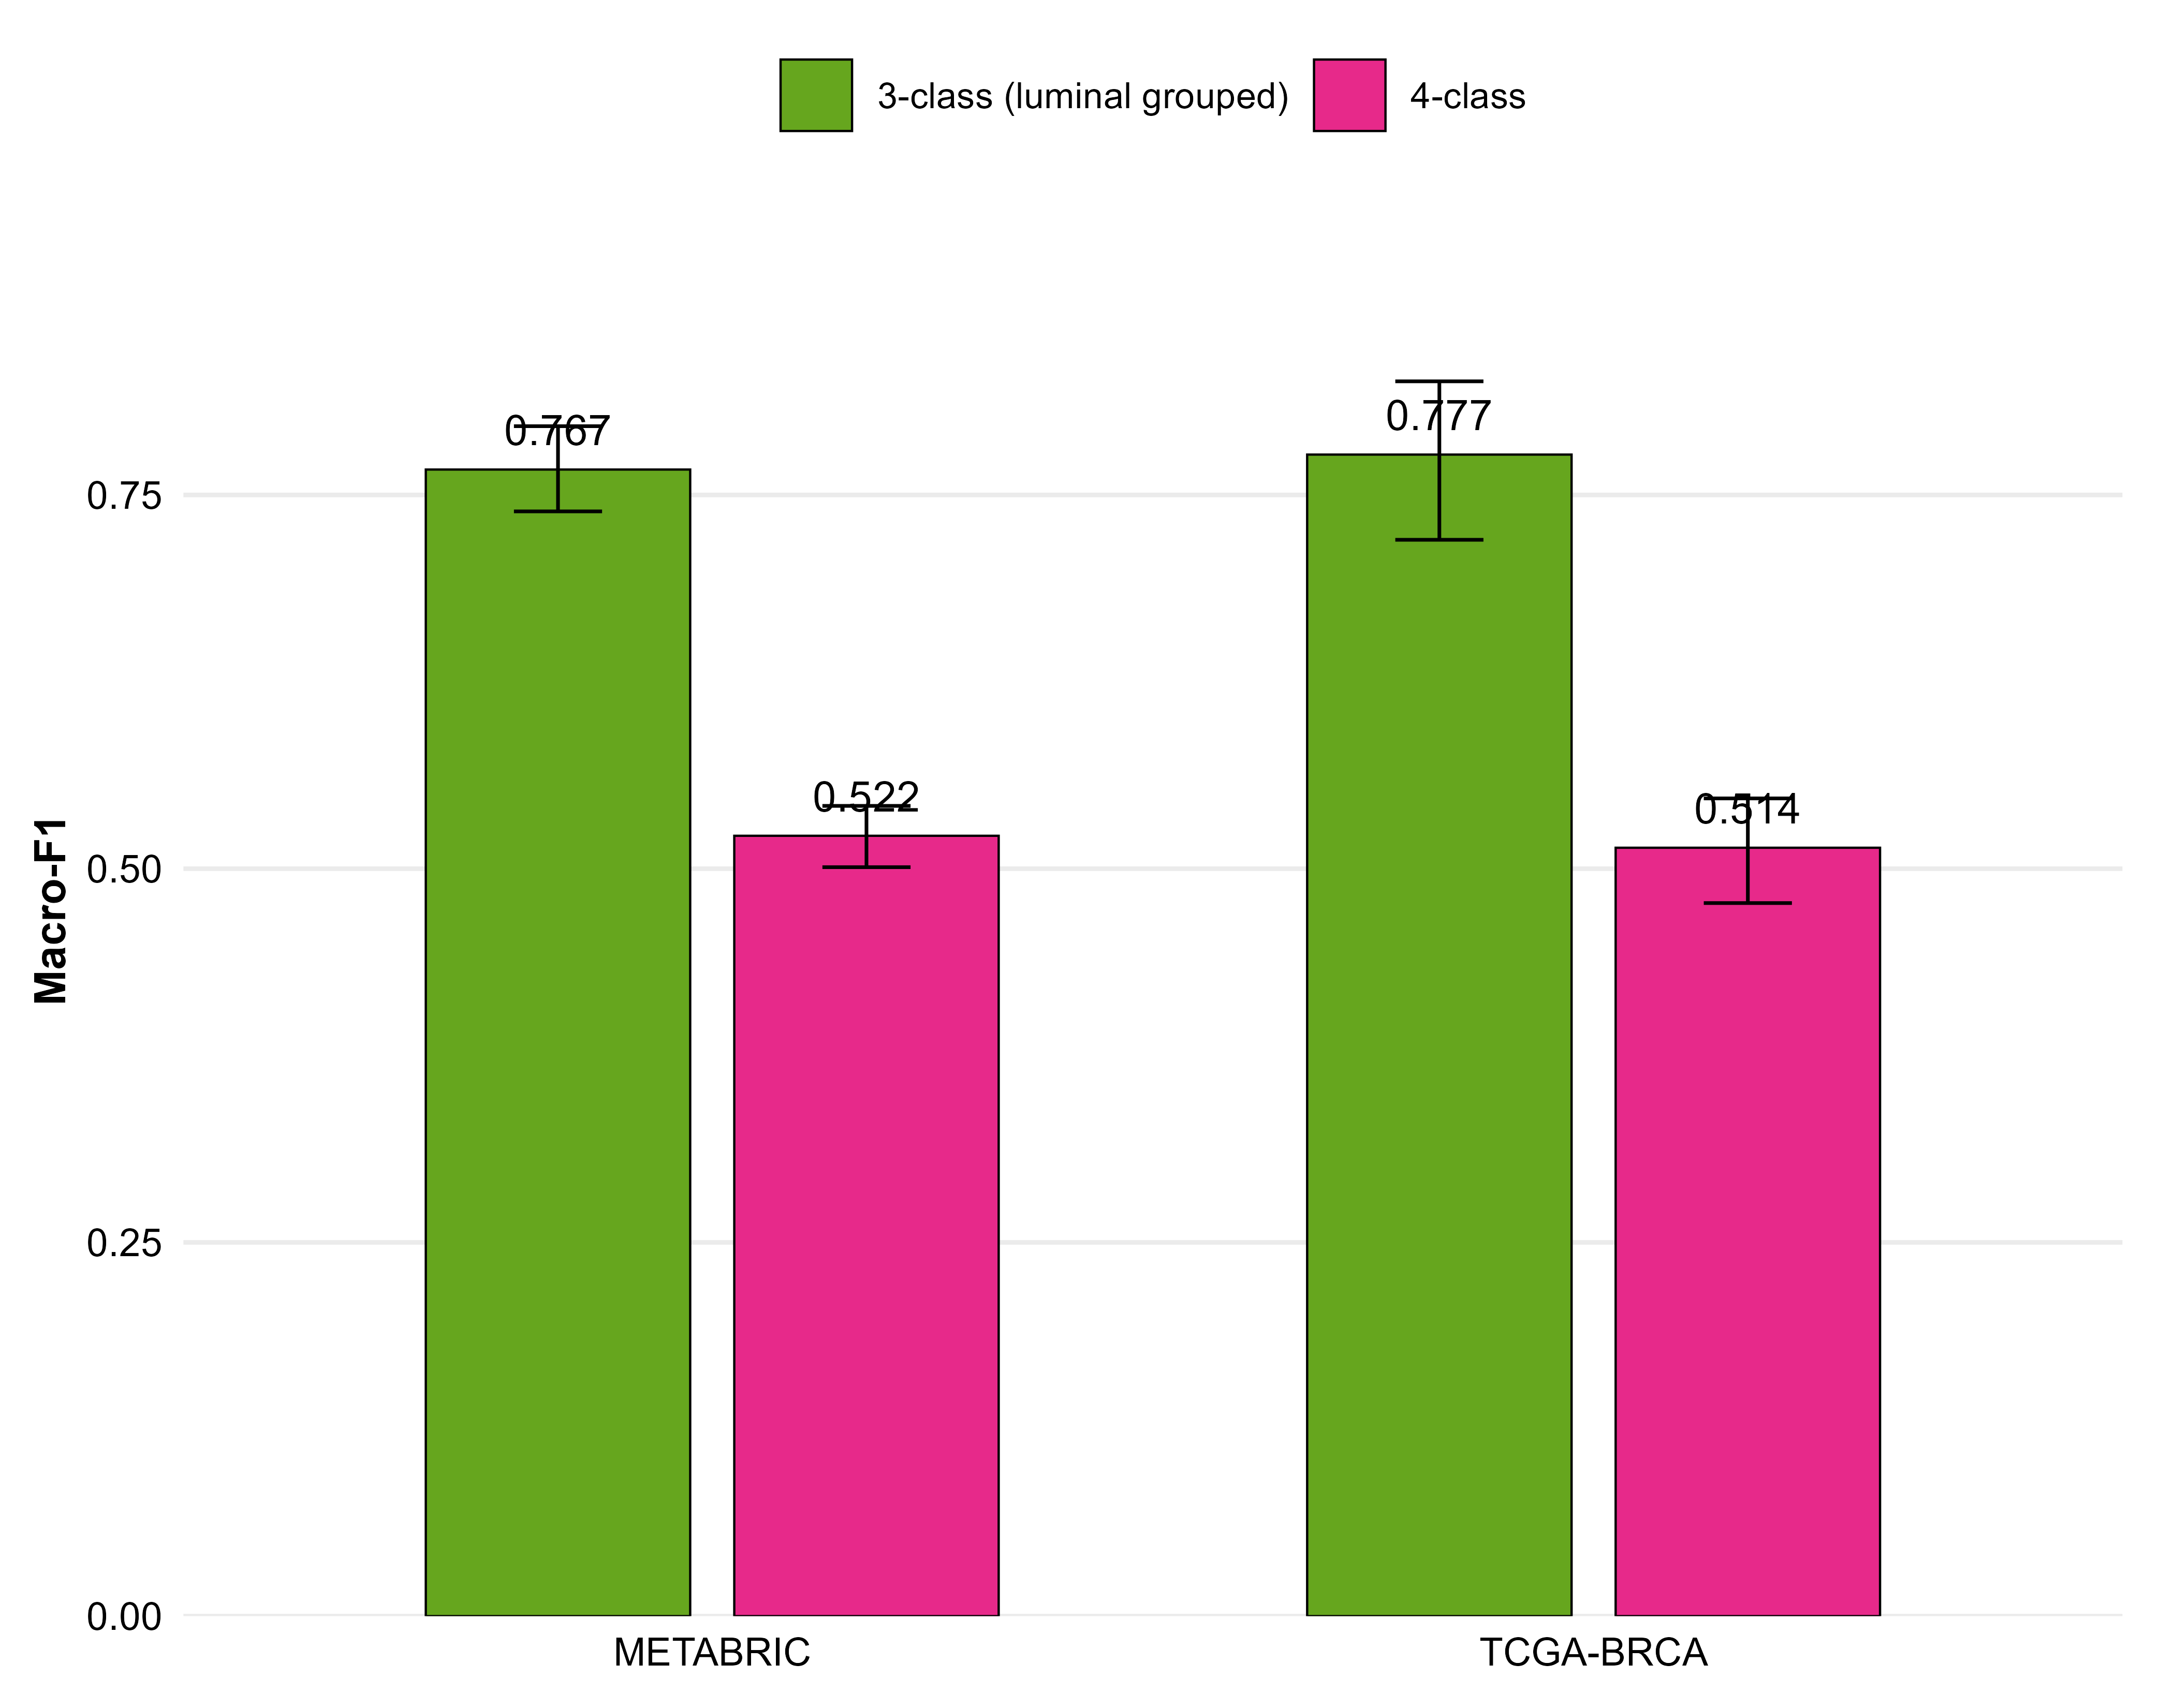
Supplementary Fig. S3. Sensitivity analysis: 4-class versus 3-class macro-F1.
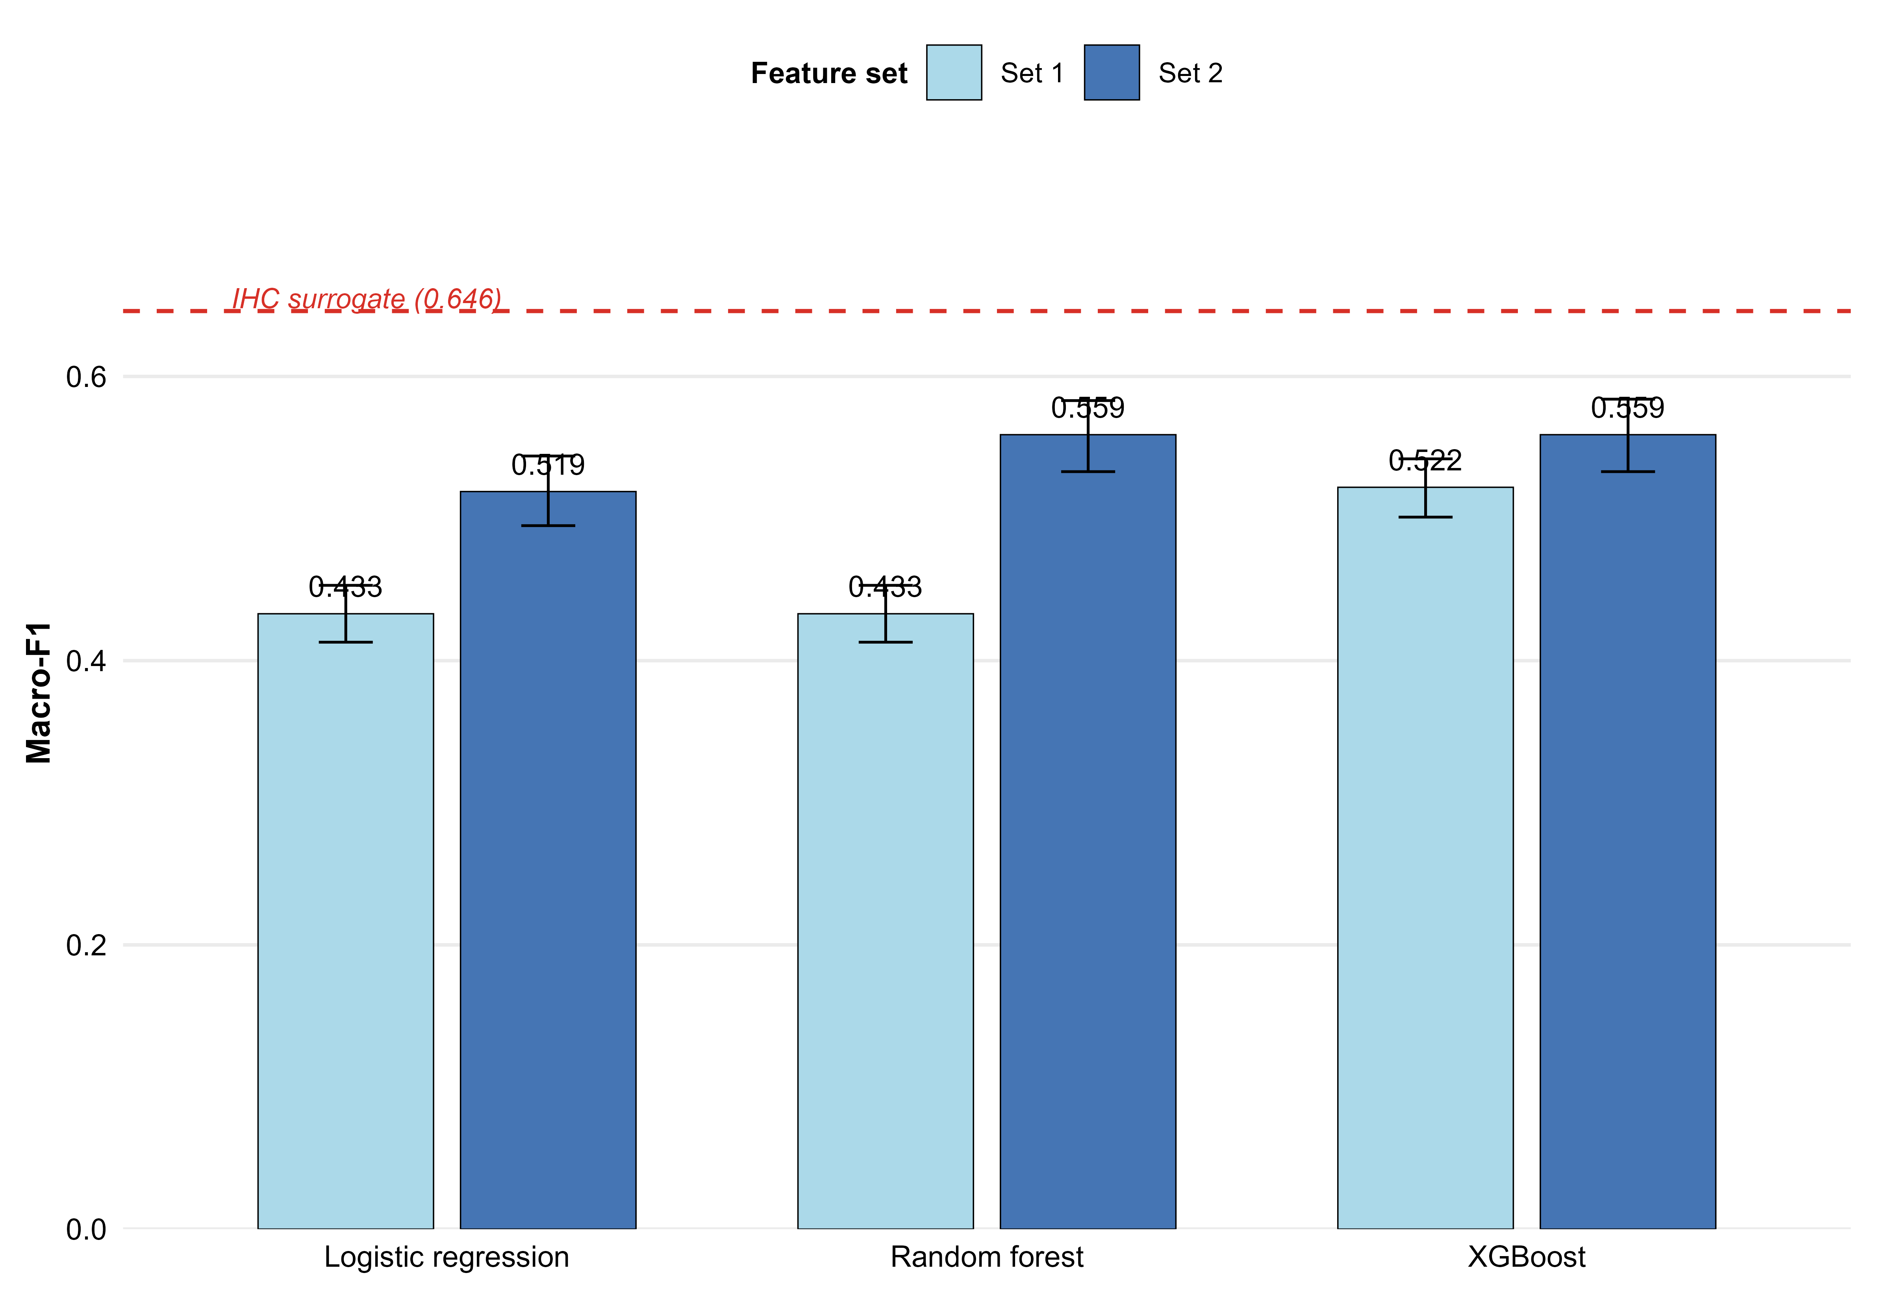
Supplementary Fig. S4. Feature set comparison across cohorts.

