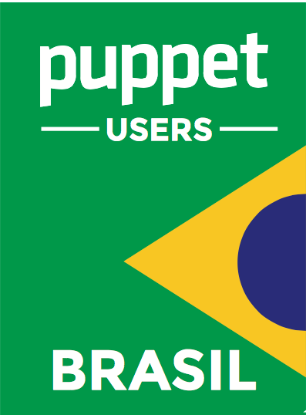

Puppet

**Mantida pela comunidade Puppet-BR**

[**https://github.com/puppet-br/apostila-puppet**](https://github.com/puppet-br/apostila-puppet)

**Apostila**