SAS – Portal DGADR

Software Requirements Specification – vERSION 1.0

Nuno marmeleiro 1190922

ROGÉRIO SOUSA 1191017

RAFAEL FAÍSCA 1180658

ÓSCAR FOLHA 1181600

RAFAEL OLIVEIRA 1191611

2023

Index

1 Introduction 13

1.1 Purpose 13

1.2 Document conventions 13

1.3 Project scope 13

1.4 References 13

2 Overall description 14

2.1 Product Prespective 14

2.2 User classes and characteristics 16

2.3 Operating environment 18

2.4 Design and implementation contraints 18

2.5 Assumptions and dependencies 18

3 System features 19

3.1 Use case diagram 19

3.2 System Feature: Registering Apiaries and Their Data 22

3.2.1 Description 22

3.2.2 Stimulus/Response Sequences 22

3.2.3 Functional Requirements 22

3.3 System Feature: Creating Tasks 23

3.3.1 Description 23

3.3.2 Stimulus/Response Sequences 23

3.3.3 Functional Requirements 23

3.4 System Feature: Hive Inspection Recording 23

3.4.1 Description 23

3.4.2 Stimulus/Response Sequences 24

3.4.3 Functional Requirements 24

3.5 System Feature: Recording Treatments per Hive 24

3.5.1 Description 24

3.5.2 Stimulus/Response Sequences 24

3.5.3 Functional Requirements 24

3.6 System Feature: Viewing Issued Alerts 25

3.6.1 Description 25

3.6.2 Stimulus/Response Sequences 25

3.6.3 Functional Requirements 25

3.7 System Feature: Issuing Entry/Exit Requests to Management Entities 25

3.7.1 Description 25

3.7.2 Stimulus/Response Sequences 25

3.7.3 Functional Requirements 26

3.8 System Feature: Viewing Zone Information 26

3.8.1 Description 26

3.8.2 Stimulus/Response Sequences 26

3.8.3 Functional Requirements 26

3.9 System Feature: Viewing Calendar with Tasks and Agendas 27

3.9.1 Description 27

3.9.2 Stimulus/Response Sequences 27

3.9.3 Functional Requirements 27

3.10 System Feature: Recording Produced Products 27

3.10.1 Description 27

3.10.2 Stimulus/Response Sequences 27

3.10.3 Functional Requirements 28

3.11 System Feature: Providing Permission to Certification Companies to View Data of X Hives 28

3.11.1 Description 28

3.11.2 Stimulus/Response Sequences 28

3.11.3 Functional Requirements 28

3.12 System Feature: Session Scheduling 29

3.12.1 Description 29

3.12.2 Stimulus/Response Sequences 29

3.12.3 Functional Requirements 29

3.13 System Feature: Inspection Record Keeping 29

3.13.1 Description 29

3.13.2 Stimulus/Response Sequences 29

3.13.3 Functional Requirements 30

3.14 System Feature: Session Report Creation 30

3.14.1 Description 30

3.14.2 Stimulus/Response Sequences 30

3.14.3 Functional Requirements 30

3.15 System Feature: Session Cancellation 30

3.15.1 Description 30

3.15.2 Stimulus/Response Sequences 31

3.15.3 Functional Requirements 31

3.16 System Feature: Certification Registration 31

3.16.1 Description 31

3.16.2 Stimulus/Response Sequences 31

3.16.3 Functional Requirements 31

3.17 System Feature: Certification Revalidation 32

3.17.1 Description 32

3.17.2 Stimulus/Response Sequences 32

3.17.3 Functional Requirements 32

3.18 System Feature: Time Recording for Issue Resolution 32

3.18.1 Description 32

3.18.2 Stimulus/Response Sequences 32

3.18.3 Functional Requirements 33

3.19 System Feature: Treatment History Viewing 33

3.19.1 Description 33

3.19.2 Stimulus/Response Sequences 33

3.19.3 Functional Requirements 33

3.20 System Feature: Certification Requirements Viewing 33

3.20.1 Description 33

3.20.2 Stimulus/Response Sequences 34

3.20.3 Functional Requirements 34

3.21 System Feature: Automatic Session Notification 34

3.21.1 Description 34

3.21.2 Stimulus/Response Sequences 34

3.21.3 Functional Requirements 34

3.22 System Feature: Annual Existence Declaration Generation 35

3.22.1 Description 35

3.22.2 Stimulus/Response Sequences 35

3.22.3 Functional Requirements 35

3.23 System Feature: Scheduling Interventions/Inspections 35

3.23.1 Description 35

3.23.2 Stimulus/Response Sequences 35

3.23.3 Functional Requirements 36

3.24 System Feature: Viewing Notifications from Beekeepers 36

3.24.1 Description 36

3.24.2 Stimulus/Response Sequences 36

3.24.3 Functional Requirements 36

3.25 System Feature: Viewing Apiary Information 36

3.25.1 Description 36

3.25.2 Stimulus/Response Sequences 37

3.25.3 Functional Requirements 37

3.26 System Feature: Intervention/Inspection Calendar Viewing 37

3.26.1 Description 37

3.26.2 Stimulus/Response Sequences 37

3.26.3 Functional Requirements 37

3.27 System Feature: Notification of Approaching Interventions/Inspections 38

3.27.1 Description 38

3.27.2 Stimulus/Response Sequences 38

3.27.3 Functional Requirements 38

3.28 System Feature: Inspection Report Recording 38

3.28.1 Description 38

3.28.2 Stimulus/Response Sequences 38

3.28.3 Functional Requirements 39

3.29 System Feature: Fine Recording 39

3.29.1 Description 39

3.29.2 Stimulus/Response Sequences 39

3.29.3 Functional Requirements 39

3.30 System Feature: Sanitary Closure Recording 40

3.30.1 Description 40

3.30.2 Stimulus/Response Sequences 40

3.30.3 Functional Requirements 40

3.31 System Feature: Recording Severe Diseases 40

3.31.1 Description 40

3.31.2 Stimulus/Response Sequences 40

3.31.3 Functional Requirements 41

3.32 System Feature: Notification of Severe Diseases 41

3.32.1 Description 41

3.32.2 Stimulus/Response Sequences 41

3.32.3 Functional Requirements 41

3.33 System Feature: Viewing Apiary Information 42

3.33.1 Description 42

3.33.2 Stimulus/Response Sequences 42

3.33.3 Functional Requirements 42

3.34 System Feature: Registering/Viewing Zones 42

3.34.1 Description 42

3.34.2 Stimulus/Response Sequences 42

3.34.3 Functional Requirements 43

3.35 System Feature: Alert Emission for Events/Recommendations 43

3.35.1 Description 43

3.35.2 Stimulus/Response Sequences 43

3.35.3 Functional Requirements 43

3.36 System Feature: Management of Declarations of Entry/Exit for Zones 44

3.36.1 Description 44

3.36.2 Stimulus/Response Sequences 44

3.36.3 Functional Requirements 44

3.37 System Feature: Viewing Annual Existence Declaration 44

3.37.1 Description 44

3.37.2 Stimulus/Response Sequences 45

3.37.3 Functional Requirements 45

3.38 System Feature: Viewing Disease Records by DGAV Technicians 45

3.38.1 Description 45

3.38.2 Stimulus/Response Sequences 45

3.38.3 Functional Requirements 45

3.39 System Feature: Scheduling Inspections 46

3.39.1 Description 46

3.39.2 Stimulus/Response Sequences 46

3.39.3 Functional Requirements 46

3.40 System Feature: Recording Inspections 46

3.40.1 Description 46

3.40.2 Stimulus/Response Sequences 46

3.40.3 Functional Requirements 47

3.41 System Feature: Dashboard Viewing 47

3.41.1 Description 47

3.41.2 Stimulus/Response Sequences 47

3.41.3 Functional Requirements 47

3.42 System Feature: Viewing Zone Information 48

3.42.1 Description 48

3.42.2 Stimulus/Response Sequences 48

3.42.3 Functional Requirements 48

3.43 System Feature: Product Stock Management 48

3.43.1 Description 48

3.43.2 Stimulus/Response Sequences 48

3.43.3 Functional Requirements 49

3.44 System Feature: Task Management 49

3.44.1 Description 49

3.44.2 Stimulus/Response Sequences 49

3.44.3 Functional Requirements 49

3.45 System Feature: Beekeeper and Apiary Registration 50

3.45.1 Description 50

3.45.2 Stimulus/Response Sequences 50

3.45.3 Functional Requirements 50

3.46 System Feature: Task Assignment 50

3.46.1 Description 50

3.46.2 Stimulus/Response Sequences 50

3.46.3 Functional Requirements 51

3.47 System Feature: Viewing All Tasks 51

3.47.1 Description 51

3.47.2 Stimulus/Response Sequences 51

3.47.3 Functional Requirements 51

3.48 System Feature: Beekeeper and Apiary Registration 52

3.48.1 Description 52

3.48.2 Stimulus/Response Sequences: 52

3.48.3 Functional Requirements 52

4 Data requirements 52

4.1 Logical data model 52

4.2 Data dictionary 53

4.3 Reports 64

5 Domain model 66

5.1 Domain model overview 66

5.2 User Bounded Context 67

5.3 Beekeeper Bounded Context 67

5.4 Appointment Bounded Context 67

5.5 Sanitary Lock Bounded Context 67

5.6 Apiary Bounded Context 67

5.7 Annual Inventory Declaration Bounded Context 68

5.8 Task Bounded Context 68

5.9 Zone Bounded Context 68

5.10 SAlert Bounded Context 68

5.11 Message Bounded Context 68

5.12 Certification Bounded Context 68

5.13 Product Bounded Context 68

6 External interface requirements 69

6.1 User interfaces 69

6.2 Software interfaces 69

6.3 Hardware interfaces 70

6.4 Communication interfaces 70

7 Quality attributes 71

7.1 Usability 71

7.2 Performance 71

7.3 Security 71

7.4 Safety 71

7.5 Reliability 72

7.6 Scalability 72

7.7 Interoperability 72

7.8 Maintainability 72

7.9 Testing and Quality Assurance 72

7.10 Notifications and Reminders 73

7.11 Reporting and Audit Trails 73

7.12 Compliance and Regulations 73

7.13 Scalability 73

7.14 Error Handling and Recovery 73

7.15 Feedback and Support 73

7.16 Cost Efficiency 73

8 Internationalization and localization requirements 74

9 Other requirements 74

9.1 Transition Requirements 74

9.1.1 Migration scripts 74

9.1.2 Compatibility and Integration 74

9.1.3 User Training 74

9.1.4 Data Backup and Rollback Plan 75

9.1.5 Testing and Quality Assurance 75

9.1.6 User Feedback Mechanism 75

9.1.7 Contingency Plan 75

10 Process adopted for elicitation 75

10.1 Stakeholders 75

10.2 Applied techniques 76

10.2.1 Stakeholders’ Interviews 76

10.2.2 Team Meetings 77

10.3 Effort involved 77

10.4 Constraints and limitations 78

11 Product Backlog 79

12 Appendix 86

12.1 Appendix – Glossary 86

12.2 Appendix – Analysis models 86

12.3 Elicitation data detail 86

Table of Figures

Figure 1 - Workflow Diagram - Certification Companies 14

Figure 2 - Workflow Diagram - DGAV Technicians 15

Figure 3 - Workflow Diagram - Management Entities 16

Figure 4 – Beekeeper use case diagram 19

Figure 5 - Certification Companies use case diagram 20

Figure 6 - DGAV Technicians use case diagram 20

Figure 7 - Management Entities use case diagram 21

Figure 8 - Beekeeper manager use case diagram 22

[Figure 9 - Logical Data Model 53](https://myisepipp-my.sharepoint.com/personal/1190922_isep_ipp_pt/Documents/SRS.docx#_Toc150099876)

Figure 10 - Report Example 65

Figure 11 - Domain Model and its bounded contexts 66

[Figure 12 - Component Diagram 70](https://myisepipp-my.sharepoint.com/personal/1190922_isep_ipp_pt/Documents/SRS.docx#_Toc150099879)

Table of Tables

Table 1 – Data dictionary 64

Table 2 - Effort evolved 78

Table 3 - Product Backlog Requirements 85

Document Approval

|  |  |  |  |
| --- | --- | --- | --- |
| Name | Title | Date | Signature |
|  |  |  |  |
|  |  |  |  |
|  |  |  |  |
|  |  |  |  |

Revision history

|  |  |  |  |
| --- | --- | --- | --- |
| Version | Author | Description | Date |
| 1.0 | Nuno Marmeleiro | Initial version | 28-10-2023 |
| 1.1 | Rogério Sousa | Realization of Overall Description | 30-10-2023 |
| 1.2 | Rogério Sousa | Realization of Process adopted for elicitation | 01-11-2023 |
| 1.3 | Rafael Faísca | Addition of External Interface Requirements  and Internationalization and localization  Requirements | 01-11-2023 |
| 1.4 | Óscar Folha | Addition of the logical data model | 01-11-2023 |
| 1.5 | Óscar Folha | Addition of the data dictionary | 02-11-2023 |
| 1.6 | Óscar Folha | Quality Attributes addition | 02-11-2023 |
| 1.7 | Nuno Marmeleiro | Updated domain model | 02-11-2023 |
| 1.8 | Rafael Faísca | Updated External Interface Requirements | 02-11-2023 |

# Introduction

# Purpose

This document’s intention is to describe and to document an application asked to be done during the curricular unit Engenharia de Requisitos, ENGREQ.

The application to be developed was proposed by the company Sustainable Agriculture Solutions (SAS). Its environment is in the agriculture and apiculture area. The principal reason for its development is to dynamize the daily work of the beekeepers and the entities of this area. It is necessary to be available on several devices, mobile or not.

This document will describe the multiple functionalities that each user can have, the process and methodologies applied by the development team to gather all requirements and structural information about the application.

## Document conventions

For the development of this document some conventions were followed, such as:

* IEEE bibliographic citation style.
* For the development of domain model, logical data model and use case diagrams it was used the Unified Modeling Language (UML) notation. (Object Management Group®, 2023)
* For the development of the workflow diagrams of each stakeholder, the notation Business Process Model and Notation (BPMN) was used. (Camunda, 2023)

## Project scope

Nowadays, the applications available in the apiculture business are not being used. So, SAS found an opportunity to create one application that will contradict this fact.

This application is supposed to be fast and available on any mobile device or desktop so that the beekeepers and other entities can use it anytime. Since there are more entities that are related to apiculture area, besides the apiaries, this application will also make the communication between them, through a Web Portal.

It will make the daily work easier of the beekeepers and beekeepers’ managers.

## References

Camunda. (2023). *BPMN*. (Camunda Services GmbH) Retrieved from https://bpmn.io/

Object Management Group®, I. (2023). *UML*. (Unified Modeling Language) Retrieved from https://www.uml.org/

# Overall description

# Product Prespective

Sustainable Agriculture Solutions (SAS) is a company that develops technological solutions that support agricultural and forestry activity. It identified the possibility of increasing the volume of business in the apiculture sector.

So, to dynamize the daily work in this sector, it is intended to implement this application that will manage the data processes related to beekeeping and apiary management. Also, there are many applications that are not being used and this one will counteract it.

Besides the beekeeping and apiary management, this application will have connection to Portal DGADR, Direção-Geral de Agricultura e Desenvolvimento Rural. Nowadays, this Portal is used to fill the Annual Inventory Declaration and it is intended to gather several requirements to make it more useful.

The following images, Figure 1, Figure 2 and Figure 3, represent the flows diagrams of each Stakeholder:

###### Certification Companies

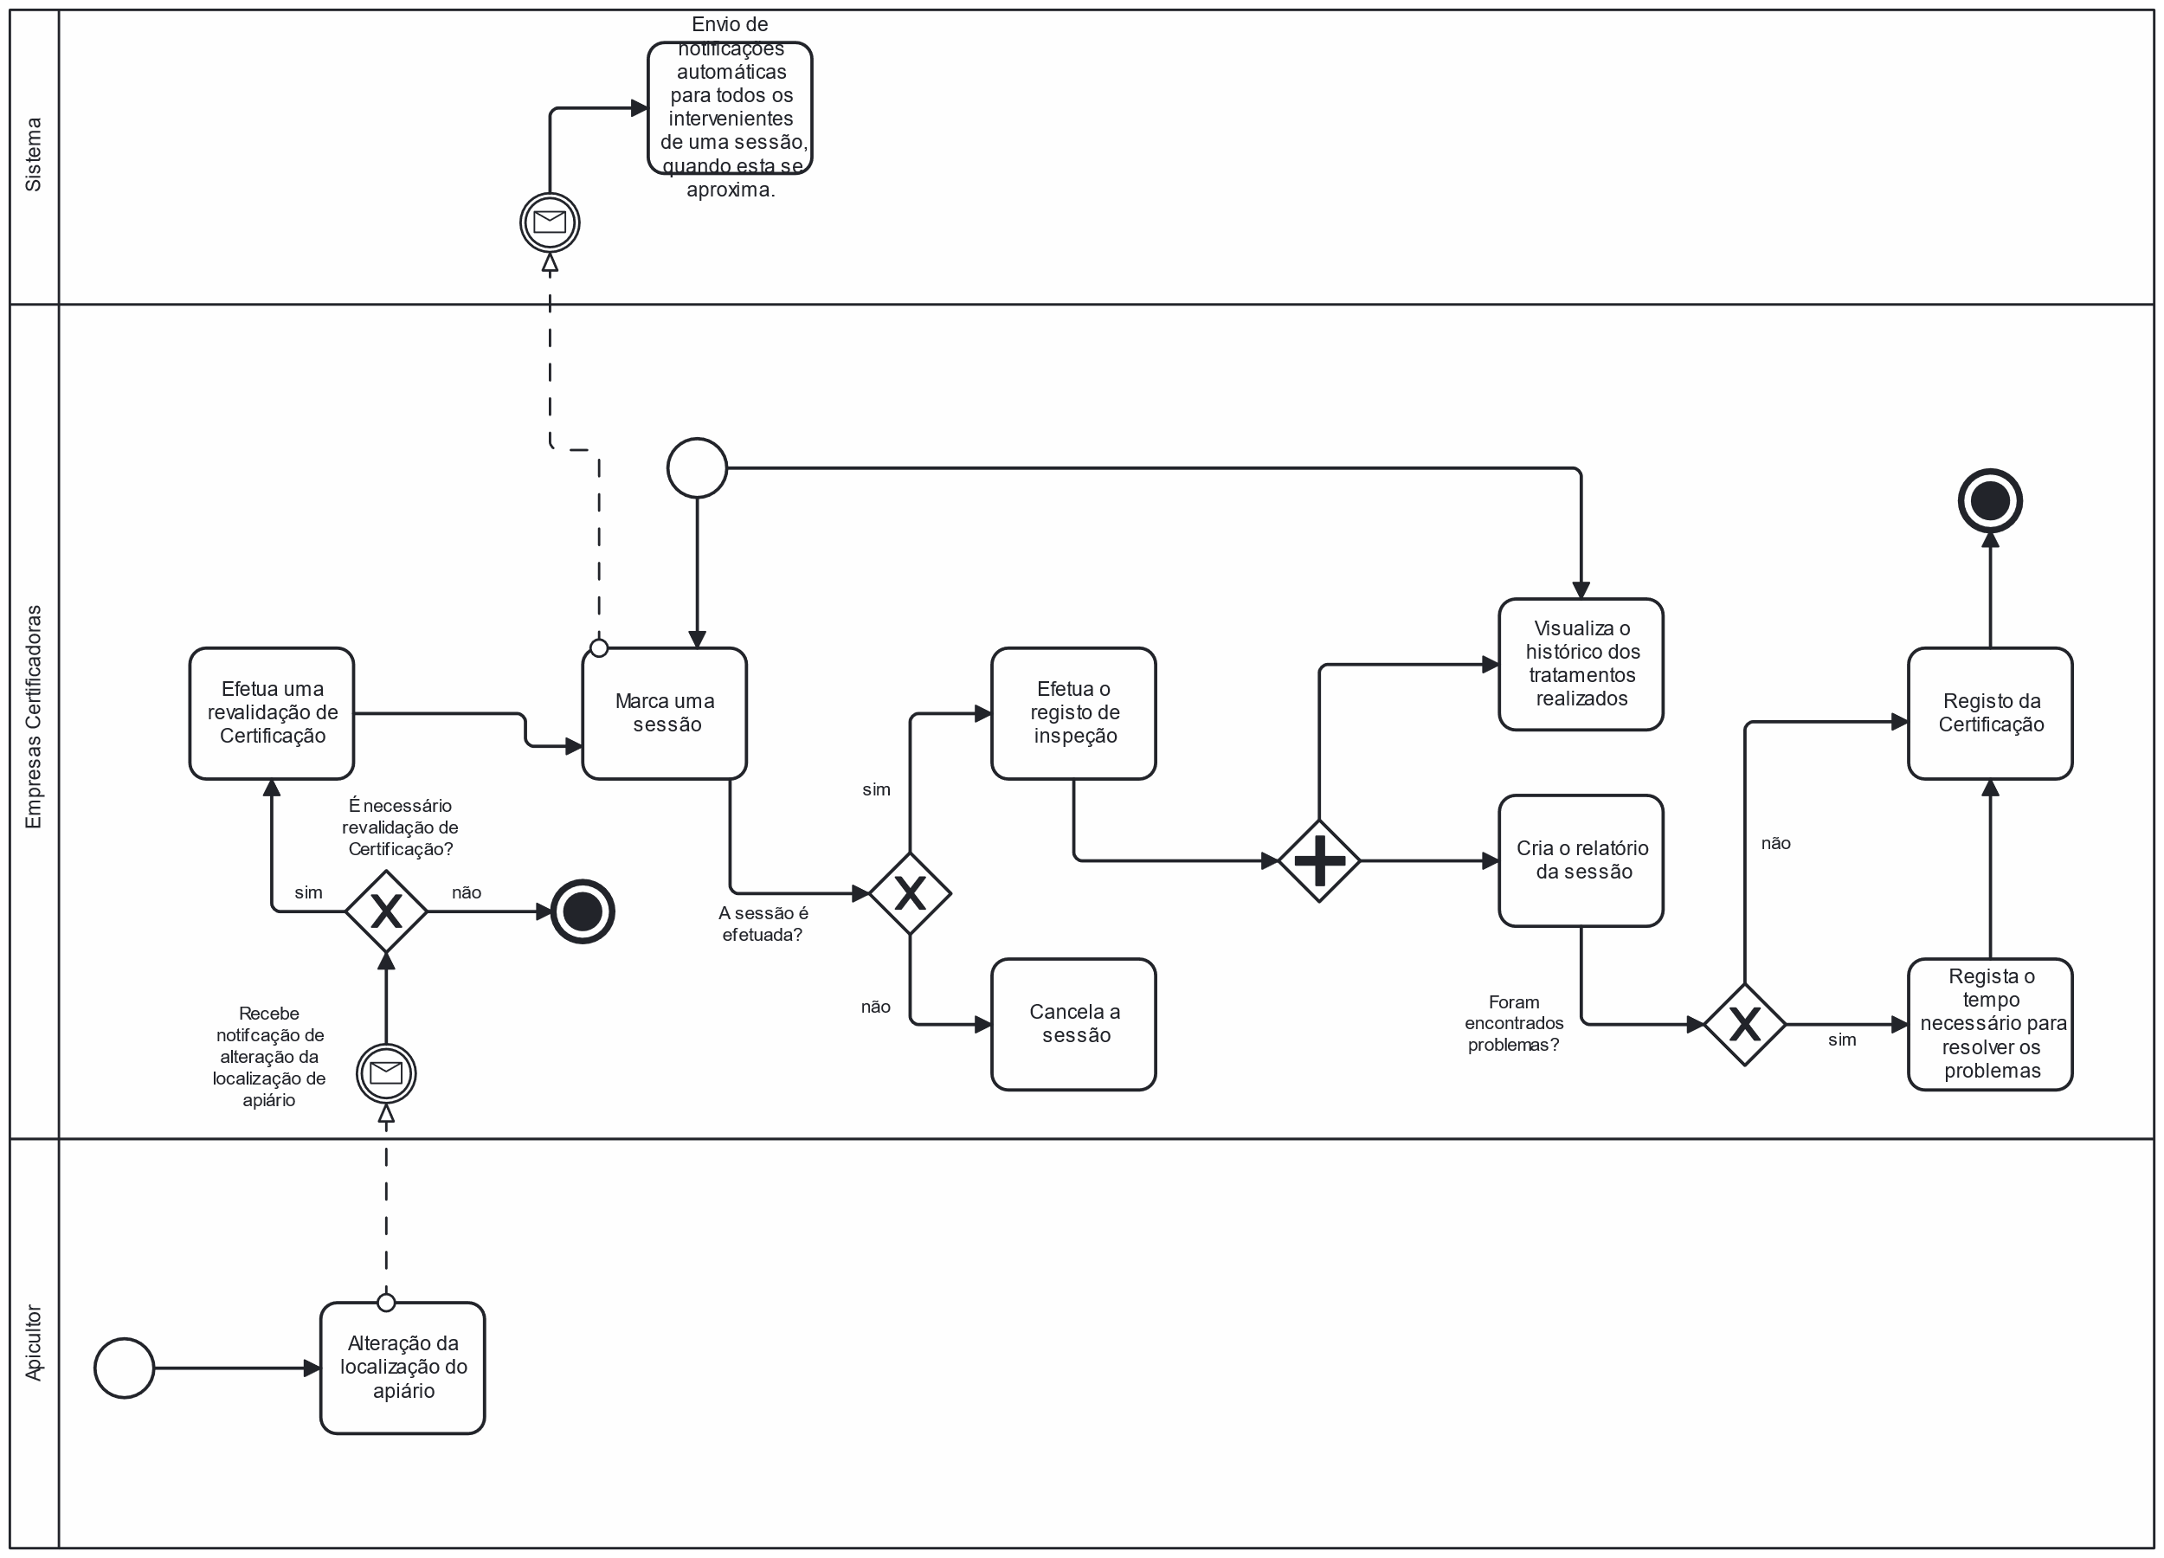

Figure 1 - Workflow Diagram - Certification Companies

###### DGAV Technicians

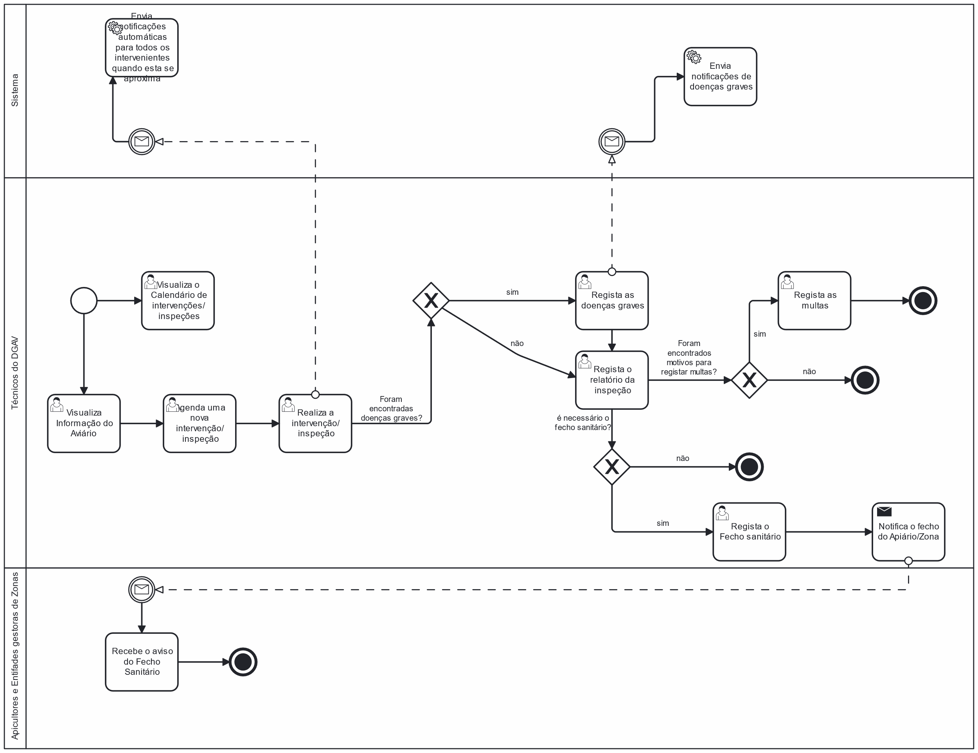

Figure 2 - Workflow Diagram - DGAV Technicians

###### Management Entities

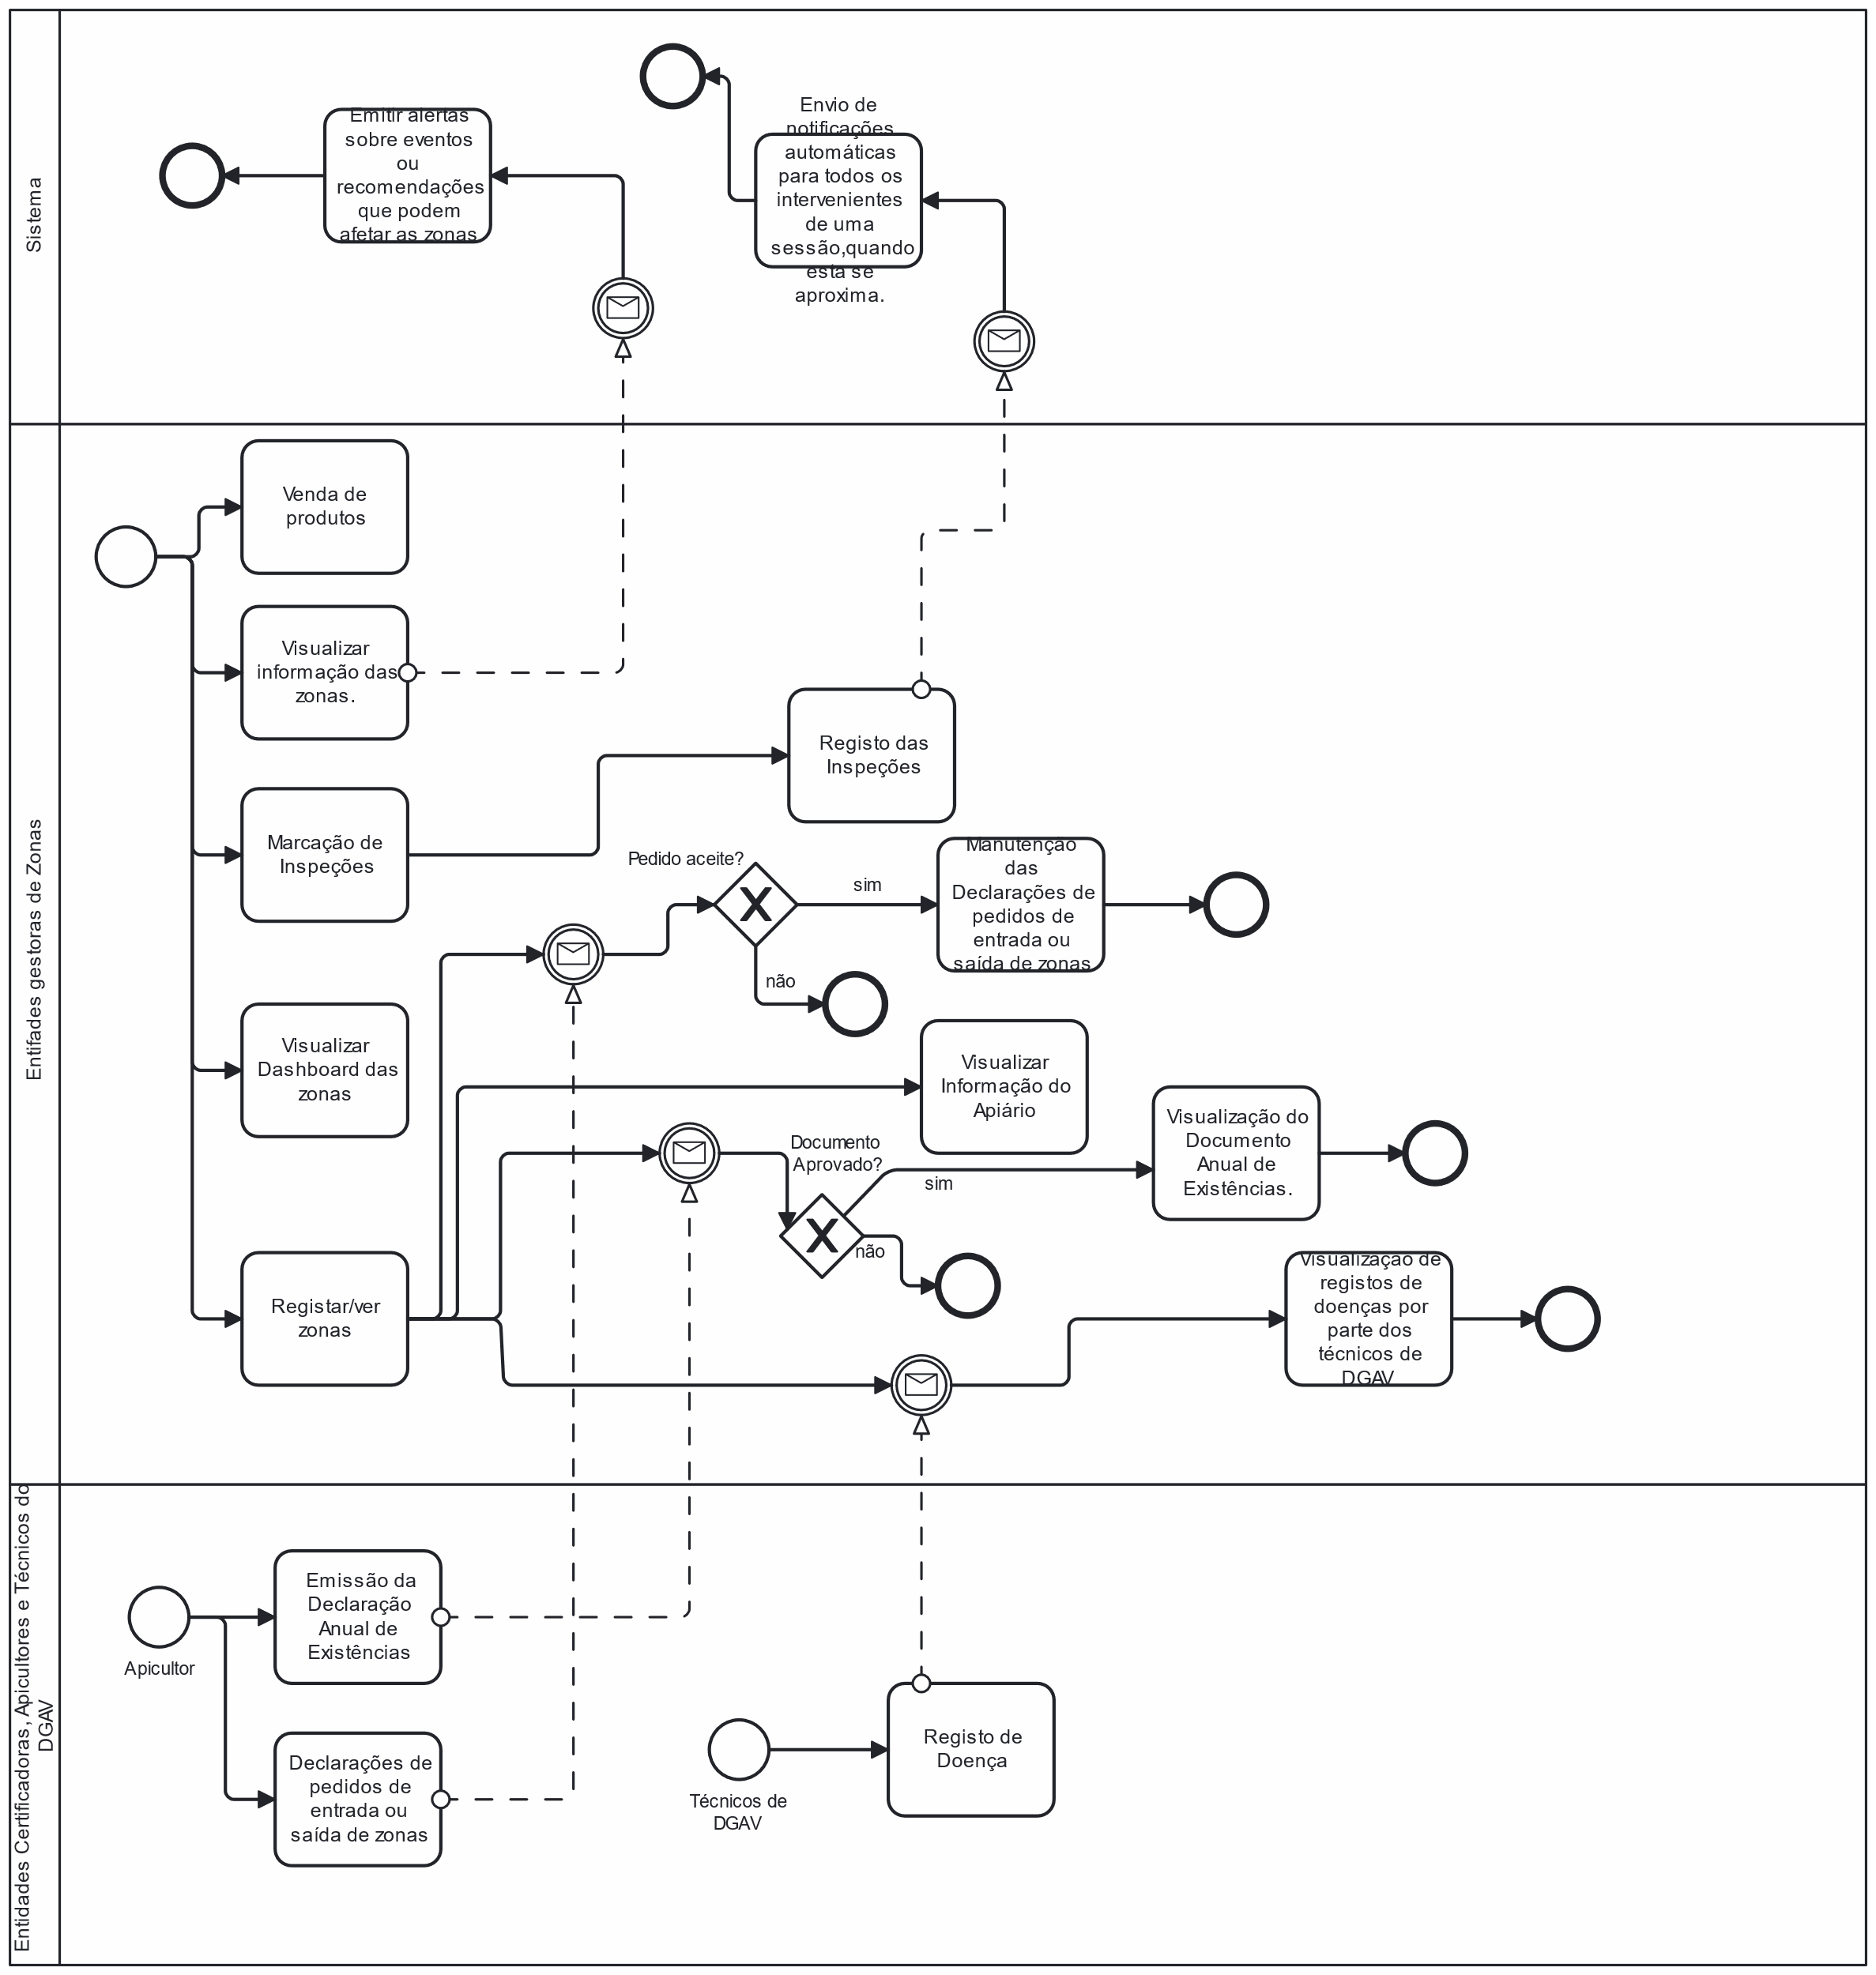

Figure 3 - Workflow Diagram - Management Entities

# User classes and characteristics

#### General Application

On the general application a user class was identified.

###### Beekeeper Manager

Beekeeper Manager has common functionalities of a manager:

* Create Tasks.
* Assign Tasks.
* View all tasks.
* Register Beekeepers and their data.
* Register apiaries and their data.

###### Beekeeper

The Beekeeper has many functions in the application. He has several functionalities:

* Registering the apiary information.
* Visualize alerts from Management Entities and DGAV Technicians.
* Requests to enter or leave any zone to the Management Entity.
* Visualize zones’ information, weather, among others.
* Calendar with Tasks.
* Registration of products produced quantities and type of honey.
* Allow Certification Companies to visualize beehive’s information.
* Emit the Annual Inventory Existence.

#### Portal DGADR

According to the Portal that the Marketing Department asked to develop, many stakeholders were discovered.

###### DGAV Technicians

DGAV Technicians are responsible for inspecting the apiaries to check their conditions. In more detail, they will schedule an inspection, according to requests from the Beekeeper or not, and when it is realized a report will be produced registering the critical deceases found and any more util information. Also, if it is necessary, they will register fines, or the Sanitary Lock of the Apiary inspected.

###### Certification Companies

The Certification Companies are responsible for certifying the apiaries. The Beekeeper will make a request on the Portal to apply for a specific Certificate. After, the Certification Companies will schedule a session to examine the apiary and a report will be done stating the result of the certification and any util information such as the registration of the problems found.

###### Management Entities

The Management Entities manage the Zones. So, any information and any situation that happens inside a zone, goes through them or they need to have knowledge of it. They are responsible for viewing the information of the Zone and advising the apiaries to facilitate and look after their safety. Also, like the others user classes mentioned, they can schedule inspections and register them.

Every user class has important functions in the application.

# Operating environment

The environment must operate on every available and active browser, to be used by every type of technology. For example:

* Mozilla Firefox
* Google Chrome
* Microsoft Edge

The database and application servers will be in Portugal.

The users’ geographical location is in Europe. So, according to EU (European Union), the GDPR (General Data Protection Regulation) is necessary to be applied on every relevant terms.

# Design and implementation contraints

The application will be maintained by the SAS company, so there will not be many limitations because it can be continuously developed. Initially, the application will contain only the essential functionalities to be used.

The protocol to communicate with Portal is REST (Representational State Transfer).

To implement the authorization, it will be used OAuth2 (Open Authorization).

It is necessary to evaluate the application. So, it will be used tools such as Sonarqube, JMeter and WASP.

# Assumptions and dependencies

The scheduling of sessions requires a framework that allows the user to do it.

Visualizing the weather conditions can be done with support from a third party that presents this information.

Since the application is supposed to be compatible with mobile devices, a framework to transform web pages into mobile screens is needed.

It is necessary to implement an Authorization system to increase security in the application, it can also be used as a framework to do it.

For the notification and email systems, an API or framework will be used.

The creation of reports is needed, so a framework to create PDF files is required.

# System features

A general overview of the use cases identified for the system can be seen in subchapter 3.1, Figure 4, Figure 5, Figure 6, Figure 7 and Figure 8.

This was done to facilitate the understanding of the number of stakeholders, as well as how many use cases each stakeholder requires and how many system interactions they have.

Each feature listed in the subchapters below can lead to one or more product requirements.

Each feature will be classified according to the QFD scale as low, medium, and high priority.

# Use case diagram

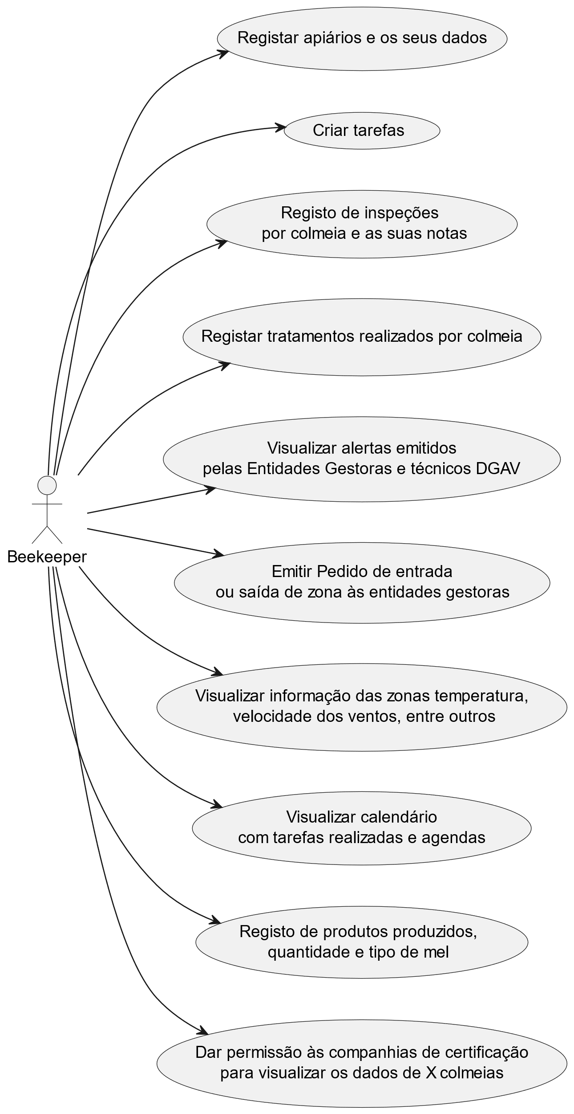

Figure 4 – Beekeeper use case diagram

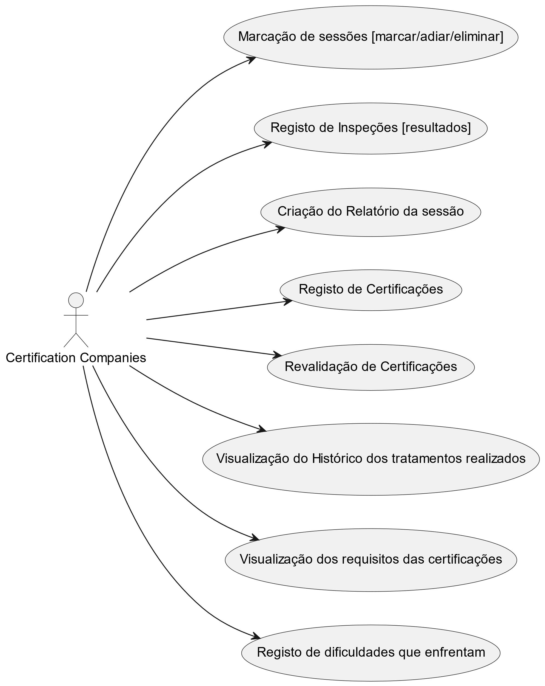

Figure 5 - Certification Companies use case diagram

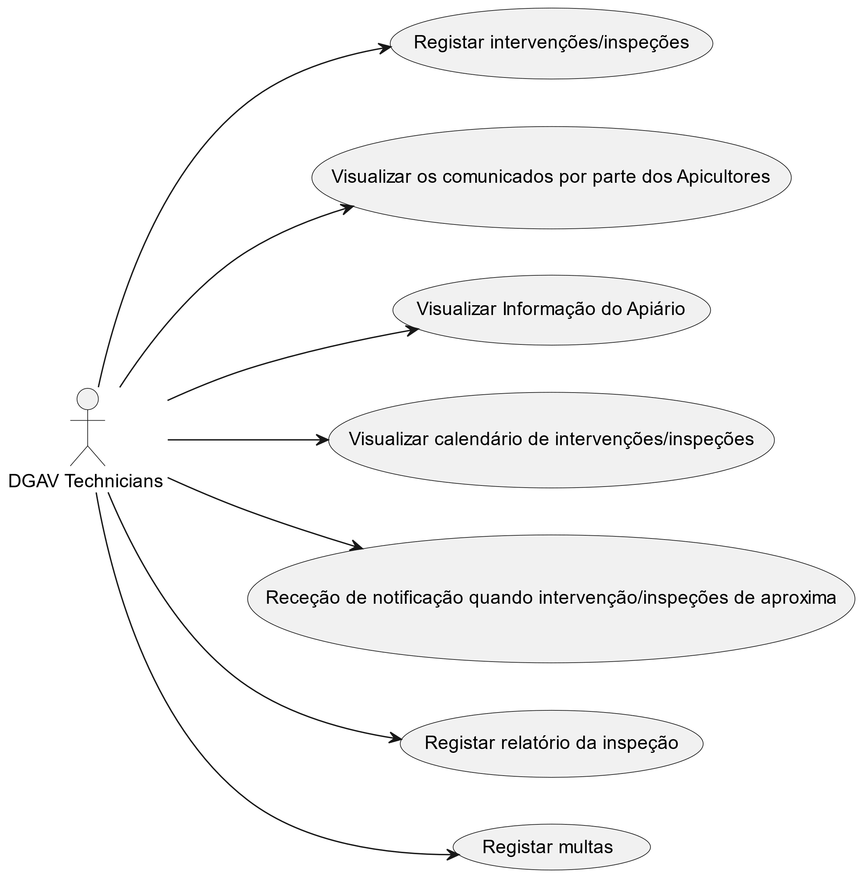

Figure 6 - DGAV Technicians use case diagram

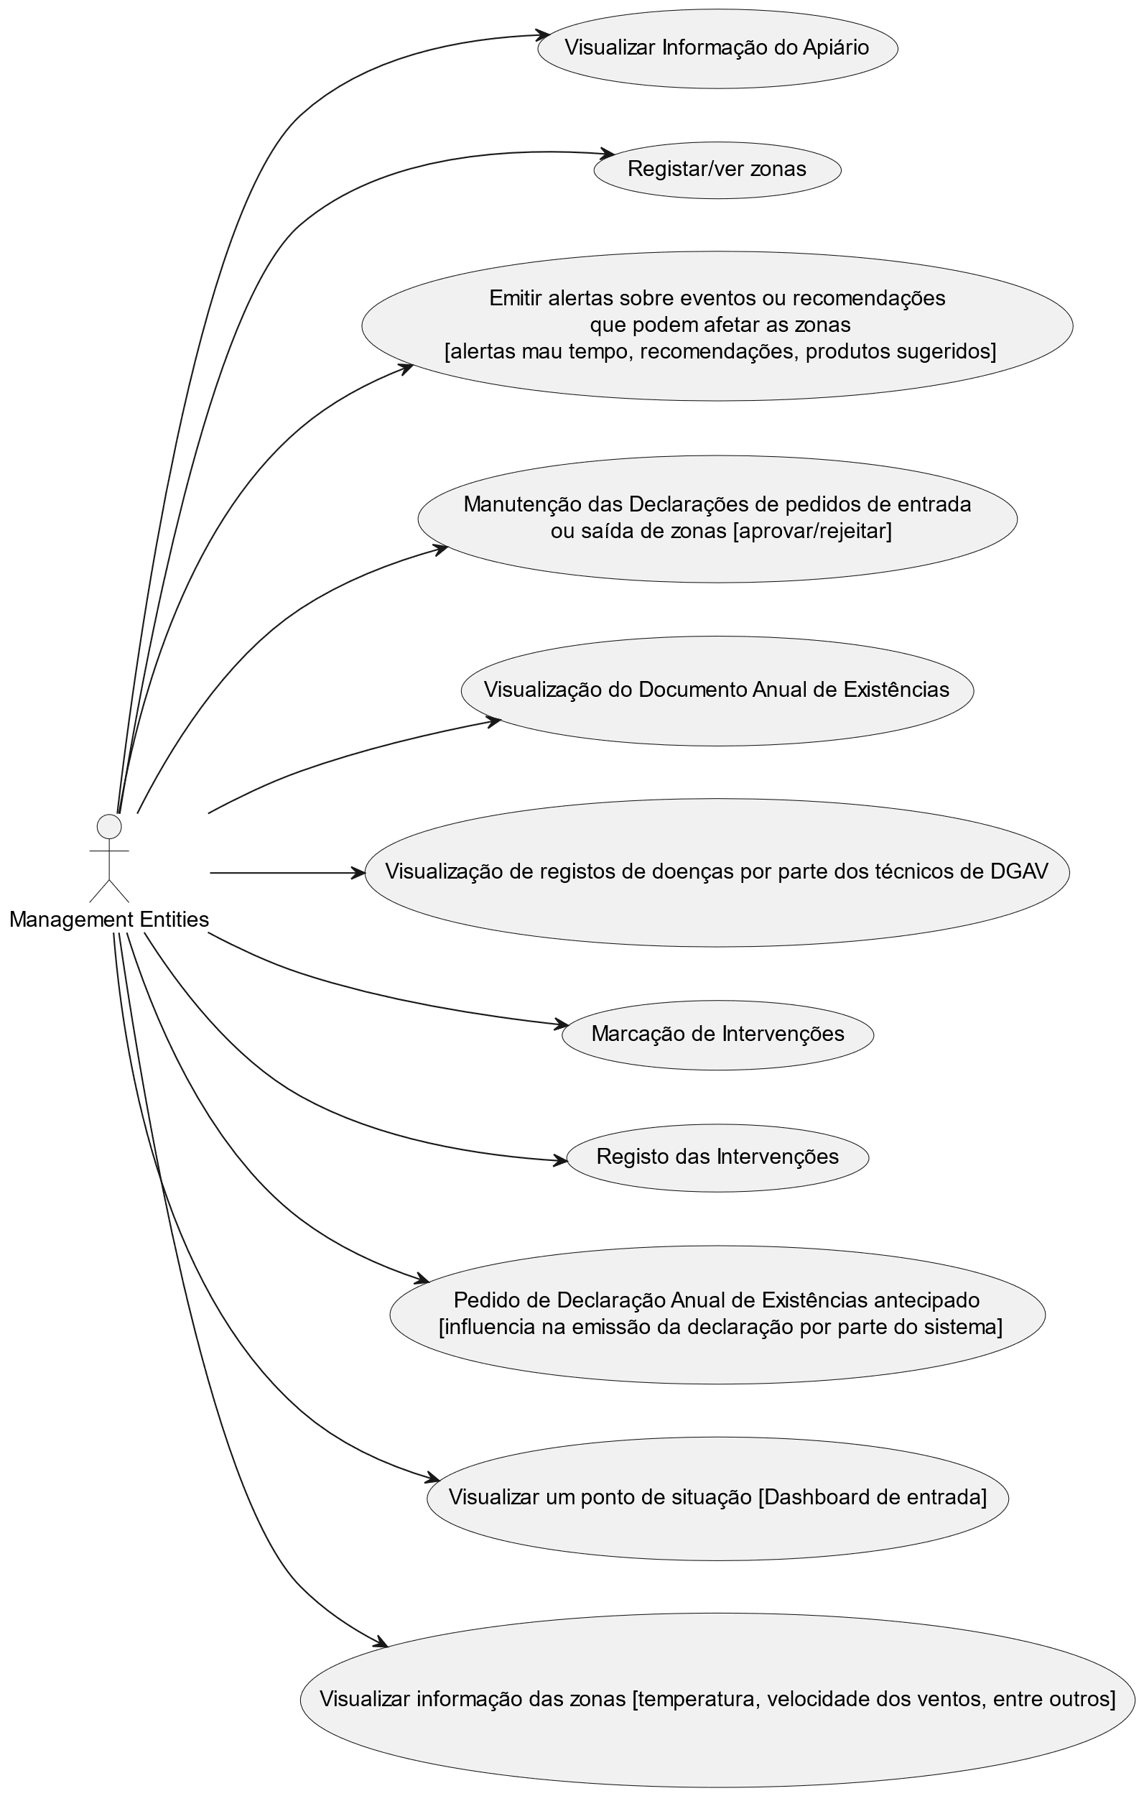

Figure 7 - Management Entities use case diagram

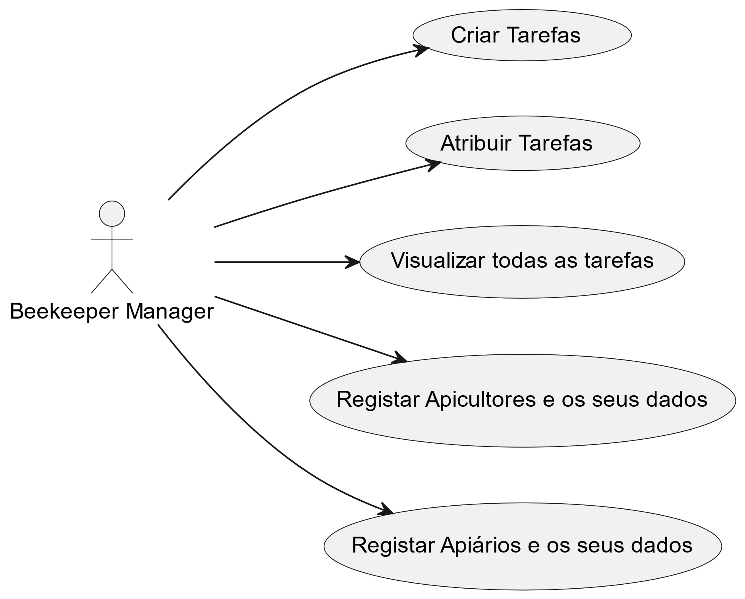

Figure 8 - Beekeeper manager use case diagram

# System Feature: Registering Apiaries and Their Data

# Description

This feature allows beekeepers to register apiaries and their associated data. Accurate apiary registration is essential for regulatory compliance and effective management. This feature is of High priority.

# Stimulus/Response Sequences

Stimulus: Beekeeper accesses the system to register a new apiary.

Response: The system provides an interface for entering apiary details, including location, size, and ownership information.

Stimulus: Beekeeper confirms the registration of the apiary.

Response: The system saves the apiary data and notifies the beekeeper.

# Functional Requirements

REQ-1: The system must provide beekeepers with the capability to register new apiaries and enter relevant data.

REQ-2: Apiary registration should include comprehensive details, such as location, size, and ownership information.

REQ-3: The system should send notifications to confirm the successful registration.

# System Feature: Creating Tasks

# Description

This feature allows beekeepers to create tasks related to apiary and hive management. Task creation is essential for organizing and prioritizing activities. This feature is of High priority.

# Stimulus/Response Sequences

Stimulus: Beekeeper accesses the system to create a new task.

Response: The system provides an interface for specifying task details, including description, due date, and priority.

Stimulus: Beekeeper creates the task and assigns it to a specific apiary or hive.

Response: The system saves the task and associates it with the chosen apiary or hive.

# Functional Requirements

REQ-4: The system must offer beekeepers a user-friendly interface for creating tasks related to apiary and hive management.

REQ-5: Task creation should include details such as description, due date, and priority.

REQ-6: The system should associate tasks with specific apiaries or hives.

# System Feature: Hive Inspection Recording

# Description

This feature allows beekeepers to record hive inspections, including notes and observations. Accurate inspection recording is crucial for hive health management. This feature is of High priority.

# Stimulus/Response Sequences

Stimulus: Beekeeper selects a hive for inspection recording.

Response: The system provides an interface for entering inspection details, including observations, notes, and health status.

Stimulus: Beekeeper records the inspection findings and confirms the recording.

Response: The system saves the inspection record and associates it with the chosen hive.

# Functional Requirements

REQ-7: The system must provide beekeepers with an interface for recording hive inspections, including notes, observations, and health status.

REQ-8: Inspection recording should be comprehensive and include the ability to save inspection records.

# System Feature: Recording Treatments per Hive

# Description

This feature allows beekeepers to record treatments performed on individual hives. Treatment recording is essential for hive health management and compliance. This feature is of High priority.

# Stimulus/Response Sequences

Stimulus: Beekeeper selects a hive to record a treatment.

Response: The system provides an interface for entering treatment details, including type, date, and dosage.

Stimulus: Beekeeper records the treatment details and confirms the recording.

Response: The system saves the treatment record and associates it with the chosen hive.

# Functional Requirements

REQ-9: The system must offer beekeepers the capability to record treatments performed on individual hives, including treatment type, date, and dosage.

REQ-10: Treatment recording should be comprehensive and include the ability to save treatment records.

# System Feature: Viewing Issued Alerts

# Description

This feature allows beekeepers to view alerts issued by Management Entities and DGAV technicians. Access to alerts is essential for staying informed about relevant events and recommendations. This feature is of High priority.

# Stimulus/Response Sequences

Stimulus: Beekeeper accesses the system to view issued alerts.

Response: The system presents a list of alerts, including information about the issuing entity, type of alert, and message.

Stimulus: Beekeeper selects a specific alert for viewing.

Response: The system displays the content of the selected alert.

# Functional Requirements

REQ-11: The system must provide beekeepers with the capability to view alerts issued by Management Entities and DGAV technicians.

REQ-12: Alerts should be organized and easily accessible for review.

# System Feature: Issuing Entry/Exit Requests to Management Entities

# Description

This feature enables beekeepers to issue requests for entry or exit from specific apiary zones to Management Entities. Requesting entry or exit is essential for managing access and activities within zones. This feature is of High priority.

# Stimulus/Response Sequences

Stimulus: Beekeeper accesses the system to issue a request for entry or exit from a specific zone.

Response: The system provides an interface for specifying the request details, including zone, purpose, and duration.

Stimulus: Beekeeper confirms the request for entry or exit.

Response: The system records the request and sends it to the specified Management Entity.

# Functional Requirements

REQ-13: The system must offer beekeepers an interface for issuing requests for entry or exit from specific apiary zones to Management Entities.

REQ-14: Request details should include information about the zone, purpose, and duration.

REQ-15: The system should send requests to the specified Management Entities.

# System Feature: Viewing Zone Information

# Description

This feature enables beekeepers to view information about apiary zones, including temperature, wind speed, and other relevant data. Access to this information is crucial for monitoring conditions within zones. This feature is of High priority.

# Stimulus/Response Sequences

Stimulus: Beekeeper selects a specific zone for viewing.

Response: The system displays information about the selected zone, including temperature, wind speed, and other relevant data.

# Functional Requirements

REQ-16: The system must provide beekeepers with the capability to view information about apiary zones, including temperature, wind speed, and other relevant data.

REQ-17: Zone information should be accurate and up to date.

# System Feature: Viewing Calendar with Tasks and Agendas

# Description

This feature allows beekeepers to view a calendar that displays tasks, agendas, and scheduled activities. Access to a calendar is essential for managing apiary-related tasks and activities. This feature is of High priority.

# Stimulus/Response Sequences

Stimulus: Beekeeper accesses the system to view the calendar.

Response: The system displays a calendar that shows tasks, agendas, and scheduled activities, including due dates and times.

# Functional Requirements

REQ-18: The system must provide beekeepers with a calendar that displays tasks, agendas, and scheduled activities related to their apiaries.

REQ-19: The calendar should be organized and easy to navigate, showing due dates and times.

# System Feature: Recording Produced Products

# Description

This feature allows beekeepers to record details of honey production, including the quantity and types of honey produced. Accurate recording of honey production is essential for management and reporting. This feature is of High priority.

# Stimulus/Response Sequences

Stimulus: Beekeeper selects a hive for recording honey production.

Response: The system provides an interface for specifying the quantity and types of honey produced.

Stimulus: Beekeeper records the honey production details and confirms the recording.

Response: The system saves the production record and associates it with the chosen hive.

# Functional Requirements

REQ-20: The system must offer beekeepers an interface for recording details of honey production, including the quantity and types of honey produced.

# System Feature: Providing Permission to Certification Companies to View Data of X Hives

# Description

This feature enables beekeepers to grant permission to certification companies to access and view data of a specified number of hives (X hives). Providing permission is essential for compliance and transparency with certification requirements. This feature is of High priority.

# Stimulus/Response Sequences

Stimulus: Beekeeper initiates the process of providing permission to a certification company.

Response: The system provides an interface for specifying the number of hives (X hives) and the duration of permission.

Stimulus: Beekeeper confirms the permission settings.

Response: The system records the permission and notifies the specified certification company.

# Functional Requirements

REQ-21: The system must offer beekeepers a user-friendly interface for providing permission to certification companies to access and view data of a specified number of hives.

REQ-22: Permission settings should include the number of hives and the duration of permission.

REQ-23: The system should notify the specified certification company about the granted permission.

# System Feature: Session Scheduling

# Description

This feature allows certification companies to schedule, reschedule, or delete certification sessions. Efficient session management is crucial for organizing inspections and certifications. This feature is of High priority.

# Stimulus/Response Sequences

Stimulus: Certification company accesses the system to schedule a session.

Response: The system provides an interface for session scheduling.

Stimulus: Certification company selects a date and time for the session.

Response: The system saves the session details.

Stimulus: Certification company reschedules or deletes a session.

Response: The system updates the session information accordingly.

# Functional Requirements

REQ-24: The system must offer a user-friendly interface for certification companies to schedule, reschedule, or delete certification sessions.

REQ-25: Session details, including date and time, should be accurately recorded.

REQ-26: The system should send notifications to relevant parties regarding session changes.

# System Feature: Inspection Record Keeping

# Description

This feature enables certification companies to record the results of inspections conducted during certification sessions. Maintaining accurate inspection records is essential for compliance and reporting. This feature is of High priority.

# Stimulus/Response Sequences

Stimulus: Certification company selects a completed session for inspection record keeping.

Response: The system provides an interface for entering inspection results.

Stimulus: Certification company records the inspection findings.

Response: The system saves the inspection results and associates them with the session.

# Functional Requirements

REQ-27: The system must offer a dedicated interface for certification companies to record inspection results for completed sessions.

# System Feature: Session Report Creation

# Description

This feature allows certification companies to create session reports summarizing the results of certification sessions. Session reports are crucial for documentation and reporting purposes. This feature is of High priority.

# Stimulus/Response Sequences

Stimulus: Certification company selects a completed session for report creation.

Response: The system generates a session report based on the inspection results.

# Functional Requirements

REQ-28: The system must provide the capability to create session reports based on inspection results.

# System Feature: Session Cancellation

# Description

This feature allows certification companies to cancel scheduled certification sessions when necessary. Cancellation management is essential for efficient scheduling and resource allocation. This feature is of High priority.

# Stimulus/Response Sequences

Stimulus: Certification company selects a scheduled session for cancellation.

Response: The system allows the certification company to confirm the cancellation.

Stimulus: The certification company confirms the cancellation.

Response: The system updates the session status and notifies relevant parties.

# Functional Requirements

REQ-29: The system must provide an option for certification companies to cancel scheduled sessions.

REQ-30: Cancellation confirmations should update the session status and notify relevant parties.

# System Feature: Certification Registration

# Description

This feature allows certification companies to register new certifications or update existing ones. Maintaining accurate certification records is crucial for regulatory compliance. This feature is of High priority.

# Stimulus/Response Sequences

Stimulus: Certification company accesses the system to register or update certifications.

Response: The system provides an interface for certification registration and updates.

Stimulus: The certification company inputs or updates certification details.

Response: The system saves the certification information and ensures it is up to date.

# Functional Requirements

REQ-31: The system must offer a user-friendly interface for certification companies to register or update certifications.

REQ-32: Certification data should include details such as certification type, expiration date, and other relevant information.

# System Feature: Certification Revalidation

# Description

This feature allows certification companies to revalidate certifications that have expired or need renewal. Accurate revalidation is essential for maintaining compliance. This feature is of High priority.

# Stimulus/Response Sequences

Stimulus: Certification company selects a certification for revalidation.

Response: The system provides options for revalidating the certification.

Stimulus: Certification company confirms the revalidation.

Response: The system updates the certification status and notifies relevant parties.

# Functional Requirements

REQ-33: The system must provide the capability for certification companies to revalidate certifications that have expired or need renewal.

REQ-34: Revalidation confirmations should update the certification status and notify relevant parties.

# System Feature: Time Recording for Issue Resolution

# Description

This feature allows certification companies to record the time required to resolve issues identified in session reports. Accurate time recording helps in assessing efficiency and resource management. This feature is of Medium priority.

# Stimulus/Response Sequences

Stimulus: Certification company selects a session with identified issues.

Response: The system provides an interface to record the time needed to resolve the issues.

Stimulus: Certification company records the time spent on issue resolution.

Response: The system saves the time records for each issue.

# Functional Requirements

REQ-35: The system must offer an interface for certification companies to record the time required for resolving issues identified in session reports.

REQ-36: Time records should be associated with specific issues and sessions.

# System Feature: Treatment History Viewing

# Description

This feature allows certification companies to view the treatment history of an apiary, including records of treatments and interventions. Access to this information is essential for assessing the apiary's compliance and health. This feature is of Medium priority.

# Stimulus/Response Sequences

Stimulus: Certification company selects an apiary to view its treatment history.

Response: The system displays a history of treatments, interventions, and relevant details.

# Functional Requirements

REQ-37: The system must provide a feature for certification companies to view the treatment history of an apiary.

REQ-38: The treatment history should include details of past treatments and interventions.

# System Feature: Certification Requirements Viewing

# Description

This feature enables certification companies to view the requirements for specific certifications. Access to this information is crucial for ensuring that the certification process aligns with the established criteria. This feature is of Medium priority.

# Stimulus/Response Sequences

Stimulus: Certification company selects a certification for viewing its requirements.

Response: The system accesses external certification APIs to display the requirements for the selected certification.

# Functional Requirements

REQ-39: The system must provide a feature for certification companies to view the requirements of specific certifications through external certification APIs.

REQ-40: The system should display certification requirements accurately and in a user-friendly manner.

# System Feature: Automatic Session Notification

# Description

This feature enables the system to send automatic notifications to all relevant parties involved in a certification session as the session's date approaches. Notifications help in ensuring that all stakeholders are prepared for the session. This feature is of High priority.

# Stimulus/Response Sequences

Stimulus: The system identifies a certification session with an approaching date.

Response: The system sends automatic notifications to all parties involved in the session.

# Functional Requirements

REQ-41: The system must have the capability to send automatic notifications to all parties involved in a certification session as the session's date approaches.

REQ-42: Notifications should be timely and include essential session details.

# System Feature: Annual Existence Declaration Generation

# Description

This feature allows certification companies to generate the annual declaration of existence, a document that certifies the presence of apiaries. Accurate document generation is essential for regulatory compliance and reporting. This feature is of High priority.

# Stimulus/Response Sequences

Stimulus: Certification company initiates the generation of the annual declaration of existence.

Response: The system generates the document, incorporating information about the existence of apiaries and relevant data.

# Functional Requirements

REQ-43: The system must provide certification companies with the capability to generate the annual declaration of existence document.

# System Feature: Scheduling Interventions/Inspections

# Description

This feature allows DGAV technicians to schedule interventions and inspections. Efficient scheduling is essential for managing regulatory compliance and monitoring apiaries. This feature is of High priority.

# Stimulus/Response Sequences

Stimulus: DGAV technician accesses the system to schedule an intervention or inspection.

Response: The system provides an interface for setting up the schedule, including date, time, and location.

Stimulus: DGAV technician confirms the scheduling.

Response: The system updates the schedule and sends notifications to relevant parties.

# Functional Requirements

REQ-44: The system must offer DGAV technicians a user-friendly interface to schedule interventions and inspections.

REQ-45: The scheduling process should include setting the date, time, and location.

REQ-46: The system should send notifications to inform relevant parties about the scheduled interventions/inspections.

# System Feature: Viewing Notifications from Beekeepers

# Description

This feature enables DGAV technicians to view notifications and communications received from beekeepers. Access to this information is essential for effective communication and issue resolution. This feature is of High priority.

# Stimulus/Response Sequences

Stimulus: DGAV technician accesses the system to view notifications.

Response: The system presents a list of notifications and messages received from beekeepers.

Stimulus: DGAV technician selects a specific notification for viewing.

Response: The system displays the content of the selected notification.

# Functional Requirements

REQ-47: The system must provide DGAV technicians with the capability to view notifications and messages received from beekeepers.

REQ-48: Notifications should be organized and easily accessible for review.

# System Feature: Viewing Apiary Information

# Description

This feature allows DGAV technicians to access and view information related to specific apiaries. Access to apiary information is essential for regulatory oversight and issue resolution. This feature is of High priority.

# Stimulus/Response Sequences

Stimulus: DGAV technician selects an apiary to view its information.

Response: The system displays detailed information about the selected apiary, including location, bee counts, and inspection history.

# Functional Requirements

REQ-49: The system must provide DGAV technicians with the capability to access and view information about specific apiaries.

REQ-50: The information should be comprehensive, including location details, bee counts, and inspection history.

# System Feature: Intervention/Inspection Calendar Viewing

# Description

This feature enables DGAV technicians to view a calendar that displays scheduled interventions and inspections. The calendar helps in organizing and planning regulatory activities. This feature is of High priority.

# Stimulus/Response Sequences

Stimulus: DGAV technician accesses the system.

Response: The system presents a calendar with scheduled interventions and inspections.

Stimulus: DGAV technician selects a date on the calendar.

Response: The system displays the list of interventions and inspections scheduled for the chosen date.

# Functional Requirements

REQ-51: The system must provide DGAV technicians with a calendar to view scheduled interventions and inspections.

REQ-52: The calendar should allow technicians to review and plan regulatory activities efficiently.

# System Feature: Notification of Approaching Interventions/Inspections

# Description

This feature enables the system to send automatic notifications to DGAV technicians as scheduled interventions or inspections approach. Notifications help in ensuring that technicians are well-prepared for these activities. This feature is of High priority.

# Stimulus/Response Sequences

Stimulus: The system identifies a scheduled intervention or inspection with an approaching date.

Response: The system sends automatic notifications to DGAV technicians to inform them about the upcoming activity.

# Functional Requirements

REQ-53: The system must have the capability to send automatic notifications to DGAV technicians as scheduled interventions or inspections approach.

REQ-54: Notifications should be timely and include essential details about the upcoming intervention/inspection.

# System Feature: Inspection Report Recording

# Description

This feature allows DGAV technicians to record and document the results of inspections conducted during certification sessions. Accurate report recording is essential for regulatory oversight and reporting. This feature is of High priority.

# Stimulus/Response Sequences

Stimulus: DGAV technician selects a completed inspection session for report recording.

Response: The system provides an interface for entering inspection results and generating inspection reports.

Stimulus: DGAV technician records the inspection findings and recommendations.

Response: The system saves the inspection report and associates it with the respective session.

# Functional Requirements

REQ-55: The system must provide DGAV technicians with an interface for recording inspection results and generating inspection reports.

REQ-56: Inspection reports should be comprehensive and include findings, recommendations, and supporting data.

# System Feature: Fine Recording

# Description

This feature allows DGAV technicians to record fines imposed on beekeepers for non-compliance or violations. Fine recording is essential for regulatory enforcement and penalty tracking. This feature is of High priority.

# Stimulus/Response Sequences

Stimulus: DGAV technician selects a beekeeper for fine recording.

Response: The system provides an interface for entering fine details, including the amount, reason, and due date.

Stimulus: DGAV technician records the fine details and confirms the recording.

Response: The system saves the fine information and notifies the beekeeper.

# Functional Requirements

REQ-57: The system must offer DGAV technicians the capability to record fines imposed on beekeepers for non-compliance or violations.

REQ-58: Fine recording should include details such as the fine amount, reason, and due date.

# System Feature: Sanitary Closure Recording

# Description

This feature allows DGAV technicians to record the temporary closure of an apiary for sanitary reasons. Sanitary closure recording is essential for preventing the spread of diseases and ensuring public health safety. This feature is of High priority.

# Stimulus/Response Sequences

Stimulus: DGAV technician selects an apiary for sanitary closure recording.

Response: The system provides an interface for specifying the reasons for closure and the expected reopening date.

Stimulus: DGAV technician records the sanitary closure details.

Response: The system saves the closure information and notifies the apiary owner.

# Functional Requirements

REQ-59: The system must provide DGAV technicians with the capability to record the temporary closure of an apiary for sanitary reasons.

REQ-60: Sanitary closure recording should include details of the reasons for closure and the expected reopening date.

# System Feature: Recording Severe Diseases

# Description

This feature allows DGAV technicians to record instances of severe diseases affecting apiaries. Accurate recording of severe diseases is crucial for monitoring and controlling disease outbreaks. This feature is of High priority.

# Stimulus/Response Sequences

Stimulus: DGAV technician identifies a severe disease outbreak in an apiary.

Response: The system provides an interface for recording disease details, affected apiaries, and containment measures.

Stimulus: DGAV technician records the disease outbreak information.

Response: The system saves the disease outbreak record and notifies relevant parties.

# Functional Requirements

REQ-61: The system must offer DGAV technicians a dedicated interface for recording instances of severe diseases affecting apiaries.

REQ-62: Disease outbreak recording should include comprehensive details about the disease, affected apiaries, and containment measures.

# System Feature: Notification of Severe Diseases

# Description

This feature enables the system to send automatic notifications to relevant parties when severe diseases affecting apiaries are recorded by DGAV technicians. Timely notifications are essential for disease containment and response. This feature is of High priority.

# Stimulus/Response Sequences

Stimulus: The system identifies a recorded instance of a severe disease affecting an apiary.

Response: The system sends automatic notifications to relevant parties, including apiary owners and authorities.

# Functional Requirements

REQ-63: The system must have the capability to send automatic notifications to relevant parties when DGAV technicians record instances of severe diseases affecting apiaries.

REQ-64: Notifications should be timely and include essential details about the disease outbreak and containment measures.

# System Feature: Viewing Apiary Information

# Description

This feature allows management entities to access and view information related to specific apiaries. Access to apiary information is essential for oversight and decision-making. This feature is of High priority.

# Stimulus/Response Sequences

Stimulus: Management entity selects an apiary to view its information.

Response: The system displays detailed information about the selected apiary, including location, bee counts, and inspection history.

# Functional Requirements

REQ-65: The system must provide management entities with the capability to access and view information about specific apiaries.

REQ-66: The information should be comprehensive, including location details, bee counts, and inspection history.

# System Feature: Registering/Viewing Zones

# Description

This feature allows management entities to register and view zones. Zones are crucial for organizing and managing apiaries effectively. This feature is of High priority.

# Stimulus/Response Sequences

Stimulus: Management entity registers a new zone.

Response: The system provides an interface for specifying zone details, including name, description, and boundaries.

Stimulus: Management entity selects a zone to view its details.

Response: The system displays zone information, including boundaries and associated data.

# Functional Requirements

REQ-67: The system must offer management entities a user-friendly interface for registering new zones.

REQ-68: The system should allow viewing and managing zone information, including associated data.

# System Feature: Alert Emission for Events/Recommendations

# Description

This feature allows management entities to emit alerts related to events or recommendations that may affect apiary zones. Alerts can include information about adverse weather conditions, recommendations, and suggested products. This feature is of High priority.

# Stimulus/Response Sequences

Stimulus: Management entity accesses the system to emit an alert for a specific zone.

Response: The system provides an interface for specifying alert details, including type, message, and target zone.

Stimulus: Management entity emits an alert with relevant information.

Response: The system sends the alert to the specified zone and relevant parties.

# Functional Requirements

REQ-69: The system must provide management entities with the capability to emit alerts related to events or recommendations for specific apiary zones.

REQ-70: Alerts should include information about the type of event or recommendation, the message, and the target zone.

REQ-71: The system should ensure that alerts are delivered to the specified zones and relevant parties.

# System Feature: Management of Declarations of Entry/Exit for Zones

# Description

This feature allows management entities to manage declarations of entry or exit for zones, including approving or rejecting these declarations. Management of declarations is essential for controlling access and activities within zones. This feature is of High priority.

# Stimulus/Response Sequences

Stimulus: Management entity accesses the system to manage declarations for a specific zone.

Response: The system provides an interface for reviewing and acting on declarations, including approval or rejection.

Stimulus: Management entity reviews declarations and approves or rejects them.

Response: The system updates the status of declarations and notifies relevant parties.

# Functional Requirements

REQ-72: The system must offer management entities an interface for managing declarations of entry or exit for zones.

REQ-73: Declaration management should include the ability to review and act on declarations, including approval or rejection.

REQ-74: The system should ensure that relevant parties are notified of declaration status changes.

# System Feature: Viewing Annual Existence Declaration

# Description

This feature enables management entities to view the annual declaration of existence, a document that certifies the presence of apiaries. Access to this document is essential for regulatory compliance and reporting. This feature is of High priority.

# Stimulus/Response Sequences

Stimulus: Management entity selects the option to view the annual declaration of existence.

Response: The system displays the document, certifying the existence of apiaries and relevant data.

# Functional Requirements

REQ-75: The system must provide management entities with the capability to view the annual declaration of existence document.

REQ-76: The document should be accurate, up-to-date, and compliant with regulatory requirements.

# System Feature: Viewing Disease Records by DGAV Technicians

# Description

This feature allows management entities to view disease records submitted by DGAV technicians. Access to disease records is crucial for monitoring and managing health issues within apiaries. This feature is of High priority.

# Stimulus/Response Sequences

Stimulus: Management entity selects an option to view disease records submitted by DGAV technicians.

Response: The system displays disease records, including details of diseases, affected apiaries, and containment measures.

# Functional Requirements

REQ-77: The system must provide management entities with the capability to view disease records submitted by DGAV technicians.

REQ-78: Disease records should be comprehensive, including details about the diseases, affected apiaries, and containment measures.

# System Feature: Scheduling Inspections

# Description

This feature allows management entities to schedule inspections. Efficient scheduling is essential for managing regulatory compliance and addressing issues. This feature is of High priority.

# Stimulus/Response Sequences

Stimulus: Management entity accesses the system to schedule an inspection.

Response: The system provides an interface for setting up the schedule, including date, time, and the target zone.

Stimulus: Management entity confirms the scheduling of the inspection.

Response: The system updates the schedule and notifies relevant parties.

# Functional Requirements

REQ-79: The system must offer management entities a user-friendly interface for scheduling inspections.

REQ-80: The scheduling process should include setting the date, time, and the target zone.

REQ-81: The system should send notifications to inform relevant parties about the scheduled inspections.

# System Feature: Recording Inspections

# Description

This feature allows management entities to record details of inspections carried out. Accurate intervention recording is essential for compliance and reporting. This feature is of High priority.

# Stimulus/Response Sequences

Stimulus: Management entity selects a completed intervention for recording.

Response: The system provides an interface for entering inspections details, including objectives, activities, and results.

Stimulus: Management entity records the inspections details and confirms the recording.

Response: The system saves the inspection record and associates it with the respective zone and activities.

# Functional Requirements

REQ-82: The system must provide management entities with an interface for recording details of inspections carried out within apiary zones.

REQ-83: Inspection recording should include objectives, activities, results, and associations with specific zones and activities.

# System Feature: Dashboard Viewing

# Description

This feature allows management entities to view a dashboard, providing a summarized view of information and activities related to apiaries and entities. The dashboard acts as a central point of access for essential information. This feature is of High priority.

# Stimulus/Response Sequences

Stimulus: Management entity accesses the system and selects the entrance dashboard.

Response: The system displays a summarized view of information and activities, including notifications, alerts, and key performance indicators.

# Functional Requirements

REQ-84: The system must provide management entities with a dashboard for viewing a summarized overview of information and activities related to apiaries and entities.

REQ-85: The dashboard should present essential information, including notifications, alerts, and key performance indicators.

# System Feature: Viewing Zone Information

# Description

This feature enables management entities to view information about apiary. Access to this information is crucial for monitoring conditions within zones. This feature is of High priority.

# Stimulus/Response Sequences

Stimulus: Management entity selects a specific zone for viewing.

Response: The system displays information about the selected zone, including temperature, wind speed, and other relevant data.

# Functional Requirements

REQ-86: The system must provide management entities with the capability to view information about apiary zones, including temperature, wind speed, and other relevant data.

# System Feature: Product Stock Management

# Description

This feature allows management entities to manage the stock of products used within apiaries. Efficient stock management is essential for ensuring the availability of necessary products. This feature is of High priority.

# Stimulus/Response Sequences

Stimulus: Management entity accesses the system to manage product stock.

Response: The system provides an interface for viewing and updating product stock levels.

Stimulus: Management entity updates product stock levels based on consumption or restocking.

Response: The system updates the product stock records and notifies relevant parties if stock levels are critical.

# Functional Requirements

REQ-87: The system must offer management entities an interface for managing the stock of products used within apiaries.

REQ-88: Product stock management should include the ability to view and update stock levels based on consumption and restocking.

REQ-89: The system should notify relevant parties when stock levels reach critical thresholds.

# System Feature: Task Management

# Description

This feature empowers Beekeeper Managers to create and manage tasks associated with apiary and hive management. Task management is pivotal for organizing and prioritizing activities effectively. This feature holds a position of high priority within the system.

# Stimulus/Response Sequences

Stimulus: Beekeeper Managers access the system with the intention of creating a new task.

Response: The system provides a user-friendly interface for specifying task details, including task description, due date, and priority.

Stimulus: Beekeeper Managers create the task and assign it to a specific apiary or hive.

Response: The system records the task and associates it with the designated apiary or hive.

# Functional Requirements

REQ-90: The system must offer Beekeeper Managers a user-friendly interface for creating and managing tasks related to apiary and hive management.

REQ-91: Task creation should encompass comprehensive details, including task description, due date, and priority.

REQ-92: The system should efficiently associate tasks with specific apiaries or hives to streamline management and tracking.

# System Feature: Beekeeper and Apiary Registration

# Description

This feature enables Beekeeper Managers to register and maintain data about beekeepers and their associated apiaries. Accurate registration is essential for effective management and collaboration. This feature is classified as high priority within the system.

# Stimulus/Response Sequences

Stimulus: Beekeeper Managers access the system to register a new beekeeper.

Response: The system provides an interface for entering beekeeper information, including personal details and apiary affiliations.

Stimulus: Beekeeper Managers create and manage apiary records.

Response: The system allows for the registration and upkeep of apiary data, including location and ownership details.

# Functional Requirements

REQ-93: The system must provide Beekeeper Managers with an intuitive interface for registering beekeepers, encompassing personal information and their connection to apiaries.

REQ-94: Beekeeper Managers should be able to create, update, and manage apiary records, including data related to location and ownership.

# System Feature: Task Assignment

# Description

This feature allows Beekeeper Managers to assign created tasks to specific individuals or teams, streamlining task delegation and responsibility management. Efficient task assignment is crucial for coordinated hive and apiary management. This feature is deemed high priority.

# Stimulus/Response Sequences

Stimulus: Beekeeper Managers access the system to assign a task.

Response: The system provides an interface for specifying the task recipient, due date, and any relevant details.

Stimulus: Beekeeper Managers confirm the task assignment.

Response: The system records the assignment and notifies the designated recipient.

# Functional Requirements

REQ-95: The system must offer Beekeeper Managers a streamlined interface for assigning tasks, allowing them to specify the recipient, due date, and task particulars.

REQ-96: Task assignment should include notification to the designated task recipient for effective communication.

# System Feature: Viewing All Tasks

# Description

This feature provides Beekeeper Managers with the capability to view all tasks, whether created or assigned. Comprehensive task visibility is essential for tracking progress and ensuring efficient task management. This feature is of high priority.

# Stimulus/Response Sequences

Stimulus: Beekeeper Managers access the system to view all tasks.

Response: The system displays a list of all tasks, including details such as task description, due dates, and assignees

Stimulus: Beekeeper Managers select a specific task for viewing.

Response: The system presents detailed information about the selected task.

# Functional Requirements

REQ-97: The system must provide Beekeeper Managers with an accessible interface for viewing all tasks, offering information about task status, assignees, and due dates.

REQ-98: Task details should be readily accessible, ensuring comprehensive task visibility for effective management.

# System Feature: Beekeeper and Apiary Registration

# Description

This feature allows Beekeeper Managers to register and maintain data about beekeepers and their associated apiaries. Accurate registration is essential for effective management and collaboration. This feature is classified as high priority within the system.

# Stimulus/Response Sequences:

Stimulus: Beekeeper Managers access the system to register a new beekeeper.

Response: The system provides an interface for entering beekeeper information, including personal details and apiary affiliations.

Stimulus: Beekeeper Managers create and manage apiary records.

Response: The system allows for the registration and upkeep of apiary data, including location and ownership details.

# Functional Requirements

REQ-99: The system must provide Beekeeper Managers with an intuitive interface for registering beekeepers, encompassing personal information and their connection to apiaries.

REQ-100: Beekeeper Managers should be able to create, update, and manage apiary records, including data related to location and ownership.

# Data requirements

This section of this Software Requirements Specification (SRS) is dedicated to elucidating the essential aspects of how data will be managed within the system. Within this section, you will find detailed information pertaining to the following key components:

# Logical data model

Figure 9 - Logical Data Model

# Data dictionary

In this section, we will describe the components you are able to see in Figure 9.

| Entity Name | | Entity Description | | | | | |
| --- | --- | --- | --- | --- | --- | --- | --- |
|  | **Column Name** | **Column Description** | **Data Type** | **Length** | **Primary Key** | **Nullable** | **Unique** |
| Alert | | An alert that is raised when something urgent occurs. All the users will be able to view this information. | | | | | |
|  | AlertID | Alert Unique Identifier. | varchar | 10 | true | false | true |
|  | AlertMessageContent | Alert message content. | varchar | 255 | false | false | false |
|  | LaunchByUserID | The unique identifier of the user who launched this alert. | varchar | 10 | false | false | false |
|  | SentByUserID | The unique identifier of the user who created this alert. | varchar | 10 | false | false | false |
| AnnualInventoryDeclaration | | The Annual Inventory Declaration | | | | | |
|  | AnnualInventoryDeclarationContent | The content of it. | varchar | 255 | false | false | false |
|  | AnnualInventoryDeclarationID | AnnualInventoryDeclaration Unique Identifier | varchar | 10 | true | false | true |
|  | ApprovedByUserID | The unique identifier of the user who approved it. | varchar | 10 | false | false | false |
|  | SubmittedByUserID | The unique identifier of the user who submitted it. | varchar | 10 | false | false | false |
| Apiary | | The apiary where the beekeepers work. | | | | | |
|  | ApiaryID | Apiary Unique Identifier. | varchar | 10 | true | false | true |
|  | TotalBees | Total number of bees in all the apiary. | integer | 10 | false | false | false |
|  | ZoneID | The unique identifier of the zone where the apiary is. | varchar | 10 | false | false | false |
| ApiaryCertification | | Certification that is valid to some apiary. | | | | | |
|  | ApiaryCertificationID | ApiaryCertification Unique Identifier. | varchar | 10 | true | false | true |
|  | ApiaryID | The certified apiary unique identifier. | varchar | 10 | false | false | false |
|  | CertificationID | The certification unique identifier. | varchar | 10 | false | false | false |
|  | EndDate | When the certification expires. | date | 0 | false | false | false |
|  | StartDate | When the certification is valid | date | 0 | false | false | false |
| ApiaryCertificationError | | Errors that might came up during certification process. | | | | | |
|  | ApiaryCertificationErrorID | ApiaryCertificationError Unique Identifier. | varchar | 10 | true | false | true |
|  | ApiaryCertificationID | The apiary certification unique identifier where the error came from. | varchar | 10 | false | false | false |
|  | ErrorDescription | Error description. | varchar | 255 | false | false | false |
|  | ErrorType | Type of error. It can be Minor, Bad or Extreme. | varchar | 10 | false | false | false |
| ApiaryProduct | | A product that exists in an apiary and the quantity. | | | | | |
|  | ApiaryID | The unique identifier of the apiary where the product exists. | varchar | 10 | false | false | false |
|  | ApiaryProductID | Apiary Product unique identifier. | varchar | 10 | true | false | true |
|  | ProductID | The unique identifier of the product. | varchar | 10 | false | false | false |
|  | quantity | Quantity of that product | integer | 10 | false | false | false |
| ApiaryProductCertification | | Certification that is valid to some apiary product. | | | | | |
|  | ApiaryProductCertificationID | ApiaryCertification Unique Identifier. | varchar | 10 | true | false | true |
|  | ApiarytProductQuantityID |  | varchar | 10 | false | false | false |
|  | CertificationID | The unique identifier of the certification. | varchar | 10 | false | false | false |
|  | EndDate | When the certification expires. | date | 0 | false | false | false |
|  | StartDate | When the certification is valid | date | 0 | false | false | false |
| ApiaryProductCertificationError | | Errors that might came up during certification process. | | | | | |
|  | ApiaryProductCertificatioID |  | varchar | 10 | false | false | false |
|  | ApiaryProductCertificationErrorID | ApiaryCertificationError Unique Identifier. | varchar | 10 | true | false | true |
|  | ErrorDescription | Error description. | varchar | 255 | false | false | false |
|  | ErrorType | Type of error. It can be Minor, Bad or Extreme. | varchar | 10 | false | false | false |
| Appointment | | An appointment to a session that involves some participants and the date of it. This is used to build calendars as well. If any participant can't go to the appointment it's canceled automatically. | | | | | |
|  | AppointmentDate | The Date and Time of the Appointment | date | 0 | false | false | false |
|  | AppointmentID |  | varchar | 10 | true | false | true |
|  | AppointmentStatus | Status of the appointment. Pending, Rejected, Accepted. | varchar | 10 | false | false | false |
| AppointmentParticipant | | Keep track of all the participants on a certain appointment. | | | | | |
|  | AppointmentID | The unique Identifier of the appointment itself. | varchar | 10 | false | false | false |
|  | ParticipantID | The unique identifier of a user that needs to be present on the appointment. | varchar | 10 | false | false | false |
| Beekeeper | | A specific type of User, Beekeeper | | | | | |
|  | UserID | Unique Identifier of the beekeeper. | varchar | 10 | true | false | false |
| BeekeeperApiary | | Keep track of all the apiaries on a certain beekeeper. | | | | | |
|  | ApiaryApiaryID |  | varchar | 10 | false | false | false |
|  | BeekeeperUserID |  | varchar | 10 | false | false | false |
| BeekeeperCertification | | Certification that is valid to some Beekeeper. | | | | | |
|  | BeekeeperCertificationID | BeekeeperCertification Unique Identifier. | varchar | 10 | true | false | true |
|  | BeekeeperUserID | Unique Identifier of the Beekeeper that's being certified. | varchar | 10 | false | false | false |
|  | CertificationID | The Unique Identifier of the certification being applied. | varchar | 10 | false | false | false |
|  | EndDate | When the certification expires. | date | 0 | false | false | false |
|  | StartDate | When the certification is valid | date | 0 | false | false | false |
| BeekeeperCertificationError | | Errors that might came up during certification process. | | | | | |
|  | BeekeeperCertificationErrorID | BeekeeperCertificationError Unique Identifier. | varchar | 10 | true | false | true |
|  | BeekeeperCertificationID |  | varchar | 10 | false | false | false |
|  | ErrorDescription | Error description. | varchar | 255 | false | false | false |
|  | ErrorType | Type of error. It can be Minor, Bad or Extreme. | varchar | 10 | false | false | false |
| Certification | | A certification that will be applied to an apiary. | | | | | |
|  | CertificationDescription | The complete description of the certification including requirements and explanation. | varchar | 255 | false | false | false |
|  | CertificationID | Certification Unique Identifier | varchar | 10 | true | false | true |
|  | CertificationType | Certification type. | varchar | 10 | false | false | false |
|  | ExpirationTime | How long does the certification lasts. | time | 7 | false | false | false |
| CertificationRequest | | A request that's made when you want to certify an apiary. | | | | | |
|  | ApiaryID | The unique identifier of the apiary that will possibly be certified. | varchar | 10 | false | false | false |
|  | CertificationID | Unique Identifier of the certification that's being requested. | varchar | 10 | false | false | false |
|  | CertificationRequestID | CertificationRequest Unique Identifier | varchar | 10 | true | false | true |
|  | CertificationStatus | Status of the Certification. Pending, Rejected, In Progress and Approved. | varchar | 10 | false | false | false |
|  | RequestedUserID | Unique Identifier of the Beekeeper who asks for the certification. | varchar | 10 | false | false | false |
| Fine | | Some sessions might result in fines. | | | | | |
|  | ApiaryID | The apiary that created this fine. | varchar | 10 | false | false | false |
|  | Cost | Cost of the fine. | double | 10 | false | false | false |
|  | FineID | Fine unique identifier. | varchar | 10 | true | false | true |
|  | Motive | Motive of the fine. | varchar | 255 | false | false | false |
|  | PaymentMethods | Payment methods are described here. | varchar | 255 | false | true | false |
|  | SessionResultID | Session Result where the fine was brought up. | varchar | 10 | false | false | false |
| Handle | | A compartment of the Hive where bees live. | | | | | |
|  | HandleID | Handle unique identifier. | varchar | 10 | true | false | false |
|  | HiveID |  | varchar | 10 | false | false | false |
|  | TotalBees | Number of bees in the Handle | integer | 10 | false | false | false |
| Hive | | A hive that contains bees. | | | | | |
|  | ApiaryID | The unique identifier of the Apiary where the Hive is located. | varchar | 10 | false | false | false |
|  | HiveID | Hive Unique Identifier. | varchar | 10 | true | false | true |
|  | HiveType | The type of Hive. Colmeia, núcleo ou cortiço. | varchar | 10 | false | false | false |
|  | TotalBees | Total number of bees in this hive. | integer | 10 | false | false | false |
| Inspection | | Inspection that will be done in some Hive. | | | | | |
|  | BeekeeperUserID | Unique Identifier of the Beekeeper. | varchar | 10 | false | false | false |
|  | Date | Dater of the inspection. | date | 0 | false | true | false |
|  | HiveID | Unique Identifier of the Hive being inspected. | varchar | 10 | false | false | false |
|  | InspectionID | Unique Identifier of the Inspection | varchar | 10 | true | false | false |
| Message | | A message that a user can send another. | | | | | |
|  | MessageContent | The message text. | varchar | 255 | false | true | false |
|  | MessageID | Message Unique Identifier. | varchar | 10 | true | false | true |
|  | ReceivedByUserID | The unique identifier of the user who received this message. | varchar | 10 | false | false | false |
|  | SentByUserID | The unique identifier of the user who sent this message. | varchar | 10 | false | false | false |
| Note | | A note that a beekeeper can write down about a hive. | | | | | |
|  | InspectionID | Unique Identifier of the Inspection that resulted in this note. | varchar | 10 | false | false | false |
|  | NoteContent | Content of the note. | varchar | 255 | false | false | false |
|  | NoteID | Note Unique Identifier. | varchar | 10 | true | false | true |
| Product | | A product that exists in a apiary. | | | | | |
|  | CautionText | Care that must be taken with the product. | varchar | 255 | false | false | false |
|  | Cost | Cost of the product. | double | 10 | false | false | false |
|  | Description | Product description. | varchar | 255 | false | true | false |
|  | Name | Product name. | varchar | 15 | false | false | false |
|  | ProductID | Product unique identifier. | varchar | 10 | true | false | true |
|  | ProductType | Type of product | varchar | 10 | false | false | false |
| SanitaryLock | | When we need to lock a certain apiary in a certain zone due to some issues. e.g. diseases and bad weather | | | | | |
|  | AdditionalComments |  | varchar | 255 | false | true | false |
|  | ApiaryID | The unique identifier of the apiary affected. | varchar | 10 | false | false | false |
|  | SanitaryLockID | SanitaryLock Unique Identifier. | varchar | 10 | true | false | true |
|  | ZoneID | The unique identifier of the zone affected. | varchar | 10 | false | false | false |
| Session | | The session itself. | | | | | |
|  | AppointmentID | The unique identifier of the appointment that created this session. | varchar | 10 | false | false | false |
|  | SessionCost | Cost of the session. | double | 10 | false | true | false |
|  | SessionEndTime | Timestamp of the session end. | timestamp | 0 | false | false | false |
|  | SessionID |  | varchar | 10 | true | false | true |
|  | SessionStartTime | Timestamp of the session start. | timestamp | 0 | false | false | false |
|  | SessionStatus | Status of the session. Pending, Rejected, In Progress and Done. | varchar | 10 | false | false | false |
|  | SessionType | The type of the session. It can be a certification company inspection, DGAV intervention or management entities inspection. | varchar | 10 | false | false | false |
| SessionResult | | The result of the session that might end up turning into a report. | | | | | |
|  | AdditionalComments |  | varchar | 255 | false | true | false |
|  | Conclusion | Conclusion of the session. | varchar | 255 | false | false | false |
|  | Files | Files that might be good to keep here such as photos or recorded data. | blob | 0 | false | true | false |
|  | Resume | Resume of the work done. | varchar | 255 | false | false | false |
|  | SessionDate | Session date. | date | 0 | false | false | false |
|  | SessionID | The session itself unique identifier. | varchar | 10 | false | false | false |
|  | SessionResultID | Session Result Unique Identifier. | varchar | 10 | true | false | true |
|  | Title | The title of the result, might be related to the Session Type. | varchar | 20 | false | false | false |
| Task | | A task that can be done by an user, specially the beekeeper. | | | | | |
|  | BeekeeperAssignedID | Unique ID of the beekeeper assigned to do the task. | varchar | 10 | false | false | false |
|  | CreatedByUserID | The unique identifier of the user who created this task. | varchar | 10 | false | false | false |
|  | TaskComment | A comment about the task. | varchar | 100 | false | true | false |
|  | TaskID | Task Unique Identifier | varchar | 10 | true | false | true |
|  | TaskStatus | Status of the task. Pending, Rejected, In Progress and Done. | varchar | 10 | false | false | false |
|  | TaskType | The type of task that's being done. | varchar | 10 | false | false | false |
|  | UserIDAssignes | Unique ID of the User who assigned a beekepper to do the task. | varchar | 10 | false | false | false |
| Treatment | | Treatment done in an Hive. | | | | | |
|  | Date | Date of the treatment. | date | 0 | false | true | false |
|  | HiveID |  | varchar | 10 | false | false | false |
|  | TreatmentID | Treatment Unique Identifier. | varchar | 10 | true | false | false |
|  | TreatmentNotes | What was done in this treatment. | integer | 10 | false | true | false |
| User | | Someone that uses the application. | | | | | |
|  | Email | Email of the user. | varchar | 50 | false | false | true |
|  | Name | Name of the user. | varchar | 50 | false | false | false |
|  | UserID | User Unique Identifier. | varchar | 10 | true | false | true |
|  | UserType | User Type such as Beekeeper , DGAV technician, Certification Responsible and Technician of the Management Entities of Controlled Areas. | varchar | 15 | false | false | false |
| Zone | | A zone that can have apiaries in it. | | | | | |
|  | City | The city where this zone is located at. | varchar | 10 | false | false | false |
|  | Country | The country where this zone is located at. | varchar | 10 | false | false | false |
|  | TerrainType | Terrain type of this zone such as Mountain, Hill, Forest, Plain, Tundra , Swamp, Desert , Valley, Marsh, Canyon, Plateau, Oasis , Butte, Dune... | varchar | 10 | false | false | false |
|  | xCoordinate | The x coordinate of the zone. | double | 10 | false | false | false |
|  | yCoordinate | The y coordinate of the zone. | double | 10 | false | false | false |
|  | zCoordinate | The z coordinate of the zone. | double | 10 | false | true | false |
|  | ZoneID | Zone Unique Identifier. | varchar | 10 | true | false | true |
| ZonePermission | | Keep track of all the zone permissions by apiary. | | | | | |
|  | ApiaryID | The unique identifier of the apiary that has permission to be in a certain zone. | varchar | 10 | false | false | false |
|  | ZoneID | The unique identifier of the zone the apiary has permission, | varchar | 10 | false | false | false |
|  | ZonePermissionD | ZonePermission Unique Identifier. | varchar | 10 | true | false | true |
|  | ZonePermissionRequestID | The ZonePermissionRequest Unique Identifier. | varchar | 10 | false | false | false |
| ZonePermissionRequest | | A request that's made when you want the permission to access a zone. | | | | | |
|  | AcceptedDeclinedByUserID | The unique identifier of the user who accepts/declines the request. | varchar | 10 | false | false | false |
|  | ApiaryID | The apiary that will be moved to this new zone. | varchar | 10 | false | false | false |
|  | RequestedByUserID | The unique identifier of the beekeeper that request the zone permission. | varchar | 10 | false | false | false |
|  | RequestStatus | Status of the zone permission request. Pending, Rejected, In Progress and Accepted. | varchar | 10 | false | false | false |
|  | ZoneID | The zone in cause. | varchar | 10 | false | false | false |
|  | ZonePermissionRequestID | ZonePermissionRequest unique identifier. | varchar | 10 | true | false | true |

Table 1 – Data dictionary

# Reports

In our application, it is possible to create reports that are linked to sessions. Once a session is completed, we offer users the option to populate a page with the session results. Subsequently, certain users have the capability to generate a report based on the information entered on the session result page.

The report will present the Session Date, a Title linked to the Session, a Resume of the work done, a Conclusion and the name of all the participants. It can also have some additional comments and files attached to it such as photos or data collected during the session.

Here’s an example of how a report would look like:

Figure 10 - Report Example

# Domain model

This system is intended to be a portal, so it consists of a user interacting with the system to insert information.

There is a User Entity, that represents the different types of users that will use the system, such as the beekeepers, the DGAV Technicians and the Certification Companies Administrators.

The beekeeper mainly inserts information about the Entity Apiary, so that the other users can see this information.

There is a focus on the appointments and the inspections. The main objective is the exchange of information.

The rest of this chapter it will be shown and explained the domain model and its bounded contexts (BC).

# Domain model overview

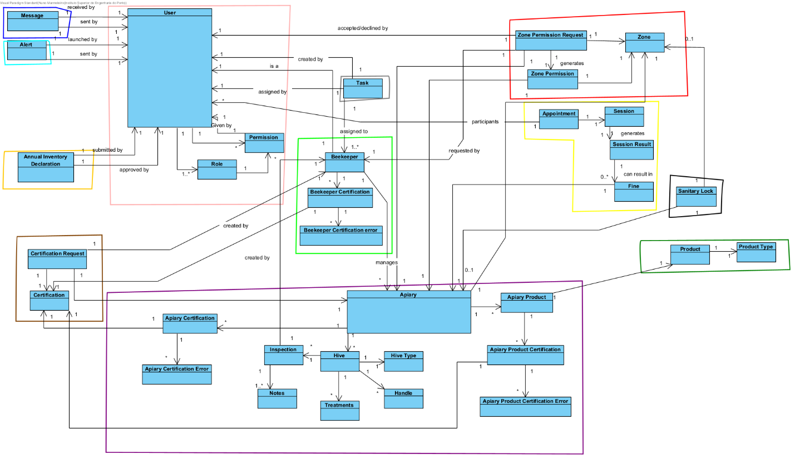

Figure 11 - Domain Model and its bounded contexts

In Figure 11, it is possible to analyse the Domain Model and identified bounded contexts. Each one of the bounded contexts answers to a problem.

The bounded contexts represented are the following:

* User B.C. (Pink);
* Beekeepr B.C. (Green);
* Appointment B.C. (Yellow);
* Sanitary Lock B.C. (Black);
* Apiary B.C. (Purple);
* Annual Inventory Declaration B.C. (Orange);
* Task B.C. (Gray);
* Zone B.C. (Red);
* Alert B.C. (Cyan);
* Message B.C. (Blue);
* Certification B.C. (Brown);
* Product B.C. (Dark Green).

# User Bounded Context

This bounded context represents the user and its role (such has DGAV Technician, Certification Personnel, Zone manager, Beekeeper Manager) and permissions given. It is the main bounded context because it controls all the other entities. In this bounded context it is possible to give permissions to satisfy the requirement to give permissions to see data for certifications and others.

# Beekeeper Bounded Context

This bounded context represents the beekeeper, who manages their apiaries and their certifications. A beekeeper is also a user, but a user it is not always a beekeeper.

# Appointment Bounded Context

This bounded context represents the appointments, and everything included in this, such as the sessions and their result and their fines if applicable.

Each user can create appointments with their participants.

# Sanitary Lock Bounded Context

This bounded context represents the sanitary lock and its information. It references an apiary or a zone.

# Apiary Bounded Context

This bounded context represents the apiary, and everything directly involved with it, like the certifications it has, its hives and the products that are then produced and sold.

Also, it has all the history of actions about the hives, which is a crucial point for the beekeeper, to keep track of all inspections that he makes and the treatments as well.

# Annual Inventory Declaration Bounded Context

This bounded context has in its logic the submission and the approval of the annual inventory declaration.

# Task Bounded Context

This bounded context represents the task, which is created and performed by the beekeeper, so he can take track of what was done.

# Zone Bounded Context

This bounded context represents the zone, and every aspect of it, including the permissions needed about the apiary.

# SAlert Bounded Context

This bounded context represents the alert, which are sent by a user and received by them too.

# Message Bounded Context

This bounded context represents the message, that are sent by users and received by them.

# Certification Bounded Context

This bounded context represents the certification. These certifications are after requested by the beekeepers about their apiaries.

# Product Bounded Context

This bounded context represents the product. It has the product and what type of product it is, so the beekeeper knows what is being produced and sold.

# External interface requirements

# User interfaces

The design of the user interface will have a focus on ease of use and accessibility.

Considering the user’s area of expertise and the fact that most processes were being handled manually until now, it’s expected that the user will not have a lot of experience working with computers. Because of this, the interface needs to be as simple as possible.

Buttons, errors, icons and links need to be clear and visible, to increase speed of use and how easy it is to interact with the Application.

In terms of accessibility, the Application will cover a lot of the web content recommendations made by the WCAG (Web Content Accessibility Guidelines), like for example, most of the app will be possible to use with keyboard only.

The screens identified by the team so far were:

* Login page – a simple page that serves the purpose of allowing the user to authenticate and gain access to the Application.
* Home page – the first page the user sees after login-in.
* Register pages – these pages are used to register something new in the Application.
* Listing pages – the type of page a user will see when visualizing a list of data.
* Detail pages – pages with information related to a specific data object.

All these types of screens will have similar structure and design to make the page clearer and to ensure the user learns quicky how to work with the Application.

Moreover, the screen will have a top bar, to always have all the functionalities available to the user. On the top bar there will also be a logout link, to logout from the current account.

# Software interfaces

The component diagram presented in Figure 12 shows the software interfaces present in the system.

Figure 12 - Component Diagram

The back-end service communicates with all other components of the system: its API is consumed by the web application and the SMS Service. The back end consumes the Database.

# Hardware interfaces

The application will work in both computer and mobile devices if they support chromium-based browsers (Google Chrome, Opera, Brave, Microsoft Edge, etc.). It will also work with Mozilla Firefox and Safari. The website should be responsive, and it needs to work with multiple screen resolutions.

# Communication interfaces

The application will use HTTPs protocol to have safe connection between the user and the server. The application will also use SMS (phone message) and SMTP (mail message) protocols to send notifications. Communications between the back end and the rest of the components will be done using REST APIs.

# Quality attributes

This section specifies other nonfunctional requirements. These quality requirements should be specific, quantitative, and verifiable.

These quality attributes should help design and develop an application that meets the needs of beekeepers, DGAV technicians, certification companies, and zone management, while ensuring that the application is secure, reliable, and user-friendly. It's important to prioritize and balance these attributes based on your specific project requirements and constraints.

# Usability

Usability requirements deal with ease of learning, ease of use, efficiency, and accessibility.

**User-Friendly Interface:** Design an intuitive and easy-to-use user interface that caters to the varying technical skills of beekeepers, technicians, and certification companies.

**Accessibility:** Ensure the application is accessible to users with disabilities.

# Performance

**Response Time:** Aim for fast response times when users perform actions like scheduling appointments or receiving notifications.

**Throughput:** Ensure the application can handle a high number of concurrent users and appointment requests.

# Security

**Data Privacy:** Ensure the confidentiality and integrity of sensitive information, such as beekeepers' and technicians' personal data and certification records.

**Authentication and Authorization:** Implement robust user authentication and authorization mechanisms to control access to different parts of the application based on user roles.

# Safety

**Data Protection:** Safeguard sensitive information in compliance with data protection regulations (e.g., GDPR) to prevent data breaches.

**Compliance with Beekeeping Regulations:** Ensure the application aligns with local and international regulations and policies related to beekeeping.

**User Safety:** Provide safety guidelines and instructions to prevent beekeepers and technicians from harm while interacting with the system.

**Secure Payment Processing:** If there are financial transactions, use secure payment gateways to protect financial information.

**Reporting and Fines:** Implement a transparent reporting system for sessions that result in fines and ensure that stakeholders have access to a dispute resolution mechanism.

# Reliability

**Availability:** The application should be available when needed, especially during critical periods like appointment scheduling and reporting.

**Fault Tolerance:** It should continue to function, or fail gracefully, in the presence of errors or network issues.

# Scalability

**Handle Increasing Users and Data:** As the number of users and data grows, the application should scale to meet the demand effectively.

# Interoperability

**Integration with External Systems:** Consider how the application can interface with external systems, such as notification services and government certification databases.

# Maintainability

**Modularity:** Design the application in a way that makes it easy to update, add new features, and maintain over time.

**Documentation:** Maintain clear and comprehensive documentation to aid developers and administrators.

# Testing and Quality Assurance

**Quality Testing:** Implement rigorous testing procedures to identify and rectify bugs and vulnerabilities.

**User Acceptance Testing (UAT):** Conduct UAT with stakeholders to ensure the application meets their needs.

# Notifications and Reminders

**Timely Notifications:** Ensure that notifications and reminders are delivered reliably and in a timely manner to all stakeholders for appointments and reports.

**Customization:** Allow users to customize their notification preferences.

# Reporting and Audit Trails

**Reporting:** Implement a robust reporting system for documenting session outcomes, which may include reports and fines.

**Audit Trails:** Keep records of user actions and system events for accountability and auditing purposes.

# Compliance and Regulations

**Regulatory Compliance:** Ensure that the application complies with relevant beekeeping and agricultural regulations, including certification and zoning rules.

# Scalability

**Data Storage Scalability:** Ensure that the application can handle the growing volume of data, including session reports and fines.

# Error Handling and Recovery

Implement effective error handling mechanisms and recovery procedures to minimize disruptions when issues occur.

# Feedback and Support

Provide channels for users to offer feedback, report problems, and seek support when needed.

# Cost Efficiency

Consider cost optimization in terms of infrastructure and data storage, especially as the user base and data volume increase.

# Internationalization and localization requirements

The application will only be used in Portugal, so it is not considered necessary for the system to support different formatting options for dates or addresses. There will also be no support for other language translations.

# Other requirements

# Transition Requirements

The transition from an existing system to your newly developed beekeeper management application is a critical phase in ensuring the continued smooth operation of the beekeeping ecosystem. This application serves as a central platform for beekeepers, DGAV technicians, certification companies, and zone management to collaborate efficiently and ensure the well-being of apiaries. To achieve a successful transition, several key requirements need to be addressed, including database migration scripts.

### Migration scripts

One of the primary transition requirements is the seamless migration of data from the existing system to the new application. This includes beekeeper profiles, session history, certification records, and zone management data. Develop comprehensive database migration scripts that can transfer data accurately, maintaining data integrity throughout the process. We also guarantee the creation of new migration scripts within the development of new functionalities and database changes that come with new versions of our project.

### Compatibility and Integration

Ensure that the new application can seamlessly integrate with existing systems, such as DGAV databases or certification company records. Compatibility is essential to minimize disruptions and facilitate a smooth transition.

### User Training

Prepare training materials and conduct training sessions for beekeepers, DGAV technicians, certification company personnel, and zone management administrators. They should be proficient in using the new application to maintain their daily operations effectively.

### Data Backup and Rollback Plan

Develop a comprehensive data backup and rollback plan to ensure that in case of unexpected issues during the transition, you can restore the application and data to a previous state without loss of information.

### Testing and Quality Assurance

Extensive testing is crucial to identify and rectify any issues or bugs before the transition. Ensure that all functionalities, including appointment scheduling, notification delivery, and reporting, are thoroughly tested.

### User Feedback Mechanism

Create a system for users to provide feedback and report any issues they encounter during the transition. This feedback will be valuable for continuous improvement and addressing any concerns promptly.

### Contingency Plan

Develop a contingency plan to address unexpected challenges during the transition, such as technical issues, data inconsistencies, or user adoption challenges.

# Process adopted for elicitation

From the beginning of the request to develop this application, the team adopted a process that was going to be executed every week. An interview per week, that was prepared before in a team meeting and the registration of the information gathered in the meeting.

# Stakeholders

Several stakeholders were interviewed to gather all the necessary requirements.

##### CEO

The CEO was bothered only with the success of the application. His intention was to create an application that was going to be used, opposite of the other existence products in the market.

Essentially, it is needed to have a usable application in the beginning to be sold. During the time, it should and will be improved.

##### Beekeeper Manager

On apiaries with big dimensions, it is possible to have Beekeeper Managers. Their intentions are like a common manager, organize the daily work of the Beekeepers creating tasks and assigning them, among others.

##### Beekeeper

From the Beekeeper’s interviews, it was noticed that many tasks were very much manual which causes constraints in his daily life, for example he identifies an inspection with rocks on the ground. Also, it is supposed to make easier and formal the communication between him and the other entities.

Emitting the Annual Stock Declaration is an obligation.

##### DGAV Technicians

DGAV Technicians are responsible for verifying the apiaries’ conditions related to the bees and workers too. Their intentions are to be able to register formally every problem found in the apiary and if needed register a sanitary lock.

##### Management Entities

The Management Entities were bothered only with the information about the Zones. So, their principal intentions were to visualize the zone’s information to see if it was needed to notify the apiary if something happens. For example, notifying bad weather coming or serious diseases in the zone.

As the beekeepers are obliged to emit the Annual Stock Declaration, the Management Entities want to see it in the Portal.

Also, they have products that can be sold to the apiaries, and this should be registered in the application.

##### Certification Companies

From its identification, the Certification Companies are responsible for certifying the apiaries. They want to manage this type of area. The apiary applies to a Certificate, and they should be able to manage and register all the information needed to achieve it.

# Applied techniques

# Stakeholders’ Interviews

Every Thursday, the team did an interview with several stakeholders to reach the requirements needed. These meetings had several templates, the first ones were a Question and Answer to reunite the problems that each stakeholder has on his day by day.

After a few, the team already had the requirements that needed to specify what was going to be done. So, the team prepared Use Cases Diagrams for each stakeholder and gathered feedback from him.

With the feedback gathered and discussed, the team made workflow diagrams for each stakeholder, concluding the interviews with the stakeholders.

# Team Meetings

Every meeting was prepared the weekend before. Also, every meeting’s registration was made on the same weekend. The team met to discuss developments and requirements raised by the customer.

# Effort involved

Describe in detail the total effort, and per business analyst, involved in the production of this work.

|  |  |  |  |
| --- | --- | --- | --- |
| Task | Brief description | BA name | Hours |
| 1 | Preparation for Interviews | All Team Members | 8 |
| 2 | Interviews | Al Team Members | 1 |
| 3 | Registration of Interviews | All Team Members | 5 |
| 4 | Use Cases Diagrams | Nuno Marmeleiro | 1 |
| 5 | Workflow Diagram to DGAV Technicians | Rafael Faísca | 1 |
| 6 | Workflow Diagram to Management Entities | Rafael Oliveira | 1 |
| 7 | Workflow Diagram to Certification Companies | Rogério Sousa | 1 |
| 8 | Domain Model Diagram | Nuno Marmeleiro and Óscar Folha | 2 |
| 9 | SRS – Overall Description | Rogério Sousa | 3 |
| 10 | SRS – Systems features | Rafael Oliveira | 3 |
| 11 | SRS – Data requirements | Óscar Folha | 4 |
| 12 | SRS – Domain Model | Nuno Marmeleiro | 2 |
| 13 | SRS – External interface requirements | Rafael Faísca | 3 |
| 14 | SRS – Quality Attributes | Óscar Folha | 2 |
| 15 | SRS – Internationalization and localization requirements | Rafael Faísca | 2 |
| 16 | SRS – Other Requirements | Rafael Oliveira | 2 |
| 17 | SRS – Process adopted for elicitation | Rogério Sousa | 2 |
| 18 | SRS – Product Backlog | Nuno Marmeleiro | 2 |
| 19 | SRS – Conclusion and other topics | All Team Members | 4 |

Table 2 - Effort evolved

Total hours: 51

# Constraints and limitations

The principal constraint found in the development of this application was the lack of knowledge from the team in this area. The apiculture and agriculture factory are areas not explored by the team.

# Product Backlog

The table shown below represents the requirements identified connected to the user story. There is an estimative of hours associated with which counts every step of development involved. Priority is also taken into consideration on a scale 1 to 3, 1 being the highest value for prioritization and 3 the least.

|  |  |  |  |  |
| --- | --- | --- | --- | --- |
| US Nr. | IR  Nr. | User story | Estimative hours | Priority |
| 1 | REQ-1 | The system must provide beekeepers with the capability to register new apiaries and enter relevant data. | 6h | 1 |
| 1 | REQ-2 | Apiary registration should include comprehensive details, such as location, size, and ownership information. | 2h | 1 |
| 1 | REQ-3 | The system should send notifications to confirm the successful registration. | 4h | 1 |
| 2 | REQ-4 | The system must offer beekeepers a user-friendly interface for creating tasks related to apiary and hive management. | 6h | 1 |
| 2 | REQ-5 | Task creation should include details such as description, due date, and priority. | 2h | 1 |
| 2 | REQ-6 | The system should associate tasks with specific apiaries or hives. | 2h | 1 |
| 3 | REQ-7 | The system must provide beekeepers with an interface for recording hive inspections, including notes, observations, and health status. | 6h | 1 |
| 3 | REQ-8 | Inspection recording should be comprehensive and include the ability to save inspection records. | 2h | 1 |
| 4 | REQ-9 | The system must offer beekeepers the capability to record treatments performed on individual hives, including treatment type, date, and dosage. | 6h | 1 |
| 4 | REQ-10 | Treatment recording should be comprehensive and include the ability to save treatment records. | 2h | 1 |
| 5 | REQ-11 | The system must provide beekeepers with the capability to view alerts issued by Management Entities and DGAV technicians. | 3h | 1 |
| 5 | REQ-12 | Alerts should be organized and easily accessible for review. | 1h | 2 |
| 6 | REQ-13 | The system must offer beekeepers an interface for issuing requests for entry or exit from specific apiary zones to Management Entities. | 3h | 1 |
| 6 | REQ-14 | Request details should include information about the zone, purpose, and duration. | 1h | 1 |
| 6 | REQ-15 | The system should send requests to the specified Management Entities. | 2h | 1 |
| 7 | REQ-16 | The system must provide beekeepers with the capability to view information about apiary zones, including temperature, wind speed, and other relevant data. | 8h | 1 |
| 7 | REQ-17 | Zone information should be accurate and up to date. | 2h | 1 |
| 8 | REQ-18 | The system must provide beekeepers with a calendar that displays tasks, agendas, and scheduled activities related to their apiaries. | 10h | 1 |
| 8 | REQ-19 | The calendar should be organized and easy to navigate, showing due dates and times. | 2h | 1 |
| 9 | REQ-20 | The system must offer beekeepers an interface for recording details of honey production, including the quantity and types of honey produced. | 8h | 1 |
| 10 | REQ-21 | The system must offer beekeepers a user-friendly interface for providing permission to certification companies to access and view data of a specified number of hives. | 7h | 1 |
| 10 | REQ-22 | Permission settings should include the number of hives and the duration of permission. | 1h | 1 |
| 10 | REQ-23 | The system should notify the specified certification company about the granted permission. | 2h | 2 |
| 11 | REQ-24 | The system must offer a user-friendly interface for certification companies to schedule, reschedule, or delete certification sessions. | 6h | 1 |
| 11 | REQ-25 | Session details, including date and time, should be accurately recorded. | 2h | 1 |
| 11 | REQ-26 | The system should send notifications to relevant parties regarding session changes. | 4h | 2 |
| 12 | REQ-27 | The system must offer a dedicated interface for certification companies to record inspection results for completed sessions. | 8h | 1 |
| 13 | REQ-28 | The system must provide the capability to create session reports based on inspection results. | 6h | 1 |
| 14 | REQ-29 | The system must provide an option for certification companies to cancel scheduled sessions. | 2h | 1 |
| 14 | REQ-30 | Cancellation confirmations should update the session status and notify relevant parties. | 1h | 1 |
| 15 | REQ-31 | The system must offer a user-friendly interface for certification companies to register or update certifications. | 6h | 1 |
| 15 | REQ-32 | Certification data should include details such as certification type, expiration date, and other relevant information. | 2h | 1 |
| 16 | REQ-33 | The system must provide the capability for certification companies to revalidate certifications that have expired or need renewal. | 3h | 1 |
| 16 | REQ-34 | Revalidation confirmations should update the certification status and notify relevant parties. | 1h | 1 |
| 17 | REQ-35 | The system must offer an interface for certification companies to record the time required for resolving issues identified in session reports. | 8h | 2 |
| 17 | REQ-36 | Time records should be associated with specific issues and sessions. | 2h | 2 |
| 18 | REQ-37 | The system must provide a feature for certification companies to view the treatment history of an apiary. | 6h | 2 |
| 18 | REQ-38 | The treatment history should include details of past treatments and interventions. | 1h | 2 |
| 19 | REQ-39 | The system must provide a feature for certification companies to view the requirements of specific certifications through external certification APIs. | 12h | 3 |
| 19 | REQ-40 | The system should display certification requirements accurately and in a user-friendly manner. | 2h | 2 |
| 20 | REQ-41 | The system must have the capability to send automatic notifications to all parties involved in a certification session as the session's date approaches. | 3h | 1 |
| 20 | REQ-42 | Notifications should be timely and include essential session details. | 1h | 2 |
| 21 | REQ-43 | The system must provide certification companies with the capability to generate the annual declaration of existence document. | 3h | 1 |
| 22 | REQ-44 | The system must offer DGAV technicians a user-friendly interface to schedule interventions and inspections. | 6h | 1 |
| 22 | REQ-45 | The scheduling process should include setting the date, time, and location. | 2h | 1 |
| 22 | REQ-46 | The system should send notifications to inform relevant parties about the scheduled interventions/inspections. | 4h | 2 |
| 23 | REQ-47 | The system must provide DGAV technicians with the capability to view notifications and messages received from beekeepers. | 4h | 1 |
| 23 | REQ-48 | Notifications should be organized and easily accessible for review. | 2h | 2 |
| 24 | REQ-49 | The system must provide DGAV technicians with the capability to access and view information about specific apiaries. | 6h | 1 |
| 24 | REQ-50 | The information should be comprehensive, including location details, bee counts, and inspection history. | 2h | 1 |
| 25 | REQ-51 | The system must provide DGAV technicians with a calendar to view scheduled interventions and inspections. | 6h | 1 |
| 25 | REQ-52 | The calendar should allow technicians to review and plan regulatory activities efficiently. | 2h | 1 |
| 26 | REQ-53 | The system must have the capability to send automatic notifications to DGAV technicians as scheduled interventions or inspections approach. | 6h | 1 |
| 26 | REQ-54 | Notifications should be timely and include essential details about the upcoming intervention/inspection. | 2h | 1 |
| 27 | REQ-55 | The system must provide DGAV technicians with an interface for recording inspection results and generating inspection reports. | 6h | 1 |
| 27 | REQ-56 | The system must provide DGAV technicians with an interface for recording inspection results and generating inspection reports. | 2h | 1 |
| 28 | REQ-57 | The system must offer DGAV technicians the capability to record fines imposed on beekeepers for non-compliance or violations. | 6h | 1 |
| 28 | REQ-58 | Fine recording should include details such as the fine amount, reason, and due date. | 2h | 1 |
| 29 | REQ-59 | The system must provide DGAV technicians with the capability to record the temporary closure of an apiary for sanitary reasons. | 6h | 1 |
| 29 | REQ-60 | Sanitary closure recording should include details of the reasons for closure and the expected reopening date. | 2h | 1 |
| 30 | REQ-61 | The system must offer DGAV technicians a dedicated interface for recording instances of severe diseases affecting apiaries. | 6h | 1 |
| 30 | REQ-62 | The system must offer DGAV technicians a dedicated interface for recording instances of severe diseases affecting apiaries. | 2h | 1 |
| 31 | REQ-63 | The system must have the capability to send automatic notifications to relevant parties when DGAV technicians record instances of severe diseases affecting apiaries. | 8h | 2 |
| 31 | REQ-64 | Notifications should be timely and include essential details about the disease outbreak and containment measures. | 2h | 2 |
| 32 | REQ-65 | The system must provide management entities with the capability to access and view information about specific apiaries. | 6h | 1 |
| 32 | REQ-66 | The information should be comprehensive, including location details, bee counts, and inspection history. | 2h | 1 |
| 33 | REQ-67 | The system must offer management entities a user-friendly interface for registering new zones. | 6h | 1 |
| 33 | REQ-68 | The system should allow viewing and managing zone information, including associated data. | 2h | 1 |
| 34 | REQ-69 | The system must provide management entities with the capability to emit alerts related to events or recommendations for specific apiary zones. | 6h | 1 |
| 34 | REQ-70 | Alerts should include information about the type of event or recommendation, the message, and the target zone. | 2h | 1 |
| 34 | REQ-71 | The system should ensure that alerts are delivered to the specified zones and relevant parties. | 2h | 2 |
| 35 | REQ-72 | The system must offer management entities an interface for managing declarations of entry or exit for zones. | 6h | 1 |
| 35 | REQ-73 | Declaration management should include the ability to review and act on declarations, including approval or rejection. | 2h | 1 |
| 35 | REQ-74 | The system should ensure that relevant parties are notified of declaration status changes. | 2h | 2 |
| 36 | REQ-75 | The system must provide management entities with the capability to view the annual declaration of existence document. | 2h | 1 |
| 36 | REQ-76 | The document should be accurate, up-to-date, and compliant with regulatory requirements. | 1h | 1 |
| 37 | REQ-77 | The system must provide management entities with the capability to view disease records submitted by DGAV technicians. | 2h | 1 |
| 37 | REQ-78 | Disease records should be comprehensive, including details about the diseases, affected apiaries, and containment measures. | 1h | 1 |
| 38 | REQ-79 | The system must offer management entities a user-friendly interface for scheduling inspections. | 3h | 1 |
| 38 | REQ-80 | The scheduling process should include setting the date, time, and the target zone. | 1h | 1 |
| 38 | REQ-81 | The system should send notifications to inform relevant parties about the scheduled inspections. | 2h | 2 |
| 39 | REQ-82 | The system must provide management entities with an interface for recording details of inspections carried out within apiary zones. | 4h | 1 |
| 39 | REQ-83 | Inspection recording should include objectives, activities, results, and associations with specific zones and activities. | 2h | 1 |
| 40 | REQ-84 | The system must provide management entities with a dashboard for viewing a summarized overview of information and activities related to apiaries and entities. | 6h | 1 |
| 40 | REQ-85 | The dashboard should present essential information, including notifications, alerts, and key performance indicators. | 2h | 1 |
| 41 | REQ-86 | The system must provide management entities with the capability to view information about apiary zones, including temperature, wind speed, and other relevant data. | 3h | 1 |
| 42 | REQ-87 | The system must offer management entities an interface for managing the stock of products used within apiaries. | 1h | 1 |
| 42 | REQ-88 | Product stock management should include the ability to view and update stock levels based on consumption and restocking. | 4h | 1 |
| 42 | REQ-89 | The system should notify relevant parties when stock levels reach critical thresholds. | 2h | 2 |
| 43 | REQ-90 | The system must offer Beekeeper Managers a user-friendly interface for creating and managing tasks related to apiary and hive management. | 8h | 1 |
| 43 | REQ-91 | Task creation should encompass comprehensive details, including task description, due date, and priority. | 2h | 1 |
| 43 | REQ-92 | The system should efficiently associate tasks with specific apiaries or hives to streamline management and tracking. | 2h | 2 |
| 44 | REQ-93 | The system must provide Beekeeper Managers with an intuitive interface for registering beekeepers, encompassing personal information and their connection to apiaries. | 8h | 1 |
| 44 | REQ-94 | Beekeeper Managers should be able to create, update, and manage apiary records, including data related to location and ownership. | 2h | 1 |
| 45 | REQ-95 | The system must offer Beekeeper Managers a streamlined interface for assigning tasks, allowing them to specify the recipient, due date, and task particulars. | 4h | 1 |
| 45 | REQ-96 | Task assignment should include notification to the designated task recipient for effective communication. | 2h | 2 |
| 46 | REQ-97 | The system must provide Beekeeper Managers with an accessible interface for viewing all tasks, offering information about task status, assignees, and due dates. | 8h | 1 |
| 46 | REQ-98 | Task details should be readily accessible, ensuring comprehensive task visibility for effective management. | 2h | 1 |
| 47 | REQ-99 | The system must provide Beekeeper Managers with an intuitive interface for registering beekeepers, encompassing personal information and their connection to apiaries. | 6h | 1 |
| 47 | REQ-100 | Beekeeper Managers should be able to create, update, and manage apiary records, including data related to location and ownership. | 2h | 1 |
| - | REQ-101 | Create authentication for the system | 16h | 1 |
| - | REQ-102 | Create authorization for the system | 16h | 1 |

Table 3 - Product Backlog Requirements

To develop all the functionalities of this document the software house will need a total of 401 hours. However, it is also important to refer that if we add the time to configure and setup all the infrastructure needed for this software, the nonfunctional requirements referred in this document and follow the best software development practices, a safer estimate would be around 600-700 hours of work.

# Appendix

# Appendix – Glossary

* BC – Bounded Context
* BPMN - Business Process Model and Notation
* CEO – Chief Executive Officer
* DGADR - Direção-Geral de Agricultura e Desenvolvimento Rural
* DGAV - Directorate General for Food and Veterinary
* ENGREQ - Engenharia de Requisitos
* EU – European Union
* GDPR - General Data Protection Regulation
* HTTPS - Hypertext Transfer Protocol Secure
* OAuth2 - Open Authorization version 2
* REST - Representational State Transfer
* SAS - Sustainable Agriculture Solutions
* SMS – Short Message Service
* SMTP - Simple Mail Transfer Protocol
* UML - Unified Modeling Language

# Appendix – Analysis models

The details of our analysis models and all the diagrams showed within this report can be found in the folder [UseCases](https://bitbucket.org/1181600/engreq_6_m1b/src/master/UseCases/) and [Artifacts](https://bitbucket.org/1181600/engreq_6_m1b/src/master/Artifacts/) of our repository.

The UseCases folder is divided by stakeholders, presents the use cases and workflows of respective user.

The Artifact folder contains DomainModel, Logical data model, data dictionary and report example.

# Elicitation data detail

The details of our meetings with all the stakeholders can be found within our repository in the folder [**Interviews**](https://bitbucket.org/1181600/engreq_6_m1b/src/master/Interviews/)**.** There we have the stakeholders divided by folders and the meetings separated by date.