**SUCCESS**

* **Given** a user is viewing the map with multiple Wi-Fi locations,  
  **When** they select a specific Wi-Fi location,  
  **Then** the option "Go to this Location" should be displayed.

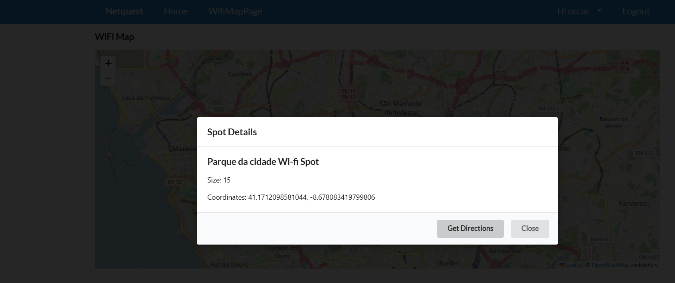

**SUCCESS**

* **Given** a user selects "Open in Google Maps" from the pop-up,  
  **When** they confirm the selection,  
  **Then** Google Maps should launch, displaying the route from the user's current location to the selected Wi-Fi locatioUma imagem com texto, captura de ecrã, software, diagrama

  Descrição gerada automaticamenten.