**Test Case 1: Successfully award points for creating a new Wi-Fi spot SUCCESS**

**Preconditions:**

* User is logged in.

**Steps:**

1. Navigate to the "Add Wi-Fi Spot" page.
2. Enter valid details for the new Wi-Fi spot (e.g., location, name, description).
3. Click the "Submit" button.

**Expected Result:**

* The Wi-Fi spot is created successfully.
* The user receives points for creating the Wi-Fi spot, and their points balance is updated.

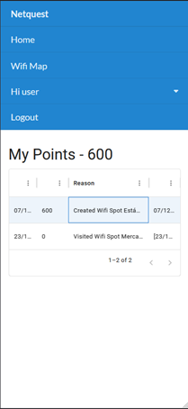

**Test Case 2: Handle errors during point awarding SUCCESS**

**Preconditions:**

* User is logged in.
* An error occurs during the points calculation or awarding process.

**Steps:**

1. Create a new Wi-Fi spot with valid details.
2. Wait for the system to process the points**.**

**Expected Result:**

* Points are not immediately awarded.
* An error is logged.
* The system retries awarding points or prompts the user to contact support.